simple command in terminal

1.date

2.cal-it shows calender of current month

3.cal -y-it shows calender of whole year

4.cal 1990-it calender of whole year of 1995

5.cal 1 1995-it shows calender of january of 1995

6.cal -3 -it show calender of 3 months (i)-current (ii)-previous(iii)-next

7.clear -clear your terminal

8.exit -simply exit the terminal session

9. (.) 🡪 one reperesnts the current directory

10.(..)🡪 represents the parent directory

Linux file system-\n

\*Tree like structure

\*also known as directory tree

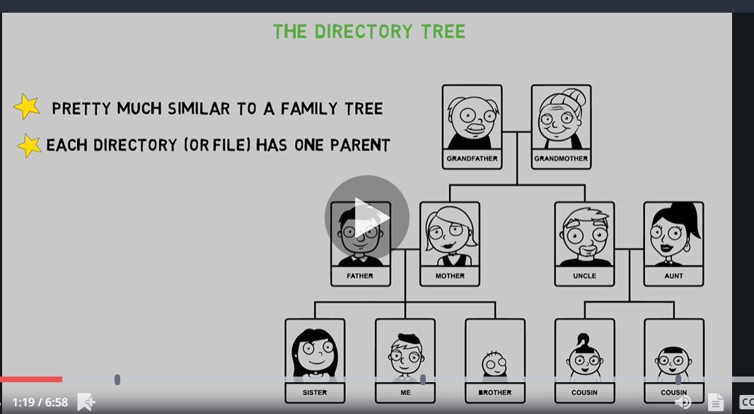

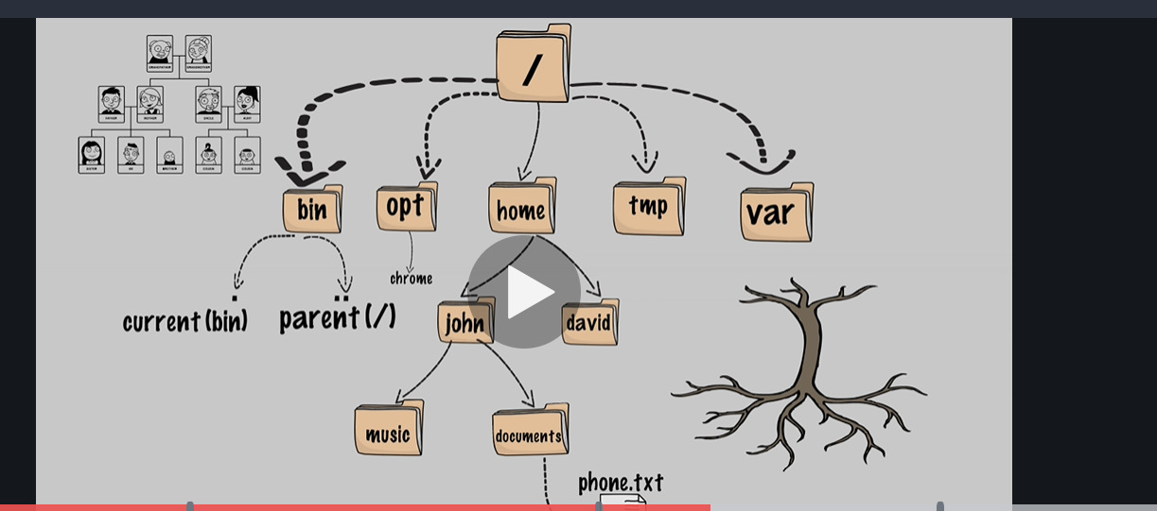

The fore most directory is / directory and it has many subdirectories-

(i)-bin directory stands for binary director

(ii)-opt directory is for optional directory it means chrome is not installed in linux we have to install later

(iii)-home

(iv)-tmp-temporary directory files that are often change or deleted ,never store a file that you want to store for a large time.

(v)-var-var is another directory it contain variable data ,data that changes frequently overtime

These directory you can find in each directory like bin,opt,home etc

(i) . current (bin) directory

(ii) .. parent (/) directory

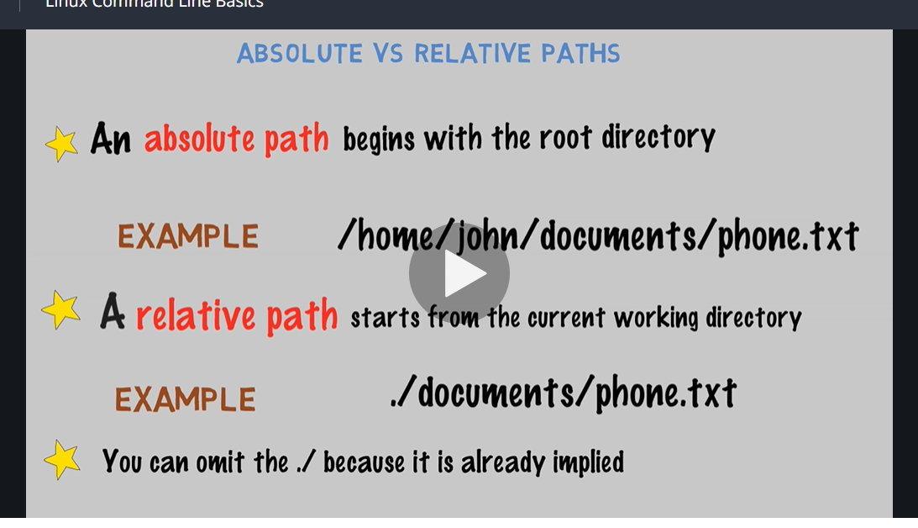

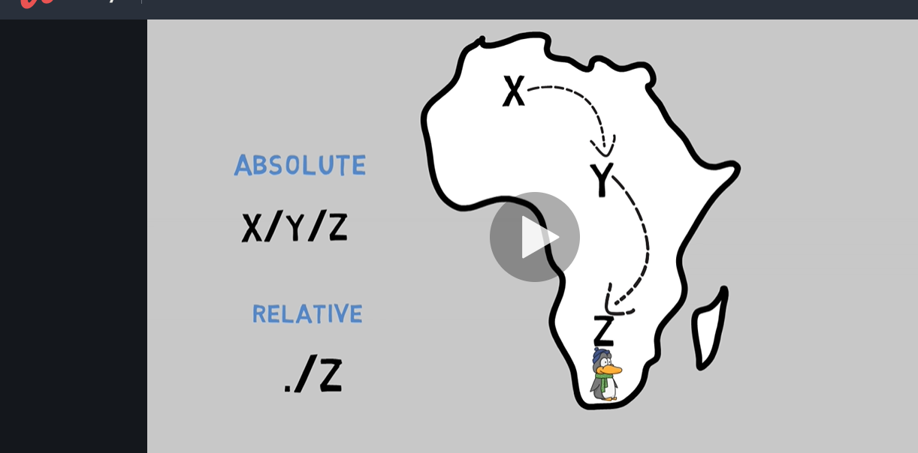

NAVIGATE THE LINUX FILE SYSTEM-

1.Pwd-present working directory

2.ls-list of a directory content

3.cd change directory

4. Cd /🡪 will take you to the root directory

5. Cd. --> will take you to the home directory

To show the inode number

* Ls -i🡪 inode number of your files in a current directory
* Ls -i /🡪 Inode number for root directory
* Ls -l🡪 it will show the file size(bytes) and many more things
* Ln Original fileName HardlinkName 🡪 it will create hardlink for file not for folder all the hardlink has same inode number as it will create same file size .If you delete original file then also you can able to open hardlink.
* Ln -s OriginalfileName softlinkName🡪 it will create soft link it will have diff inode number ,smaller file size then the original one. Once when you delete the original file then you are nit able to open the softlink.You can create it for directory also.

A directory loop

Ln -s .. 🡪 it will create the infinte loop ex🡪 if you are inside the desktop/a/b—

The when you create a soft link c and when you go inside the desktop then you press a then b then their creates c then press c then b came again like when you press b then c came again like this infinite loop willl be done .

LS command option🡪

* Ls-i 🡪 it will show the Inode number
* Ls -l 🡪 is used for long listing
* Ls -a 🡪 it shows the all the files including hidden file (a stands for all)
* Any file begin with dot is a hidden file
* Ls -t will show the file according to the modification date as first and last modified/made at last.
* Ls -r 🡪 will show the file in reverse order from the general ls(reverse)
* Ls -R it will show all the files including sub directory(R=recursive)
* Ls -i -l / Ls -l -i / ls -il/ls -li🡪 it will show both inode number and long listing
* Ls -tr 🡪 it will reverse the t option
* Ls – lt

🡪To change the time of the file use command “touch filename” now when you do ls -l then it shows todays date .For more than one file at a time “touch filename1 filename2”.

🡪If you do “touch filename(that does not exist)” it will simply create one file , for more than one file write “touch f1 f2 f3” , it will create 3 file f1,f2,f3.

Remove command option🡪

🡪For creating more than 1 directory write “mkdir 1 2 “ it will create 2 directory 1,2 .

* To delete empty directory “rmdir directoryName” , for more than 1 use rmdir”1,2,3”.
* “touch directoryName/filename” is used to create the file inside the directory .
* “rm filename ”is used to delete file for more than one write more than filename.
* To delete the unempty directory use “rm -R DirectoryName”(remove directory recursively) .
* “rm -i fileName” it will ask you confirmation before deleting . y/n.
* “rm -Ri DirectoryName” it will ask one by one to delete the total number of file/directory present Inside directory.
* “rm -f(forcefully) file/Dir” it will not ask any confirmation it will delete,it will ignore non-existing file.
* “rm -Rv dir” it will show you the summary what you have deleted .
* R=r(it is not case senstive)
* “touch filename” to create file.

Copy file command option🡪

* “cp file1 file2” it will copy the data of file1 into file2, if file2 doesn’t exist it will create and copy if it exist it will copy the content simply.
* “cp f1 f2 f3 dir” it will copy f1,f2,f3 in directory (dir).
* “cp -R dir1 dir2” it will copy directory 2 into 1.
* “cp -I ”
* “cp-Rv dir1 dir2” it will show the summary what he do.

To rename file name🡪

* “mv oldFileName newFileName”
* To hide the file use “mv filename .NewFileName” it will hide the file and if show the file use “ls -a”.
* To bring back use “ mv .hiddenFile FileName ”it will bring back.
* If you want to move file into directory “mv f1, f2 ,f3 directoryName”
* “mv -i f1,f2 directoryName” it will ask confirmation
* In linux we don’t have concept of extension.
* “file FileName ” It will give a description of filename what it is inside wheather image ,text or whatever.
* To create file named as my job with space b/w them then use “mkdir ‘my job’ ” or “mkdir “my job” ”.
* We can also use “mkdir my/job ”
* Same concept in removing.

Special character for linux🡪

* $ to make Directoey name $mydir use command “\$dolaar”, for directory name $$dollar use command “/$/$dollar”
* > “four/>one” to create directory four>one
* <
* &
* |
* ;
* ‘
* “
* \
* To create directory name cats&dogs use command “cats\&dogs
* If a directory name is too long then use the command “cd (2-3 words) (tabkey)”
* “cd (tabkey)\*2” it shows all the available option.
* “rm -- ” is used to see all the available option of rm--.
* Ctrl+a🡺 it will take the cursor to first position.
* Ctrl+d🡪 will delete where the cursor points.
* Ctrl+e🡪 will take you to the end of line
* Ctrl+f🡪will work as right arrow key.
* Ctrl+b🡪will work as left arrow key.
* Alt+f 🡪 will move one word forward.
* Alt+b 🡪 will move one word backward.
* Alt+u🡪 will convert lower case to upper case.
* Alt+l🡪 will convert upper case to lower case.
* ctrl+k🡺 will cut all the line from the cursor points to right side.if you want to paste it again ctrl+y.
* ctrl+u 🡪 will erase to eft side.
* Ctrl+l🡪 to clear screen.
* “History “will show the full history.
* “! (command number)” will do the same thinfas it done earlier.
* “history -c ” will clear whole history.
* To view file in cmd terminal use”less filename” press q for exit.