
RAJALAKSHMI INSTITUTE OF TECHNOLOGY
(An Autonomous Institution, Affiliated to Anna University, Chennai)

DEPARTMENT OF CSE (ARTIFICIAL INTELLIGENCE AND MACHINE LEARNING)
ACADEMIC YEAR 2025 - 2026
SEMESTER IV
AL23421 - MACHINE LEARNING LABORATORY
MINI PROJECT REPORT

REGISTER NUMBER | 2117240030165
NAME | YASHWANTH.M.C.
PROJECT TITLE | Planetary Data Anomaly Detection using Random Forest
DATE OF SUBMISSION
FACULTY IN-CHARGE | Mrs. S. Divya

Signature of Faculty In-charge Signature of HoD

INTRODUCTION
Machine Learning is a branch of artificial intelligence that enables systems to learn patterns from data and make predictions without explicit programming. In recent years, anomaly detection has become an important application in various domains such as cybersecurity, healthcare, and space research.This project focuses on detecting anomalies in planetary data using the Random Forest algorithm. Planetary systems generate large volumes of data such as temperature, pressure, and radiation levels. Identifying abnormal patterns in such data is crucial for early detection of unusual planetary conditions.The proposed system uses a supervised machine learning approach where a Random Forest classifier is trained to distinguish between normal and anomalous data points. The project aims to develop an efficient and scalable model capable of real-time anomaly detection.
PROBLEM STATEMENT
To develop a machine learning model that can accurately detect anomalies in planetary data based on features such as temperature, pressure, and radiation levels, and classify the data as normal or anomalous.
GOAL
The goal of this project is to:
- Build a Random Forest-based classification model
- Accurately identify anomalies in planetary data
- Achieve high prediction accuracy with realistic data
- Enable real-time anomaly detection
- Analyze feature importance influencing anomaly detection

THEORETICAL BACKGROUND
Random Forest Algorithm
Random Forest is an ensemble learning algorithm that combines multiple decision trees to improve prediction accuracy and reduce overfitting.Each tree is trained on a random subset of the data, and the final prediction is made by majority voting.
Literature Survey
- Random Forest is widely used for anomaly detection due to its robustness
- It handles large datasets efficiently
- Compared to SVM and Decision Trees, Random Forest reduces overfitting

Mathematical Representation
For a dataset $D=\{(x_{1},y_{1}),(x_{2},y_{2}),...,(x_{n},y_{n})\}$
Each tree predicts:
$$h_{i}(x)$$
Final prediction:
$$H(x)=\text{majority vote}(h_{1}(x),h_{2}(x),...,h_{n}(x))$$
Justification for Choosing Algorithm
Random Forest is chosen because:
- It provides high accuracy
- Handles non-linear data effectively
- Less prone to overfitting
- Easy to implement and interpret

ALGORITHM EXPLANATION WITH EXAMPLE
- Input planetary dataset (Temperature, Pressure, Radiation)
- Split dataset into training and testing sets
- Train multiple decision trees using random subsets
- Each tree predicts output independently
- Final output is determined using majority voting

Example:
Input:
Temperature = 45
Pressure = 60
Radiation = 130
Prediction:
→ Anomaly Detected

IMPLEMENTATION CODE AND DATASET USED
Category | Description
Dataset Name | Planetary Synthetic Dataset
Domain | Space / Scientific Data
Objective | Classification
Data Source | Synthetic
Number of Samples | 6000
Data Type | Tabular
Instance Description | Each row represents planetary condition
Features | Temperature, Pressure, Radiation
Feature Types | Numerical
Target Variable | Label (0 = Normal, 1 = Anomaly)
Number of Classes | 2
License | Open
Version | 1.0
Code:
import numpy as np
import pandas as pd
np.random.seed(42)
# Large normal data
normal_temp = np.random.normal(15, 5, 5000)
normal_pressure = np.random.normal(101, 10, 5000)
normal_radiation = np.random.normal(50, 10, 5000)
anom_temp = np.random.normal(35, 8, 1000)
anom_pressure = np.random.normal(80, 15, 1000)
anom_radiation = np.random.normal(110, 25, 1000)
X = np.vstack([
np.column_stack((normal_temp, normal_pressure, normal_radiation)),
np.column_stack((anom_temp, anom_pressure, anom_radiation))
])
y = np.array([0]*5000 + [1]*1000)
data = pd.DataFrame(X, columns=["Temperature", "Pressure", "Radiation"])
data["Label"] = y
print("Dataset size:", data.shape)
data.head()
import time
import pandas as pd
print("Real-time anomaly detection simulation:\n")
model.fit(X_train, y_train)
for i in range(5):
new_sample_list = [
np.random.normal(20, 10),
np.random.normal(90, 15),
np.random.normal(60, 20)
]
new_sample = pd.DataFrame([new_sample_list], columns=X_train.columns)
prediction = model.predict(new_sample)
print("Input:", new_sample_list)
if prediction[0] == 0:
print("Result: Normal\n")
else:
print("Result: Anomaly Detected!\n")
time.sleep(1)
print("Total samples:", len(data))
new_data = pd.DataFrame([[45, 60, 130]],
columns=["Temperature", "Pressure", "Radiation"])
prediction = model.predict(new_data)
print("Test Input:", test_anomaly)
if prediction[0] == 0:
print("Result: Normal")
else:
print("Result: Anomaly Detected!")
import matplotlib.pyplot as plt
importance = model.feature_importances_
features = ["Temperature", "Pressure", "Radiation"]
plt.bar(features, importance)
plt.title("Feature Importance in Anomaly Detection")
plt.show()

OUTPUT:
Model Accuracy
Accuracy = 99.75%
Confusion Matrix
- True Normal = 1003
- False Positive = 1
- False Negative = 2
- True Anomaly = 194
Performance Metrics
- Precision = High
- Recall = High
- F1 Score = High
Visualization
- Scatter plot of data distribution
- Feature importance graph

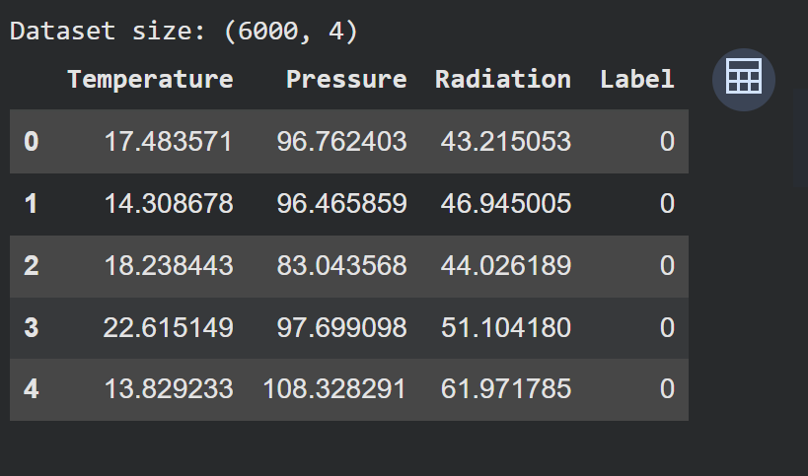

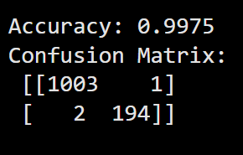
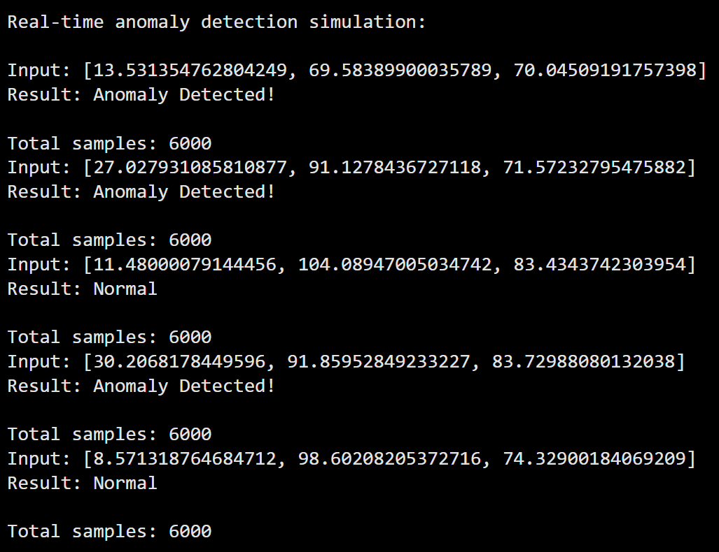
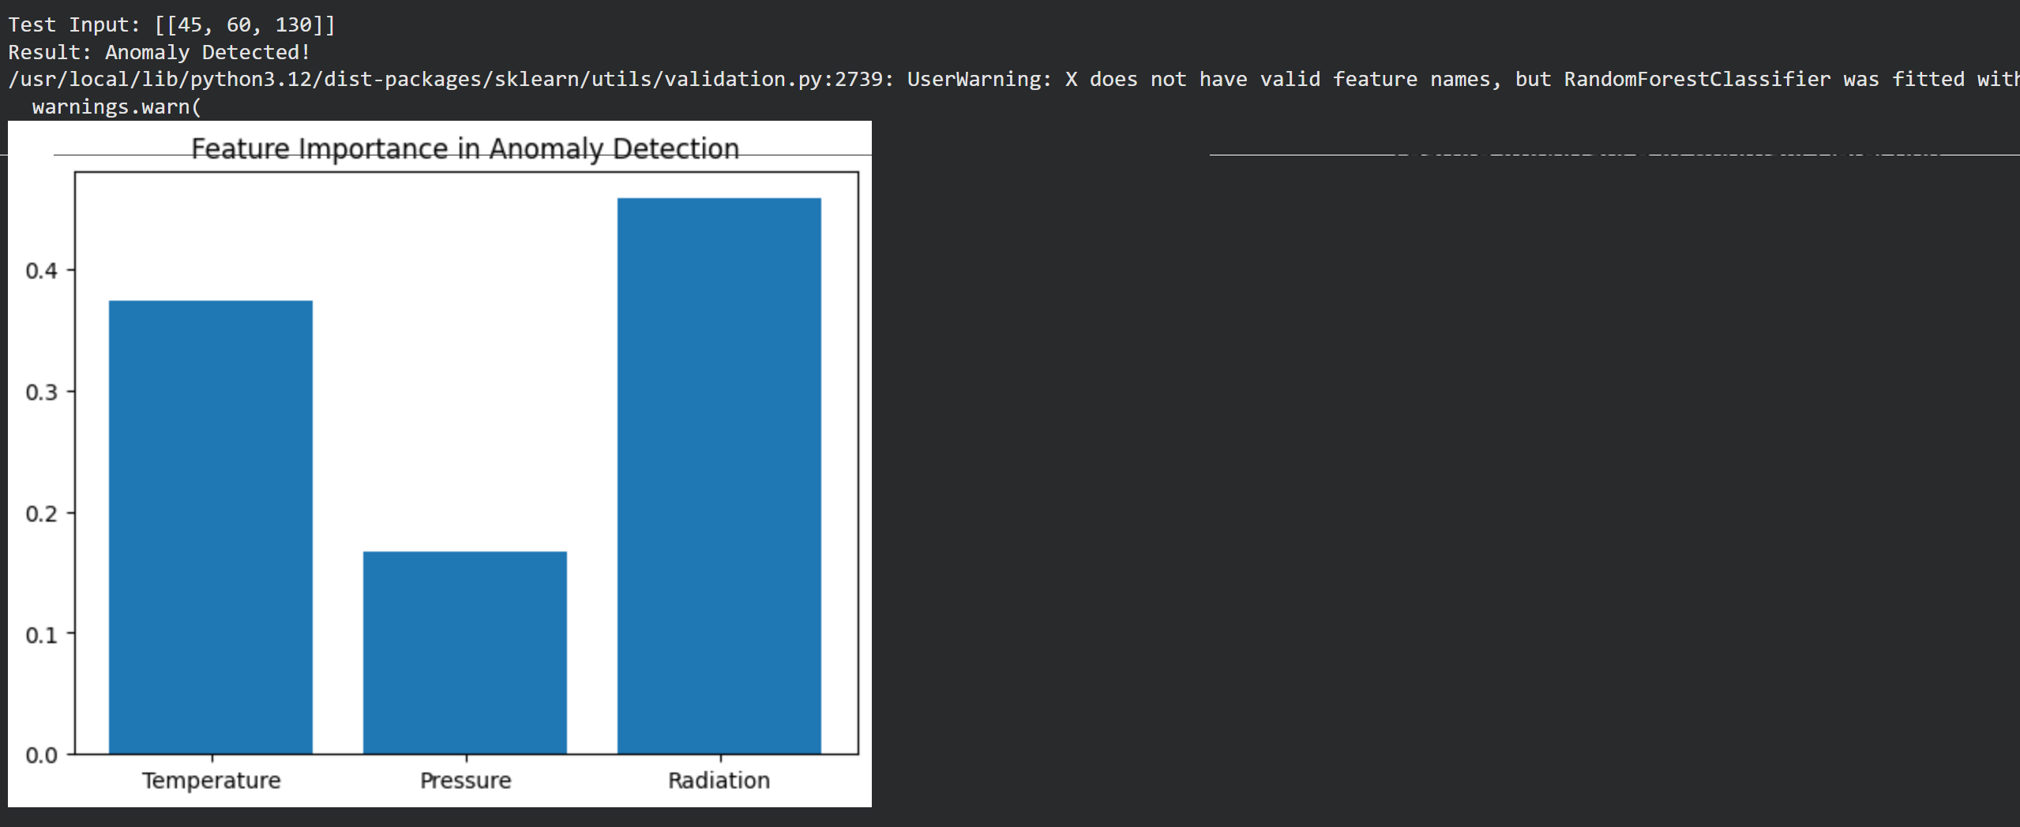

RESULTS AND FUTURE ENHANCEMENT
Results
- High accuracy achieved (99.75%)
- Model successfully detects anomalies
- Real-time prediction implemented
Future Enhancements
- Use real planetary datasets (NASA)
- Improve model using deep learning
- Build web-based interface
- Integrate IoT sensor data

Git Hub Link of the project along with the report | https://github.com/Yashwahthmc/ML-MINI-PROJECT.git
REFERENCES
Use these:
- Ethem Alpaydın – Introduction to Machine Learning
- Scikit-learn Documentation
- Kaggle Datasets
- Random Forest Research Papers
- Python Documentation

