**Yashwant Desai – Assignment 14**

1. What does RGBA stand for?

Answer: RGBA stands for Red, Green, Blue, and Alpha

2. From the Pillow module, how do you get the RGBA value of any images?

Answer: Below is the same code to get the RGBA

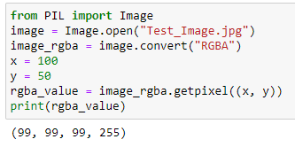

3. What is a box tuple, and how does it work?

Answer: a box tuple refers to a tuple that represents a rectangular region or bounding box. It is commonly used in various image processing operations to define an area within an image. A box tuple usually consists of four values i.e. left, upper, right & lower

4. Use your image and load in notebook then, How can you find out the width and height of an Image object?

Answer:

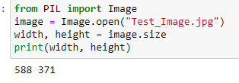

5. What method would you call to get Image object for a 100×100 image, excluding the lower-left quarter of it?

Answer:

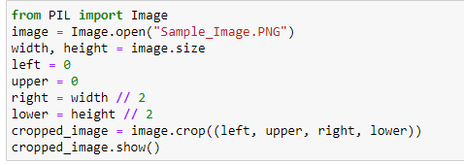

6. After making changes to an Image object, how could you save it as an image file?

Answer: Using .save we can save an image

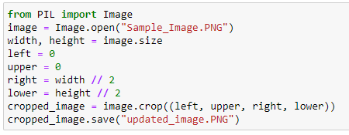

7. What module contains Pillow’s shape-drawing code?

Answer: ImageDraw module contains Pillow shape-drawing code

8. Image objects do not have drawing methods. What kind of object does? How do you get this kind of object?

Answer: Image object in the pillow library do not have drawing methods. Drawing methods are available in ImageDraw module. To get an ImageDraw object we need to create it using the ImageDraw.Draw() method.

**Regards,**

**Yashwant**