**Yashwant Desai – Assignment 16**

1. Create a list called years_list, starting with the year of your birth, and each year thereafter until the year of your fifth birthday. For example, if you were born in 1980. the list would be years_list = [1980, 1981, 1982, 1983, 1984, 1985].

Answer: please find below years list

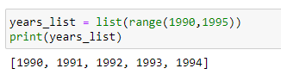

2. In which year in years_list was your third birthday? Remember, you were 0 years of age for your first year.

Answer: index for 3rd year is 2.

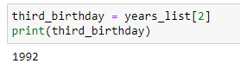

3.In the years list, which year were you the oldest?

Answer: oldest year is 1994

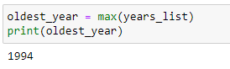

4. Make a list called things with these three strings as elements: "mozzarella", "cinderella", "salmonella".

Answer:

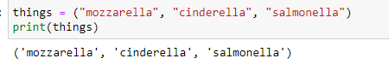

5. Capitalize the element in things that refers to a person and then print the list. Did it change the element in the list?

Answer: yes it did change the element in the list. Please find below the result

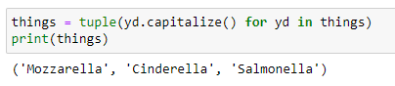

6. Make a surprise list with the elements "Groucho," "Chico," and "Harpo."

Answer: please find below the surprise list.

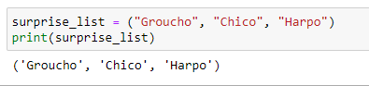

7. Lowercase the last element of the surprise list, reverse it, and then capitalize it.

Answer: below is an outcome

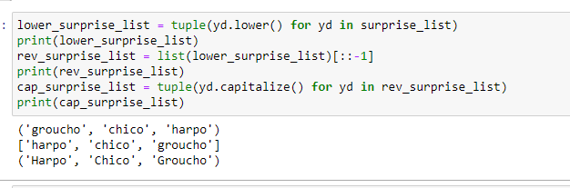

8. Make an English-to-French dictionary called e2f and print it. Here are your starter words: dog is chien, cat is chat, and walrus is morse.

Answer: please find below the dictionary

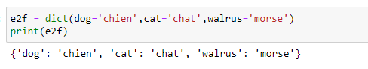

9. Write the French word for walrus in your three-word dictionary e2f.

Answer: The French word has been added

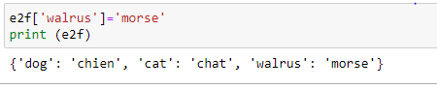

10. Make a French-to-English dictionary called f2e from e2f. Use the items method.

Answer: below is the French to English dictionary as per e2f

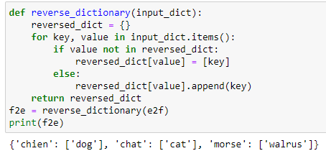

11. Print the English version of the French word chien using f2e.

Answer: Below is the English version of the French word

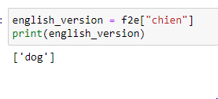

12. Make and print a set of English words from the keys in e2f.

Answer: below are English words from the e2f

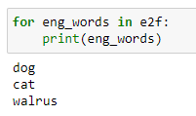

13. Make a multilevel dictionary called life. Use these strings for the topmost keys: 'animals', 'plants', and 'other'. Make the 'animals' key refer to another dictionary with the keys 'cats', 'octopi', and 'emus'. Make the 'cats' key refer to a list of strings with the values 'Henri', 'Grumpy', and 'Lucy'. Make all the other keys refer to empty dictionaries.

Answer: Below is an outcome

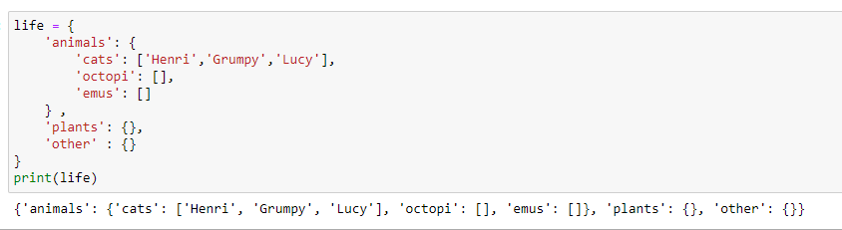

14. Print the top-level keys of life.

Answer: Below are top level keys of life

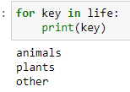

15. Print the keys for life['animals'].

Answer: below are keys for life['animals']

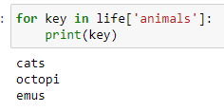

16. Print the values for life['animals']['cats']

Answer: below are keys for life['animals']['cats']

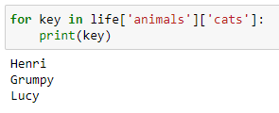

**Regards,**

**Yashwant**