**Yashwant Desai – Assignment 17**

1. Assign the value 7 to the variable guess_me. Then, write the conditional tests (if, else, and elif) to print the string 'too low' if guess_me is less than 7, 'too high' if greater than 7, and 'just right' if equal to 7.

Answer: below is an outcome

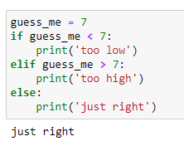

2. Assign the value 7 to the variable guess_me and the value 1 to the variable start. Write a while loop that compares start with guess_me. Print too low if start is less than guess me. If start equals guess_me, print 'found it!' and exit the loop. If start is greater than guess_me, print 'oops' and exit the loop. Increment start at the end of the loop.

Answer: Below is an outcome

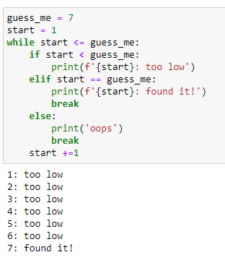

3. Print the following values of the list [3, 2, 1, 0] using a for loop.

Answer: Below is a for loop result.

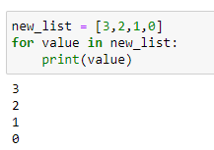

4. Use a list comprehension to make a list of the even numbers in range(10)

Answer: below is then even numbers list

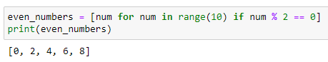

5. Use a dictionary comprehension to create the dictionary squares. Use range(10) to return the keys, and use the square of each key as its value.

Answer: Below is squares dictionary result

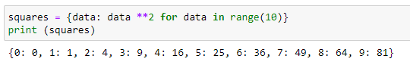

6. Construct the set odd from the odd numbers in the range using a set comprehension (10).

Answer: below is the odd numbers result

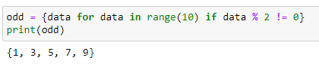

7. Use a generator comprehension to return the string 'Got ' and a number for the numbers in range(10). Iterate through this by using a for loop.

Answer: below is the data range generator outcome

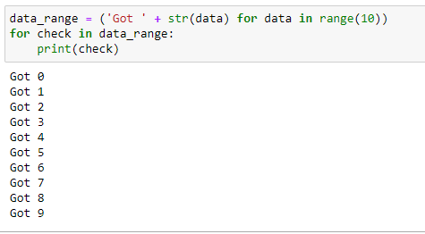

8. Define a function called good that returns the list ['Harry', 'Ron', 'Hermione'].

Answer: below is an outcome

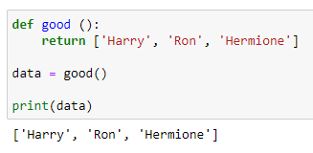

9. Define a generator function called get_odds that returns the odd numbers from range(10). Use a for loop to find and print the third value returned.

Answer: below is the third odd value function result

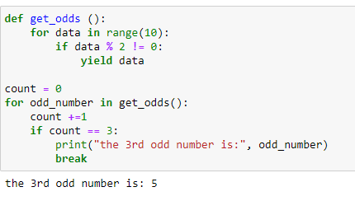

10. Define an exception called OopsException. Raise this exception to see what happens. Then write the code to catch this exception and print 'Caught an oops'.

Answer: below is an exception outcome

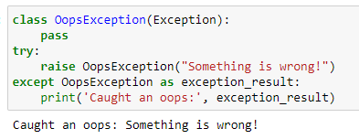

11. Use zip() to make a dictionary called movies that pairs these lists: titles = ['Creature of Habit', 'Crewel Fate'] and plots = ['A nun turns into a monster', 'A haunted yarn shop'].

Answer: Please find below the result

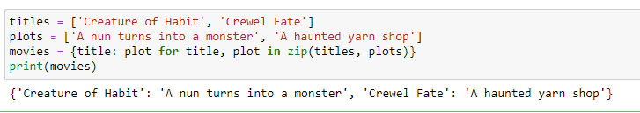

**Regards,**

**Yashwant**