**Yashwant Desai – Assignment 18**

1. Create a zoo.py file first. Define the hours() function, which prints the string 'Open 9-5 daily'. Then, use the interactive interpreter to import the zoo module and call its hours() function.

Answer: I have created zoo.py file with hours function. Below is an outcome

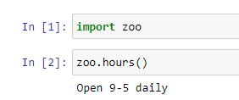

2. In the interactive interpreter, import the zoo module as menagerie and call its hours() function.

Answer: below is an outcome

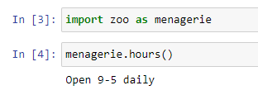

3. Using the interpreter, explicitly import and call the hours() function from zoo.

Answer: below is an outcome

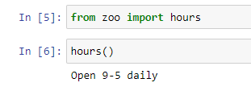

4. Import the hours() function as info and call it.

Answer: below is an outcome

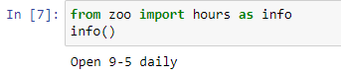

5. Create a plain dictionary with the key-value pairs 'a': 1, 'b': 2, and 'c': 3, and print it out.

Answer: Below is the dictionary result

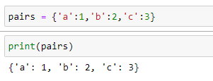

6.Make an OrderedDict called fancy from the same pairs listed in 5 and print it. Did it print in the same order as plain?

Answer: An order dictionary fancy has been created and the OrderedDict preserves the order in which the items were inserted. Below in an outome.

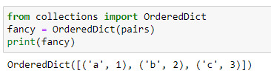

7. Make a default dictionary called dict_of_lists and pass it the argument list. Make the list dict_of_lists['a'] and append the value 'something for a' to it in one assignment. Print dict_of_lists['a'].

Answer: Below is an outcome

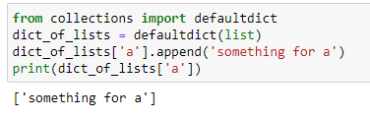

**Regards,**

**Yashwant**