**Yashwant Desai – Assignment 20**

1. Set the variable test1 to the string 'This is a test of the emergency text system,' and save test1 to a file named test.txt.

Answer: below is an outcome

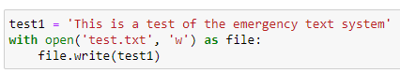

2. Read the contents of the file test.txt into the variable test2. Is there a difference between test 1 and test 2?

Answer: below is an outcome

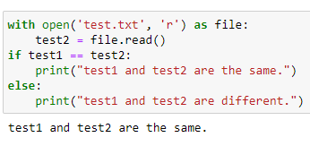

3. Create a CSV file called books.csv by using these lines:

title,author,year

The Weirdstone of Brisingamen,Alan Garner,1960

Perdido Street Station,China Miéville,2000

Thud!,Terry Pratchett,2005

The Spellman Files,Lisa Lutz,2007

Small Gods,Terry Pratchett,1992

Answer: below is an outcome

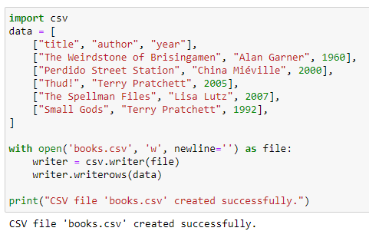

4. Use the sqlite3 module to create a SQLite database called books.db, and a table called books with these fields: title (text), author (text), and year (integer).

Answer: below is an outcome

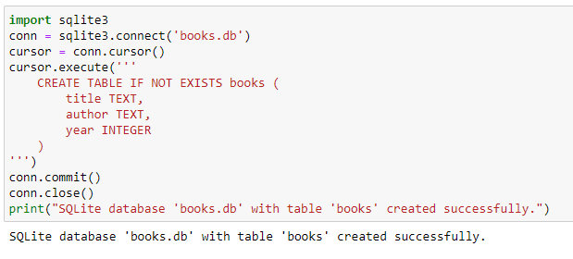

5. Read books.csv and insert its data into the book table.

Answer: below is an outcome

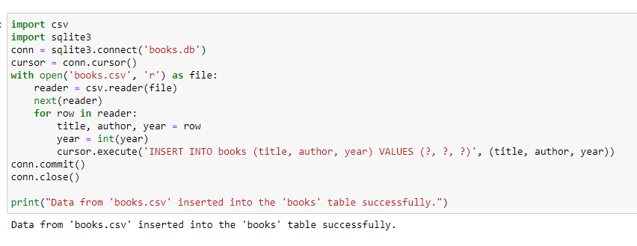

6. Select and print the title column from the book table in alphabetical order.

Answer: below is an outcome

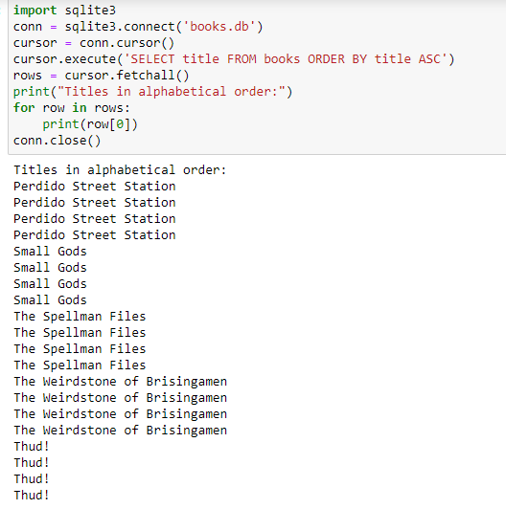

7. From the book table, select and print all columns in the order of publication.

Answer: below is an outcome

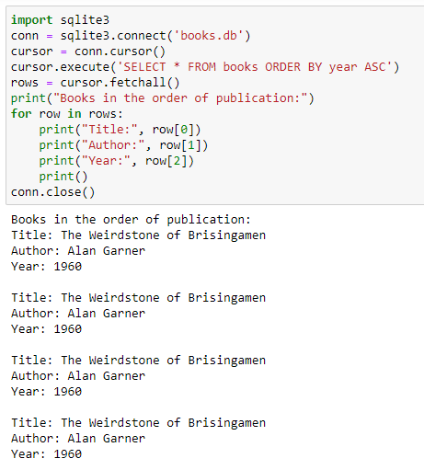

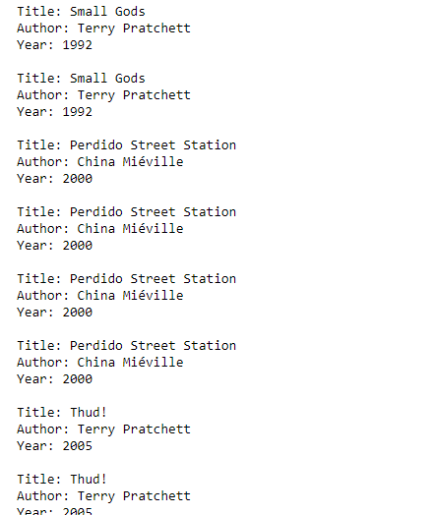

8. Use the sqlalchemy module to connect to the sqlite3 database books.db that you just made in exercise 6.

Answer: below is an outcome

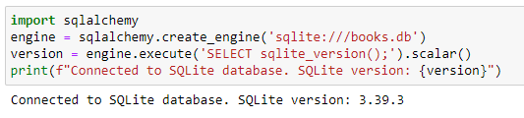

9. Install the Redis server and the Python redis library (pip install redis) on your computer. Create a Redis hash called test with the fields count (1) and name ('Fester Bestertester'). Print all the fields for test.

Answer: below is an outcome

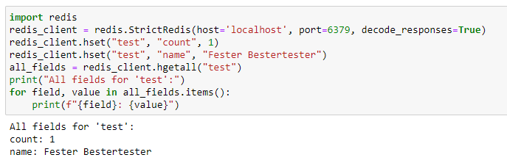

10. Increment the count field of test and print it.

Answer: below is an outcome

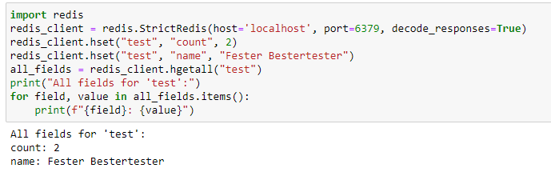

**Regards,**

**Yashwant**