**Yashwant Desai – Assignment 21**

1. Add the current date to the text file today.txt as a string.

Answer: below is an outcome

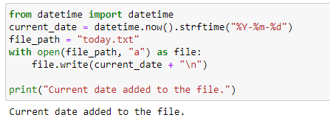

2. Read the text file today.txt into the string today_string

Answer: below is an outcome

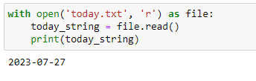

3. Parse the date from today_string.

Answer: below is an outcome

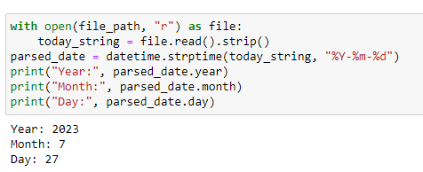

4. List the files in your current directory

Answer: below is an outcome

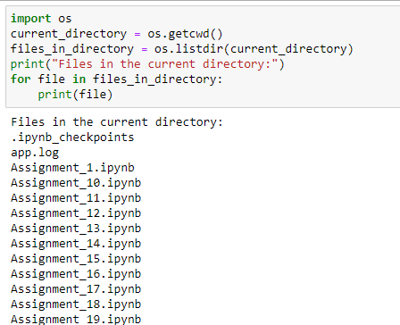

5. Create a list of all of the files in your parent directory (minimum five files should be available).

Answer: below is an outcome

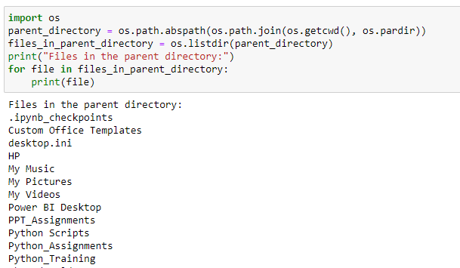

6. Use multiprocessing to create three separate processes. Make each one wait a random number of seconds between one and five, print the current time, and then exit.

Answer: below is an outcome

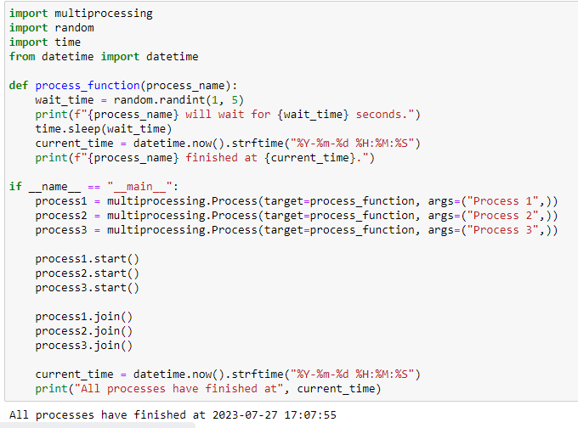

7. Create a date object of your day of birth.

Answer: below is an outcome

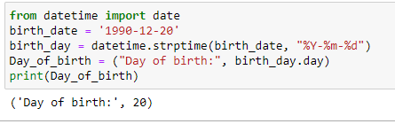

8. What day of the week was your day of birth?

Answer: below is an outcome

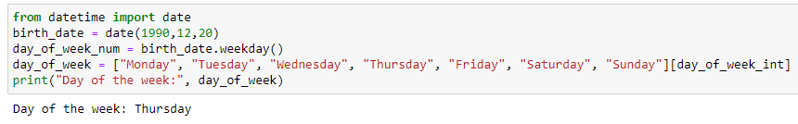

9. When will you be (or when were you) 10,000 days old?

Answer: below is an outcome

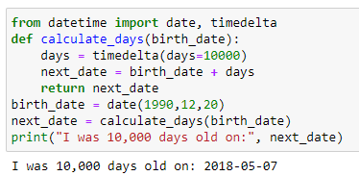

**Regards,**

**Yashwant**