Campus Equipment Booking Service
Set D - Borrower Identifier Validation | CI/CD Pipeline Lab
Student | Course / Assessment | Date
Yashwant J (23011102120) | CS4801 DevOps Lab – CIA 2 | 27 October 2026
Github: https://github.com/YashwantOstwal/devops-cia-2

Aim
To fix the booking-capacity bug, check borrower ID validation, and prepare the Spring Boot application for testing and deployment using Maven, Docker and Minikube.

Task 1 – Git workflow (4 marks)
I worked on feature/borrower-validation, keeping the starter commit on main. The commits separate the capacity fix, borrower validation, Docker/Kubernetes setup and the Jenkins pipeline added later.
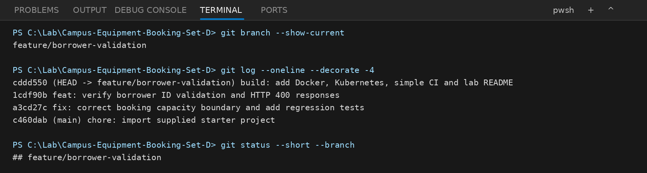

Development sequence
Commit | Work recorded
c460dab | Import the supplied student starter project
a3cd27c | Fix the booking-capacity boundary and add tests
1cdf90b | Check borrower validation; add API tests and HTTP 400 handling
cddd550 | Add Dockerfile, Kubernetes YAML, README and simple CI workflow
059adf9 | Add Jenkins pipeline running inside Docker

Git check: the feature branch is active and the original six BookingServiceTest tests are preserved. The terminal figure shows the first four commits; Jenkins was added in a separate fifth commit (059adf9).

Task 2 – Maven build and automated tests (8 marks)
The starter uses Spring Boot 3.3.5 and Java 17. Its pom.xml has the Web, Actuator, Validation and Test starters, plus the Spring Boot Maven plugin for packaging the JAR.

Relevant pom.xml configuration
<java.version>17</java.version>
<artifactId>spring-boot-starter-test</artifactId>
<artifactId>spring-boot-maven-plugin</artifactId>

Test files in the source repository
Test class | Number of @Test methods | What it covers
BookingServiceTest | 6 (original) | Normal booking, zero quantity, blank borrower, unknown equipment, overbooking and cancellation
BookingCapacityTest | 3 (new) | Exact capacity, one-unit overbooking and inventory/booking integrity
BorrowerValidationTest | 4 (new) | Valid, empty, whitespace-only and missing borrower identifier

The source contains 13 JUnit test methods: six from the starter and seven added for Set D.

Build commands
mvn clean test
mvn clean package
dir target\*.jar

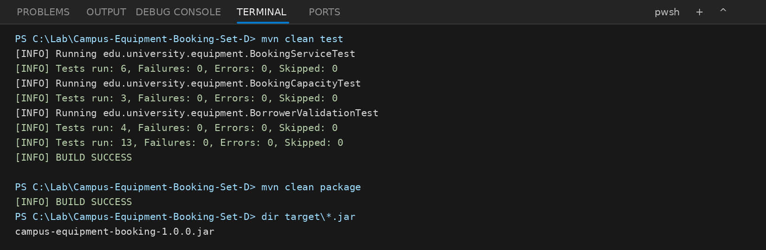
After a successful package step, Maven should create target/campus-equipment-booking-1.0.0.jar. The terminal view above is a generated example; it is not a recorded Maven run.

Task 3 – Booking-capacity defect (10 marks)

Problem identified
The capacity check in BookingService.create() compared the request with availableQuantity + 1. For PROJECTOR01, which starts with 4 units, a request for 5 could pass and take the inventory below zero. The fix removes the + 1, so only the actual stock can be booked.
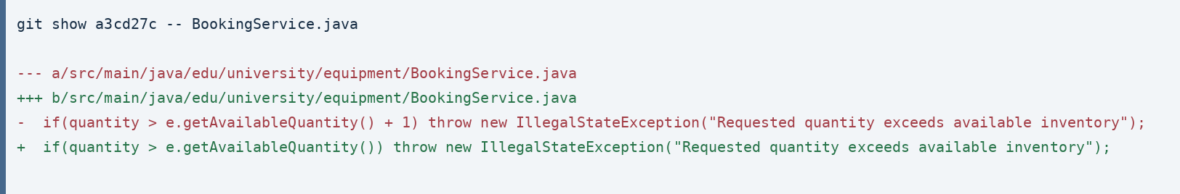

Corrected booking rule
if (borrower == null || borrower.isBlank()) ...
if (quantity <= 0) ...
if (quantity > e.getAvailableQuantity())
throw new IllegalStateException(
"Requested quantity exceeds available inventory");
// Inventory is reduced only after all checks pass.

Regression tests added
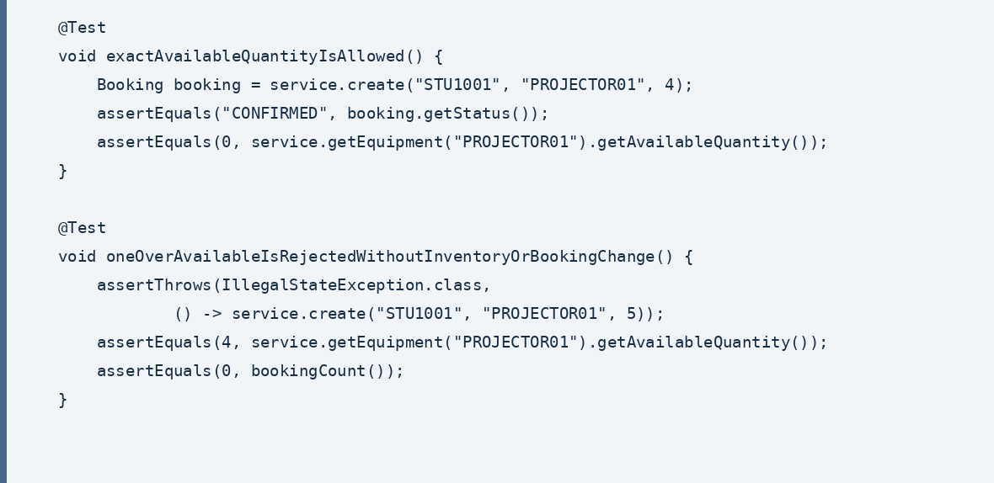

Quantity requested | Expected result | Inventory / booking
4 of 4 projectors | Accept, CONFIRMED | Available = 0; booking saved
5 of 4 projectors | Reject, HTTP 409 through API | Available = 4; no new booking
3 after booking 2 | Reject (only 2 remain) | Available = 2; original booking remains

The failure happens before the quantity is deducted or a booking is stored. The tests check the available quantity and booking count after rejection.

Task 4 – Borrower identifier validation (4 marks)
For Set D, borrowerId must contain at least one non-whitespace character. The starter already had @NotBlank and a service-level isBlank() check, so I kept those checks and added API tests around them.

Validation implementation
// CreateBookingRequest.java
@NotBlank(message = "must not be blank")
private String borrowerId;
// BookingService.java
if (borrower == null || borrower.isBlank())
throw new IllegalArgumentException("borrowerId must not be blank");

POST /api/bookings uses @Valid to reject blank input. The exception handlers return HTTP 400 for invalid borrower IDs, instead of creating a booking.

API test cases
borrowerId input | Expected HTTP | Inventory / booking
"STU2001" | 201 Created | 1 tablet reserved; booking CONFIRMED
"" (empty) | 400 Bad Request | Unchanged; no booking
" " (spaces) | 400 Bad Request | Unchanged; no booking
Field omitted | 400 Bad Request | Unchanged; no booking

Test assertions
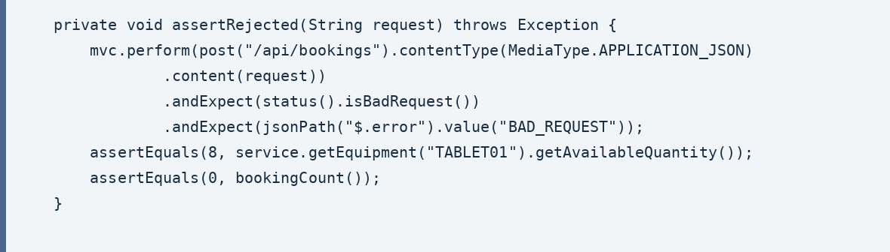
For each rejected request, MockMvc checks HTTP 400 and the test also confirms TABLET01 still has all 8 units and there is no saved booking.

Task 5 – Docker image and container verification (10 marks)
The Dockerfile uses eclipse-temurin:17-jre, copies the packaged JAR as app.jar and runs it on port 8080.

Dockerfile included in the project
FROM eclipse-temurin:17-jre
WORKDIR /app
COPY target/campus-equipment-booking-1.0.0.jar app.jar
EXPOSE 8080
ENTRYPOINT ["java", "-jar", "app.jar"]

Commands for image and container checks
mvn clean package
docker build -t campus-equipment-booking:set-d .
docker run -d --name campus-booking -p 8080:8080 campus-equipment-booking:set-d
docker images campus-equipment-booking
docker ps
curl.exe -i http://localhost:8080/actuator/health

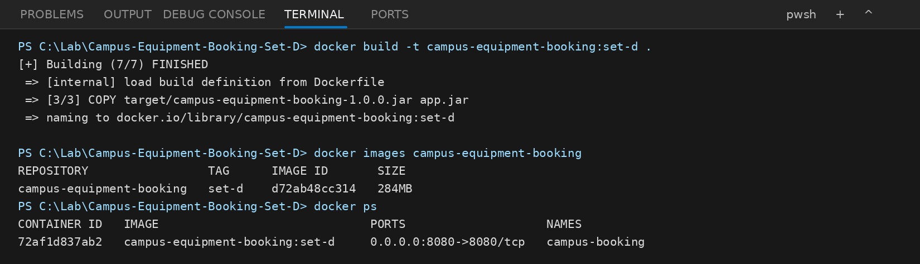
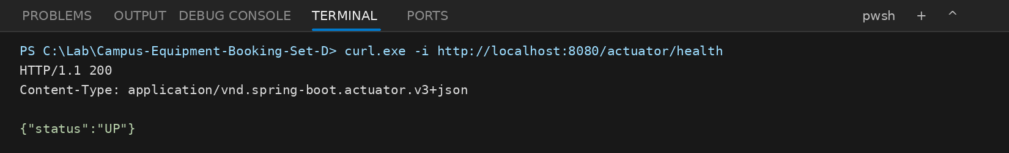
The image must be tagged campus-equipment-booking:set-d. Docker build, container startup and the health response still need to be checked on a running Docker engine.

Task 6 – Minikube / Kubernetes deployment (8 marks)
For Minikube, I set up one Deployment with one initial replica and a NodePort Service. The container listens on port 8080; the Service forwards port 8080 to it.

Relevant YAML configuration
Deployment: k8s/deployment.yaml
replicas: 1
image: campus-equipment-booking:set-d
imagePullPolicy: Never
containerPort: 8080
readinessProbe: GET /actuator/health :8080
Service: k8s/service.yaml
type: NodePort
port: 8080
targetPort: 8080
nodePort: 30080

Deployment commands
minikube start --driver=docker
minikube image load campus-equipment-booking:set-d
kubectl apply -f k8s/deployment.yaml
kubectl apply -f k8s/service.yaml
kubectl rollout status deployment/campus-equipment-booking
kubectl get deployments,pods,services

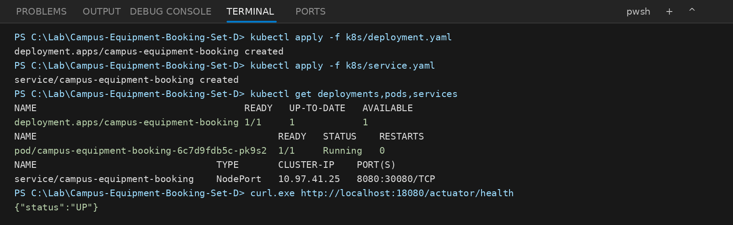
To check the Service locally, forward port 18080 to 8080 in one terminal, then request /actuator/health from a second terminal.

Scaling to two replicas
kubectl scale deployment/campus-equipment-booking --replicas=2
kubectl rollout status deployment/campus-equipment-booking
kubectl get deployments,pods

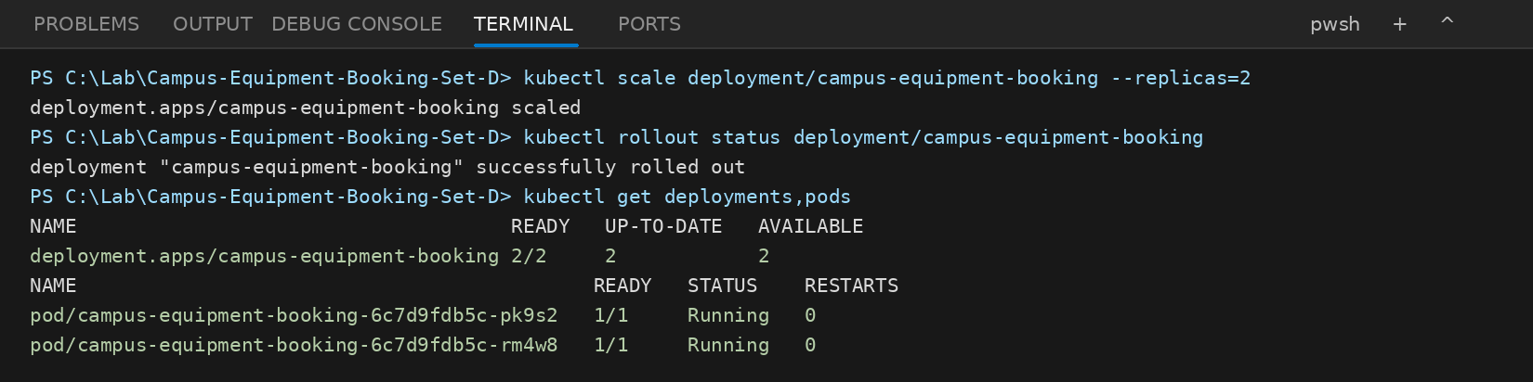

Task 7 – README, CI workflow and submission evidence (6 marks)

README.md and included files
The README has the commands I would need to repeat the lab: Maven tests and package, Docker build/run, Minikube setup, health check and scaling.
Path | Purpose
src/main/java/ | Booking API and corrected service logic
src/test/java/ | Original six tests and seven new regression tests
pom.xml | Java 17 dependencies and build plugin
Dockerfile | Java 17 container configuration
k8s/deployment.yaml, k8s/service.yaml | Deployment and NodePort Service resources
.github/workflows/ci.yml | Automated Maven testing, packaging and Docker build
README.md | Commands and setup instructions
Jenkinsfile | Five-stage Maven, Docker and health-check pipeline
jenkins/Dockerfile, jenkins/compose.yaml | Docker-hosted Jenkins on localhost:8081

CI workflow – .github/workflows/ci.yml
on: push / pull_request
runs-on: ubuntu-latest
actions/checkout@v4
actions/setup-java@v4 (Temurin Java 17)
mvn -B clean test
mvn -B clean package
docker build -t campus-equipment-booking:set-d .

GitHub Actions still handles push/PR checks. I also added Jenkins as a separate, locally hosted pipeline for checkout, tests, JAR packaging, Docker build and container health verification. A successful Jenkins run has not yet been recorded.

Evidence summary
Area | Evidence included
Git workflow | Actual branch, history, status and code diff from Git
Source changes | Capacity comparison, borrower validation and tests
Build & runtime | Commands and generated expected-output figures (not live execution records)
Deployment | Dockerfile, Kubernetes YAML, health and scaling commands
Documentation | README and CI workflow

Conclusion
The capacity defect is fixed, the borrower validation cases are covered, and the six starter tests are retained. Source, Docker, Kubernetes, GitHub Actions and Jenkins configuration are included. The example terminal images in this report still need to be replaced with real execution evidence.

Additional automation – Jenkins running in Docker
I added Jenkins as an extension to the CI/CD setup. The Jenkins controller runs locally in a Docker container with Java 17, Maven, Git and the Docker CLI installed. It uses the local Docker engine to build and check the same Spring Boot image used in Task 5.

Jenkins files included
File | What it does
Jenkinsfile | Defines test, package, Docker build and health-check stages
jenkins/Dockerfile | Jenkins controller with Java 17, Maven and Docker CLI
jenkins/compose.yaml | Starts Jenkins locally using Docker Compose, port 8081

Pipeline stages
Checkout → Maven Tests → Package JAR → Build Docker Image → Container Health Check
The test stage runs mvn -B clean test. Maven then packages the JAR, which Jenkins archives. Docker builds campus-equipment-booking:set-d. Finally, the pipeline starts a temporary application container and checks GET /actuator/health from a curl container on the same Docker network. JUnit results and the health-response file are saved as Jenkins artifacts. The temporary containers and Docker network are cleaned up at the end.

How to run Jenkins locally
docker compose -f jenkins/compose.yaml up -d --build
docker exec campus-booking-jenkins cat /var/jenkins_home/secrets/initialAdminPassword
Open http://localhost:8081. Set up a Pipeline job with “Pipeline script from SCM”, Git repository https://github.com/YashwantOstwal/devops-cia-2.git, branch */feature/borrower-validation and script path Jenkinsfile. Push the Jenkins commit to GitHub before running Build Now.

Evidence after execution
Capture the Jenkins Stage View with green stages, the Maven test summary and Docker build in the console, the JUnit test report, and the archived jenkins-health.txt file containing {"status":"UP"}. The Jenkins files and Git commit are present in the repository; a successful Jenkins execution is not claimed here.
Note: The compose setup mounts the Docker socket and runs Jenkins with elevated privileges. It is intended for local lab use only, not public deployment.

