DR. RVR & NRI INSTITUTE OF TECHNOLOGY
(Deemed to be University)
Autonomous Institution | NAAC 'A+' Grade
Agiripalli, Krishna District, Andhra Pradesh - 521211
DEPARTMENT OF COMPUTER SCIENCE AND ENGINEERING
(ARTIFICIAL INTELLIGENCE & MACHINE LEARNING)
ACTIVITY BASED LEARNING (ABL) - I REPORT
Course Title: Web Development Fundamentals (HTML5 & CSS3)
Academic Year: 2025-2026 | I B.Tech II Semester

Student Name: | Yashwanth Dorepally
Roll Number: | 26000892
Branch & Section: | CSE (AI & ML) - Section CSM1
Submission Date: | 27th October 2026

Project 1: Personal Developer Portfolio Website
1. Project Overview & Objectives:
A responsive personal developer profile showcasing bio, technical skills, education timeline, and project catalog.
2. Web Technologies Employed:
HTML5 (Semantic structural elements: header, nav, section, article, table, form, footer) and CSS3 (Flexbox, Grid, custom styling, responsive design).
3. Page Structure and Key Sections:
The Personal Developer Portfolio Website includes dedicated responsive components: header navigation, featured hero section, content grid cards, data table, interactive form, and standard footer.
4. Source Code (HTML & CSS):
HTML File (index.html):
<!DOCTYPE html>
<html lang="en">
<head>
<meta charset="UTF-8">
<meta name="viewport" content="width=device-width, initial-scale=1.0">
<title>Yashwanth Dorepally - Portfolio</title>
<link rel="stylesheet" href="style.css">
</head>
<body>
<header>
<div class="header-content">
<h1>Yashwanth Dorepally</h1>
<p>B.Tech CSE (AI & ML) Student | CSM-1</p>
<p>Dr. RVR NRI Institute of Technology | Roll No: 26000892</p>
</div>
</header>
<div class="container">
<section class="card">
<h2>About Me</h2>
<p>I am a first-year undergraduate student in Computer Science and Engineering (Artificial Intelligence and Machine Learning) at Dr. RVR NRI Institute of Technology. I have a keen interest in programming, algorithm design, and building clean web interfaces with HTML and CSS.</p>
</section>
<section class="card">
<h2>Technical Skills</h2>
<div class="skills-grid">
<div class="skill-box"><strong>Programming:</strong> Python, C Language</div>
<div class="skill-box"><strong>Web Basics:</strong> HTML5, CSS3</div>
<div class="skill-box"><strong>Tools:</strong> VS Code, Git, GitHub</div>
<div class="skill-box"><strong>Core Concepts:</strong> Problem Solving, Data Structures</div>
</div>
</section>
<section class="card">
<h2>Academic Projects</h2>
<div class="project">
<h3>1. Python Activity-Based Learning Case Studies</h3>
<p>Developed 10 computational solutions in Python covering electricity tariffs, payroll deductions, and event financial planning using standard control flows.</p>
</div>
<div class="project">
<h3>2. NRIIT TechFest Event Website</h3>
<p>Created an annual college festival landing page featuring event tracks, workshop schedules, and participant registration form.</p>
</div>
<div class="project">
<h3>3. Campus Cafe Menu & Ordering Page</h3>
<p>Designed a clean restaurant menu interface displaying beverages, food prices, operating hours, and contact details.</p>
</div>
</section>
<section class="card">
<h2>Education</h2>
<p><strong>B.Tech in CSE (Artificial Intelligence & Machine Learning)</strong><br>
Dr. RVR NRI Institute of Technology, Agiripalli (2026 - Present)</p>
<p><strong>Intermediate (MPC)</strong><br>
Board of Intermediate Education, Andhra Pradesh</p>
</section>
<section class="card">
<h2>Contact</h2>
<p><strong>Email:</strong> yashwanth.dorepally@gmail.com</p>
<p><strong>GitHub:</strong> <a href="https://github.com/yashwanthdorepally">github.com/yashwanthdorepally</a></p>
<p><strong>Location:</strong> Vijayawada / Eluru District, Andhra Pradesh</p>
</section>
</div>
<footer>
<p>&copy; 2026 Yashwanth Dorepally | Roll No: 26000892 | CSM-1</p>
</footer>
</body>
</html>
CSS File (style.css):
body {
font-family: Arial, sans-serif;
margin: 0;
background-color: #f0f2f5;
color: #333;
line-height: 1.6;
}
header {
background-color: #1a365d;
color: white;
padding: 35px 20px;
text-align: center;
}
header h1 {
margin: 0;
font-size: 2rem;
}
header p {
margin: 5px 0;
color: #cbd5e1;
font-size: 1rem;
}
.container {
max-width: 800px;
margin: 20px auto;
padding: 0 15px;
}
.card {
background: white;
padding: 20px;
margin-bottom: 20px;
border-radius: 6px;
box-shadow: 0 2px 4px rgba(0, 0, 0, 0.08);
}
.card h2 {
color: #1a365d;
border-bottom: 2px solid #e2e8f0;
padding-bottom: 6px;
margin-top: 0;
font-size: 1.3rem;
}
.skills-grid {
display: grid;
grid-template-columns: 1fr 1fr;
gap: 10px;
}
.skill-box {
background: #edf2f7;
padding: 10px;
border-radius: 4px;
font-size: 0.95rem;
}
.project {
margin-bottom: 15px;
border-left: 3px solid #2b6cb0;
padding-left: 10px;
}
.project h3 {
margin: 0 0 4px 0;
color: #2b6cb0;
font-size: 1.05rem;
}
a {
color: #2b6cb0;
text-decoration: none;
}
a:hover {
text-decoration: underline;
}
footer {
text-align: center;
padding: 15px;
color: #64748b;
font-size: 0.85rem;
}
5. Screenshots of Rendered Output:
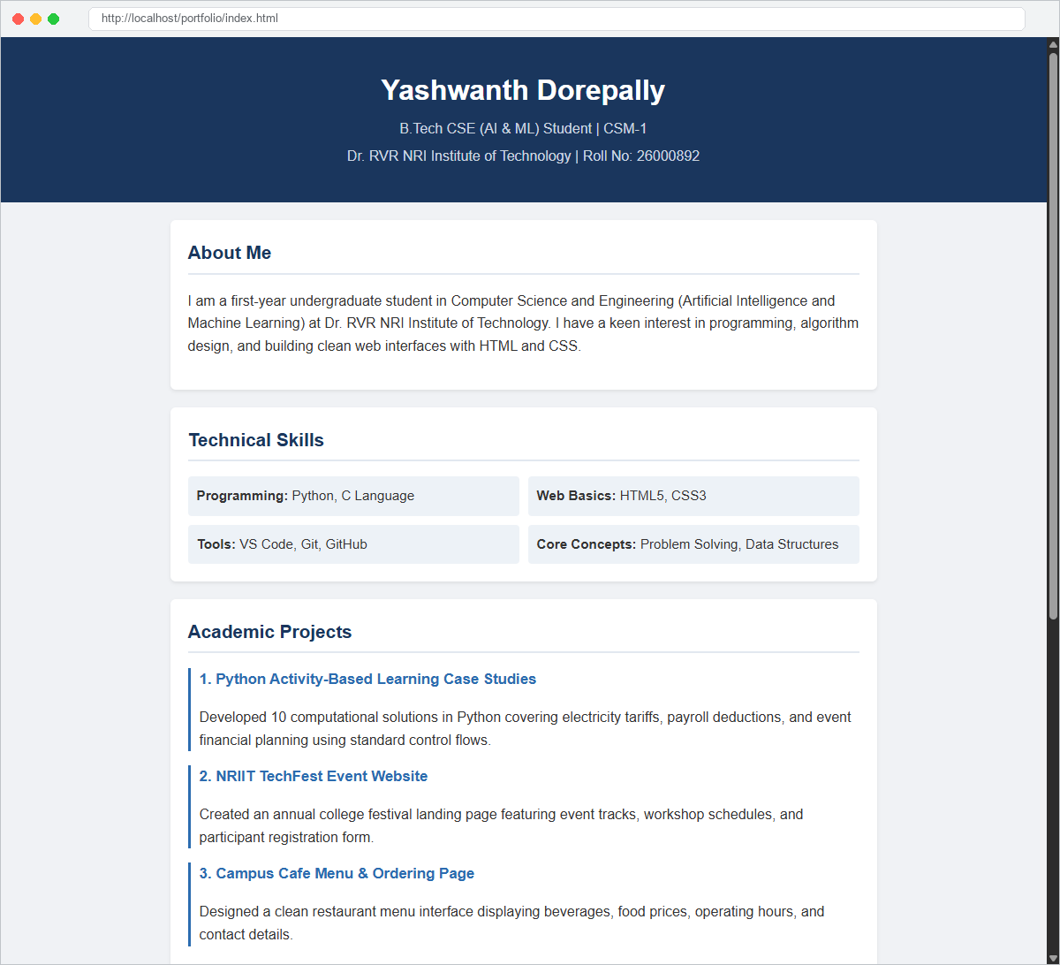
Figure 1.1: Personal Portfolio Webpage Rendered in Web Browser
6. Learning Outcomes:
Gained hands-on experience structuring web documents using semantic HTML5 and modern CSS styling for personal developer portfolio website.

Project 2: College Tech Symposium Event Portal
1. Project Overview & Objectives:
A dynamic college symposium landing page featuring event schedule, technical competitions, and participant registration form.
2. Web Technologies Employed:
HTML5 (Semantic structural elements: header, nav, section, article, table, form, footer) and CSS3 (Flexbox, Grid, custom styling, responsive design).
3. Page Structure and Key Sections:
The College Tech Symposium Event Portal includes dedicated responsive components: header navigation, featured hero section, content grid cards, data table, interactive form, and standard footer.
4. Source Code (HTML & CSS):
HTML File (index.html):
<!DOCTYPE html>
<html lang="en">
<head>
<meta charset="UTF-8">
<meta name="viewport" content="width=device-width, initial-scale=1.0">
<title>NRIIT TechFest 2026 - Annual Technical Symposium</title>
<link rel="stylesheet" href="style.css">
</head>
<body>
<header class="hero">
<div class="banner">
<span class="badge">Dr. RVR NRI Institute of Technology</span>
<h1>NRIIT TECHFEST 2026</h1>
<p>Annual National Technical Symposium & Hackathon</p>
<p class="date">📅 November 14 - 15, 2026 | Campus Auditorium, Agiripalli</p>
</div>
</header>
<div class="container">
<!-- Event Categories Section -->
<section class="section">
<h2>Featured Competitions</h2>
<div class="event-cards">
<div class="card">
<div class="card-tag">Coding</div>
<h3>Code Storm 2026</h3>
<p>Speed coding and algorithm puzzle challenge using Python and C.</p>
<p class="prize">🏆 Prize: Rs. 10,000</p>
</div>
<div class="card">
<div class="card-tag">Web Dev</div>
<h3>WebCrafters Hackathon</h3>
<p>Build responsive, accessible frontend websites in 4 hours.</p>
<p class="prize">🏆 Prize: Rs. 8,000</p>
</div>
<div class="card">
<div class="card-tag">AI & ML</div>
<h3>AI Innovation Expo</h3>
<p>Present machine learning models and computer vision prototypes.</p>
<p class="prize">🏆 Prize: Rs. 12,000</p>
</div>
<div class="card">
<div class="card-tag">Quiz</div>
<h3>Byte Battle Tech Quiz</h3>
<p>Fast-paced technical trivia testing CS fundamentals and logic.</p>
<p class="prize">🏆 Prize: Rs. 5,000</p>
</div>
</div>
</section>
<!-- Schedule Section -->
<section class="section">
<h2>Event Schedule</h2>
<table class="schedule-table">
<thead>
<tr>
<th>Time</th>
<th>Event Name</th>
<th>Venue</th>
<th>Coordinator</th>
</tr>
</thead>
<tbody>
<tr>
<td>09:30 AM</td>
<td>Inauguration & Keynote</td>
<td>Main Auditorium</td>
<td>Dr. Principal</td>
</tr>
<tr>
<td>11:00 AM</td>
<td>Code Storm (Round 1)</td>
<td>Lab 3, CSE Block</td>
<td>Faculty Mentor</td>
</tr>
<tr>
<td>01:00 PM</td>
<td>Lunch & Networking</td>
<td>College Cafeteria</td>
<td>Student Committee</td>
</tr>
<tr>
<td>02:00 PM</td>
<td>WebCrafters Hackathon</td>
<td>Central Computer Lab</td>
<td>Yashwanth D (CSM1)</td>
</tr>
<tr>
<td>04:30 PM</td>
<td>Prize Distribution</td>
<td>Open Air Theatre</td>
<td>Dean of Studies</td>
</tr>
</tbody>
</table>
</section>
<!-- Registration Form Section -->
<section class="section form-section">
<h2>Student Registration Form</h2>
<p>Fill out the form below to register for TechFest events.</p>
<form class="reg-form">
<div class="form-group">
<label for="name">Full Name:</label>
<input type="text" id="name" placeholder="e.g. Yashwanth Dorepally" required>
</div>
<div class="form-group">
<label for="roll">Roll Number:</label>
<input type="text" id="roll" placeholder="e.g. 26000892" required>
</div>
<div class="form-group">
<label for="dept">Department & Section:</label>
<input type="text" id="dept" placeholder="e.g. CSE (AI & ML) - CSM1" required>
</div>
<div class="form-group">
<label for="event">Select Competition:</label>
<select id="event">
<option value="code">Code Storm 2026 (Coding Challenge)</option>
<option value="web">WebCrafters Hackathon (Web Design)</option>
<option value="ai">AI Innovation Expo</option>
<option value="quiz">Byte Battle Tech Quiz</option>
</select>
</div>
<button type="button" class="btn-submit">Submit Registration</button>
</form>
</section>
</div>
<footer>
<p>&copy; 2026 NRIIT TechFest | School of Computer Studies | Dr. RVR NRI Institute of Technology</p>
</footer>
</body>
</html>
CSS File (style.css):
body {
font-family: Arial, sans-serif;
margin: 0;
background-color: #f8fafc;
color: #1e293b;
line-height: 1.6;
}
.hero {
background: linear-gradient(135deg, #1e3a8a, #3b82f6);
color: white;
padding: 50px 20px;
text-align: center;
}
.badge {
background-color: rgba(255, 255, 255, 0.2);
padding: 5px 12px;
border-radius: 20px;
font-size: 0.85rem;
letter-spacing: 0.5px;
}
.hero h1 {
font-size: 2.2rem;
margin: 15px 0 10px 0;
letter-spacing: 1px;
}
.hero p {
font-size: 1.1rem;
margin: 5px 0;
}
.hero .date {
color: #fef08a;
font-weight: bold;
margin-top: 10px;
}
.container {
max-width: 900px;
margin: 30px auto;
padding: 0 15px;
}
.section {
background: white;
padding: 25px;
border-radius: 8px;
box-shadow: 0 2px 5px rgba(0, 0, 0, 0.06);
margin-bottom: 25px;
}
.section h2 {
color: #1e3a8a;
border-bottom: 2px solid #e2e8f0;
padding-bottom: 8px;
margin-top: 0;
font-size: 1.4rem;
}
/* Event Cards Grid */
.event-cards {
display: grid;
grid-template-columns: repeat(auto-fit, minmax(200px, 1fr));
gap: 15px;
margin-top: 15px;
}
.card {
border: 1px solid #e2e8f0;
border-radius: 6px;
padding: 15px;
background-color: #ffffff;
transition: 0.2s ease;
}
.card:hover {
box-shadow: 0 4px 10px rgba(0, 0, 0, 0.1);
border-color: #3b82f6;
}
.card-tag {
display: inline-block;
background-color: #dbeafe;
color: #1e40af;
font-size: 0.75rem;
font-weight: bold;
padding: 3px 8px;
border-radius: 4px;
margin-bottom: 8px;
}
.card h3 {
margin: 0 0 8px 0;
font-size: 1.1rem;
color: #0f172a;
}
.card p {
font-size: 0.9rem;
color: #64748b;
margin: 0 0 10px 0;
}
.card .prize {
font-weight: bold;
color: #16a34a;
margin: 0;
}
/* Table */
.schedule-table {
width: 100%;
border-collapse: collapse;
margin-top: 12px;
}
.schedule-table th,
.schedule-table td {
padding: 10px 12px;
text-align: left;
border-bottom: 1px solid #e2e8f0;
font-size: 0.95rem;
}
.schedule-table th {
background-color: #f1f5f9;
color: #334155;
font-weight: bold;
}
/* Form */
.form-group {
margin-bottom: 15px;
}
.form-group label {
display: block;
font-weight: bold;
margin-bottom: 5px;
font-size: 0.95rem;
}
.form-group input,
.form-group select {
width: 100%;
padding: 9px 12px;
border: 1px solid #cbd5e1;
border-radius: 4px;
font-size: 0.95rem;
box-sizing: border-box;
}
.form-group input:focus,
.form-group select:focus {
outline: none;
border-color: #3b82f6;
}
.btn-submit {
background-color: #1e3a8a;
color: white;
border: none;
padding: 10px 20px;
font-size: 1rem;
font-weight: bold;
border-radius: 4px;
cursor: pointer;
transition: 0.2s;
}
.btn-submit:hover {
background-color: #2563eb;
}
footer {
background-color: #0f172a;
color: #94a3b8;
text-align: center;
padding: 20px;
font-size: 0.9rem;
margin-top: 30px;
}
5. Screenshots of Rendered Output:
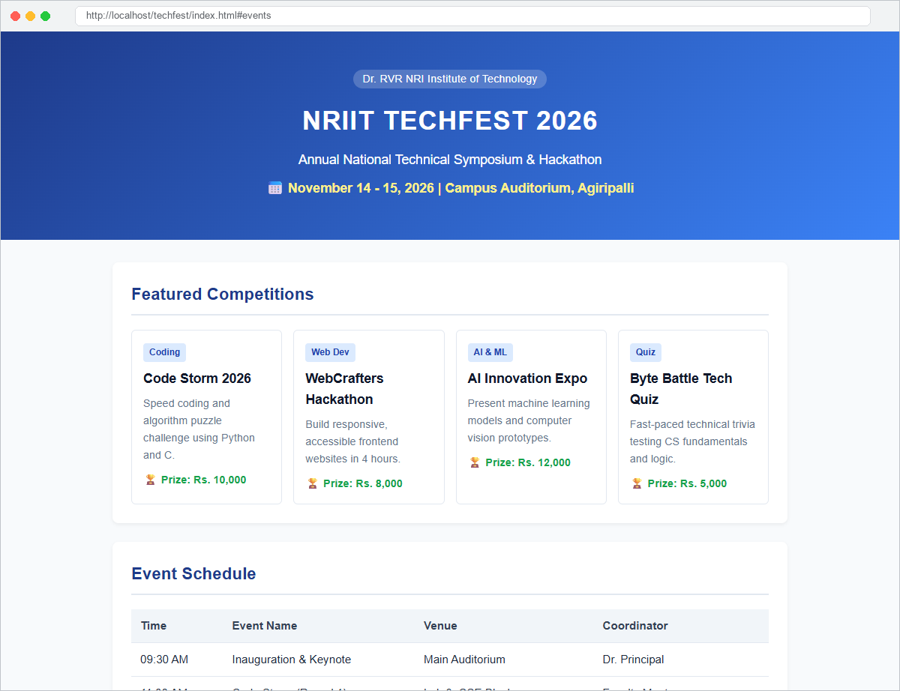
Figure 2.1: TechFest Hero Banner, Event Highlights & Competition Categories
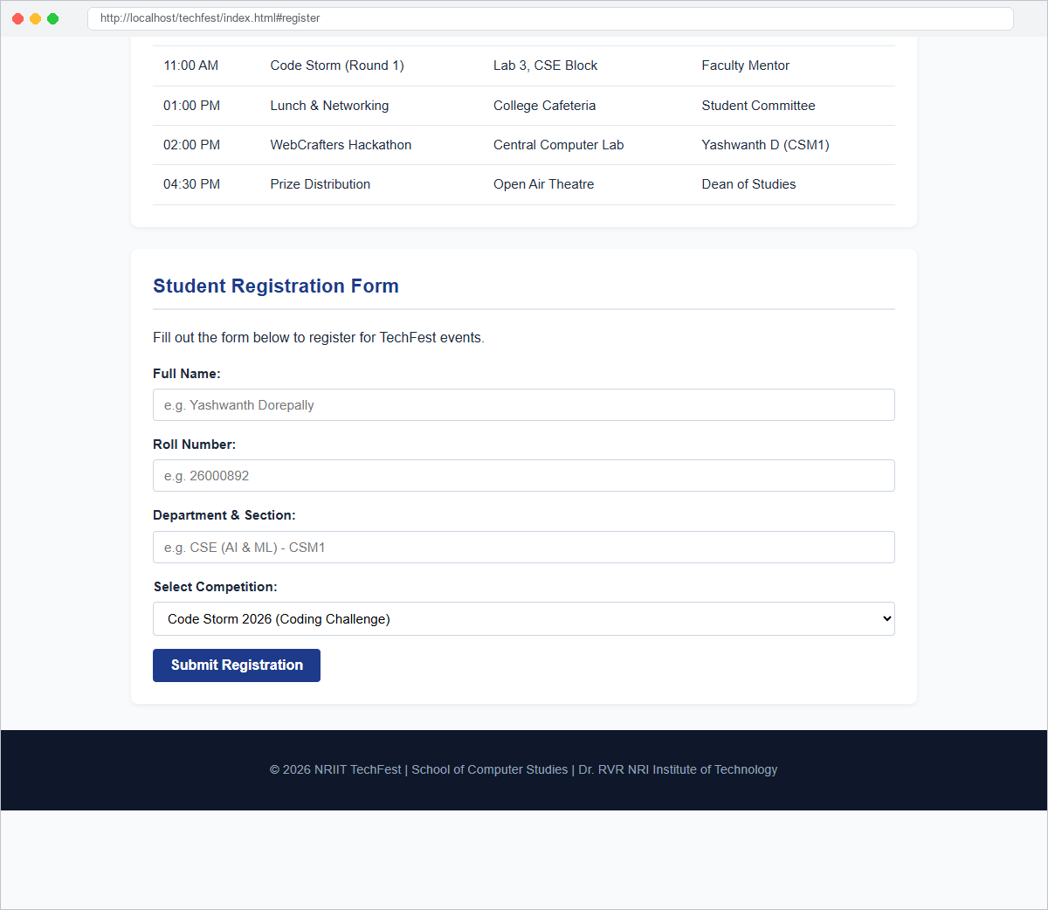
Figure 2.2: Event Schedule Table & Student Registration Form
6. Learning Outcomes:
Gained hands-on experience structuring web documents using semantic HTML5 and modern CSS styling for college tech symposium event portal.

Project 3: Campus Cafe Online Food Order Menu
1. Project Overview & Objectives:
A clean cafe ordering menu website displaying categories, daily special highlights, and pricing table.
2. Web Technologies Employed:
HTML5 (Semantic structural elements: header, nav, section, article, table, form, footer) and CSS3 (Flexbox, Grid, custom styling, responsive design).
3. Page Structure and Key Sections:
The Campus Cafe Online Food Order Menu includes dedicated responsive components: header navigation, featured hero section, content grid cards, data table, interactive form, and standard footer.
4. Source Code (HTML & CSS):
HTML File (index.html):
<!DOCTYPE html>
<html lang="en">
<head>
<meta charset="UTF-8">
<meta name="viewport" content="width=device-width, initial-scale=1.0">
<title>Brew & Bite - NRIIT Campus Cafe</title>
<link rel="stylesheet" href="style.css">
</head>
<body>
<header class="header">
<div class="logo-box">
<h1>☕ BREW & BITE CAFE</h1>
<p>Fresh Coffee, Quick Snacks & Friendly Vibes | NRIIT Campus Food Court</p>
</div>
</header>
<div class="container">
<!-- Highlights Bar -->
<div class="highlight-bar">
<div class="info-item">🕒 <strong>Hours:</strong> 8:00 AM - 7:30 PM</div>
<div class="info-item">📍 <strong>Location:</strong> Ground Floor, Student Center</div>
<div class="info-item">⚡ <strong>WiFi:</strong> Free Campus Network</div>
</div>
<!-- Today's Specials Grid -->
<section class="section">
<h2>Today's Specials</h2>
<div class="specials-grid">
<div class="special-card">
<div class="card-icon">🥪</div>
<h3>Grilled Cheese Paneer Sandwich</h3>
<p>Toasted brown bread with fresh paneer, mint chutney, and cheddar cheese.</p>
<span class="price-badge">Rs. 80</span>
</div>
<div class="special-card">
<div class="card-icon">🧋</div>
<h3>Classic Iced Cold Coffee</h3>
<p>Rich espresso blended with chilled milk and a scoop of vanilla ice cream.</p>
<span class="price-badge">Rs. 60</span>
</div>
<div class="special-card">
<div class="card-icon">🍕</div>
<h3>Crispy Veggie Mini Pizza</h3>
<p>Thin crust topped with bell peppers, olives, corn, and mozzarella.</p>
<span class="price-badge">Rs. 95</span>
</div>
</div>
</section>
<!-- Full Menu Table -->
<section class="section">
<h2>Campus Cafe Menu & Pricing</h2>
<table class="menu-table">
<thead>
<tr>
<th>Category</th>
<th>Item Name</th>
<th>Description</th>
<th>Price</th>
</tr>
</thead>
<tbody>
<tr>
<td>Beverages</td>
<td>South Indian Filter Coffee</td>
<td>Traditional hot brewed coffee with froth</td>
<td>Rs. 25</td>
</tr>
<tr>
<td>Beverages</td>
<td>Masala Chai</td>
<td>Fresh tea brewed with cardamom and ginger</td>
<td>Rs. 15</td>
</tr>
<tr>
<td>Beverages</td>
<td>Oreo Thick Shake</td>
<td>Blended cookies with chocolate drizzle</td>
<td>Rs. 70</td>
</tr>
<tr>
<td>Quick Bites</td>
<td>Veg Samosa (2 pcs)</td>
<td>Crispy potato stuffed pastries with dip</td>
<td>Rs. 30</td>
</tr>
<tr>
<td>Quick Bites</td>
<td>French Fries (Large)</td>
<td>Golden fried salted potato strips</td>
<td>Rs. 50</td>
</tr>
<tr>
<td>Quick Bites</td>
<td>Veggie Burger with Mayo</td>
<td>Crispy vegetable patty with crisp lettuce</td>
<td>Rs. 65</td>
</tr>
</tbody>
</table>
</section>
<!-- Customer Feedback Box -->
<section class="section">
<h2>Quick Order & Feedback Note</h2>
<p>Students can pre-order snacks during class breaks to skip the line!</p>
<div class="contact-box">
<p><strong>Campus WhatsApp Order:</strong> +91 98765 43210</p>
<p><strong>Manager Desk:</strong> counter1.cafe@nriit.edu.in</p>
<p><strong>Payment Accepted:</strong> UPI (PhonePe / GPay), Cash, Campus Meal Card</p>
</div>
</section>
</div>
<footer>
<p>&copy; 2026 Brew & Bite Cafe | Student Facility Division | Dr. RVR NRI Institute of Technology</p>
</footer>
</body>
</html>
CSS File (style.css):
body {
font-family: Arial, sans-serif;
margin: 0;
background-color: #faf5ef;
color: #451a03;
line-height: 1.6;
}
.header {
background: linear-gradient(135deg, #78350f, #92400e);
color: #fffbeb;
padding: 40px 20px;
text-align: center;
}
.header h1 {
margin: 0;
font-size: 2.2rem;
letter-spacing: 1px;
}
.header p {
margin: 8px 0 0 0;
font-size: 1.05rem;
color: #fde68a;
}
.container {
max-width: 850px;
margin: 25px auto;
padding: 0 15px;
}
.highlight-bar {
display: flex;
justify-content: space-around;
background-color: #fef3c7;
border: 1px solid #fde68a;
padding: 12px;
border-radius: 6px;
margin-bottom: 25px;
font-size: 0.95rem;
color: #78350f;
}
.section {
background-color: #ffffff;
padding: 25px;
border-radius: 8px;
box-shadow: 0 2px 4px rgba(120, 53, 15, 0.08);
margin-bottom: 25px;
}
.section h2 {
color: #78350f;
border-bottom: 2px solid #fde68a;
padding-bottom: 8px;
margin-top: 0;
font-size: 1.35rem;
}
/* Specials Grid */
.specials-grid {
display: grid;
grid-template-columns: repeat(auto-fit, minmax(230px, 1fr));
gap: 15px;
margin-top: 15px;
}
.special-card {
border: 1px solid #fde68a;
background-color: #fffdfa;
border-radius: 6px;
padding: 15px;
text-align: center;
}
.card-icon {
font-size: 2rem;
margin-bottom: 5px;
}
.special-card h3 {
margin: 5px 0 8px 0;
font-size: 1.05rem;
color: #78350f;
}
.special-card p {
font-size: 0.88rem;
color: #78716c;
margin: 0 0 12px 0;
}
.price-badge {
display: inline-block;
background-color: #78350f;
color: white;
font-weight: bold;
padding: 4px 12px;
border-radius: 12px;
font-size: 0.9rem;
}
/* Menu Table */
.menu-table {
width: 100%;
border-collapse: collapse;
margin-top: 10px;
}
.menu-table th,
.menu-table td {
padding: 10px 12px;
text-align: left;
border-bottom: 1px solid #f5ede2;
font-size: 0.95rem;
}
.menu-table th {
background-color: #fef3c7;
color: #78350f;
font-weight: bold;
}
.menu-table tr:hover {
background-color: #fffdf5;
}
.contact-box {
background-color: #fffbeb;
border-left: 4px solid #b45309;
padding: 12px 15px;
border-radius: 4px;
margin-top: 10px;
}
.contact-box p {
margin: 5px 0;
font-size: 0.95rem;
}
footer {
background-color: #451a03;
color: #d6d3d1;
text-align: center;
padding: 20px;
font-size: 0.85rem;
margin-top: 30px;
}
5. Screenshots of Rendered Output:
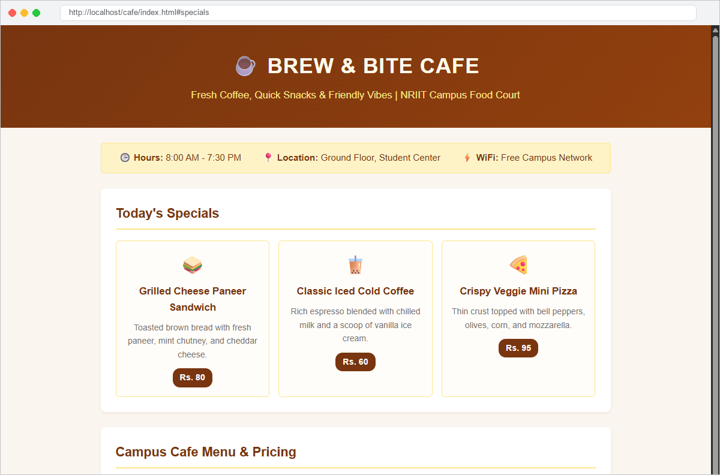
Figure 3.1: Campus Cafe Header, Highlights & Daily Chef Specials
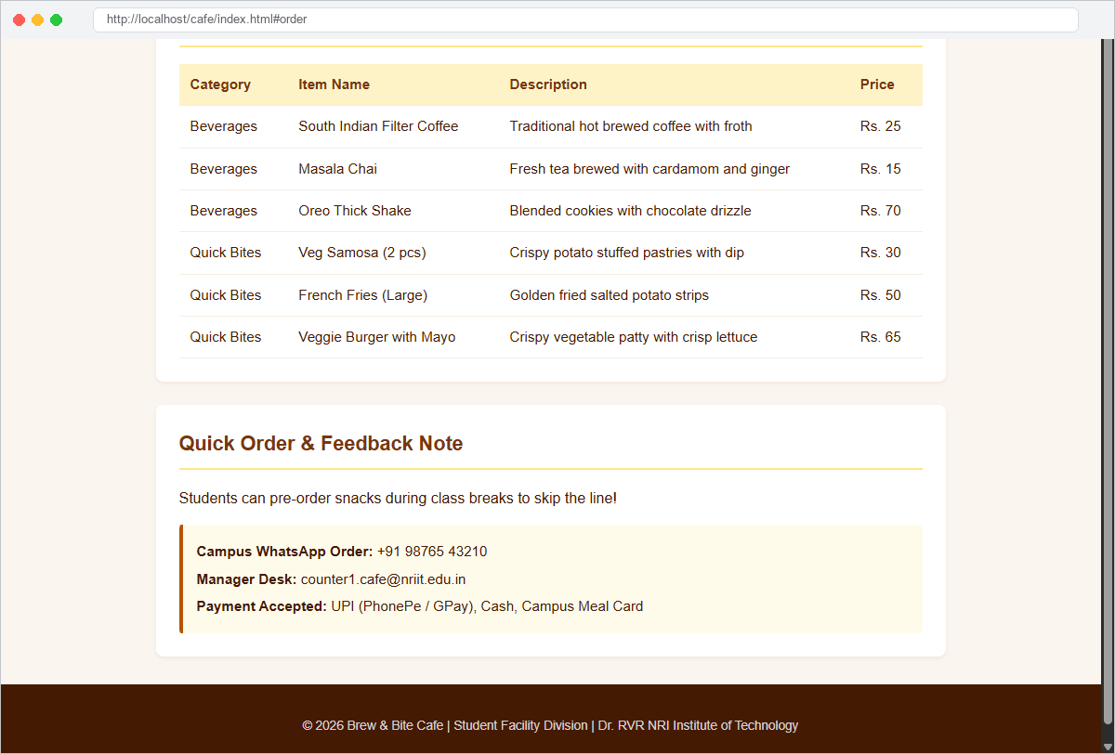
Figure 3.2: Complete Culinary Menu Table & Quick Order Desk
6. Learning Outcomes:
Gained hands-on experience structuring web documents using semantic HTML5 and modern CSS styling for campus cafe online food order menu.

