**Phase3**

Product sales analysis

Loading and preprocessing a dataset for product sales analysis in Python typically involves the following steps

**1.Import necessary libraries:** You'll need libraries like Pandas, NumPy, and possibly others for data manipulation and analysis.

import pandas as pd

import numpy as np

**2.Load the dataset**: Load your dataset using Pandas. The dataset can be in various formats, such as CSV, Excel, or a database. For this example, we'll assume a CSV file.

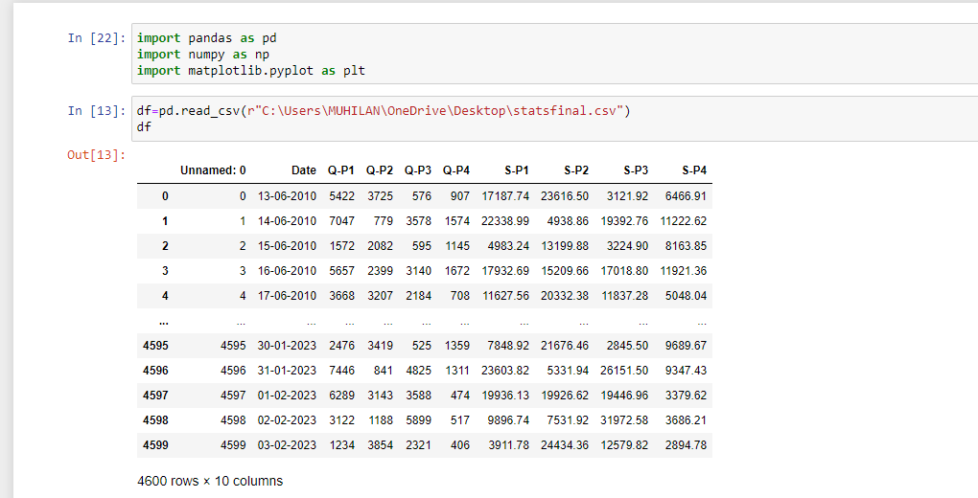

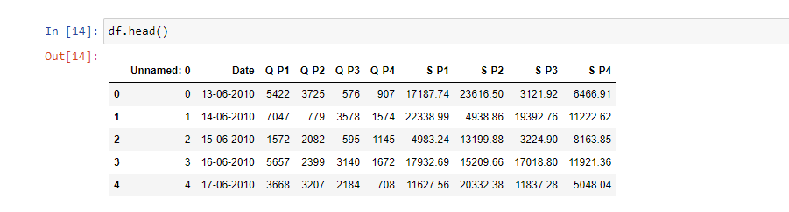

**3.Explore the dataset:** Understand the structure of your data by checking the first few rows, data types, and summary statistics.

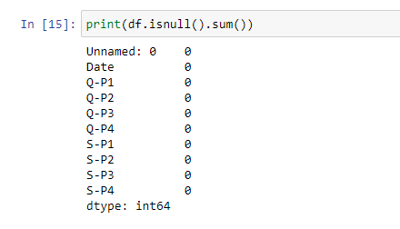

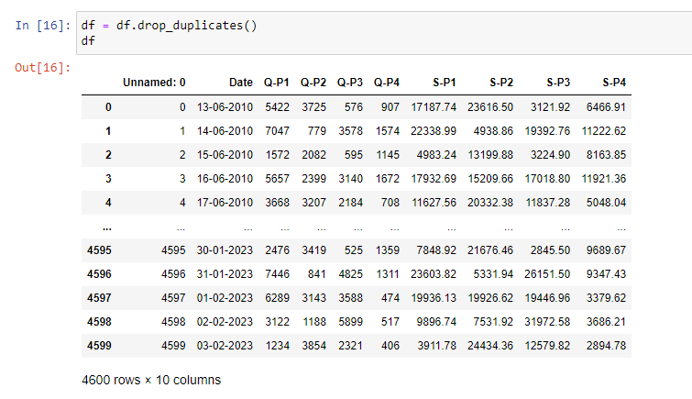

**4.Clean and preprocess the data:** Data cleaning involves handling missing values, duplicates, and other inconsistencies in the dataset. You may also need to convert data types or reformat columns as required.

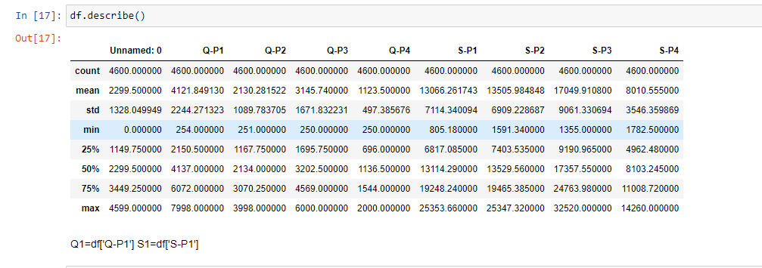

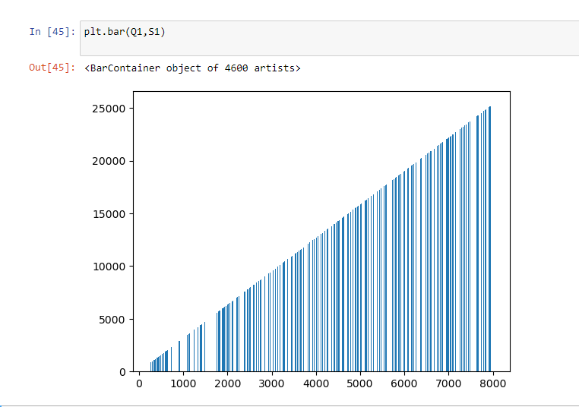

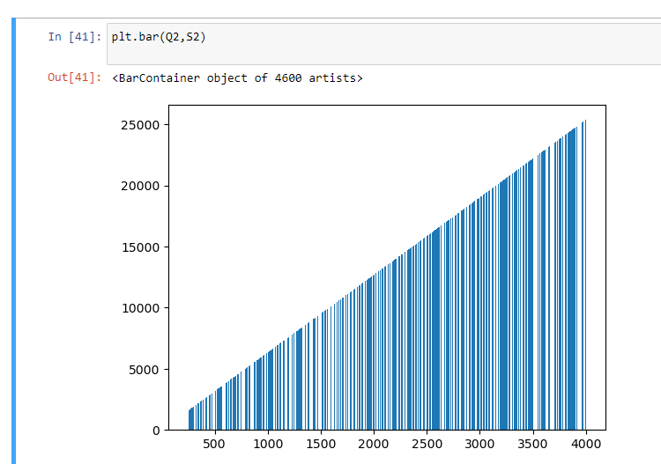

**5.Feature engineering:** You can create new features from existing ones to aid in your analysis. For example, you can extract month and year from the date.

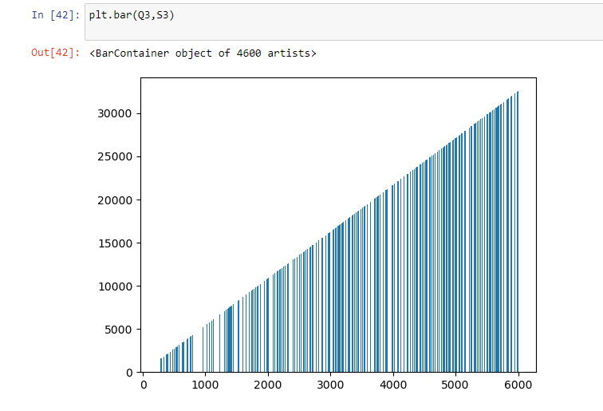

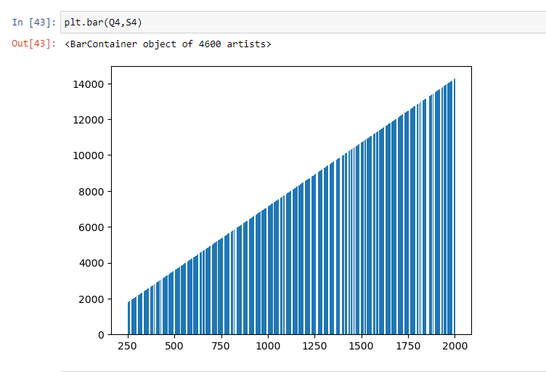

**6.Save the preprocessed data:** Once you've cleaned and processed the dataset, save it for further analysis or modeling.

