
22MAT220 - Mathematics for Computing 3
report
analog computation of simple harmonic motion

team d11 :
hemanth sn - cb.sc.u4aie24321
jaswanth saravanan – cb.sc.u4aie24324
mahakisore m - cb.sc.u4aie24333
yashwanth b - cb.sc.u4aie24360

Objective
The goal of this project was to understand the fundamental principles of analog computing by building and testing an electronic circuit that solves a second-order linear differential equation. The chosen equation was for Simple Harmonic Motion, a classic example that forms the basis of all oscillators.

1. The Operational Amplifier (Op-Amp)
The core of our computer is the 741 IC Op-Amp. It's a "smart" amplifier that follows one main rule: it adjusts its output voltage to do whatever it takes to make its two inputs (Pin 2 and Pin 3) have the same voltage. In our circuits, we connected Pin 3 to ground (0V), so the op-amp's entire job was to keep Pin 2 at 0V.
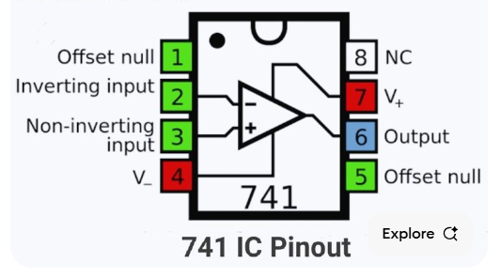

2. The Inverting Amplifier (The "Sign-Flipper")
This is the first building block we perfected. Its job is to take an input voltage and output the exact negative of that voltage.
- How it's built: It uses an op-amp with two equal-value resistors: one at the input and one in the feedback loop.
- How it works: The op-amp creates a negative output voltage that is perfectly sized to push a "balancing" current back through the feedback resistor, cancelling out the current from the input and keeping Pin 2 at 0V.
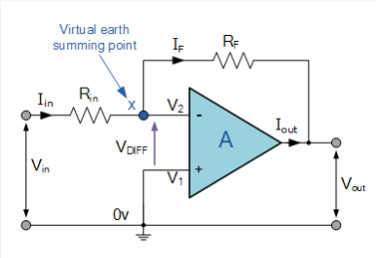
3. The Integrator (The "Accumulator")
This is the second building block. Its job is to produce an output that is the running total, or integral, of its input over time.
- How it's built: It uses an op-amp with a resistor at the input and a capacitor in the feedback loop.
- How it works: The op-amp forces all the input current to charge the feedback capacitor. The op-amp's output voltage must ramp up or down to mirror the voltage on the charging capacitor, which is the physical act of integration.
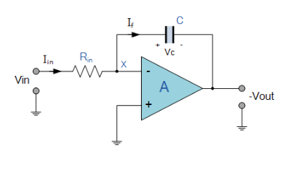

Project Circuit: The Simple Harmonic Oscillator
The specific equation we solved is:
This means "acceleration is the opposite of position." To build this, we created a three-stage loop that continuously solves this equation.
Bill of Materials
- 3 x 741 Op-Amp ICs
- 4 x 10 kΩ Resistors
- 2 x 0.1 µF Capacitors
- Breadboard and Jumper Wires
- ADALM2000 for power and measurement
Complete Circuit Diagram
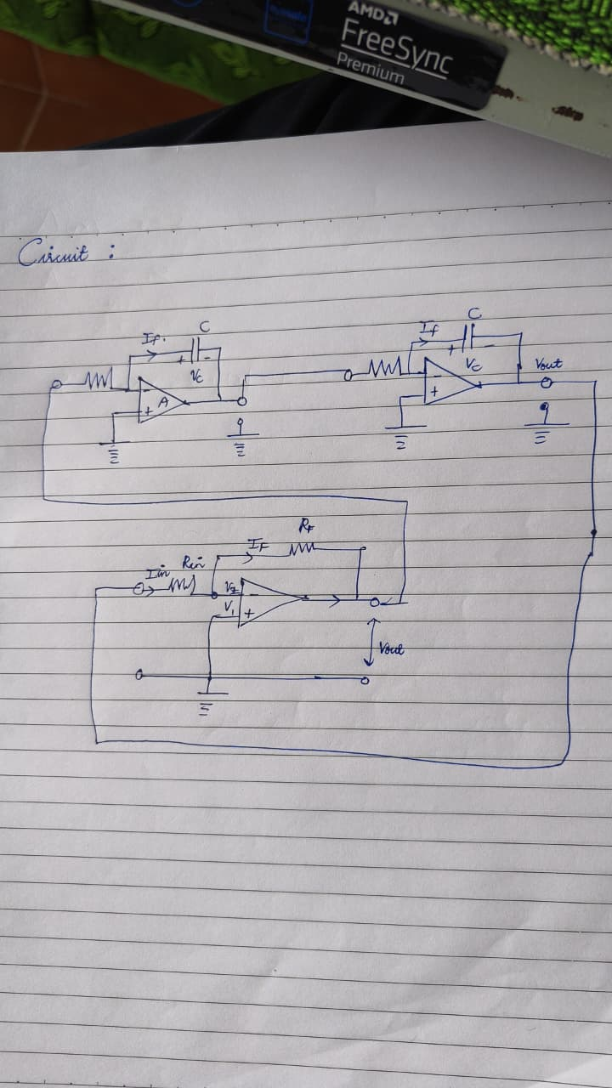
This diagram shows the final assembly of the inverter and two integrators in a closed loop.

Complete Assembly and Connections
This is the final, step-by-step guide for the complete circuit.
1. Power Connections
- Connect ADALM2000 V+ and V- to the breadboard power rails. Create a ground rail.
- For all three ICs, connect Pin 7 to the V+ rail and Pin 4 to the V- rail.
2. Stage Connections
- IC #1 (Inverter):
  - Pin 3 → connects to ground.
  - 10 kΩ resistor → connects from the stage input to Pin 2.
  - 10 kΩ resistor → connects from Pin 6 back to Pin 2.
- IC #2 (First Integrator):
  - Pin 3 → connects to ground.
  - 10 kΩ resistor → connects from the stage input to Pin 2.
  - 0.1 µF capacitor → connects from Pin 6 back to Pin 2.
- IC #3 (Second Integrator):
  - Pin 3 → connects to ground.
  - 10 kΩ resistor → connects from the stage input to Pin 2.
  - 0.1 µF capacitor → connects from Pin 6 back to Pin 2.
3. Loop Connections
- Output of IC #3 (Pin 6) → connects to the input resistor of IC #1.
- Output of IC #1 (Pin 6) → connects to the input resistor of IC #2.
- Output of IC #2 (Pin 6) → connects to the input resistor of IC #3.

Testing and Final Result
- Test Connections:
  - The Signal Generator (W1) is not used.
  - Oscilloscope 1+ connects to the Output of IC #3 (Pin 6) to see position (x).
  - Oscilloscope 2+ connects to the Output of IC #2 (Pin 6) to see velocity (-\dot{x}).
  - Both 1- and 2- connect to the ground rail.
- Final Output: The correctly functioning circuit produces a continuous and stable sine wave (x) and cosine wave (-\dot{x}), confirming it is successfully solving the differential equation.

