AIAC ASSIGNMENT - 16.1
CH.YASHWANTH

HTNO: 2303A51093

BATCH – 11

Taskl: Design a database schema for a Student Information System and generate queries using Al.

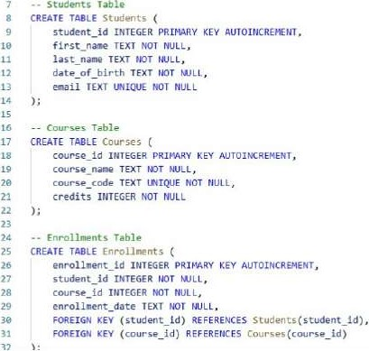
Task; Design a database schema for a Student Tnfornation Systen and berate queriev using At. - Or-OP tables already exist (to avoid errors)
TABLE EXISTS Ennollnents;
4 OROP TABLE IF EXISTS students; TABLE IF EXISTS Courses;
1. Query : Insert a new student record

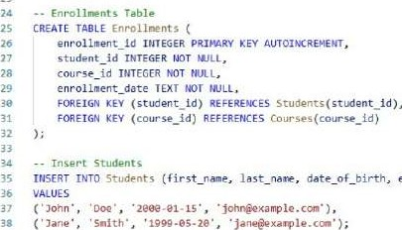email )
- Insert Courses
InsERT INTO (course_name. credits)
'WOE s
( Introduction to Computer Science • •cslgl% 3),
44 C • Oatabase Systens•, •CS182% 4);
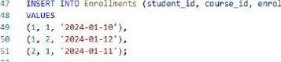Ime n t_ date)
- Query : Fetch all courses enrolled by a student.
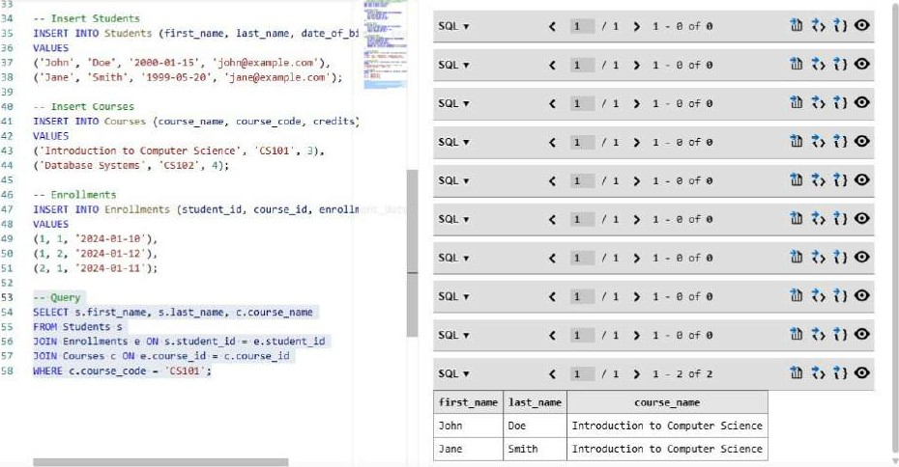
- Query : Count number of students in each course.
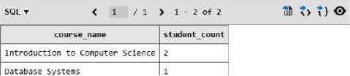
Count number of students In each Course.
SELECT c. Course_nme. COUNT (e. student_id) AS student cc
FRO" Courses c
LEFT Enrollnent5 e c. course_id = e.course_id
GROUP BY c.course_åd;
TASK 2 : Create schema and queries for a Hospital Management System.

- Create schema and queries for a Hospital management System
- Drop tables if already exist (to avoid errors)
DROP TABLE IF EXISTS Appointments;
DROP TABLE IF EXISTS Patients;
OROP TABLE IF EXISTS Doctors; - Patients Table
CREATE TABLE Patients ( patient_id TNTEGER PRIMARY KEY AUTOINCREMENT, first naæ TEXT NOT NULL, last name TEXT NOT NULL, date of birth TEXT NOT WLL, email TEXT UNIQUE TOT NULL
- Doctors Table
CREATE TABLE Doctors doctor id INTEGER PRIMARY KEY AUTOINCRENENT, first name TEXT NOT NULL, last name TEXT NOT NULL, specialty TEXT NOT NULL, email TEXT UNIQUE WLL
Appointments Table
CREATE TABLE Appointments ( appointment_id INTEGER PRIMARY KEY AUTOINCREMENT, patient_id INTEGER NOT NULL, doctor id INTEGER MJLL, appointment_date TEXT NOT NULL,
FOREIGN KEV (patient_id) REFERENCES Patients(patient id). FOREIGN KEY (doctor_ld) REFERENCES

Appointments Table
CREATE TABLE Appointments ( appointment_ld INTEGER PRIMARY KEY AUTOINCREMENT, patient_id INTEGER NOT NULL, doctor Id INTEGER NOT 'LLC , appoint.ent_date TEXT NULL,
FOREIGN KEY (patient_id) REFERENCES patients (patient_id). FOREIGN KEV (doctor_id) REFERENCES
- Insert Patients
INSERT INTO patients (first_nane, last_name, , email)
VALUES
•clark% • anilyæxample. con ' ) ,
( •nichael , 'Broun•, '1990-11-es•, nichael@exanple.com ) ;
- Insert Doctors
IISERT INTO Doctors (first_name, last_name, specialty, email) VALUES
( •Dr. Sarah', •Johnson', • Cardiology' sarah.johnson@example.con•),
David% •Neurology•, 'davld.smith@example.com');
- Insert Appointnents
IISERT INTO Appointments (patient_id, doctor_id, appointment_date)
VALUES
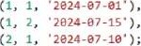
Query 1: List all appointments for a specific doctor.
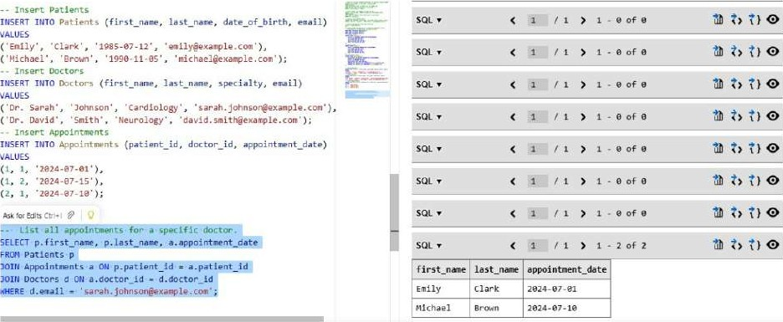
Query 2 : Retrieve patient history by patient ID.
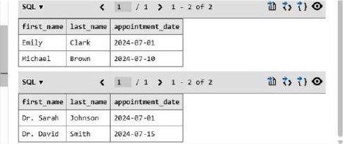
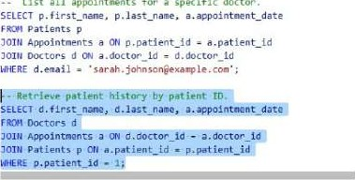
I-st
first
Query 3 : Count total patients treated by each doctor.
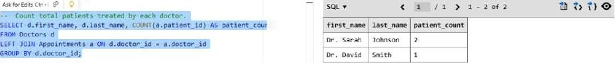
TASK 3 : Design schema for a Library Management System
• Design schema for a Library Management System
Drop tables if already exist (to avoid errors)
DROP TABLE IF EXISTS Borryowings;
OROP TABLE IF EXISTS Books; OROP TABLE IF EXISTS - Members Table
CREATE TABLE ( id INTEGER PRIMARY AUTOINCREMENT. first_nane TEXT NOT last TEXT 'KIT NULL, email TEXT '"T paJLL
Books Table
CREATE TABLE Books ( book_id INTEGER PRIMARY KEY AUTOINCREMENT. title NOT UULL,
author TEXT NOT NULL, isbn TEXT UNIWE NULL
- Borrowings Table
CREATE TABLE ( borroulng_åd INTEGER PRIMARY AUTOINCREMENT, nor,ber id INTEGER WLL, book Id INTEGER NOT POLL, bor•rou date TEXT NULL, retur•n date TEXT,
FOREIGN KEY REFERENCES
FOREIGN KEY (book_ld) REFERENCES
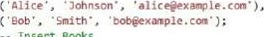
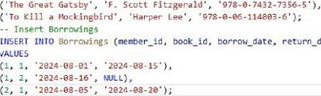
- Insert members
-
Insert
Books
return_date)
INSERT INTO Venber•s last_nane, email )
VALUES
INSERT INTO Books (title, author, Isbn)
'ALOES
Query 1 : Retrieve all books currently issued.
title | first name | las t nam | date
To Kill %ckin8båre | •lice |  | ma-e-*-16
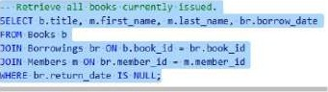 SQL1 - 1 0f1
Query 2 : Find the most purchased product.
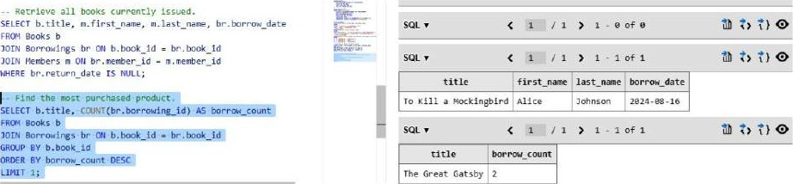
Query 3 : Count number of books loaned by each member.
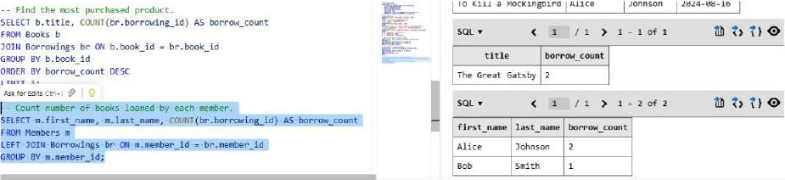
TASK 4 : Design a database for an E-commerce platform.
- Design a database for an E-cor"erce platform,
- Drop tables if already exist (to avoid errors)
DROP IF EXISTS Orders;
DROP TABLE IF EXISTS Products;
DROP TABLE If EXISTS custoners:
- Customers Table
CREATE 'ABLE customers ( customer_id INTEGER PRIMARY KEY AUTOINCREMENT, first_name TEXT NOT NULL.
last_name TEXT nor NULL s email TEXT NOT
Products I able
CREATE products ( product_id PRIMRY KEY AUTOINCREMENT , product_nane TEXT WLL, pr•fte REAL KOT UULL, stock INTEGER NOT 'WLL
- Orders Table
CREATE TABLE orders C order Id INTEGER PRIMARY KEY AUTOINCREtE-UT. id INTEGER NOT 'a.'LL, product_id TUTEGER NOT NULL, order date TEXT NOT UI-ILL, quantity INTEGER NULL,
FOREIGN KEY (customer id) REFERENCES customers(customer Id). FOREIGN KEY (product_id) REFERENCES
- Insert Custmers
INSERT INTO Customers (fir5t_nae. last_nane,
VALUES
( • John • 'Doe'. • •johneexarple.ccn•).
( • Jane • , • Stfth•. '
• Insert Products
INSERT INTO Products (product_name, price, stock)
VALUES ('Laptop', 999.99, 1B),
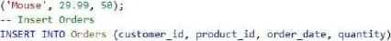
VALUES
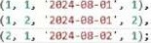
Query 1 : Retrieve all orders by a user.
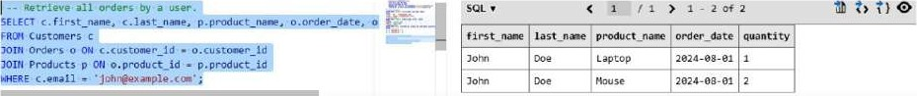
2 : Find the most purchased product. Query
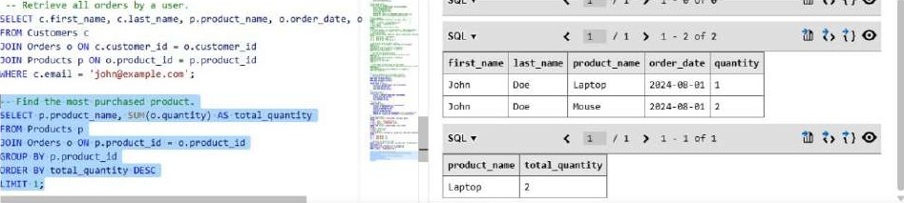
Query 3 : Calculate total revenue in a given month
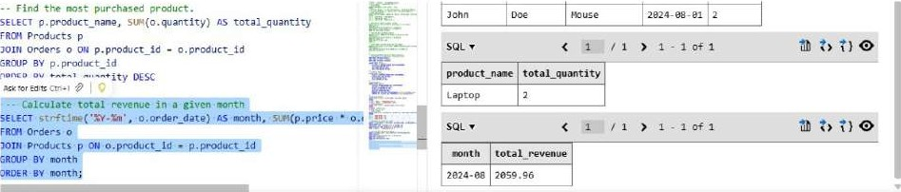1
TASK 5 : Design a database schema for a University Examination System and generate SQL queries using Al.
- Design a database schema for university Examination System and generate SQL queries using Al. - Orop tables if already exist (to avoid
OROP
DROP TABLE IF EX15T5 students; DROP TABLE IF EX15T5 Exams; - Students Table
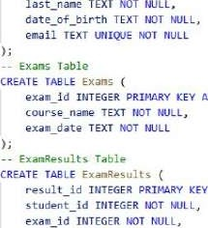
CREATE TABLE students ( student_id INTEGER PRIRARV KEY AUTOINCREMENT, first_name TEXT NULL, last name
AUTOINCREMENT,
AUTOINCREMEUT.
exam id TUTEGER score REAL NOT NULL,
FOREIGN KEY (student_id) REFEREuCäS
FOREIGN KEY (exer_id) REFERENCES
CREATE TAELE Exams ( exam_id INTEGER PRIMARY KEY course name TEXT NULL, exam_date TEXT NULL
- ExamResuIts Table
CREATE TABLE ExanResu1ts ( result id TUTE6ER PRrmARY KEV AUTOTNcREHENT,
student id NOT exam_id TuTF6ER NOT uuLL,
REAL NOT
FORF16N KEY (student_id) REFERENCES
FOREIGN KEY (exam_id) REFERENCES
— Insert Students
INSERT students (first_nane, last_name, email)
VALUES
( •Alice• , •Johnson', •2em-ø3-22", •alice@example.com•),
( 'Bob' , • Smith' . • 2øee-e7-Is•,
- Insert Exams
INSERT INTO Exans (course_name, exam_date)
VALUES
'2e24•e-zs•). ( 'Physics'.
Insert Exam ResuLt5
(student_id, exam_id score)
VALUES
(1, 1, gs.5). (1. g2.ey.
(2, 1, 78.e),
Query I : Insert examination results for a student.
Query 1 : Insert examination results for a student.
INSERT INTO ExamResu1ts (student_id, exam_id, score) VALUES (1, 1, 85.5);
Query 2: Retrieve subject-wise marks for a student.
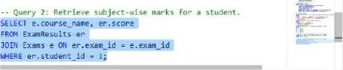 | smaøe_næe Score  "athenatiC5 85. S  "athematics 85.5
Query 3 : Calculate average marks for each subject.
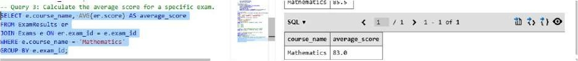> 1 - 1 0+1
LAB OBSERVATIONS
- Objective
To design and implement database schemas for various real-world systems and perform SQL operations such as table creation, data insertion, and query execution using SQL.
Observation 1: Student Information System
- Createdthreetables: Students, Courses, Enrollments.
- Established many-to-many relationship usingabridge table (Enrollments).
- Used primary keys and foreign keys to maintaindata integrity.
Inserted sample student and course data successfully.
Performed queries to:
- Retrieve students enrolled in a specific course.
- Count number of students in each course.
- Observedthat JOIN operations help combinedatafrom multiple tables.
Observation 2: Hospital Management System
Designedtables: Patients, Doctors, Appointments. Implemented relationships using foreign keys. Inserted patient, doctor, and appointment data.
- Executed queries to:
- List appointments for a specific doctor.
- Retrieve patient history.
⁰ Count total patients handled by each doctor.
Observedthat LEFT JOIN helpsincludedoctors with no appomtments.
Observation 3: Library Management System
- Createdtables: Members, Books, Borrowings. Maintained relationships using foreign keys.
- Inserted borrowing records with return status.
Executed queries to:
- Find currently issued books (using NULL condition).
- Identify most borrowed book.
- Count books borrowed by each member.
- Observed that NULL values are useful for tracking incomplete actions (e.g., not returned books).
- Observation 4: E-Commerce System
- Designed tables: Customers, Products, Orders.
Established relationships using foreign keys.
- Inserted sample order and product data.
- Executed queries to:
- Retrieve all orders by a specific customer.
- Find most purchased product.
- Calculate total revenue per month.
- Observed that aggregate functions (SUM, COUNT) are useful for business analysis.
- Observation 5: University Examination System
Created tables: Students, Exams,ExamResults
- Linked students and exams using a result table.
- Inserted exam and result data.
- Executed queries to:
- Retrieve subject-wise marks.
- Calculate average scores for exams.
Observed that GROUP BY and AVG functionshelp in performance evaluation.

