HIGH PERFORMANCE COMPUTING

Assignment-3

NAME : CH.YASHWANTH

Hall Ticket no : 2303A51093
Batch no : 11
Assignment 3: One-to-One Communication Pattern using MPI

Scenario
In a distributed simulation, each process must exchange boundary data with its neighboring process.

Objective
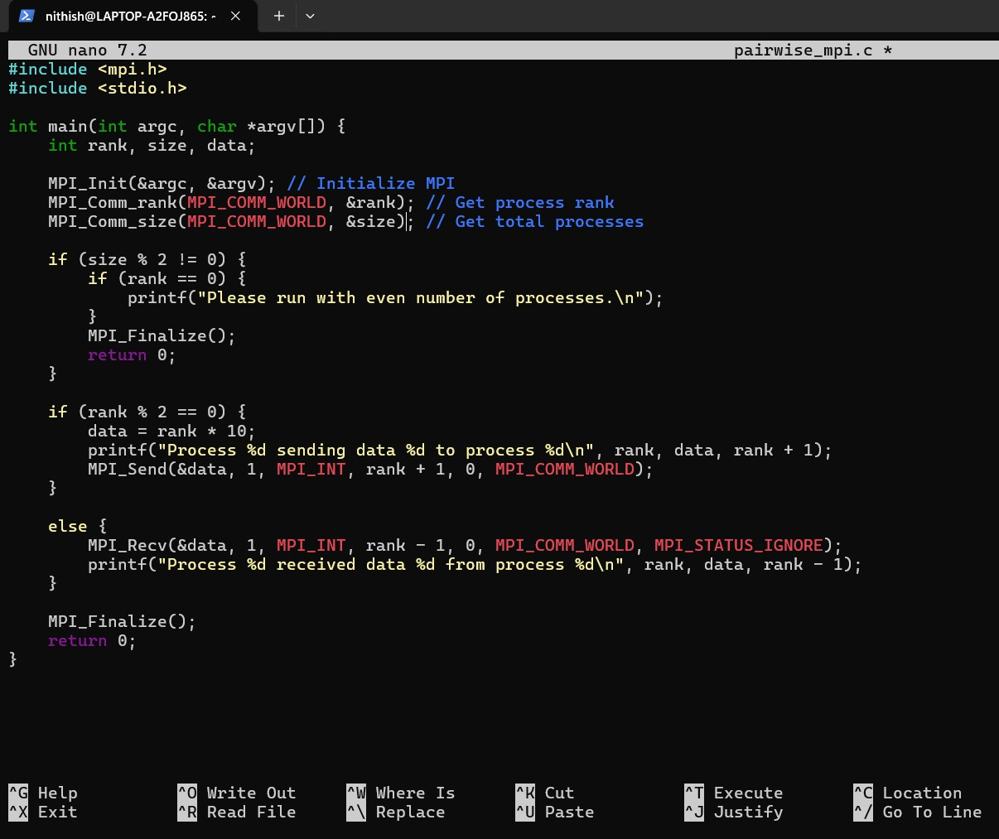
Implement pairwise Send/Receive communication among MPI Processes.

Tasks
- Run the program with an even number of processes.
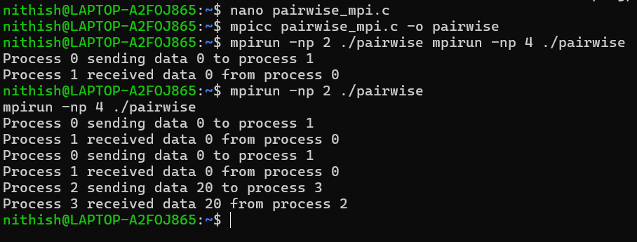
- Each process with even rank sends data to the next odd- ranked process.

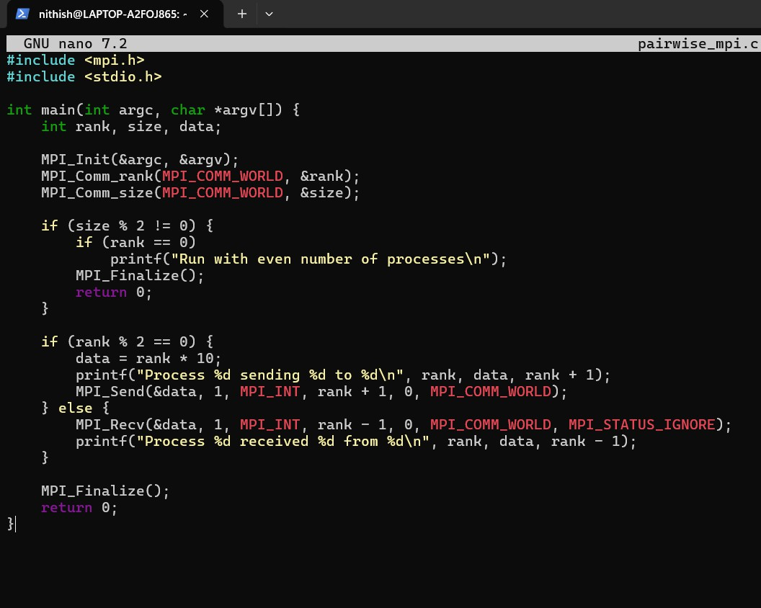
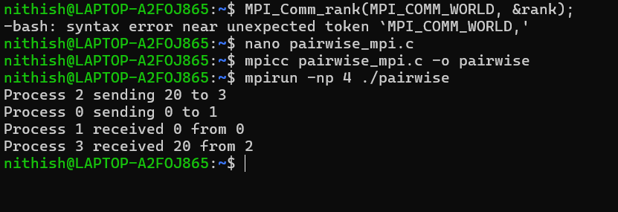
- Odd-ranked processes receive and print the data.

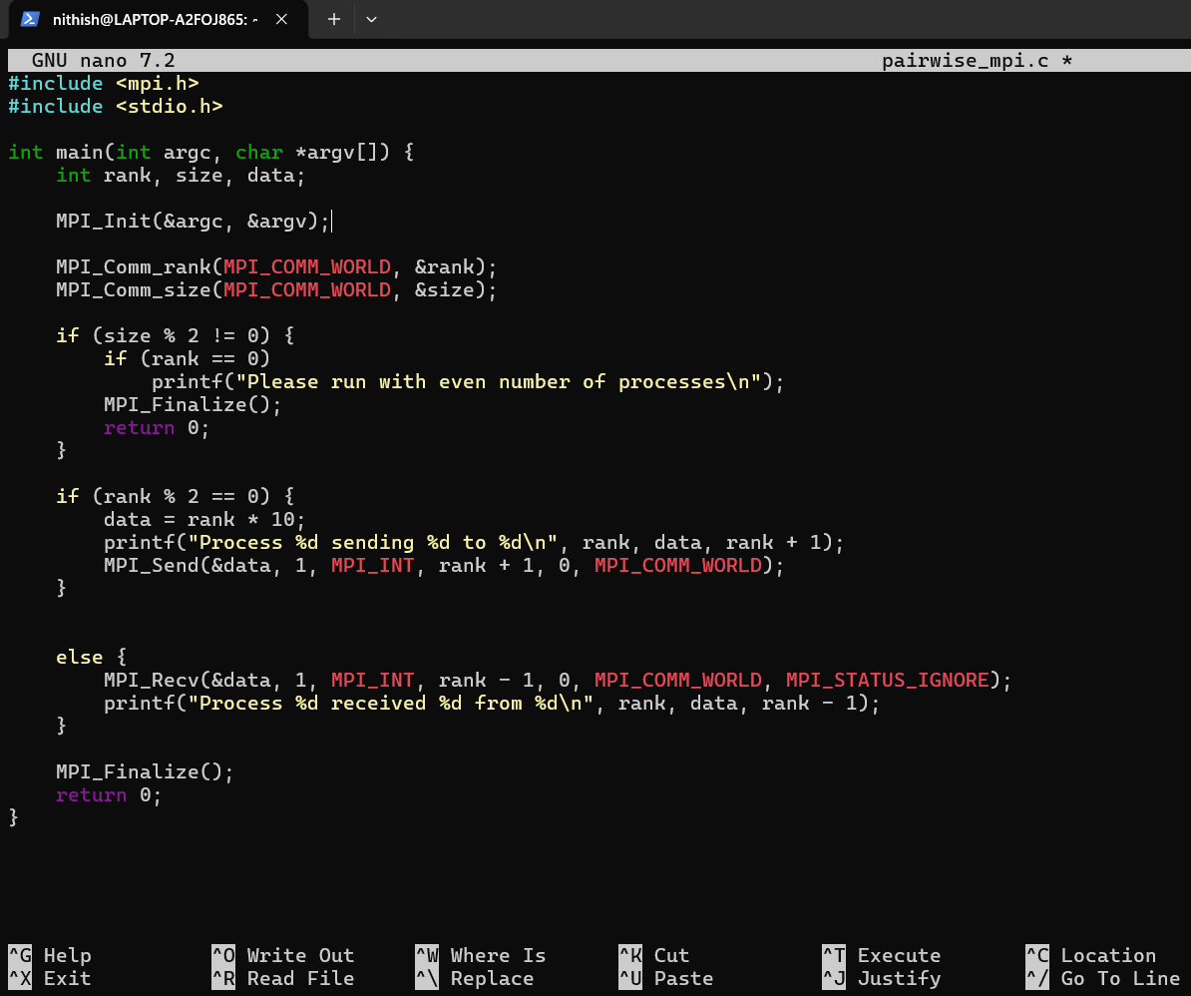

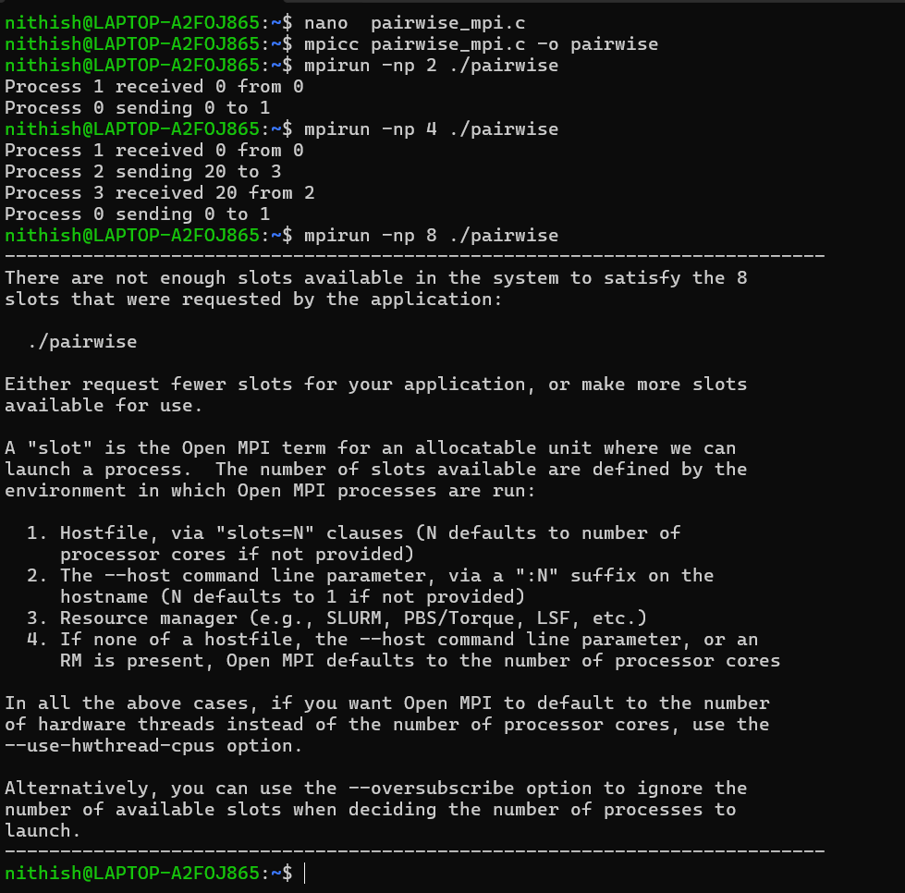
- Analyze blocking behavior of Send/Receive.
In this program, both MPI_Send() and MPI_Recv() are blocking operations. This means that the processes do not continue execution immediately—they wait until the communication is completed.
When an even-ranked process sends data, it pauses until the data is properly handled. Similarly, the odd-ranked process waits until it receives the data before continuing. Because of this, both sending and receiving processes stay synchronized during execution.

There is no deadlock in this program because the communication pattern is simple and well-organized. Even-ranked processes only send data, and
odd-ranked processes only receive it. Since there is no circular waiting between processes, the program runs smoothly.
Overall, the blocking nature of MPI ensures that data is transferred correctly and that all processes remain properly coordinated.

Learning Outcomes
- Pairwise communication patterns
I understood how processes communicate in pairs, where each process exchanges data directly with a specific neighboring process.

Blocking communication behavior
I learned that send and receive operations are blocking, meaning a process waits until the data transfer is completed before continuing execution.

Process synchronization
I understood how processes stay coordinated with each other during communication, ensuring correct and orderly data exchange.

