Colorectal Cancer Detection using Pre-Trained Ensemble Algorithms
In this project we are employing Pre-trained ensemble deep learning algorithms such as InceptionV3, Resnet50 and EfficientNetB0. To train this algorithms we have utilized colorectal cancer images dataset from KAGGLE repository which can be downloaded from below KAGGLE URL.
https://www.kaggle.com/code/allunia/patterns-of-colorectal-cancer-image-clustering/input
Each algorithm is compared with various metrics such as Accuracy, precision, recall and FSCORE. Among all algorithms InceptionV3 is performing well.
To implement this project we have designed following modules
- New User Sign up: using this module user can sign up with the application
- User Login: after sign up user can login to system
- Load & Process Dataset: using this module system will load and process dataset and then split dataset into train and test where application using 80% dataset for training and 20% for testing.
- Run Inception: 80% dataset will be input to Inception algorithm to train a model and this model will be applied on 20% test data to calculate accuracy and other metrics
- Run ResNet50: 80% dataset will be input to ResNet50 algorithm to train a model and this model will be applied on 20% test data to calculate accuracy and other metrics
- Run EfficientNetB0: 80% dataset will be input to Inception algorithm to train a model and this model will be applied on 20% test data to calculate accuracy and other metrics
- Chatbot Colorectal Cancer Detection: using this module Chatbot will get activated which will ask user to upload image and then employ InceptionV3 algorithm to uploaded image to detect cancer. If cancer detected then Chatbot will forward user to Appointment page where user can appointment with desired doctor. If no cancer detected then user will get greet message from Chatbot.
SCREEN SHOTS
To run project install MYSQL database and then copy content from DB.txt and paste in MYSQL console to create database.
Install python 3.7.2 and then install all packages given in requirement.txt file and then double click on run.bat file to get below page
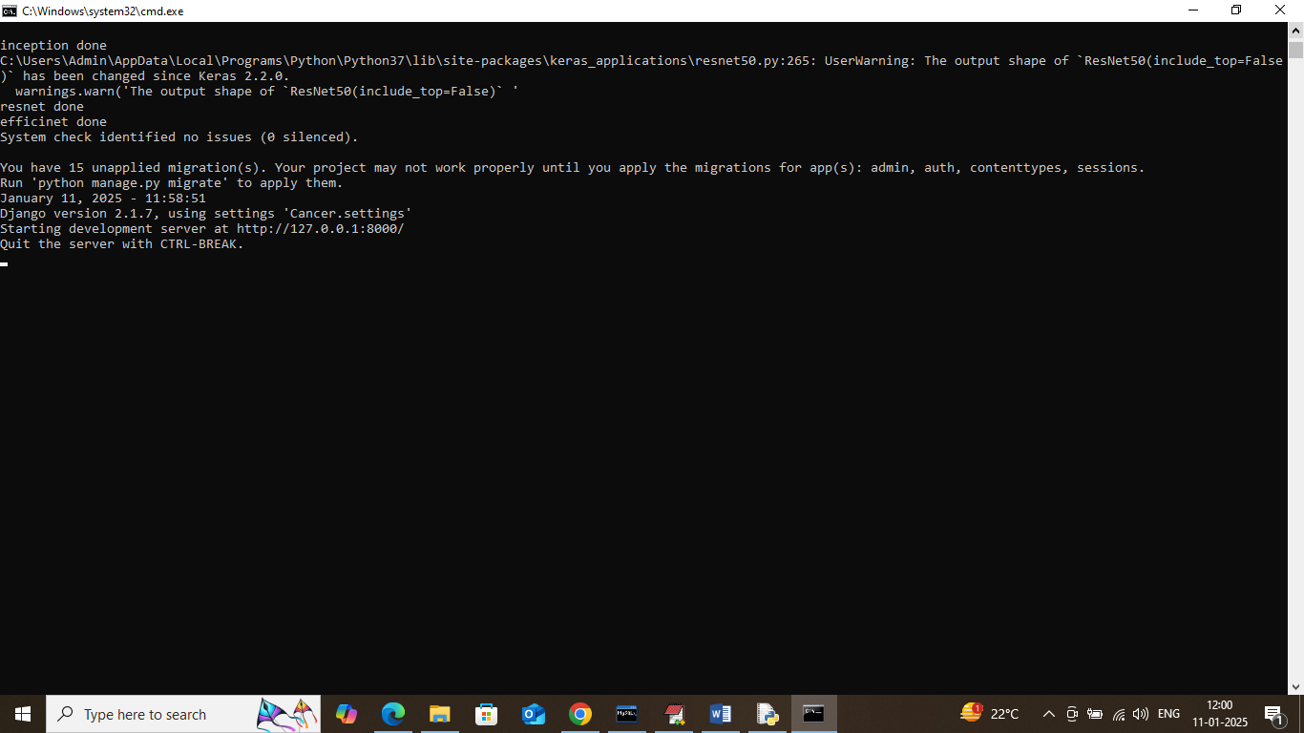
In above screen python server started and now open browser and enter URL as http://127.0.0.1:8000/index.html and press enter key to get below page
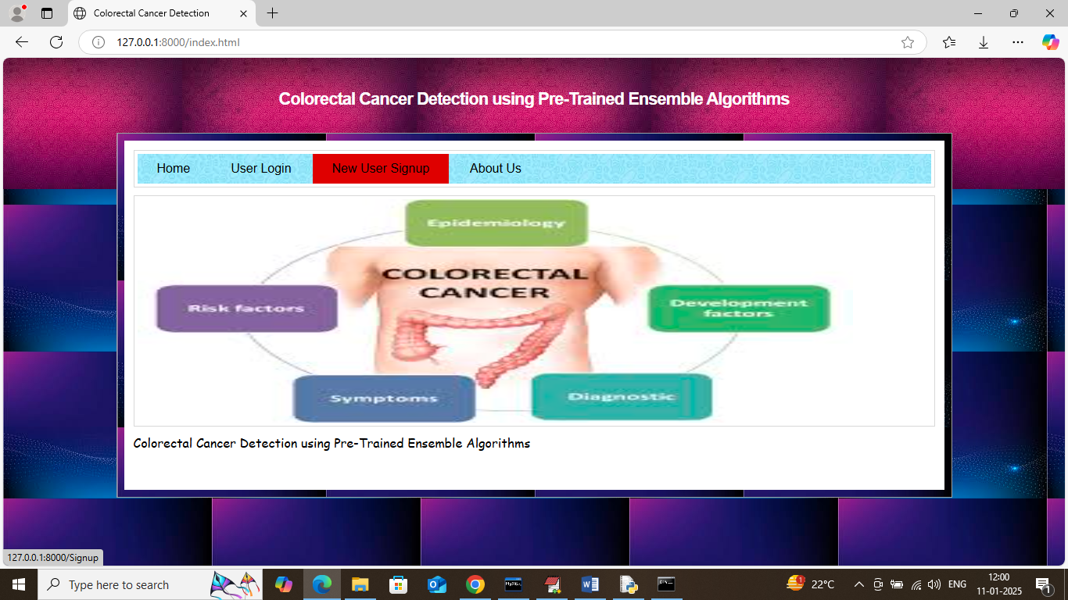
In above screen click on ‘New User Sign up’ link to get below page
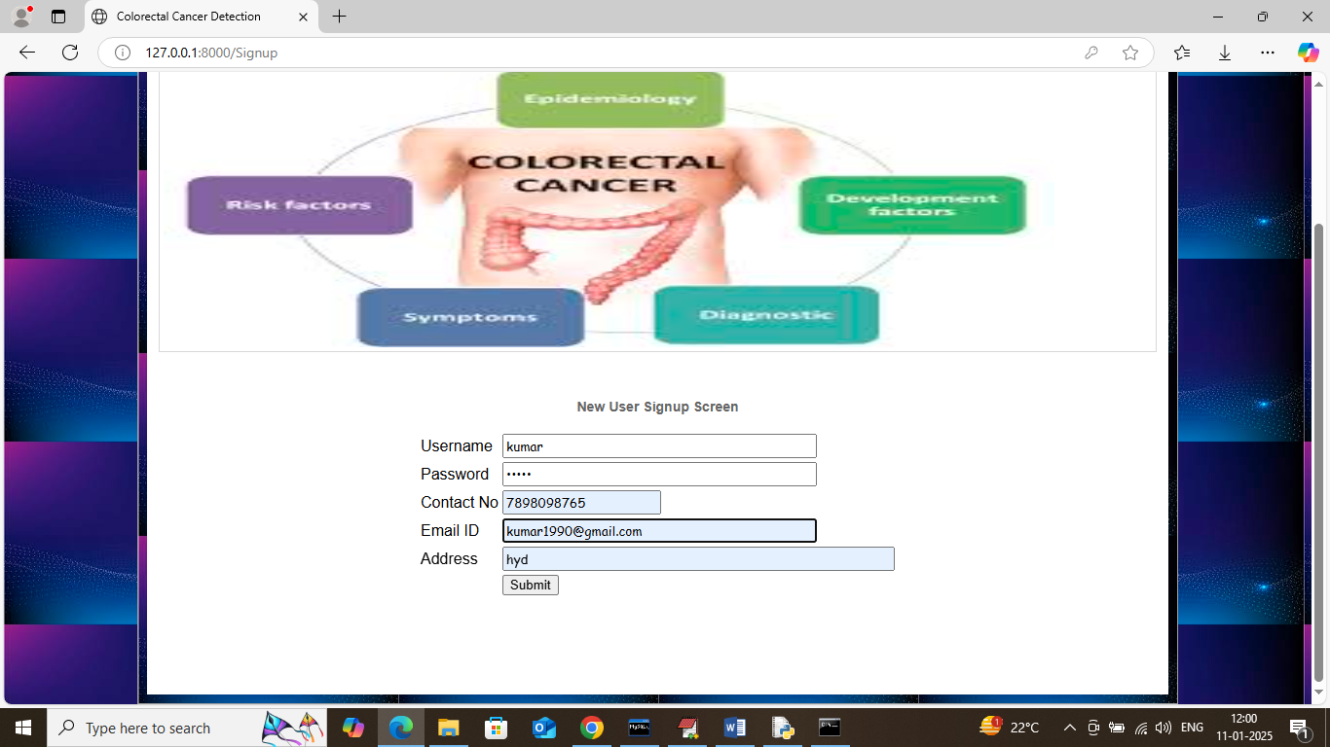
In above screen user entering sign up data and then press button to get below page
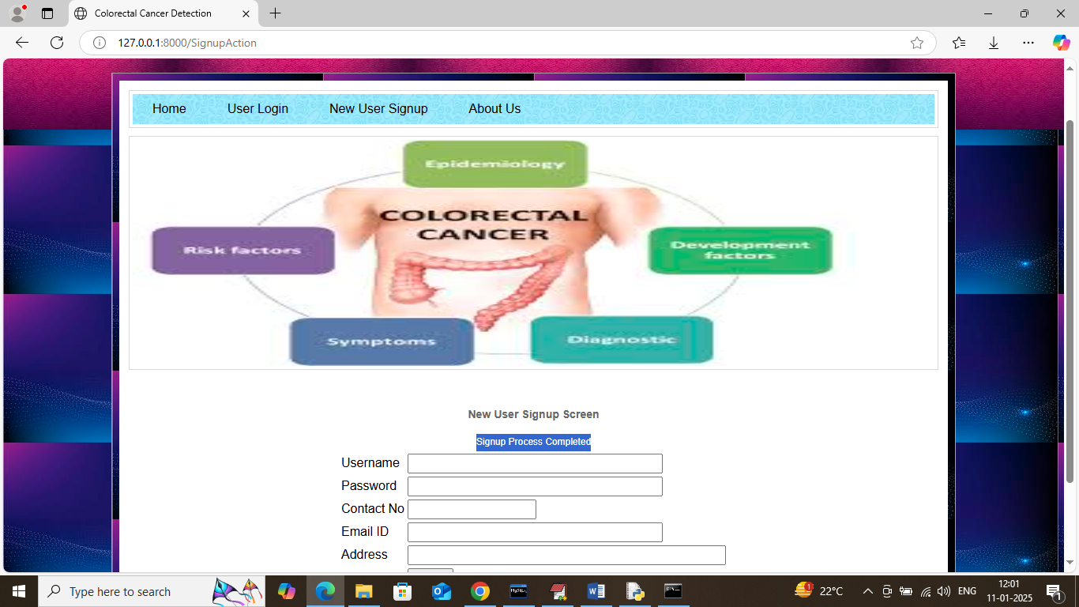
In above screen sign up task completed and now click on ‘User Login’ link to get below page
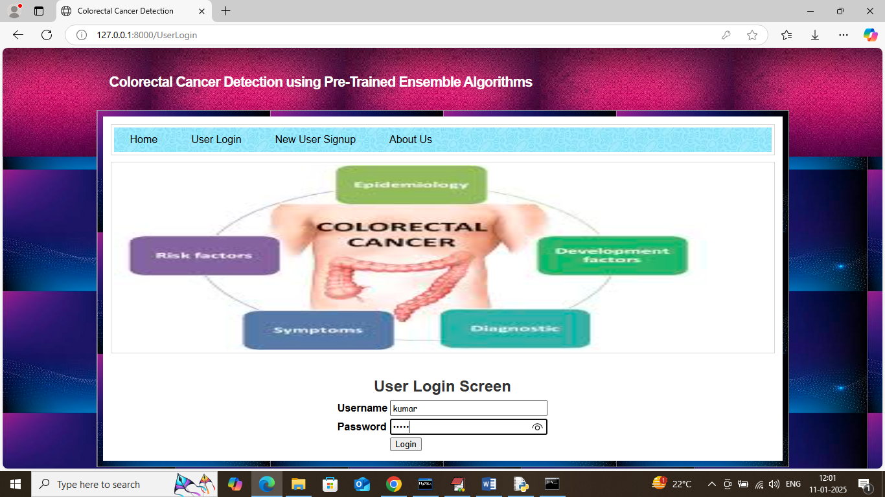
In above screen user is login and after login will get below page
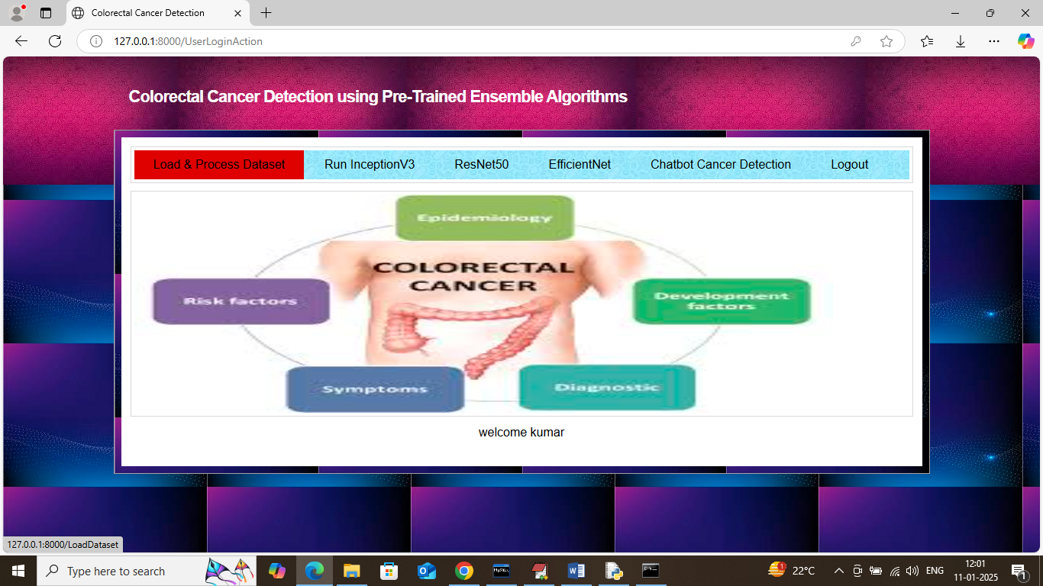
In above screen user can click on ‘Load & Process Dataset’ link to load dataset and then split to train and test and then will get below page
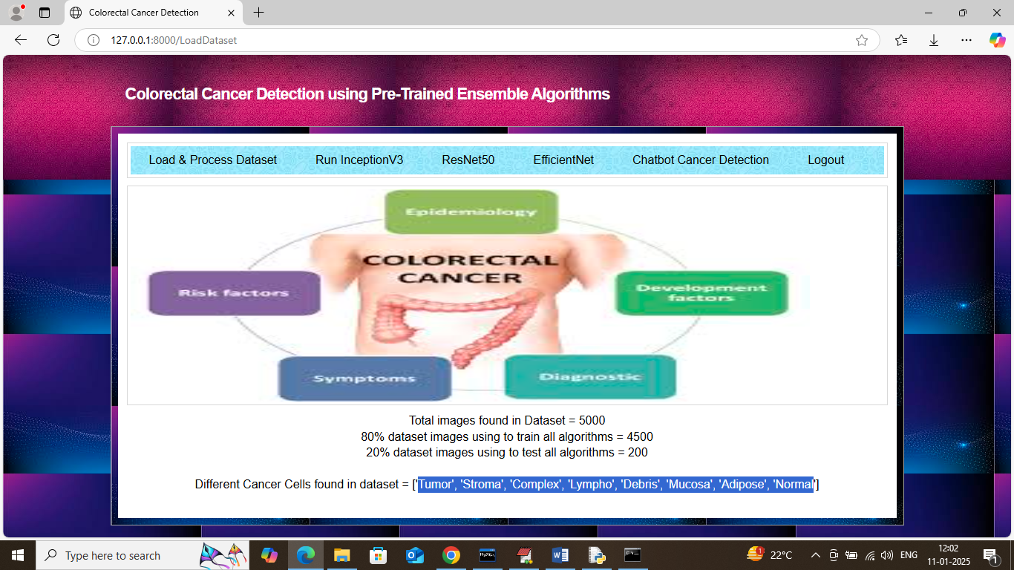
In above screen can see total images loaded and found in dataset and then can see train and test size and then can see different cancer cells found in dataset in blue text and now click on ‘Run InceptionV3’ link to train inception and get below page
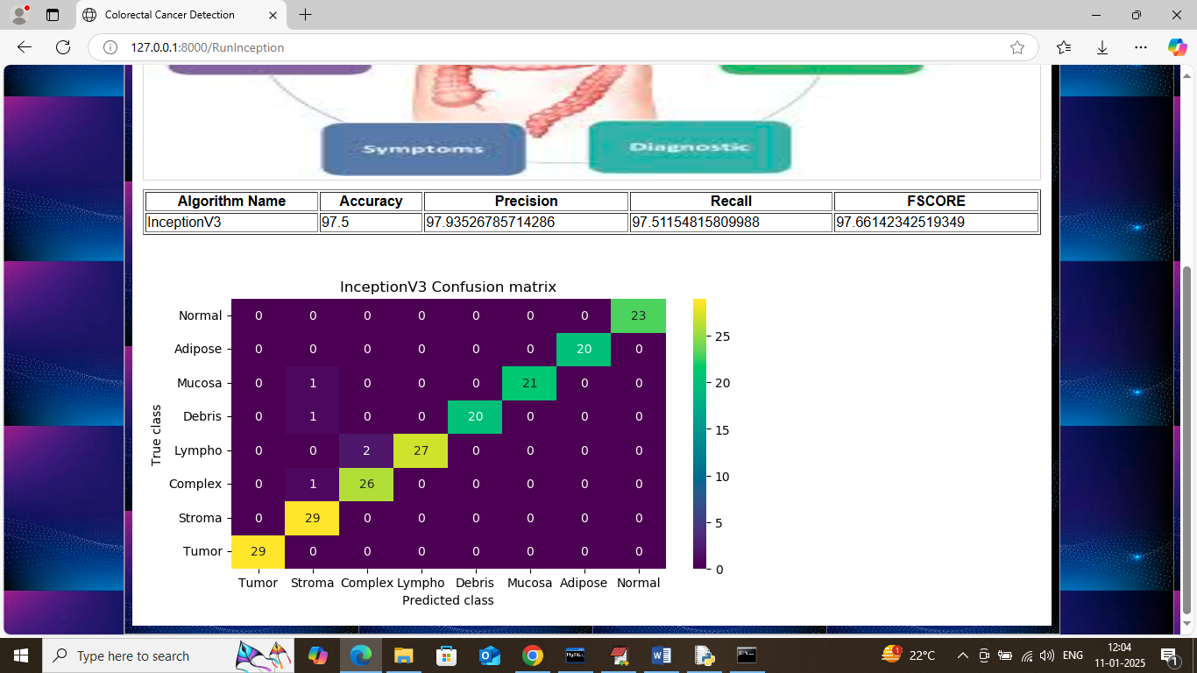
In above screen in table format can see Inception got 97% accuracy and can see other metrics like, precision, recall and FSCORE. In Inception confusion matrix graph x-axis represents Predicted Labels and y-axis represents True labels and then all different colour boxes in diagonal represents correct prediction count and remaining blue boxes represents incorrect prediction count. Now click on ‘Run ResNet50’ link to train ResNet50 and get below page
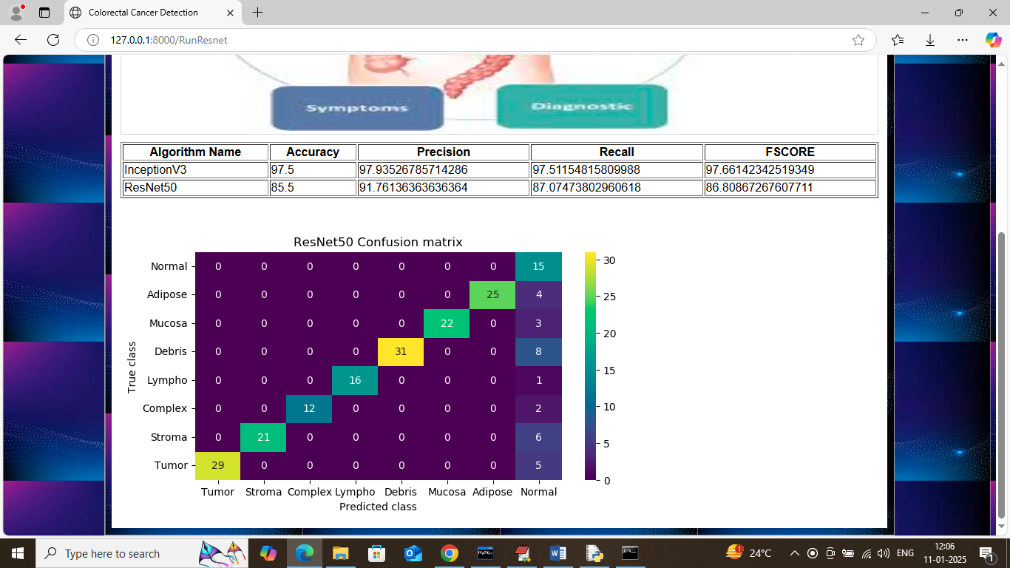
In above screen ResNet50 got 85% accuracy and can see other metrics also. Now click on ‘Run EfficientNetB0’ link to train EfficientNet and get below page
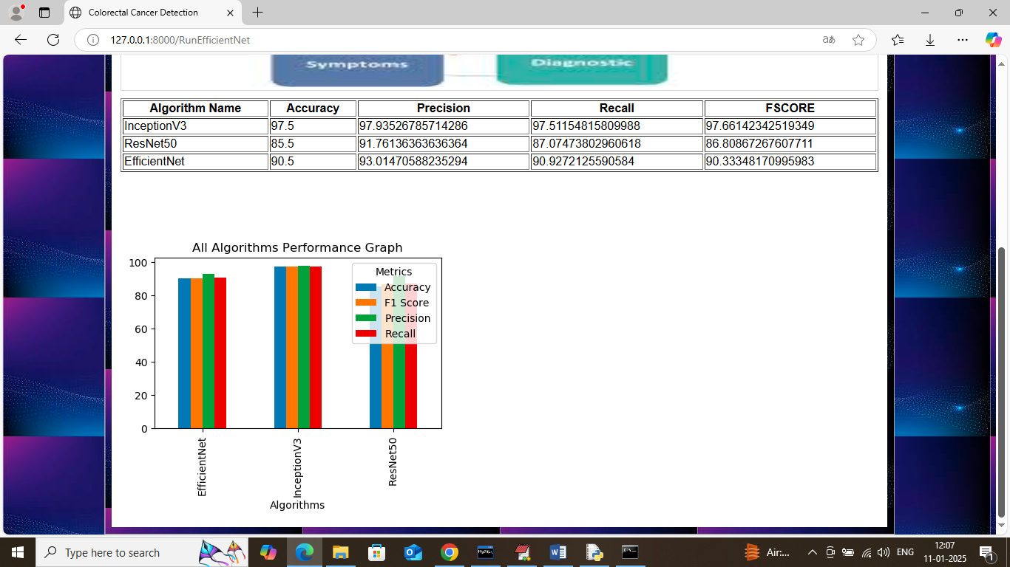
In above screen can see training of all algorithms completed and can see all algorithms results in tabular and graph format. In above graph x-axis represents algorithm names and y-axis represents accuracy and other metrics in different colour bars and in all algorithms IncpetionV3 got high accuracy and now click on ‘Chatbot Colorectal Cancer Detection’ link to get below page
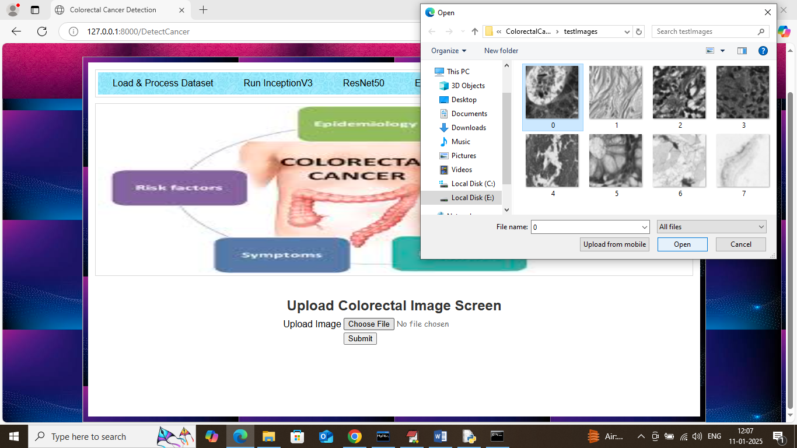
In above screen user will select and upload image and then Chatbot will apply InceptionV3 algorithm to detect cancer type and get below page
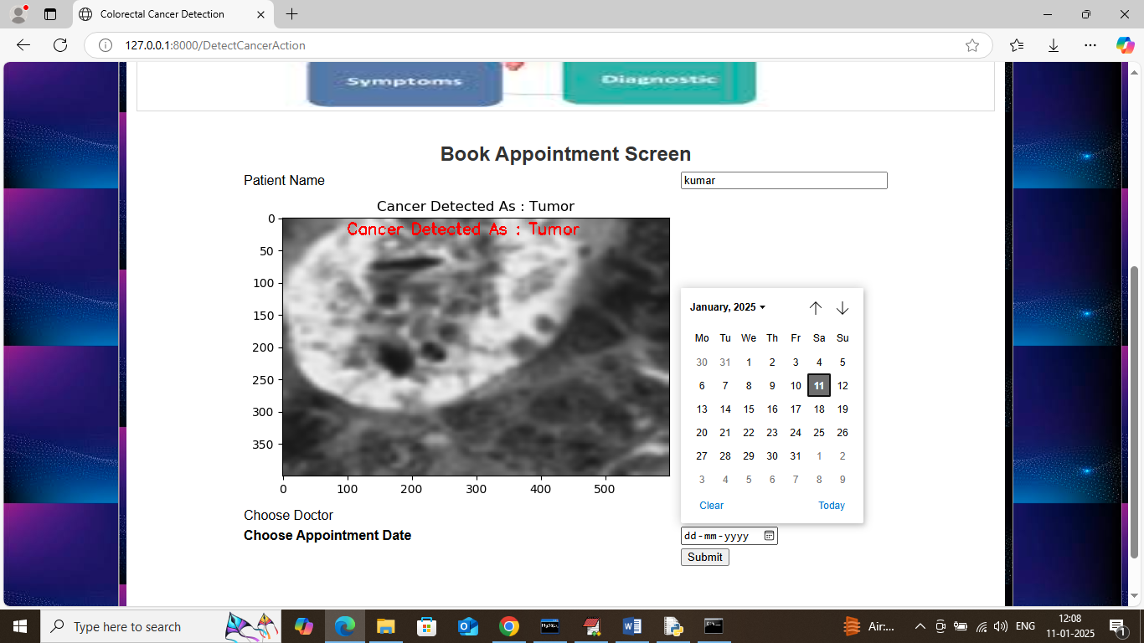
In above screen in first text field can see name of patient who uploaded image and then in image red colour text can see cancer detected as ‘Tumor’ and now Chatbot display available doctor names and appointment date and if user want he can make appointment with desired doctor and get below output

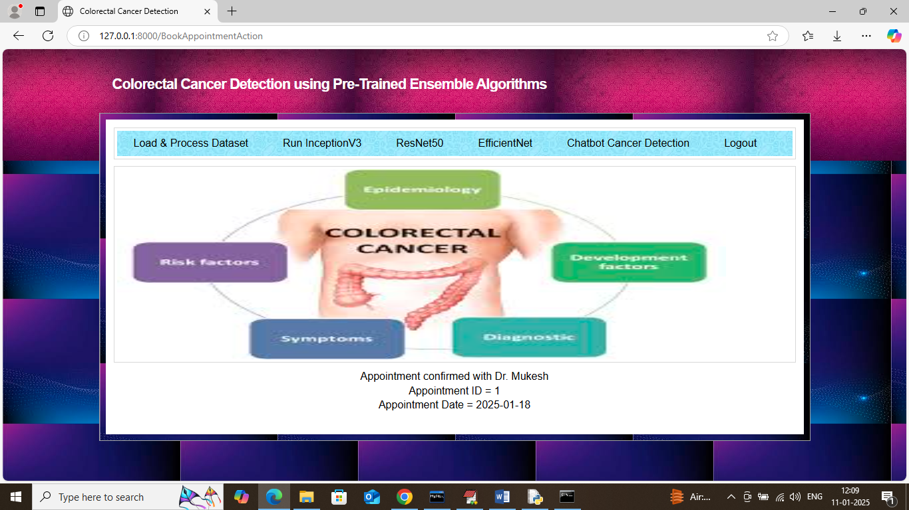
In above screen in black colour text can see appointment confirmed with doctor Mukesh and displaying appointment ID and date. Similarly you can upload and detected cancer by following above screens. Below is another example and all test images are available inside ‘test Images’ folder
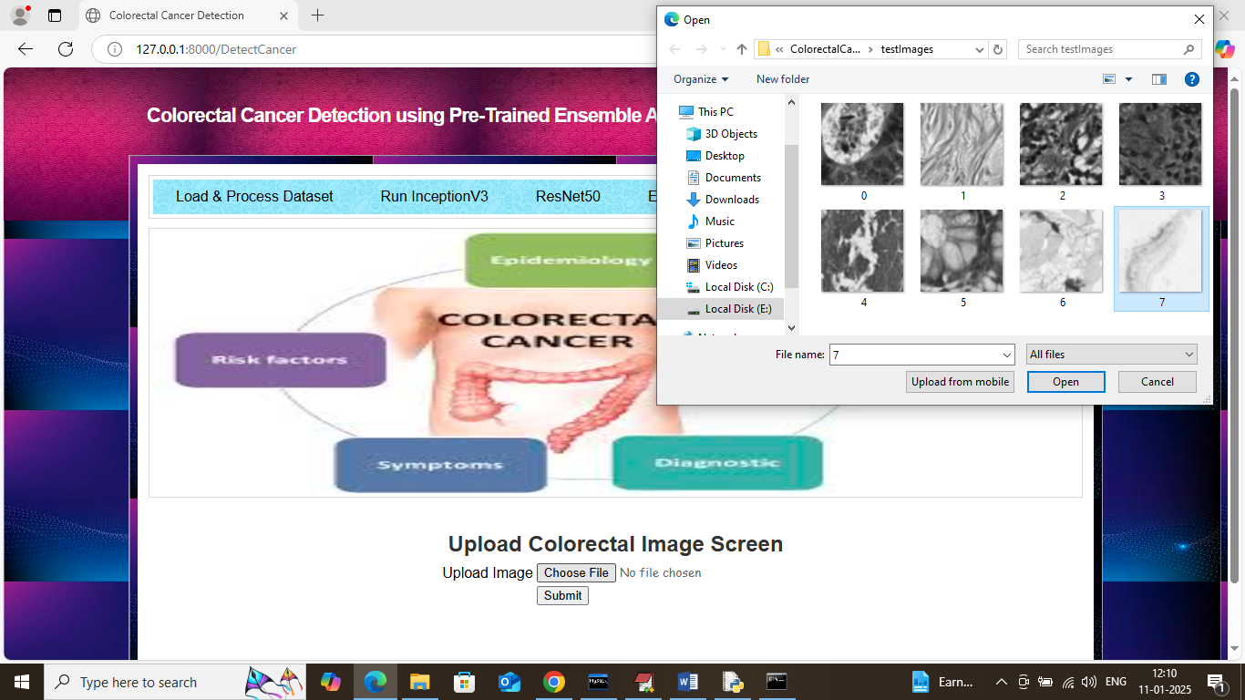
In above screen selecting and uploading 7.png image and then click on Open’ and ‘Submit’ button to get below page
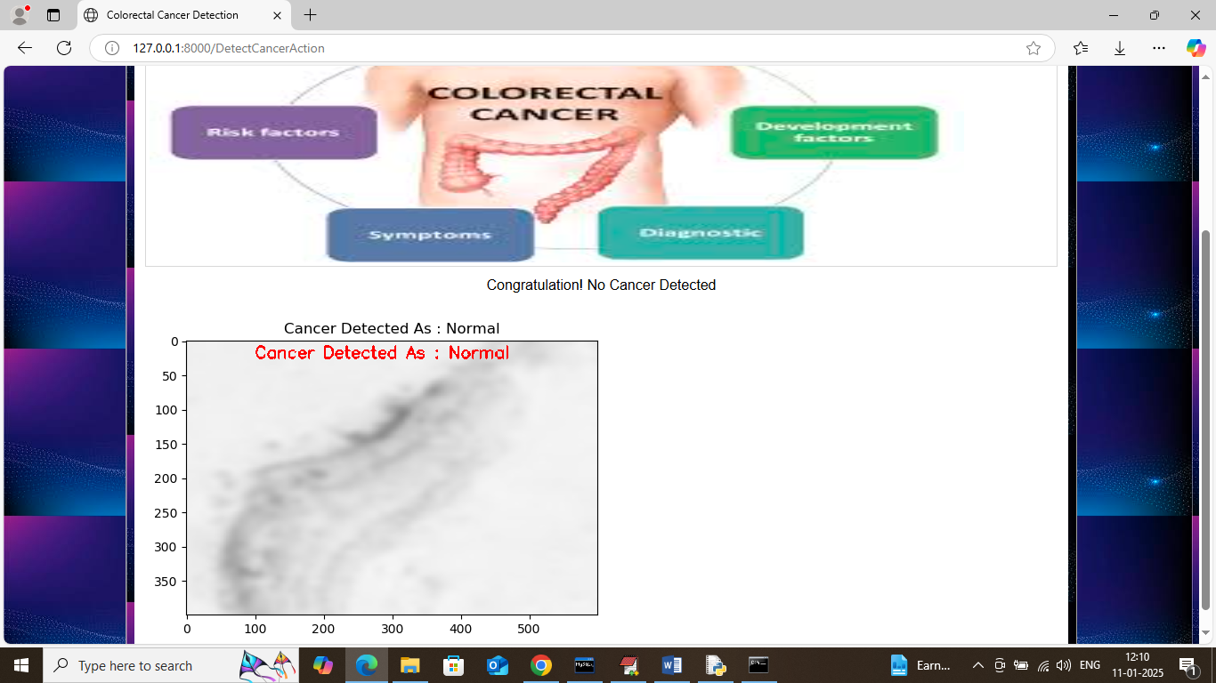
In above screen Chatbot detected ‘Normal’ so no appointment required.
Similarly by following above screens you can upload image and detect different types of cancer.

