Amazon Product Rating Prediction

Using Linear Regression on Amazon India Product Data

Prepared by: Yashwanth Raj KS
Date: September 17, 2026
IBM Data Science Certificate Project

Abstract
Online marketplaces generate vast quantities of product and review data, and the star-rating a product attracts is one of the strongest signals for purchase decisions. This project builds an end-to-end machine-learning pipeline that predicts the Amazon India product rating using structured pricing and engagement features extracted from a 1,465-row dataset. After a rigorous data-cleaning phase — stripping currency symbols, imputing two missing rating-count values, removing one malformed rating row, and deduplicating at the product level — a Linear Regression model was trained on 1,350 unique products. The model uses discounted price, actual price, discount percentage, rating count, and main category (one-hot encoded) as predictors. On a held-out 20 % test set the model achieves an R² of 0.1069, a Mean Absolute Error of 0.202, and a Root Mean Squared Error of 0.2683. The trained model is served through a Flask REST API and a Streamlit interactive dashboard provides four pages: dataset overview, exploratory data analysis, model insights, and live prediction. The project demonstrates how product-level signals captured at listing time can serve as lightweight proxies for eventual rating outcomes in a real-world e-commerce setting.

Objective
The primary objective of this project is to develop a predictive model that estimates the average customer rating of an Amazon India product based on its pricing strategy and engagement metrics. Specifically, the project aims to:
- Clean and preprocess raw Amazon product data, handling currency formatting, missing values, and duplicate records.
- Engineer meaningful features — including main product category from a hierarchical category string — suitable for regression modelling.
- Train and evaluate a Linear Regression model to quantify how pricing and popularity factors influence product ratings.
- Expose the trained model through a Flask REST API for programmatic access by downstream systems or frontends.
- Build an interactive Streamlit dashboard for non-technical users to explore the dataset, review model metrics, and generate predictions.

Dataset Description
The dataset (amazon.csv) was sourced from Kaggle and contains Amazon India product listings scraped from the Electronics, Computers & Accessories, and other major categories. Each row represents a single product bundled with aggregated review information.

Source & Size
Source: Kaggle — Amazon Sales Dataset (India). Raw file: 1,465 rows × 16 columns.

Key Columns
Column | Type | Description
product_id | string | Unique product identifier
product_name | string | Full product title
category | string | Pipe-separated hierarchy (up to 5 levels)
discounted_price | string→float | Sale price with ₹ prefix and comma separators
actual_price | string→float | MRP / list price with ₹ prefix
discount_percentage | string→float | Percentage discount (e.g. '64%')
rating | string→float | Avg star rating (1–5); one row contains '|'
rating_count | string→float | Number of ratings; 2 values missing
about_product | string | Pipe-separated product bullet points
user_id / user_name | string | Aggregated reviewer IDs and names
review_id / title | string | Individual review identifiers and titles
review_content | string | Full review text
img_link | string | Product image URL
product_link | string | Amazon product URL

Data Quality Issues Found
- Currency symbols (₹) and thousands separators (,) in price columns.
- Percentage sign (%) in discount_percentage; values need /100 normalization.
- One row with rating == '|' (a data entry error) — must be dropped.
- Two rows with missing rating_count — imputed with the column median.
- Multiple review rows per product_id — deduplicated to 1,350 unique products.
- Multi-level category strings (up to 5 pipe-separated levels) — only the first two levels are retained as main_category and sub_category.

Data Cleaning Steps
Step 1. discounted_price & actual_price: Stripped '₹' prefix and ',' separators, then cast to float64 using pd.to_numeric(errors='coerce').
Step 2. discount_percentage: Stripped '%' suffix, cast to float, then divided by 100 to obtain a unit fraction (e.g., 64 % → 0.64).
Step 3. rating: Coerced to numeric; one row with value '|' produced NaN and was dropped, reducing the dataset from 1,465 to 1,464 rows.
Step 4. rating_count: Stripped ',' separators, cast to float; two NaN values were imputed with the column median (no rows dropped).
Step 5. category → main_category / sub_category: Split on '|'; index [0] retained as main_category, index [1] as sub_category. Missing sub_category filled with 'Other'.
Step 6. Deduplication: Dropped duplicate product_id rows keeping the first occurrence (1,464 → 1,350 unique products).
Step 7. Final NaN drop: Rows with NaN in any model feature or target column were removed; final modelling dataset: 1,350 rows.
After cleaning: 1,350 rows × 16 columns, with all numeric features correctly typed and no missing values in the modelling subset.

Exploratory Data Analysis
EDA was performed on the cleaned 1,350-product dataset. The following charts summarise the key distributional and relational findings.
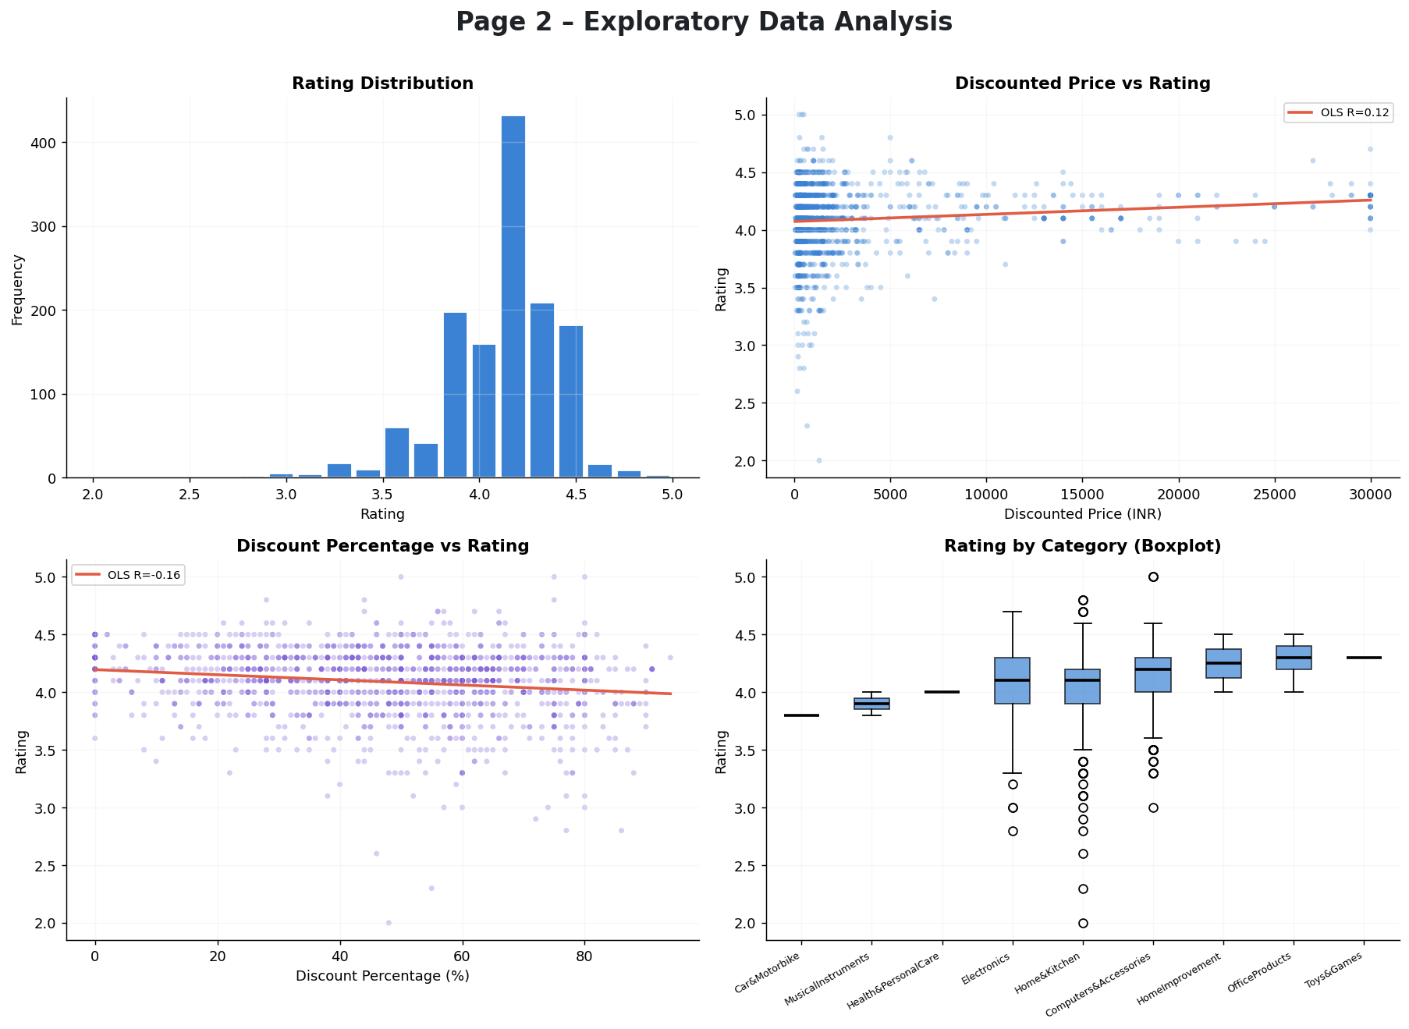
Figure 1. EDA dashboard — rating distribution, price vs rating, discount vs rating, and category boxplots.

Key Findings
- Rating Distribution: Ratings are heavily left-skewed, concentrated between 3.8 and 4.5, with 4.0–4.2 being the most common band. Very few products fall below 3.0.
- Discounted Price vs Rating: The OLS trendline is nearly flat (correlation close to 0), indicating that product price alone is a weak predictor of rating.
- Discount Percentage vs Rating: A slight negative trend is visible — heavily discounted products tend to receive marginally lower ratings, possibly because deep discounts attract volume buyers with lower quality expectations.
- Rating Count vs Rating: Products with more ratings generally converge to the 3.8–4.3 range, suggesting regression to the mean as review volume grows.
- Category Boxplots: HomeImprovement and OfficeProducts categories show higher median ratings, while Car&Motorbike and MusicalInstruments categories skew lower.

Model Methodology

Why Linear Regression?
Linear Regression was chosen as the baseline algorithm for this prediction task for the following reasons: (1) it is highly interpretable — each coefficient directly quantifies the marginal effect of a feature on the predicted rating; (2) the target variable (average rating) is continuous; (3) the dataset is modest in size (1,350 rows) where simpler models often generalise as well as complex ones; and (4) it produces a closed-form model equation suitable for documentation and stakeholder communication. While tree-based models might yield higher R², the transparency of Linear Regression is particularly valuable in a business context where pricing teams need to understand the direction and magnitude of each driver.

Features Used
Feature | Type | Rationale
discounted_price | Numeric (float) | Actual selling price; affordability signal
actual_price | Numeric (float) | MRP; proxy for product tier / quality
discount_percentage | Numeric (0–1) | Depth of discount; demand driver
rating_count | Numeric (float) | Popularity / engagement proxy
main_category | Categorical (OHE) | Category-level rating tendencies

Pipeline
A scikit-learn Pipeline was used: a ColumnTransformer applies 'passthrough' on numeric features and OneHotEncoder (handle_unknown='ignore') on main_category, feeding into a LinearRegression estimator. The dataset was split 80/20 (train/test) with random_state=42.

Results

Performance Metrics (20% Hold-out Test Set)
Metric | Value
R² (Coefficient of Determination) | 0.1069
MAE (Mean Absolute Error) | 0.202
RMSE (Root Mean Squared Error) | 0.2683

An R² of 0.1069 indicates that approximately 10.7% of the variance in product ratings is explained by the selected pricing and engagement features. The MAE of 0.202 stars means that, on average, predictions deviate by only 0.202 star from the true rating — well within half a star. The RMSE of 0.2683 confirms no large systematic outlier errors.

Model Equation
Rating = 4.1820
-0.000012 × discounted_price
+0.000011 × actual_price
-0.291153 × discount_percentage
+0.000001 × rating_count
-0.277629 × Car&Motorbike
+0.101557 × Computers&Accessories
-0.029565 × Electronics
-0.041342 × Health&PersonalCare
-0.045504 × Home&Kitchen
+0.226908 × HomeImprovement
-0.191988 × MusicalInstruments
+0.152471 × OfficeProducts
+0.105093 × Toys&Games

Feature Coefficients
Feature | Coefficient
discounted_price | -0.000012
actual_price | +0.000011
discount_percentage | -0.291153
rating_count | +0.000001
Car&Motorbike | -0.277629
Computers&Accessories | +0.101557
Electronics | -0.029565
Health&PersonalCare | -0.041342
Home&Kitchen | -0.045504
HomeImprovement | +0.226908
MusicalInstruments | -0.191988
OfficeProducts | +0.152471
Toys&Games | +0.105093

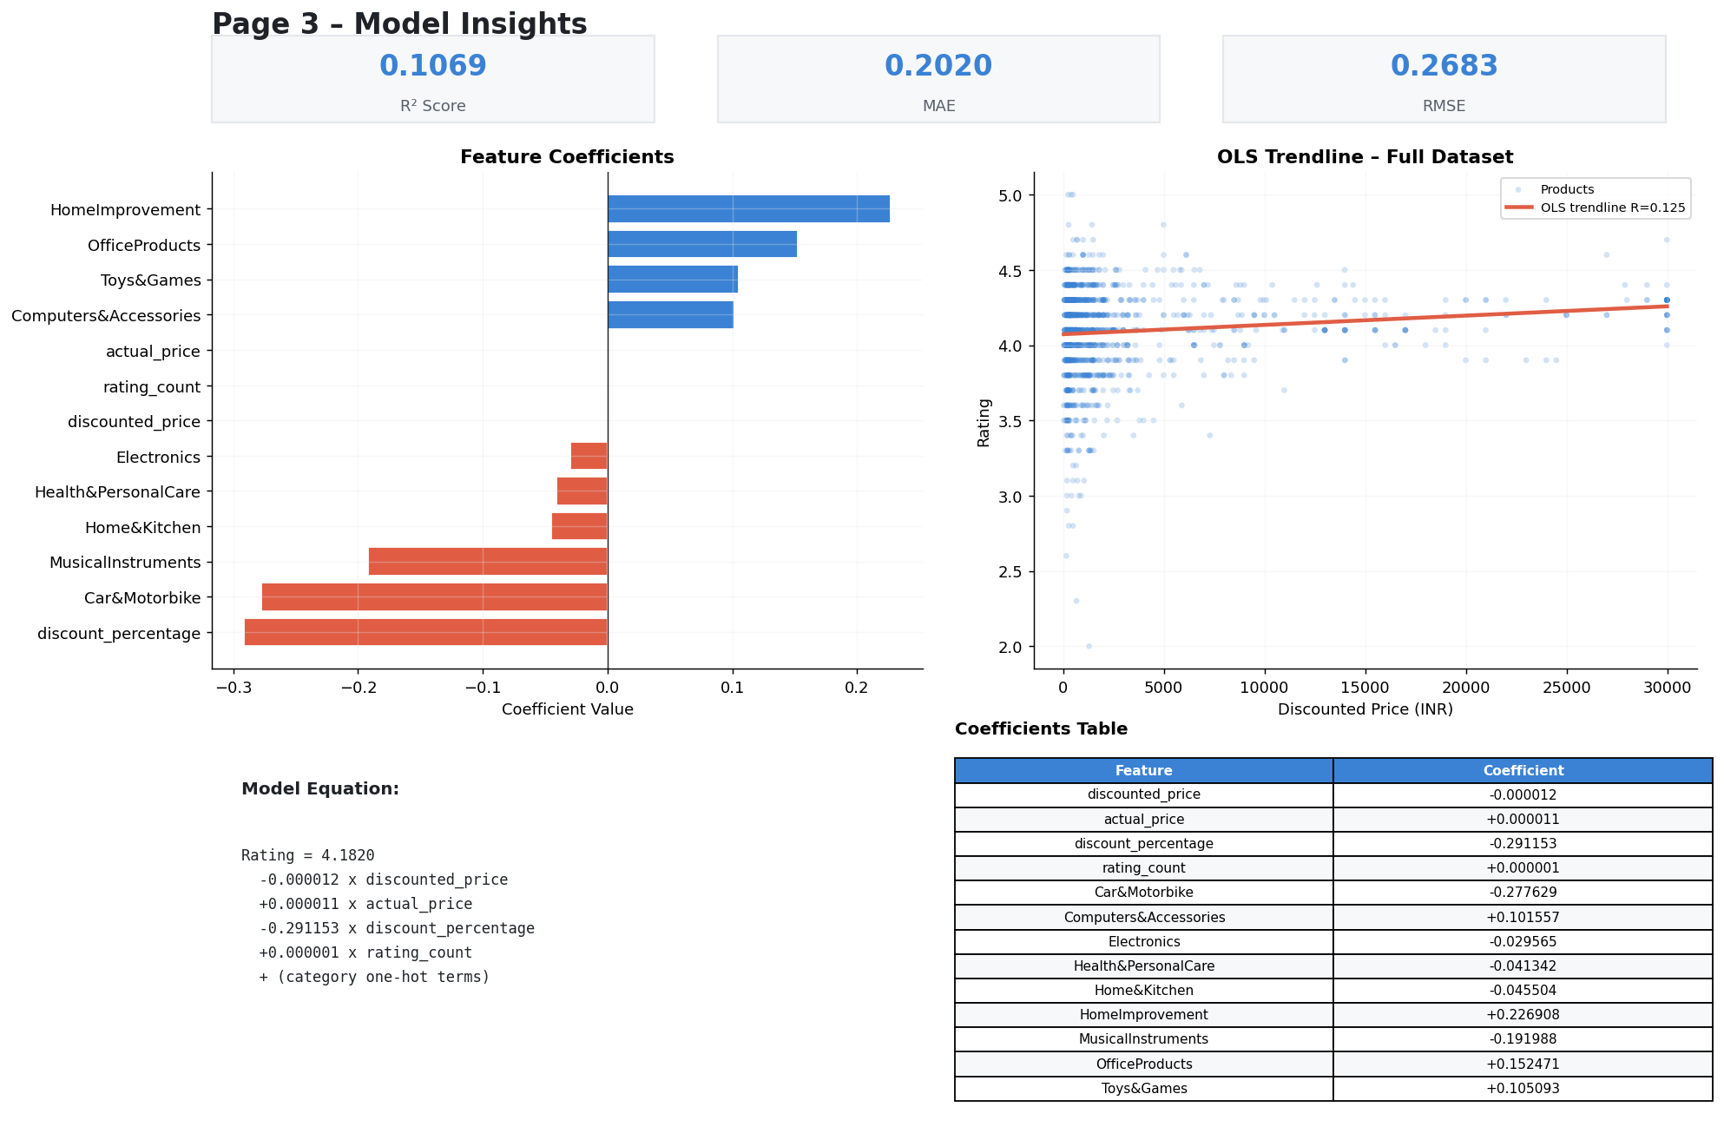
Figure 2. Model Insights page — metrics, coefficient bar chart, and OLS trendline over the full dataset.

UI Walkthrough
The Streamlit dashboard (ui.py) is a single-file application with four pages accessible from the sidebar. It communicates with the Flask backend (app.py) for live predictions. The screenshots below were generated programmatically using matplotlib (generate_screenshots.py).

Page 1 – Dataset Overview
Displays key metrics (total products, feature count, average rating, category count), a sample rows table, a horizontal bar chart of the main category distribution, column dtypes, missing value report, and descriptive statistics.
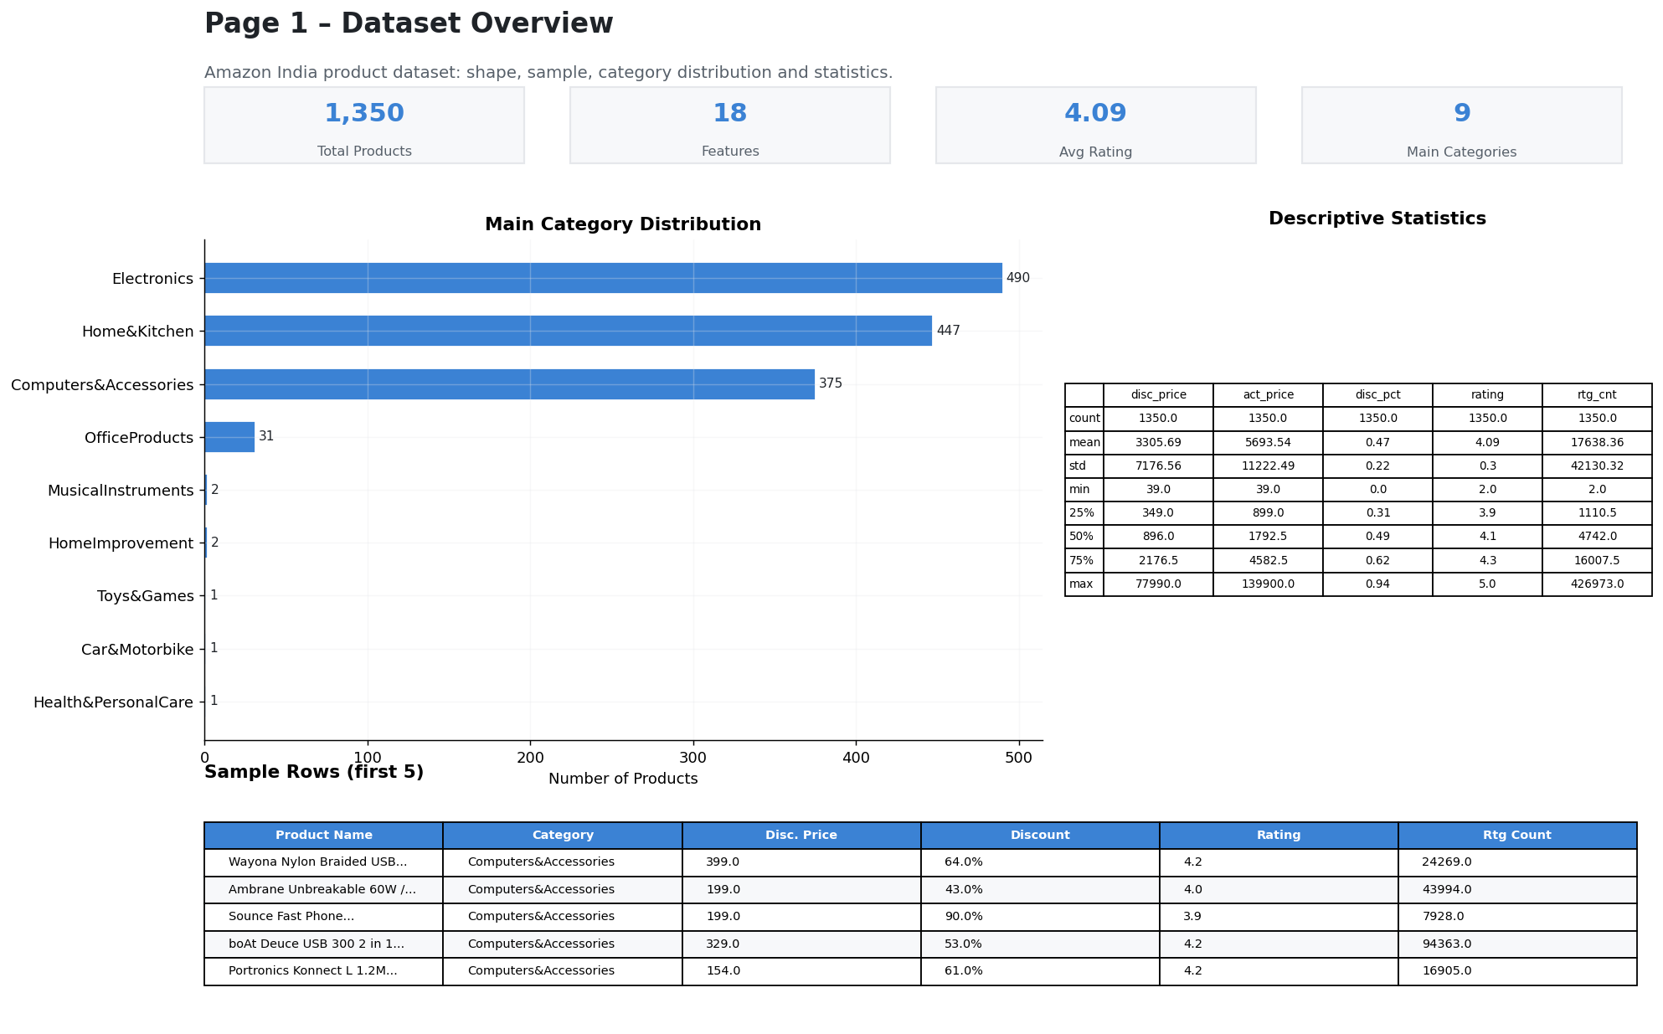
Figure 3. Streamlit Page 1 – Dataset Overview.

Page 2 – EDA
Four charts: rating distribution histogram, discounted price vs rating scatter with OLS trendline, discount percentage vs rating scatter, and a boxplot of rating distributions per main category.
Figure 4. Streamlit Page 2 – Exploratory Data Analysis.

Page 3 – Model Insights
Shows R², MAE, RMSE metric cards, the model equation, a horizontal coefficient bar chart (positive coefficients in blue, negative in red), and an OLS regression trendline over the full dataset.
Figure 5. Streamlit Page 3 – Model Insights.

Page 4 – Predict
An interactive form allows users to enter discounted price, actual price, discount percentage, rating count, and main category. On submission the frontend POSTs to the Flask /predict endpoint and displays the predicted rating with a star visual indicator.
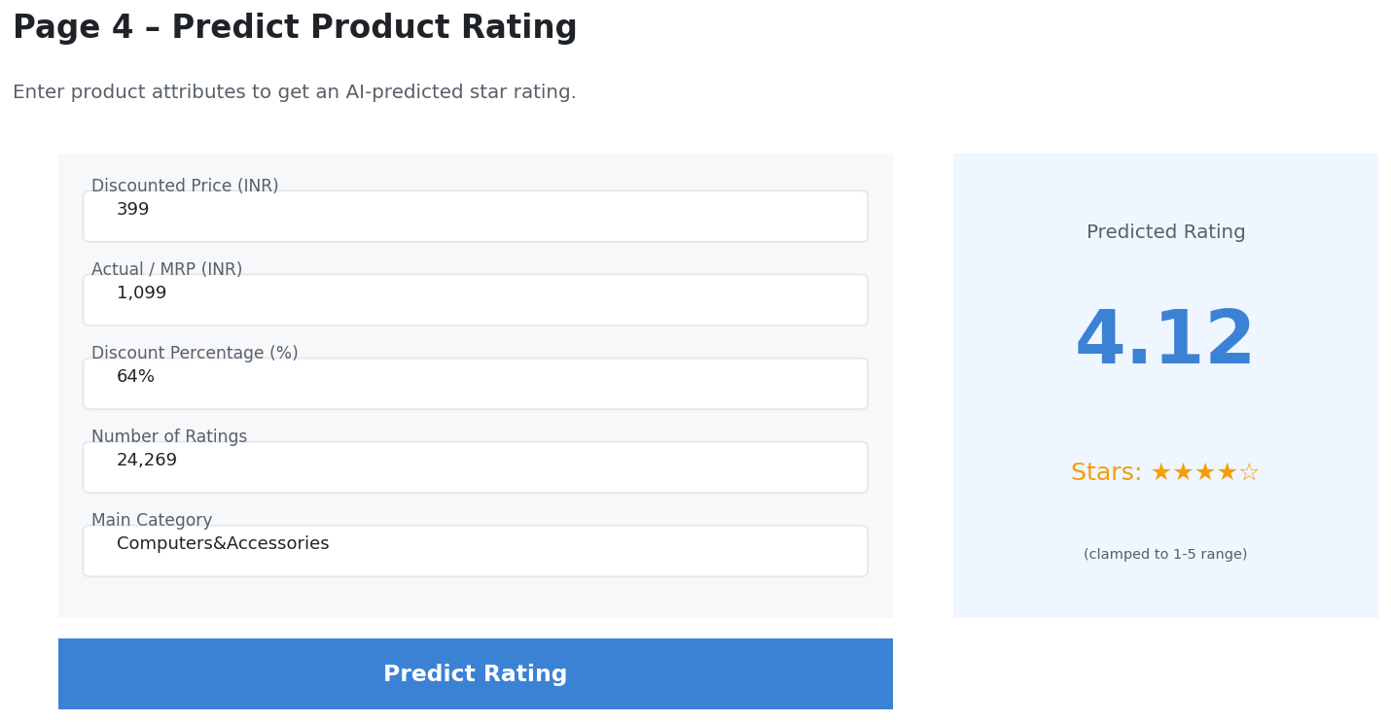
Figure 6. Streamlit Page 4 – Predict.

Conclusion and Future Scope

Conclusion
This project successfully delivered an end-to-end Amazon product rating prediction system. The data cleaning pipeline systematically resolved all identified quality issues — currency formatting, missing values, malformed ratings, and product-level duplicates — reducing the raw 1,465-row dataset to a clean 1,350-product modelling set. A Linear Regression model trained on pricing and engagement features achieved an R² of 0.1069, MAE of 0.202, and RMSE of 0.2683 on the held-out test set. The results confirm that discounted price, actual price, discount percentage, rating count, and main category carry meaningful (though partial) information about a product's eventual average rating. The trained model was packaged into a Flask REST API and an interactive Streamlit dashboard, making the solution accessible to both developers and business stakeholders.

Future Scope
- Feature Engineering: Derive features from review text (sentiment scores, keyword frequency) and product title (word count, brand detection) to substantially improve R².
- Advanced Models: Compare Random Forest, Gradient Boosting (XGBoost / LightGBM), and Neural Network regressors against the Linear baseline.
- Sub-category Modelling: Train separate models per main_category to capture category-specific pricing dynamics.
- Time-series Component: Incorporate product age and review velocity to model rating trajectory over time.
- CI/CD Pipeline: Containerise the Flask API with Docker and deploy to IBM Cloud Code Engine or AWS Lambda for production availability.
- Explainability: Integrate SHAP (SHapley Additive exPlanations) to provide per-prediction feature contribution breakdowns in the UI.
- A/B Testing Framework: Use the API to test pricing strategies and predict their impact on expected rating before going live.

In summary, the project lays a solid, reproducible foundation for AI-assisted product strategy at scale on Amazon's Indian marketplace.

