Activity Recognition Using Predictive Analytics

*V Yashwanth Rao*

**Overview**

Using devices such as Jawbone Up, Nike FuelBand, and Fitbit, it is now possible to collect a large amount of data about personal activity relatively inexpensively. The aim of this project is to predict the manner in which participants perform a barbell lift. The data comes from http://groupware.les.inf.puc-rio.br/har wherein 6 participants were asked to perform the same set of exercises correctly and incorrectly with accelerometers placed on the belt, forearm, arm, and dumbell.

For the purpose of this project, the following steps would be followed:

1. Data Preprocessing

2. Exploratory Analysis

3. Prediction Model Selection

4. Predicting Test Set Output

**Data Preprocessing**

First, we load the training and testing set from the online sources and then split the training set further into training and test sets.

**library**(caret)

**setwd**("~/Projects/R/Coursera-Practical-Machine-Learning-Assignment-1/")

trainURL <- ["http://d396qusza40orc.cloudfront.net/predmachlearn/pml-training.csv" testURL <-](http://d396qusza40orc.cloudfront.net/predmachlearn/pml-training.csv) ["http://d396qusza40orc.cloudfront.net/predmachlearn/pml-testing.csv"](http://d396qusza40orc.cloudfront.net/predmachlearn/pml-testing.csv)

training <- **read.csv**(**url**(trainURL))

testing <- **read.csv**(**url**(testURL))

label <- **createDataPartition**(training$classe, p = 0.7, list = FALSE)

train <- training[label, ]

test <- training[-label, ]

From among 160 variables present in the dataset, some variables have nearly zero variance whereas some contain a lot of NA terms which need to be excluded from the dataset. Moreover, other 5 variables used for identification can also be removed.

NZV <- **nearZeroVar**(train) train <- train[ ,-NZV] test <- test[ ,-NZV]

label <- **apply**(train, 2, function(x) **mean**(**is.na**(x))) > 0.95 train <- train[, -**which**(label, label == FALSE)]

test <- test[, -**which**(label, label == FALSE)]

train <- train[ , -(1:5)]

test <- test[ , -(1:5)]

As a result of the preprocessing steps, we were able to reduce 160 variables to 54.

**Exploratory Analysis**

Now that we have cleaned the dataset off absolutely useless varibles, we shall look at the dependence of these variables on each other through a correlation plot.

**library**(corrplot)

corrMat <- **cor**(train[,-54])

**corrplot**(corrMat, method = "color", type = "lower", tl.cex = 0.8, tl.col = **rgb**(0,0,0))

num_window roll_belt pitch_belt yaw_belt total_accel_belt gyros_belt_x gyros_belt_y gyros_belt_z accel_belt_x accel_belt_y accel_belt_z magnet_belt_x magnet_belt_y magnet_belt_z roll_arm pitch_arm yaw_arm total_accel_arm gyros_arm_x gyros_arm_y gyros_arm_z accel_arm_x accel_arm_y accel_arm_z magnet_arm_x magnet_arm_y magnet_arm_z roll_dumbbell pitch_dumbbell yaw_dumbbell

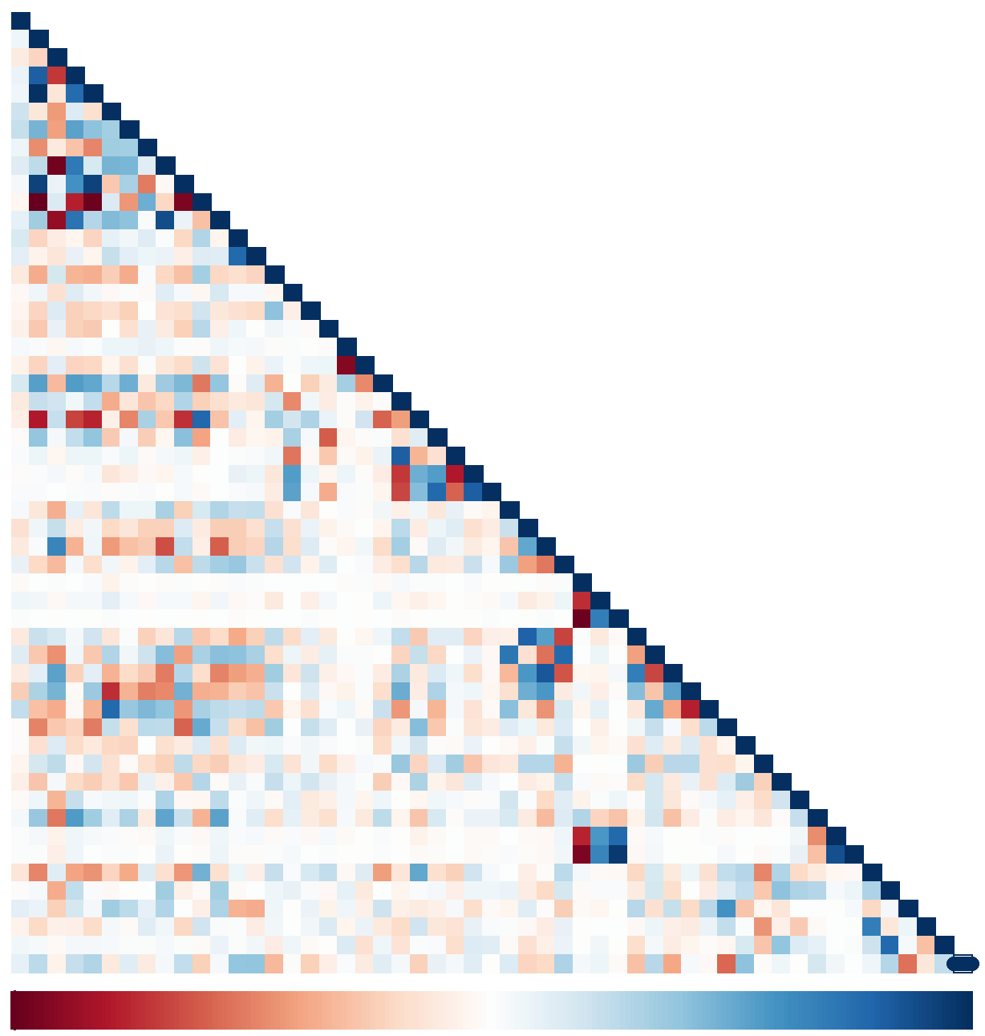

num_window roll_belt

pitch_belt

yaw_belt total_accel_belt

gyros_belt_x

gyros_belt_y gyros_belt_z

accel_belt_x accel_belt_y

accel_belt_z magnet_belt_x

magnet_belt_y magnet_belt_z

roll_arm pitch_arm

yaw_arm

total_accel_arm

total_accel_dumbbell gyros_dumbbell_x gyros_dumbbell_y gyros_dumbbell_z accel_dumbbell_x accel_dumbbell_y accel_dumbbell_z magnet_dumbbell_x magnet_dumbbell_y magnet_dumbbell_z roll_forearm pitch_forearm yaw_forearm total_accel_forearm gyros_forearm_x gyros_forearm_y gyros_forearm_z accel_forearm_x accel_forearm_y accel_forearm_z magnet_forearm_x magnet_forearm_y magnet_forearm_z

−1 −0.8 −0.6 −0.4 −0.2 0 0.2 0.4 0.6 0.8 1

gyros_arm_x gyros_arm_y

gyros_arm_z

accel_arm_x accel_arm_y

accel_arm_z magnet_arm_x

magnet_arm_y magnet_arm_z

roll_dumbbell pitch_dumbbell

yaw_dumbbell

total_accel_dumbbell gyros_dumbbell_x

gyros_dumbbell_y gyros_dumbbell_z

accel_dumbbell_x accel_dumbbell_y

accel_dumbbell_z magnet_dumbbell_x

magnet_dumbbell_y magnet_dumbbell_z

roll_forearm pitch_forearm

yaw_forearm

total_accel_forearm gyros_forearm_x

gyros_forearm_y gyros_forearm_z

accel_forearm_x accel_forearm_y

accel_forearm_z magnet_forearm_x

magnet_forearm_y magnet_forearm_z

In the plot above, darker gradient correspond to having high correlation. A Principal Component Analysis can be run to further reduce the correlated variables but we aren’t doing that due to the number of correlations being quite few.

**Prediction Model Selection**

We will use 3 methods to model the training set and thereby choose the one having the best accuracy to predict the outcome variable in the testing set. The methods are Decision Tree, Random Forest and Generalized Boosted Model.

A confusion matrix plotted at the end of each model will help visualize the analysis better.

**Decision Tree**

**library**(rpart) **library**(rpart.plot) **library**(rattle)

**set.seed**(13908)

modelDT <- **rpart**(classe ~ ., data = train, method = "class")

**fancyRpartPlot**(modelDT)

*11*

A

.28 .19 .17 .16 .18

100%

*yyes* **rroll_belt < 130** *no*

*22*

A

.31 .21 .19 .18 .11

92%

**pitch_forearm < −34**

*55*

A

.24 .23 .21 .20 .12

84%

**num_window >= 46**

*10*

A

.26 .24 .22 .20 .09

80%

**magnet_dumbbell_y < 440**

*20*

A

.29 .19 .25 .19 .09

68%

**rroll_forearm < 124**

*21*

B

.03 .56 .04 .25 .11

12%

**total_accel_dumbbell >= 5.5**

*40*

A

.42 .19 .19 .16 .04

43%

**num_window < 242**

*41*

C

.08 .18 .35 .23 .16

25%

**magnet_dumbbell_y < 292**

*42*

B

.05 .74 .06 .03 .12

8%

**rroll_belt >= −0.6**

*81*

A

.30 .21 .25 .19 .05

32%

**magnet_dumbbell_z < −28**

*82*

C



.10 .14 .50 .15 .11

15%

**magnet_forearm_z < −245**

*83*

D

.06 .25 .11 .34 .24

10%

**accel_forearm_x >= −100**

*163*

C

.11 .22 .35 .26 .07

23%

**accel_dumbbell_y >= −40**

*165*

C

.03 .15 .55 .16 .11

14%

**num_window < 88**

*166*

E

.05 .31 .16 .15 .33

7%

**rroll_dumbbell < 40**

*326*

D

.12 .25 .25 .29 .08

19%

**rroll_belt >= 126**

*652*

C

.00 .37 .59 .03 .01

5%

*653*

D

.16 .21 .15 .38 .10

15%

**pitch_belt < −43 num_window < 278**

*1306*

C

.00 .46 .54 .00 .00

2%

*1307*

D

.18 .17 .10 .43 .12

13%

**num_window < 260 pitch_belt < −42**

*44 80*

*162*

*1304 1305*

*2612 2613*

*2614 2615 327*

*164*

*330 331*

*332 333 167*

*84 85 43 11 33*

A A A

B C B C A

D C A

B C B

E D B

E D E E

.99 .01 .00 .00 .00 .77 .13 .00 .07 .03 .74 .19 .02 .05 .00 .00 .93 .00 .05 .02 .00 .03 .95 .02 .00 .00 1.00 .00 .00 .00 .00 .00 1.00 .00 .00 .40 .35 .16 .08 .02 .13 .12 .08 .52 .14 .00 .04 .92 .04 .00 .81 .06 .00 .05 .08 .15 .85 .00 .00 .00 .02 .08 .60 .18 .12 .05 .82 .01 .08 .04 .05 .19 .19 .16 .40 .08 .14 .04 .68 .07 .06 .81 .07 .03 .03 .00 .00 .00 .00 1.00 .00 .15 .00 .75 .10 .00 .00 .00 .20 .80 .01 .00 .00 .00 .99

8% 11%

10% 2%

3% 1%

1% 3%

10% 3% 1%

1% 13% 1%

5% 4%

7% 1%

4% 4% 8%

Rattle 2017−Aug−16 01:03:52 Yash_Kumar_Singh

predictDT <- **predict**(modelDT, test, type = "class") confMatDT <- **confusionMatrix**(predictDT, test$classe) confMatDT

## Confusion Matrix and Statistics

##

## Reference

## Prediction A B C D E

## A 1505 233 44 80 29

## B 39 609 36 21 25

## C 21 76 818 143 88

## D 86 145 51 612 131

## E 23 76 77 108 809

##

## Overall Statistics

##

## Accuracy : 0.7397

## 95% CI : (0.7283, 0.7509)

## No Information Rate : 0.2845

## P-Value [Acc > NIR] : < 2.2e-16

##

## Kappa : 0.6696

## Mcnemar's Test P-Value : < 2.2e-16

##

## Statistics by Class:

##

## Class: A Class: B Class: C Class: D Class: E

## Sensitivity 0.8990 0.5347 0.7973 0.6349 0.747

## Specificity 0.9083 0.9745 0.9325 0.9161 0.9409

## Pos Pred Value 0.7959 0.8342 0.7138 0.5971 0.7402

## Neg Pred Value 0.9577 0.8972 0.9561 0.9276 0.9430

## Prevalence 0.2845 0.1935 0.1743 0.1638 0.1839

## Detection Rate 0.2557 0.1035 0.1390 0.1040 0.1375

## Detection Prevalence 0.3213 0.1240 0.1947 0.1742 0.1857

## Balanced Accuracy 0.9037 0.7546 0.8649 0.7755 0.8443

**Random Forest**

**library**(caret)

**set.seed**(13908)

control <- **trainControl**(method = "cv", number = 3, verboseIter=FALSE)

modelRF <- **train**(classe ~ ., data = train, method = "rf", trControl = control)

modelRF$finalModel

##

## Call:

## randomForest(x = x, y = y, mtry = param$mtry)

## Type of random forest: classification

## Number of trees: 500

## No. of variables tried at each split: 27

##

## OOB estimate of error rate: 0.24%

## Confusion matrix:

## A B C D E class.error

## A 3904 1 0 0 1 0.0005120328

## B 7 2645 5 1 0 0.0048908954

## C 0 4 2392 0 0 0.0016694491

## D 0 0 8 2243 1 0.0039964476

## E 0 0 0 5 2520 0.0019801980

predictRF <- **predict**(modelRF, test)

confMatRF <- **confusionMatrix**(predictRF, test$classe)

confMatRF

## Confusion Matrix and Statistics

##

## Reference

## Prediction A B C D E

## A 1674 5 0 0 0

## B 0 1130 1 0 0

## C 0 3 1025 6 0

## D 0 1 0 958 3

## E 0 0 0 0 1079

##

## Overall Statistics

##

## Accuracy : 0.9968

## 95% CI : (0.995, 0.9981)

## No Information Rate : 0.2845

## P-Value [Acc > NIR] : < 2.2e-16

##

## Kappa : 0.9959

## Mcnemar's Test P-Value : NA

##

## Statistics by Class:

##

## Class: A Class: B Class: C Class: D Class: E

## Sensitivity 1.0000 0.9921 0.9990 0.9938 0.9972

## Specificity 0.9988 0.9998 0.9981 0.9992 1.0000

## Pos Pred Value 0.9970 0.9991 0.9913 0.9958 1.0000

## Neg Pred Value 1.0000 0.9981 0.9998 0.9988 0.9994

## Prevalence 0.2845 0.1935 0.1743 0.1638 0.1839

## Detection Rate 0.2845 0.1920 0.1742 0.1628 0.1833

## Detection Prevalence 0.2853 0.1922 0.1757 0.1635 0.1833

## Balanced Accuracy 0.9994 0.9959 0.9986 0.9965 0.9986

**Generalized Boosted Model**

**library**(caret)

**set.seed**(13908)

control <- **trainControl**(method = "repeatedcv", number = 5, repeats = 1, verboseIter = FALSE) modelGBM <- **train**(classe ~ ., data = train, trControl = control, method = "gbm", verbose = FALSE) modelGBM$finalModel

## A gradient boosted model with multinomial loss function.

## 150 iterations were performed.

## There were 53 predictors of which 44 had non-zero influence.

predictGBM <- **predict**(modelGBM, test)

confMatGBM <- **confusionMatrix**(predictGBM, test$classe)

confMatGBM

## Confusion Matrix and Statistics

##

## Reference

## Prediction A B C D E

## A 1669 15 0 0 0

## B 5 1110 9 10 9

## C 0 13 1012 7 2

## D 0 1 5 945 13

## E 0 0 0 2 1058

##

## Overall Statistics

##

## Accuracy : 0.9845

## 95% CI : (0.981, 0.9875)

## No Information Rate : 0.2845

## P-Value [Acc > NIR] : < 2.2e-16

##

## Kappa : 0.9804

## Mcnemar's Test P-Value : NA

##

## Statistics by Class:

##

## Class: A Class: B Class: C Class: D Class: E

## Sensitivity 0.9970 0.9745 0.9864 0.9803 0.9778

## Specificity 0.9964 0.9930 0.9955 0.9961 0.9996

## Pos Pred Value 0.9911 0.9711 0.9787 0.9803 0.9981

## Neg Pred Value 0.9988 0.9939 0.9971 0.9961 0.9950

## Prevalence 0.2845 0.1935 0.1743 0.1638 0.1839

## Detection Rate 0.2836 0.1886 0.1720 0.1606 0.1798

## Detection Prevalence 0.2862 0.1942 0.1757 0.1638 0.1801

## Balanced Accuracy 0.9967 0.9838 0.9909 0.9882 0.9887

As Random Forest offers the maximum accuracy of 99.75%, we will go with Random Forest Model to predict our test data class variable.

**Predicting Test Set Output**

predictRF <- **predict**(modelRF, testing)

predictRF

## [1] B A B A A E D B A A B C B A E E A B B B

## Levels: A B C D E