**SMART HOME AUTOMATION**

**CIRCUIT DIAGRAM**

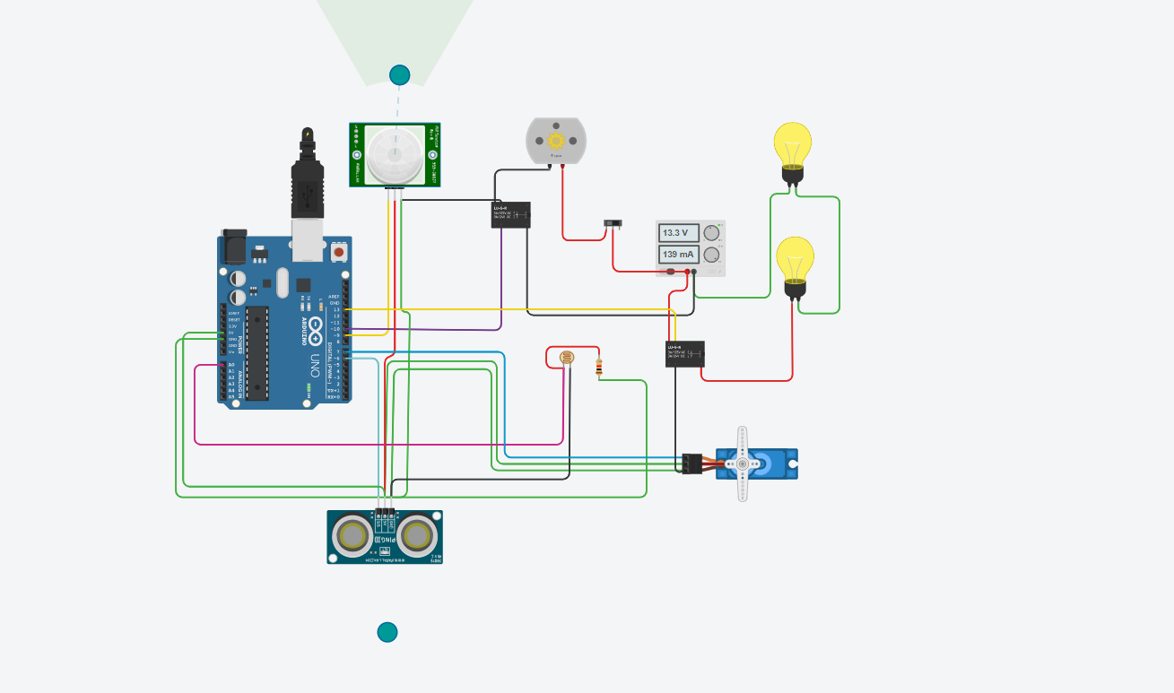

**LINK**

<https://www.tinkercad.com/things/4P2Uky1SL2N>