Pristyn Care Health — Patient Funnel Analysis
Milestone 3: Deep-Dive Analysis | Yashwanth J V Nayak · Data Analyst Intern · Cynaris Solutions
1. Headline Findings
- Specialty is the one statistically significant driver of no-shows (chi-square p < 0.0001); department, visit reason, insurance, age group, lead time, appointment hour and wait time are not.
- Top-3 leakage points: General Medicine (22.5%), Dermatology (20.5%), Ophthalmology (19.9%). They hold 39.0% of bookings but 50.3% of all no-shows. Cardiology and Gynecology sit at 9.5%.
- Overall, 16.2% of booked appointments (324 of 2,000) are lost between booking and attendance. Every attended patient completed a consultation.
- May 2025 is an anomaly: 26.0% no-show vs. about 15.2% in other months (p = 0.0002). The data does not explain why; it needs a business check.
2. Scope: What the Data Can Support
The appointments file (2,000 rows, 1,800 patients, Jan 2025 – Jan 2026) supports a booking → attended → consultation funnel. The brief's other stages (ad click, enquiry, diagnostics, surgery) are not present as fields, and follow-up appears only as a visit reason. The funnel below is therefore a partial funnel, not the full 7-stage view.
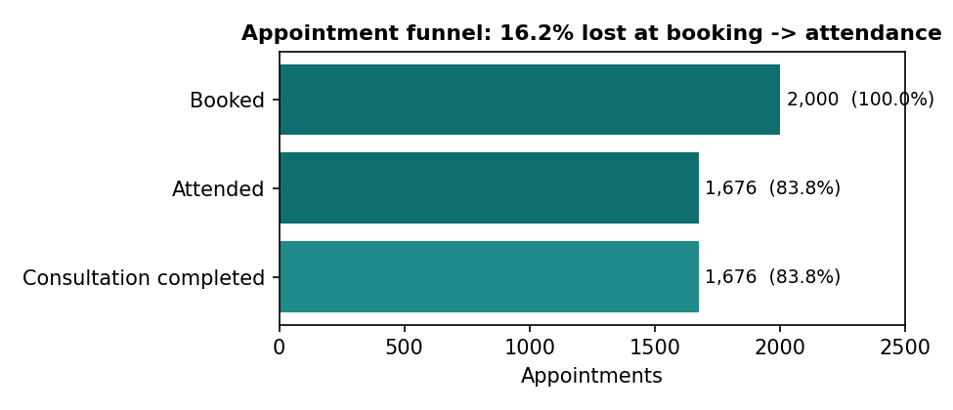
3. Segmentation and Significance Tests
Segment | Chi-square | d.o.f. | p-value | Significant at 5%?
Specialty | 32.61 | 7 | 0.00003 | Yes
Patient age group | 7.45 | 4 | 0.114 | No
Appointment hour band | 2.65 | 2 | 0.266 | No
Booking lead time | 2.29 | 3 | 0.515 | No
Department | 2.13 | 3 | 0.545 | No
Visit reason | 2.97 | 4 | 0.564 | No
Insurance type | 1.18 | 3 | 0.757 | No
Wait time (r = 0.014, p = 0.54) and lead days (r = 0.009, p = 0.68) are also uncorrelated with no-show. Prior no-show history did not predict a repeat no-show (15.2% vs 12.6%, Fisher p = 0.78, only 200 repeat bookings).
A logistic regression controlling for age, insurance, department, lead time and wait time keeps the specialty effect (every specialty except Gynecology and Orthopedics is significantly higher than Cardiology). Its pseudo-R² is only 0.025, so these variables describe where leakage concentrates; they are not a reliable no-show predictor.
4. Top-3 Leakage Points
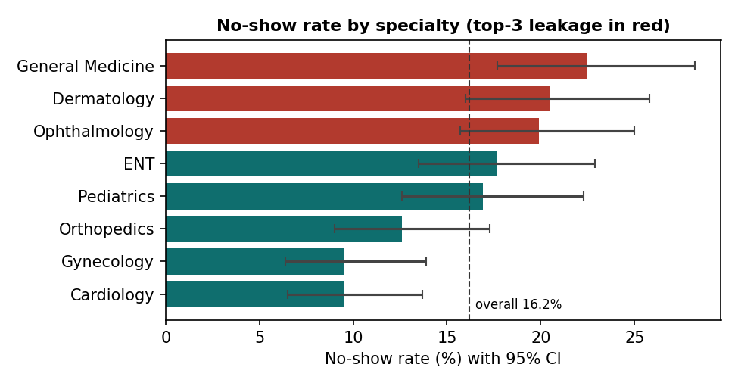
Specialty | Appts | No-show % | 95% CI | Bonferroni p (vs rest)
General Medicine | 240 | 22.5% | 17.7 – 28.2 | 0.038
Dermatology | 259 | 20.5% | 16.0 – 25.8 | 0.368
Ophthalmology | 281 | 19.9% | 15.7 – 25.0 | 0.538
Cardiology | 253 | 9.5% | 6.5 – 13.7 | 0.015
Gynecology | 242 | 9.5% | 6.4 – 13.9 | 0.021
Honest reading: after correcting for 8 comparisons, only General Medicine is individually significant on the high side. Dermatology and Ophthalmology are not individually significant, but the three together (20.9%) are clearly higher than Cardiology + Gynecology (9.5%; p < 0.0001).
5. Monthly Pattern
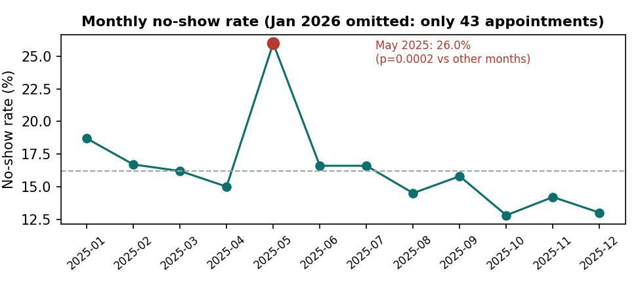
May 2025 is above each specialty's own average in 7 of 8 specialties (Dermatology 38%, General Medicine 32%, Ophthalmology 32%). From June onward the rate drifts down; the booking-month trend is weak (r = −0.05, p = 0.018) and should be treated as tentative.
6. Data Quality and Limits
Resource-utilisation file is not reliable enough to analyse
336 of 400 rows (84%) contain physically impossible values: occupied beds above total beds (175 rows), ICU occupied above ICU total (175 rows), and surgeries completed above scheduled (182 rows). Only 64 rows are clean. Columns are also almost uncorrelated (beds total vs occupied r = 0.10; scheduled vs completed r = 0.01). I did not build conclusions on it and recommend confirming the source with the mentor.

Satisfaction file: weak signal, different organisation
600 surveys from four Sunrise hospitals (not Pristyn Care) with no key linking them to appointments. Hospital differences are significant (ANOVA p = 0.003; South 3.37 vs East 2.81), but sub-ratings barely relate to overall satisfaction (|r| < 0.08) and waiting time shows only a borderline link (Spearman p = 0.0499). 58.5% would recommend. Treat as context, not evidence for the appointment funnel.
7. Method and Assumptions
- No-show = appointment_id with no_show = 1. Every no-show has 0 consultation minutes and every attended visit has more than 0, so attended and consultation-completed are identical.
- Chi-square tests for categorical segments; Wilson intervals for rates; Bonferroni correction across 8 specialties; logistic regression for adjusted effects. Significance threshold 5%.
- January 2026 (43 appointments) is excluded from the monthly chart because it is a partial month.
- No revenue or price field exists in the data, so the revenue model for a 5% conversion lift needs an agreed average revenue per consultation as an explicit assumption.
8. Next Steps
- Confirm with the mentor whether upstream funnel stages and revenue data exist, and the source of the resource file.
- Investigate May 2025 (campaign, doctor leave, holiday or data-entry cause).
- Build the Excel revenue model with a sensitivity table on the three leakage specialties, then draft A/B tests (reminders, double-booking buffers, deposit or confirmation calls) for Checkpoints 4–5.
Repository: https://github.com/Yashwanthjvnaik/pristyn-care-health-analysis

