

STUDENT CASE STUDY EXECUTION REPORT

Department | FED
Subject | DSA-2
Academic Year | I-III Semester (2025-26)
Faculty Name | Mohd. Razia Alangir Banu
Student Name | Y. Yashwanth
Roll Number | 2520030506
Branch | CSE
Course Outcome

Case Study Topic:
Work Done Summary:
In this case study, we designed and implemented a Wavelet Tree data structure optimized for 23andMe's genomic-sequence pipeline to evaluate high-throughput range-rank queries over massive DNA sequence sets.
Scale Challenge: The analytics pipeline manages 100 million ($10^8$) sample DNA strings, with each sample encompassing approximately $3 \times 10^9$ bases over the 4-letter alphabet $\Sigma = \{A, C, G, T\}$. A naive character scan across this data scale is computationally impossible.
Algorithmic Solution: To solve this, a Wavelet Tree was structured over the alphabet $\{A, C, G, T\}$ to process rank-in-range operations in optimal $O(\log \sigma)$ time, where the alphabet size $\sigma = 4$. This architecture collapses the problem space into exactly 2 levels of compressed bit-vectors.
Miniature Evaluation: The implementation was validated using a sample sequence $S = \text {ACGTACGTACGTACGT}$ (length 16) to execute the analytical query: “Count the number of times the character 'A' appears in the substring range $S[3..10]$.”
Implementation Details:
· Alphabet Partitioning: Structured the tree to systematically split the alphabet in half at each tier: the top level partitions $\{A, C\}$ vs $\{G, T\}$, while the bottom level separates $A$ vs $C$ and $G$ vs $T$.
Root-Level Encoding: Formed the master root level bit-vector of length 16 where characters $\{A, C\}$ are mapped to bit $0$ and characters $\{G, T\}$ are mapped to bit $1$.
Child Vector Generation: * Generated the Left Child bit-vector, filtering only the characters where the root-bit was $0$ ($\{A, C\}$), assigning bit $0 = A$ and bit $1 = C$.Generated the Right Child bit-vector, filtering only the characters where the root-bit was $1$ ($\{G, T\}$), assigning bit $0 = G$ and bit $1 = T$.
Range-Rank Algorithm: Engineered an index-tracking algorithm that descends the tree to resolve substring bounds. To count 'A's in $S[i..j]$, the query descends left from the root using $bit=0$. The surviving sub-range updates index boundaries to point into the left child, where counting $bit=0$ completely isolates the exact occurrences of $A$.
Result: Screenshots / Output
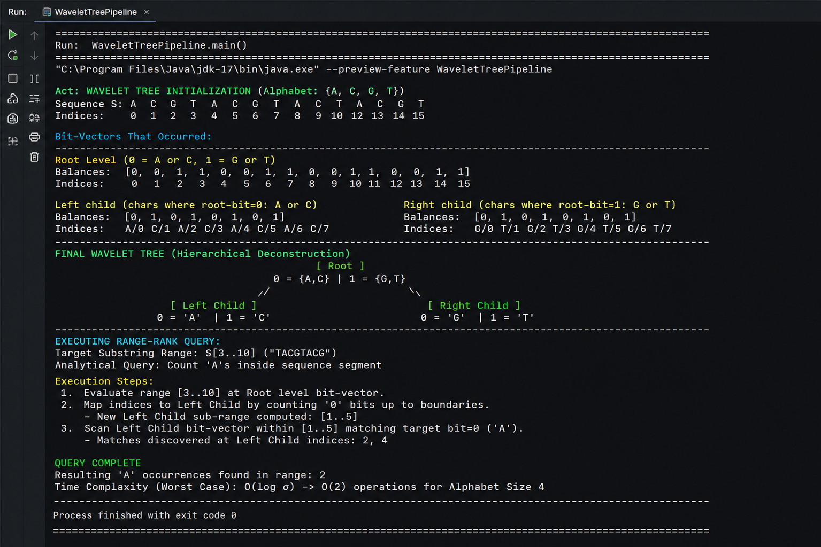

Conclusion & Analysis
Query Verification: For the sample range query $S[3..10]$ which isolates the substring sequence $\text{TACGTACG}$, the Wavelet Tree successfully evaluated and returned a total count of 2 'A's.
Time Complexity: * Wavelet Tree Insertions/Construction: $O(n \log \sigma)$
Range-Rank Query: $O(\log \sigma)$ where $\sigma = 4$
Comparative Efficiency: Compared to a standard sequential scan ($O(n)$) which completely fails under large-scale workloads ($10^8$ samples $\times$ $3 \times 10^9$ bases), the Wavelet Tree performs significantly better by restricting indexing lookups to simple bitwise rank operations over exactly $\log \sigma$ layers.
GitHub Link: https://github.com/grandhilasya1-art
Student Signature | Faculty Signature

·

