

STUDENT CASE STUDY EXECUTION REPORT

Department | FED
Subject | DSA-2
Academic Year | I-III Semester (2025-26)
Faculty Name | Mohd. Razia Alangir Banu
Student Name | Y. Yashwanth
Roll Number | 2520030506
Branch | CSE
Course Outcome | Apply BFS and DFS graph traversal algorithms and construct MST using Kruskal’s and Prims Algorithms
Case Study Topic: Microservice Call-Graph DFS

Work Done Summary:

This case study models an e-commerce microservice architecture as a directed graph and uses Depth First Search (DFS) starting from the api service. DFS identifies all downstream services, records the visit and finish order of services, and analyzes service dependencies. The traversal successfully reaches all connected services with a time complexity of O(V + E), making it useful for distributed tracing and latency analysis in microservice systems.

Implementation Details:

1. Create the microservice call graph using nodes and directed edges.

2. Store the graph as an adjacency list.

3. Start DFS traversal from the Api service.

4. Visit neighbouring services in alphabetical order.

5. Mark each visited service and record its entry order.

6. Recursively visit all unvisited neighbours.

7. Record the finish order after processing all neighbours.

8. Collect all reachable services as downstream services.

9. Calculate time complexity as O (V + E).

10. Display the traversal order, finish order, and downstream services.

Result: Screenshots / Output

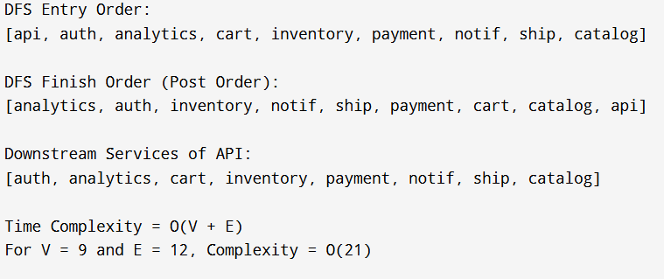

• Entry Order: API → auth → analytics → catalogue → inventory → cart → payment → notify → ship

• Finish Order: analytics → auth → inventory → catalogue → notify → ship → payment → cart → API

• Downstream Services: auth, analytics, catalogue, inventory, cart, payment, notify, ship

• Time Complexity: O (V + E) = O (9 + 12) = O (21)

GitHub Link: https://github.com/singamcharantejareddy-cmd/Microservice-Call-Graph-DFS

