**LAB ASSIGNMENT**

Name - Yashwant Patidar

Scholar no. - 191112243

Section - CSE_2

Semester - 3 rd

Q.1 Program to sort an array using Pointer.

:-

#include<iostream>

#include<conio.h>

#include<stdlib.h>

using namespace std;

int main()

{

int r,i,n,*p,t;

cout<<"Enter the size of the array\t";

cin>>n;

p=(int*)calloc(n,sizeof(int));

cout<<"Enter the elements of the array\t";

for(i=0;i<n;i+=1)

{

cout<<"\nElement "<<i+1<<"\t";

cin>>*(p+i);

}

for(r=1;r<n;r+=1)

for(i=0;i<n-1;i+=1)

if(*(p+i)>=*(p+i+1))

{

t=*(p+i);

*(p+i)=*(p+i+1);

*(p+i+1)=t;

}

cout<<"The sorted array is\n";

for(i=0;i<n;i+=1)

cout<<*(p+i)<<"\t";

getch();

return 0;

}

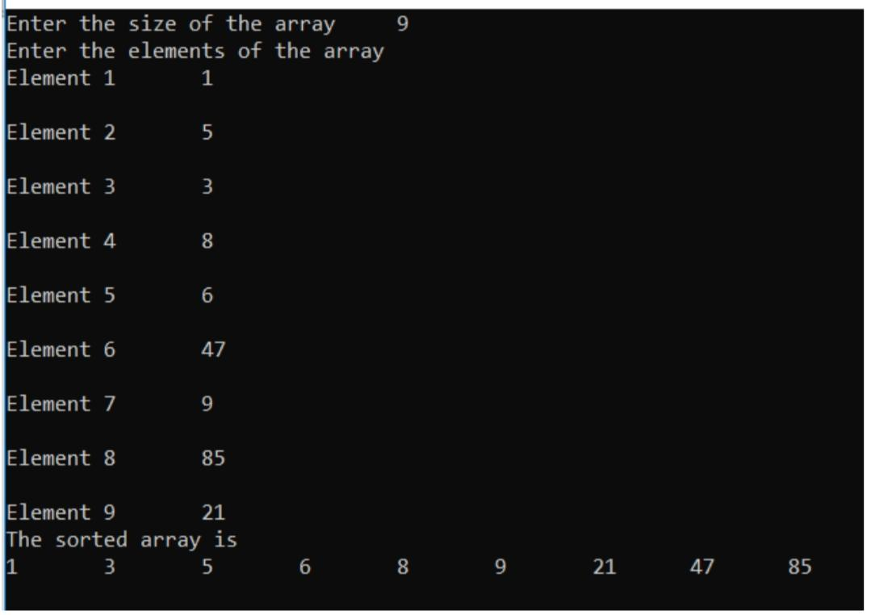Output:-

Q2. Write a program to print a string in reverse order using a pointer.

:-

#include<iostream>

#include<conio.h>

#include<stdio.h>

#include<string.h>

using namespace std;

int main()

{

char s[100],t,*p;

int i,l;

p=s;

cout<<"Enter a string\n";

gets(p);

l=strlen(s);

for(i=0;i<l/2;i++)

{

t=*(p+i);

*(p+i)=*(p+l-i-1);

*(p+l-i-1)=t;

}

puts(s);

getch();

return 0;

}

Output:-

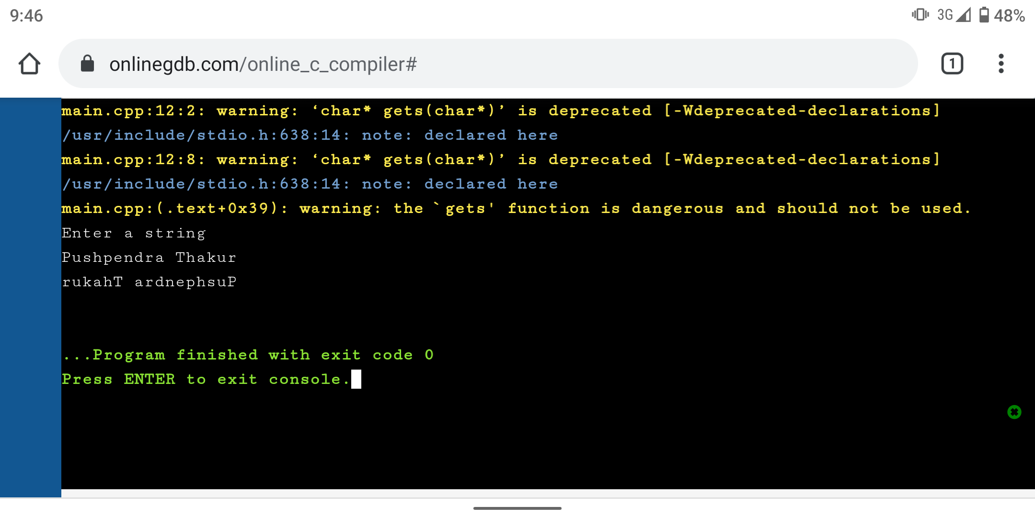

Q3. Write a program to compute the sum of all elements in an array using pointers.

:-

#include<iostream>

#include<conio.h>

#include<stdlib.h>

using namespace std;

int main()

{

int i,*p,n,s;

cout<<"Enter the number of elements in the array\t";

cin>>n;

p=(int*)calloc(n,sizeof(int));

cout<<"Enter the elements of the array\n\n";

for(i=0,s=0;i<n;i+=1)

{

cout<<"Element "<<i+1<<"\t";

cin>>*(p+i);

s+=*(p+i);

}

cout<<"\nThe sum of the elements is "<<s;

getch();

return 0;

}

Output:-

