LAB WORK

**Question 1:** WAP to convert a 3x3 matrix into upper triangular matrix.

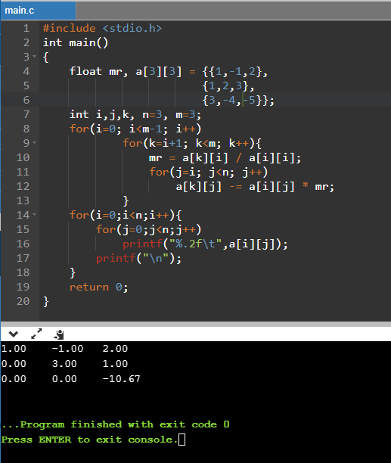

**Question 2:** WAP to find duplicate elements from an array and then after remove duplicate elements.

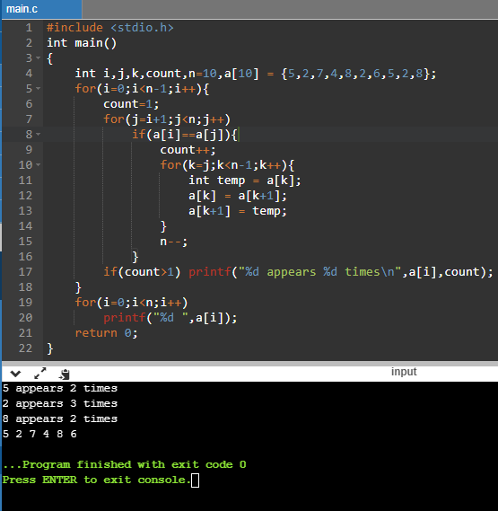

**Question 3:** WAP to generate all sets of two elements such that the sum of sets is less than the maximum element of given array.

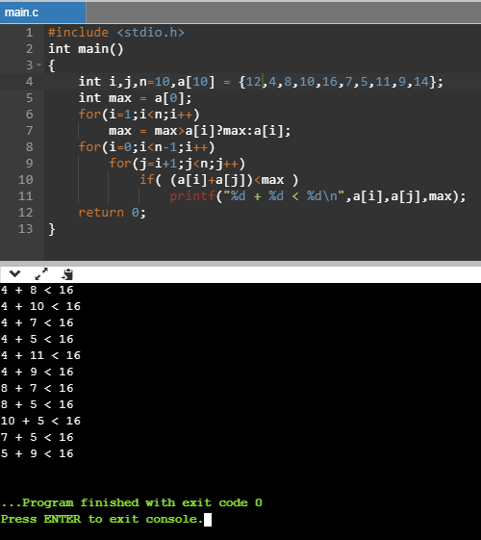

**Question 4:** WAP to combine two arrays and then sort the array.

