name : Yashwant Patidar

scholar No. : 191112243

sec: cse 2

#include <iostream>

using namespace std;

int main()

{ // question 1

use of pointer (initialize,access,assign and access a pointer)

int num=5;

int \*ptr=NULL;

ptr=&num;

cout<<"adress : "<<ptr<<" Value : "<<\*ptr ;

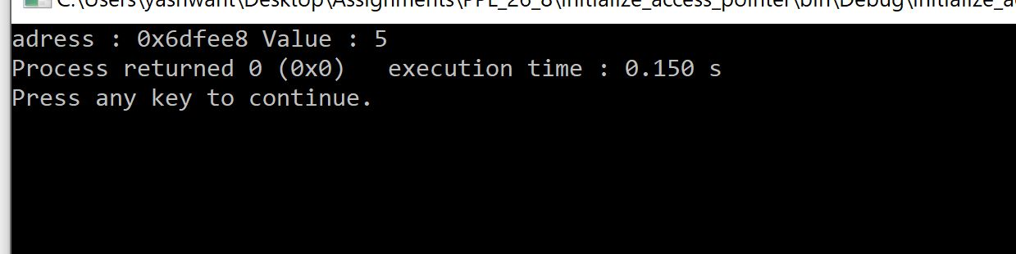

//question 2

int num1=5;

int num2=10;

int \*ptr1=NULL;

int \*ptr2=NULL;

cout<<num1<<" "<<num2<<endl;

ptr1=&num1;

ptr2=&num2;

\*ptr1=\*ptr1+\*ptr2;

\*ptr2=\*ptr1-\*ptr2;

\*ptr1=\*ptr1-\*ptr2;

cout<<num1<<" "<<num2;

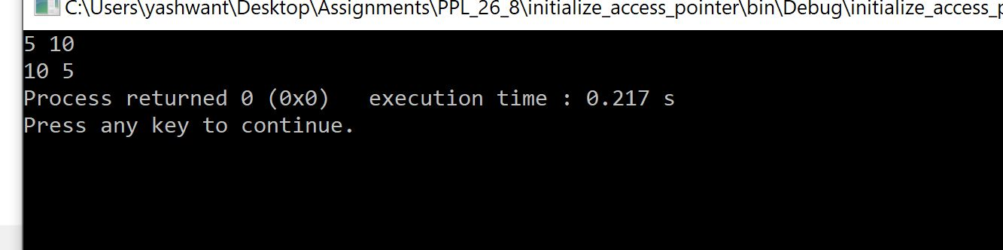

//question 3

string str="hello there";

char \*ptr=NULL;

ptr=&str[0];

int vowels {0};

int consonants {0};

for(int i=0;i<str.length();i++){

if(\*(ptr+i)=='a'||\*(ptr+i)=='e'||\*(ptr+i)=='i'||\*(ptr+i)=='o'||\*(ptr+i)=='u'){

vowels+=1;

}

else if (\*(ptr+i)!=' '){

consonants+=1;

}

}

cout<<"vowels "<<vowels<<" consonants "<<consonants<<endl;

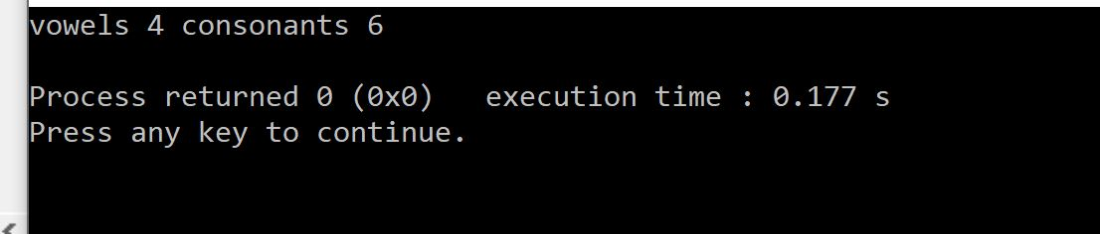

//question 4

int arr[5] {1,2,3,4,5};

int s=sizeof(arr)/sizeof(arr[0]);

int \*ptr;

ptr=arr;

for (int i=0;i<s;i++)

{

cout<<"Address is : "<<(ptr+i)<<" Value is : "<<\*(ptr+i)<<endl;

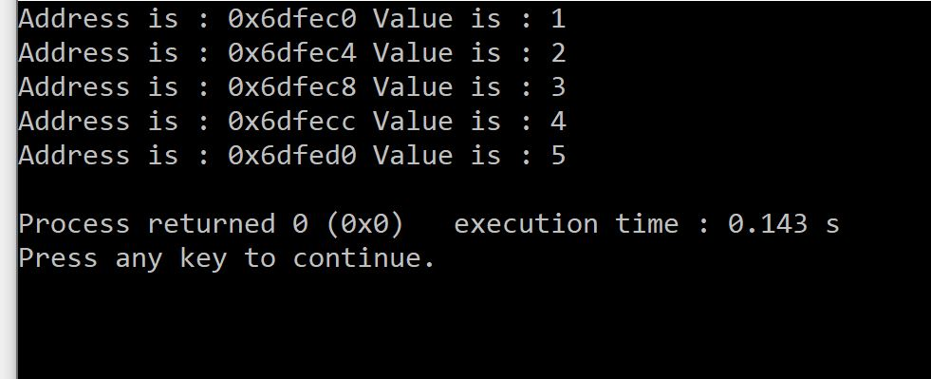

}

return 0;

}