//Question 1

class Cylinder{

float r;

float h;

public:

Cylinder(float radius,float height){

r=radius;

h=height;}

float area(){

return (2\*3.14\*r\*h +3.14\*r\*r);

}};

int main()

{

float r=2.32;

float h=323;

Cylinder cylinder (r,h);

cout<<cylinder.area()<<endl;

cout << "Hello world!" << endl;

return 0;

}

cout << "Hello world!" << endl;

return 0;

}



#include <iostream>

using namespace std;

//Question 2

class Volume{

int height ,radius,\*sides;

public:

Volume(int h,int r){

height=h;

radius=r;}

Volume(int s[]){

sides=s;}

float coneVolume(){

return (3.14\*radius\*radius\*height)/3;}

float cuboidVolume(){

return sides[0]\*sides[1]\*sides[2];}

};

int main()

{

int r=2.32,h=323;

int sides[3]{2,3,4};

Volume cone (r,h);

Volume cuboid(sides);

cout<<"area of cone " <<cone.coneVolume()<<endl;

cout<<"area of cuboid " <<cuboid.cuboidVolume()<<endl;

return 0;

}

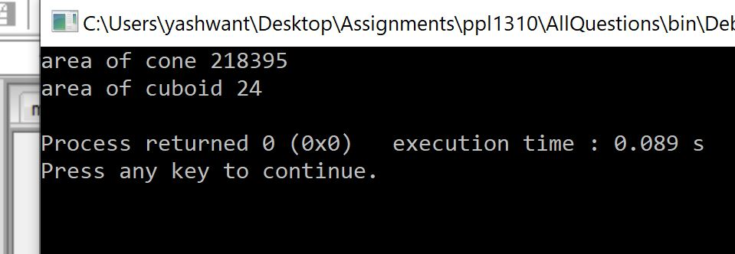

#include <iostream>

//Question 3

class Employee{

int salary;

int hours;

public:

void Addinfo(int s,int h){

salary=s;

hours=h;

}

void AddSal(){

if(salary<500){

salary+=10;

}}

void AddWork(){

hours>6?salary+=10:salary;}

void display(){

cout<<"salary is "<<salary<<" hours is "<<hours<<endl;}

};

int main()

{

int salary,hours;

Employee e1;

e1.Addinfo(300,4);

e1.display();

e1.AddSal();

e1.AddWork();

e1.display();

Employee e2;

e2.Addinfo(600,7);

e2.display();

e2.AddSal();

e2.AddWork();

e2.display();

return 0;

}

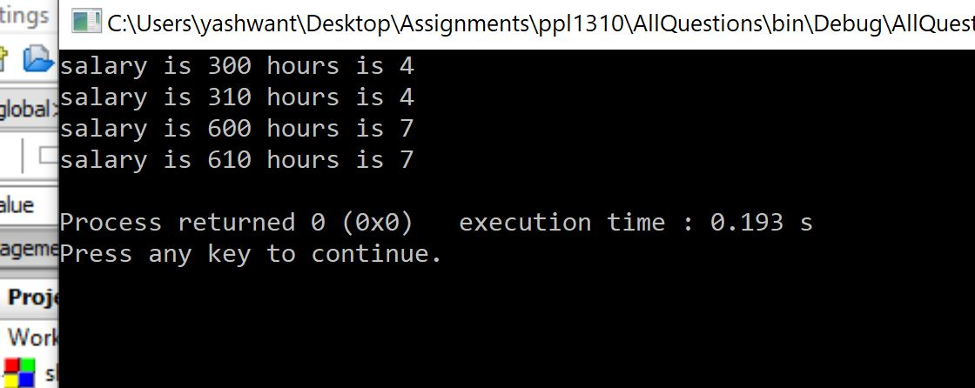

//Question 4

class Student{

int m1,m2,m3;

public:

static int roll;

Student(int marks1,int marks2,int marks3){

roll+=1;

m1=marks1;

m2=marks2;

m3=marks3;}

void average(){

cout<<"roll no. is "<<roll<<endl<<

"average marks are "<<(m1+m2+m3)/3<<endl;}

}

;

int Student::roll=0;

int main()

{

Student s1(10,20,30);

s1.average();

Student s2(40,50,60);

s2.average();

Student s3(70,80,90);

s3.average();

Student s4(20,50,80);

s4.average();

Student s5(30,60,90);

s5.average();

return 0;

}

