Que-1: to find the upper triangular matrix?

#include <stdio.h>

#include <stdlib.h>

int main()

{

int i,j,k,n,m;

float A[10][10];

float r;

n=3,m=3;

printf("enter the elements of matrix\n");

for(i=0;i<n;i++)

{

for(j=0;j<3;j++)

{

scanf("%3f/t",&A[i][j]);

}

}

printf("matrix is\n");

for(i=0;i<3;i++)

{

for(j=0;j<3;j++)

{

printf("%.2f\t",A[i][j]);

}

printf("\n");

}

for(i=0;i<m-1;i++)

for(k=i+1;k<m;k++)

{

r=A[k][i]/A[i][i];

for(j=i;j<n;j++)

A[k][j]-=A[i][j]\*r;

}

printf("upper ");

for(i=0;i<n;i++)

{

for(j=0;j<n;j++)

{

printf("%.2f\t",A[i][j]);

}

printf("\n");

}

}

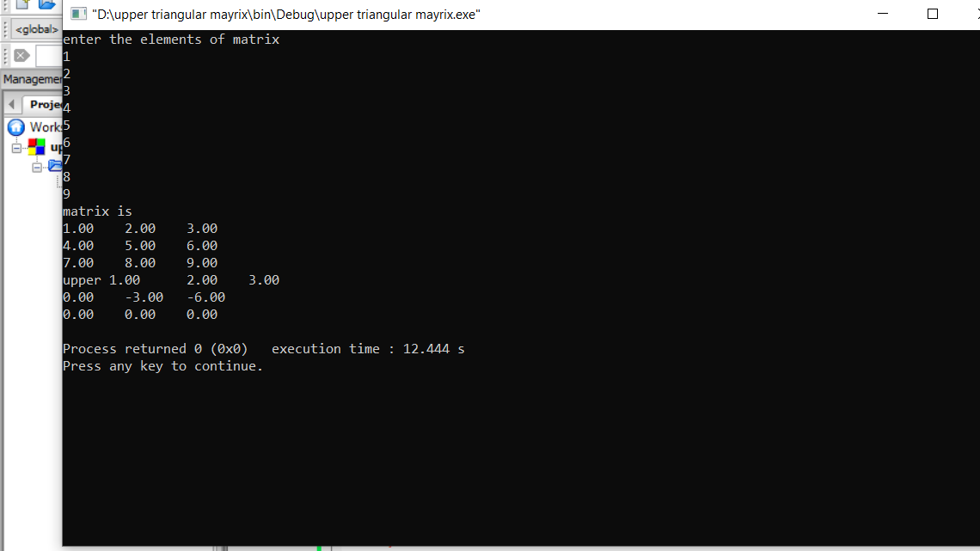

Que 2- WAP to find duplicate elements from an array?

Ans

#include <stdio.h>

#include <stdlib.h>

int main()

{

int i,j,k,n,t,c,a[30];

printf("enter the number of elements:");

scanf("%d",&n);

printf("enter the numbers:");

for(i=0;i<n;i++)

{

scanf("%d\t",&a[i]);

}

printf("the input array is \n");

for(i=0;i<n;i++)

{

printf("%d\t",a[i]);

}

for(i=0;i<n;i++)

{

c=1;

for(j=i+1;j<n;j++)

if(a[i]==a[j])

{

c++;

for(k=j;k<n-1;k++)

{

t=a[k];

a[k]=a[k+1];

a[k+1]=t;

}

n--;

}

if(c>1)

printf("\n%d appears %d times\n",a[i],c);

}

printf("the array is:\n");

for(i=0;i<n;i++)

printf("%d\t",a[i]);

}

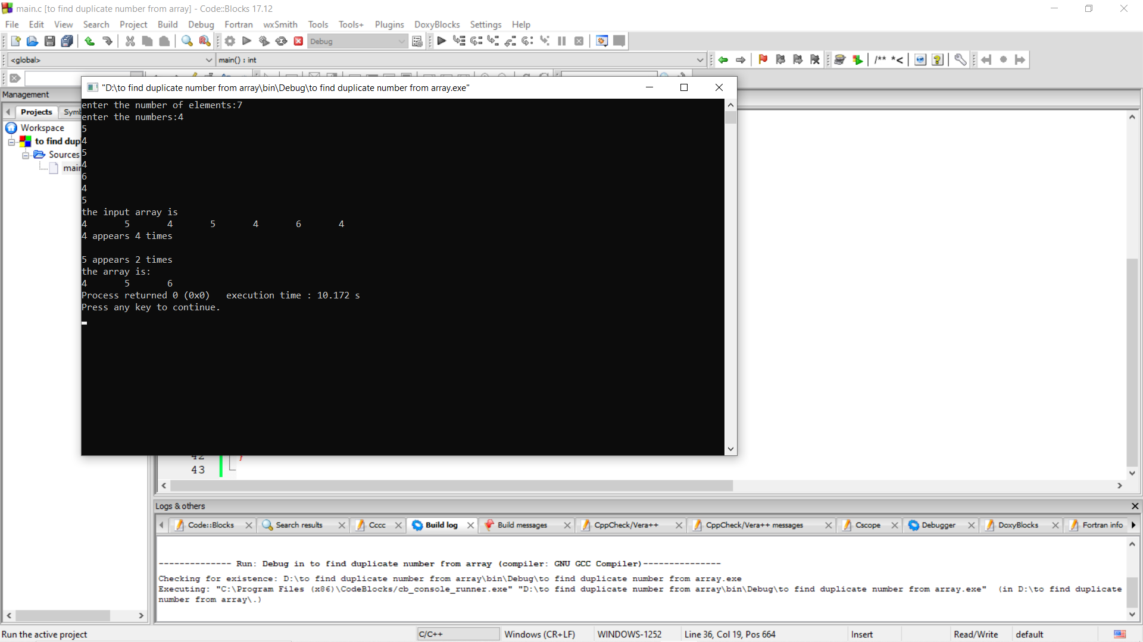

Que 3: WAP to generate all sets of two elements which is less than the maximum of an elemets of an array?

Ans:

#include <stdio.h>

#include <stdlib.h>

int main()

{

int i,j,n=10,a[30];

printf("enter the number of elements:");

scanf("%d",&n);

printf("enter the numbers:");

for(i=0;i<n;i++)

{

scanf("%d\t",&a[i]);

}

printf("the input array is \n");

for(i=0;i<n;i++)

{

printf("%d\t",a[i]);

}

int max = a[0];

printf("\nthe sets which are less than the maximum \n");

for(i=1;i<n;i++)

max = max>a[i]?max:a[i];

for(i=0;i<n;i++)

for(j=i+1;j<n;j++)

if((a[i]+a[j])<max )

printf("\n%d + %d < %d\n",a[i],a[j],max);

}

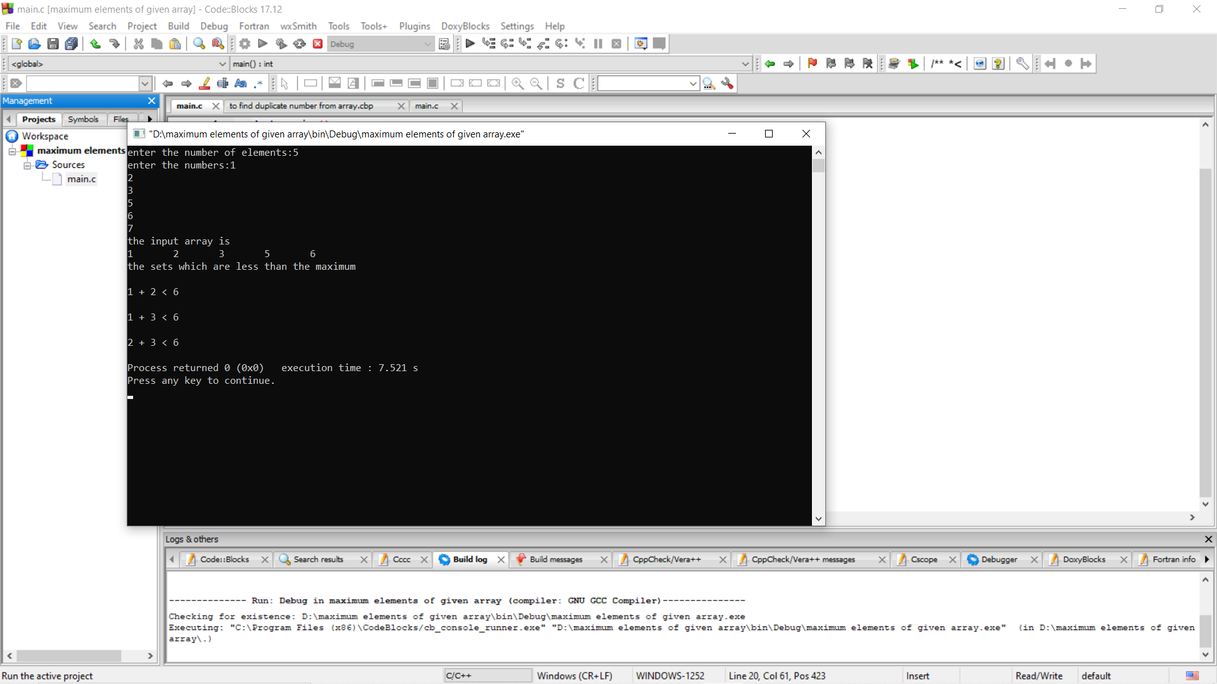

Que 4: WAP to combine two array and short them?

Ans:

#include <stdio.h>

#include <stdlib.h>

int main()

{

int i,j,k,n,m,a[30],b[30];

printf("enter the number of elements of first array:");

scanf("%d",&n);

printf("enter the number of elements of second array:");

scanf("%d",&m);

printf("\nenter the numbers of first array:\n");

for(i=0;i<n;i++)

{

scanf("%d\t",&a[i]);

}

printf("the input array is \n");

for(i=0;i<n;i++)

{

printf("%d\t",a[i]);

}

printf("\nenter the numbers of second array:\n");

for(j=0;j<m;j++)

{

scanf("%d\t",&b[j]);

}

printf("the input array is \n");

for(j=0;j<m;j++)

{

printf("%d\t",b[j]);

}

int c[n+m];

for(i=0;i<n;i++)

c[i]=a[i];

for(j=0;j<n;j++)

c[n+j]=b[j];

printf("\nafter merging the two arrays\n");

for(i=0;i<n+m;i++)

{

printf("%d\t",c[i]);

}

for(i=0;i<n+m;i++)

{

for(j=0;j<n+m-i-1;j++)

if(c[j]>c[j+1])

{

int temp=c[j];

c[j]=c[j+1];

c[j+1]=temp;

}

}

printf("\nafter sorting the array\n");

for(i=0;i<n+m;i++)

printf("%d\t",c[i]);

}