#include <iostream>

using namespace std;

int main()

{

//Question 1 sort an array using pointers

int arr[10]={9,8,7,5,4,3,2,1,9,8};

int \*l=NULL ;

int \*h=NULL;

int n=sizeof(arr)/sizeof(arr[0]);

for (int i=0;i<n-1;i++){

l=&arr[i];

for (int j=i+1;j<n;j++){

h=&arr[j];

if(\*h<\*l){

\*h=\*h+\*l;

\*l=\*h-\*l;

\*h=\*h-\*l;

}

}

}

for (auto i:arr){

cout<<i<<" ";

}

return 0;

}

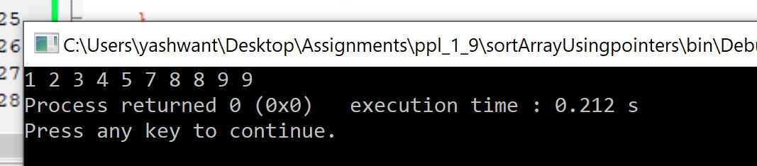

// question 2 reverse a string

string s="this is a test";

char \*c=NULL;

c=&s[s.length()-1];

for (int i{0};i<s.length();i++){

cout<<\*(c-i)<<"";

}

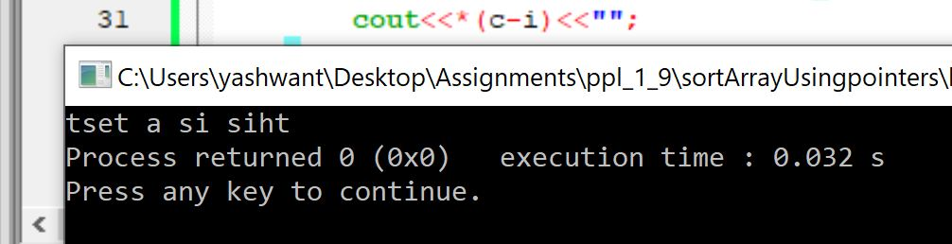

//question 3 add elements

int arr [9]={1,2,3,4,5,6,7,8,9};

// cout<<vec.size();

int \*p=NULL;

int total{0};

p=arr;

for (int i=0;i<9;i++){

total+=\*(p+i);

}

cout<<total;

