Question 1: write a program in c++ to create two classes named A and B. create another class named C which inherits both class A and B.  
Now, create a function in each of these classes which prints " A-class", "B-class" and "both-class: A and B" respectively.  
now create an object for each class. call the function of each of its parent by the object of class C.

#include <iostream>

using namespace std;

class A{

public:

void printA(){

cout<<"A-Class"<<endl;

}

};

class B{

public:

void printB(){

cout<<"B-Class"<<endl;

}

};

class C:public A,public B{

public:

void printC(){

cout<<"A-Class and B-Class"<<endl;

}

};

int main()

{

C obj;

obj.printA();

obj.printB();

obj.printC();

return 0;}

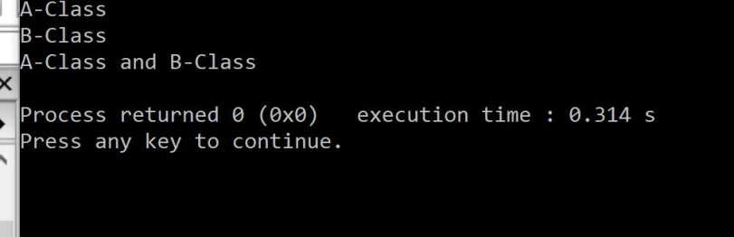

write a program in c++ to read and display information about employees and managers. Emp is a class that contains emp_no, name, address and department.  
manager class contains all information of the Emp class and a list of employees working under a manager.

#include <iostream>

#include <vector>

using namespace std;

class Emp{

int empNo;

string name;

string address;

string department;

public:

void setName(string n){

name=n;

}

string getName(){

return name;

}

void setAddress(string a){

address=a;

}

string getAddress(){

return address;

}

void setEmpNo(int no){

empNo=no;

}

int getEmpNo(){

return empNo;

}

void setDepartment(string d){

department=d;

}

string getDepartment(){

return department;

}

};

class Manager{

Emp e;

static vector <Emp> empList;

public:

Manager(int en=0 ,string n="noname",string a="noAddress",string d="noDepartment"){

e.setEmpNo(en);

e.setName(n);

e.setAddress(a);

e.setDepartment(d);

empList.push_back(e);

}

void disPlay(){

int i=0;

while(i!=empList.size()){

cout<<"Emp No. "<<empList.at(i).getEmpNo()<<endl;

cout<<"Emp Name "<<empList.at(i).getName()<<endl;

cout<<"Emp Address "<<empList.at(i).getAddress()<<endl;

cout<<"Emp Department. "<<empList.at(i).getDepartment()<<endl;

cout<<endl;

i+=1;

}

}

};

vector <Emp> Manager::empList;

int main(){

Manager * m=new Manager(1,"yash","jaora","cse");

m=new Manager (2,"dheeraj","jaora","cse");

m=new Manager(3,"veeresh","goa","civil");

m->disPlay();

return 0;}

