HEALTH-TRACK

A Project Report

*Submitted by*

Yashwanth Kumar-AP23110010511

Sudarshan-AP23110010531

Ismael-AP23110010569

Viswaj-AP23110010564

***Under the Supervision of***

**Mr. B. L. V. SIVA RAMA KRISHNA  
Assistant Professor  
Department of Computer Science and Engineering  
SRM University-AP**

*In partial fulfilment for the requirements of the Web Technology(CSE210) Project*

**BACHELOR OF TECHNOLOGY  
IN  
COMPUTER SCIENCE AND ENGINEERING**



**DEPARTMENT OF COMPUTER SCIENCE AND ENGINEERING**

**SRM UNIVERSITY-AP**

**NEERUKONDA**

**MANAGALAGIRI - 522503**

**ANDHRA PRADESH, INDIA**

**APRIL-2025**

**CERTIFICATE**

This is to certify that the project work entitled **“Health-Track”** is a Bonafide record of project work carried out by the following students:

* **Mr. Yashwenth Kumar** (Roll No.: AP23110010511)
* **Mr. Sudarshan** (Roll No.: AP23110010531)
* **Mr. Ismael**(Roll No.: AP23110010569)
* **Mr. Viswaj** (Roll No.: AP23110010564)

from the **Department of Computer Science and Engineering, SRM University-AP.** The students conducted this project work under my supervision during the period **January 2025 to April 2024**.It is further certified that, to the best of my knowledge, this project has not previously formed the basis for the award of any degree or any similar title to this or any other candidate.

This is also to certify that the project work represents the **teamwork** of the candidates.

Station: Mangalagiri **Mr. B. L. V. Siva Rama Krishna**

Date: 25/03/2025 Assistant Professor**Department of Computer Science & Engineering**

SRM University-AP  
 Andhra Pradesh.

**TABLE OF CONTENTS**

| **S. NO.** | **TITLE** | **PAGE NO.** |
| --- | --- | --- |
| 1 | Introduction | 1 |
| 2 | Problem Definition |  |
| 3 | Problem Statement |  |
| 4 | Objectives |  |
| 5 | Software Requirements Specifications |  |
| 6 | Design(DFD Diagram) |  |
| 7 | Implementation |  |
| 8 | Database Design |  |
| 9 | Output Screenshots |  |
|  |  |  |
|  |  |  |

**Introduction to Health-Track:**

**Think of having all your medical records, doctor visits, and health metrics in one safe location—no more rummaging through files or missing medication reminders. That's what HealthTrack is all about!**

**What's This Site For?**

**We've designed HealthTrack Pro to make healthcare easier, smarter, and more connected**. Whether you're living with a chronic condition, monitoring fitness progress, or simply need easy access to your medical history, this platform keeps you in control of your health without the hassle.**

**Here's What You Can Do:**

**✔ Securely Store Medical Records – Submit lab results, prescriptions, and scans—all encrypted and stored in your digital medical safe.**

**✔ Monitor Vitals & Medications – Record blood pressure, blood sugar, or steps, and schedule reminders so you never forget a dose.**

**✔ Consult with Doctors Online – Schedule video appointments, receive e-prescriptions, and communicate with healthcare professionals without leaving your home.**

**✔ Set & Crush Health Goals – Whether it’s losing weight or improving sleep, get personalized tips and progress charts.**

**✔ Emergency Ready – One-tap access to emergency contacts and critical health info when every second counts.**

**Why You’ll Love It:**

**- No more paper clutter – Everything’s digital and easy to find.**

**- Works with your devices – Syncs with Apple Watch, Fitbit, and others.**

**- Private and secure – We take care of your data like it's our own (because it matters!).**

**- Friendly reminders – Reminders for appointments, meds, and check-ups so you stay on track.**

**Think of it like a 24/7 health assistant in your pocket. Whether you’re a busy parent, a fitness enthusiast, or someone managing long-term care, HealthTrack Pro is designed to simplify your healthcare journey.**

**Problem Definition:**

**Fragmented healthcare systems lead to disorganized medical records, poor medication adherence, delayed doctor access, and reactive (vs preventive) care - causing inefficiencies, higher costs, and worse health outcomes.**

**Problem Statement:**

**1.)HealthTrack Pro solves these challenges by providing:**

**2.)A unified platform for secure medical record storage**

**3.)Smart medication tracking with AI reminders**

**4.)On-demand telehealth consultations**

**5.)Predictive health analytics**

**Objectives:**

**Consolidate healthcare data into a single, secure platform for 100% digital record access**

**Boost medication adherence by 40% through AI-powered reminders and tracking**

**Enable 24-hour telehealth access, prioritizing underserved areas**

**Shift to preventive care by detecting 70% of health risks early through predictive analytics**

**Reduce healthcare inefficiencies by 30% fewer duplicate tests and 25% fewer preventable ER visits**

**Delivering measurable improvements in care coordination, accessibility, and health outcomes.**

**Software Requirements Specification:**

**Technical Stack**

**Frontend: HTML5, CSS3, JavaScript**

**Backend Options: Node.js (Recommended) / PHP / Python**

**Database : MySQL / Firebase**

**Hosting: AWS/Azure (Basic) / Heroku (Starter)**

**Design(DFD Diagram):**

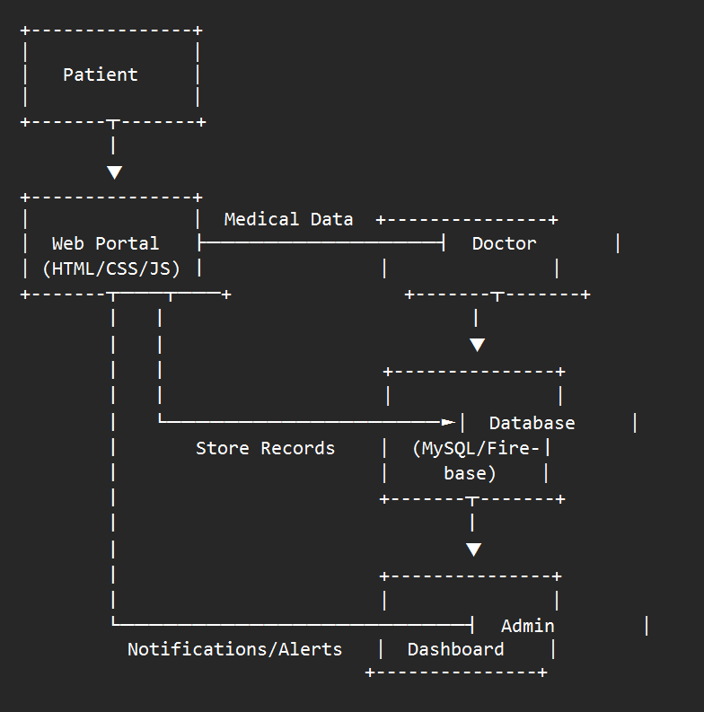

**Patient Interaction:**

**1.)Upload medical records**

**2.)Book appointments**

**3.)Receive reminders/notifications**

**Doctor Interaction:**

**1.)View patient records**

**2.)Confirm appointments**

**3.)Send prescriptions**

**Data Storage:**

**1.)MySQL/Firebase for structured data**

**2.)File storage for documents (AWS S3 recommended)**

**Admin Oversight:**

**1.)User management**

**2.)System monitoring**

**Implementation:**

**Phase 1: Setup of Foundation**

**1. Frontend Development**

**- Design responsive pages with HTML/CSS/JavaScript**

**- Develop core screens:**

**- Dashboard**

**- Uploading/viewing medical records**

**- Reviewing Medicine Tracking**

**- Booking appointment**

**- Doctor consultation panel**

**- Setting health goals**

**- Doctor profile**

**2. Backend Selection**

**- Node.js with Express**

**- Fall-back: PHP with Laravel**

**Phase 2: Core Features**

**1. Medical Records System**

**- Drag-and-drop file upload interface**

**- PDF/image preview feature**

**- Folder-like organization**

**2. Appointment Management**

**- Interactive calendar widget**

**- Email/SMS notifications**

**- Doctor availability checker**

**3. Basic Telemedicine**

**- Text messaging system (version 1)**

**- Video consultation (phase 3 upgrade)**

**Phase 3: Data & Security**

**1. Database Setup**

**- MySQL for organized data (users, appointments)**

**- Cloud storage (AWS S3) for medical records**

**2. Security Measures**

**- Encryption of user passwords**

**- Secure HTTPS connections**

**- Session timeout automatically**

**Phase 4: Testing & Launch**

**1. Quality Checks**

**- Mobile/desktop compatibility test**

**- Optimization of upload speed**

**- Simulations of doctor-patient flow**

**2. Deployment**

**- Begin with limited user base (100 patients + 10 doctors)**

**- Keep an eye on the server load**

**- Roll out gradually**

**WebSite Output:**

