Detecting Insider Threats in Cloud Environments using Ensemble Learning Model
Cloud servers are managed through centralized infrastructures and are susceptible to both insider and outsider attacks. Outsider attacks are initiated by external hackers or attackers attempting to compromise the system, while insider attacks are perpetrated by internal employees such as database administrators or server managers. These insiders may alter records or share sensitive information with third parties. To mitigate such risks, cloud servers maintain logs of internal activities, including email exchanges and file access, to monitor employee behavior. This study proposes the use of ensemble machine learning algorithms—namely Random Forest, LightGBM, XGBoost, and AdaBoost—to detect insider attacks. Among these, LightGBM demonstrated superior accuracy. Each algorithm's performance is evaluated using metrics such as accuracy, precision, recall, F-score, and a confusion matrix. To enhance detection accuracy, an advanced ensemble algorithm, CatBoost, was introduced as an extension to the proposed methodology. CatBoost is a gradient boosting algorithm that handles categorical data efficiently and improves prediction accuracy.
The research utilizes the CERT dataset, which contains detailed logs of cloud access activities by employees. Each record in the dataset is labeled as either:
0: Normal activity
1: Insider attack.
The dataset comprises 830 features, representing various activities, with the final column indicating the class labels (0 or 1).
Modules
The system implementation involves the following modules:
- Upload CERT Database: This module uploads the CERT dataset into the application, which then visualizes the data by plotting the distribution of normal and insider attacks.
- Preprocess & Split Dataset: Handles missing values, shuffles the data, and normalizes features. Splits the dataset into training (80%) and testing (20%) subsets.
- Run Random Forest: Trains the Random Forest algorithm on the training data (80%) and tests it on the remaining 20% to evaluate prediction accuracy.
- Run AdaBoost: Trains the AdaBoost algorithm using the training data and applies it to the test data to calculate performance metrics.
- Run XGBoost: Employs XGBoost to train a model on the training data and evaluates it on the test data for prediction accuracy.
- Run LightGBM: Trains the LightGBM algorithm on the training data and evaluates its performance on the test data.
- Run Extension CatBoost: Uses the CatBoost algorithm to train on the same dataset split and compares its prediction accuracy with other algorithms.
- Comparison Graph: Generates a comparison graph displaying the performance of all algorithms based on evaluation metrics.
Results and Conclusion
The experimental results demonstrated that LightGBM outperformed other traditional ensemble algorithms, while CatBoost, as an extension, showed further improvement in detection accuracy. The results underscore the effectiveness of advanced ensemble techniques in identifying insider attacks in cloud server environments.
SCREEN SHOTS
To run project double click on run.bat file to get below screen
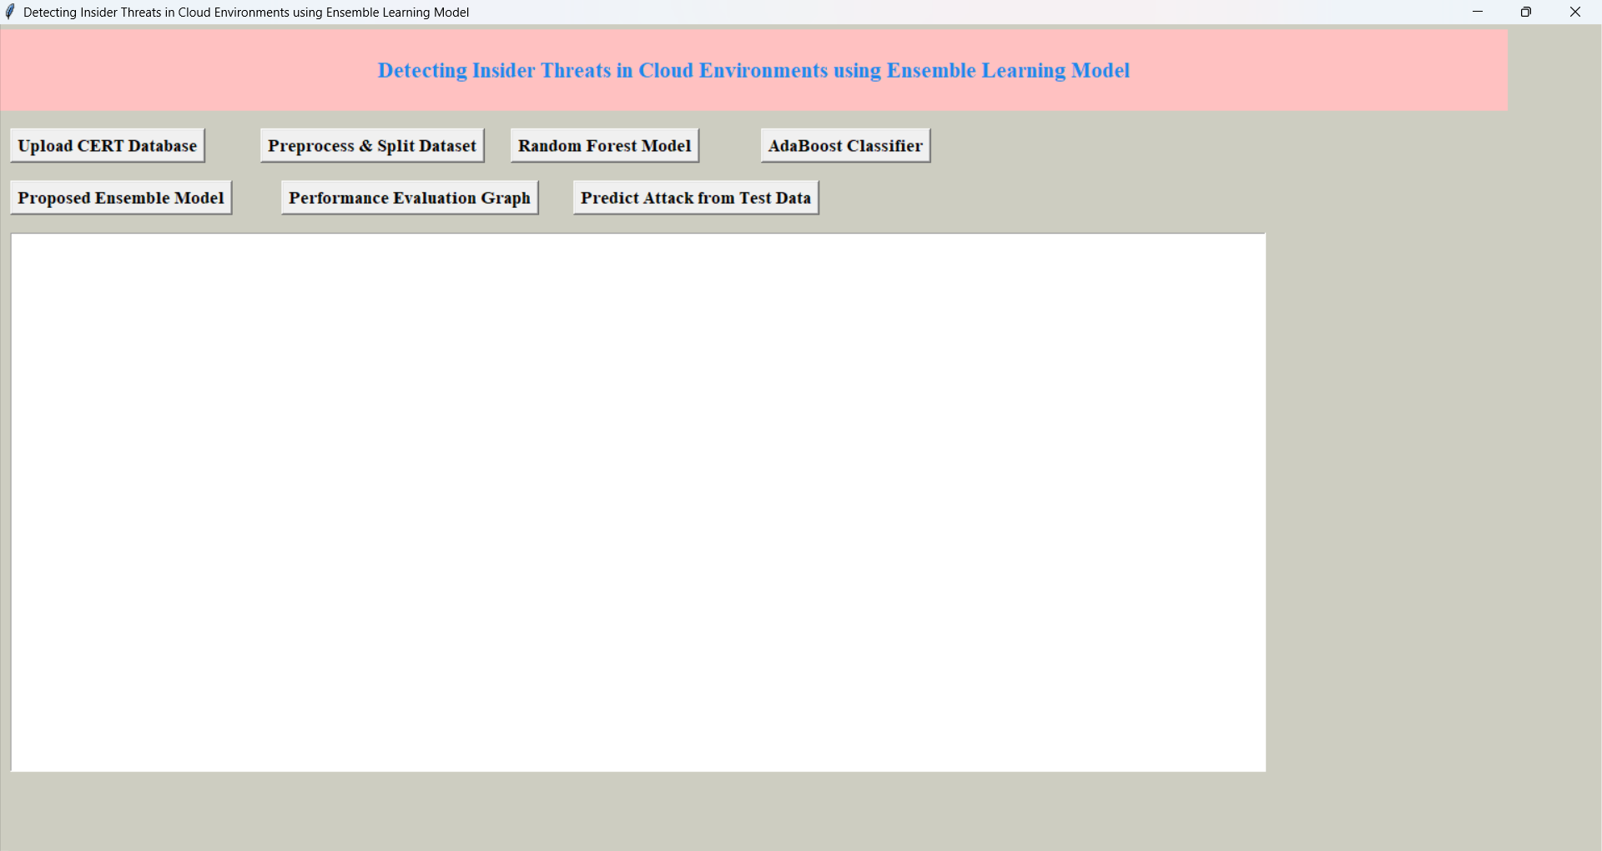
In above screen click on ‘Upload CERT Database’ button to select and upload ‘CERT’ dataset file and then click on ‘Open’ button to load dataset and get below page

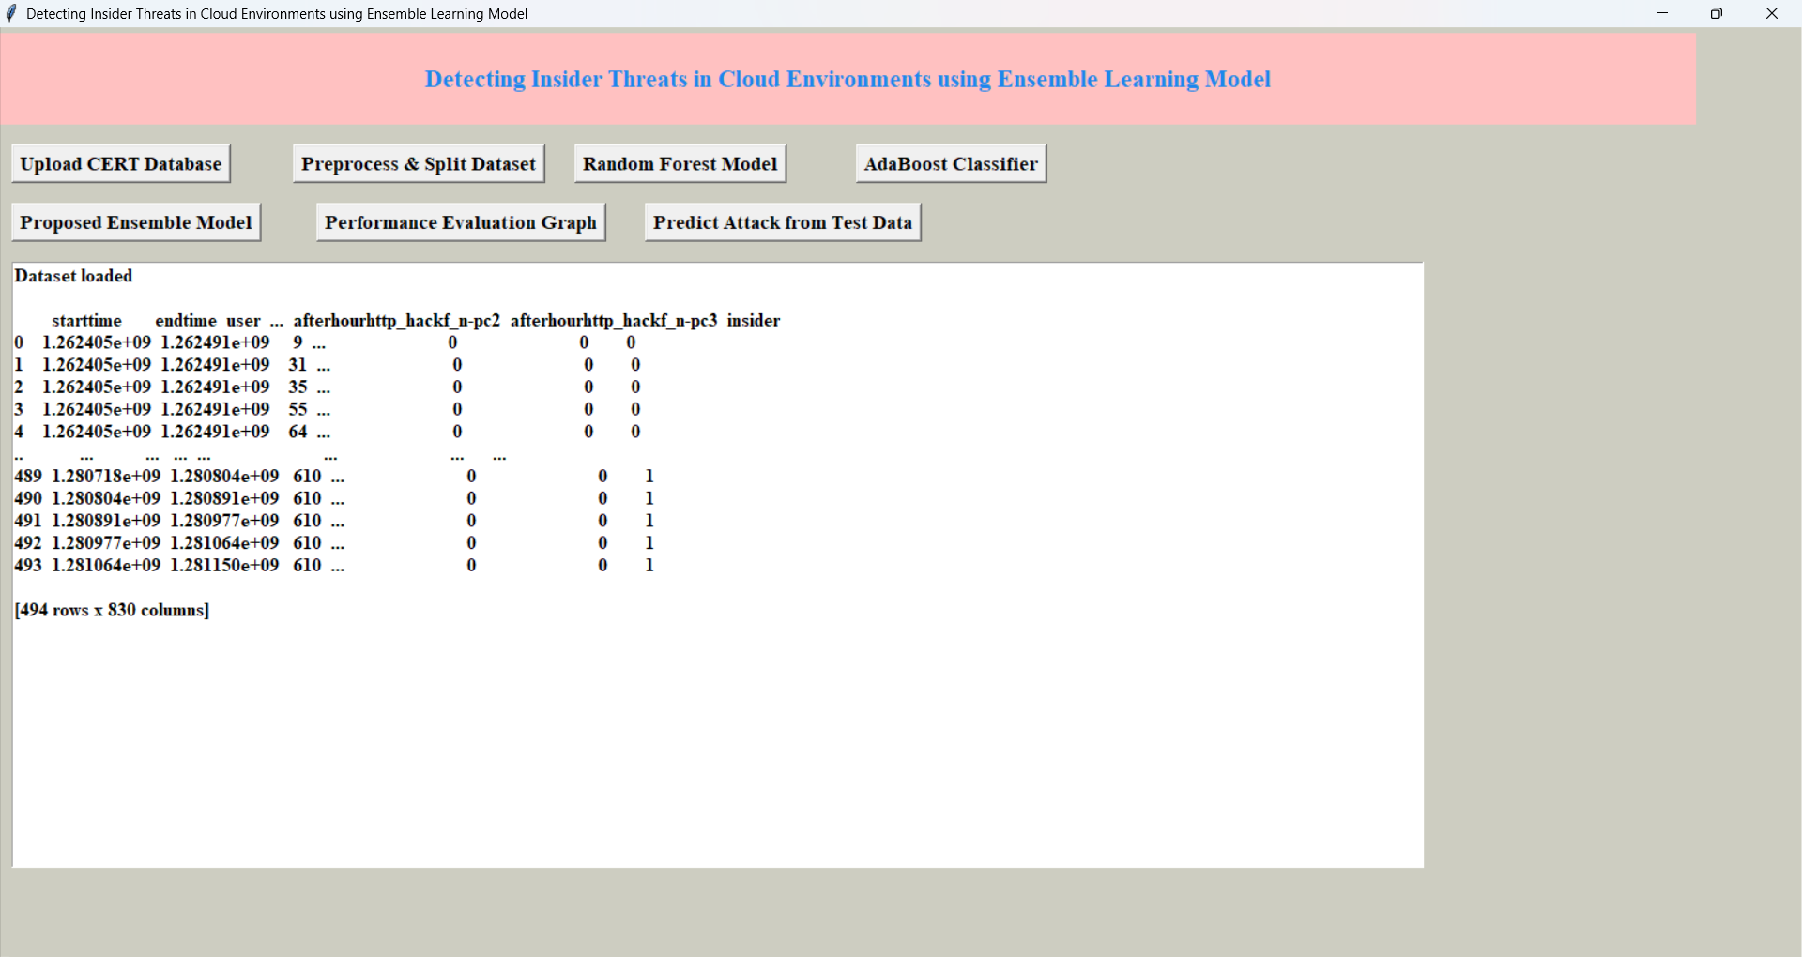
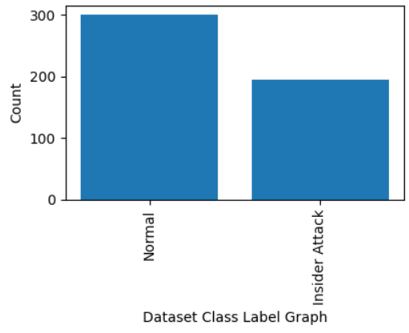
In above screen can see dataset loaded and can see dataset contains 830 columns and in graph x-axis represents class label types and y-axis represents number of instances under that class label and now click on ‘Pre-process & Split Dataset’ button to process dataset and get below page

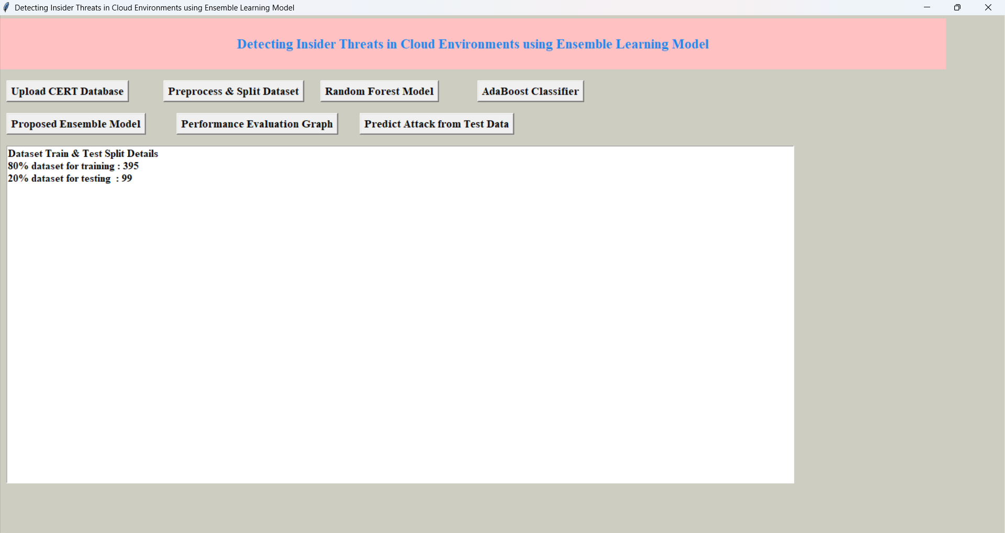
In above screen dataset processing completed and can see train and test size and now click on ‘Random Forest’ button to train Random Forest and get below output
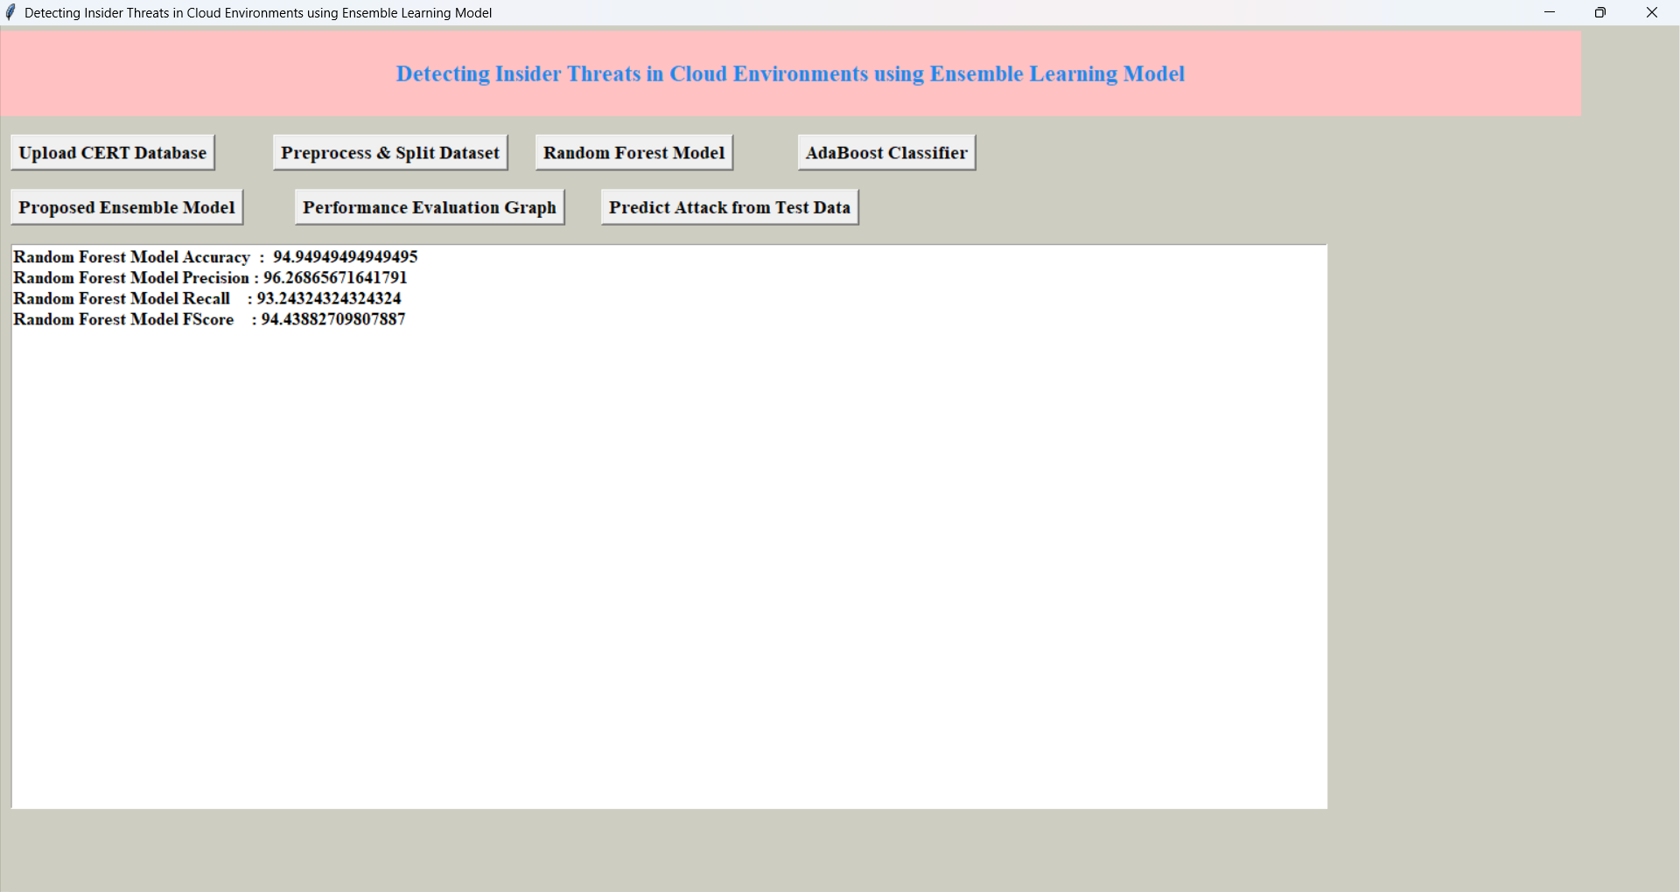
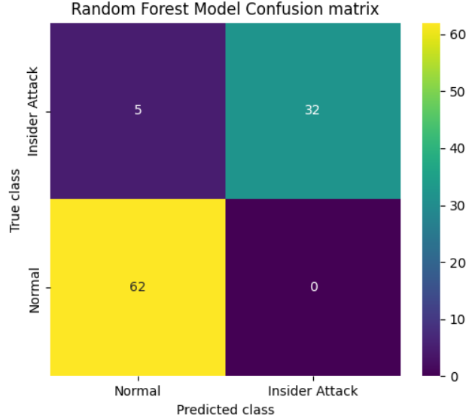
In above screen Random Forest got 94.94% accuracy and can see other metrics also and in confusion matrix graph x-axis represents Predicted Labels and y-axis represents True Labels and then yellow and green boxes in diagonal represents correct prediction count and blue boxes contains incorrect prediction count and now click on ‘ADABOOST Classifier’ button to get below output
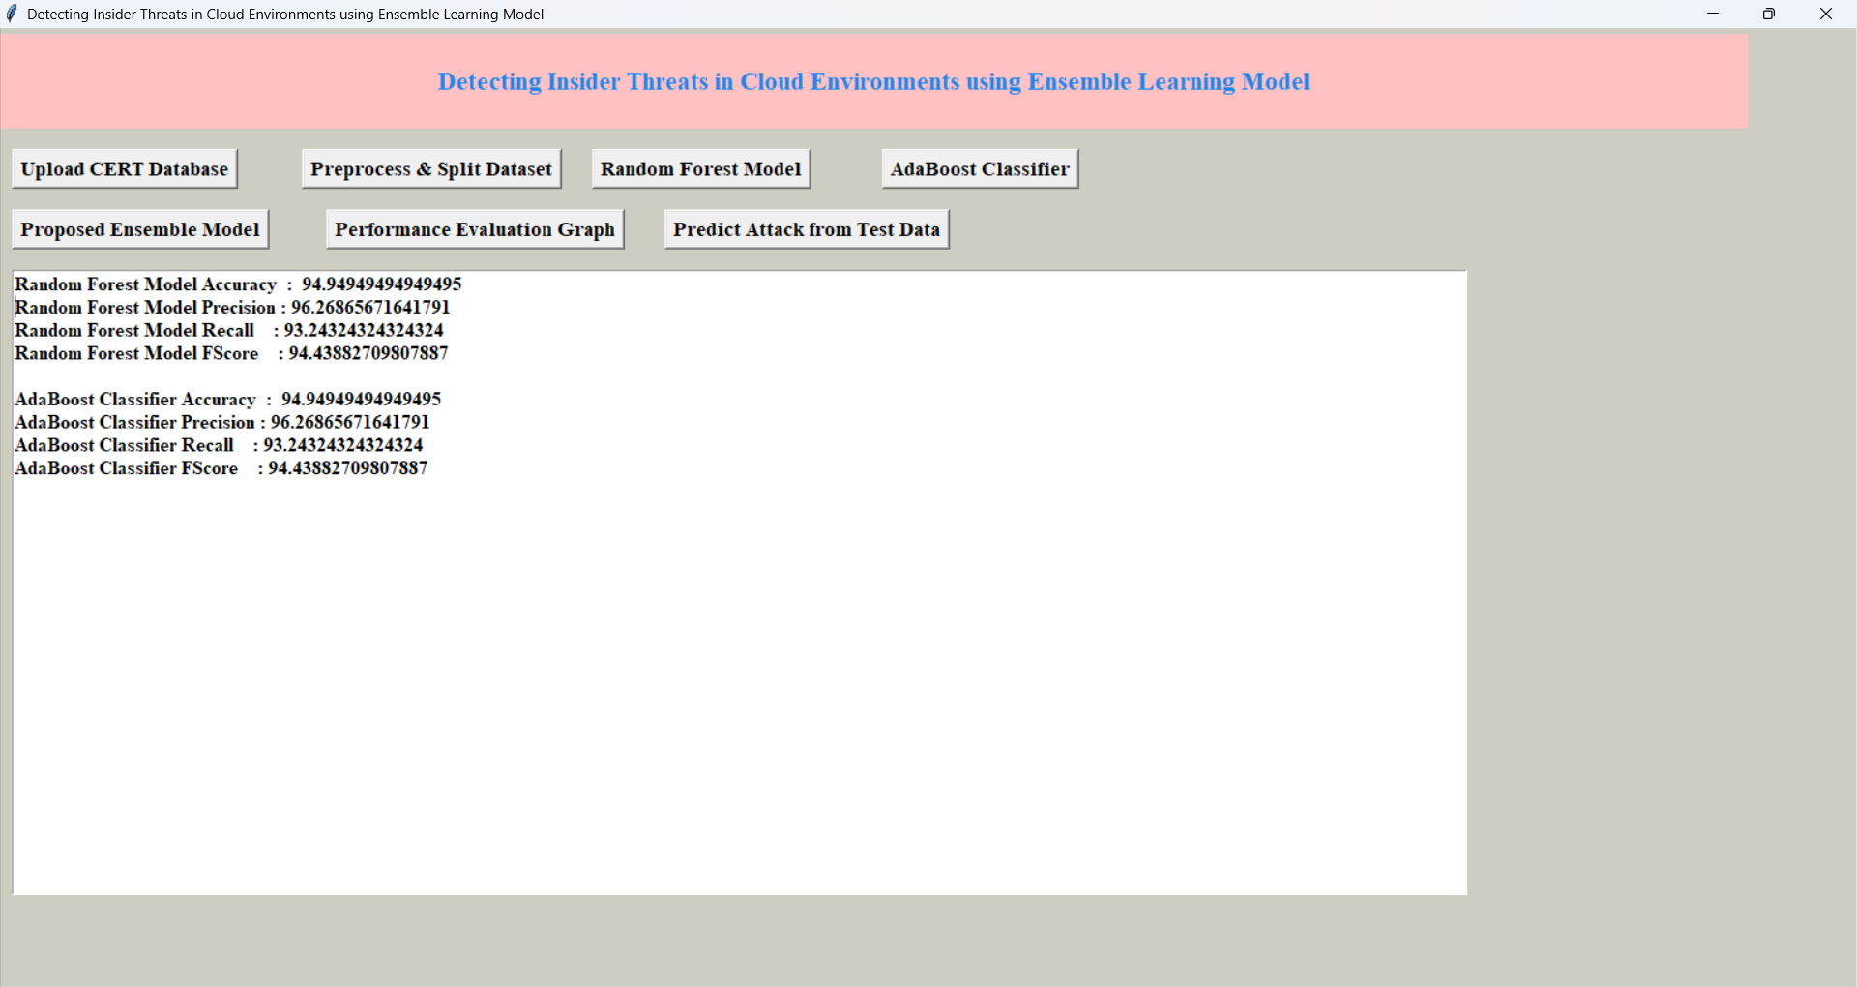
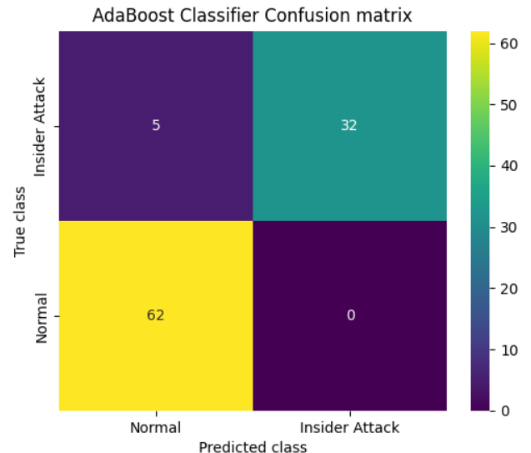
In above screen can see ADABOOST performance and now run Proposed Ensemble Model to get below output
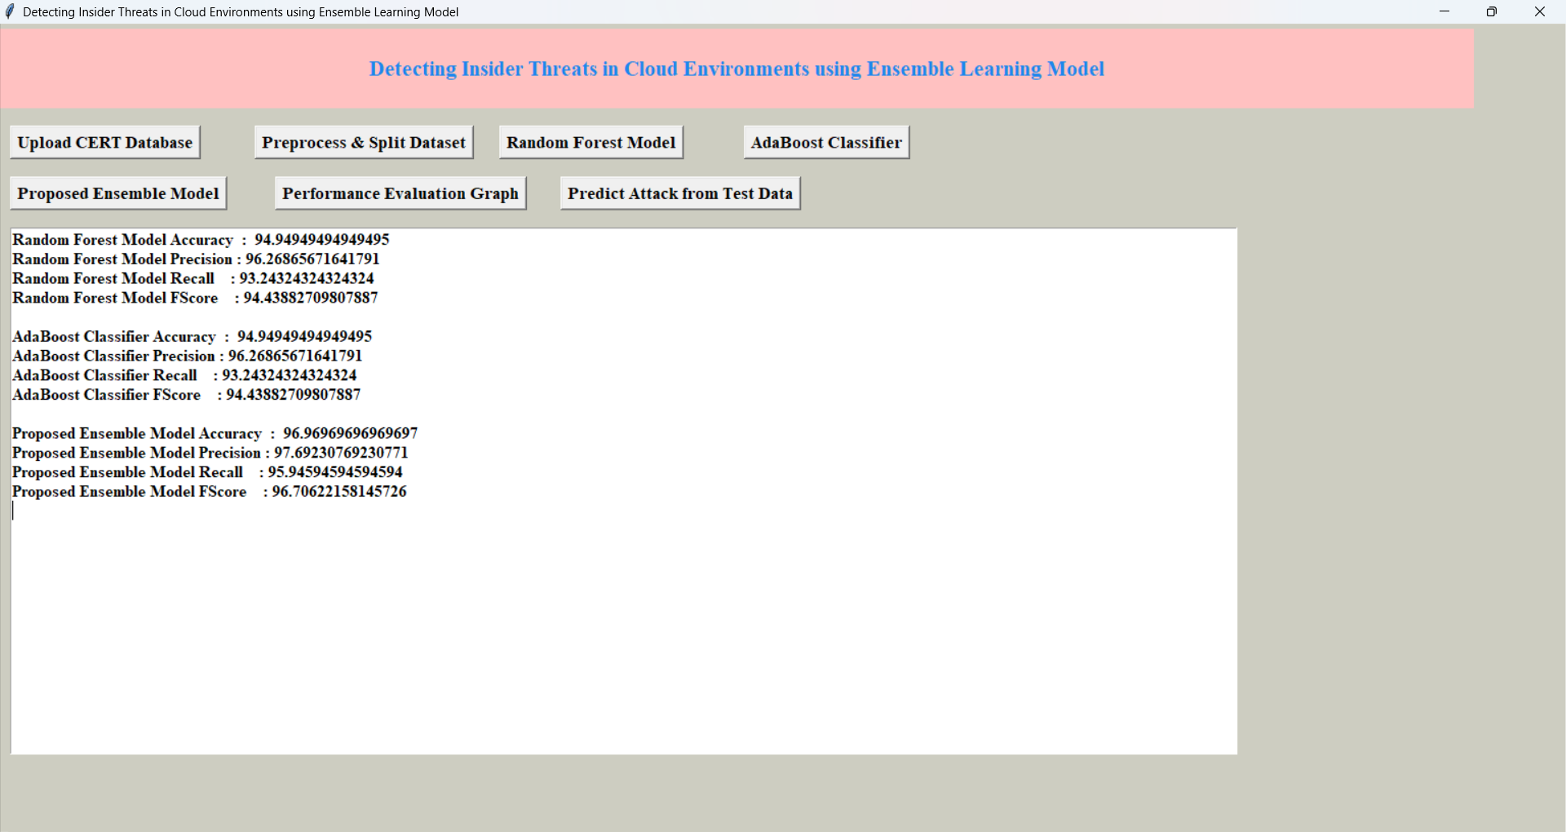
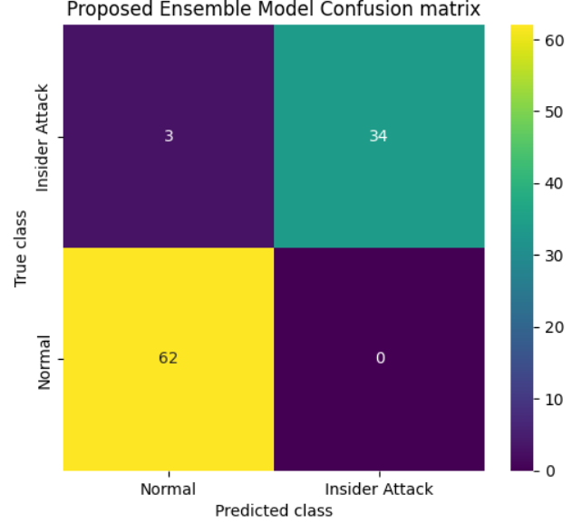
In above screen proposed ensemble model got 97% accuracy and now click on ‘Comparison Graph’ button to get below graph
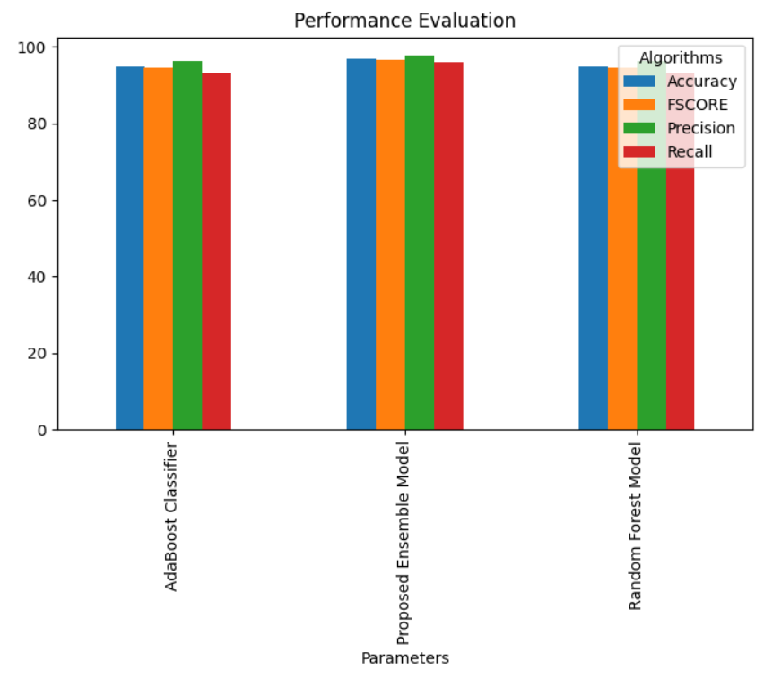
In above graph x-axis represents algorithms names and y-axis represents accuracy and other metrics in different colour bars and in all algorithms, proposed ensemble got high performance.
