**GUJARAT TECHNOLOGICAL UNIVERSITY**

**CHANDKHEDA, AHMEDABAD**

**AFFILIATED**



**SARVAJANIK COLLEGE OF ENGINEERING &**

**TECHNOLOGY**

**A**

**PROJECT REPORT**

**ON**

**TOPIC: Pocket Doctor**

**PROJECT TYPE: UDP**

**B. E. IV, SEMESTER – VII**

**COMPUTER (M)**

**SUBMITTED BY:**

**GROUP: 16_M**

|  |  |  |  |
| --- | --- | --- | --- |
| **SR** | **NAME OF STUDENT** | **ENNROLLMENT NO.** | |
| **1** | **PARMAR NANDINI** | **140423107008** | |
| **2** | **PATEL POOJA 140423107010** | |  | |
| **3** | **KARELIYA NILESH 120420107051** | |  | |
|  |  |  | |

**Prof.Urmi Desai**

**(FACULTY GUIDE)**

[**Prof. (Dr.) Pariza Kamboj**](http://scet.ac.in/co/co_pk)

**HEAD OF THE DEPARTMENT**

**ACADEMIC YEAR (2016-2017)**

**DEPARTMENT OF COMPUTER ENGINEERING**

**CERTIFICATE**

**This is to certify that the project entitled POCKET DOCTOR**

**has been carried out, PARMAR NANDINI (140423107008),PATEL POOJA (140423107010),KARELIYA NILESH KARELIYA(120420107051), students of B.E.IV CO(M), Semester-VII, under my guidance in fulfilment of the degree of Bachelor of Engineering in Computer Engineering of Gujarat Technological University, Ahmadabad for the academic year Oct-2016.**

**Signature of** **Signature of**

**Guide** **Head of the Department**

**-------------------------------------** **-------------------------------------**

**Dr. Pariza Kamboj**

**Signature of Jury Members**

**------------------------------- , -------------------------------- , --------------------------------**

**Acknowledgements**

We thank our guide Prof. Urmi Desai for guiding us and giving us her valuable time and advice. She always enriched us with her knowledge and gave us the necessary input to carry out this work. We are grateful to her for her extra efforts and for being patient with us.

We take this opportunity to thank all our lecturers who have directly or indirectly helped in our project.

**Table of Contents**

**1.INTROUCTION** **7**

1.1 Problem Statement and Introduction 7

1.2 Aim and Objectives of the Project 8

1.3 Problem Specification 8

1.3.1 Interface Specification 8

1.3.2 Technical Specification 9

1.3.3 System Features 9

1.3.4 Non-functional Requirement 9

1.3.5 Class Diagram 11

1.3.6 State Diagram 12

1.3.7 Use Case Diagram 12

1.3.8 Sequence Diagram 13

1.3.9 Activity Diagram 14

1.4 Brief Literature Review about Project 15

1.5 Plan of Project Work 16

1.6 Material/Tools Required 17

**2. Design Analysis, Methodology and implementation Strategy…………..19**

2.1 AEIOU Summary 22

2.2 Empathy Mapping 2552

2.3 Ideation 26

2.4 Product Development 29

**3. Implementation** **33**

3.1 GUI 33

3.2 Registration…………………………………………………………………………………………………………33

3.3 Timeline………………………………………………………………………………………………………34

**4. Summary** **34**

4.1 Advantages 34

4.2 System Features 35

**5. References** **35**

**List of Figures**

|  |  |  |
| --- | --- | --- |
| **Figure No.** | **Figure Caption** | **Page No.** |
| 1.1 | Class Diagram | 11 |
| 1.2 | State Diagram | 12 |
| 1.3 | Use Case Diagram | 12 |
| 1.4 | Sequence Diagram | 13 |
| 1.5 | Activity Diagram | 14 |
| 1.6 | Module | 16 |
| 2.1 | Activity Canvas | 19 |
| 2.2 | Environment Canvas | 20 |
| 2.3 | Interaction Canvas | 20 |
| 2.4 | Object Canvas | 21 |
| 2.5 | User Canvas | 22 |
| 2.6 | AEIOU canvas | 22 |
| 2.7 | User | 23 |
| 2.8 | Stockholders | 23 |
| 2.9 | Activities | 24 |
| 2.10 | Story Boarding | 24 |
| 2.11 | Empathy Mapping Canvas | 25 |
| 2.12 | People | 26 |
| 2.13 | Activities | 26 |
| 2.14 | Situation/Context/Location | 27 |
| 2.15 | Props | 28 |
| 2.16 | Ideation Canvas | 29 |
| 2.17 | Purpose | 29 |
| 2.18 | People | 29 |
| 2.19 | Product Experience | 30 |
| 2.20 | Product Functions | 30 |
| 2.21 | Product Features | 30 |
| 2.22 | Components | 31 |
| 2.23 | Product Experience | 31 |
| 2.24 | Product Development Canvas | 32 |
| 3.1 | Login Page | 33 |
| 3.2 | Registration Page | 33 |
| 3.3 | Timeline Page | 34 |

**1. Introduction**

Here we mention the introduction and problem statement of the project, aim and main objective of our problem.

**1.1 Problem Statement and Introduction**

Our Pocket Doctor application will focus on giving diet plane and exercise suggestions to user to help them to achieve their goal to reduce the weight and continuous updating information of heart patient to their doctor and providing user to communicate easily with doctor and patient with each other easily via text massages.

**Introduction**

Pocket Doctor is a software application. User has to register with the detail like weight, height and medical history. After successful registration user will login to access application feature. The application will provide a diet suggestion to user who want to maintain or loss the weight. Also give the detail of the calorie user have consumed .user need to enter the detail of the food consumption and water intake. User can also post there query on timeline and other users and doctors can suggest the solution. Patient of heart and blood pressure can connect to their doctors using application. We are going to add one gear watch which is wered by users. The gear watch is interfaced with application and gives the users pulse rate information to the application. Also the gear watch can sense the motion of the user. User can keep track of his activity and can also share it to other if user wants.

Patient’s medical history is maintained online so that user don’t have to carry it everywhere and also doctor can see it from anywhere .patient’s regularly updates is provided to their doctors so that any changes to the patient situation can be easily track by their doctors . Different users from different location can do competition.

**1.2 Aim and Main Objectives of the Project**

Our main aim is to provide users a platform to know the better and right way to solve their health maintenance issues and provide ability to heart patients so that they can track their daily health progress.

The main objectives of building such systems are as follow:

To provide interactive Graphical User Interface. To provide user a proper diet plane

To maintain patient medical history report online.

To save time of patient’s and doctor’s.

To provide the calorie count according to food consumed by user.

.

1. **Problem Specification**

Problem specification is description about system requirement, software, hardware, interface requirement, system features and other non functional requirements. It is useful in order to help the users to achieve their goals.

**1.3.1 Interface Specification**

Interface requirements are particularly useful to achieve high quality of interaction. The user interface and functionality are evaluated and designed to perform well and give a user-friendly interface to all the users of the system.

Users must be able to understand the application navigation properly.

Pocket Doctor provides the interactive GUI for user so, that they can interact with the system properly.

**1.3.2 Technical Specification**

Technical specification contains all details about implementation. That is concern with the tools, languages for front end and databases for backend. Java, android is the front end languages and sql server is the back end database for our system.

**1.3.3 System Features**

Smart assessment system provides the following features:

Provide personalized login

Dynamic system Interactive GUI

Easy to use and understand

**1.3.4 Non-Functional Requirement**

**Performance**

Product must perform for designed features and functions as per the requirement of the user in actual working environment for that Performance of product is mandatory.

Product Performance is Given Below:

System provide diet plan and exercise details

Maintain and update patient history report online

Quick result

Time saving

Interactive GUI

Easy to use and understand

**Safety**

Safety is the most important aspect of human centric product. Reasonable factor of safety should be taken into account considering all adverse and factual factors.

Product Safety is Given Below:

System becomes safe due to personalized login

User’s data are secure and not visible to other users until user allowed to share it.

**Reliability**

Reliability is the ability of a system or component to perform its required functions under stated conditions for a specified period of time. Final product should be reliable as required by the user and should perform its desired functions as required for desired time period.

Product Reliability is Given Below:

Reliability depends on the diet plan and exercise provided by the application to the user and pulse rate information of user which is provided to doctor.

**Software Quality Attribute**

Good quality of the framework produces robust, bug free software which contains all necessary requirements customer satisfaction.

**Class Diagram**

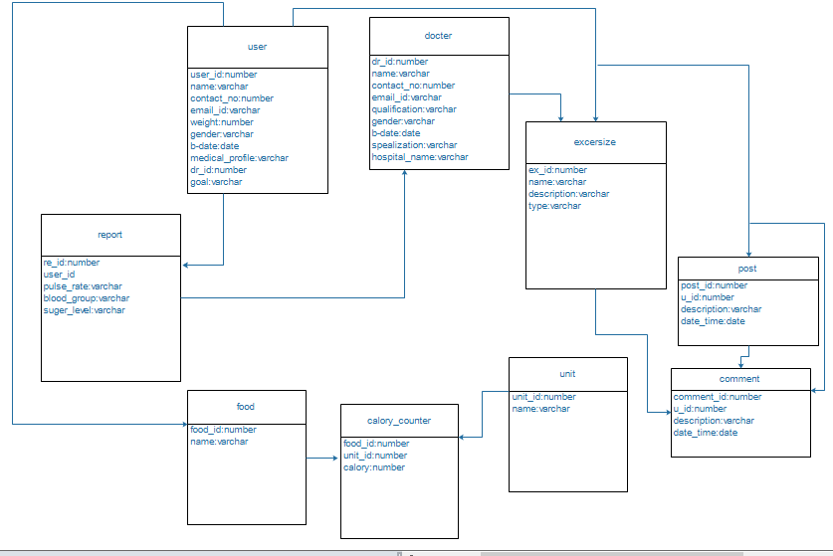

**Figure 1.1: Class Diagram**



**11**

**Figure 1.1: class Diagram**

**State Diagram**

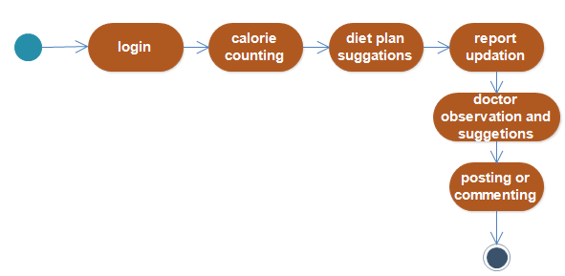

**Figure 1.2: State Diagram**

**Use case Diagram**

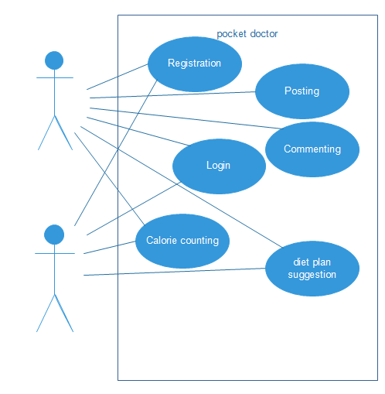





**Figure 1.3: Use case Diagram**

**12**

Sequence Diagram

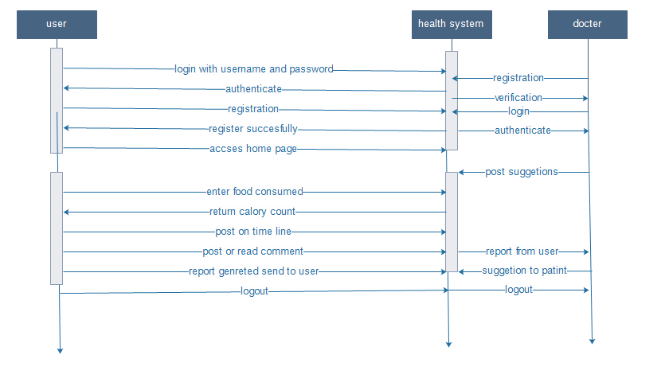

**Figure 1.4: Sequence Diagram**

**Activity Diagram**

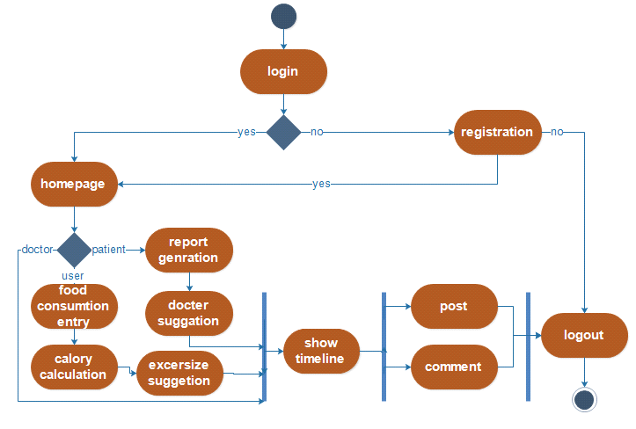

**Figure1.5: Activity Diagram**

**1.4 Brief Literature Review about Project**

We find out the literature for the health related android application and study that literature for reference. We studied about the gear watch and use patent for reference.

We studied patent for online medical data collection. A method for filling out of a medical evaluation form online and/or facilitating of reviewing of medical information online are disclosed. A doctor can review the medical evaluation form generally anywhere and generally any time prior to the consultation. Online and face-to-face medical evaluations and interactions can potentially be made safer, more efficient and of higher quality by using such a process. [1]

The second patent we referred is method for increasing fitness level while losing body weight . A method of six (6) weeks duration for increasing body fitness level while reducing health risks, reducing inches of girth for body parts and losing body weight is provided. The method is comprised of three steps: (1) Body Cleansing, (2) Muscle Toning and Strengthening, and (3) Body Balancing. Each step is of two weeks duration and is comprised of a specific eating plan (in the case of step 1 includes a water intake regimen) and a specific exercise plan. The eating plan and exercise plan of each step is specifically formulated to provide upon completion of the six (6) weeks significant weight loss, lower BMI and reduced body part girth.[2]

Third patent is wearable communication device and user interface. Wearable communication devices, e.g. implemented in a watch, using short range communication to a cell phone, and facilitating natural and intuitive user interface with low-power implementation allow a user to easily access all features of the phone, all while a phone is nearby but not visible. Notification is performed with vibration, an LED light and OLED text display of incoming calls, texts, and calendar events. It allows communicating hands-free. This allows using the communication device as “remote control” for home devices, etc. via voice and buttons. The device comprises interfaces motion sensors such as accelerometers, magnetometer and gyroscope, infrared proximity sensors, vibrator motor, and/or voice recognition. Low power consumption is achieved by dynamical configuration of sensor parameters to support only the necessary sensor functions at any given state of the device.[3]

**1.5 Plan of Work**

For the project work we divide our pocket doctor system into number of modules like user identification module, timeline module, report generation and maintenance of patient, calorie counting. Each module described in detail below:

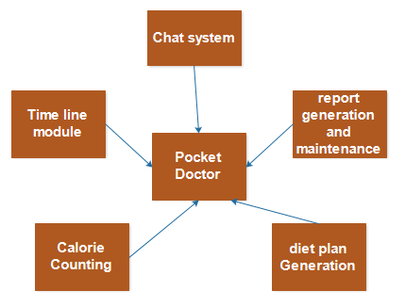

**Figure 1.6: Module**

**User Identification Module**

It is required to Sign-in in the system. A user should log-in into system when he/she opens. If the user has not registered, he/she should be able to do that on the log-in page. If the user is new, then they will have to fill up the registration details like email id, name, etc.

**Timeline module**

System will provide user a timeline where user can post there queries and all other user and doctors can give solution or comment on it.

**16**

**Report generation and maintenance**

The user medical history report will be maintained and get updated regularly. And the information about all the update are provided to the doctor periodically

**Calorie counting**

User will enter the detail of the food consumed and the system will give the detail of how much calorie user had consumed.

**Report Generation**

Generate report of each user which contains student details and his/her test details along with their marks of test.

**1.6 Material /Tools Required**

To design perfect user friendly GUI we require IDE for relative language dependant. As our easy comfort select one developing environment like android and for database concern preferable options are available.

**Components as below:**

IDE – Interactive Development Environment Developing languages for front end – android

Back End Database – Sql Server

Designing Tools

Wearable gear watch

Android mobile phone

**Props**

Mobile/tablet

Diet plan information

Information

General algorithm

Database

**2. Design Analysis, Methodology and Implementation**

**Strategy**

Here in this section we mention the details about all canvases that described below:

**2.1 AEIOU**

It is a concept which includes observation in the different fields like Activity, Environment, Interaction, Objects and Users. To make AEIOU framework we select location as College.

**Activity** – We observed different activities for the heart patient and user who want to

Loss weight and the activities are like goal setting, exercising, reporting, observing,

food entry, water intake entry, calorie counting etc.

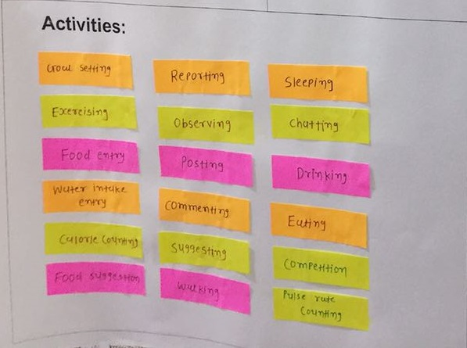

**Figure 2.1: Activities Canvas**

.

**19**

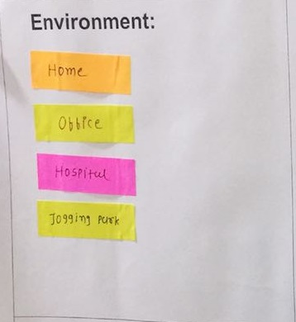**Environment** – It not only includes natural environment but also surrounding atmospheredepending on time and location. User can be ate office, ate home or at jogging park or can be at hospital

**Figure 2.2: Environment Canvas**

**Interaction** – It takes place between the user to user, patient to doctor, patient to patient etc. interaction topic can be problem related to health or suggestions or can be the user chat.

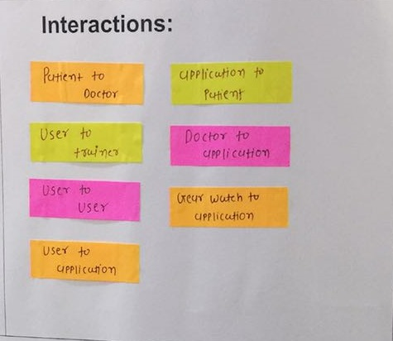

**Figure 2.3: Interaction Canvas**

**Objects** – They are things which are present in our selected location i.e. home where user can have exercise tools for exercising. Mobile ,gear watch are the object used id our system.

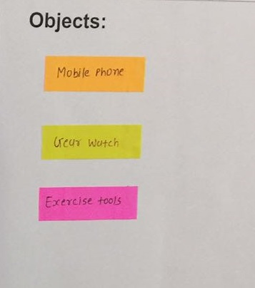

**Figure 2.4: Objects Canvas**

**Users** –This is the most important part of this framework. It includes the people who areactually going to use this product. This canvas has list of identified people involved. They patient doctor, and a user can ne man, woman, youngster, older, children

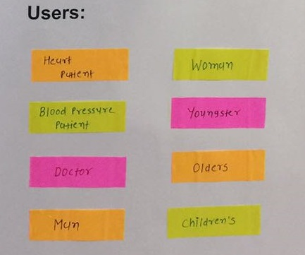

**Figure 2.5: Users Canvas**

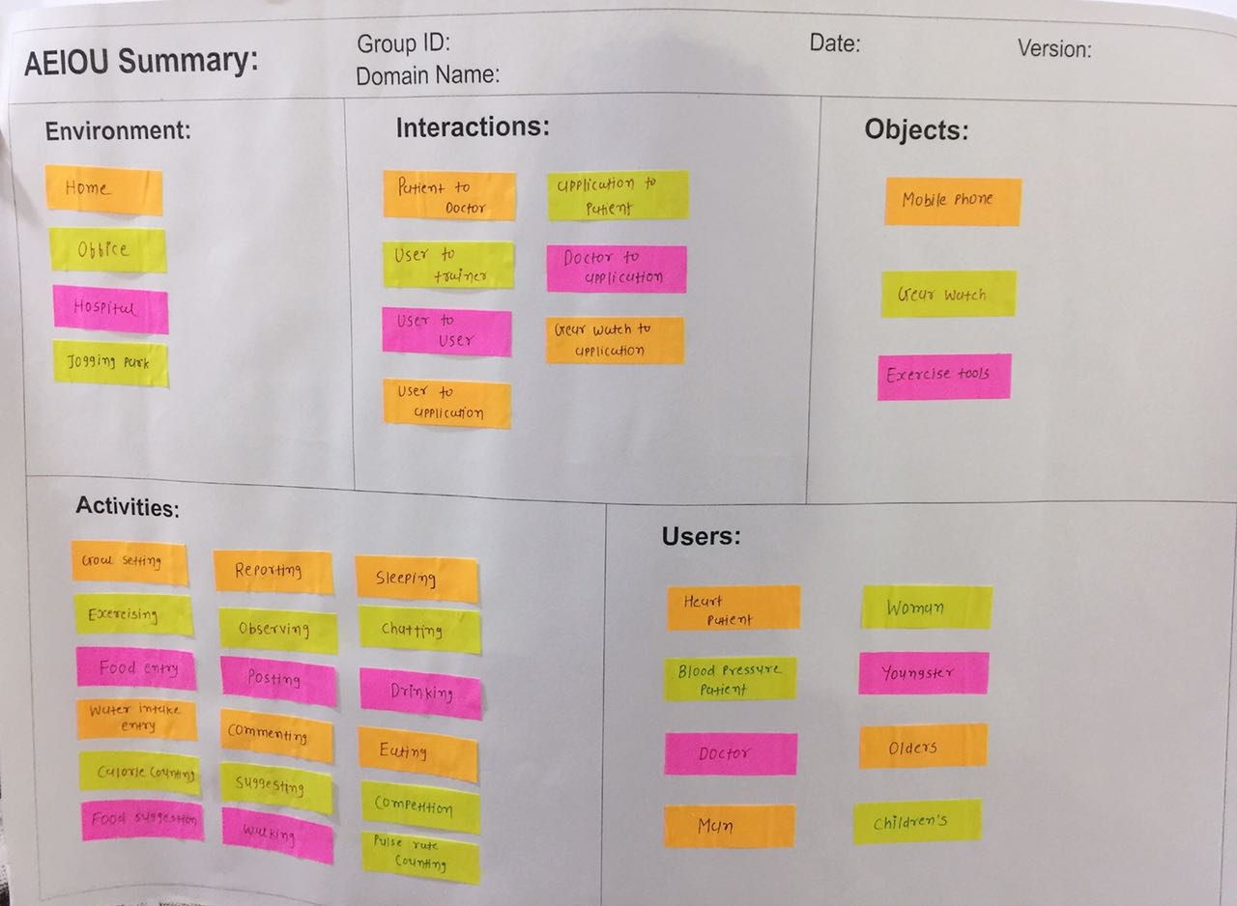**AEIOU SUMMERY**



**Figure 2.6: AEIOU Canvas**

**2.2 Empathy Mapping**

In empathy canvas, first of all we select **Assessment Methodology** as our domain. In this canvas, we choose **user** as **Examiner** and **Examinee.**

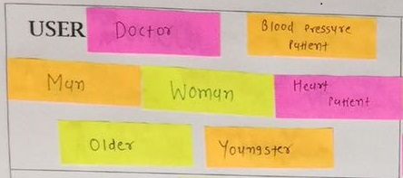

**Figure 2.7: User**

**Stakeholders** are given below:

Student

Trainer

Nurse

Professor

Businessman

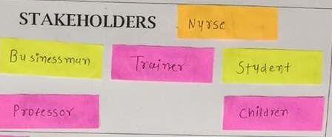

**Figure 2.8: Stakeholders**

**Activities:** Users do different activities like goal setting, chatting, food entry, observing, exercising, water intake entry etc.

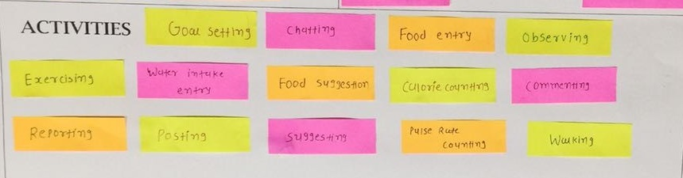

**Figure 2.9: Activities**

**Story bonding:**

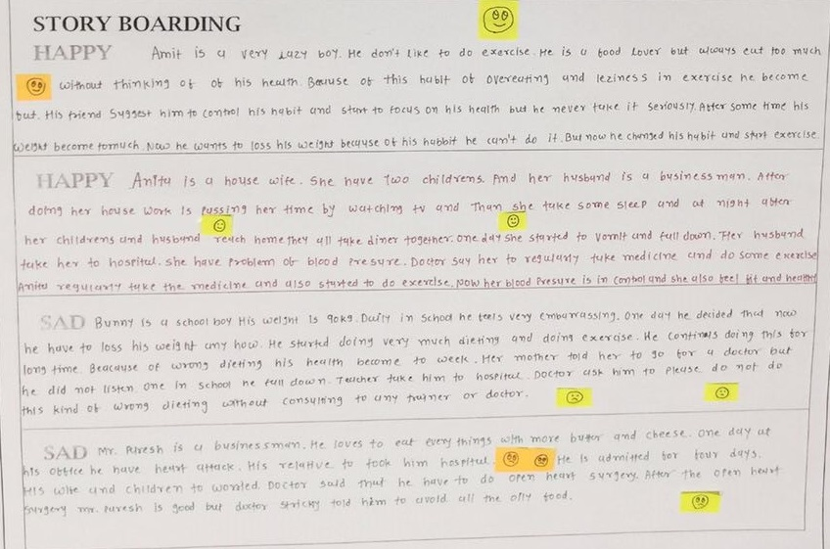

**Figure 2.10: Story bonding**

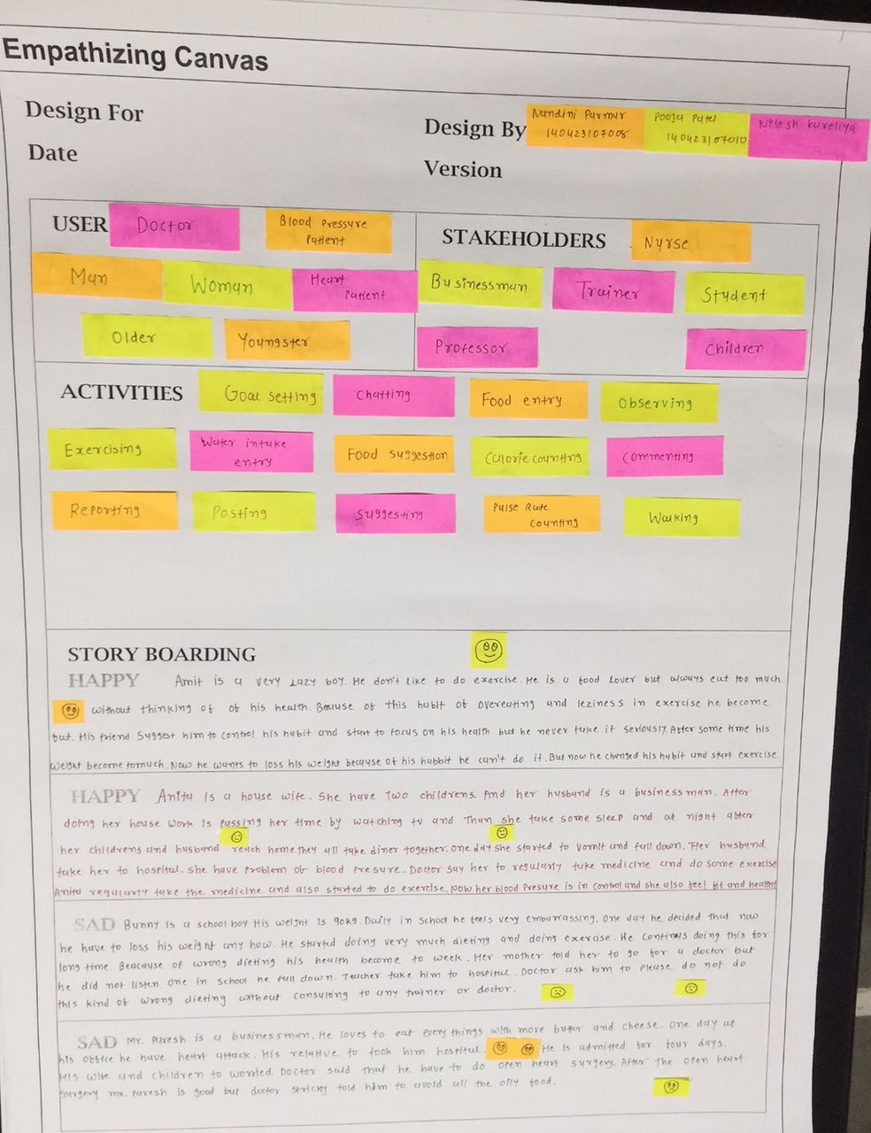**Empathy canvas:**

**Figure 2.11: Empathy canvas**

**Ideation canvas:**

In ideation canvas we retrieve the data of people and their activities from Empathy mapping canvas. Then we select 1 user from people and relate it to 1 activity and ask the 3 questions 1) Where 2) when 3) Why to find out location or situation or context. By continuously iterating in this way we get the data for Situation/Context/Location. For Props we do the iteration by selecting 1 user, 1 activity and 1 Situation/Context/Location and ask question that what we need to fulfill the problem face by user.

**People:**

Patient

Doctor

Children

Youngsters

Older

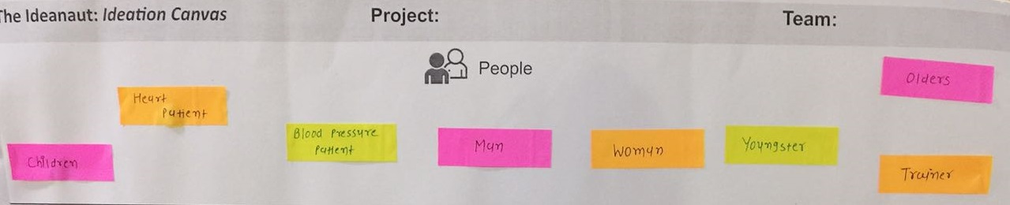

**Figure 2.12: People**

**Activities:**

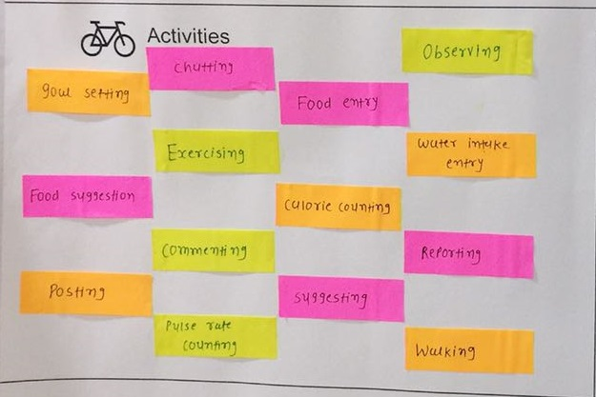

**Figure 2.12: Activities**

**Situation/context/location:**

This gives at which place and in which condition the user is. User can be at home, office, jogging park or at hospital in different situation.

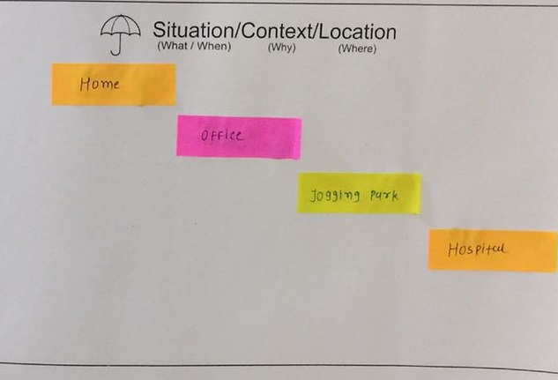

**Figure 2.13:Situation/context/location**

**Props:**

Different props used to solved the users problem like android phone, gear watch etc. 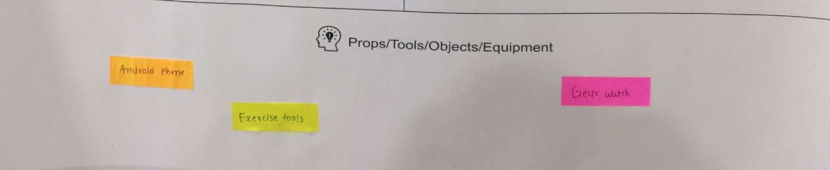

**Figure 2.14: People**

**Ideation:**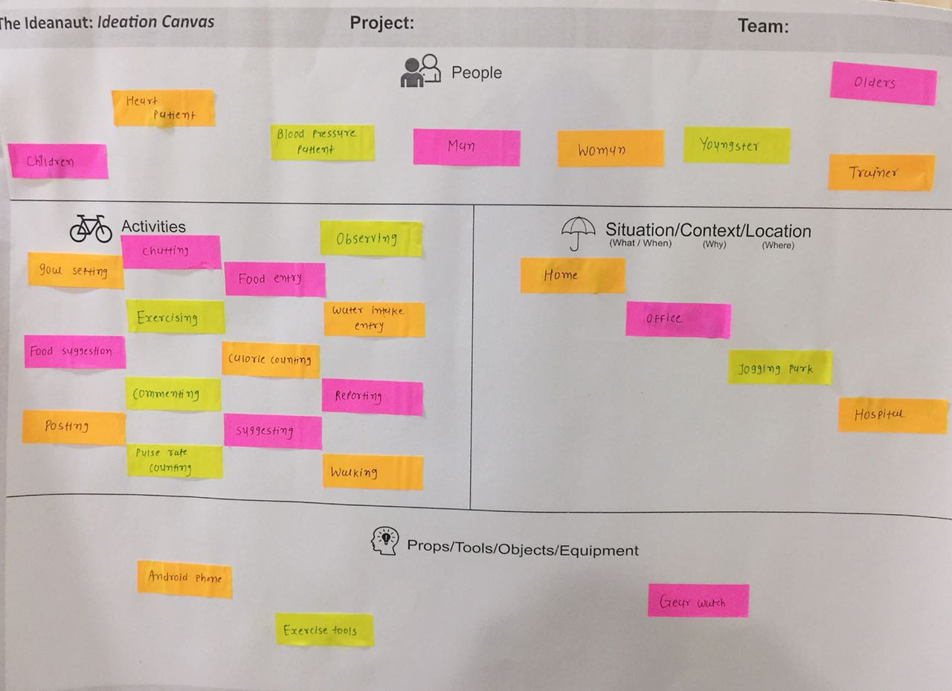

**Figure 2.15:**  Ideation canvas

**Product development canvas:**

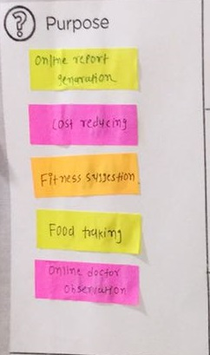 Our system will focus on giving diet plane and exercise suggestions to user to help them to achieve their goal to reduce the weight and continuous updating information of heart patient to their doctor

**Figure 2.16:** Purpose

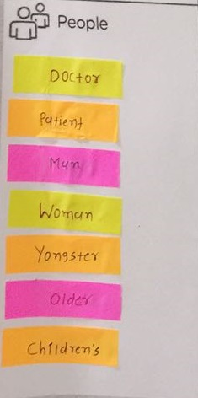**People:** We are implementing our system for user like heart patient, user who wants to lose weight and doctors

**Figure 2.17: People**

**Function:** We are going to provide many functions in our system, here some main function:

Report generation

Calorie counting

Chat system

Timeline

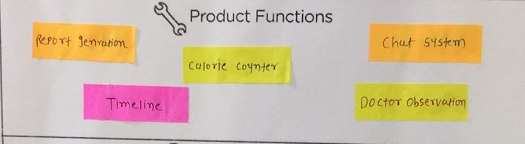Doctor observation

**Figure 2.18: Product Functions**

**Features**: some of the features of the system are listed below:

Provide diet suggestion

Messaging

Maintain patient history

Posting queries

Doctor observation

Exercise guidance

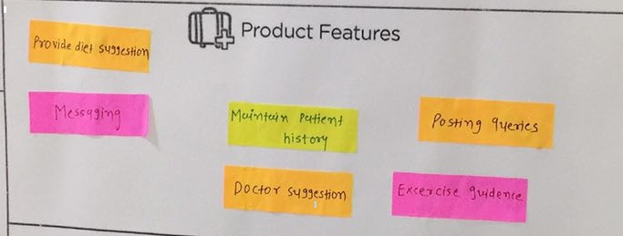

**Figure 2.19: product feature**

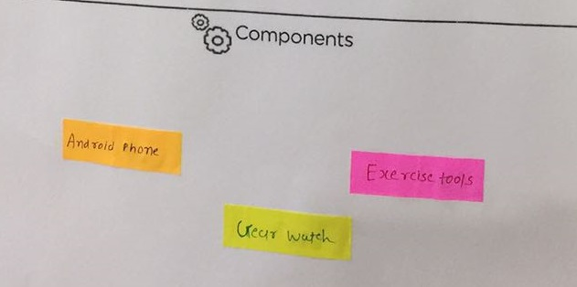**Component**: The components we are going to use for solving user problem are android mobile gear watch etc.

**Figure 2.20: Component**

**Product Experience:**

Time Saving

Effortless Examination Dynamic System

Quick result

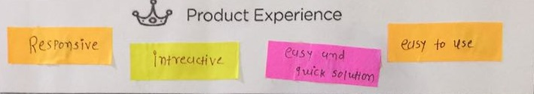 Set difficulty level Stress Free

**Figure 2.21: Product Experience**

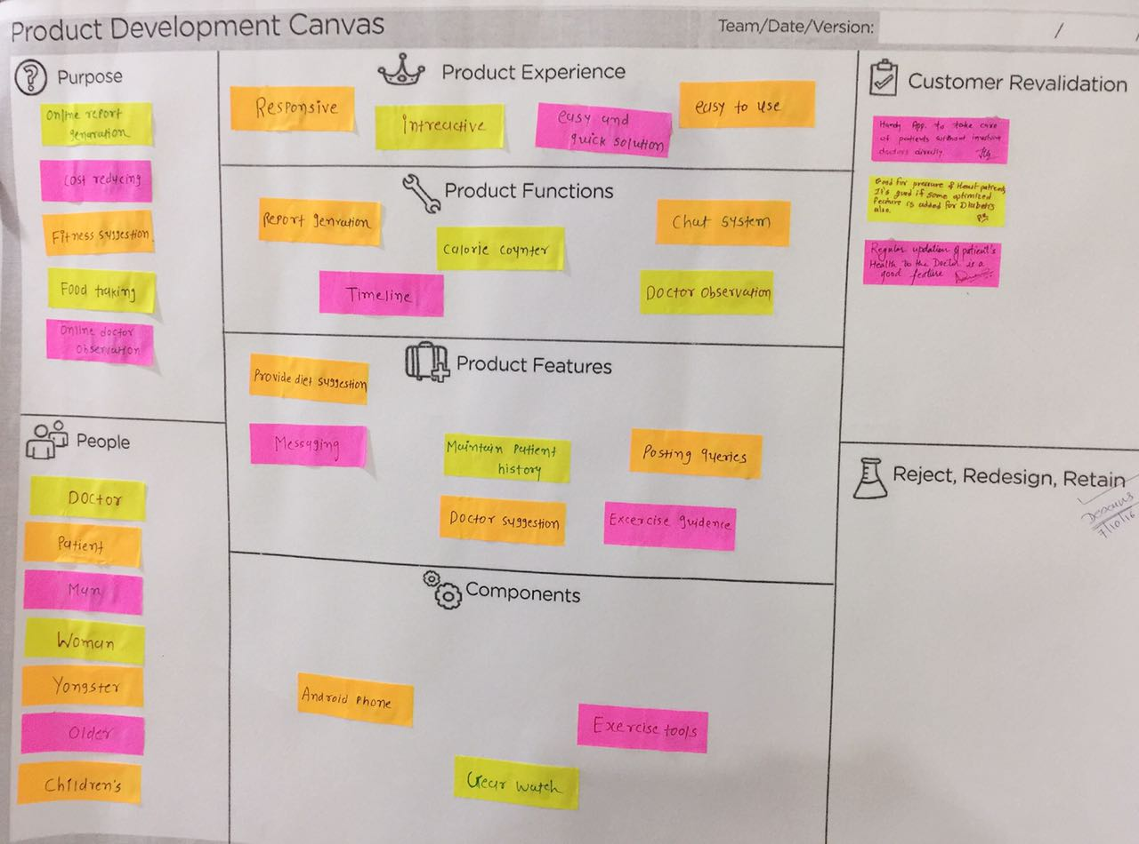

**Product development canvas:**

**Figure 2.22: Product development canvas**

**3 implementation**

In this section we include the implementation part of the project. In the web model, first user needs to log in into his account.

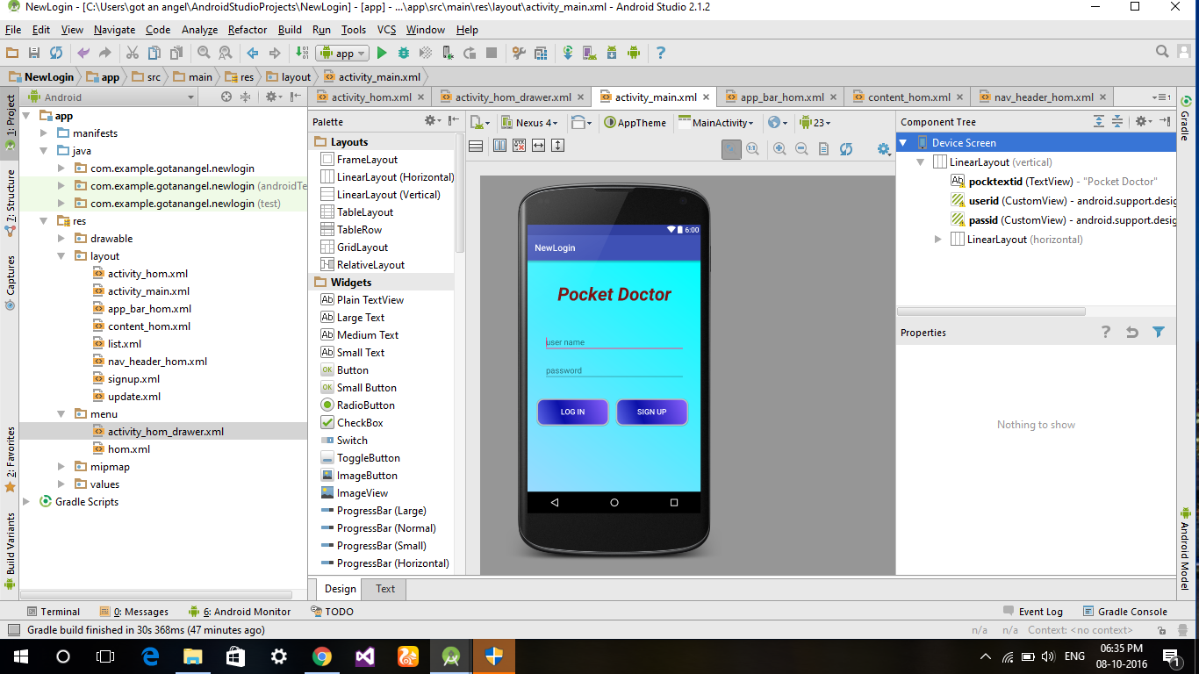

**Figure 2.23: login**

After the successful login user will be redirected to the home page.

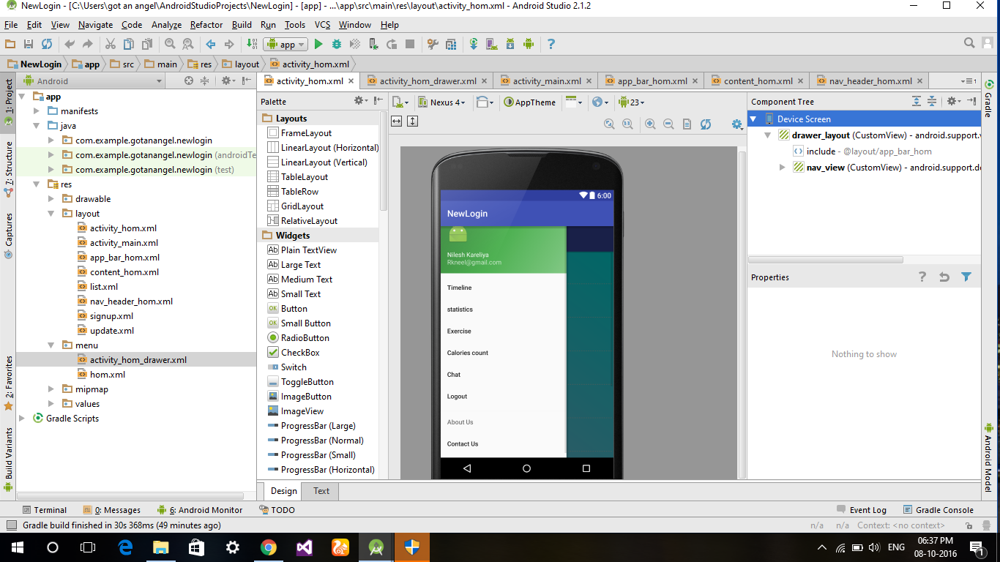

**Figure 2.24: Registration**

This is the timeline page where user can post or comment.

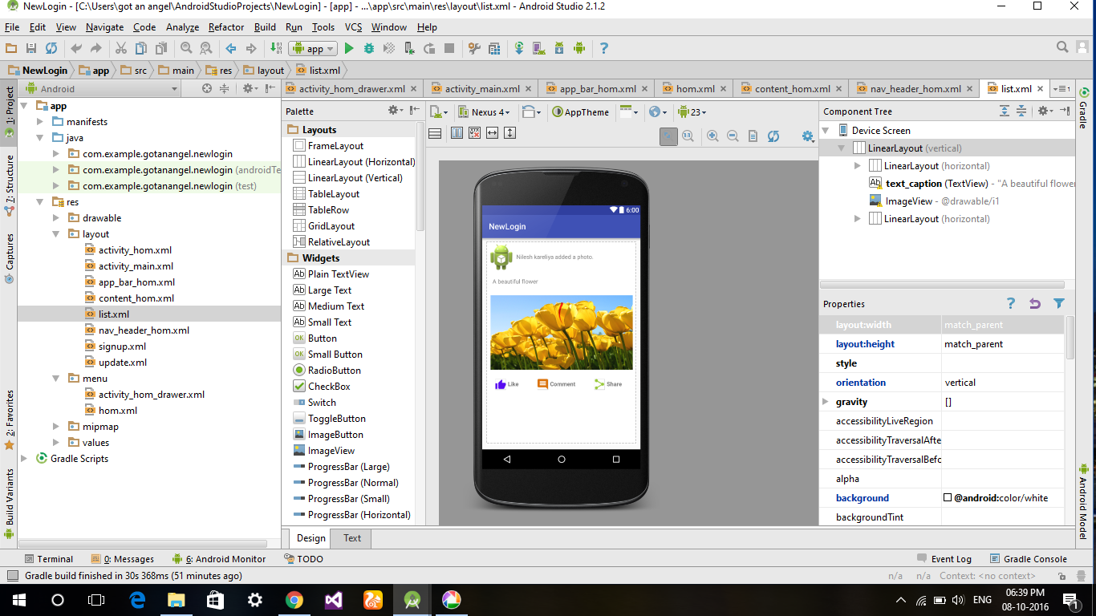

**Figure 2.15: Timeline**

# 4. Summary

We getting proper validation for registration and login phase .and also time line is allowing to posting and commenting. This is what up till now we have implemented and it is working correctly.

**4.1 Advantages**

Our system is useful for the entire age group .any one can use it from youngsters to older. it provide a way to maintain health without need to go to any trainer user can by self know how to do and what to do . patient medical history report is also maintain in application database so that user need not to carry the report all the time and also it is available from anywhere .doctor can also see the report from anywhere. We are using gear watch through which we can have information about the user’s pulse rate. This information help us to see the medical condition of the heart and blood pressure patient so that if any critical condition to a patient can be easily track before it happens.

User who what to lose weight for them it is a great platform where they are suggested with the diet plan and what kind of exercise they should do to maintain or lose the body fat.

**4.2 Features of Project**

* Easy to use and understand (user friendly)
* Smart software
* Dynamic System
* Personalized login
* Interactive GUI
* Increase Productivity

**References**

[1] https://www.google.co.in/patents/US6663564

[2] https://www.google.co.in/patents/US20060184393

[3] <https://www.google.co.in/patents/US20070238593>

[4] https://www.google.co.in/patents/ US20130029807

[5] https://www.google.co.in/patents/ US20140045547

[6] Black book of Android and w3schools tutorial for android.