HOFFMANN LABORATORY
Cow Uterine Contraction Analysis
Data-processing workflow, exploratory analyses, and current findings
Laboratory: Hoffmann Laboratory
Data: Cows 6263 and 6269
Repository: github.com/Yashwitha-7/Cow-Uterine-Contractions-Analysis
Report date: August 2026

Executive summary
A reproducible local workflow was developed to ingest, clean, review, analyze, and visualize cow uterine contraction sensor data. The current dataset contains contraction recordings from cows 6263 and 6269; cow 6263 also has bolus temperature and activity data. The workflow preserves all original observations, reconstructs timestamps for the current device, handles incomplete files and recording gaps, uses movement information to identify artifacts, and requires human review before applying possible polarity reversals.
Across both cows, 203,013 contraction observations produced 1,438 detected strain peaks. After movement, polarity, and bad-signal exclusions, 26 peaks remained as clean contraction candidates. Cow 6263 showed a cluster of accepted events approximately two hours before calving. Cow 6269 did not show the same retained pattern, but a substantial amount of its activity remains excluded because of unresolved polarity. Bolus temperature for cow 6263 showed a clearer 24-hour rhythm than contraction-candidate activity.
Interpretation: The retained events are signal-processing candidates, not physiologically confirmed uterine contractions. No predictive model was developed.

1. Study objective and scope
The objectives of this initial phase were to:
- Create a clean and traceable ingestion workflow for contraction TXT files and bolus Excel data.
- Reconstruct the contraction timeline while preserving incomplete files and true recording gaps.
- Identify movement, flat signal, and possible polarity problems before event analysis.
- Generate conservative contraction candidates for exploratory review.
- Compare contraction activity with bolus temperature on a common ten-minute timeline.
- Perform descriptive day/night and fixed 24-hour rhythm analyses.

2. Available data
Measurement | Cow 6263 | Cow 6269
Contraction observations | 137,322 | 65,691
Contraction files | 85 | 44
Timeline span | Approximately 90 hours | Approximately 40 hours
Bolus data | Available | Not available
Calving time | June 26, 2026, 3:54 AM | July 4, 2026, 1:41 AM

3. Sensor measurements

3.1 Contraction device
Each TXT row contains strain, three accelerometer axes, three gyroscope axes, a binary movement flag, and two unused user-input fields. The device developer confirmed that the movement flag is derived from the first six motion channels.
Flag value | Meaning | Cow 6263 rows | Cow 6269 rows
0 | No movement detected | 95,114 | 40,693
5 | Movement detected | 42,208 | 24,998

No intermediate movement-flag values occurred in any of the 129 available contraction files. Approximately 30.7% of cow 6263 observations and 38.1% of cow 6269 observations were marked as movement.

3.2 Bolus device
Cow 6263 has 1,116 ten-minute bolus observations. Drink-cycle-corrected temperature was used for analysis, with raw temperature as a fallback. This avoids interpreting temporary cooling after water intake as a physiological temperature decrease. Raw temperature reached 34.66°C, whereas corrected temperature began at 38.27°C.

4. Processing challenges
- The current contraction files do not contain a reliable per-observation time column.
- The sampling interval varies and is approximately 1.8–2.2 seconds rather than exactly one second.
- Hourly files can begin from different strain baselines.
- The final file may be incomplete because the device was removed early.
- Movement can produce strain peaks that resemble contraction events.
- Possible polarity reversals cannot be established safely from skew alone.
- No independent physiological reference confirms every contraction.

5. Data-processing workflow

5.1 Ingestion and preservation
Every raw file is copied to an immutable cow-specific raw-data folder. Numeric sensor columns are validated and standardized, and all observations remain traceable to the source filename. Processed CSVs are saved separately from raw files.

5.2 Timestamp reconstruction
File start times are extracted from filenames. Reliable full-hour files provide sample-period estimates. Each row is assigned a timestamp from the file start, sample index, and estimated period. Partial files inherit a nearby reliable period and are shortened to the next file boundary when necessary to prevent timestamp overlap. True gaps create separate continuous recording segments.

5.3 Strain and movement quality control
Raw strain is retained. File-level median centering provides a robust QC representation that reduces arbitrary baseline differences without being dominated by isolated peaks. Acceleration and gyroscope magnitudes and their 30-second variability are calculated. A region is considered movement-associated when the binary device flag equals 5 or when calculated IMU variability is unusually high.
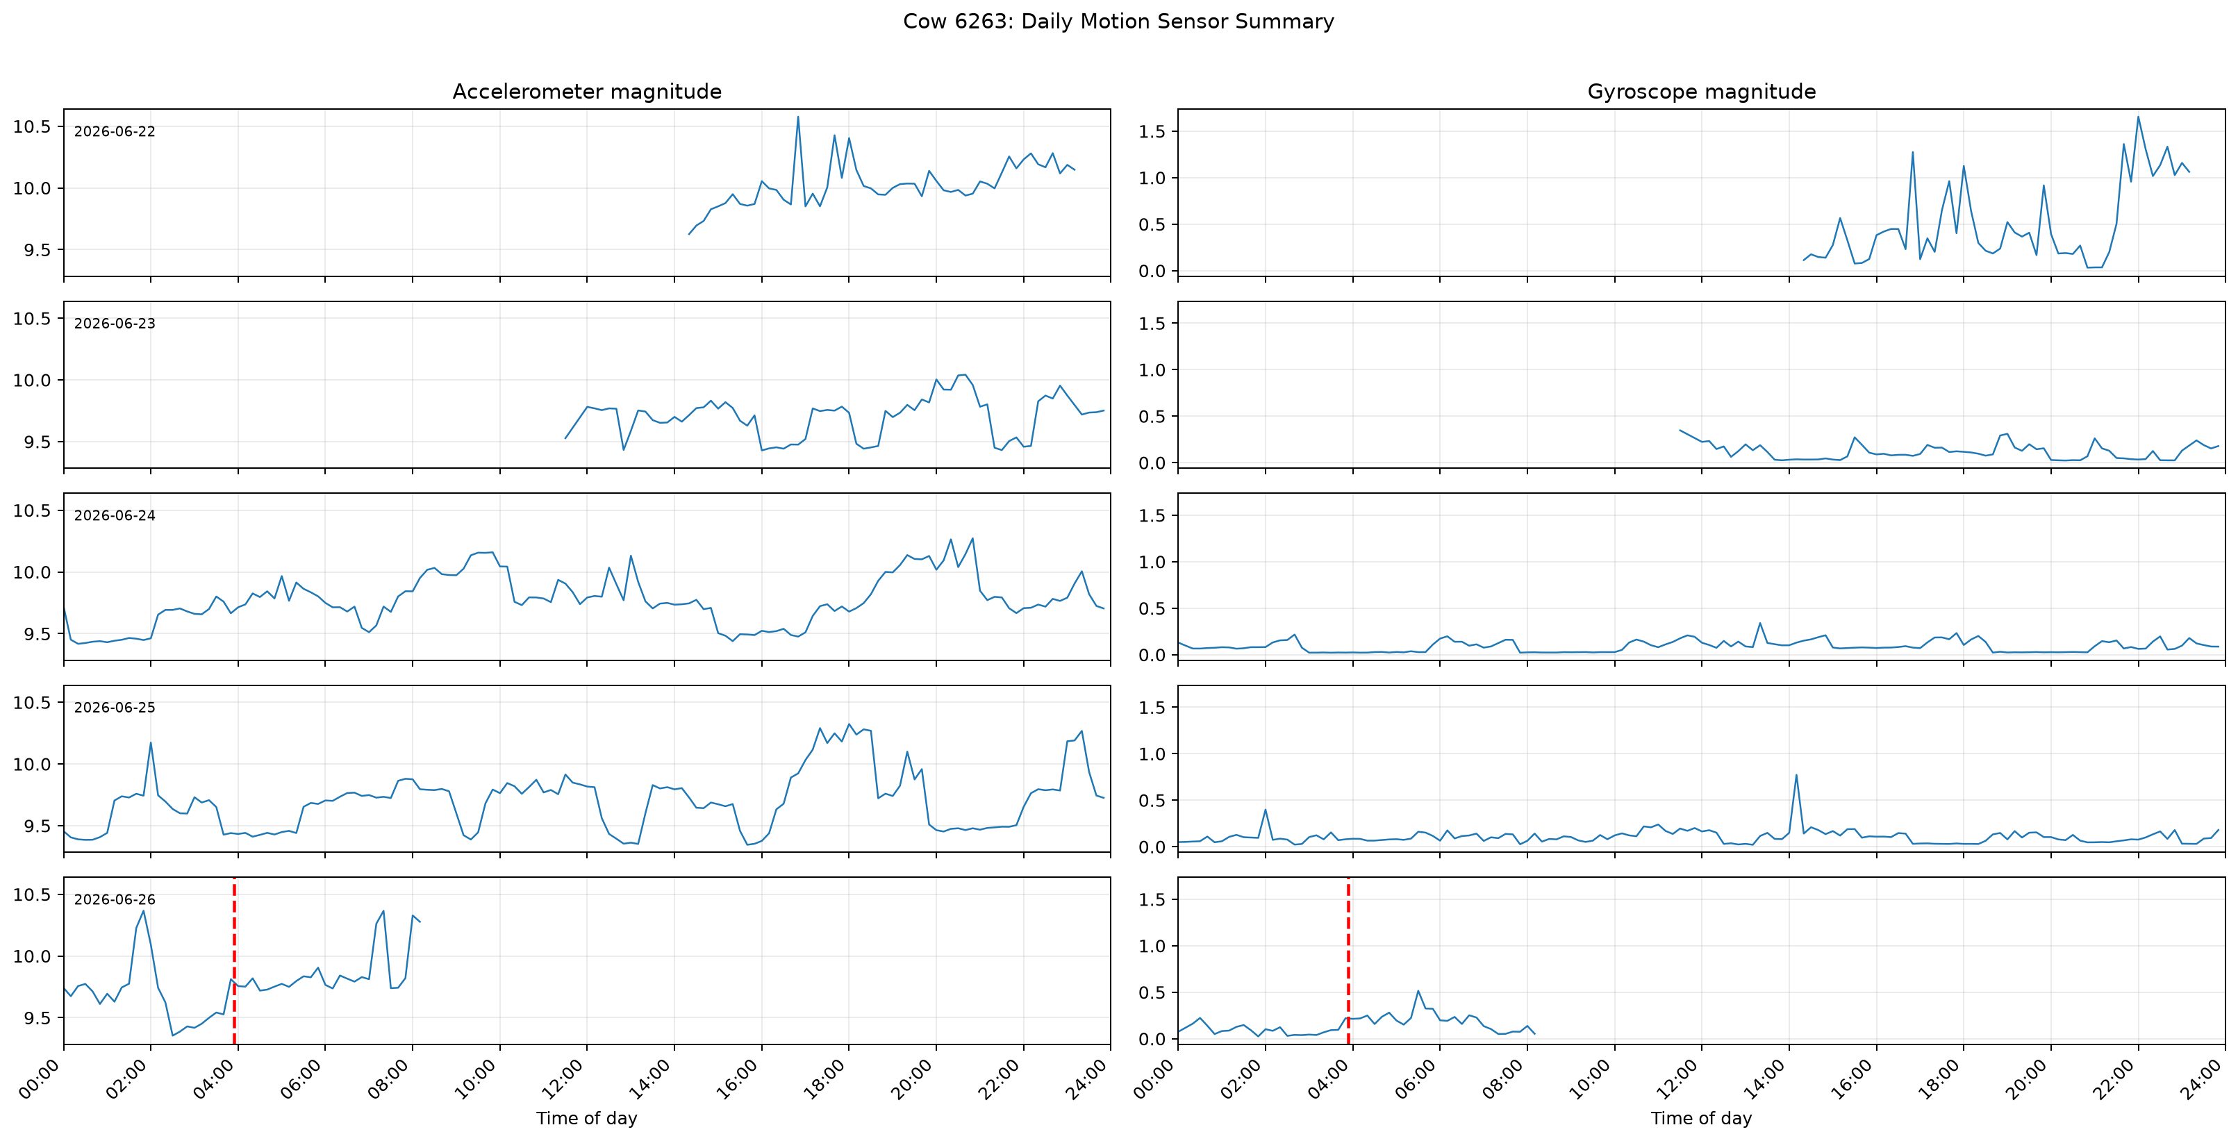
Figure 1. Cow 6263 acceleration and gyroscope magnitude by day.

5.4 Polarity review
Files in which negative strain excursions dominate positive excursions are marked for human review. Consecutive flagged files are grouped. The reviewer sees the complete section, 30 minutes before and after it, exact time boundaries, strain, acceleration, and gyroscope signals. Decisions are Keep, Flip, or Uncertain / exclude. Raw files are never modified.
Current status: Unresolved sections were temporarily marked uncertain and excluded from clean candidate counts. They remain available for review with the device developer.

5.5 Candidate detection
The reviewed centered strain is smoothed with a robust median window. Prominent peaks are detected using minimum prominence, temporal separation, and width rules. Each peak is classified as a clean candidate, movement-associated, uncertain-polarity, or bad-signal event. Clean candidates are exploratory and not confirmed contractions.

5.6 Ten-minute synchronization
The full-resolution contraction signal is preserved, while summary features and event counts are calculated in ten-minute intervals. Bolus observations are aligned with these intervals. Missing contraction coverage is explicitly recorded and not treated as zero activity.

5.7 Statistical analyses
- Candidate count per valid recording hour
- Day/night comparison using 6:00 AM–5:59 PM and 6:00 PM–5:59 AM
- Fixed 24-hour cosinor summaries
- Bolus temperature mean, median, variability, and daily rhythm
- Candidate timing relative to documented calving

6. Event-quality results
Event category | Cow 6263 | Cow 6269
Total detected peaks | 787 | 651
Movement-associated | 698 | 413
Uncertain polarity | 47 | 210
Bad signal | 23 | 21
Clean candidates | 19 | 7

Only 2.4% of cow 6263 peaks and 1.1% of cow 6269 peaks passed the current clean-candidate criteria. Movement was the dominant exclusion category. Polarity uncertainty had a particularly large effect on cow 6269.

7. Cow 6263 contraction findings
Cow 6263 produced 19 clean candidates. Nine occurred between approximately 1:45 AM and 2:03 AM on June 26, approximately 1 hour 51 minutes to 2 hours 9 minutes before the documented 3:54 AM calving time. Three clean candidates occurred within the final two hours, and five occurred two to six hours before calving.
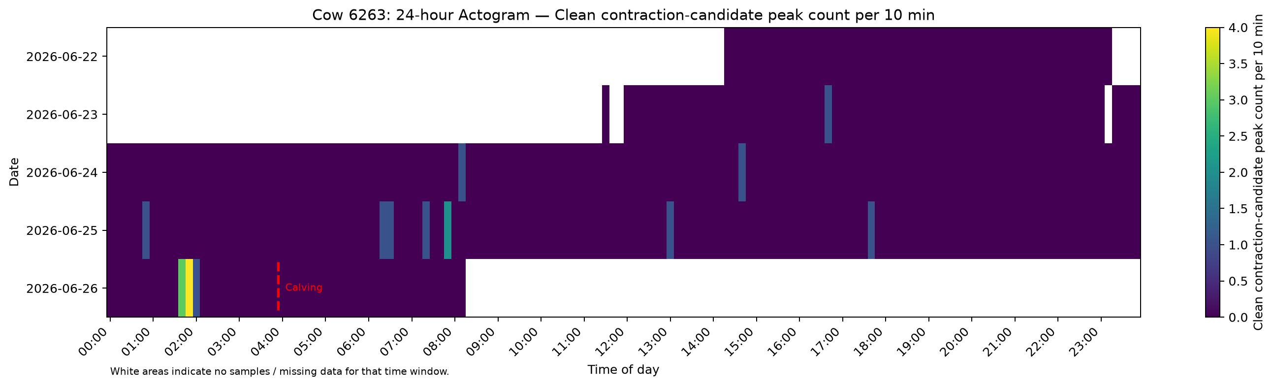
Figure 2. Cow 6263 clean contraction-candidate count per ten-minute interval. White denotes missing samples.
The clustering is an important observation for this cow, but it cannot yet define a general prediction window. The all-candidate actogram is much denser, demonstrating how strongly movement and QC exclusions affect interpretation.

8. Cow 6269 contraction findings
Cow 6269 produced seven clean candidates. No clean candidate was retained in the final two hours before the documented 1:41 AM calving time. One occurred two to six hours before calving, and three occurred 12–24 hours before calving. Fifty-two peaks in the final two hours were excluded because they occurred in unresolved polarity sections.
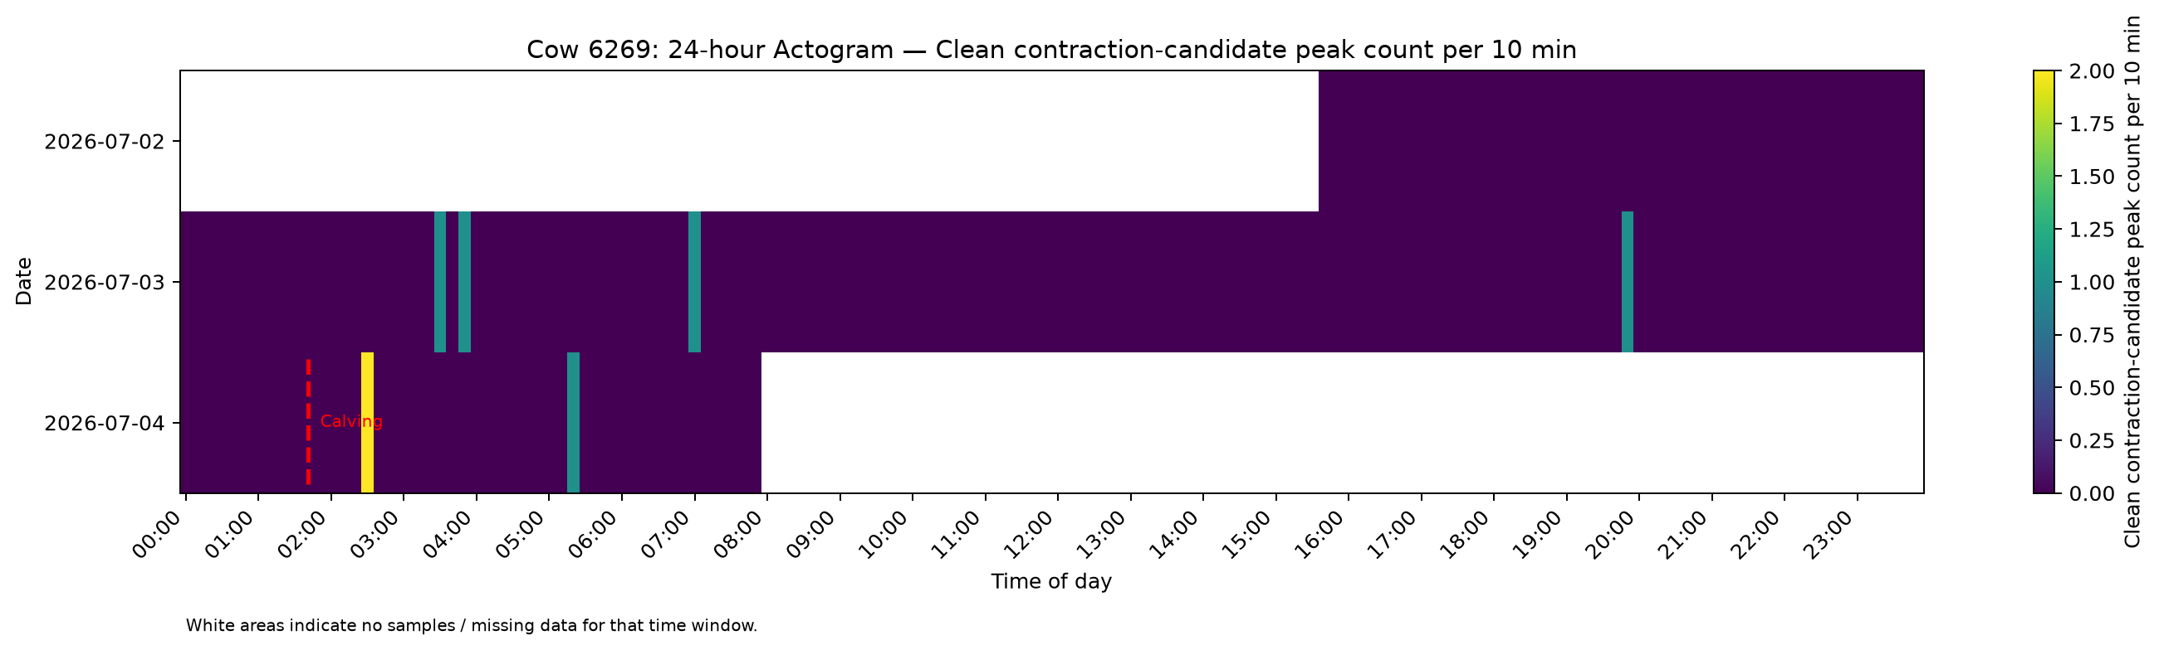
Figure 3. Cow 6269 clean contraction-candidate count per ten-minute interval.
The absence of retained pre-calving candidates does not demonstrate absence of uterine contractions. Cow 6269 must be reassessed after polarity review because 210 detected peaks currently fall in uncertain-polarity regions.

9. Cow 6263 bolus-temperature findings
Statistic | Result
Ten-minute observations | 1,116
Rhythm-adjusted mean | 39.20°C
Estimated 24-hour amplitude | 0.19°C
Estimated peak phase | Approximately 3:33 AM
24-hour variance explained | 21.8%
Daytime mean | 39.13°C
Nighttime mean | 39.28°C

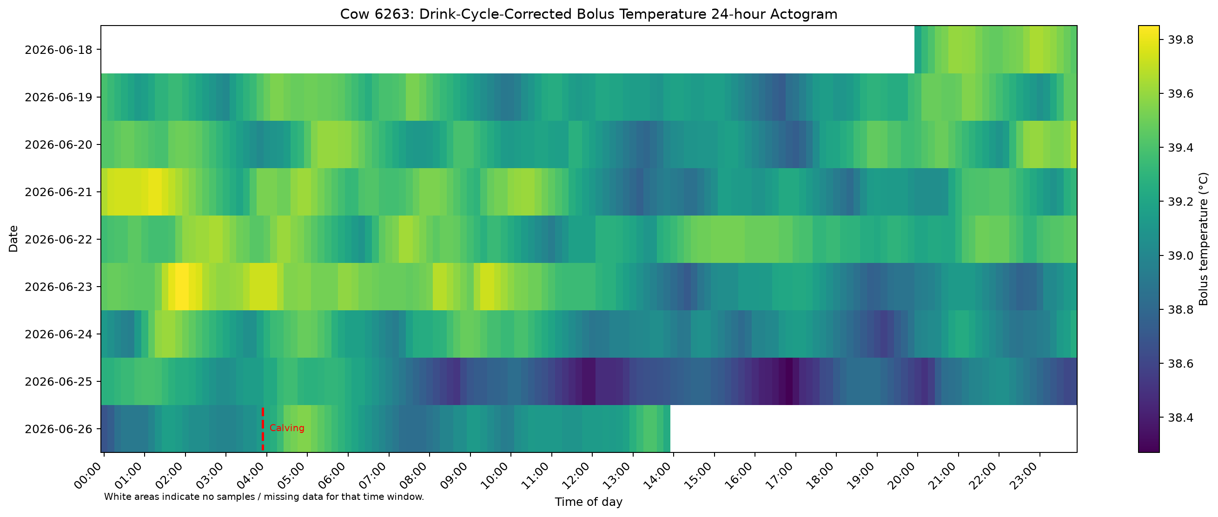
Figure 4. Cow 6263 drink-cycle-corrected bolus temperature by date and time of day.
Nighttime temperature was approximately 0.15°C warmer on average. The 24-hour temperature pattern was clearer than the contraction-candidate rhythm.

10. Parallel bolus and contraction view
Bolus temperature changes slowly, whereas strain candidates are short mechanical events. The shared ten-minute timeline permits parallel examination around calving without assuming that temperature and strain peaks should occur simultaneously.
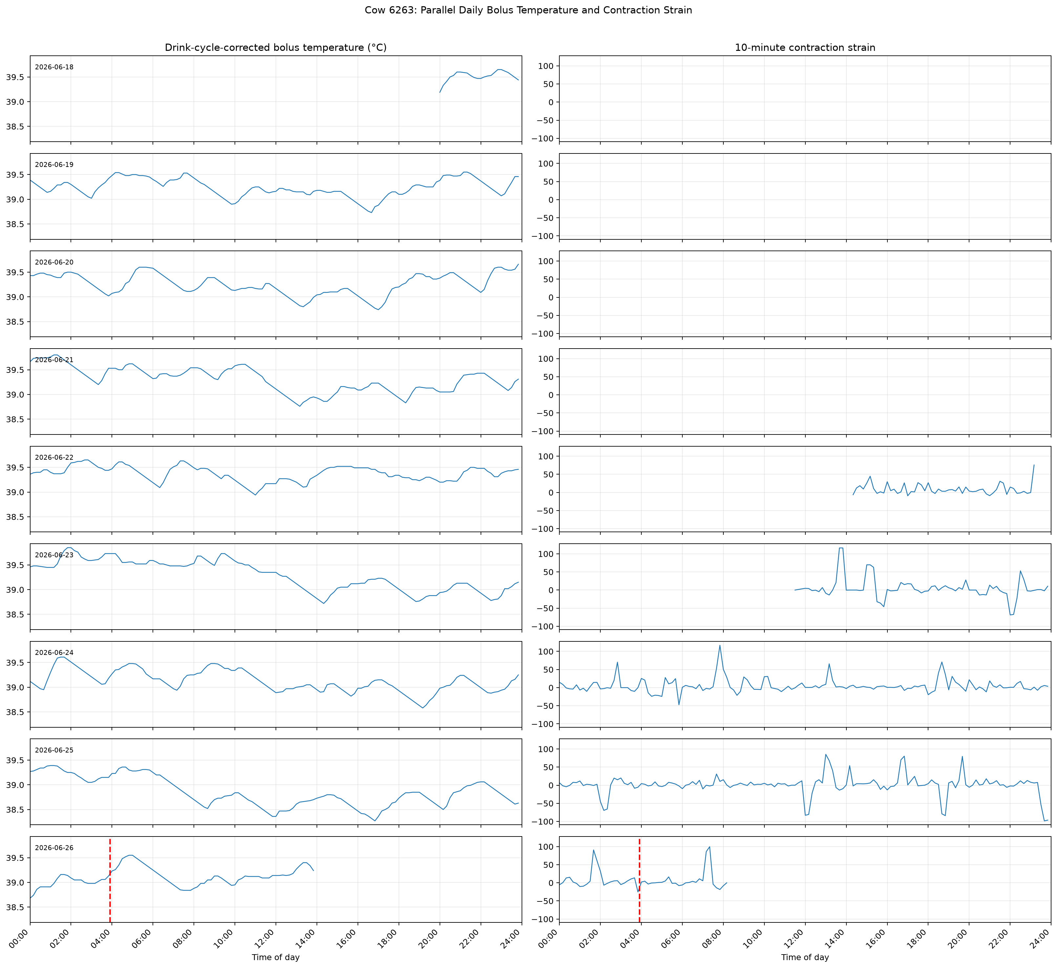
Figure 5. Cow 6263 bolus temperature and contraction strain on a common daily timeline.

11. Day/night results
Measurement | Cow 6263 | Cow 6269
Day clean candidates | 10 | 1
Day valid hours | 36.17 | 16.33
Day candidates/hour | 0.276 | 0.061
Night clean candidates | 9 | 6
Night valid hours | 41.17 | 24.00
Night candidates/hour | 0.219 | 0.250

Cow 6263 had similar day and night rates. Cow 6269 had a higher nighttime rate. The cows do not show a consistent shared day/night pattern, and these comparisons are descriptive rather than population-level inference.

12. Circadian results
Signal | Estimated phase | Variance explained
Cow 6263 candidates | 4:25 AM | 0.5%
Cow 6269 candidates | 3:54 AM | 1.8%
Cow 6263 bolus temperature | 3:33 AM | 21.8%

The contraction-candidate rhythm was weak in both cows; therefore, the estimated phases should not be emphasized. Bolus temperature showed a clearer daily pattern.

13. Main conclusions
- The workflow preserves raw data and produces traceable QC, processed data, statistics, and figures.
- Movement is a major component of the recorded strain signal and must be considered during peak interpretation.
- Cow 6263 showed a cluster of clean candidates approximately two hours before calving.
- Cow 6269 did not show the same retained pattern, but polarity uncertainty limits interpretation.
- Cow 6263 bolus temperature showed a measurable daily rhythm.
- The two cows show substantial individual and signal-quality differences.

14. Limitations
- Only two cows are available.
- Only one cow has bolus data.
- Current contraction timestamps are reconstructed.
- Polarity review is incomplete.
- No independent physiological reference confirms candidate contractions.
- The meaning of the device’s movement algorithm is known at the binary-output level, but its internal threshold and time window remain undocumented.
- No predictive or classification model is justified at the current sample size.

15. Recommended next steps
- Review uncertain polarity sections with the device developer and rerun the analysis.
- Use the next device version’s per-observation time column and document clock synchronization.
- Collect additional cows with both contraction and bolus devices.
- Place two contraction sensors on the same cow and compare agreement.
- Standardize sensor placement, restart logging, calibration logging, and calving metadata.
- Create an independently reviewed validation set before developing predictive models.

16. Reproducibility and sharing
The GitHub repository contains code and documentation but deliberately excludes raw cow data, processed results, figures, and the SQLite database. A complete shared-folder package should contain:
- Raw contraction and bolus files
- Cow metadata and calving timestamps
- Polarity decisions
- The Git commit identifier used for analysis
- Generated processed CSVs, statistics, and figures
- This report and the repository user guide
Repository: https://github.com/Yashwitha-7/Cow-Uterine-Contractions-Analysis

