4. ACCEPTANCE TESTING
Acceptance testing is the final stage of the testing process. Its purpose is to confirm, from the point of view of the end user (the student), that UniReg meets the agreed acceptance criteria and is ready for delivery. Unlike functional and system testing, which check the system against its specification, acceptance testing checks the system against what the customer needs, and ends with a formal decision to accept or reject the system.
This section defines the acceptance criteria for UniReg (4.1), presents the acceptance test plan and test cases (4.2 and 4.3), and reports the results of executing them, including the defect found and the final acceptance decision (4.4).

4.1 Acceptance Criteria
The acceptance criteria were derived from two sources: the criteria given in the project brief for UniReg (registration confirmation in under 5 seconds and prevention of over-enrolment), and the core student activities that UniReg must support (log in, view courses, register, drop and view timetable). Each criterion is measurable, so that its outcome is an objective Met or Not met rather than a matter of opinion.
ID | Criterion | Description | Measure / threshold | Source | Priority
AC-01 | Registration confirmation | After a valid registration, a confirmation message with a unique reference number is displayed within 5 seconds. | Response time < 5 s; reference in format REG-XXXXXXXX | Project brief | High
AC-02 | No over-enrolment | The system never enrols more students than a course's capacity, including when many students register for the last seats at the same time. | Enrolled count <= capacity in 100% of attempts | Project brief | Critical
AC-03 | Secure access | Only valid students can log in. Invalid credentials are rejected with a message, the account locks after 3 failed attempts, and logout ends access. | Lock after exactly 3 failures; 0 protected pages reachable after logout | Derived | High
AC-04 | Drop course | A dropped course is removed from the student's timetable and its seat is released immediately for other students. | Seat count reduced by 1; course absent from timetable | Derived | High
AC-05 | Timetable accuracy | The timetable lists exactly the registered courses with the correct day, time and venue, in day/time order, with total credits. | 100% match with registered courses | Derived | High
AC-06 | Clash prevention | Registration is rejected when the new course overlaps an already registered course, and the clashing course is named. | Clash detected in 100% of overlapping cases | Derived | Medium
AC-07 | Credit limit | A student cannot exceed the maximum of 20 credit hours per semester. | Registration rejected when total > 20 | Derived | Medium
AC-08 | Duplicate prevention | A student cannot register for the same course twice (e.g. by re-submitting the form). | 0 duplicate enrolments | Derived | Medium
AC-09 | Performance under load | When 50 students submit registrations at the same moment, every request is answered within 5 seconds and no valid registration fails. | Slowest response < 5 s; 100% of valid requests confirmed | Project brief | High
Table 4.1: UniReg acceptance criteria

4.2 Acceptance Test Plan

4.2.1 Objectives
- Verify that every acceptance criterion in Table 4.1 is met by the delivered system.
- Exercise UniReg through realistic end-to-end student journeys rather than isolated functions.
- Record and report any defect that would stop the system being accepted, and confirm its fix by retesting.
- Provide evidence for a formal accept or reject decision.

4.2.2 Scope
In scope: student login, account lockout and logout; viewing available courses; course registration including capacity, clash, credit-limit and duplicate rules; dropping a course; viewing the timetable; and registration response time when 50 students register at the same moment.
Out of scope: administrator and lecturer functions, payment of fees, email/SMS notifications, and load beyond 50 simultaneous users. Load and stress limits are covered by the System Test Design section.

4.2.3 Test Approach
Acceptance testing was carried out as black-box user acceptance testing (UAT) from the student role. Test cases UAT-01 to UAT-13 follow one continuous student journey through the web interface, so the result of one step forms the starting state of the next, as it would for a real student. The browser steps were scripted with Playwright so that every click could be replayed exactly and response times measured precisely from the moment the Register button is clicked to the moment the confirmation message appears. Test cases UAT-14 and UAT-15 simulate 50 students submitting registrations at the same instant, which cannot be done reliably by hand.
Two test cycles were planned: Cycle 1 runs every test case on the delivered build. If any test fails, the defect is reported to the development team and, after a fix, Cycle 2 re-runs the complete set of test cases (not only the failed one) to confirm the fix and check that nothing else has broken (regression).

4.2.4 Test Environment and Test Data
Item | Details
System under test | UniReg web prototype. Cycle 1: build v1.0. Cycle 2: build v1.1 (contains the fix for DEF-01).
Server | Python 3.13 web server with SQLite database, Linux
Client | Chromium browser (headless), 1100 x 650 window, driven by Playwright 1.56
Load simulation | Node.js script sending 50 simultaneous registration requests from 50 logged-in student sessions
Student accounts | 60 accounts, S001 to S060, password Pass@123
Courses | 9 courses (3 or 4 credits each) with capacities from 10 to 40. SWC4413 Human Computer Interaction is pre-filled to 30/30 to test a full course.
Business rules | Maximum 20 credit hours per student; no overlapping classes; account locks after 3 failed logins
Table 4.2: Test environment and test data

4.2.5 Entry and Exit Criteria
Entry criteria: functional and system testing completed; the build installed in the test environment; test accounts and course data loaded; no open Critical defects from earlier stages.
Exit criteria: all acceptance test cases executed; every acceptance criterion Met; no open Critical or High severity defects; acceptance test report completed and signed off.

4.2.6 Roles and Responsibilities
Role | Responsibility | Person
Acceptance test lead | Defines criteria and test cases, executes tests, logs defects, writes the acceptance test report | Yasierul
Development team | Analyses and fixes reported defects, delivers the new build | Group (simulated)
Reviewers | Review the acceptance criteria and the final decision | Amir, Ramzi, Aliff
Table 4.3: Roles and responsibilities

4.2.7 Defect Severity Classification
Severity | Meaning | Effect on acceptance
Critical | Breaks a business rule or corrupts data; no workaround | System cannot be accepted until fixed
High | Major function fails, a workaround exists | Must be fixed before acceptance
Medium | Function works but incorrectly in some cases | May be accepted with a fix plan
Low | Cosmetic or wording issue | Does not block acceptance
Table 4.4: Defect severity levels

4.2.8 Requirements Traceability
Table 4.5 links each acceptance criterion to the test cases that verify it. Every criterion is covered by at least one test case, and the two criteria from the brief (AC-01 and AC-02) are covered by several.
Criterion | Verified by test cases
AC-01 Registration confirmation | UAT-04, UAT-06, UAT-09, UAT-12, UAT-15
AC-02 No over-enrolment | UAT-05, UAT-06, UAT-14
AC-03 Secure access | UAT-01, UAT-02, UAT-03, UAT-13
AC-04 Drop course | UAT-11, UAT-12
AC-05 Timetable accuracy | UAT-10
AC-06 Clash prevention | UAT-08
AC-07 Credit limit | UAT-09, UAT-12
AC-08 Duplicate prevention | UAT-07
AC-09 Performance under load | UAT-14, UAT-15
Table 4.5: Traceability between acceptance criteria and test cases

4.3 Acceptance Test Cases
Table 4.6 lists the fifteen acceptance test cases. Each case states the criterion it verifies, its preconditions, the steps a student follows, and the expected result.
ID | AC | Scenario | Preconditions | Steps | Expected result
UAT-01 | AC-03 | Valid login | Student S001 exists (password Pass@123). | 1. Open UniReg login page.  2. Enter S001 / Pass@123.  3. Click Login. | Student is logged in and taken to the Available Courses page.
UAT-02 | AC-03 | Invalid password | Student S002 exists. | 1. Enter S002 with a wrong password.  2. Click Login. | Login refused with "Invalid student ID or password" and the remaining attempts shown.
UAT-03 | AC-03 | Account lockout | UAT-02 done (1 failed attempt). | 1. Enter two more wrong passwords for S002.  2. Enter the correct password. | After the 3rd failure the account is locked; the correct password is also refused while locked.
UAT-04 | AC-01 | Register an open course | S001 logged in; SWC4263 has 0/40 seats taken. | 1. Click Register for SWC4263.  2. Time from click to message. | Confirmation with reference REG-XXXXXXXX shown in < 5 s; seats become 1/40.
UAT-05 | AC-02 | Register a full course | SWC4413 is full (30/30). | 1. Click Register for SWC4413. | Registration rejected with a "full" message; seats remain 30/30.
UAT-06 | AC-01, AC-02 | Last remaining seat | SWC4613 has 29/30 seats taken. | 1. S001 registers for SWC4613.  2. Student S060 then tries the same course. | S001 is confirmed (30/30). S060 is rejected; seats stay 30/30.
UAT-07 | AC-08 | Duplicate registration | S001 already registered for SWC4263. | 1. Re-submit the SWC4263 registration form (Back + resubmit). | Rejected with "already registered"; seats stay 1/40.
UAT-08 | AC-06 | Timetable clash | S001 has SWC4263 (Mon 09:00-11:00). | 1. Register for SWC4113 (Mon 10:00-12:00). | Rejected; message names the clashing course SWC4263.
UAT-09 | AC-07 | Credit limit | S001 has 6 credits. | 1. Register SWC4213, SWC4323, SWC4513, SWC4723 (total 20).  2. Register SWC4823 (3 credits). | First four confirmed. SWC4823 rejected with "Credit limit exceeded".
UAT-10 | AC-05 | View timetable | S001 has 6 courses (20 credits). | 1. Open My Timetable. | Exactly 6 courses listed with correct day, time and venue in day/time order; "Total credits: 20 / 20".
UAT-11 | AC-04 | Drop a course | S001 registered for SWC4613 (30/30). | 1. Click Drop for SWC4613.  2. Check timetable and seat count. | Course removed, total becomes 17 credits, SWC4613 seats become 29/30.
UAT-12 | AC-04, AC-07 | Reuse freed capacity | UAT-11 done. | 1. S001 registers SWC4823 (17 + 3 = 20).  2. S060 retries SWC4613. | Both registrations confirmed.
UAT-13 | AC-03 | Logout | S001 logged in. | 1. Click Logout.  2. Try to open My Timetable. | Redirected to the login page.
UAT-14 | AC-02, AC-09 | Race for last seats | Fresh system. SWC4823 has 10 free seats; 50 students logged in. | 1. All 50 students submit SWC4823 at the same instant.  2. Count confirmations and stored enrolments. | Exactly 10 confirmed and 10 stored; 40 rejected; all responses < 5 s.
UAT-15 | AC-01, AC-09 | Concurrent registration load | 50 students logged in; enough seats (40 x SWC4263, 10 x SWC4213). | 1. All 50 students submit at the same instant.  2. Record each response time. | All 50 confirmed; slowest response < 5 s.
Table 4.6: Acceptance test cases

4.4 Acceptance Test Report

4.4.1 Execution Summary
Cycle | Build | Date | Executed | Passed | Failed | Outcome
1 | v1.0 | 12 Oct 2026 | 15 | 14 | 1 | Rejected: DEF-01 (Critical) raised
2 | v1.1 | 12 Oct 2026 | 15 | 15 | 0 | All criteria met
Table 4.7: Summary of acceptance test cycles

4.4.2 Cycle 1 Results (build v1.0)
ID | Actual result | Status
UAT-01 | Logged in as S001 and redirected to Available Courses page. | PASS
UAT-02 | Message shown: "Invalid student ID or password. 2 attempt(s) left." | PASS
UAT-03 | After 3rd wrong attempt: "Account locked after 3 failed attempts. Contact the Registry.". Correct password then gives: "Account locked after 3 failed attempts. Contact the Registry." | PASS
UAT-04 | "Registration confirmed for SWC4263 Software Testing and Quality Assurance. Reference: REG-7C65035C at 2026-10-12 06:18:04." displayed in 0.14 s; seats now 1/40. | PASS
UAT-05 | "SWC4413 is full (30/30). Registration rejected." Seats before 30/30, after 30/30. | PASS
UAT-06 | Seats before 29/30. S001: "Registration confirmed for SWC4613 Data Mining. Reference: REG-8CB90BE1 at 2026-10-12 06:18:06." (0.12 s). S060 then: "SWC4613 is full (30/30). Registration rejected.". Seats after 30/30. | PASS
UAT-07 | Re-submitted SWC4263: "You are already registered for SWC4263."; seats remain 1/40. | PASS
UAT-08 | "Timetable clash with SWC4263 (Mon 09:00-11:00)." | PASS
UAT-09 | SWC4213 confirmed (0.13 s), SWC4323 confirmed (0.15 s), SWC4513 confirmed (0.16 s), SWC4723 confirmed (0.15 s). Then SWC4823: "Credit limit exceeded: 20 + 3 credits is more than the maximum of 20." | PASS
UAT-10 | 6 courses listed in day/time order (Mon 09:00-11:00 SWC4263; Tue 14:00-16:00 SWC4213; Wed 09:00-12:00 SWC4323; Thu 14:00-16:00 SWC4513; Fri 09:00-11:00 SWC4613; Fri 14:00-17:00 SWC4723). Total credits: 20 / 20. | PASS
UAT-11 | "SWC4613 dropped. Your seat has been released." Course removed from timetable: true. Total credits: 17 / 20. SWC4613 seats now 29/30. | PASS
UAT-12 | S001 registers SWC4823: "Registration confirmed for SWC4823 Final Year Project Seminar." (0.13 s). S060 retries the released SWC4613 seat: confirmed. | PASS
UAT-13 | After logout, opening My Timetable redirects to the login page. | PASS
UAT-14 | 50 simultaneous requests for 10 seats: 16 confirmed, 34 rejected; 16 students stored as enrolled (capacity 10). Slowest response 1.46 s. | FAIL
UAT-15 | 50/50 confirmed. Average 1.07 s, 95th percentile 1.52 s, slowest 1.54 s. | PASS
Table 4.8: Cycle 1 actual results
Fourteen of the fifteen test cases passed in Cycle 1. Every rule worked correctly when students registered one at a time: full courses, clashes, duplicates and the credit limit were all rejected with clear messages, and confirmations appeared in at most 0.14 seconds. However, UAT-14 failed: when 50 students tried to register for the 10 remaining seats of SWC4823 at the same moment, the system confirmed and stored 16 students. This is the over-enrolment the brief explicitly requires the system to prevent, so it was logged as defect DEF-01.

4.4.3 Defect Report
Field | Details
Defect ID | DEF-01
Title | Course over-enrolled when several students register for the last seats at the same time
Found in | Cycle 1, build v1.0, test case UAT-14
Criterion violated | AC-02 No over-enrolment (also AC-09)
Severity | Critical: breaks a business rule from the brief and stores invalid data; there is no workaround for students or staff
Steps to reproduce | 1. Start with SWC4823 at 0/10 seats.  2. Log in 50 students.  3. Submit all 50 registrations for SWC4823 at the same instant.  4. Count stored enrolments for SWC4823.
Expected result | Exactly 10 enrolments stored; 40 requests rejected as full.
Actual result | 16 enrolments stored (capacity 10). Reproduced in 3 out of 3 runs, with 16, 12 and 11 students enrolled.
Root cause | The system checks the number of free seats and then saves the enrolment as two separate steps. Requests arriving together all read the seat count before any of them saved, so several saw the same last seat as free.
Fix | Build v1.1 locks the course record before checking the seat count, so registrations for the same seats are processed one after another.
Retest | Cycle 2, UAT-14: 50 simultaneous requests for 10 seats: 10 confirmed, 40 rejected; 10 students stored as enrolled (capacity 10). Slowest response 1.27 s. Repeated 3 times, exactly 10 enrolled each time.
Status | Closed
Table 4.9: Defect DEF-01

4.4.4 Cycle 2 Results (build v1.1, full regression)
ID | Actual result | Status
UAT-01 | Logged in as S001 and redirected to Available Courses page. | PASS
UAT-02 | Message shown: "Invalid student ID or password. 2 attempt(s) left." | PASS
UAT-03 | After 3rd wrong attempt: "Account locked after 3 failed attempts. Contact the Registry.". Correct password then gives: "Account locked after 3 failed attempts. Contact the Registry." | PASS
UAT-04 | "Registration confirmed for SWC4263 Software Testing and Quality Assurance. Reference: REG-BA520F00 at 2026-10-12 06:18:54." displayed in 0.13 s; seats now 1/40. | PASS
UAT-05 | "SWC4413 is full (30/30). Registration rejected." Seats before 30/30, after 30/30. | PASS
UAT-06 | Seats before 29/30. S001: "Registration confirmed for SWC4613 Data Mining. Reference: REG-894FA286 at 2026-10-12 06:18:55." (0.14 s). S060 then: "SWC4613 is full (30/30). Registration rejected.". Seats after 30/30. | PASS
UAT-07 | Re-submitted SWC4263: "You are already registered for SWC4263."; seats remain 1/40. | PASS
UAT-08 | "Timetable clash with SWC4263 (Mon 09:00-11:00)." | PASS
UAT-09 | SWC4213 confirmed (0.14 s), SWC4323 confirmed (0.14 s), SWC4513 confirmed (0.13 s), SWC4723 confirmed (0.14 s). Then SWC4823: "Credit limit exceeded: 20 + 3 credits is more than the maximum of 20." | PASS
UAT-10 | 6 courses listed in day/time order (Mon 09:00-11:00 SWC4263; Tue 14:00-16:00 SWC4213; Wed 09:00-12:00 SWC4323; Thu 14:00-16:00 SWC4513; Fri 09:00-11:00 SWC4613; Fri 14:00-17:00 SWC4723). Total credits: 20 / 20. | PASS
UAT-11 | "SWC4613 dropped. Your seat has been released." Course removed from timetable: true. Total credits: 17 / 20. SWC4613 seats now 29/30. | PASS
UAT-12 | S001 registers SWC4823: "Registration confirmed for SWC4823 Final Year Project Seminar." (0.14 s). S060 retries the released SWC4613 seat: confirmed. | PASS
UAT-13 | After logout, opening My Timetable redirects to the login page. | PASS
UAT-14 | 50 simultaneous requests for 10 seats: 10 confirmed, 40 rejected; 10 students stored as enrolled (capacity 10). Slowest response 1.27 s. | PASS
UAT-15 | 50/50 confirmed. Average 0.95 s, 95th percentile 1.49 s, slowest 1.53 s. | PASS
Table 4.10: Cycle 2 actual results

4.4.5 Acceptance Criteria Status
Criterion | Evidence | Cycle 1 | Cycle 2
AC-01 Registration confirmation | UAT-04, UAT-06, UAT-09, UAT-12, UAT-15 | Met | Met
AC-02 No over-enrolment | UAT-05, UAT-06, UAT-14 | Not met | Met
AC-03 Secure access | UAT-01, UAT-02, UAT-03, UAT-13 | Met | Met
AC-04 Drop course | UAT-11, UAT-12 | Met | Met
AC-05 Timetable accuracy | UAT-10 | Met | Met
AC-06 Clash prevention | UAT-08 | Met | Met
AC-07 Credit limit | UAT-09, UAT-12 | Met | Met
AC-08 Duplicate prevention | UAT-07 | Met | Met
AC-09 Performance under load | UAT-14, UAT-15 | Not met | Met
Table 4.11: Acceptance criteria status after each cycle

4.4.6 Analysis of Results
- Response time comfortably meets the 5-second target. A single registration was confirmed in at most 0.14 s in Cycle 2. With 50 students registering at once, the average response was 0.95 s and the slowest 1.53 s, still well under 5 s, although response time grows noticeably under load (from about 0.1 s to about 1 s).
- Business rules hold for individual students. Capacity, clash, credit-limit and duplicate rules were all enforced with clear messages that tell the student why the registration was refused.
- Concurrency was the real risk. The only defect appeared when students competed for the same seats at the same time, a situation that occurs on registration day and cannot be found by testing one student at a time. This shows why the acceptance plan included a simultaneous-registration test even though the functional tests had already passed.
- The fix did not introduce regressions. All 15 test cases passed when the full suite was re-run on v1.1.

4.4.7 Acceptance Decision
Cycle 1 (v1.0): REJECTED. Build v1.0 could not be accepted because DEF-01 breaks acceptance criterion AC-02, one of the two criteria set by the brief.
Final decision (v1.1): ACCEPTED. Build v1.1 meets all nine acceptance criteria, all 15 acceptance test cases pass, DEF-01 is closed and there are no open defects. UniReg v1.1 is therefore accepted for delivery, with the following recommendations:
- Repeat UAT-14 and UAT-15 with a larger number of students (for example 500) before the first real registration day, since only 50 simultaneous users were tested.
- Include the over-enrolment race test (UAT-14) permanently in the regression suite so that DEF-01 cannot return unnoticed.
- Carry out a short usability session with real students, since this cycle confirmed behaviour and timing but not ease of use.

Prepared by | Role | Signature | Date
Yasierul | Acceptance test lead |  | 12 October 2026

4.5 Test Evidence
The screenshots below were captured automatically during Cycle 2 (build v1.1) at the moment each expected result was checked. Cycle 1 screenshots and the raw result files for both cycles are kept with the test scripts.
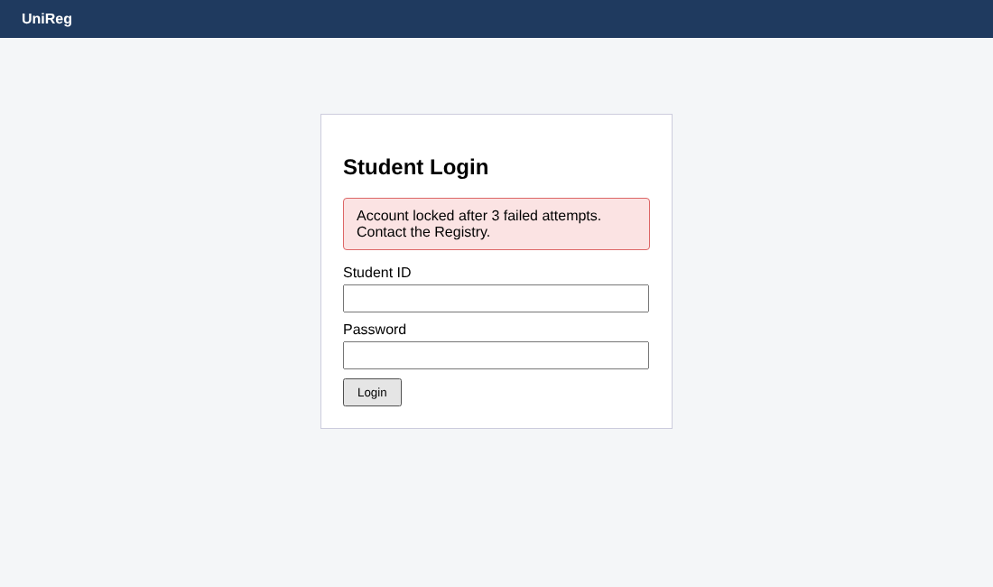
Figure 4.1: UAT-03 account locked after three failed login attempts
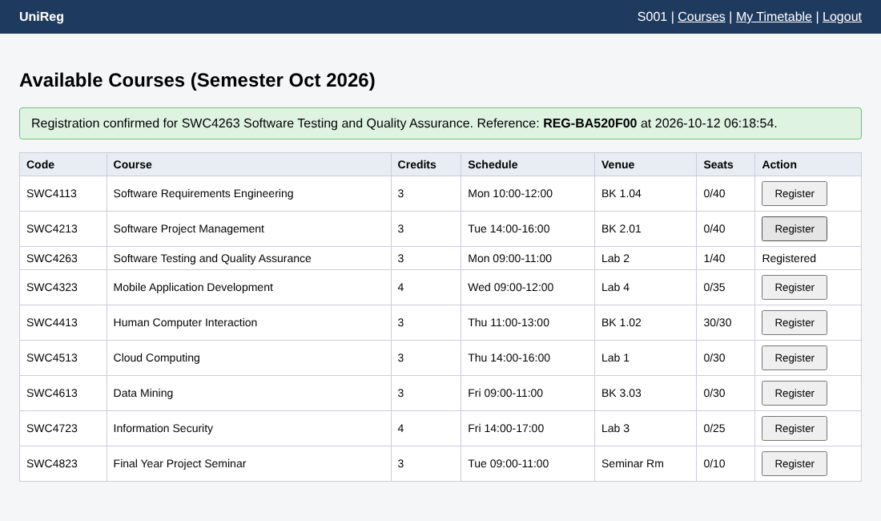
Figure 4.2: UAT-04 registration confirmation with reference number
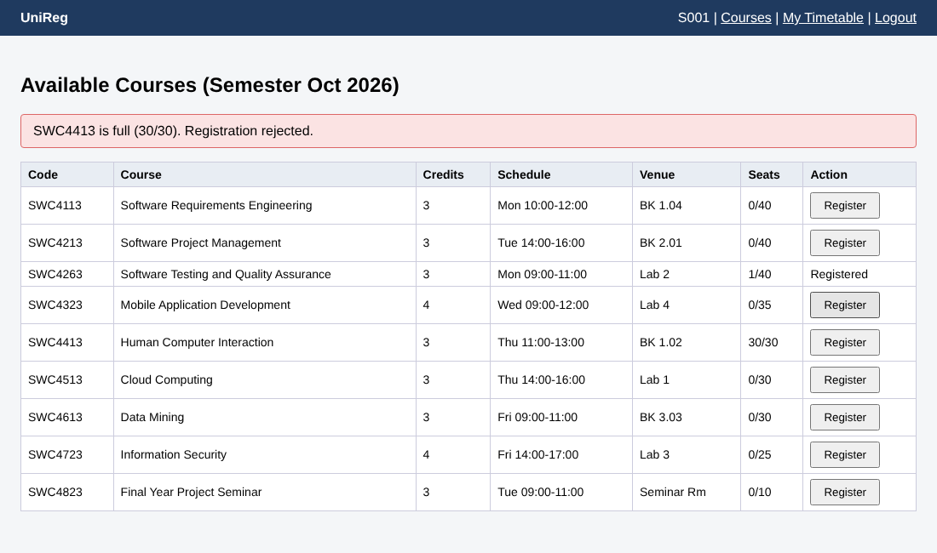
Figure 4.3: UAT-05 registration for a full course rejected
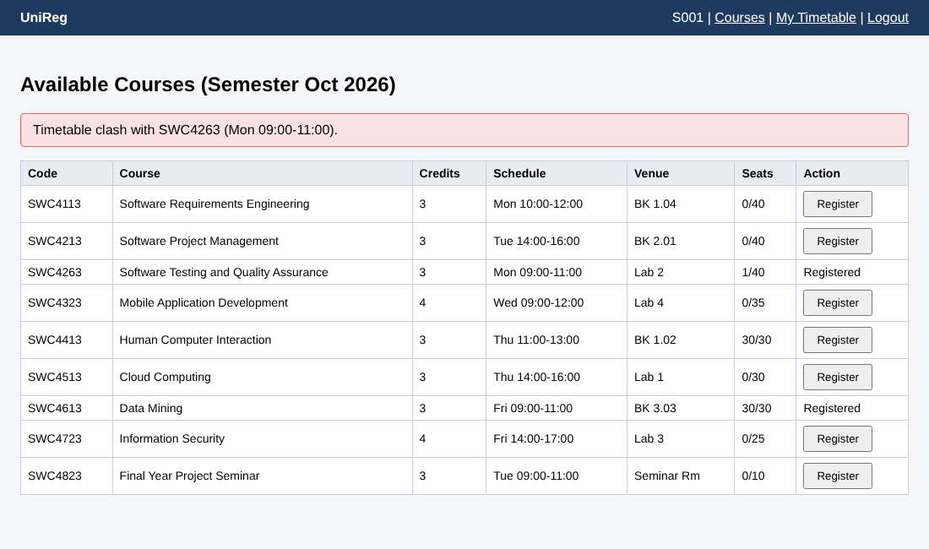
Figure 4.4: UAT-08 timetable clash detected
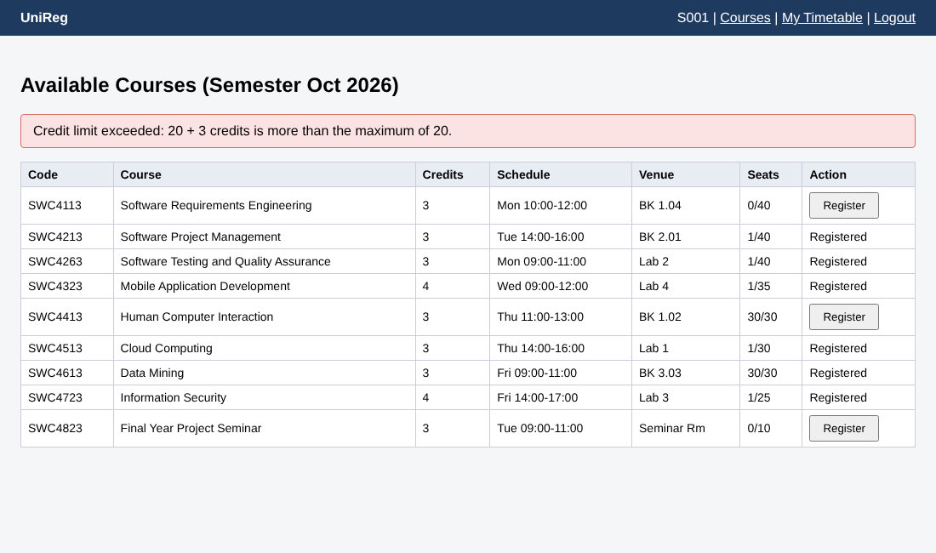
Figure 4.5: UAT-09 credit limit enforced
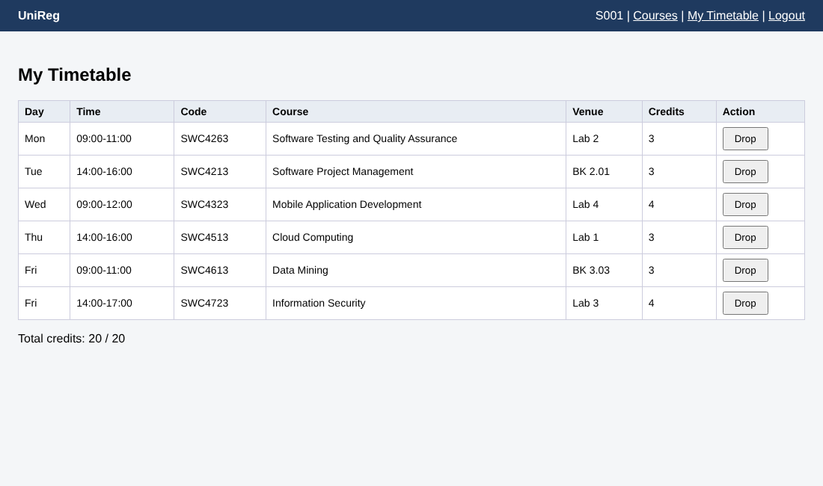
Figure 4.6: UAT-10 timetable showing 6 courses and 20 credits
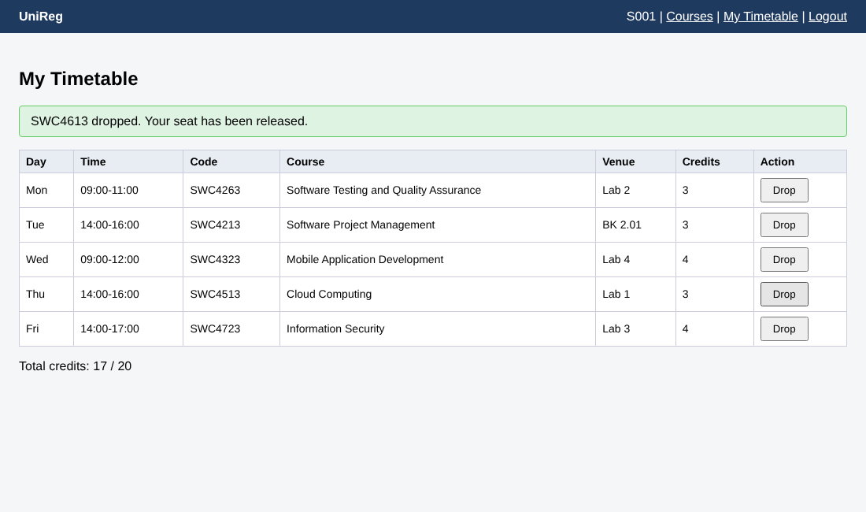
Figure 4.7: UAT-11 course dropped and seat released

