*System architecture diagram*

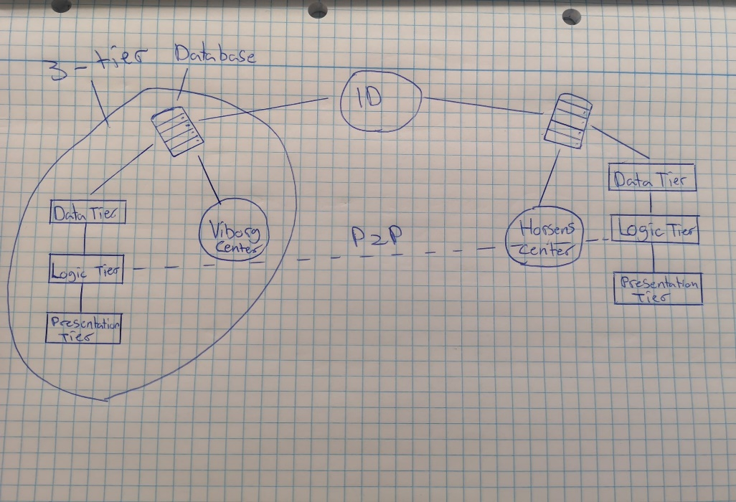

* Two centers one in Viborg and one in Horsens
* Regular member only can access user interface to see events for that center only
* Premium member can access user interface for both centers
* Both centers have a three-tier-architecture consisting of
* Tier-1 = The Presentation tier.
* Tier-2 = The Logic tier.
* Tier-3 = The Data tier.
* There is a p2p connection between the two centers (distributed system).
* Each center has a database. Now the two databases need to connect, this is done by having a different id for each center.
* In order to, make the systems heterogenous the one of tier could be coded in another language fx. The client

*Conceptual domain diagram*

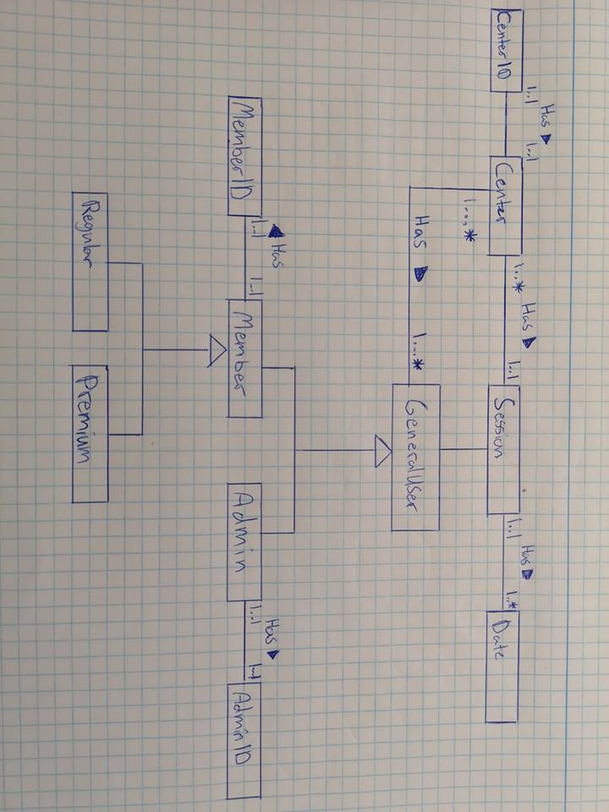

*System sequence diagram*

