PREDICT & RETAIN
Data-Driven HR Employee Attrition & Workforce Analytics
Foundations of Data Science | October 2026 | Submission-Ready Technical Report
Executive Summary
This study evaluates employee attrition patterns across 1,470 employee records from the IBM HR Analytics benchmark dataset using exploratory data analysis, statistical hypothesis testing, and an interactive Streamlit dashboard.
- Overtime Association: Employees assigned to overtime exhibit an observed attrition rate of 30.53% vs 10.44% for non-overtime staff (Chi-square = 87.56, p < 0.001).
- Compensation Gap: Retained personnel average $6,832.74 monthly earnings vs $4,787.09 for departing staff ($2,045.65 difference, Welch t = -7.48, p < 0.001).
- Tenure Cohorts: Employees in years 0–2 experience an observed attrition rate of 29.82%, dropping to 13.82% in years 3–5 and 8.13% after 11 years.
- Job Role Variation: Highest observed attrition occurs in Sales Representatives (39.76%), Laboratory Technicians (23.94%), and Human Resources (23.08%).
- Commute Distance: Staff living >20 km away exhibit 22.06% attrition compared to 13.77% within 0–5 km.
1. Dataset & Analytical Fields
The dataset contains 1,470 rows and 35 baseline columns, with 0 missing values and 0 duplicate records. Overall workforce turnover is 16.12% (237 departed / 1,233 retained). Key fields include Attrition, Age, Department, JobRole, MonthlyIncome, OverTime, YearsAtCompany, DistanceFromHome, JobSatisfaction, and WorkLifeBalance.
2. Salary Reference Reconciliation
The project specification referenced salary values of approximately $11,330 for retained staff and $9,592 for departing staff. The authentic dataset (final_dataset.csv) yields actual calculated mean monthly incomes of $6,832.74 for retained employees and $4,787.09 for departing employees. In accordance with data integrity guidelines, all reported values reflect actual dataset calculations rather than forced reference figures. Both indicate a statistically significant compensation gap (p < 0.001).
3. Visual Assets & Key Findings
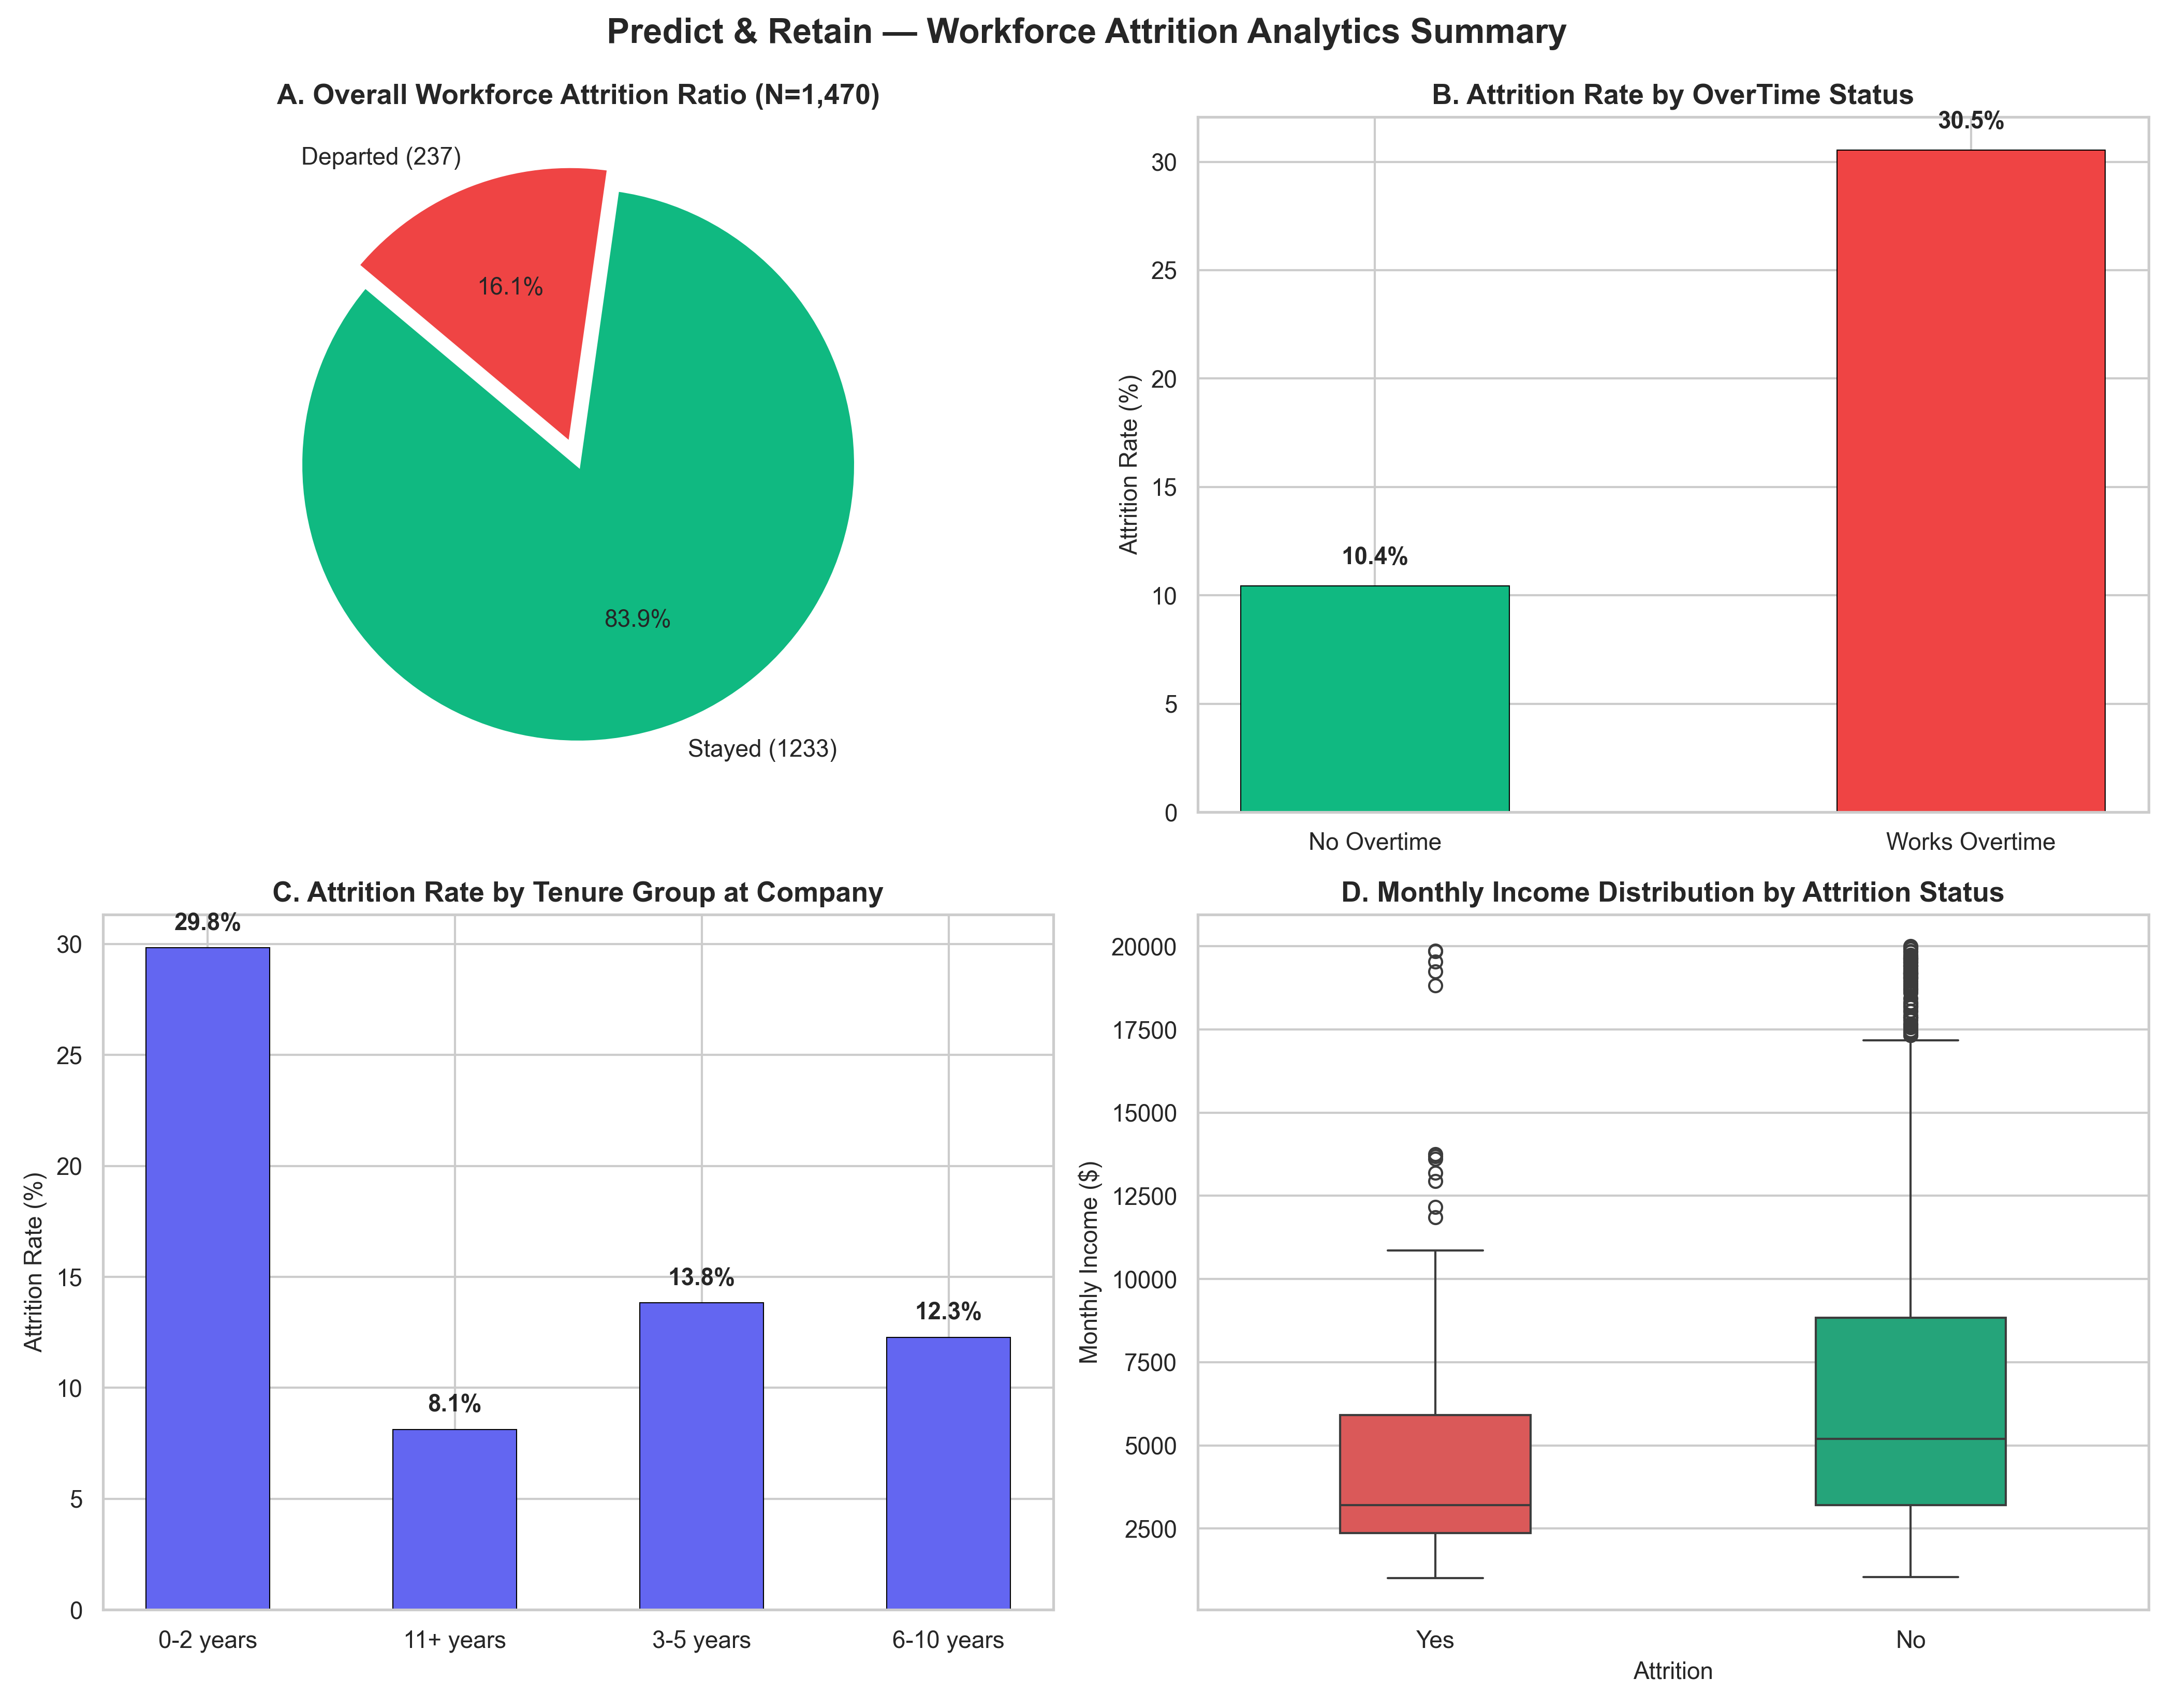
Figure 1: Workforce Analytics Multi-Panel Summary.
3.1 Department and Role Turnover
Sales exhibits an observed attrition rate of 20.63%, Human Resources 19.05%, and Research & Development 13.84%. Job roles with the highest observed attrition rates are Sales Representatives (39.76%), Laboratory Technicians (23.94%), and Human Resources (23.08%).
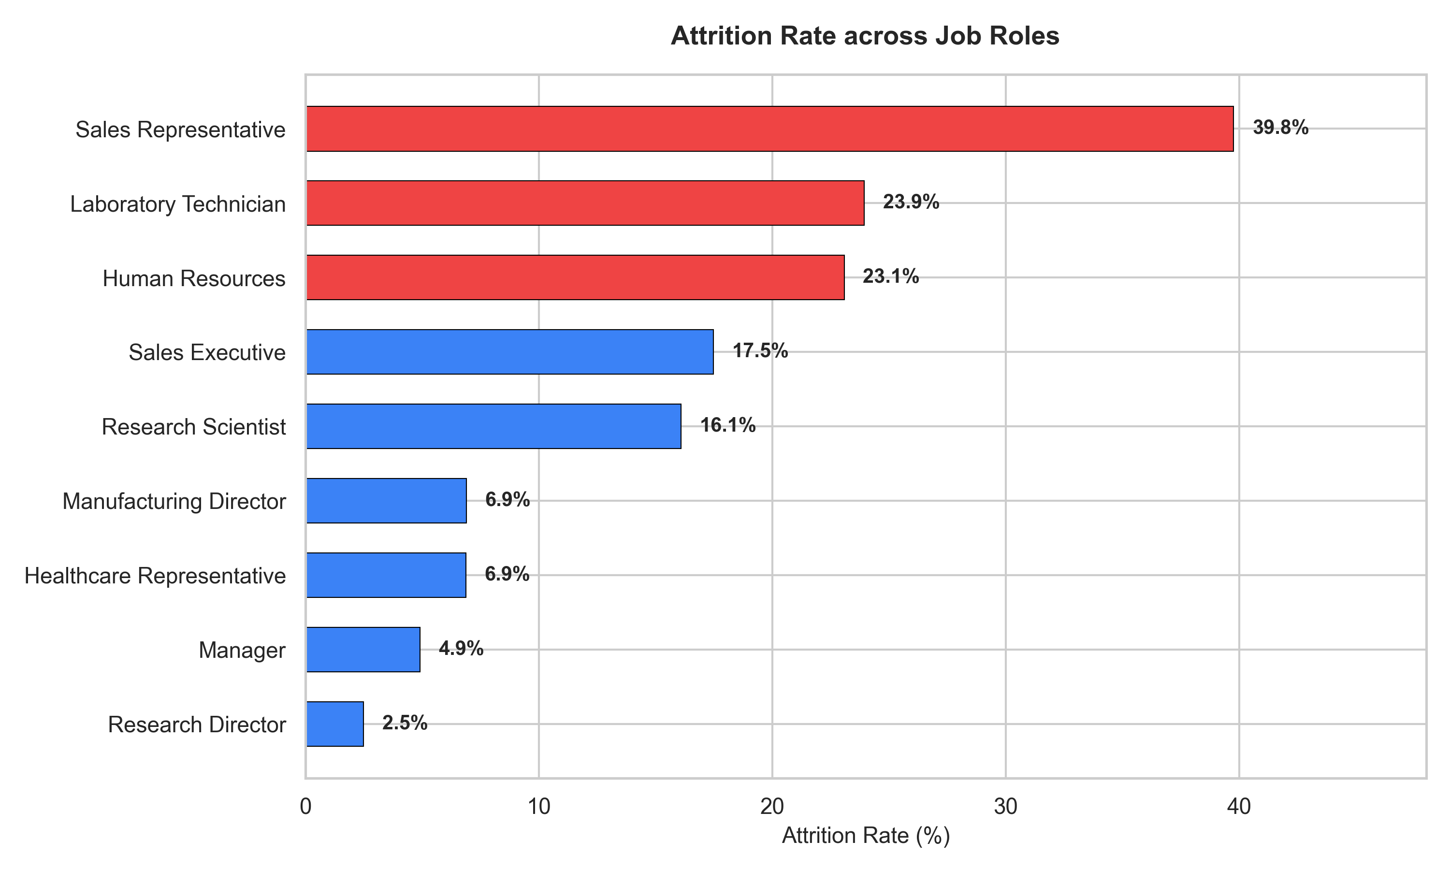
Figure 2: Observed Attrition Rate by Job Role.
3.2 Overtime and Compensation
Overtime status demonstrates a strong statistical association with turnover (30.53% vs 10.44%, Chi-square = 87.56, p < 0.001). Retained employees earn significantly higher monthly incomes ($6,832.74 vs $4,787.09, t = -7.48, p < 0.001).
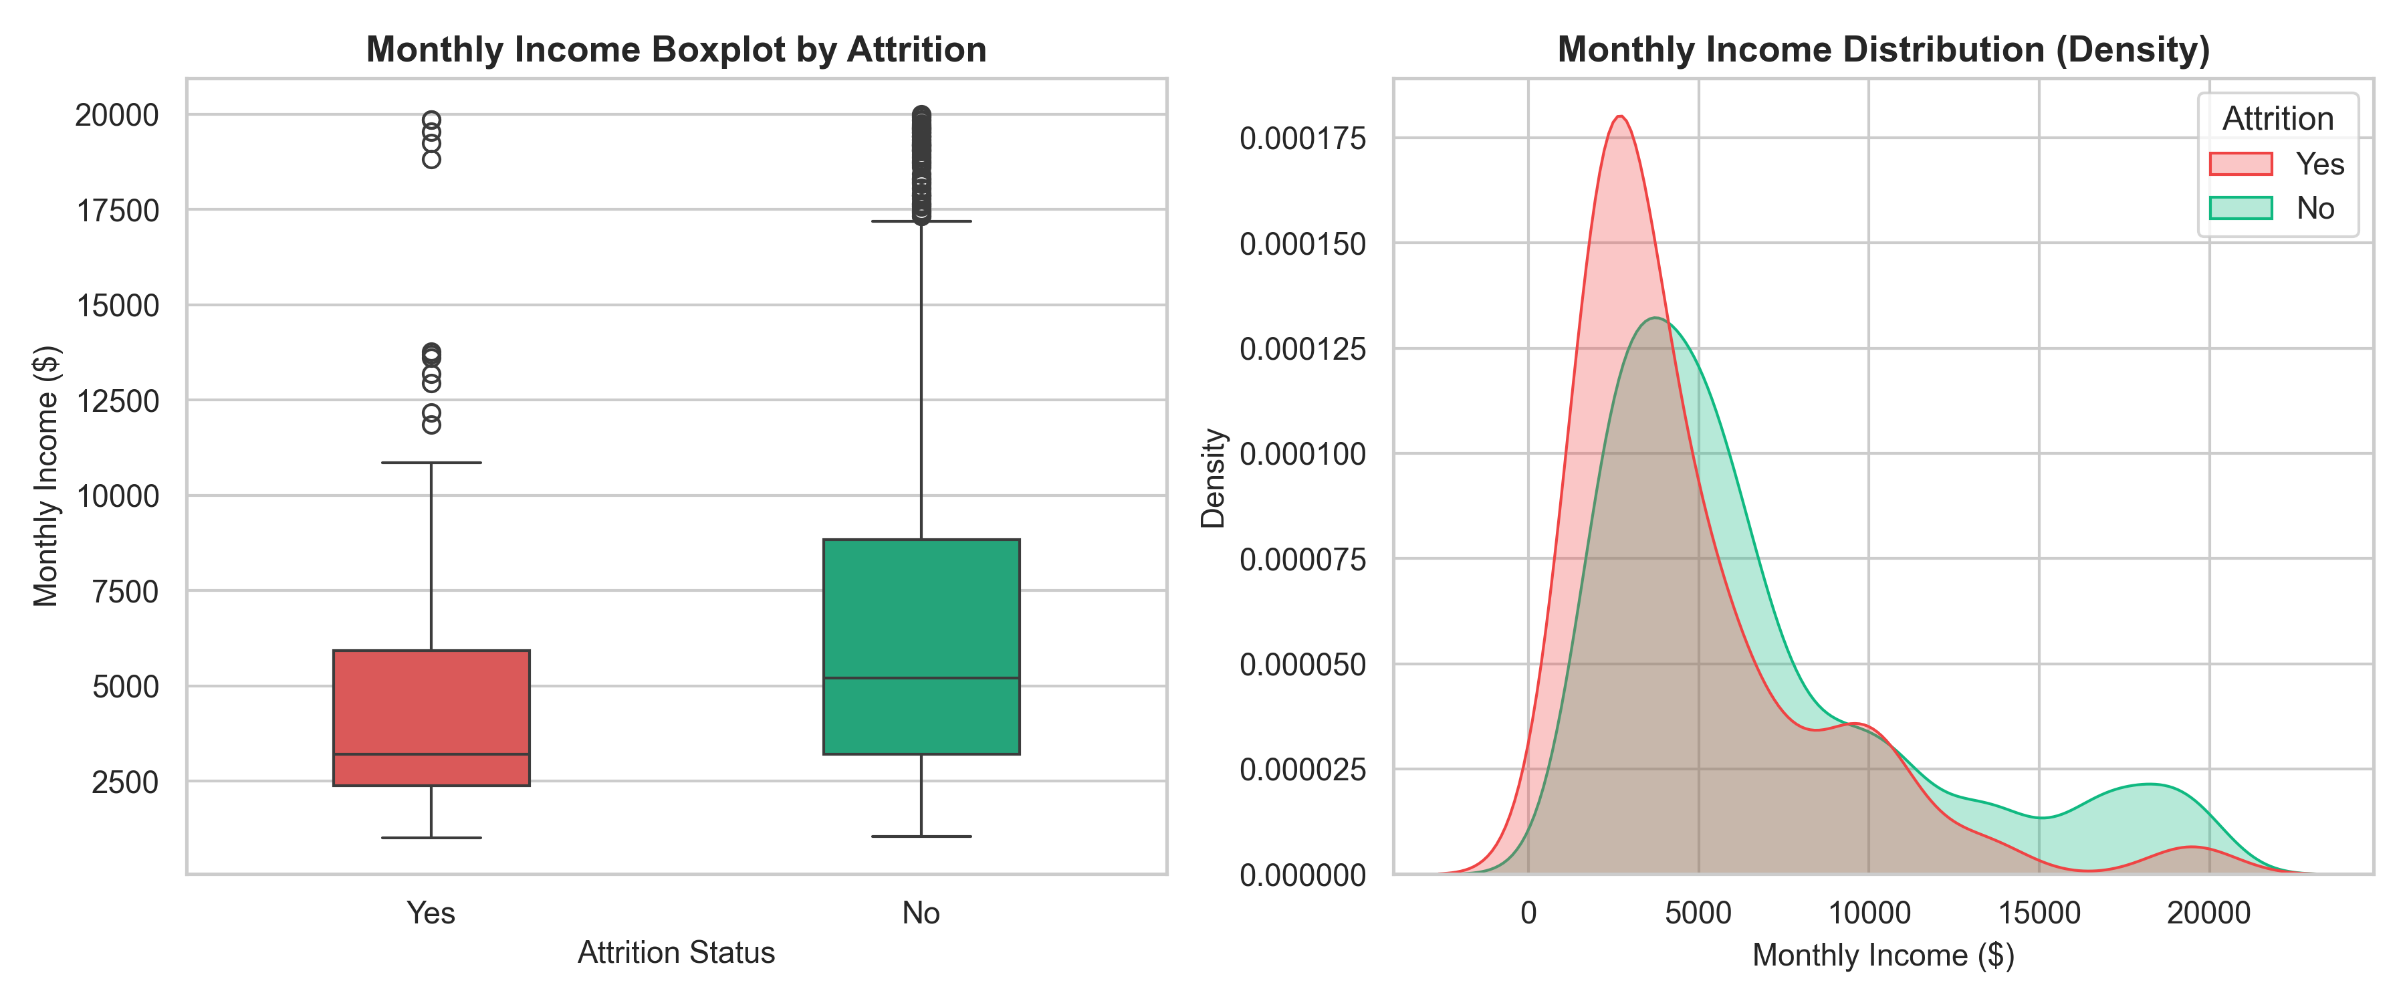
Figure 3: Monthly Compensation Distribution by Attrition Cohort.
4. Streamlit Dashboard Architecture
The dashboard (dashboard/app.py) provides live KPI metrics, dynamic sidebar filtering (Department, Job Role, Overtime, Business Travel), 5 exploration tabs, and empty-filter handling.
5. Evidence-Based HR Recommendations
- 1. Overtime Governance: Monitor recurring overtime hours and evaluate staffing levels in high-overtime units.
- 2. Compensation Alignment: Review compensation for roles showing elevated turnover (Sales Representatives, Laboratory Technicians).
- 3. Early-Tenure Mentorship: Implement structured onboarding check-ins and mentorship during the 0–24 month tenure period.
- 4. Commute Accommodation: Offer flexible scheduling or commute accommodations for staff living >20 km away.
- 5. Role-Specific Support: Design clear progression pathways and support systems tailored to individual job roles.
6. Conclusion & References
Employee attrition is strongly associated with observable factors including overtime status, compensation levels, service tenure, and specific job roles. Addressing these areas provides concrete opportunities for retention improvement.
References: IBM Watson Analytics; Agresti (2018); Streamlit Documentation (2026).

