AUTOMATIC CLASSIFICATION OF CRIME-RELATED TEXT REPORTS USING NLP
YAASIIN MOHAMUUD ABDULLAAHI NAIMA ABDIAZIZ SAID
NASTEHA MOHAMUUD MOHAMED NAJMA MUHUDIIN MOHAMED

SUBMISSION OF GRADUATION PROJECT FOR PARTIAL FULFILLMENT OF THE
DEGREE OF BACHELOR OF SCIENCE IN COMPUTER APPLICATIONS

JAHMURIYA UNIVERSITY OF SCIENCE AND TECHNOLOGY (JUST)
FACULTY OF COMPUTER & INFORMATION TECHNOLOGY

AUGUST 2026

Table Of Contents

CHAPTER I: INTRODUCTION 4
  - Background Of The Study 4
  - Problem Statement 7
  - Research Objectives 7
    - General Objective 7
    - Specific Objectives 8
  - Research Questions 8
  - Significance of the Study 8
  - Scope of the Study 8
  - Organization of the Study 8
CHAPTER II:LITERATURE REVIEW 10
  - Introduction 10
  - Impact of crimes on social media 13
  - Traditional Classification techniques in crimes 16
  - Cybercrime detection in social media 19
  - Challenges in the Classification of Crime-Related Text 21
  - Related Work 24
  - Gap and Contribution 29
  - Proposed System 29
CHAPTER III: METHODOLOGY 30
  - Introduction 30
  - System Description 31
  - System Architecture 32
  - System Features 34
    - Authentication and Authorization 34
    - Crime Text Analysis 34
    - Analytics Dashboard 35
    - Blacklist Monitoring 35
    - Investigation Case Management 36
    - Notifications and Alerts 36
    - Reports and Data Export 36
    - Facebook Page Monitoring 37
  - System Methodology 37
    - Dataset 38
    - Data Preparation 39
      - Text Cleaning 39
      - Lowercasing 39
      - Tokenization 39
      - Stop Word Removal 39
      - TF-IDF Vectorization 39
      - Train-Validation-Test Split 40
      - Class Balancing 40
      - Outlier Detection 40
  - System Development Environment 44
  - System Requirements 44
    - Hardware Requirements 44
    - Software Requirements 45
    - Required Libraries and Frameworks 45
REFERENCES 47

CHAPTER I: INTRODUCTION

Background Of The Study

A crime is an illegal act that is penalized by the state or another authority. The term “crime” refers to an offence that harms not only a single person but also a community, society, or state (Khan et al., 2022).
Criminal activity is present daily, in a multiplicity of illegal actions in several domains, such as drug trafficking, computer crime, and theft, to just mention a few examples. Upon the occurrence of a crime, criminal police investigators are in charge and start a set of actions to enable the construction of the so-called 'chain of custody' to identify the alleged culprits and to present them in court.(Carnaz et al., 2021).
Classification of Crime Reports is an important process in the analysis and management of crime-related data. In this Context: An ID, such as the type of crime, date and time of the incident, location, witnesses, and description of the incident(Hariguna & Ruangkanjanases, 2023)
Text classification specifically focuses on categorising and organising text data to facilitate easier management and analysis. These techniques leverage natural language processing, machine learning, and data mining to extract meaningful patterns and categorize text data. thereby transforming unstructured text into structured, actionable insights (Taha et al., 2024)
Crime-related data is exploding due to the constant reporting and distribution of crimerelated information on the internet in the rapidly evolving information technology and communication era. Online newspapers and social networks offer real-time information about what is happening in a specific location, at a particular moment, and with numerous cause(Ali et al., 2023).
Natural language processing is an area of computer science that is primarily concerned with transforming natural language into a formal language, such as a programming language, so that a computer can process and understand it, mainly combining algorithms. (Martínez Hernández et al., 2026).

Automated Crime Report Analysis is a technological approach used to automate the process of evaluating, sorting and understanding crime reports that enter the police system or relevant government agencies(Hariguna & Ruangkanjanases, 2023). The rise in cybercrime and the complexity of multilingual and code-mixed complaints present significant challenges for law enforcement and cybersecurity agencies. These organizations need automated, scalable methods to identify crime types, enabling efficient processing and prioritization of large complaint volumes. Manual triaging is inefficient, and traditional machine learning methods fail to capture the semantic and contextual nuances of textual cybercrime complaints(Rani et al., 2024).
The proposed research paper explores the application of machine learning techniques in crime analysis problem, specifically focusing on the classification of crime-related textual data. Through a comparative analysis of various machine learning models, including traditional approaches and deep learning architectures, the study evaluates the data (Mussiraliyeva & Baispay, 2024)
The 2021 amendment to South Korea’s Criminal Procedure Law has significantly enhanced the role of the police as investigative authorities. Consequently, there is a heightened demand for advanced investigative expertise among the police, driven by an increase in the number of cases each investigator handles and the extended time required for report preparation. This situation underscores the necessity for an
artificial-intelligence-supported system to augment the efficiency of investigators. (Park et al., 2024).
The ability to be anonymous on social media and the lack of adequate resources to fight cybercrime are catalysts for the rise in criminal activities, especially in South Africa. We proposed a system that will analyse and detect crime in social media posts or messages. The new system can detect attacks and drug-related crime messages, hate speech, and offensive messages.(Lombo Lombo et al., 2022).

The integration of machine learning techniques in crime analysis offers unprecedented opportunities to harness the vast amount of online textual data for enhancing public safety and security. By overcoming inherent challenges and leveraging the capabilities of ML algorithms, researchers and law enforcement agencies can gain invaluable insights into criminal behaviour and trends, ultimately contributing to more effective crime prevention and intervention strategies (Mussiraliyeva & Baispay, 2024)
In today’s world, security is the most prominent aspect that has been given higher priority. Despite the rapid growth and usage of digital devices, the measurement of crimes in underdeveloped countries is still challenging(Umair et al., 2020)
The majority of Somalia's current crime reporting and management systems are manual. Labor-intensive and prone to human error. By creating an automated NLP framework especially suited for the Somali language, this study seeks to address these issues. It is anticipated that this transition from manual sorting to AI-driven analysis will greatly speed up law enforcement responses and enhance data integrity in the Somali security industry.

Problem Statement

Crime posts sent using digital channels (such as social media, or online forms) thought to be processed and categorised instantly in a perfect law enforcement setting. This enables prompt prioritisation and routing to the appropriate department (such as cybercrime, homicide, or theft), guaranteeing a prompt response that can save lives and stop additional criminal behaviour.
The majority of crime posts classifications are now done by hand. Every day, thousands of text-based posts must be evaluated by human dispatchers or officers in order to determine the type of crime. Today's massive amount of digital data makes this manual approach labour-intensive, slow, and prone to major delays.
The use of manual classification results in a number of serious problems: Slow Reaction: When a post is waiting in a queue, human error – fatigue brought on by information overload – causes posts to be misclassified or high-priority threats to be missed. Resource inefficiency: Instead of actively investigating and ensuring community safety, skilled staff devote hours to administrative sorting.
This study suggests using natural language processing (NLP) to create an automated classification system. The system will be trained to examine the linguistic patterns of crime posts, classify them automatically with high accuracy, and identify urgent instances for prompt attention by utilising machine learning methods. The goal of this shift from manual to AI-driven sorting is to significantly increase the speed of police and court responses.

Research Objectives

General Objective

The main objective of this research is to develop and put into use an intelligent automated framework that uses machine learning and natural language processing to transform the way Security agencies classify crime posts. This framework will replace manual sorting with high-Speed semantic analysis that guarantees operational efficiency and data integrity.

Specific Objectives

      - To reduce the reliance on manual methods of classifying crime posts.

      - To collect and preprocess crime-related text data for analysis.

      - To extract and analyse key features from crime-related text data for accurate classification.
      - To develop an automated NLP system for classifying crime-related text posts.

Research Questions
- How to reduce the reliance on manual methods of classifying crime posts?

- How to collect and preprocess crime-related text data for analysis?

- How to extract and analyse key features from crime-related text data for accurate Classification?
- How to develop an automated NLP system for classifying crime-related text posts?

Significance of the Study
The goal of this project is to create an AI-powered natural language processing system that can automatically categorize text posts pertaining to crimes, making it noteworthy. Researchers and law enforcement organizations can save time and money on manual data analysis by automating the classification process. Decision-making procedures may be improved; the system can help create intelligent crime monitoring tools, and it can increase the accuracy of identifying various sorts of crimes. Additionally, by showing how Natural Language Processing (NLP) may be used practically in crime analysis, this study advances the academic subject of NLP.

Scope of the Study
The design, development, and assessment of a system based on Natural Language Processing (NLP) that automatically ascertains whether a given text report is related to a crime or not is the main objective of this study.

Organization of the Study

- Chapter II: Literature Review The Literature Review chapter is the summary of the study conducted by the researcher on the existing literature and studies that are

associated with the topic of the study. This study reviews the existing research conducted to determine the effectiveness of crime detection and text classification using Natural Language Processing (NLP) techniques. Additionally, this chapter aims to identify the various machine learning algorithms and approaches that have been implemented on social media data to classify and identify crimes.
- Chapter III: Methodology The third chapter discusses the methodology used for the research in this study. It shows how the social media data is collected and preprocessed. That is, in the stage of data preprocessing, the texts in social media posts are cleaned, tokenized, and the useful features are extracted. This chapter also provides more light about the machine learning algorithms that are employed in this study to classify the social media posts as crime and non-crime. Hence, the researcher fully explained data preparation and selection of the machine learning algorithm used.
- Chapter IV System Analysis, Design And Implementation. This chapter will discuss the analysis, design, and implementation of the proposed system, which is an NLP system to classify social media posts. It will discuss the system architecture, data flow, text preprocessing, feature extraction, and classification of social media text. It will also show the flow of social media text from the input to the output of the system. It will also discuss the coding structure of the system and the deployment of the system.
- Chapter V: Conclusion and Recommendations This chapter concludes and summarizes all the findings from the study. It also discussed the validity of the experimental results. The study discussed how the NLP model is used to classify crimes on social media and some possible ways of improving it. Recommendations were made on how to improve the performance of the system. These include increasing the number of samples for training and re-training the model for accuracy. The system could also be integrated into existing policing platforms for effective crime control

CHAPTER II:LITERATURE REVIEW

Introduction
Crimes are the most common social issues nowadays, affecting the economic growth, quality of life, and economy of any country. Crimes affect the reputation of a country on an international scale and affect the economy of the country by placing a financial burden on the government in hiring additional police forces. For the eradication of crimes, the government needs to adopt an optimized strategy and sustainable e-governance information systems. Algorithms that predict the occurrence of crimes based on time and location can help the government to deploy law enforcement in highly dangerous areas (Umair et al., 2020)
Criminal activity is present daily, in a multiplicity of illegal actions in several domains, such as drug trafficking, computer crime, and theft, just to mention a few examples. Upon the occurrence of a crime, criminal police investigators are in charge and start a set of actions to enable the construction of the so-called chain of custody to identify the alleged culprits and to present them in court. These actions are multidisciplinary and, depending on the crime, they may involve distinct tasks, such as digital and biological forensics analysis, interviews with witnesses, and interrogations with suspects and other individuals who may be potentially implicated (Carnaz et al., 2021)
The classification of crime reports is a crucial process in the analysis and management of crime-related data. In this context, a crime report is written or digital information that contains various details about the crime incident, such as the type of crime, date and time of the incident, location, witnesses, and description of the incident. The goal of crime report classification is to group these reports into appropriate groups based on their characteristics, which facilitates efficient analysis, monitoring, and action by the authorities. One of the main benefits of classifying crime reports is their ability to aid law enforcement and investigation. By classifying crime reports by crime type, authorities can more easily identify potential crime patterns(Hariguna & Ruangkanjanases, 2023)
Crime-related data is exploding due to the constant reporting and distribution of crime-related information on the internet in the rapidly evolving information technology and

communication era.Online newspapers and social networks offer real-time information about what is happening in a specific location, at a particular moment, and with numerous causes.These facts depict real-world events, such as accidents, innovations, conferences, natural disasters, or crime events. These resources have provided a substantial amount of crime data, which is the domain of their study, presenting a need to extract precise and valuable information to promote and strengthen the fighting capacities against crime capabilities, thus improving public protection and reducing the likelihood of future crime prospects. Moreover, information possession and effective deployment are essential in fighting crime and are in high demand from various end-users.(Ali et al., 2023)
Criminal detection and prediction constitute an essential practice in crime analysis, seeking to provide effective techniques for supporting law enforcement. Researchers develop diverse strategies and solutions utilizing machine learning (ML) and deep learning (DL) algorithms to foresee or detect criminal activities that have demonstrated considerable potential in addressing crime detection issues (Al-harbi & Alghieth, 2025)
Natural language processing is an area of computer science that is primarily concerned with transforming natural language into a formal language, such as a programming language, so that a computer can process and understand it, mainly combining techniques from AI, linguistics, statistics, and computing for the development of algorithms. It is a fundamental part of NLP as it focuses on understanding the meaning of words, phrases, or sentences and how they are used in a specific context.(Martínez Hernández et al., 2026)
Extracting events from news stories as the aim of several Natural Language Processing (NLP) applications (e.g., question answering, news recommendation, news
summarization) is not a trivial task, due to the complexity of natural language and the fact that news reporting is characterized by journalistic style and norms. Those aspects entail scattering an event description over several sentences within one document (or more documents), applying a mechanism of gradual specification of event-related information.(Bonisoli et al., 2023)

Automated Crime Report Analysis is a technological approach used to automate the process of evaluating, sorting, and understanding crime reports that enter the police system or relevant government agencies. The main objective of this method is to improve efficiency and effectiveness in crime data management, as well as enabling authorities to respond to crime events faster and more accurately. Automated analysis of crime reports involves using technologies such as artificial intelligence and natural language processing to extract key information from incoming crime reports. (Hariguna & Ruangkanjanases, 2023)
The rise in cybercrime and the complexity of multilingual and code-mixed complaints present significant challenges for law enforcement and cybersecurity agencies. These organizations need automated, scalable methods to identify crime types, enabling efficient processing and prioritization of large complaint volumes. Manual triaging is inefficient, and traditional machine learning methods fail to capture the semantic and contextual nuances of textual cybercrime complaints.(Rani et al., 2024.)
The proposed research paper explores the application of machine learning techniques in the crime analysis problem, specifically focusing on the classification of crime-related textual data. Through a comparative analysis of various machine learning models, including traditional approaches and deep learning architectures, the study evaluates their effectiveness in accurately detecting and categorizing crime-related text data. The performance of the models is assessed using rigorous evaluation metrics, such as the area under the receiver operating characteristic curve (AUC-ROC), to provide insights into their discriminative power and reliability.(Mussiraliyeva & Baispay, 2024)
The 2021 amendment to South Korea’s Criminal Procedure Law has significantly enhanced the role of the police as investigative authorities. Consequently, there is a heightened demand for advanced investigative expertise among the police, driven by an increase in the number of cases each investigator handles and the extended time required for report preparation.This situation underscores the necessity for an artificialintelligence-supported system to augment the efficiency of investigators. In
response, their study designs a hybrid model that fine-tunes two Transformer-based

pretrained language models to extract 18 key pieces of information from legal documents automatically.(Park et al., 2024)
The integration of machine learning techniques in crime analysis offers unprecedented opportunities to harness the vast amount of online textual data for enhancing public safety and security. By overcoming inherent challenges and leveraging the capabilities of ML algorithms, researchers and law enforcement agencies can gain invaluable insights into criminal behaviors and trends, ultimately contributing to more effective crime prevention and intervention strategies(Mussiraliyeva & Baispay, 2024)
In the contemporary era, ensuring security has become a critical priority due to the rapid proliferation of digital technologies and devices. As digital adoption increases globally, especially in developing regions, monitoring and addressing crime accurately becomes increasingly complex and challenging. Research suggests that developing countries face persistent cybersecurity challenges and limitations in effectively detecting and combating digital crime and security risks in these environments (Yadav et al., 2020)
In today’s world, security is the most prominent aspect that has been given higher priority. Despite the rapid growth and usage of digital devices, the measurement of crimes in underdeveloped countries is still challenging(Umair et al., 2020)

Impact of crimes on social media

Social media representations of crime have the power to influence how the general public views crime, law enforcement, and the legal system. Inaccurate coverage of crime-related news can lead to mistakes, portrayal of crime as a necessity and a demand of the time, which makes people sympathetic to the criminal and, in a way, encourages crime. It also undermines public confidence in the government and gives power to those who have taken the law into their own hands. Hate crime is the overrepresentation of crimes committed by a certain segment of society against that segment, which has become a social media trademark and fosters hatred and negative perceptions toward that segment(Abhishek Kumar, 2025)

The Social media exposure of crime refers to the way crime-related content is shared, discussed, and highlighted on social media platforms. Social media is now a major tool for people to know what is happening around them. It is now a necessary part of everyone's life, even for students. As the use of social media as a platform for gathering information continues, individuals will encounter posts that are related to crime incidents. People will have their own insights based on the topic, which might affect them in some ways. Social media networks make it simple to spread both positive and negative emotions among individuals. Criminology students often recognize that social media can serve as an educational tool. By exposing users to real-time information about crime trends and safety issues, social media can enhance public awareness. Research indicates that platforms like Twitter and Facebook facilitate the rapid dissemination of crime-related information, potentially empowering communities to take preventative measures. Exposure to crime on social media can distort public perception, leading to fear and anxiety(Ezekwe, 2025)
According to the data, a large number of students share excessive amounts of information via social media and emails, which could endanger them. The majority of organizations have put in place multiple security measures to prevent information from leaking on social media. Cyberbullying has become widespread, particularly among those who are vulnerable to it. Social media is frequently the target of security threats such as hacking, spoofing, spamming, cyberstalking, Trojan horses, worms, viruses, and exposure scams; for this reason, government and ICT policies have addressed these problems. Higher education institutions must devote more funds to student education, awareness, research and development, IT security, and social media crimes(Benard et al., 2021).
Social media is substantially affecting the world’s dynamics and proves to be particularly true when it comes to the legal realm.3 As a matter of fact, in this digital era, these massive online platforms give rise to new challenges and opportunities in relation to the existing framework of international criminal law (hereinafter ‘ICL’)(Ali, 2021)
The penetration of social media into nearly every aspect of contemporary life has reshaped
patterns of communication, information consumption, and interpersonal interaction.

Beyond its role as a tool for social connectivity, digital platforms have emerged as influential spaces where narratives of crime circulate rapidly and where offenders increasingly exploit online affordances to facilitate unlawful behavior. Their study investigates the extent to which these platforms affect both criminal conduct and public interpretations of crime trends within modern societies. The purpose of the research is to analyze how social media environments enable planning, performance, and dissemination of criminal acts, while also shaping public emotions, risk perceptions, and trust in institutions responsible for maintaining public order(Rashid et al., 2025)
These days, people utilize a variety of social media platforms to share information with friends, family, and other people for official, business, and personal reasons. Cyberstalking is another major problem brought on by social media use. Cyberstalking has been recognized as an increasingly prevalent anti-social issue that impacts victims, educational institutions, and human society as a whole. Cyberstalking on social media must be detected by an intelligent system(Gautam & Bansal, 2022)
Numerous risks that have been recognized and categorized are present on social media, according to the International Journal of Network Security & Its Applications. Al Hasib categorized social networking threats into three categories: identity-related threats, which include phishing, friending malicious actors, profile squatting, stalking, and corporate espionage; privacy-related threats, which include the sharing of private information on social media; and information security threats, which include well-known security threats on social media like worms, viruses, and cross-site scripting. Similar to this, Fire et al. divided the threats associated with social media
(Umeugo, 2023).
In today’s digital age, the widespread growth of the digital media sector and information technology has significantly improved communication flexibility through platforms such as Facebook, Twitter, Instagram, and others. These platforms, driven by Web 2.0 technologies, enable global connectivity, fostering social interaction and community building beyond geographical constraints. Despite their advantages, such as accessibility and interactivity, social media also pose risks like cybercrimes and threats to security,

making it crucial to evaluate their impact on societal security in the United Arab Emirates (UAE). The research problem focuses on how social media simultaneously affects societal security, aiming to identify strategies to mitigate risks while preserving its benefits (Alnaqbi & Ali, 2025)

Traditional Classification techniques in crimes

Traditional methods of crime prevention and detection have played an essential role in maintaining law and order within communities. These methods are characterized by their reliance on human intervention, community participation, and well-established policing practices. This section discusses these key traditional methods, highlighting their strengths and limitations(Apene et al., 2024)
The efficacy of several machine learning models, such as LSTM, GRU, Random Forest, SVM, and Logistic Regression is examined in their study. Based on thorough testing, the Random Forest, SVM, and Logistic Regression models performed well on tasks involving the classification of crimes. Traditional inspection of a large number of crime reports, however, may be laborious and prone to human error. However, the conventional manual classification of crimes based on textual descriptions is laborious, prone to human error, and frequently inconsistent(Eldho,2023)
Moreover, the manual annotation of some visual content can be problematic from an occupational health and safety perspective, as the potential exists for individuals to be exposed to a large number of indecent and disturbing images. To further compound matters, forensic practitioners generally have limited background knowledge of big data, Artificial Intelligence, and data sciences to help create models tailored for their own practices. In order to make full use of large forensic image databases and remove associated practical issues, specialized high-performance and accurate computer vision (e.g., automatic recognition and content filtering) and data analytics tools are required(Taha, 2024)

Clustering is also another common technique used to predict patterns of geographic criminal history and behavior. Remond and Baveja proposed a case-based reasoning (CBR) system that filtered out police cases for better prediction. It worked on noisy data and explained how police reports show only individual criminal activities and do not address gang crimes. Social networks are also used as a potential source of criminal activity indicators. Sadhana and Sangareddy used Twitter information to find real-time criminal offences. They also used the same data set to find the concentration of crime occurrences, and find large scale of hotspots. Thus, several techniques are used for analyzing crimes(Hossain et al., 2020)
From high-level categories to lower-level subtypes, the conventional classification of crime types is based on a hierarchical framework. This tree-based classification lacks tricategory semantic linkages since it recognizes different types of crimes as mutually independent when they do not branch from the same higher-level category. In any event, the prevailing trend is on the initial classification of crime types offered by each nation or local organization, which consists of hierarchical structures from a single point of view, ranging from high-level categories to lower-level subtypes. When crime types are not mutually independent, this conventional tree-based classification recognizes them as such. branch from the same higher-level category; hence, there are no semantic connections across categories. Even though they may be closely linked, crime types that originate from distinct high-level categories are handled very differently. For example, the crime type "disturbing the peace" and the crime type "liquor—drinking in public" may be perceived as inherently related since, from a police standpoint, the two offenses are related. However, according to the city of Boston's crime classification, "disturbing the peace" falls under the category of "disorderly conduct," while "drinking in public" falls under the category of "liquor violation."(Crivellari & Ristea, 2021)
Police in the United Kingdom use a hierarchical framework of UK Home Office codes, classes, sub-classes, and offence categories to categorize crime events. These classifications correspond to the Notifiable Offence List, which, for each class,
corresponds to a pertinent law that is used to prosecute people who are thought to have

committed a specific crime. For example, code 28/3, class "Burglary," subclass "Residential Burglary," offence category "28F Attempted Burglary— Residential," and its application related to Section 9 of the Theft Act (1968) are used to record an attempted residential burglary. The aforementioned categories were created to facilitate a variety of criminal justice procedures and allow for comparisons in crime statistics both within and between jurisdictions. However, even if this method of categorization is essential for the criminal justice system's administrative requirements, crimes may not adequately describe the ecological aspects of real-world criminal issues. Simply put, not all offenses of a given classification are created equal. Although classifying them as such makes administrative sense, it might not be the best way to comprehend the kinds of criminal opportunities and behaviors that arise in a given context to cause crime problems (Birks et al., 2020)
Using text mining, natural language processing, and machine learning approaches, our system tackles the problem of classifying unstructured legal documents by organizing and analyzing this data and extracting reports related to crime scenes. Our work stands out because we created a crime lexicon with 151 related terms and 70 crime instruments that were taken from different forensic sources. Despite being regarded as rather modest, it helped provide positive categorization results. To enhance crime scene investigation, the suggested crime dictionary can be expanded, used in sophisticated searches, and linked with police databases. (Bifari et al., 2024)
For a limited portion of the crime data sets, K-Nearest Neighbor (KNN), Support Vector Machines (SVM), decision trees, random forests, Naive Bayes, and so forth are comparatively more effective. The fundamental framework of crime prediction is shown in Fig. 1. A plan based on conventional machine learning is presented in Part (a). First, a training set and a test set are created from the data set. In order to achieve an appropriate representation of the crime data, the algorithm's fundamental requirement is to extract the crucial information that can represent the crime event data. Since there are many various kinds of crime data, it is vital to choose pertinent attribute data and then extract all of the data's features at once to increase the data's capacity for effective expression. The crime

is then forecasted using a range of machine learning algorithms, including support vector machines, decision trees, and linear regression models.( Yin, 2022)

Cybercrime detection in social media

Cybercrime, to put it simply, is any criminal offense that uses a computer, digital devices, or the internet as a conduit. It falls under the category of contemporary crimes brought about by developments in the Internet and related technology. They might be categorized as hybrid offenses because, in contrast to more conventional crimes like robbery and theft, which can be clearly localized in terms of time and place of occurrence, these crimes may have a connection that is challenging to pinpoint. Given the aforementioned, some authors have characterized it as a composite crime that includes cyber-dependent crimes made possible by the Internet and digital technology, as well as cyber-enabled crimes, including organized crime, fraud, forgery, theft, and money laundering(Chinedu et al., 2021)
Social media is being used for a variety of activities, but it can also lead to cybercrime. Online sharing of personal information can lead to crime. Victims may be reluctant to report crimes due to triviality, embarrassment, or lack of awareness. Social media monitoring can be used to augment conventional crime reporting. Social media is being used to facilitate criminal activity, much like other emerging technologies and communication channels. It is imperative to protect private data being transferred via networks (Abdalrdha et al., 2023)
As with all cybersecurity and cybercrime issues, awareness is critical to help combat cybercrime on social media. Employees and organizations risk falling victim to cybercrime on social media. Awareness is also required to avert inadvertent perpetration and participation in cybercrime on social media. Organizations must incorporate cybercrime on social media awareness into general cybersecurity and cybercrime awareness training. Organizations must also measure their employees' cybercrime on social media awareness levels to gauge the effectiveness of their awareness training programs. Few studies exist on cybercrime awareness on social media, and most

cybercrime awareness measurements do not consider cybercrime on social media(Umeugo, 2023)
According to the National White Collar Crime Center's "Criminal Use of Social Media" white paper, social media's recent rise has significantly altered the communication environment. Social media sites like Instagram, Facebook, LinkedIn, YouTube, and Twitter are used daily by millions of individuals. People interact with each other via various sites. These channels are used for advertising, hiring new employees, and routine communication within the public sector(Kaur et al., 2024)
Online social networks (OSNs) such as Twitter are being used more and more in today's society to spread information globally. Online social networks have gained popularity because of their broad reach, streamlined dialogues, anonymity, and capacity to deliver brief bursts of information. additionally could go into a channel for different forms of online harassment and bullying. Common conversations and banter on social networking sites can occasionally turn explosive, leading to the unchecked expression of hate, harassment, and aggressiveness without the possibility of personal danger or reciprocal physical harm. Reports of mental and psychological health problems in recent years have been directly connected to cyberbullying, abuse, and harassment. Quickly identifying posts meant for abuse and expunging them from the network to lessen user exposure is necessary to stop these abusive activities(Osho et al., 2020)
The proliferation of digital communication platforms has led to the emergence of cyberbullying as a major social issue. In contrast to conventional bullying, cyberbullying enables offenders to reach victims at any time and from any place, transcending physical boundaries. Particularly common among teenagers and young adults, this type of harassment has been connected to a number of detrimental effects, such as anxiety, sadness, and even suicidal ideation(Altayeva et al., 2024)
The findings show that many students share too much information through emails and social media, which may pose a threat to them. Most organizations have implemented multilayered security mechanisms information security may leak on social sites.

Cyberbullying has spread widely, especially among those who are prone to the practice of cyberbullying. Security attacks such as hacking, spoofing, spamming, cyber stalking, Trojans, worms, viruses, and exposure scams are common through social media, hence the ICT policy and government policy have addressed such issues. Higher learning institutions need to invest more resources in training students, awareness, research and development, IT security, and social media crimes. (Benard et al., 2021)
Threats from cybercrime are becoming more frequent every day. Due to a lack of record keeping at relevant offices for a variety of reasons, including victims' presumptions about police response, users' ignorance of IT (information technology) acts on cybercrimes, and victims' incapacity to identify that they have been victimized, there is currently no foolproof, systematic, and trustworthy tool for reviewing cybercrimes. Reducing and categorizing cybercrimes may also be aided by promoting and educating the public about them, as well as by identifying and maintaining area-specific cybercrime rates (Ch et al., 2020)

Challenges in the Classification of Crime-Related Text

Developing highly effective classifiers for such imbalanced datasets remains a significant challenge. As the dataset imbalance increases, the model tends to overfit the majority class, impairing its ability to achieve the desired performance on minority classes and leading to biased outcomes. Hence, the reliability of the model in real-world applications deteriorates, resulting in failures in critical scenarios where the accurate detection of minority classes is essential. (Taskiran et al., 2025)
Multi-label text classification involves assigning more than one class to a text based on analyzing the terms in the text body. presents an open-world multi-label text classification. In this type of task, the possible classes are not available a priori. The method needs to perform topic modeling for subsequent text classification. So, it fragments the texts and sends them to an LLM for keyword extraction. The words are grouped, and the centroids of each group form the labels for text classification. The labels for the text classification

procedure can all be available a priori. However, some researchers investigate the need for a dynamic update of the possible labels available for
classification(Vieira et al., 2025)

Text classification can be done manually, but it is time-consuming and has a high cost. Manual classification comes with lots of errors and is less accurate because of human error and a lack of domain knowledge. There was a huge revolution in text classification when machine learning models, such as the Support Vector Machines (SVM), Naive Bayes (NB), and Random Forest (RF) started to replace manual work, because these models not only reduce the time and cost but also are highly accurate for classification. Since the inception of machine learning models, numerous studies have been conducted to enhance, optimize, and refine the text classification process (Palanivinayagam et al., 2023)
The entire legal text is then divided into several predefined logical segments using structural characteristics. Next, the corresponding entities are extracted from each logical segment using a hybrid method of rules and deep learning. For simple entities, the rules and patterns are generated in the process of knowledge modeling to extract entities. For complex entities, the pre-trained model Bidirectional Encoder Representations from Transformers (BERT) is introduced into the task of legal text information extraction, and is combined with Bi-directional Long Short-Term Memory (Bi-LSTM) and Conditional Random Field (CRF) algorithms to extract entities. It is effective in solving the problem of polysemy in legal texts (Ren et al., 2022)
Beyond the analyses of free-text recorded by police, several studies have also explored how LDA topic models might be used to analyze crime-related phenomena discussed in unstructured content posted online. Combine LDA and collaborative representation classifiers in an attempt to detect ‘criminal intention’ in free-text extracted from online blogs. Relatedly, applies LDA topic models to geotagged tweets posted to the online platform Twitter in Chicago to generate neighborhood dominant topics indicative of the ecology of a particular location. These classifications are then used to positively augment

a kernel density estimation-based crime prediction algorithm that seeks to estimate the levels of distinct offences in the immediate future (Birks et al., 2020)
A large language model (LLM) is a class of artificial intelligence models, typically based on deep learning, specifically designed to comprehend and generate human language. These models are characterized by their enormous size, often containing hundreds of millions or even billions of parameters, which allows them to perform a wide range of natural language understanding and text generation tasks. For crime prediction tasks, an ML model can be trained on inputs to output labels from a fixed set of classes. However, recent advances in LLMs such as BERT and GPT-3 have introduced a novel approach known as prompting. In prompting, there is typically no need for further training; instead, the model's input contains a task-specific text called a prompt (Sarzaeim et al., n.d.)
Securing large language models (LLMs) and NLP technology in general has not been a priority until recently. Yet mass adoption of this technology has led to deployment in contexts where security failures present a risk to individuals, organizations, and society at large—demonstrated by, inter alia, LLM-assisted identity fraud phishing campaigns and automated influence operations If the latest NLP technologies are to withstand an increasing barrage of threats, NLP practitioners must now educate themselves on cybersecurity and cybersecurity practitioners must educate themselves on NLP (Lent et al., 2025)

As another example, if there is a spike in traffic accidents during a festival period, local police could investigate the causes and allocate appropriate healthcare resources to the affected area. If drunken driving is a significant cause, police could dispatch corresponding real-world statistics provided by administrative authorities. It conducted a case study on the efficacy of the news classification models using two reputable online news sources and seven prevalent types of crimes/accidents in Thailand(Tuarob et al., 2025)

Additionally, the issue of creating software tools and methods to aid in the investigation and prevention of criminal acts based on textual material disseminated online is still unsolved today. Numerous applications are available to handle the problem, such as hate voice recognition, crime prediction, criminal pattern modeling, identification of crime-related topics, etc. However, more effective techniques for analyzing criminal content in computer-mediated communication (CMC) are still required in order to prevent and solve crimes. Crime-related event extraction (CREE) is one of the most difficult and effective methods for identifying and forecasting criminal activity. The possibilities to gather organized data on a crime that has occurred or is likely to occur, compile this data, and then model a crime pattern are responsible for the success of the CREE job. In the meantime, it is still very difficult to extract different kinds of crime-related events (CRE) from texts that are not police or witness narrative reports, even with the presence of studies pertaining to the CREE task. Additionally, materials produced in low-resource and under-annotated languages make the Event Extraction process more challenging(Khairova et al., 2023)

Related Work

In recent years, there has been a lot of interest in using artificial intelligence (AI) and machine learning (ML) to analyze crime (Hariguna & Ruangkanjanases, 2023). created a model for an adaptive decision-support system that is specifically for automatically analyzing and sorting crime reports in the context of e-government. Their study built an automated framework that used Natural Language Processing (NLP) techniques to pull out important information from reports that came in. The system was found to greatly improve the efficiency of managing crime data, allowing authorities to respond to crime events more quickly and accurately. Looking at things together (Mussiraliyeva & Baispay, 2024).tested different machine learning methods - old styles and newer deep learning setups - to sort through text about crimes. Rather than making assumptions, they turned to reliable methods - such as the Area Under the Receiver Operating Characteristic Curve (AUC-ROC) - to assess which model performed best.

This shift led to tangible insights for police departments, revealing patterns in offender behavior along with hints about future actions. These findings didn’t just show new tools
- they helped shape smarter ways to stop crimes before they grow. Looking closely at tough investigation issues. (Park et al., 2024). created a mixed system to help South Korean law enforcement deal with new pressures after changes to the criminal procedure law in 2021 made cases harder to solve. Instead of relying on manual review, their approach used two existing transformer-based models that had already been trained on legal data - tweaked slightly through additional learning - to pull out 18 crucial details from paperwork automatically. Looking back, it became clear how vital AI tools are when investigators face growing workloads and longer report prep intervals.When it comes to sorting public crime data, (Ali et al., 2023). suggested using a BERT-driven system to boost how news documents about crimes are sorted. Because clear information and swift deployment matter in crime prevention, their work highlighted the need for precise data pulling by different user groups. It turned out that using existing language models led to much stronger narrative handling - especially
for stories tied to criminal activity - than older approaches did. Focusing first on materials not in English, (Carnaz et al., 2021).faced little data by building a labeled set of crime-linked Portuguese texts. Their effort showed how complex crime exams truly are - blending fields like digital enforcement, interview handling, and keeping evidence trails intact. This dataset came together to build a base resource - key for creating NLP and machine learning tools that handle intricate crime cases across languages beyond English. Looking into better training data, Liu et al. (2023) explored ways to boost text variety while keeping results accurate. Instead of just adding more samples, they tried swapping words with synonyms, tossing in random terms, or reshuffling full sentences. These shifts helped spread out the examples used to teach models. Because of this mix, the system learned to recognize patterns across deeper layers of meaning in crime classification. Over time, their findings pointed to stronger performance when faced with complex structures within criminal taxonomy. Starting with the challenge of uneven data spread, Franklin et al. (2024)

introduced a new approach - "text-guided mix-up" - aimed at handling the long-tail issue during sorting jobs. Drawing on how classes are linked in meaning, thanks to insights from pre-trained vision-language tools such as CLI P, they tapped into written guidance to ease imbalances shaped by sparse example sets. Looking at things this way fits well when studying crime patterns - some reported incidents happen much less often but still matter just as much in understanding what's happening. Looking at how African languages work, Sani et al. (2025), along with Alabi's group two years earlier, studied what happens when language models adjust through a method called LAFT - using a model named AfriBERTa, among others. Looking into Sani and team’s work, they explored how people feel in Hausa using text analysis. Their findings show that tweaking big language models trained on multiple languages works better when taught only on African dialects. Since building a Somali crime news tool matters, it proves machines like AfriBERTa - built to adapt - can handle smaller languages well instead of just copying from English-based systems. Though rare, such shifts matter most where data runs thin.

Author & Year | Description | Methods | Limitations

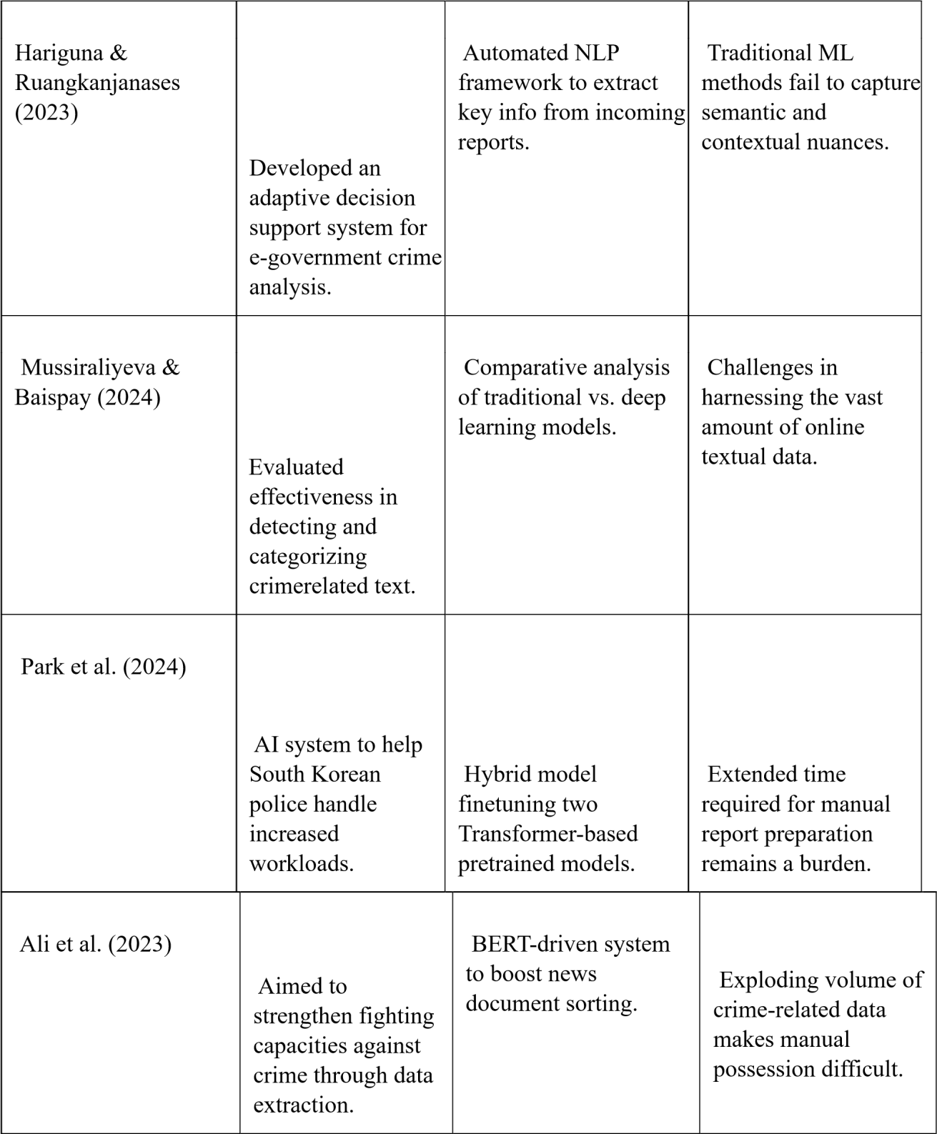

Carnaz et al. (2021) | Focused on non-English (Portuguese) crimelinked  text  classification. | Construction of a labeled dataset for forensic tasks. | Scarcity of labeled data in languages other than English.
Liu et al. (2023) | Explored data diversity in hierarchical multilabel classification. | Methods: Synonym replacement, random insertion/deletion/swap. | Excessive data enhancement may lead to model over-fitting.
Franklin et al. (2024) | Addressed long-tailed label distribution in training. | Text-guided mix-up technique using semantic relations. | Traditional deep learning requires costly, large, balanced datasets.
Sani et al. (2025) | Investigated sentiment analysis | Language-Adaptive  Fine-Tuning (LAFT) using AfriBERTa. | Smaller languages often just copy English-based

Gap and Contribution
The reviewed literature provides strong evidence for automated crime-text analysis, but it offers limited support for Somali-language and code-mixed content and rarely connects classification to an operational investigation workflow. This study addresses that gap by: (1) preparing and evaluating a Somali-oriented labelled dataset; (2) preventing data leakage through a train-only TF-IDF fit; (3) comparing multiple supervised classifiers with emphasis on F1-score and crime-class recall; (4) deploying the selected model through a reproducible service architecture; and (5) integrating classification with monitoring, alerts, blacklist checks, reporting, and case management. The contribution is an applied decision-support system, not an autonomous policing or guilt-determination tool.

Proposed System

The proposed system is an NLP (Natural Language Processing) based text classification system that classifies any given social media post as crime-related or non-crime-related. The dataset used for this proposed system consists of social media posts, which are manually labelled by humans as crime-related or non-crime-related. The output is generated after the preprocessing of the input text and then passing it to the machine learning and deep learning algorithms. The algorithms used in this proposed system are Support Vector Machine (SVM), Random Forest, and BERT. The preprocessed features of the input text are used by these algorithms to classify and find out whether the input text is crime-related or not. The proposed system is trained and tested using a manually labelled dataset, and the performance is evaluated by calculating the accuracy, precision, recall, and F1-score. The proposed system has a simple web interface developed in Python and Flask. The interface allows users to input any social media post that needs to be classified. The proposed system then classifies and provides the output of whether the input social media post is crime-related or not, along with the confidence. The proposed system thus facilitates an efficient monitoring of the social media posts as compared to the manual surveillance required in traditional systems.

CHAPTER III: METHODOLOGY

3.1 Introduction
This chapter describes the methodology used to design, develop, train, evaluate, and deploy BAREAI (Bare AI Crime Intelligence Platform), an automated system for classifying Somali text reports as crime-related or not crime-related. The methodology combines the Cross-Industry Standard Process for Data Mining (CRISP-DM) with iterative software development. CRISP-DM structured the machine-learning work into problem understanding, data understanding, data preparation, modelling, evaluation, and deployment, while iterative development enabled the user interface, application programming interfaces, database, monitoring functions, and investigation workflow to be integrated and tested progressively.
The final implementation differs from a conventional notebook-only classification experiment. It contains a React frontend, an Express backend, an independent Flask inference service, and MongoDB persistence. The modelling stage evaluated classical machine-learning algorithms, convolutional and recurrent neural networks, and Somali encoder-only transformer models. The final deployment used SomBERTa-B because the controlled comparison reported in Chapter Four showed that it provided the strongest balance of overall classification performance and crime-class recall. Classical TF-IDF models were retained as reproducible baselines and fallback research artefacts, but they were not treated as the final production model.

3.2 System Description
BAREAI is a role-based crime intelligence platform designed to reduce the manual effort required to review large volumes of unstructured Somali text. The system accepts direct text, website addresses, uploaded documents, batches of reports, monitored Facebook posts, and monitored website content. Each input is validated and cleaned before being forwarded to the AI service. The returned prediction is enriched with matched Somali crime expressions, possible Somali locations, source details, confidence information, and blacklist evidence. Results are stored for later review and may be escalated into investigation cases.
Three specialized protected workspaces were implemented. Administrators supervise users, dashboards, blacklists, cases, reports, notifications, audit logs, and monitoring. Investigators receive or claim cases, inspect evidence, add notes, update status, and record a verdict. The Dataset Manager reviews and exports collected records without receiving administrative or investigative authority. Public users may access a restricted Somali-language analysis interface. These boundaries implement least-privilege access and separate data governance from operational investigation.

3.3 System Architecture
The system follows a modular three-tier architecture with the machine-learning component isolated as a separate microservice. The presentation tier is a React 19 single-page application. It communicates with the application tier through an Express 5 REST API and does not access the database or model files directly. The backend validates requests, verifies JSON Web Tokens, applies role-based access control, coordinates analysis and monitoring, enriches predictions, and writes operational records. MongoDB provides document-oriented persistence. The AI service is implemented with Flask and loads the selected SomBERTa-B model and tokenizer at start-up.
Table 3.1: BAREAI architectural components
Component | Technology | Responsibility
Presentation tier | React 19 and Vite | Public pages, role workspaces, forms, charts, tables and responsive navigation
Application tier | Node.js and Express 5 | Authentication, authorization, validation, analysis orchestration, cases, reports, monitoring and audit
AI service | Python, Flask and Transformers/PyTorch | Somali tokenization, SomBERTa-B inference, model status and prediction response
Data tier | MongoDB and Mongoose | Persistent users, history, cases, reports, blacklist items, notifications and activity logs
External integration | Puppeteer, Cheerio, Nodemailer and Twilio | Content acquisition, email verification and optional SMS alerts

During development, the React application used port 5173, the Express API used port 5000, and the Flask service used port 5001. The AI service exposes a health endpoint and a prediction endpoint. The health response reports whether the model is loaded, identifies the model backend and name, and provides an integrity identifier. The prediction endpoint accepts JSON text and returns the assigned class and confidence-related output. This service boundary permits the AI component to be upgraded or scaled independently of the rest of the application.
The principal request flow is: user or monitor supplies content; frontend or background service sends the content to the Express API; authentication and validation are applied; extractable text is cleaned; the Flask service tokenizes and classifies the text; the backend applies Somali enrichment and blacklist checks; MongoDB stores the result; and authorized users receive dashboard, notification, report, or investigation outputs. If the model service is temporarily unavailable, a limited keyword fallback can keep monitoring operational. Fallback output is operational support rather than a substitute for the validated model and should be identifiable in stored metadata.

3.4 System Features

3.4.1 Authentication and Authorization
Authentication is based on email identity, password hashing, verification controls, and JSON Web Tokens. Protected API requests carry a bearer token that includes identity, role, and session information. Backend middleware verifies the token and applies role restrictions before a controller is executed. Login, logout, registration, email verification, password recovery, password change, session invalidation, and account-status checks are handled centrally. This approach prevents access control from depending only on whether a navigation link is hidden in the browser.

3.4.2 Crime Text Analysis
The Analysis module accepts four modes: direct Somali text, URL content, supported file content, and batch input. Direct public use is rate- and length-limited. Language validation prevents the public interface from accepting clearly non-Somali content outside the study scope. URL and file handlers extract readable text before it enters the common prediction pipeline. The response presents the crime decision, confidence, matched expressions, extracted locations, source information, and actions available to the current role.

3.4.3 Analytics Dashboard
The administrator dashboard aggregates total analyses, crime and non-crime decisions, monitored pages, active cases, recent investigations, audit activity, input-source distribution, class distribution, trends, case status, and blacklist matches. Aggregations are computed from stored records rather than being embedded static values. This converts individual predictions into operational intelligence while maintaining links to underlying records.

3.4.4 Blacklist Monitoring
Authorized users can maintain monitored names, pages, domains, identifiers, or other relevant values. Incoming content is checked for active blacklist entities after prediction. Matches create visible alerts and may support escalation. Blacklist results do not independently establish guilt; they are contextual indicators requiring review.

3.4.5 Investigation Case Management
Crime-positive records may be transformed into formal investigation cases. Cases contain the source, report text, creation time, status, assigned investigator, notes, verdict, and related report information. Administrators may assign work, while investigators may claim available cases according to the configured policy. Case transitions and important actions are recorded so that the movement from machine signal to human decision remains traceable.

3.4.6 Notifications and Alerts
Notifications inform authorized users about detections, assignments, blacklist matches, and workflow changes. Each notification stores a recipient, type, message, read state, time, and optional link to the relevant resource. Email and optional SMS integrations can extend urgent communication beyond the browser.

3.4.7 Reports and Data Export
The reporting module produces aggregate and case-level information and supports portable output. The Dataset Manager can filter collected records by source and export CSV or Excel data for controlled review. Reports and exports are permission-protected because their content may contain sensitive or personally identifiable information.

3.4.8 Facebook Page and Website Monitoring
Background monitoring collects recent content from configured Facebook pages and websites. Puppeteer supports browser-based extraction where necessary, while Axios and Cheerio support suitable web pages. Extracted text enters the same analysis and enrichment pipeline as user-provided input. Duplicate controls reduce repeated alerts, and monitoring can be enabled or disabled by authorized users. Because external page structures can change, monitoring failures are recorded and must be reviewed.

3.5 System Methodology
The machine-learning methodology was organized into dataset inspection, quality control, preprocessing, representation, partitioning, model development, validation-based selection, held-out evaluation, and deployment. All transformations that learn from data were fitted using training data to reduce leakage. The validation set supported configuration and model decisions; the test set was reserved for final comparison reported in Chapter Four.

3.5.1 Dataset
The raw dataset contained 9,999 labelled records. The target category consisted of 5,000 crime-related and 4,999 not crime-related entries, producing an effectively balanced binary classification problem. All records contained text. The dataset also included URL information and an auxiliary column that was almost entirely empty. Text-quality inspection identified 8,615 unique reports and 1,384 duplicated text values. Duplicate removal was necessary before partitioning because placing identical text in training and test sets could inflate the apparent generalization performance.
Table 3.2: Dataset profile used in the methodology
Property | Value | Methodological treatment
Raw records | 9,999 | Inspected before modelling
Crime-related | 5,000 | Positive class
Not crime-related | 4,999 | Negative class
Missing text | 0 | No removal required for missing text
Unique text | 8,615 | Retained as distinct reports
Duplicate text | 1,384 | Removed before final partitioning
Task type | Binary text classification | Crime-related versus not crime-related

3.5.2 Data Preparation

3.5.2.1 Label and Record Validation
Column names and category values were normalized, and only the two permitted target labels were retained. Empty text, invalid labels, and unusable auxiliary data were excluded. Exact duplicated text was removed before splitting. This ordering ensures that the same report cannot appear in more than one data partition.

3.5.2.2 Text Cleaning and Normalization
Text cleaning removed repeated whitespace and common extraction artefacts while preserving words that may carry crime meaning. Lowercasing was used where appropriate for classical models. Somali characters and meaningful punctuation were not indiscriminately deleted. URL content and page boilerplate were cleaned before analysis to reduce navigation, advertisement, and footer noise.

3.5.2.3 Tokenization
Two representation paths were used. Classical and word-level neural baselines used cleaned tokens suitable for statistical or vocabulary-based representations. SomBERTa models used their associated subword tokenizer. SomBERTa-B was configured with a maximum sequence length of 256 tokens, padding shorter sequences and truncating longer sequences consistently. Attention masks distinguished actual tokens from padding. The tokenizer used at inference is the same tokenizer saved with the selected training artefact.

3.5.2.4 Stop-word Handling
A Somali stop-word list supported classical feature experiments by reducing very frequent low-information terms. Stop-word removal was not applied blindly to transformer input because contextual encoders are trained to interpret function words and sentence structure. This distinction prevents classical preprocessing assumptions from damaging the contextual model representation.

3.5.2.5 TF-IDF Feature Representation
Term Frequency-Inverse Document Frequency (TF-IDF) transformed cleaned text into sparse numerical features for Logistic Regression, Naive Bayes, Decision Tree, Random Forest, Gradient Boosting, Linear SVM, and K-Nearest Neighbours. Word-feature limits and n-gram ranges were compared on validation data. TF-IDF was therefore a baseline and classical-model representation; it was not the input representation of the deployed SomBERTa-B transformer.

3.5.2.6 Train-Validation-Test Split
After quality control, the data was divided using stratified sampling so that both labels retained similar proportions in the training, validation, and test sets. The training set was used to fit model parameters. The validation set supported feature, hyperparameter, epoch, and architecture decisions. The held-out test set was evaluated only after selection. Final SomBERTa experiment metadata recorded 5,906 training observations, and the selected SomBERTa-B configuration was trained for four epochs.

3.5.2.7 Class Balance
The original target counts differed by only one record. Consequently, aggressive resampling was unnecessary. Stratification maintained this balance after partitioning. Accuracy was reported, but weighted precision, weighted recall, weighted F1-score, and crime-class recall were also required because the operational cost of a missed crime report is higher than the cost implied by an average error alone.

3.5.2.8 Outlier and Length Analysis
Character, word, and token lengths were inspected by class to identify empty, extremely short, and unusually long reports. Long inputs were not automatically assumed invalid because news and web reports can be extensive. The transformer length limit applied a consistent computational boundary, while URL extraction and cleaning reduced unrelated page content. Length analysis also confirmed that report length alone could not reliably distinguish the two classes.

3.5.3 Model and Algorithm Development

3.5.3.1 Classical Machine-Learning Baselines
Seven principal classical algorithms were trained with TF-IDF features: Logistic Regression, Naive Bayes, Decision Tree, Random Forest, Gradient Boosting, Linear SVM, and K-Nearest Neighbours. A baseline Linear SVM configuration provided an initial reference, while optimized feature configurations and hyperparameters supported fairer comparison. Linear SVM and Random Forest were particularly strong classical candidates: the former produced the strongest classical overall accuracy, while the latter produced high crime recall.

3.5.3.2 Neural Baselines
A one-dimensional convolutional neural network and a bidirectional long short-term memory network were trained to evaluate whether word-level neural sequence modelling improved upon sparse classical features. The 1D-CNN captured local phrase patterns through convolution, while the BiLSTM processed contextual sequence information in both directions. Both were evaluated on the same target task and partitions.

3.5.3.3 Somali Transformer Models
SomBERTa-A and SomBERTa-B were trained as encoder-only transformer classifiers. The selected SomBERTa-B artefact uses a BERT sequence-classification architecture with 10 hidden layers, hidden size 768, six attention heads, intermediate size 3,072, dropout probability 0.1, and a vocabulary of 70,000 tokens. Its output layer maps label 0 to not crime-related and label 1 to crime-related. SomBERTa-B used a maximum input length of 256 tokens and was fine-tuned for four epochs in the final full experiment.
Table 3.3: Candidate model families
Family | Models | Purpose
Classical ML | Logistic Regression, Naive Bayes, Decision Tree, Random Forest, Gradient Boosting, Linear SVM and KNN | Strong interpretable and computationally efficient TF-IDF baselines
Word-level deep learning | 1D-CNN and BiLSTM | Local phrase and sequential-context comparison
Encoder-only transformers | SomBERTa-A and SomBERTa-B | Contextual Somali representation and final model selection

3.5.4 Model Training, Evaluation and Selection
Model training was performed using the training partition. Validation results guided TF-IDF configuration, hyperparameters, neural architecture choices, and transformer epoch selection. Candidate models were compared using accuracy, weighted precision, weighted recall, weighted F1-score, and crime-class recall. Confusion matrices were used to examine false positives and false negatives, while ROC analysis assessed discrimination across thresholds. Training time and deployment feasibility were considered secondary to predictive quality and crime recall.
Table 3.4: Evaluation measures
Measure | Definition and reason for use
Accuracy | Proportion of all test reports classified correctly; informative because the classes are balanced
Precision | Proportion of predicted instances that belong to the stated class; reflects false-positive behaviour
Recall | Proportion of actual instances recovered; crime recall is emphasized to quantify missed crime reports
F1-score | Harmonic balance of precision and recall; supports comparison where both error types matter
Confusion matrix | Counts correct and incorrect predictions for each class
ROC/AUC | Evaluates ranking and discrimination over alternative decision thresholds

The final controlled comparison, reported fully in Chapter Four, selected SomBERTa-B. The all-model experiment recorded approximately 94.63% accuracy, 94.61% weighted F1-score, and 97.17% crime recall, exceeding the overall performance of the classical, convolutional, and recurrent alternatives. Random Forest remained a strong classical benchmark but was superseded after the transformer experiments. This update resolves the earlier methodology description that treated Random Forest as the final deployment candidate.
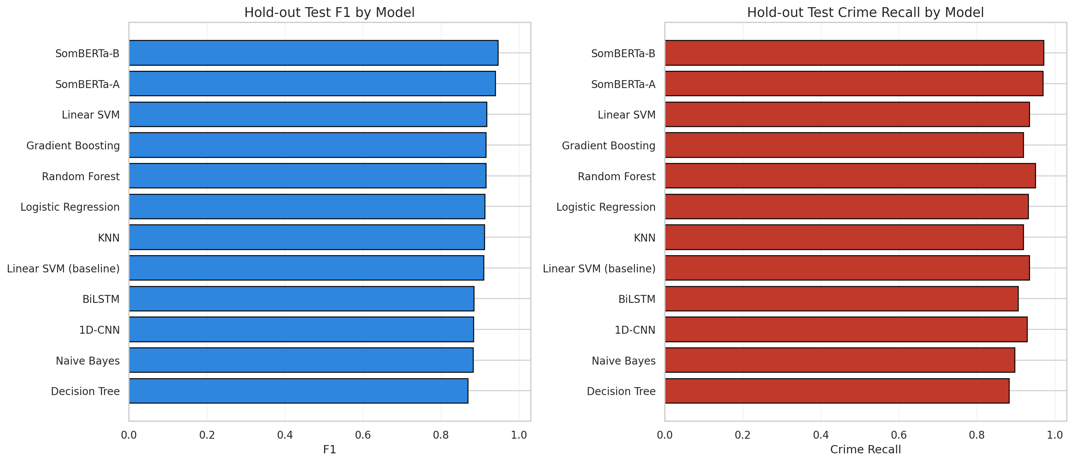
Figure 3.1: Model-selection evidence used for final deployment
The comparative experiment covers classical, word-level deep-learning, and Somali transformer models. The detailed numerical interpretation is presented in Chapter Four; within the methodology, the figure records the evidence basis for selecting SomBERTa-B.

3.5.5 Final Model Packaging and Deployment
The selected SomBERTa-B model was stored with its configuration, tokenizer, deployment metadata, label mapping, maximum sequence length, and evaluation information. The Flask service loads the model and tokenizer at start-up, selects the appropriate runtime backend, and exposes health, model-information, and prediction endpoints. The active configuration identifies somberta-b as a transformer backend. Classical model and vectorizer files remain available as comparative artefacts and optional legacy support; they are not described as the primary final inference path.
For each request, the service validates the text, tokenizes it with the saved SomBERTa tokenizer, applies padding and truncation to the configured length, creates attention masks, runs inference without gradient calculation, converts output logits into class probabilities, and returns the predicted label. Deployment metadata binds the binary labels to the correct indices, preventing accidental reversal of crime-related and not crime-related outputs.

3.5.6 Hybrid Enrichment and Operational Inference
The raw transformer prediction is followed by a backend enrichment stage. Somali crime expressions are matched using curated rules; known Somali place names are extracted; active blacklist entities are checked; source details are preserved; and confidence information is normalized for presentation. Where configured policy permits, strong domain evidence can flag a record for additional review even when the statistical decision is uncertain. Enrichment results are stored separately from the model identity so that investigators can distinguish learned prediction from rule evidence.
This hybrid design prioritizes operational recall and interpretability, but it also requires careful governance. A keyword match is contextual evidence rather than proof of a crime. Quoted reports, negation, historical discussion, and ordinary news can contain crime vocabulary. The platform therefore routes signals toward human review instead of automatically issuing legal or enforcement conclusions.

3.5.7 System Implementation Methodology
Full-stack development followed short iterative cycles. Early iterations established dataset processing, baseline models, and the Flask API. Subsequent iterations implemented authentication, analysis controllers, MongoDB schemas, and the React interfaces. Later iterations added dashboards, blacklist monitoring, cases, notifications, audit logs, reports, dataset export, Facebook and website monitoring, transformer support, integration testing, and documentation. API contracts were expressed as JSON request and response structures, allowing components to be developed and tested independently.
Table 3.5: Implementation phases
Phase | Primary activities | Deliverable
1. Data and baselines | Dataset inspection, cleaning, duplicate control, TF-IDF and classical models | Validated baseline pipeline
2. Neural and transformer experiments | 1D-CNN, BiLSTM, SomBERTa-A/B and held-out comparison | Selected SomBERTa-B artefact
3. Core services | Flask inference, Express API, MongoDB schemas and authentication | Integrated service layer
4. User application | Public analysis and protected role interfaces | React application
5. Operational workflow | Monitoring, blacklist, cases, reports, notifications and dataset management | End-to-end intelligence workflow
6. Verification | Unit, health, role, navigation, live-data and model checks | Evidence reported in Chapter Four

3.6 System Development Environment
Development was performed using Python for data processing, model training, evaluation, and Flask inference; JavaScript for the React and Express applications; Jupyter/Colab notebooks for experiments; and Visual Studio Code or equivalent tools for software development. Git-compatible version control supported source management. The frontend used React 19 and Vite, the backend used Node.js with Express 5, and MongoDB stored operational data. Transformer deployment used PyTorch and the Transformers ecosystem, while classical modelling used scikit-learn.
Table 3.6: Principal software environment
Area | Tools and frameworks
Data and classical ML | Python, pandas, NumPy, scikit-learn and joblib
Transformer NLP | PyTorch, Transformers-compatible runtime and SomBERTa tokenizer/model
AI API | Flask
Frontend | React 19, Vite, Recharts and responsive CSS
Backend | Node.js, Express 5, Mongoose, JWT and bcrypt
Database | MongoDB
Content and messaging | Puppeteer, Cheerio, Axios, Nodemailer and optional Twilio
Documentation and experimentation | Jupyter/Colab, CSV metrics and generated figures

3.7 System Requirements

3.7.1 Hardware Requirements
A development computer requires a modern multi-core processor, at least 8 GB of RAM, and sufficient storage for source data, model artefacts, dependencies, screenshots, and database records. Sixteen gigabytes of RAM is preferable for concurrent frontend, backend, database, and inference services. Transformer fine-tuning benefits substantially from a CUDA-capable GPU; however, inference can run on a CPU at reduced throughput. Production capacity should be selected after measuring request volume, model latency, monitoring frequency, and retention requirements.

3.7.2 Software Requirements
- A supported Windows or Linux operating system.
- Python 3.10 or later with the project inference and modelling dependencies.
- Node.js 18 or later with frontend and backend packages installed.
- MongoDB locally or through a secured managed deployment.
- A modern browser for the React application.
- Environment variables for database connectivity, JWT signing, frontend origin, AI service address, and optional email/SMS integrations.

3.7.3 Required Libraries and Frameworks
The principal Python dependencies include Flask, pandas, NumPy, scikit-learn, joblib, PyTorch, and transformer/tokenizer libraries required by the saved SomBERTa artefact. The server application uses Express, Mongoose, JSON Web Token support, bcrypt, Multer, Axios, Cheerio, Puppeteer, Nodemailer, and optional Twilio integration. The browser application uses React, React Router, Axios, Recharts, and supporting interface libraries. Exact dependency versions are maintained in the project requirements and package-lock files to improve reproducibility.

3.8 Ethical, Privacy and Security Considerations
Crime-related text can contain sensitive allegations, names, contact details, locations, and investigative information. The methodology therefore applies role-based access, password hashing, verified sessions, audit records, restricted exports, and separation of duties. Credentials, tokens, and private configuration values must not appear in the thesis, screenshots, logs, or public source repositories. Real institutional deployment additionally requires approved retention periods, access reviews, incident response, secure backups, encrypted transport, and compliance with applicable law and organizational policy.
The classifier is a decision-support component and not a legal authority. False positives can wrongly associate ordinary reporting with criminal activity, while false negatives can delay attention to a genuine threat. Human review is therefore mandatory before enforcement or adverse action. Dataset expansion should use lawful and ethically approved collection, documented annotation instructions, and safeguards for personal information.

3.9 Chapter Summary
This chapter presented the updated methodology for BAREAI. It described the role-based system, modular architecture, dataset profile, duplicate-aware preparation, distinct TF-IDF and transformer preprocessing paths, stratified evaluation design, candidate model families, selection measures, SomBERTa-B packaging, hybrid enrichment, implementation phases, development environment, requirements, and ethical safeguards. The update establishes SomBERTa-B as the final deployed model while retaining Random Forest and Linear SVM as important classical benchmarks. Chapter Four presents the implementation evidence, user interfaces, testing results, and detailed model comparison produced by this methodology.

CHAPTER IV: SYSTEM IMPLEMENTATION, RESULTS AND DISCUSSION

4.1 Introduction
This chapter presents the implementation, testing, empirical results, and interpretation of BAREAI, an intelligent platform developed to classify Somali crime-related text reports using Natural Language Processing (NLP). The chapter converts the methodology described in Chapter Three into a verifiable software and machine-learning outcome. It therefore reports not only the predictive performance of the final classifier, but also the manner in which the classifier was embedded within a secure web application that supports analysis, monitoring, escalation, investigation, reporting, and dataset governance.
In accordance with the University guideline for Artificial Intelligence final-year projects, the chapter begins with the dataset and implementation environment, proceeds through the deployed architecture and functional modules, presents interfaces and database outputs, documents the testing strategy, and then compares the candidate models using accuracy, precision, recall, F1-score, crime-class recall, confusion-matrix behaviour, and ROC evidence. The discussion explicitly relates the observed results to the research objectives and questions established in Chapter One. Screenshots were captured from the running application on 5 August 2026; confidential passwords and authentication tokens are intentionally excluded from the thesis.

4.2 System Overview
BAREAI is a role-based crime intelligence platform that receives unstructured Somali text from direct entry, web addresses, uploaded documents, batch files, monitored Facebook pages, and monitored websites. The text is validated, cleaned, classified, and enriched with crime keywords and Somali location information. Crime-positive reports can be forwarded to an investigation workflow, where authorized officers review evidence, update case status, record notes, and produce reports. The system additionally preserves audit events and analysis history so that a prediction can be traced to the user, source, time, model decision, and subsequent operational action.
The implemented solution is broader than a stand-alone classifier. Its public layer offers restricted Somali-language analysis, while authenticated workspaces expose different capabilities to administrators, investigators, and the Dataset Manager. Administrators supervise platform activity, users, blacklists, cases, reports, and audit logs. Investigators receive and process cases. The Dataset Manager reviews and exports collected records without being granted broader administrative authority. This separation supports least-privilege access and provides an organizational path from raw online information to accountable investigative action.
Table 4.1: Implemented system scope
Layer | Implemented responsibility | Principal technologies
Presentation | Public analysis and protected role workspaces | React 19, Vite, responsive CSS, Recharts
Application | Authentication, analysis orchestration, cases, alerts, reports, audit and monitoring | Node.js, Express 5, JWT, Mongoose
AI inference | Somali text validation, preprocessing, model loading and prediction | Python, Flask, PyTorch/Transformers and scikit-learn
Persistence | Users, histories, cases, reports, alerts, blacklist and activity records | MongoDB
External services | Web extraction, Facebook monitoring, email and optional SMS | Puppeteer, Cheerio, Nodemailer and Twilio

4.3 Dataset Description and Preparation Results
The source dataset contained 9,999 labelled records and four columns: url, text, category, and an almost entirely empty auxiliary column. All 9,999 records contained text and a valid class label. The class distribution was nearly balanced, comprising 5,000 crime-related and 4,999 not-crime-related observations. The raw text field contained 8,615 unique values; consequently, 1,384 repeated text records were detected. Duplicate removal was applied before the final split to reduce information leakage, because copies of the same report in both training and test sets could produce an unrealistically optimistic score.
Table 4.2: Dataset quality profile before modelling
Property | Observed result | Interpretation
Total records | 9,999 | Sufficient for comparative supervised experiments
Crime-related | 5,000 (50.01%) | Positive class
Not crime-related | 4,999 (49.99%) | Negative class
Missing text | 0 | No record removed for absent input
Unique text | 8,615 | Represents distinct textual reports
Duplicate text | 1,384 | Removed before leakage-safe modelling
Target classes | 2 | Binary classification task

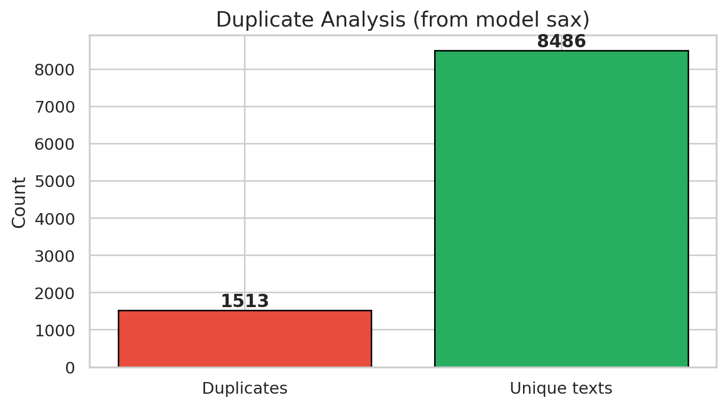
Figure 4.1: Duplicate-record assessment
The duplicate analysis quantifies repeated reports before model fitting. Removing repeated text ensures that evaluation measures generalization to unseen wording rather than memorization of duplicated observations.
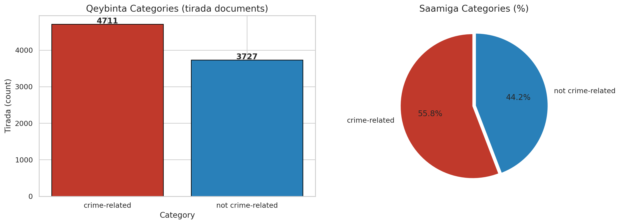
Figure 4.2: Distribution of crime-related and non-crime-related classes
The class-balance figure shows an effectively equal class distribution. Consequently, accuracy is informative, although recall and F1-score remain necessary because failure to identify a crime report carries greater operational cost than an ordinary classification error.
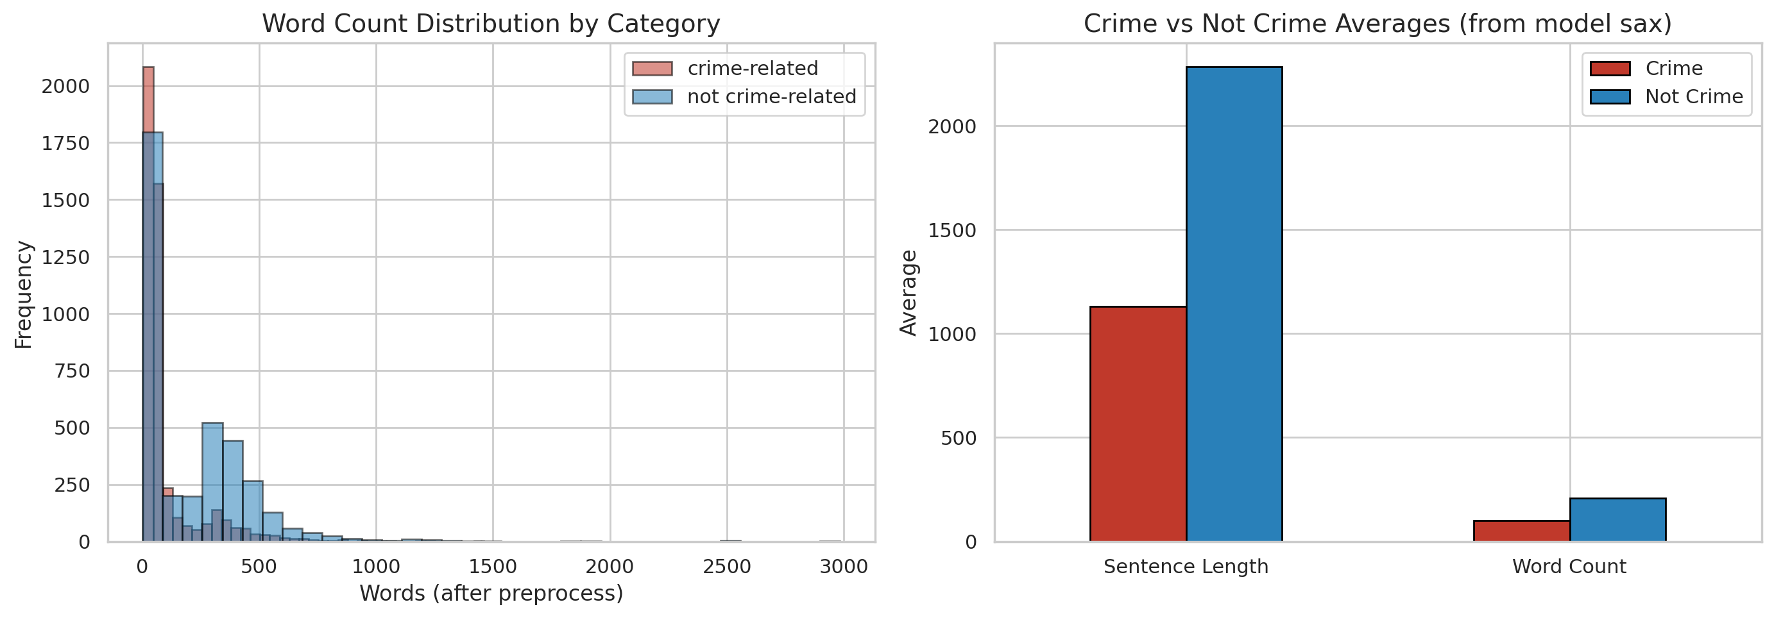
Figure 4.3: Comparison of text-length distributions by class
Text-length distributions provide evidence about input variability and potential outliers. The overlap between classes indicates that document length alone is not a reliable decision feature; the classifier must learn lexical and contextual evidence.
Preprocessing combined general NLP normalization with Somali-specific controls. Empty values and invalid labels were removed, text was normalized to lowercase where appropriate, repeated whitespace and web artefacts were cleaned, and stop words were handled using a Somali list. Classical models received TF-IDF features with word n-grams. Transformer models received tokenized sequences with a maximum length defined by their deployment configuration. A stratified split preserved the class ratio across training, validation, and test partitions. The final model-selection table records 5,906 training observations for the full SomBERTa experiments, while validation and test partitions were kept separate for model selection and final reporting.

4.4 System Architecture and Deployment
The deployed architecture uses a modular three-tier pattern with an independent AI inference service. The React single-page application sends REST requests to the Express backend. The backend verifies the JSON Web Token, enforces role permissions, validates the input, and sends prediction requests to the Flask service. The Flask service loads the selected SomBERTa-B artefacts at start-up and returns a binary label and confidence information. The backend adds keyword, location, blacklist, and source metadata before storing the result in MongoDB. This design prevents the browser from communicating directly with the model or database and centralizes authorization and audit controls.
Table 4.3: Runtime services and development ports
Service | Port | Primary request/response
React frontend | 5173 | User interaction and visual presentation
Express backend | 5000 | REST API, authorization and workflow orchestration
Flask AI service | 5001 | Text prediction and model status
MongoDB | 27017 or managed URI | Persistent document storage

The AI service exposes a health endpoint and prediction endpoints. During verification, the health response identified the active backend as transformer, the active model as somberta-b, and modelLoaded as true. The service is stateless after loading the artefacts, which permits independent scaling. If model inference is unavailable, the backend contains a limited keyword-based fallback for operational resilience; however, fallback decisions are not treated as equivalent to the validated transformer result and should be distinguished in audit metadata.

4.5 System Modules and Functional Description
Table 4.4: Functional modules of BAREAI
Module | Main functions | Authorized roles
Authentication | Login, registration, email verification, password recovery, JWT session control | All users
Analysis | Text, URL, file and batch classification; keyword and location enrichment | Guest (limited) and authenticated users
Dashboard | KPIs, class distribution, trends, sources, investigations and blacklist matches | Administrator
User Management | Create investigators, activate or suspend accounts, inspect roles | Administrator
Blacklist | Maintain monitored entities and review matches | Administrator and Investigator
Case Management | Assign/claim cases, add notes, classify, resolve and delete according to role | Administrator and Investigator
Reports | Aggregate and case-specific outputs with export functions | Administrator and Investigator
Notifications | In-app operational and blacklist alerts | Administrator and Investigator
Audit Logs | Time-stamped security and workflow activity | Administrator
Dataset Manager | Filter and export collected records by source and label | Dataset Manager
Settings/Profile | Identity, theme, alerts, password and personal settings | Authenticated users

The functional flow starts when a user supplies Somali text or a remote source. The backend validates the request and, for URLs and files, extracts readable text. The AI service returns a class decision. Crime keywords, known Somali places, and blacklist entities are then attached. A crime-positive result may be converted into an investigation case, generating notifications and an audit event. This linkage between classification and downstream accountability is a central implementation contribution because it prevents the model output from remaining an isolated experimental result.

4.6 User Interface Implementation
The interface was implemented as a responsive single-page application with a consistent navigation hierarchy, accessible headings, role-sensitive sidebars, status badges, cards, tables, charts, and modal interactions. The screenshots below are evidence from the running system. Each interface is discussed in terms of its operational purpose rather than its visual appearance alone.
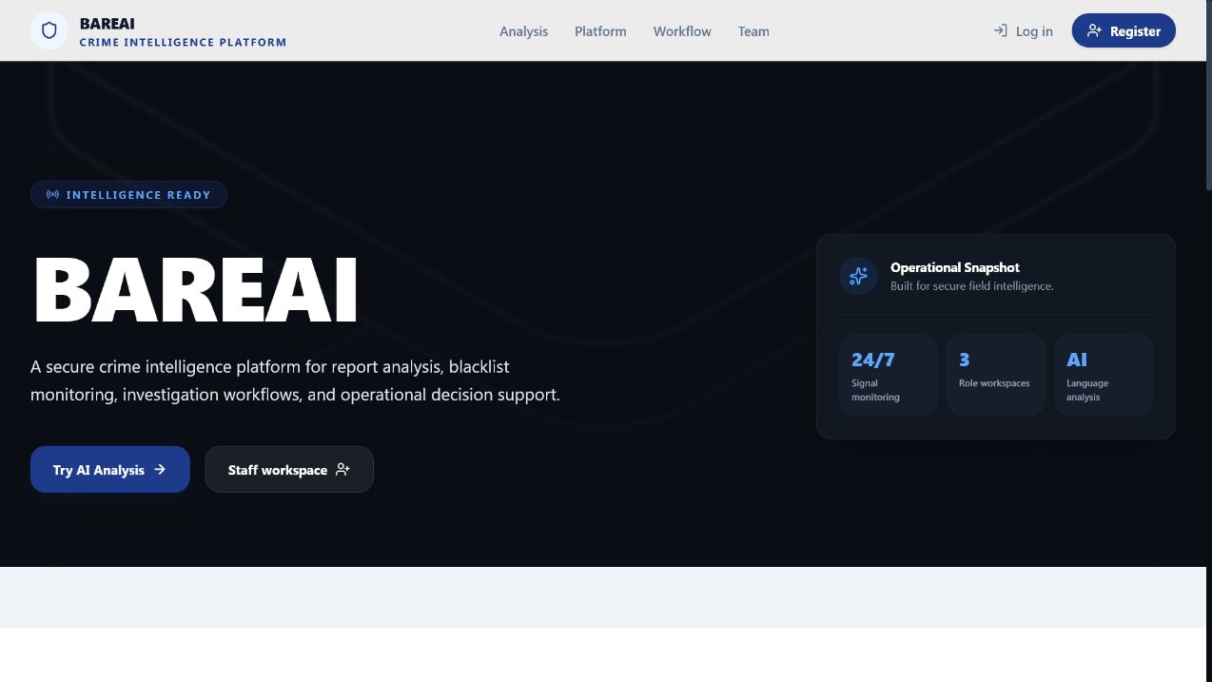
Figure 4.4: BAREAI public landing page
The landing interface communicates the system purpose and provides controlled entry to public analysis and staff authentication. It also summarizes the review-enrich-investigate workflow and distinguishes public features from protected operations.
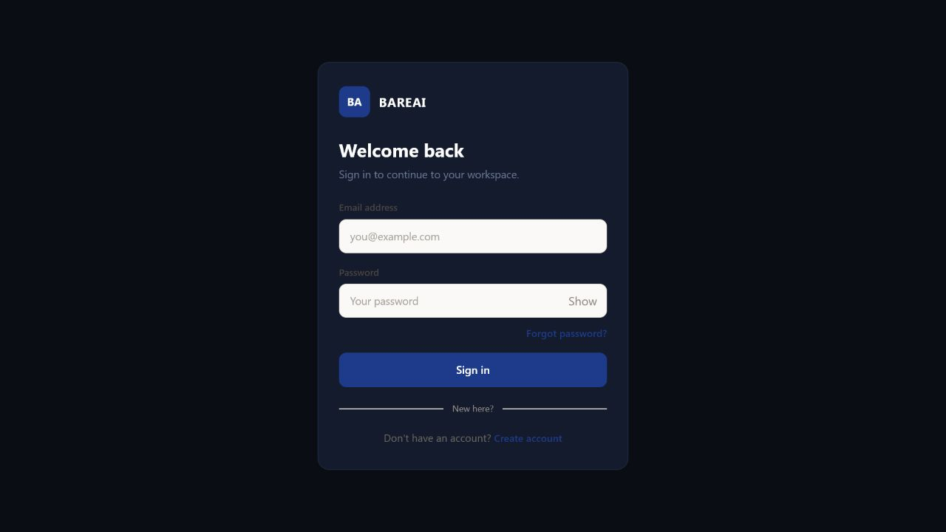
Figure 4.5: Secure login interface
The login page collects an email address and password through a dedicated authentication shell. Password visibility control and password-recovery navigation improve usability, while the backend applies hashed-password verification and JWT session creation.
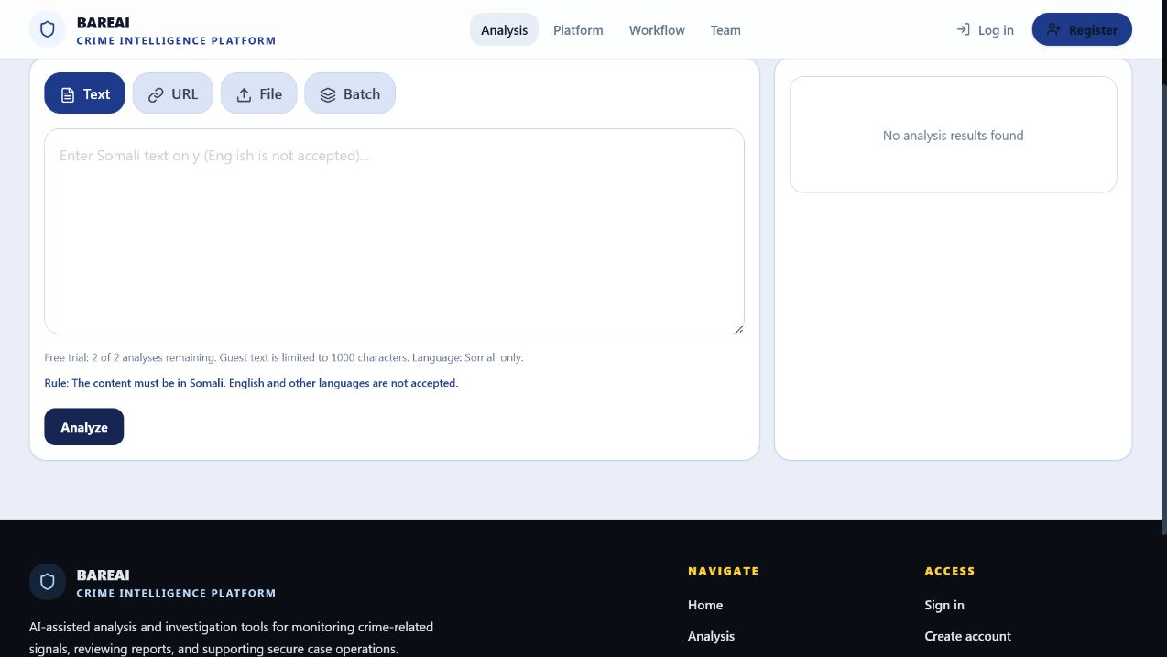
Figure 4.6: Public Somali text-analysis interface
The Analysis interface supports text, URL, file, and batch modes. For public users it enforces a limited trial, Somali-language validation, and an input-length restriction. These controls reduce misuse and align the deployed interface with the study scope.
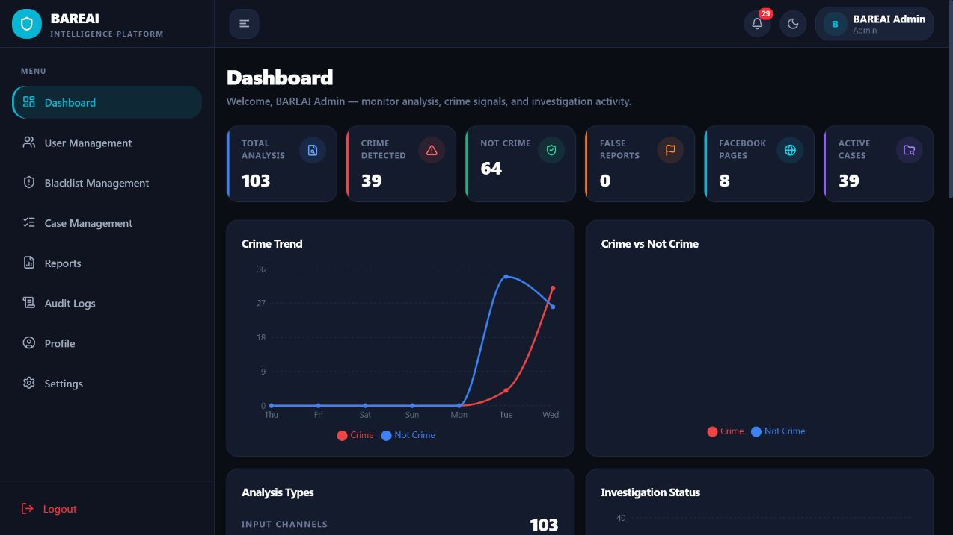
Figure 4.7: Administrator dashboard overview
The administrator dashboard consolidates the principal operational indicators. At capture time it displayed 103 analyses, 39 crime detections, 64 non-crime decisions, eight monitored Facebook pages, and 39 active cases, thereby demonstrating persistence and end-to-end system activity.
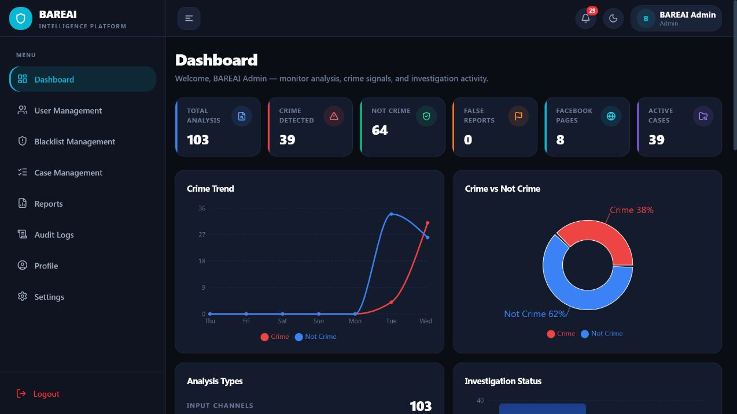
Figure 4.8: Dashboard analytical charts
Trend, class-distribution, input-source, investigation-status, and blacklist-match charts transform stored records into decision-support information. The observed class distribution was 38% crime and 62% non-crime for the live operational sample.
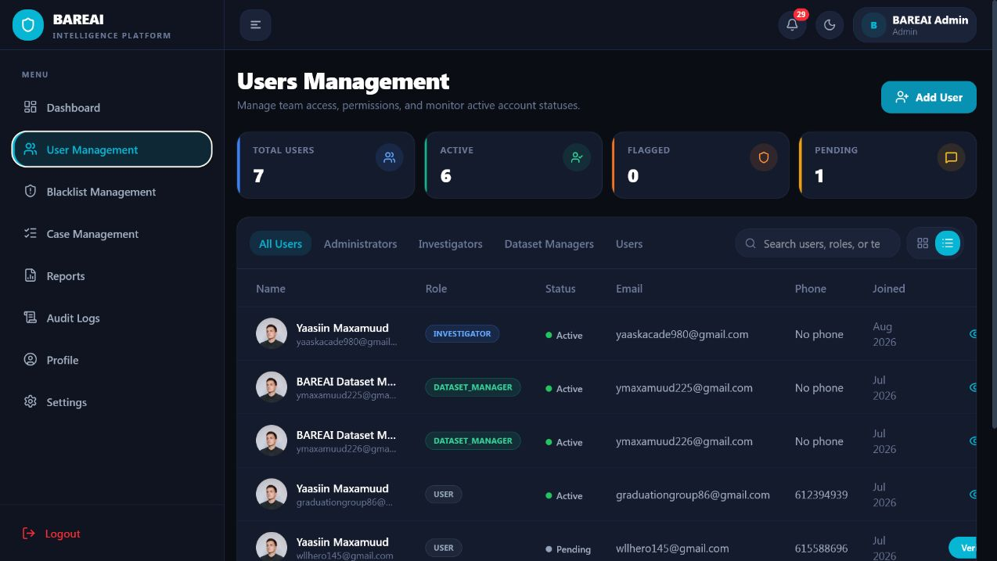
Figure 4.9: User-management interface
The user-management page enables administrators to review identities, roles, verification state, and account status. Restricting this page to the administrator protects investigator and Dataset Manager account governance.
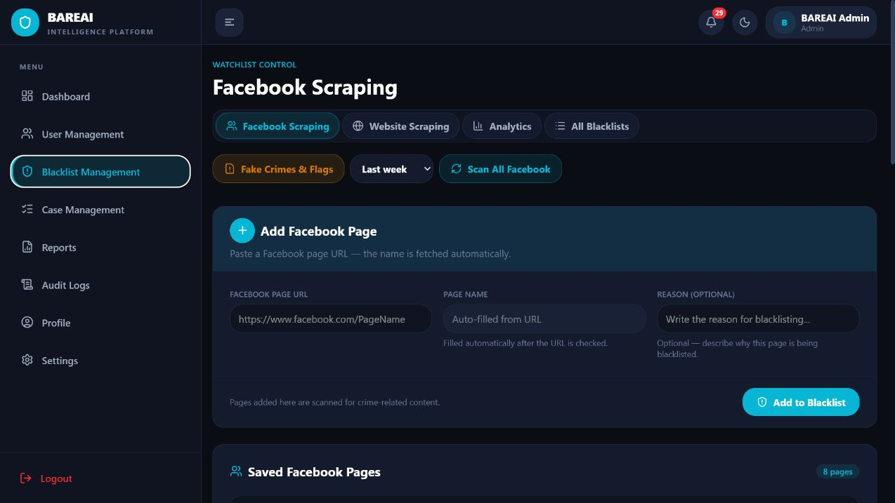
Figure 4.10: Blacklist-management interface
The blacklist module maintains entities and sources requiring special attention. Matches produced during analysis or monitoring are surfaced to authorized personnel and can support case escalation.
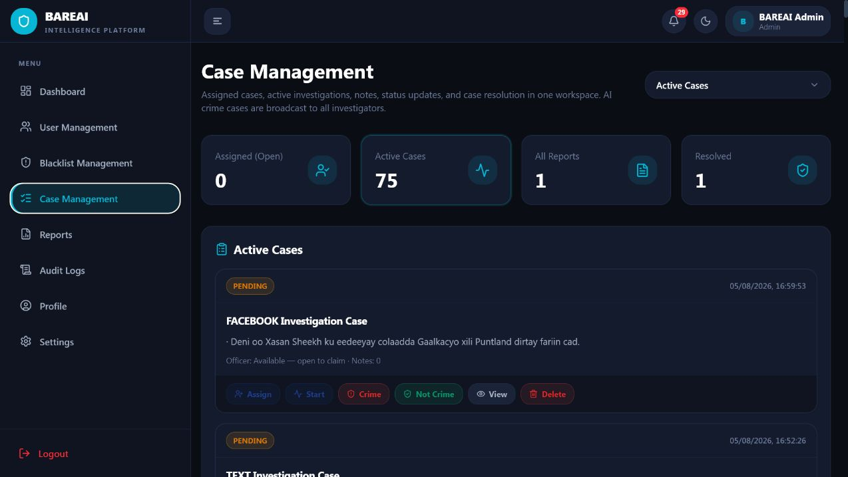
Figure 4.11: Administrator case-management interface
The case workspace presents active, assigned, reported, and resolved cases. Controls for assignment, investigation start, verdict, viewing, and deletion are role-checked and record workflow events for accountability.
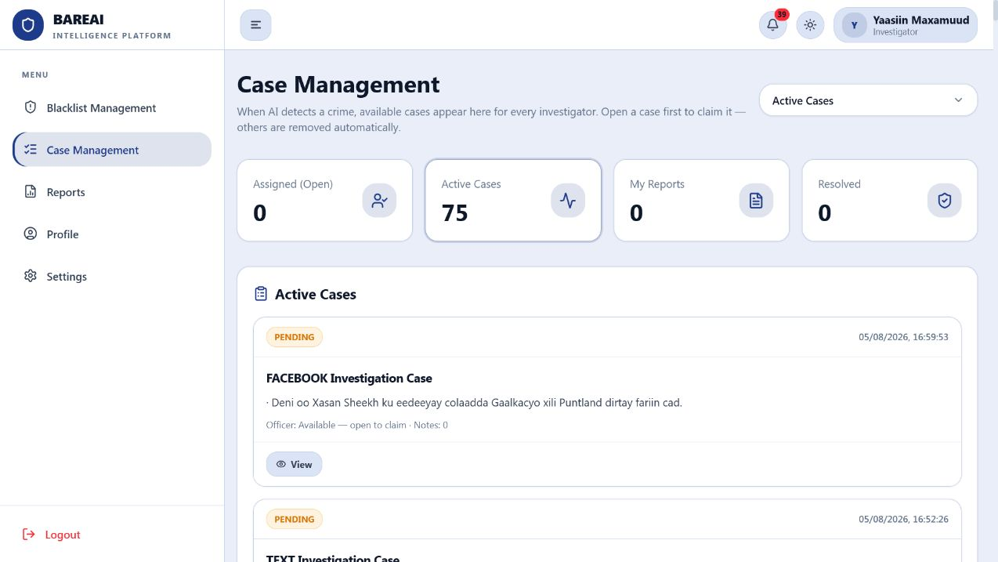
Figure 4.12: Investigator case workspace
The investigator interface removes administrative functions and focuses on available and assigned investigations, reports, and resolution. This is direct visual evidence of role-based access control.
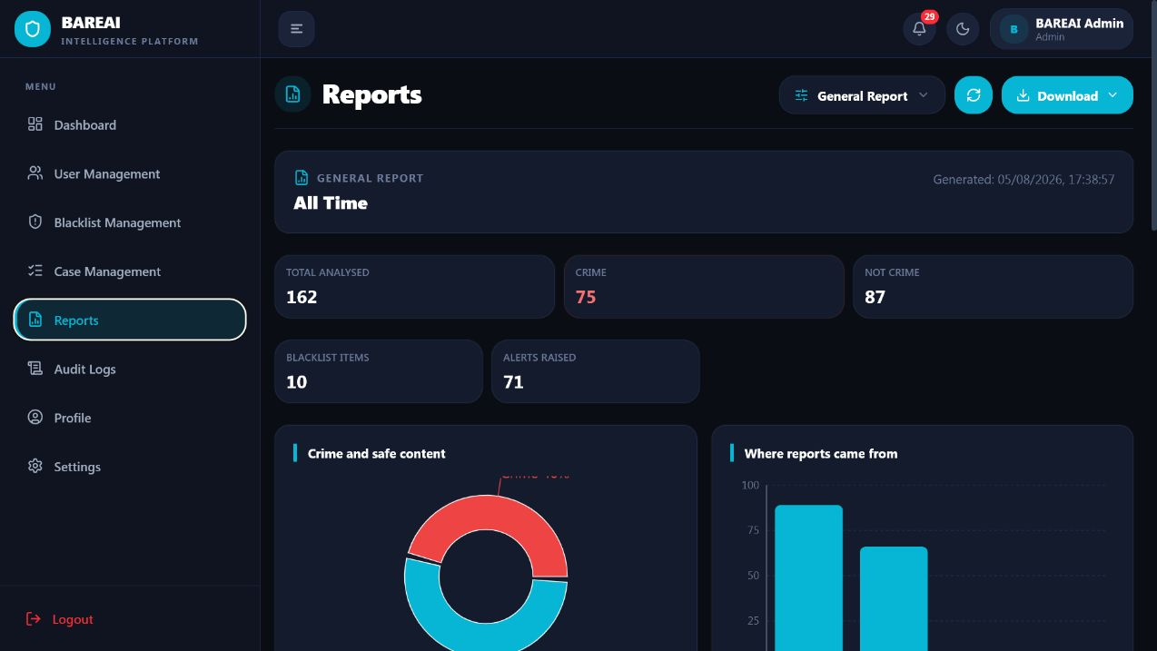
Figure 4.13: Reporting interface
The Reports page aggregates analysis and investigation information and supports formal output. Reporting translates model and workflow records into evidence that supervisors and investigators can review outside the prediction screen.
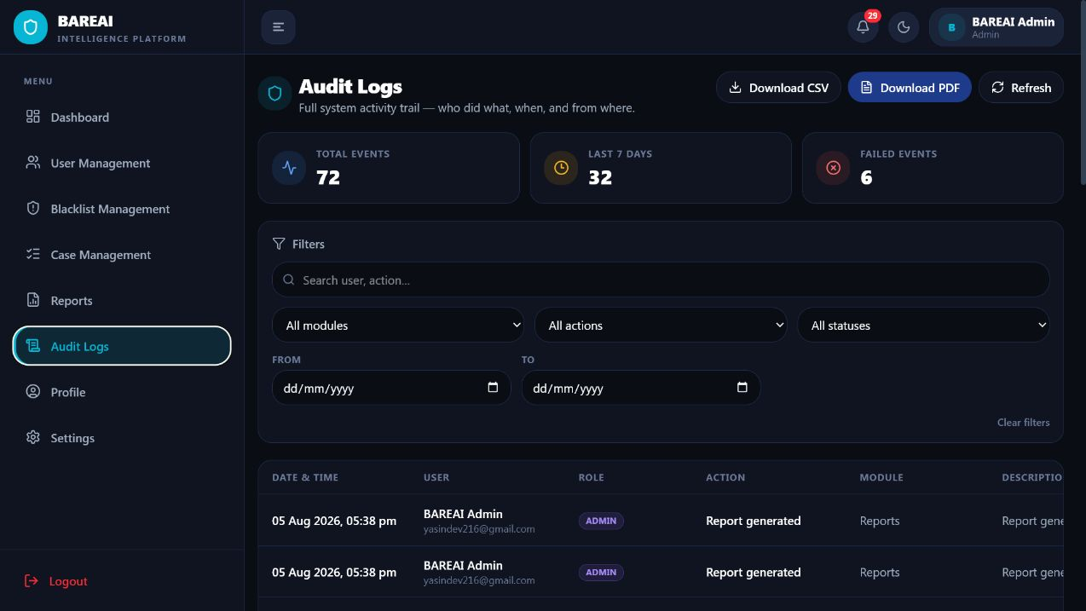
Figure 4.14: Audit-log interface
Audit logs record authentication and operational actions with user, role, module, description, status, and time. This supports traceability and assists in identifying unauthorized or failed activity.
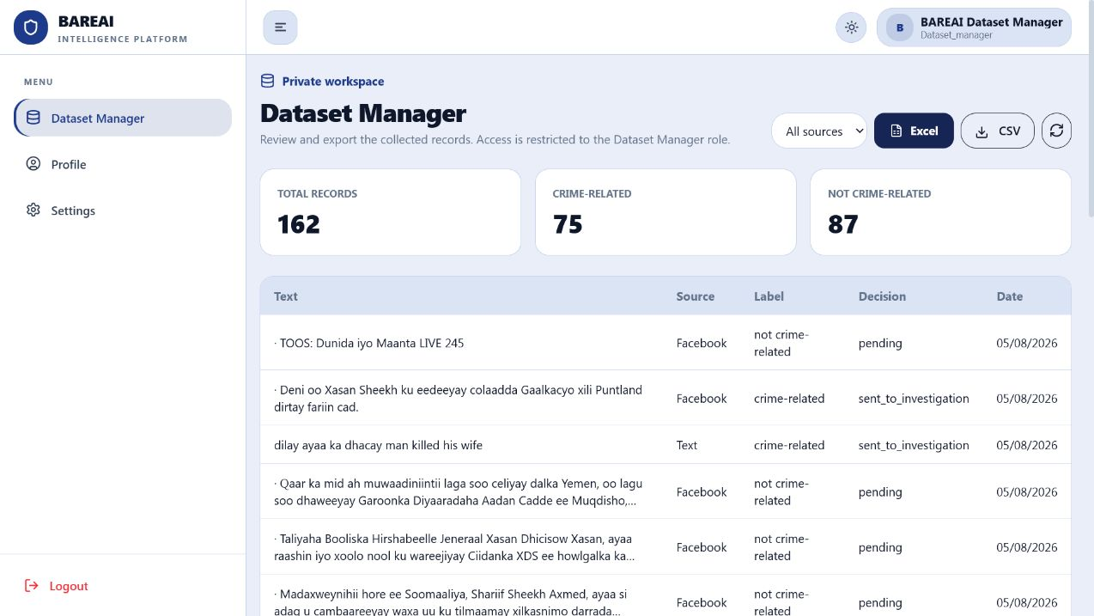
Figure 4.15: Dataset Manager workspace
The restricted Dataset Manager workspace showed 162 collected records: 75 crime-related and 87 not crime-related. It provides source filtering and CSV/Excel export while excluding administrator and investigation controls.
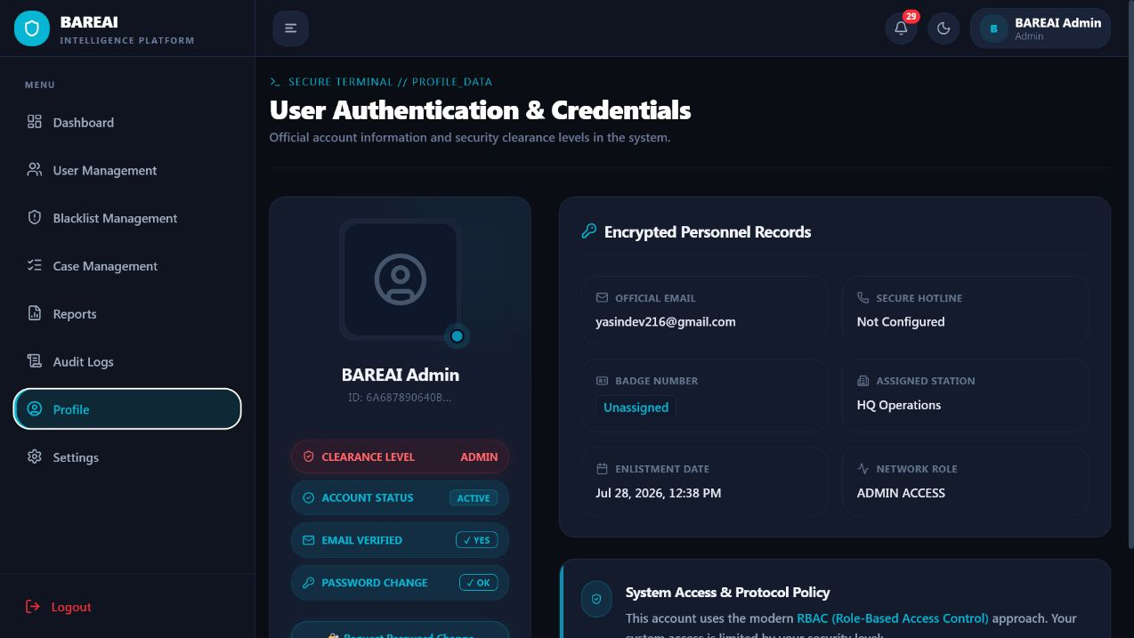
Figure 4.16: User profile interface
The profile interface centralizes personal identity and account information. Keeping profile management separate from user administration allows users to manage their own details without gaining authority over other accounts.
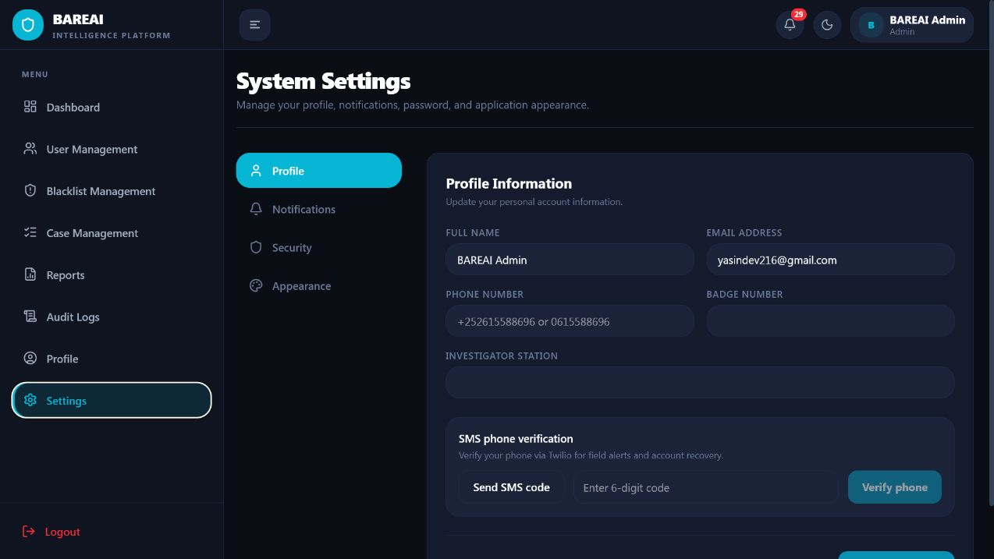
Figure 4.17: User settings and notification controls
Settings provide theme, notification, password, and preference controls. Notification counts and alerts remain available in the top bar across protected pages, enabling prioritized operational awareness while preferences remain subordinate to server-side security policy.

4.7 Database Implementation and Observed Outputs
MongoDB was implemented through Mongoose schemas that represent users, analysis history, blacklist items, investigation cases, investigation reports, notifications, and activity logs. Document storage is appropriate because analysis records contain variable-length text, keyword arrays, extracted locations, source-specific metadata, confidence values, and optional links to cases. Referential identifiers connect users to records and cases to reports, while date and status fields enable dashboard aggregation.
Table 4.5: Principal database entities
Entity | Representative stored fields | Operational use
User | name, email, password hash, role, status, verification, session identifier | Authentication and RBAC
History | input type, text/source, prediction, confidence, keywords, locations, user, time | Traceable analysis record
InvestigationCase | source, report text, assigned officer, status, verdict, notes, timestamps | Case lifecycle
InvestigationReport | case reference, findings, conclusion, author and review metadata | Formal investigative output
BlacklistItem | name, type, URL/value, status and match metadata | Priority monitoring
Notification | recipient, type, message, read state and linked resource | Operational awareness
ActivityLog | actor, role, action, module, description, status, time and request metadata | Security and auditability

Live database output was observable in the Dataset Manager table and administrator dashboard. At the time of capture, the Dataset Manager reported 162 records, of which 75 were crime-related and 87 were not crime-related. The administrator dashboard independently reported 103 analysis-history records and 39 active cases. The difference is expected because the dataset workspace consolidates records from analysis, Facebook monitoring, and website monitoring, whereas a dashboard KPI may apply a narrower collection or time/source rule. This distinction demonstrates why metric definitions must be retained with each aggregation.

4.8 Testing and Verification

4.8.1 Testing Strategy
Testing was conducted at unit, service, integration, functional, security, and usability levels. Unit verification covered Somali crime-rule behaviour. Service verification checked the AI health endpoint and successful loading of the deployed transformer. Integration verification exercised browser-to-API authentication and role navigation. Functional testing used the three supplied role accounts to verify that each role reached the correct workspace. Screenshots provide visible evidence of those outcomes. Security-oriented checks confirmed that protected pages redirected unauthenticated or invalid-session requests to login and that the role navigation differed across administrator, investigator, and Dataset Manager accounts.
Table 4.6: Representative functional test results
ID | Test condition | Expected result | Observed result | Status
T01 | Valid administrator credentials | Dashboard and administrator navigation are displayed | Dashboard loaded with KPIs and administrator modules | Pass
T02 | Valid investigator credentials | Investigator is routed to case workspace | Case workspace loaded with investigator-only navigation | Pass
T03 | Valid Dataset Manager credentials | Private dataset workspace is displayed | Dataset table, filters and exports loaded | Pass
T04 | Invalid password | Access is rejected without protected data | Login failure message displayed | Pass
T05 | Guest opens analysis | Limited Somali analysis form is available | Text/URL/File/Batch tabs and guest limit displayed | Pass
T06 | AI service health request | Active model is loaded | Transformer backend and somberta-b reported healthy | Pass
T07 | Protected route with invalid session | User is returned to login | Dashboard/case navigation redirected to login | Pass
T08 | Somali crime keyword rules | Known crime expressions are detected | Two automated tests completed successfully | Pass
T09 | Dataset filtering/export controls | Manager can select source and export | All sources, Analysis, Facebook and Website filters displayed | Pass
T10 | Audit visibility | Administrator can review recent activities | Audit table displayed user, role, action, module and status | Pass

The available automated crime-rule test suite executed two tests in 0.008 seconds and returned OK. This is a limited unit suite rather than complete coverage; therefore, the thesis does not claim exhaustive software verification. Nevertheless, the combined unit, health, role, navigation, and live-data checks establish that the main research workflow was operational at the time of evaluation.

4.9 Model Training Results
Twelve candidate configurations from classical machine learning, neural networks, and encoder-only transformers were compared on the same binary task. Weighted precision, recall, and F1-score are reported alongside accuracy, while crime-class recall is emphasized because missed crime reports represent the principal domain risk. The final all-model results identify SomBERTa-B as the strongest model, followed by SomBERTa-A. Among classical methods, Linear SVM achieved the highest accuracy, whereas Random Forest achieved slightly higher crime recall.
Table 4.7: Comparison of candidate classification models
Model | Family | Accuracy | Precision | Recall | F1 | Crime Recall
SomBERTa-B | Transformer | 94.63% | 94.69% | 94.63% | 94.61% | 97.17%
SomBERTa-A | Transformer | 93.92% | 94.00% | 93.92% | 93.89% | 96.89%
Linear SVM | Classical ML | 91.71% | 91.81% | 93.49% | 91.70% | 93.49%
Random Forest | Classical ML | 91.55% | 90.32% | 95.05% | 91.51% | 95.05%
Gradient Boosting | Classical ML | 91.55% | 92.86% | 91.94% | 91.55% | 91.94%
Logistic Regression | Classical ML | 91.23% | 91.27% | 93.21% | 91.22% | 93.21%
KNN | Classical ML | 91.15% | 92.20% | 91.94% | 91.15% | 91.94%
BiLSTM | Deep Learning | 88.47% | 88.46% | 88.47% | 88.45% | 90.52%
1D-CNN | Deep Learning | 88.39% | 88.50% | 88.39% | 88.32% | 92.93%
Naive Bayes | Classical ML | 88.23% | 89.30% | 89.67% | 88.23% | 89.67%
Decision Tree | Classical ML | 86.89% | 88.26% | 88.26% | 86.89% | 88.26%

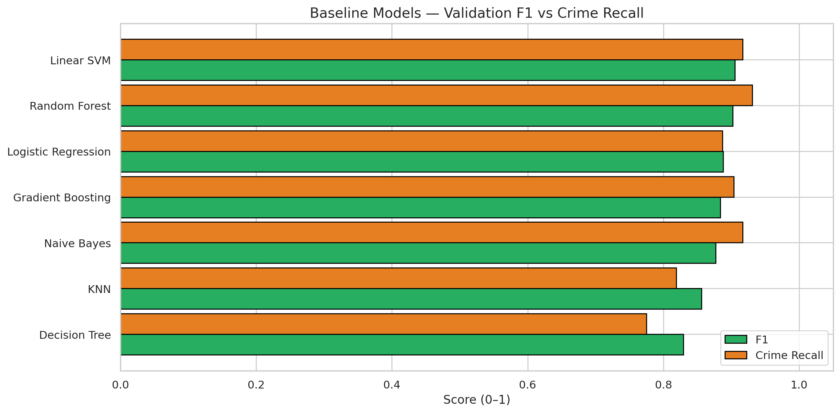
Figure 4.18: Baseline model comparison
The baseline comparison establishes the performance range of the initial classical classifiers. It provides the reference against which feature optimization, tuning, and transformer experiments were evaluated.
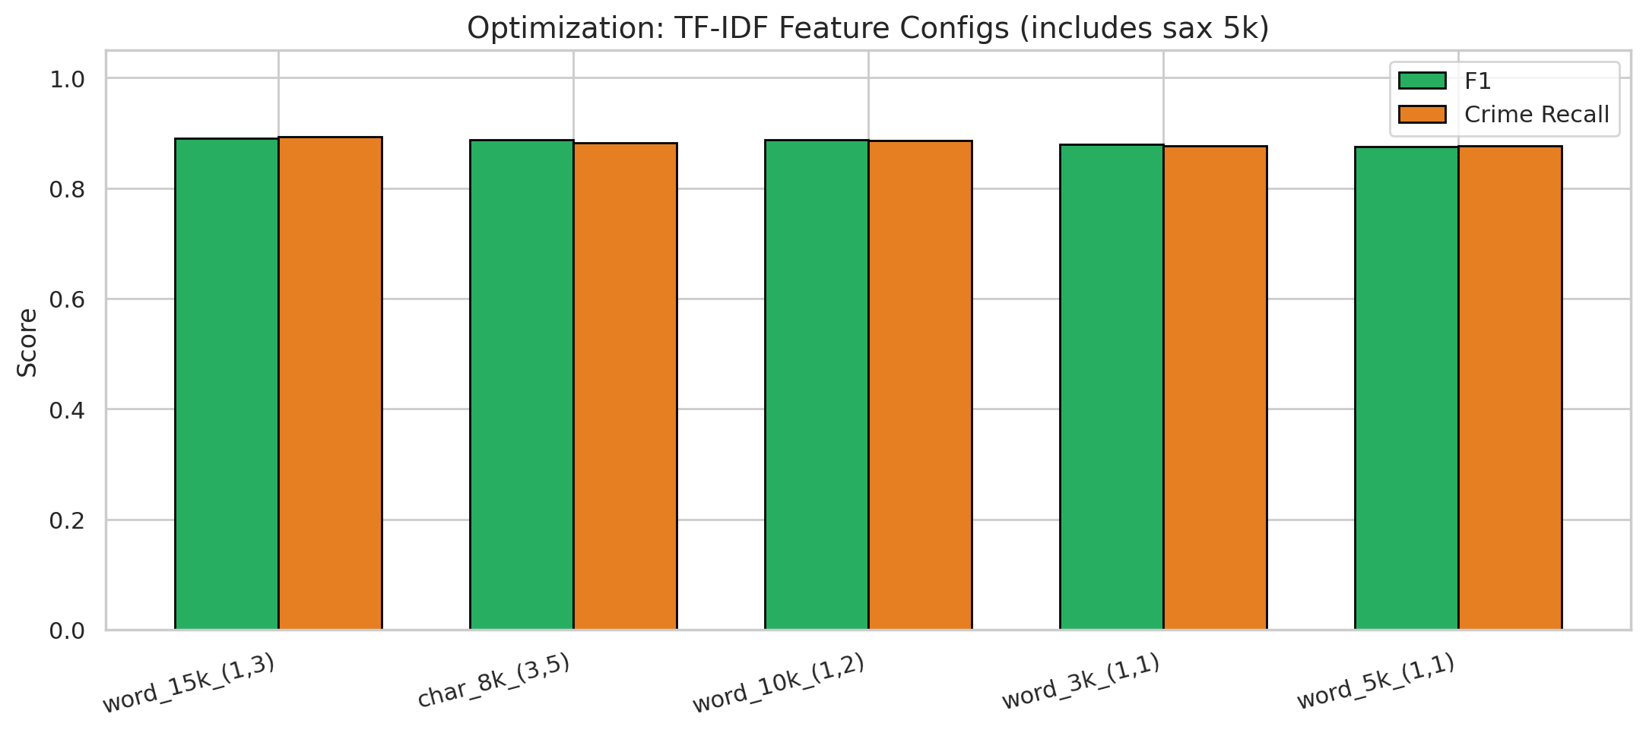
Figure 4.19: TF-IDF feature-configuration optimization
Feature optimization evaluates alternative word-feature limits and n-gram ranges. The result supports a deliberate representation choice for classical baselines rather than reliance on an arbitrary vectorizer configuration.
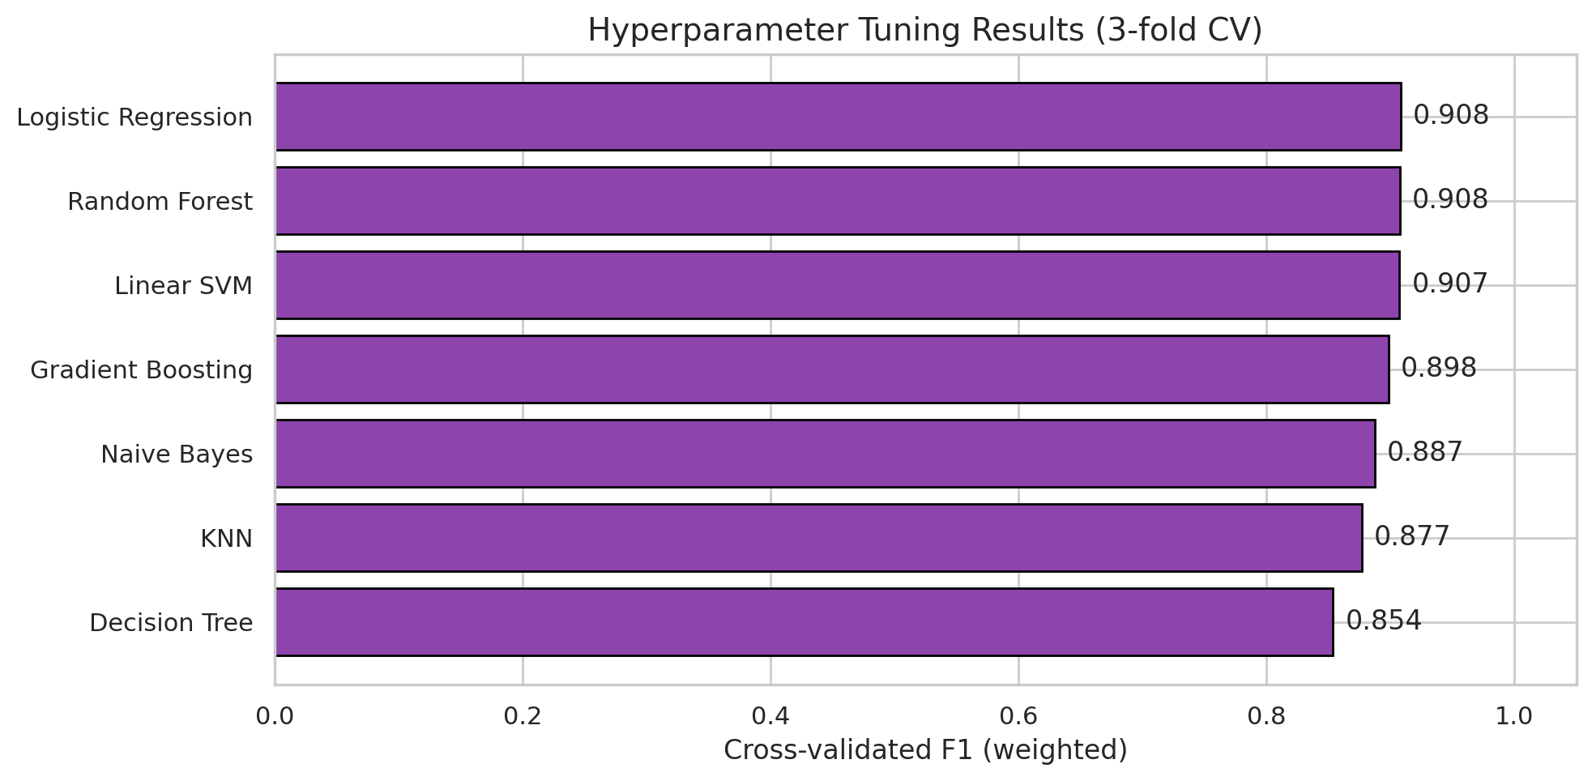
Figure 4.20: Hyperparameter-tuning results
Hyperparameter tuning refines the strongest classical configurations using validation evidence. Separating this step from final test evaluation reduces the risk of selecting parameters that merely fit the test partition.
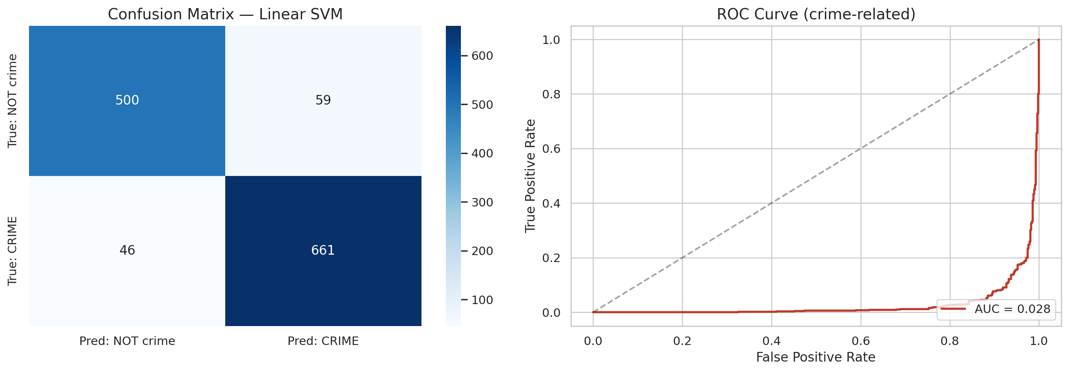
Figure 4.21: Final test confusion matrix and ROC analysis
The confusion matrix shows the distribution of correct and incorrect predictions by class, while the ROC curve summarizes discrimination across thresholds. These measures complement aggregate accuracy by exposing false-negative and false-positive behaviour.
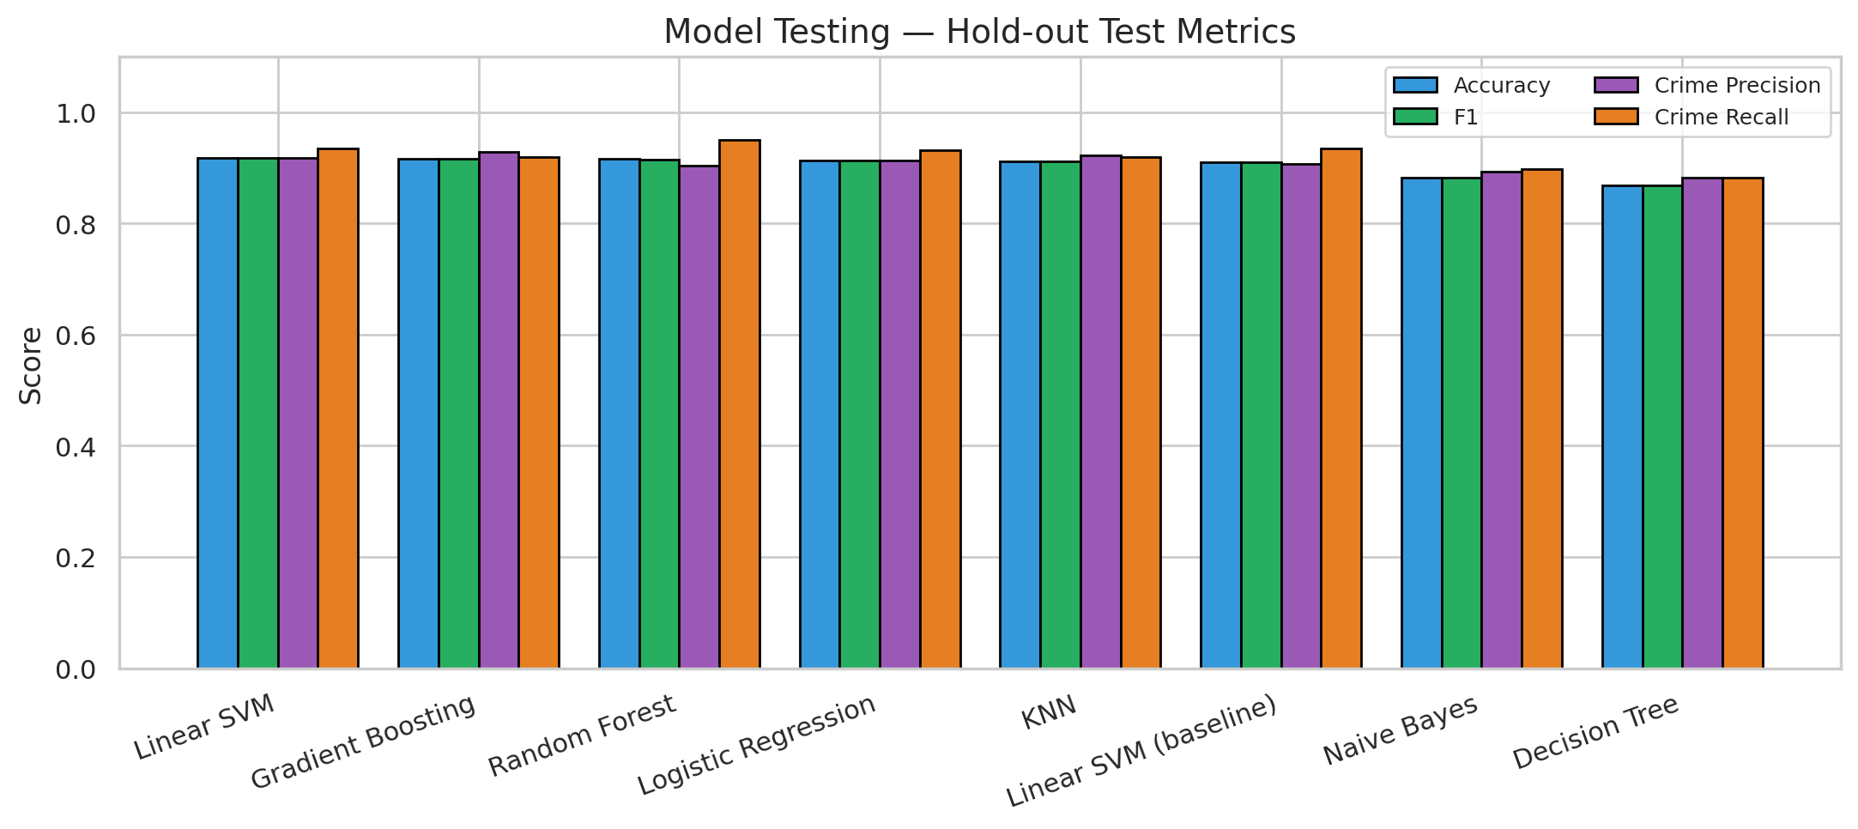
Figure 4.22: Model testing and error inspection
The testing figure summarizes final held-out performance and supports inspection of prediction behaviour. This stage is separated from training and validation to provide a less biased estimate of generalization.

Figure 4.23: Overall comparison of all trained models
The combined comparison demonstrates that the encoder-only SomBERTa variants outperform classical and recurrent/convolutional alternatives. SomBERTa-B provides the best overall balance and the highest crime recall.

4.10 Interpretation and Discussion of Results

4.10.1 Selection of the Final Model
SomBERTa-B achieved 94.63% accuracy and a weighted F1-score of 94.61%, improving on the strongest classical accuracy result, Linear SVM at 91.71%, by approximately 2.92 percentage points. More importantly for the application domain, its crime recall reached 97.17%. Relative to Linear SVM, the transformer reduced the proportion of missed positive cases because its crime recall was 3.68 percentage points higher. Random Forest obtained 95.05% crime recall, but its lower precision and overall F1-score indicate a less balanced decision boundary.
The performance advantage is consistent with the linguistic nature of the task. TF-IDF baselines represent surface word and n-gram frequency and perform strongly when crime vocabulary is explicit. SomBERTa-B can additionally model context and word use across a longer maximum sequence length of 256 tokens. This is valuable for Somali reports in which a crime term may occur within quotations, negation, background description, or code-mixed reporting. The result does not imply that transformers eliminate all errors; it shows that contextual representation was more effective for the evaluated corpus.
Chapter Three documented Random Forest as an earlier deployment choice based on the classical experiment. The final artefacts and all-model comparison produced after the transformer experiments identify SomBERTa-B as the active deployed model. This chapter therefore reports SomBERTa-B as the final result. The change is a model-selection outcome rather than a contradiction in the research logic: Random Forest served as a strong classical benchmark, while subsequent controlled experiments yielded a superior model.

4.10.2 Findings in Relation to the Research Objectives
Table 4.8: Achievement of the specific research objectives
Objective | Implementation evidence | Finding
Reduce reliance on manual classification | Automated input, prediction, history and escalation pipeline | Initial triage is automated; human review is retained for investigation and verdict
Collect and preprocess crime-related text | 9,999 labelled records; cleaning, duplicate control, Somali normalization and stratified splitting | A balanced and leakage-aware corpus was prepared
Extract and analyse key features | TF-IDF n-grams, Somali stop words, transformer tokenization, keywords and locations | Both statistical and contextual representations were evaluated
Develop an automated NLP classification system | SomBERTa-B Flask service integrated with Express, React and MongoDB | A working end-to-end platform achieved 94.63% accuracy and 97.17% crime recall

Research Question One asked how reliance on manual classification could be reduced. The implemented pipeline answers this by automatically accepting digital text, applying language validation and preprocessing, producing a class prediction, and routing a positive record toward review. Manual effort is moved from repetitive first-pass reading to higher-value verification and investigation. Research Question Two concerned collection and preprocessing. The dataset profile, duplicate analysis, normalization, stop-word handling, and stratified partitions provide the answer. Research Question Three concerned feature extraction. The classical TF-IDF experiments and contextual transformer representations demonstrate two complementary approaches, while the result shows the advantage of contextual encoding. Research Question Four concerned development of the automated system; the operational interfaces, database records, model health result, role-specific logins, and case workflow constitute the implementation evidence.

4.10.3 Operational Interpretation
High crime recall is important because a false negative can prevent a potentially urgent report from reaching investigators. However, the system must not treat every model-positive output as proven criminal evidence. Predictions are decision-support signals and require authorized human review. The case workflow correctly preserves this distinction by enabling investigators to examine text and source context before recording a verdict. Likewise, audit logs and history reduce the risk of untraceable automated action.
The live dashboard and Dataset Manager counts demonstrate that the solution operates across multiple sources rather than only laboratory test data. This increases practical relevance but introduces distribution shift: monitored news articles and social-media posts may differ from the training corpus in vocabulary, length, quoting style, and prevalence. Continuous error sampling and supervised re-evaluation are therefore necessary. The observed model score should be interpreted as held-out performance on the research dataset, not a permanent guarantee for every future online source.

4.11 Limitations Observed During Implementation
- The corpus is sizeable for an undergraduate project but remains limited relative to the regional, dialectal, and topic diversity of Somali online language.
- Some source records were duplicated, and although duplicates were removed for final modelling, repeated reporting can still affect operational database statistics.
- Binary labels distinguish crime-related from not crime-related but do not identify specific offence categories, severity, credibility, or urgency.
- The classifier may be influenced by quoted crime terms in ordinary news, negation, sarcasm, spelling variation, and Somali-English code mixing.
- Facebook and website monitoring depend on page structure and network availability; changes to external websites may interrupt extraction.
- The automated unit-test suite currently covers only a small part of the rule layer. Broader API, security, accessibility, load, and regression suites are required before institutional deployment.
- The live operational sample is not a controlled user-acceptance study, so usability effectiveness and time savings were not quantified with police personnel.
- Predictions are not legal determinations and must remain subject to authorized human review, data-protection policy, and evidential standards.

4.12 Chapter Summary
This chapter presented the complete implementation and results of BAREAI. The system integrated a React interface, Express application layer, Flask inference service, and MongoDB persistence with role-based workspaces for administrators, investigators, and the Dataset Manager. The source dataset comprised 9,999 balanced records, and duplicate-aware preparation supported comparative experiments across classical, deep-learning, and transformer models. SomBERTa-B achieved the strongest outcome with 94.63% accuracy, 94.61% F1-score, and 97.17% crime recall, and it was verified as the active transformer service. Functional evidence showed successful authentication, public analysis, dashboards, cases, reports, notifications, audit records, and dataset exports. The findings satisfy the study objectives while also revealing limitations in dataset breadth, automated testing, operational drift, and the need for human oversight.

CHAPTER V: CONCLUSION AND RECOMMENDATIONS

5.1 Introduction
This chapter concludes the study on the automatic classification of crime-related text reports using Natural Language Processing. It summarizes the research problem, methodology, implementation, and principal findings; states the contribution to knowledge and practice; presents the final conclusion; and proposes recommendations and future work. The conclusions are limited to the evidence reported in the preceding chapters and do not treat machine predictions as replacements for professional investigation or legal judgment.

5.2 Summary of the Study
The study was motivated by the growing volume of unstructured crime-related information distributed through social media, online news, digital forms, and other channels. In Somalia, manual review of such material is slow, difficult to scale, and vulnerable to fatigue and inconsistent categorization. The general objective was therefore to develop and implement an intelligent automated framework that uses machine learning and NLP to support high-speed classification while improving operational efficiency and data integrity.
The work combined a CRISP-DM-oriented machine-learning process with iterative full-stack software development. A labelled binary dataset was assessed, cleaned, deduplicated, normalized, and divided using stratified partitions. TF-IDF classical classifiers, convolutional and recurrent neural networks, and SomBERTa encoder models were evaluated. The strongest model was packaged as an independent inference service and integrated into the BAREAI platform. The full system provided public Somali analysis, authentication, dashboard analytics, user and blacklist administration, monitoring, case management, reporting, notifications, audit logs, and a private dataset-governance workspace.

5.3 Summary of Findings
- The raw dataset contained 9,999 labelled text reports and was almost perfectly balanced between the two classes. A total of 1,384 duplicated text entries required control to avoid evaluation leakage.
- Classical NLP provided strong baselines. Linear SVM achieved 91.71% accuracy, while Random Forest reached 95.05% crime recall.
- SomBERTa-B produced the best overall result, with 94.63% accuracy, 94.61% weighted F1-score, and 97.17% crime recall. It exceeded the strongest classical accuracy result by approximately 2.92 percentage points.
- The final model was successfully loaded through the Flask inference service and integrated with the Express backend, React frontend, and MongoDB database.
- The system automated the path from text acquisition to prediction, enrichment, storage, notification, and potential investigation while retaining human review for case decisions.
- Role-based access operated successfully for administrator, investigator, and Dataset Manager accounts, with materially different navigation and permissions.
- Live operational data was visible through dashboard charts, case records, audit logs, and the dataset table, demonstrating that the project progressed beyond notebook-only experimentation.
- The system’s principal remaining risks are linguistic and source distribution shift, binary-label limitations, dependence on changing external pages, incomplete automated test coverage, and the ethical consequences of false decisions.

5.4 Contribution to Knowledge and Practice
The research contributes an applied evaluation of contextual and non-contextual NLP approaches for Somali crime-related text classification. The comparative evidence shows that a Somali-oriented encoder model can improve both overall classification and positive-class recall over strong TF-IDF baselines on the evaluated corpus. The study also contributes a reproducible implementation pattern in which machine learning is isolated as a service and connected to an auditable, role-based operational workflow.
From a practical perspective, BAREAI demonstrates how automated triage can support security personnel without removing professional judgment. Its contribution is not solely the numerical model score; it is the integration of classification with source extraction, Somali keyword and location enrichment, blacklist monitoring, notification, case ownership, reports, dataset export, and auditability. This combination addresses the gap between experimental text classification and the daily information-management needs of a security organization.

5.5 Conclusion
The study concludes that Natural Language Processing can substantially reduce the first-pass manual burden involved in classifying Somali crime-related text reports. The empirical comparison demonstrates that contextual representation is advantageous for this task: SomBERTa-B achieved the best measured balance of accuracy, F1-score, and crime recall. The implemented platform further shows that the model can be deployed within a functional information system rather than remaining confined to an experimental notebook.
All four specific objectives were achieved. Manual triage was reduced through an automated pipeline; crime-related data was collected and prepared; statistical and contextual features were extracted and evaluated; and a complete NLP-enabled web platform was developed. The general objective was therefore met within the stated binary-classification scope. Nevertheless, responsible interpretation is essential. A score of 94.63% accuracy still implies errors, and the cost of a missed crime report or an incorrectly flagged person can be significant. BAREAI should consequently be used as a prioritization and decision-support tool under trained human supervision, not as an autonomous legal authority.

5.6 Recommendations

5.6.1 Recommendations for Dataset and Model Improvement
- Expand the corpus through ethically governed partnerships with Somali security, media, and research institutions, ensuring representation of regions, dialects, spelling variants, and source types.
- Introduce hierarchical or multi-label offence categories such as homicide, assault, theft, kidnapping, terrorism, cybercrime, fraud, and drug-related crime, while retaining the binary triage layer.
- Establish a documented annotation protocol with multiple trained annotators and report inter-annotator agreement before using new labels for training.
- Maintain strict duplicate and near-duplicate controls before data splitting and preserve an immutable external test set for periodic comparison.
- Calibrate probability outputs and define thresholds based on the different operational costs of false negatives and false positives rather than using accuracy alone.
- Implement drift monitoring and schedule re-evaluation when vocabulary, sources, or performance distributions change.

5.6.2 Recommendations for System and Security Improvement
- Deploy all services behind HTTPS, rotate secrets, use a managed secret store, and prohibit inclusion of passwords or tokens in academic documents, screenshots, logs, and source control.
- Add comprehensive automated tests for authentication, authorization, analysis APIs, file processing, monitoring, case transitions, exports, accessibility, and regression behaviour.
- Conduct independent penetration testing and security review before handling real sensitive or personally identifiable information.
- Define data-retention, deletion, access-review, incident-response, and model-governance policies aligned with applicable Somali law and institutional policy.
- Record the model name, model integrity identifier, threshold, fallback status, and preprocessing version with every prediction to strengthen reproducibility.
- Use robust job queues and retry controls for monitoring and notifications, with clear failure states rather than silent loss of work.

5.6.3 Recommendations for Organizational Adoption
- Pilot the platform with a small trained team and measure classification time, review time, error correction, and investigator satisfaction against the current manual process.
- Create standard operating procedures that specify who may review, escalate, assign, resolve, export, and delete records.
- Provide investigators with guidance on model limitations, confidence interpretation, false positives, false negatives, and confirmation bias.
- Require human confirmation before a prediction influences enforcement, public accusation, or adverse action against an individual.
- Establish a periodic multidisciplinary review involving security professionals, Somali-language experts, data scientists, legal advisers, and ethics representatives.

5.7 Future Work
Future research should extend the binary classifier into a multi-stage intelligence model. The first stage may retain high-recall crime screening; subsequent stages could estimate offence type, urgency, location, named entities, credibility, and whether the report describes an event, opinion, quotation, or historical context. A multi-task Somali transformer could share linguistic representations across these tasks while separate confidence thresholds protect each operational decision.
Further work should also evaluate explainability techniques suitable for Somali text, including highlighted evidence spans, counterfactual tests, and example-based explanations. Explanations must be assessed with investigators to determine whether they improve decision quality rather than merely appearing persuasive. Active learning could prioritize uncertain or novel reports for expert annotation, thereby improving the dataset efficiently. Federated or privacy-preserving learning may be investigated where agencies cannot centralize sensitive text.
On the system side, production deployment should introduce containerization, continuous integration, model and API monitoring, structured observability, automated backups, disaster recovery, and horizontal scaling. Monitoring connectors should use stable authorized APIs wherever possible. Mobile-friendly field interfaces and offline synchronization could extend the platform to low-connectivity environments. Finally, a controlled user study with law-enforcement professionals should quantify task completion time, usability, trust calibration, and the real operational effect of automated triage.
Table 5.1: Prioritized future-work roadmap
Priority | Proposed work | Expected value
High | Larger multi-region annotated corpus and independent test set | Improves generalization and credibility
High | Expanded automated security and regression testing | Reduces deployment risk
High | Human-in-the-loop pilot with measured outcomes | Validates practical benefit and safe procedures
Medium | Multi-label crime type, urgency and credibility models | Produces richer prioritization
Medium | Drift monitoring, probability calibration and threshold governance | Maintains performance over time
Medium | Explainable Somali evidence spans and investigator evaluation | Supports transparent review
Long term | Privacy-preserving inter-agency learning and mobile/offline operation | Enables responsible scale

5.8 Final Remarks
BAREAI demonstrates that a locally relevant NLP system can connect Somali-language classification research with a complete operational workflow. Its strongest result is the combination of contextual model performance, high crime recall, role-based governance, and traceable case handling. The project provides a credible foundation for further academic and institutional development, provided that future deployment is accompanied by stronger datasets, comprehensive testing, security controls, continuous evaluation, and meaningful human oversight.

