CHAPTER IV: SYSTEM IMPLEMENTATION, RESULTS AND DISCUSSION

4.1 Introduction
This chapter presents the implementation, testing, empirical results, and interpretation of BAREAI, an intelligent platform developed to classify Somali crime-related text reports using Natural Language Processing (NLP). The chapter converts the methodology described in Chapter Three into a verifiable software and machine-learning outcome. It therefore reports not only the predictive performance of the final classifier, but also the manner in which the classifier was embedded within a secure web application that supports analysis, monitoring, escalation, investigation, reporting, and dataset governance.
In accordance with the University guideline for Artificial Intelligence final-year projects, the chapter begins with the dataset and implementation environment, proceeds through the deployed architecture and functional modules, presents interfaces and database outputs, documents the testing strategy, and then compares the candidate models using accuracy, precision, recall, F1-score, crime-class recall, confusion-matrix behaviour, and ROC evidence. The discussion explicitly relates the observed results to the research objectives and questions established in Chapter One. Screenshots were captured from the running application on 5 August 2026; confidential passwords and authentication tokens are intentionally excluded from the thesis.

4.2 System Overview
BAREAI is a role-based crime intelligence platform that receives unstructured Somali text from direct entry, web addresses, uploaded documents, batch files, monitored Facebook pages, and monitored websites. The text is validated, cleaned, classified, and enriched with crime keywords and Somali location information. Crime-positive reports can be forwarded to an investigation workflow, where authorized officers review evidence, update case status, record notes, and produce reports. The system additionally preserves audit events and analysis history so that a prediction can be traced to the user, source, time, model decision, and subsequent operational action.
The implemented solution is broader than a stand-alone classifier. Its public layer offers restricted Somali-language analysis, while authenticated workspaces expose different capabilities to administrators, investigators, and the Dataset Manager. Administrators supervise platform activity, users, blacklists, cases, reports, and audit logs. Investigators receive and process cases. The Dataset Manager reviews and exports collected records without being granted broader administrative authority. This separation supports least-privilege access and provides an organizational path from raw online information to accountable investigative action.
Table 4.1: Implemented system scope
Layer | Implemented responsibility | Principal technologies
Presentation | Public analysis and protected role workspaces | React 19, Vite, responsive CSS, Recharts
Application | Authentication, analysis orchestration, cases, alerts, reports, audit and monitoring | Node.js, Express 5, JWT, Mongoose
AI inference | Somali text validation, preprocessing, model loading and prediction | Python, Flask, PyTorch/Transformers and scikit-learn
Persistence | Users, histories, cases, reports, alerts, blacklist and activity records | MongoDB
External services | Web extraction, Facebook monitoring, email and optional SMS | Puppeteer, Cheerio, Nodemailer and Twilio

4.3 Dataset Description and Preparation Results
The source dataset contained 9,999 labelled records and four columns: url, text, category, and an almost entirely empty auxiliary column. All 9,999 records contained text and a valid class label. The class distribution was nearly balanced, comprising 5,000 crime-related and 4,999 not-crime-related observations. The raw text field contained 8,615 unique values; consequently, 1,384 repeated text records were detected. Duplicate removal was applied before the final split to reduce information leakage, because copies of the same report in both training and test sets could produce an unrealistically optimistic score.
Table 4.2: Dataset quality profile before modelling
Property | Observed result | Interpretation
Total records | 9,999 | Sufficient for comparative supervised experiments
Crime-related | 5,000 (50.01%) | Positive class
Not crime-related | 4,999 (49.99%) | Negative class
Missing text | 0 | No record removed for absent input
Unique text | 8,615 | Represents distinct textual reports
Duplicate text | 1,384 | Removed before leakage-safe modelling
Target classes | 2 | Binary classification task

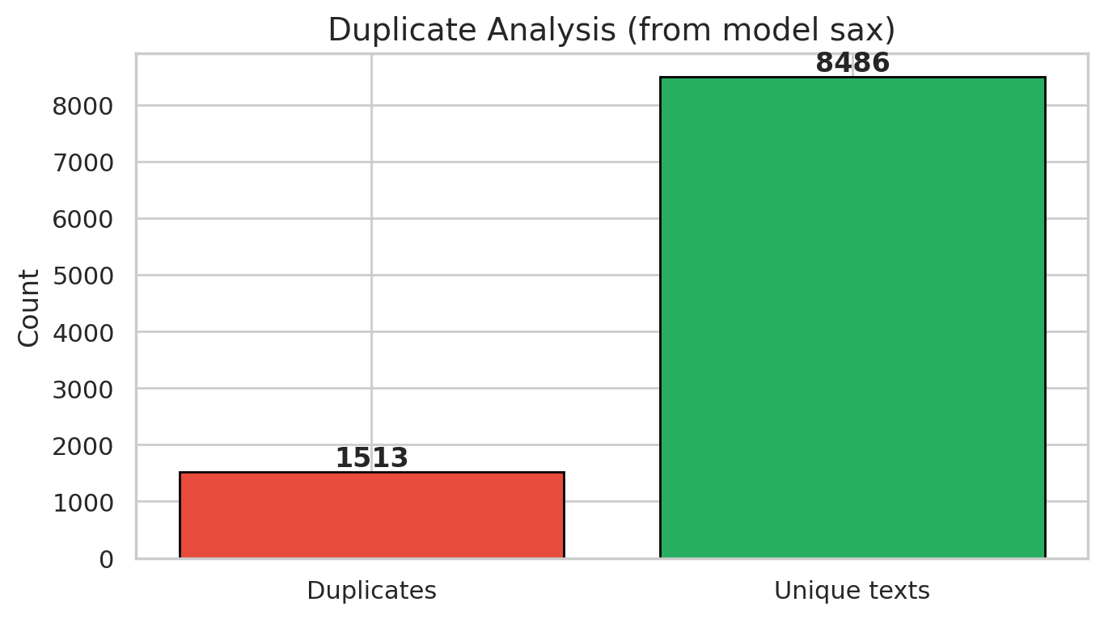
Figure 4.1: Duplicate-record assessment
The duplicate analysis quantifies repeated reports before model fitting. Removing repeated text ensures that evaluation measures generalization to unseen wording rather than memorization of duplicated observations.
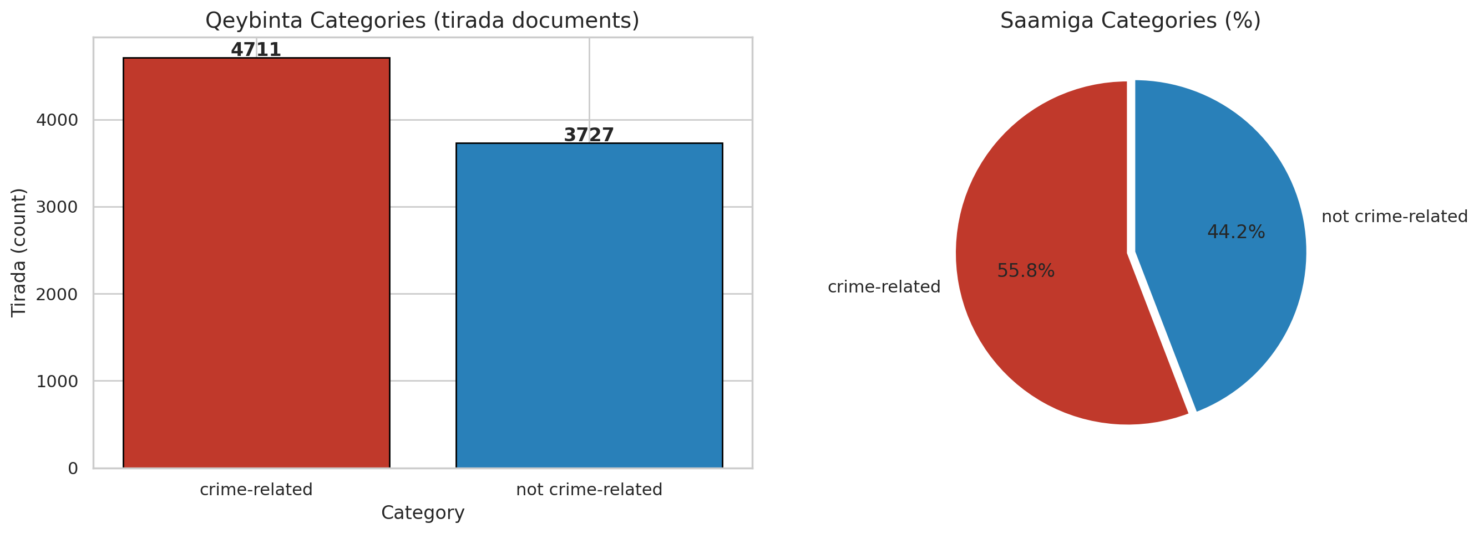
Figure 4.2: Distribution of crime-related and non-crime-related classes
The class-balance figure shows an effectively equal class distribution. Consequently, accuracy is informative, although recall and F1-score remain necessary because failure to identify a crime report carries greater operational cost than an ordinary classification error.
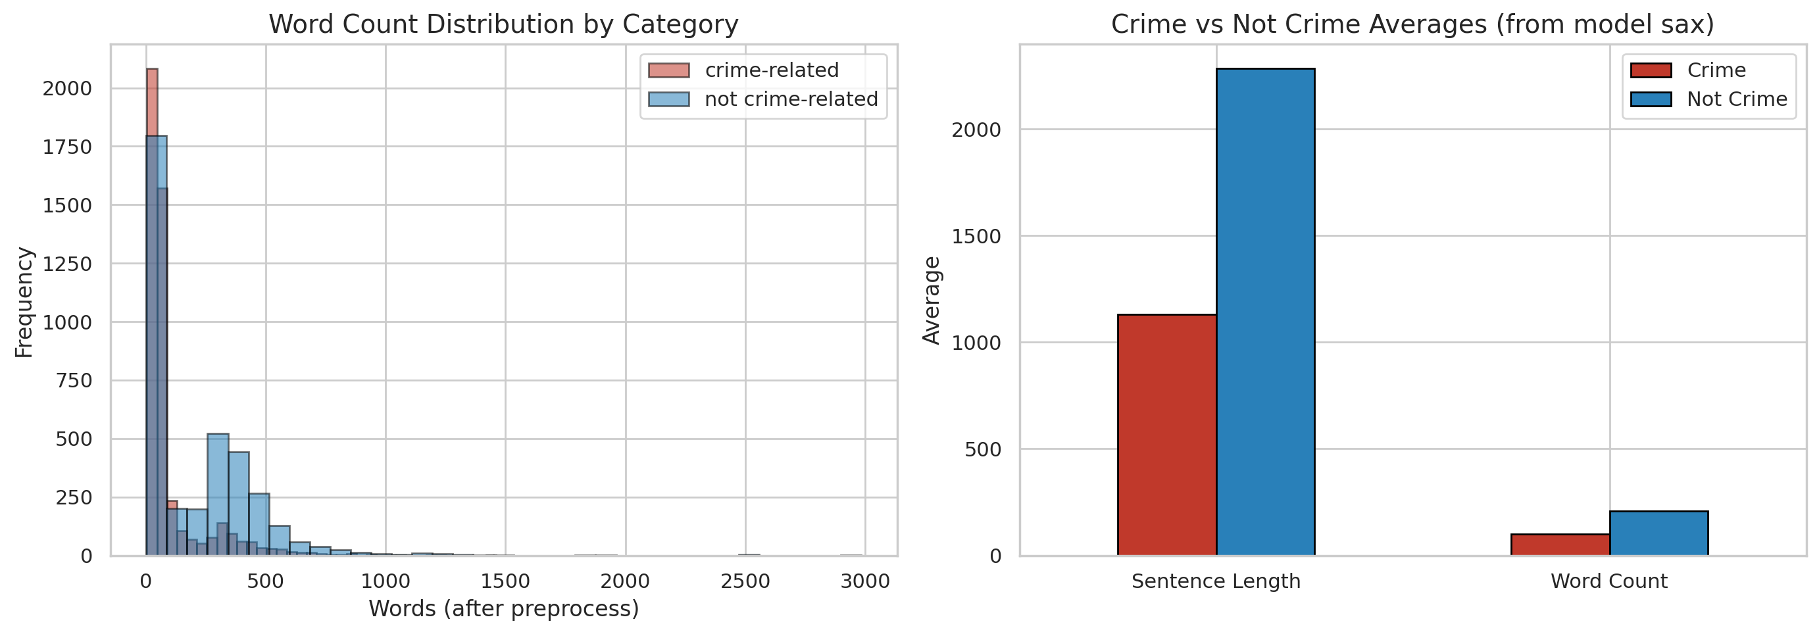
Figure 4.3: Comparison of text-length distributions by class
Text-length distributions provide evidence about input variability and potential outliers. The overlap between classes indicates that document length alone is not a reliable decision feature; the classifier must learn lexical and contextual evidence.
Preprocessing combined general NLP normalization with Somali-specific controls. Empty values and invalid labels were removed, text was normalized to lowercase where appropriate, repeated whitespace and web artefacts were cleaned, and stop words were handled using a Somali list. Classical models received TF-IDF features with word n-grams. Transformer models received tokenized sequences with a maximum length defined by their deployment configuration. A stratified split preserved the class ratio across training, validation, and test partitions. The final model-selection table records 5,906 training observations for the full SomBERTa experiments, while validation and test partitions were kept separate for model selection and final reporting.

4.4 System Architecture and Deployment
The deployed architecture uses a modular three-tier pattern with an independent AI inference service. The React single-page application sends REST requests to the Express backend. The backend verifies the JSON Web Token, enforces role permissions, validates the input, and sends prediction requests to the Flask service. The Flask service loads the selected SomBERTa-B artefacts at start-up and returns a binary label and confidence information. The backend adds keyword, location, blacklist, and source metadata before storing the result in MongoDB. This design prevents the browser from communicating directly with the model or database and centralizes authorization and audit controls.
Table 4.3: Runtime services and development ports
Service | Port | Primary request/response
React frontend | 5173 | User interaction and visual presentation
Express backend | 5000 | REST API, authorization and workflow orchestration
Flask AI service | 5001 | Text prediction and model status
MongoDB | 27017 or managed URI | Persistent document storage

The AI service exposes a health endpoint and prediction endpoints. During verification, the health response identified the active backend as transformer, the active model as somberta-b, and modelLoaded as true. The service is stateless after loading the artefacts, which permits independent scaling. If model inference is unavailable, the backend contains a limited keyword-based fallback for operational resilience; however, fallback decisions are not treated as equivalent to the validated transformer result and should be distinguished in audit metadata.

4.5 System Modules and Functional Description
Table 4.4: Functional modules of BAREAI
Module | Main functions | Authorized roles
Authentication | Login, registration, email verification, password recovery, JWT session control | All users
Analysis | Text, URL, file and batch classification; keyword and location enrichment | Guest (limited) and authenticated users
Dashboard | KPIs, class distribution, trends, sources, investigations and blacklist matches | Administrator
User Management | Create investigators, activate or suspend accounts, inspect roles | Administrator
Blacklist | Maintain monitored entities and review matches | Administrator and Investigator
Case Management | Assign/claim cases, add notes, classify, resolve and delete according to role | Administrator and Investigator
Reports | Aggregate and case-specific outputs with export functions | Administrator and Investigator
Notifications | In-app operational and blacklist alerts | Administrator and Investigator
Audit Logs | Time-stamped security and workflow activity | Administrator
Dataset Manager | Filter and export collected records by source and label | Dataset Manager
Settings/Profile | Identity, theme, alerts, password and personal settings | Authenticated users

The functional flow starts when a user supplies Somali text or a remote source. The backend validates the request and, for URLs and files, extracts readable text. The AI service returns a class decision. Crime keywords, known Somali places, and blacklist entities are then attached. A crime-positive result may be converted into an investigation case, generating notifications and an audit event. This linkage between classification and downstream accountability is a central implementation contribution because it prevents the model output from remaining an isolated experimental result.

4.6 User Interface Implementation
The interface was implemented as a responsive single-page application with a consistent navigation hierarchy, accessible headings, role-sensitive sidebars, status badges, cards, tables, charts, and modal interactions. The screenshots below are evidence from the running system. Each interface is discussed in terms of its operational purpose rather than its visual appearance alone.
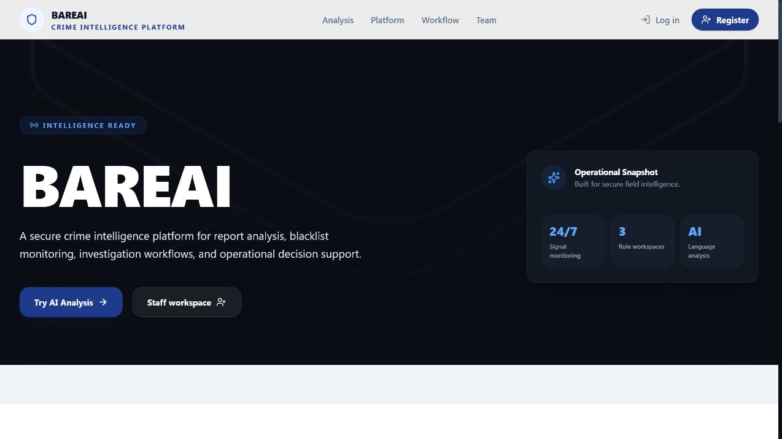
Figure 4.4: BAREAI public landing page
The landing interface communicates the system purpose and provides controlled entry to public analysis and staff authentication. It also summarizes the review-enrich-investigate workflow and distinguishes public features from protected operations.
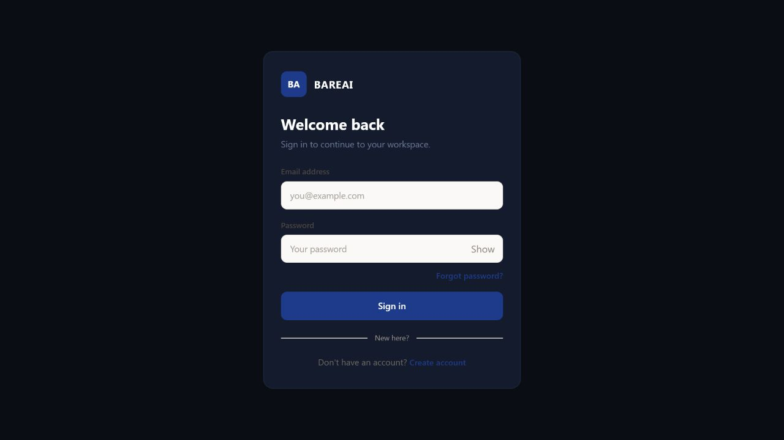
Figure 4.5: Secure login interface
The login page collects an email address and password through a dedicated authentication shell. Password visibility control and password-recovery navigation improve usability, while the backend applies hashed-password verification and JWT session creation.
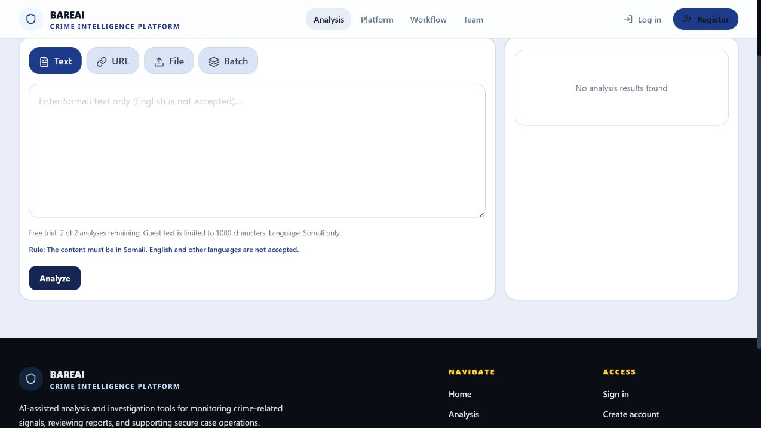
Figure 4.6: Public Somali text-analysis interface
The Analysis interface supports text, URL, file, and batch modes. For public users it enforces a limited trial, Somali-language validation, and an input-length restriction. These controls reduce misuse and align the deployed interface with the study scope.
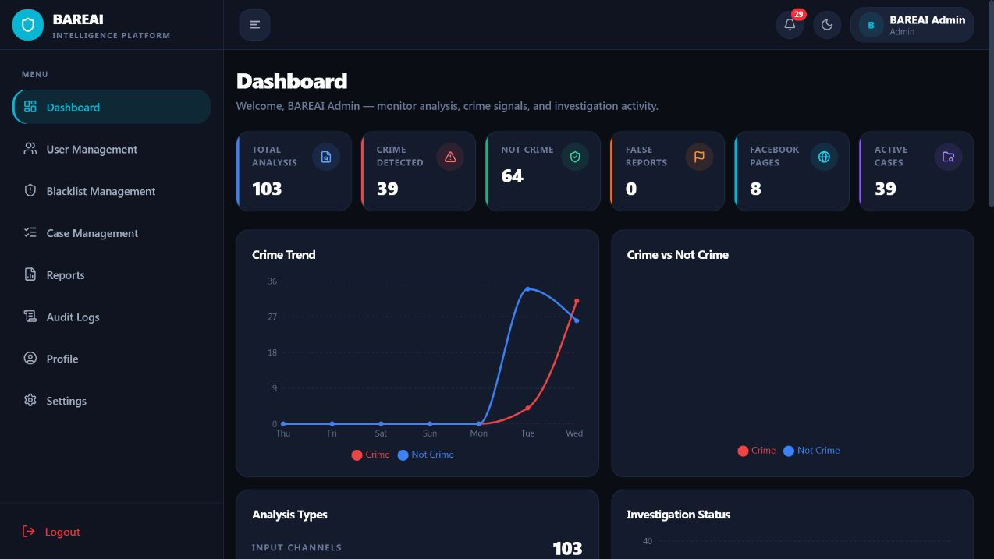
Figure 4.7: Administrator dashboard overview
The administrator dashboard consolidates the principal operational indicators. At capture time it displayed 103 analyses, 39 crime detections, 64 non-crime decisions, eight monitored Facebook pages, and 39 active cases, thereby demonstrating persistence and end-to-end system activity.
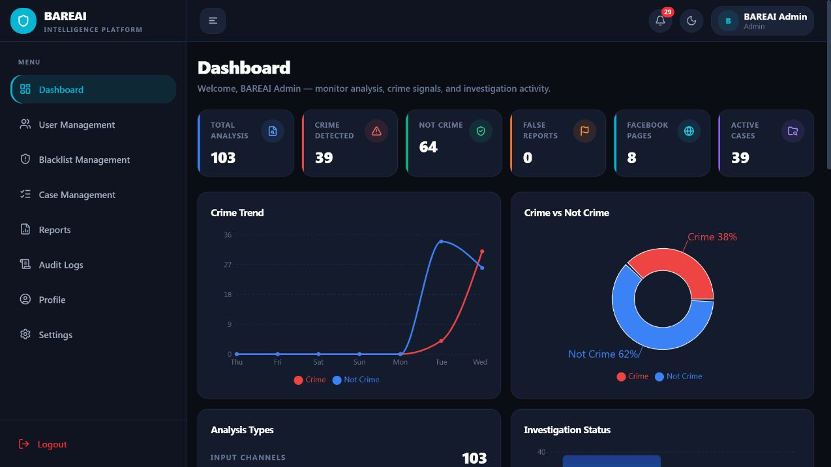
Figure 4.8: Dashboard analytical charts
Trend, class-distribution, input-source, investigation-status, and blacklist-match charts transform stored records into decision-support information. The observed class distribution was 38% crime and 62% non-crime for the live operational sample.
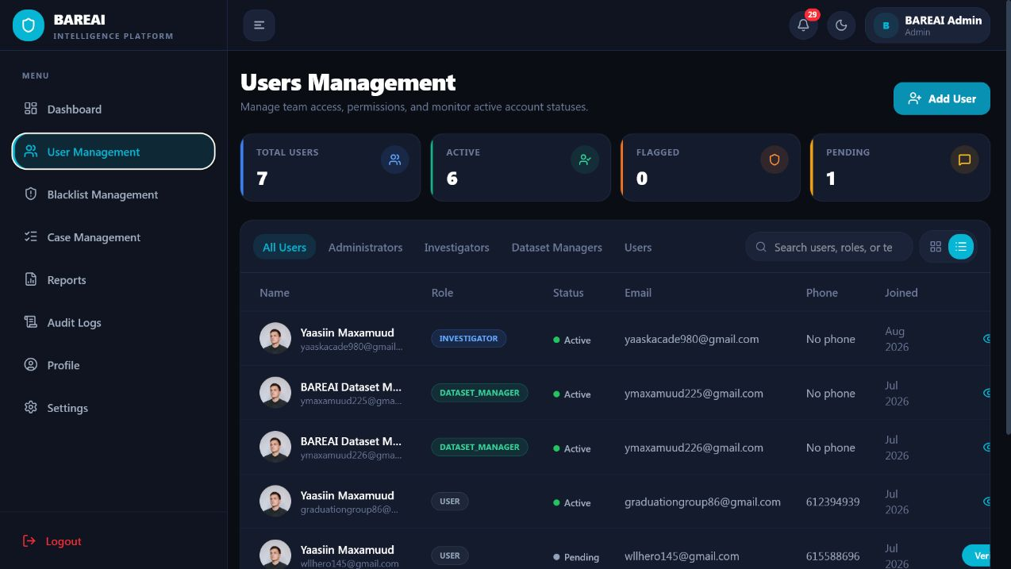
Figure 4.9: User-management interface
The user-management page enables administrators to review identities, roles, verification state, and account status. Restricting this page to the administrator protects investigator and Dataset Manager account governance.
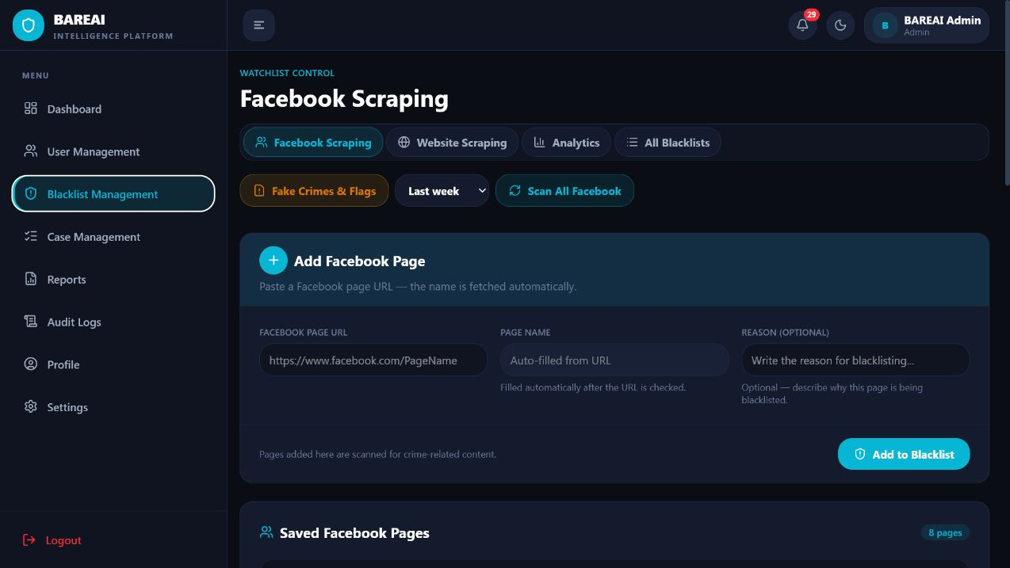
Figure 4.10: Blacklist-management interface
The blacklist module maintains entities and sources requiring special attention. Matches produced during analysis or monitoring are surfaced to authorized personnel and can support case escalation.
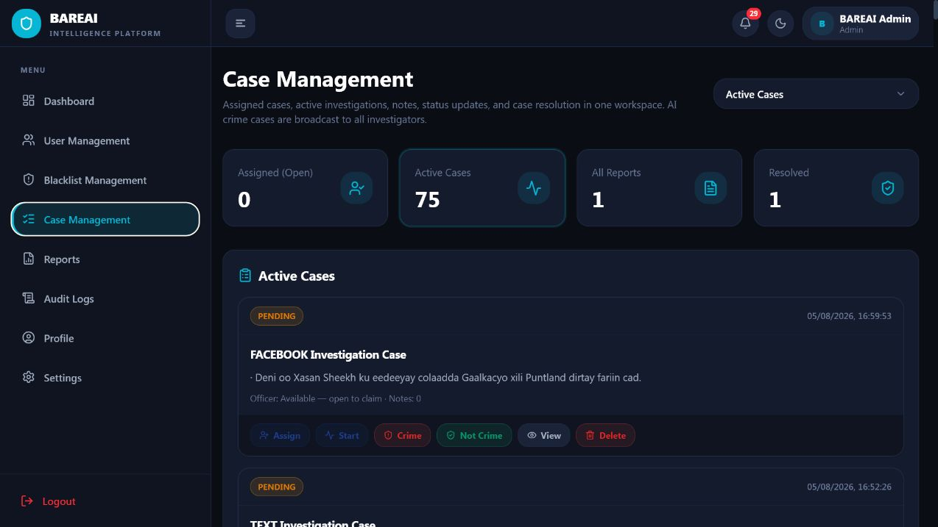
Figure 4.11: Administrator case-management interface
The case workspace presents active, assigned, reported, and resolved cases. Controls for assignment, investigation start, verdict, viewing, and deletion are role-checked and record workflow events for accountability.
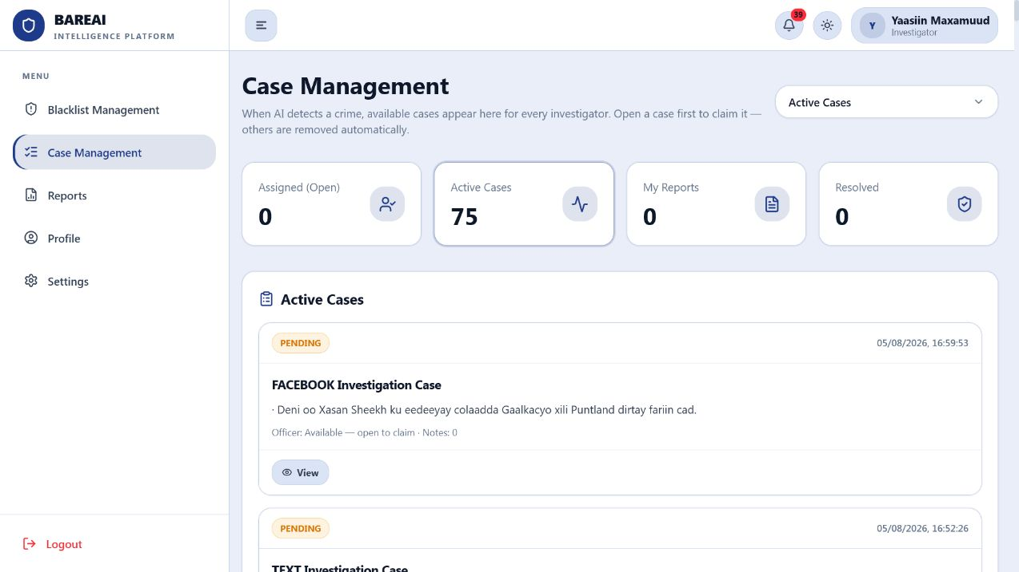
Figure 4.12: Investigator case workspace
The investigator interface removes administrative functions and focuses on available and assigned investigations, reports, and resolution. This is direct visual evidence of role-based access control.
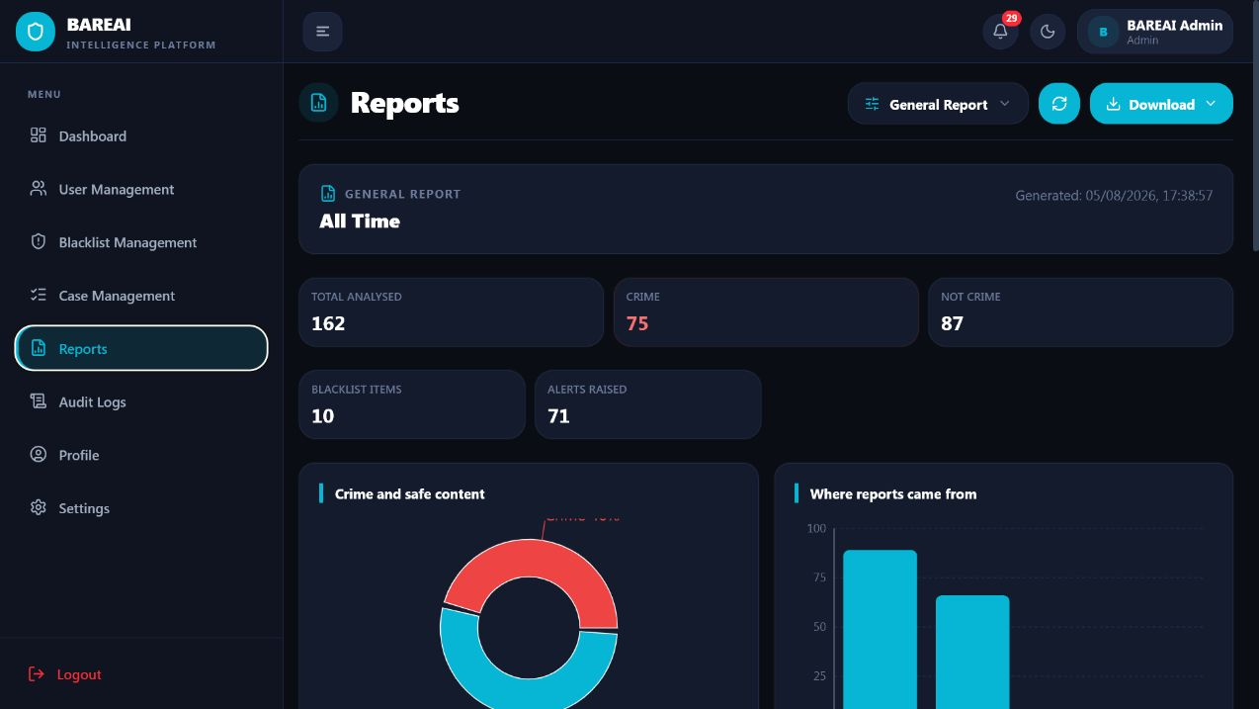
Figure 4.13: Reporting interface
The Reports page aggregates analysis and investigation information and supports formal output. Reporting translates model and workflow records into evidence that supervisors and investigators can review outside the prediction screen.
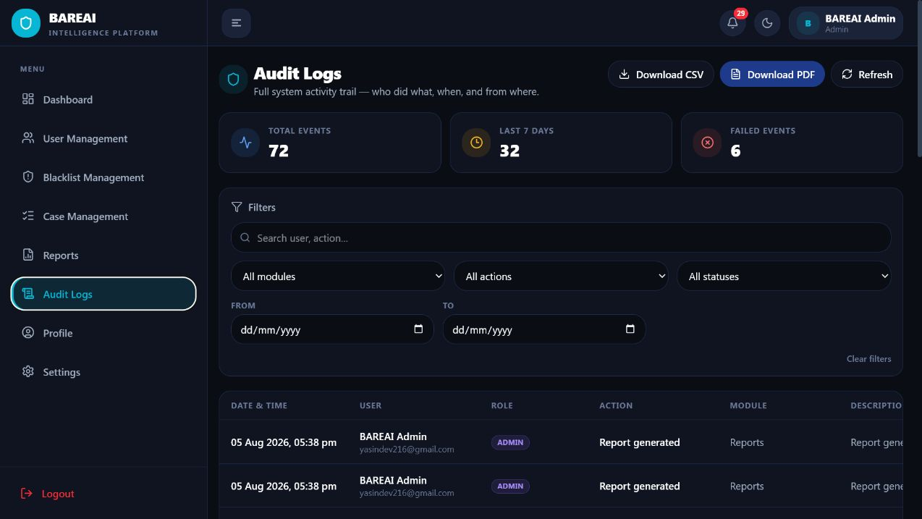
Figure 4.14: Audit-log interface
Audit logs record authentication and operational actions with user, role, module, description, status, and time. This supports traceability and assists in identifying unauthorized or failed activity.
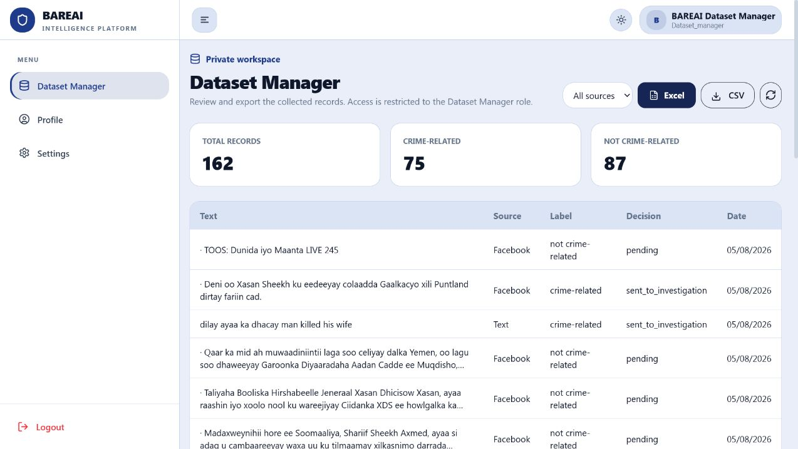
Figure 4.15: Dataset Manager workspace
The restricted Dataset Manager workspace showed 162 collected records: 75 crime-related and 87 not crime-related. It provides source filtering and CSV/Excel export while excluding administrator and investigation controls.
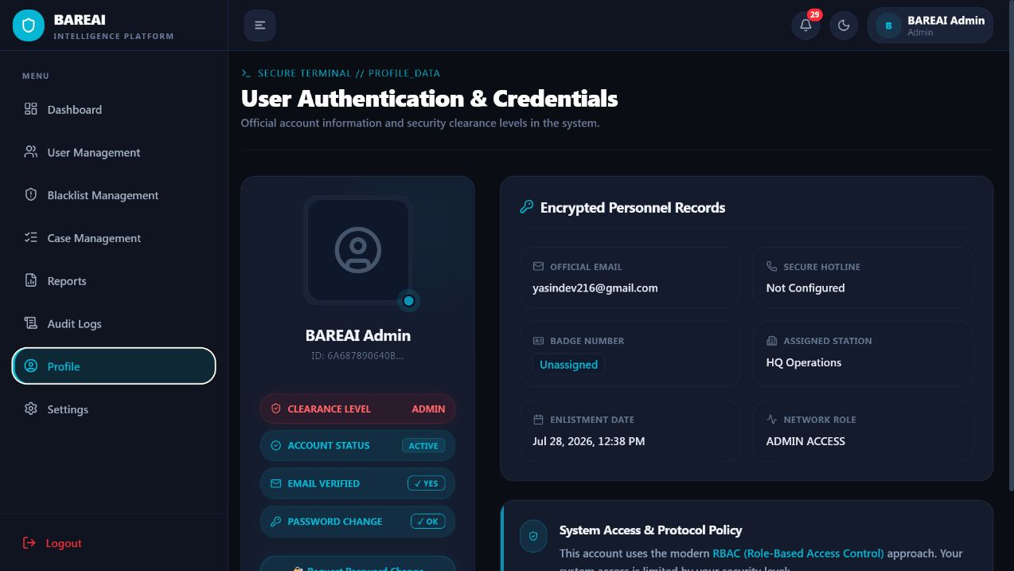
Figure 4.16: User profile interface
The profile interface centralizes personal identity and account information. Keeping profile management separate from user administration allows users to manage their own details without gaining authority over other accounts.
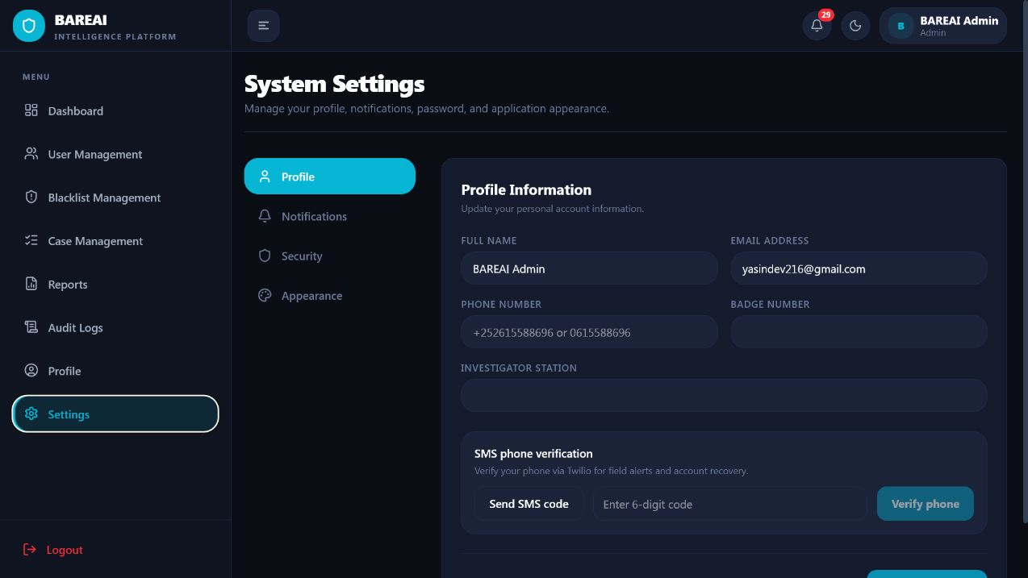
Figure 4.17: User settings and notification controls
Settings provide theme, notification, password, and preference controls. Notification counts and alerts remain available in the top bar across protected pages, enabling prioritized operational awareness while preferences remain subordinate to server-side security policy.

4.7 Database Implementation and Observed Outputs
MongoDB was implemented through Mongoose schemas that represent users, analysis history, blacklist items, investigation cases, investigation reports, notifications, and activity logs. Document storage is appropriate because analysis records contain variable-length text, keyword arrays, extracted locations, source-specific metadata, confidence values, and optional links to cases. Referential identifiers connect users to records and cases to reports, while date and status fields enable dashboard aggregation.
Table 4.5: Principal database entities
Entity | Representative stored fields | Operational use
User | name, email, password hash, role, status, verification, session identifier | Authentication and RBAC
History | input type, text/source, prediction, confidence, keywords, locations, user, time | Traceable analysis record
InvestigationCase | source, report text, assigned officer, status, verdict, notes, timestamps | Case lifecycle
InvestigationReport | case reference, findings, conclusion, author and review metadata | Formal investigative output
BlacklistItem | name, type, URL/value, status and match metadata | Priority monitoring
Notification | recipient, type, message, read state and linked resource | Operational awareness
ActivityLog | actor, role, action, module, description, status, time and request metadata | Security and auditability

Live database output was observable in the Dataset Manager table and administrator dashboard. At the time of capture, the Dataset Manager reported 162 records, of which 75 were crime-related and 87 were not crime-related. The administrator dashboard independently reported 103 analysis-history records and 39 active cases. The difference is expected because the dataset workspace consolidates records from analysis, Facebook monitoring, and website monitoring, whereas a dashboard KPI may apply a narrower collection or time/source rule. This distinction demonstrates why metric definitions must be retained with each aggregation.

4.8 Testing and Verification

4.8.1 Testing Strategy
Testing was conducted at unit, service, integration, functional, security, and usability levels. Unit verification covered Somali crime-rule behaviour. Service verification checked the AI health endpoint and successful loading of the deployed transformer. Integration verification exercised browser-to-API authentication and role navigation. Functional testing used the three supplied role accounts to verify that each role reached the correct workspace. Screenshots provide visible evidence of those outcomes. Security-oriented checks confirmed that protected pages redirected unauthenticated or invalid-session requests to login and that the role navigation differed across administrator, investigator, and Dataset Manager accounts.
Table 4.6: Representative functional test results
ID | Test condition | Expected result | Observed result | Status
T01 | Valid administrator credentials | Dashboard and administrator navigation are displayed | Dashboard loaded with KPIs and administrator modules | Pass
T02 | Valid investigator credentials | Investigator is routed to case workspace | Case workspace loaded with investigator-only navigation | Pass
T03 | Valid Dataset Manager credentials | Private dataset workspace is displayed | Dataset table, filters and exports loaded | Pass
T04 | Invalid password | Access is rejected without protected data | Login failure message displayed | Pass
T05 | Guest opens analysis | Limited Somali analysis form is available | Text/URL/File/Batch tabs and guest limit displayed | Pass
T06 | AI service health request | Active model is loaded | Transformer backend and somberta-b reported healthy | Pass
T07 | Protected route with invalid session | User is returned to login | Dashboard/case navigation redirected to login | Pass
T08 | Somali crime keyword rules | Known crime expressions are detected | Two automated tests completed successfully | Pass
T09 | Dataset filtering/export controls | Manager can select source and export | All sources, Analysis, Facebook and Website filters displayed | Pass
T10 | Audit visibility | Administrator can review recent activities | Audit table displayed user, role, action, module and status | Pass

The available automated crime-rule test suite executed two tests in 0.008 seconds and returned OK. This is a limited unit suite rather than complete coverage; therefore, the thesis does not claim exhaustive software verification. Nevertheless, the combined unit, health, role, navigation, and live-data checks establish that the main research workflow was operational at the time of evaluation.

4.9 Model Training Results
Twelve candidate configurations from classical machine learning, neural networks, and encoder-only transformers were compared on the same binary task. Weighted precision, recall, and F1-score are reported alongside accuracy, while crime-class recall is emphasized because missed crime reports represent the principal domain risk. The final all-model results identify SomBERTa-B as the strongest model, followed by SomBERTa-A. Among classical methods, Linear SVM achieved the highest accuracy, whereas Random Forest achieved slightly higher crime recall.
Table 4.7: Comparison of candidate classification models
Model | Family | Accuracy | Precision | Recall | F1 | Crime Recall
SomBERTa-B | Transformer | 94.63% | 94.69% | 94.63% | 94.61% | 97.17%
SomBERTa-A | Transformer | 93.92% | 94.00% | 93.92% | 93.89% | 96.89%
Linear SVM | Classical ML | 91.71% | 91.81% | 93.49% | 91.70% | 93.49%
Random Forest | Classical ML | 91.55% | 90.32% | 95.05% | 91.51% | 95.05%
Gradient Boosting | Classical ML | 91.55% | 92.86% | 91.94% | 91.55% | 91.94%
Logistic Regression | Classical ML | 91.23% | 91.27% | 93.21% | 91.22% | 93.21%
KNN | Classical ML | 91.15% | 92.20% | 91.94% | 91.15% | 91.94%
BiLSTM | Deep Learning | 88.47% | 88.46% | 88.47% | 88.45% | 90.52%
1D-CNN | Deep Learning | 88.39% | 88.50% | 88.39% | 88.32% | 92.93%
Naive Bayes | Classical ML | 88.23% | 89.30% | 89.67% | 88.23% | 89.67%
Decision Tree | Classical ML | 86.89% | 88.26% | 88.26% | 86.89% | 88.26%

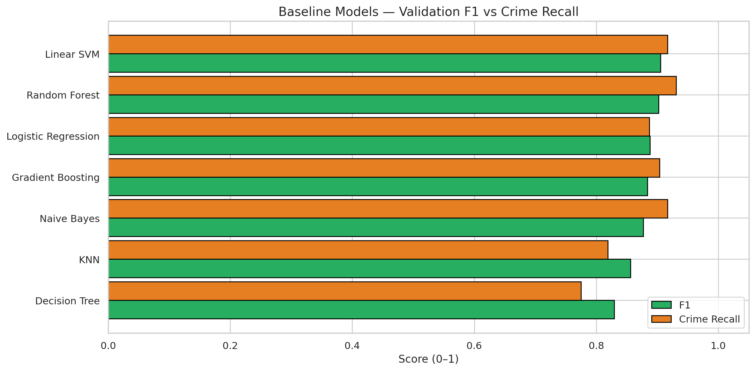
Figure 4.18: Baseline model comparison
The baseline comparison establishes the performance range of the initial classical classifiers. It provides the reference against which feature optimization, tuning, and transformer experiments were evaluated.
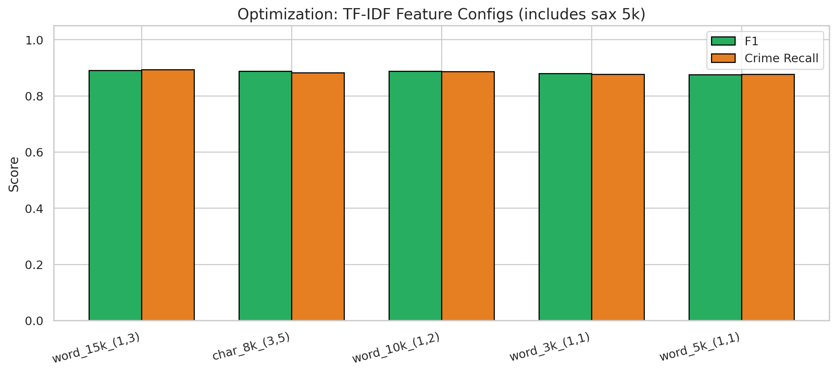
Figure 4.19: TF-IDF feature-configuration optimization
Feature optimization evaluates alternative word-feature limits and n-gram ranges. The result supports a deliberate representation choice for classical baselines rather than reliance on an arbitrary vectorizer configuration.
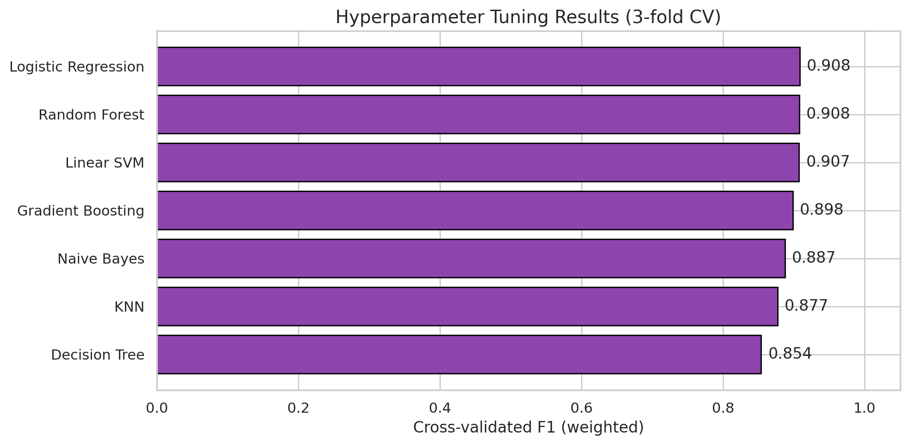
Figure 4.20: Hyperparameter-tuning results
Hyperparameter tuning refines the strongest classical configurations using validation evidence. Separating this step from final test evaluation reduces the risk of selecting parameters that merely fit the test partition.
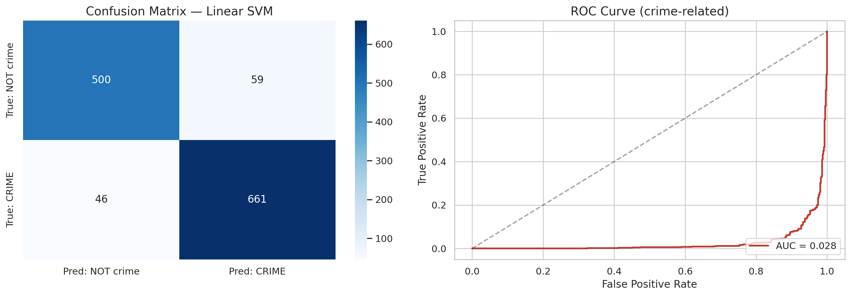
Figure 4.21: Final test confusion matrix and ROC analysis
The confusion matrix shows the distribution of correct and incorrect predictions by class, while the ROC curve summarizes discrimination across thresholds. These measures complement aggregate accuracy by exposing false-negative and false-positive behaviour.
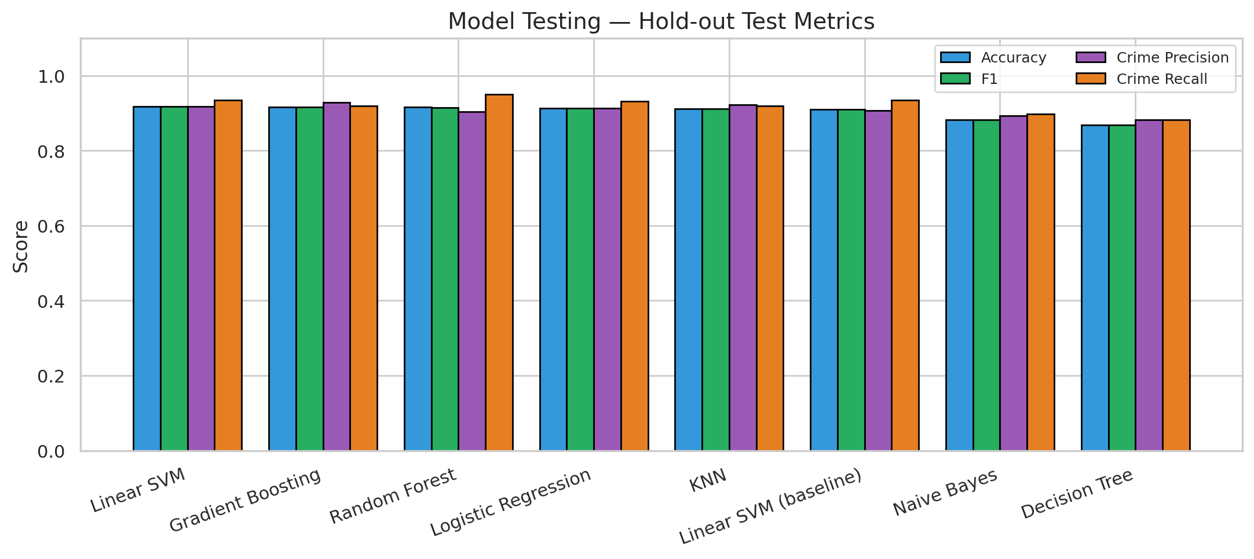
Figure 4.22: Model testing and error inspection
The testing figure summarizes final held-out performance and supports inspection of prediction behaviour. This stage is separated from training and validation to provide a less biased estimate of generalization.
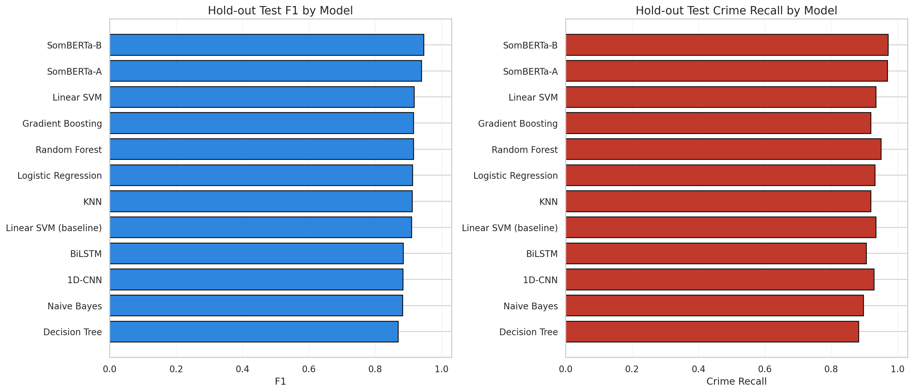
Figure 4.23: Overall comparison of all trained models
The combined comparison demonstrates that the encoder-only SomBERTa variants outperform classical and recurrent/convolutional alternatives. SomBERTa-B provides the best overall balance and the highest crime recall.

4.10 Interpretation and Discussion of Results

4.10.1 Selection of the Final Model
SomBERTa-B achieved 94.63% accuracy and a weighted F1-score of 94.61%, improving on the strongest classical accuracy result, Linear SVM at 91.71%, by approximately 2.92 percentage points. More importantly for the application domain, its crime recall reached 97.17%. Relative to Linear SVM, the transformer reduced the proportion of missed positive cases because its crime recall was 3.68 percentage points higher. Random Forest obtained 95.05% crime recall, but its lower precision and overall F1-score indicate a less balanced decision boundary.
The performance advantage is consistent with the linguistic nature of the task. TF-IDF baselines represent surface word and n-gram frequency and perform strongly when crime vocabulary is explicit. SomBERTa-B can additionally model context and word use across a longer maximum sequence length of 256 tokens. This is valuable for Somali reports in which a crime term may occur within quotations, negation, background description, or code-mixed reporting. The result does not imply that transformers eliminate all errors; it shows that contextual representation was more effective for the evaluated corpus.
Chapter Three documented Random Forest as an earlier deployment choice based on the classical experiment. The final artefacts and all-model comparison produced after the transformer experiments identify SomBERTa-B as the active deployed model. This chapter therefore reports SomBERTa-B as the final result. The change is a model-selection outcome rather than a contradiction in the research logic: Random Forest served as a strong classical benchmark, while subsequent controlled experiments yielded a superior model.

4.10.2 Findings in Relation to the Research Objectives
Table 4.8: Achievement of the specific research objectives
Objective | Implementation evidence | Finding
Reduce reliance on manual classification | Automated input, prediction, history and escalation pipeline | Initial triage is automated; human review is retained for investigation and verdict
Collect and preprocess crime-related text | 9,999 labelled records; cleaning, duplicate control, Somali normalization and stratified splitting | A balanced and leakage-aware corpus was prepared
Extract and analyse key features | TF-IDF n-grams, Somali stop words, transformer tokenization, keywords and locations | Both statistical and contextual representations were evaluated
Develop an automated NLP classification system | SomBERTa-B Flask service integrated with Express, React and MongoDB | A working end-to-end platform achieved 94.63% accuracy and 97.17% crime recall

Research Question One asked how reliance on manual classification could be reduced. The implemented pipeline answers this by automatically accepting digital text, applying language validation and preprocessing, producing a class prediction, and routing a positive record toward review. Manual effort is moved from repetitive first-pass reading to higher-value verification and investigation. Research Question Two concerned collection and preprocessing. The dataset profile, duplicate analysis, normalization, stop-word handling, and stratified partitions provide the answer. Research Question Three concerned feature extraction. The classical TF-IDF experiments and contextual transformer representations demonstrate two complementary approaches, while the result shows the advantage of contextual encoding. Research Question Four concerned development of the automated system; the operational interfaces, database records, model health result, role-specific logins, and case workflow constitute the implementation evidence.

4.10.3 Operational Interpretation
High crime recall is important because a false negative can prevent a potentially urgent report from reaching investigators. However, the system must not treat every model-positive output as proven criminal evidence. Predictions are decision-support signals and require authorized human review. The case workflow correctly preserves this distinction by enabling investigators to examine text and source context before recording a verdict. Likewise, audit logs and history reduce the risk of untraceable automated action.
The live dashboard and Dataset Manager counts demonstrate that the solution operates across multiple sources rather than only laboratory test data. This increases practical relevance but introduces distribution shift: monitored news articles and social-media posts may differ from the training corpus in vocabulary, length, quoting style, and prevalence. Continuous error sampling and supervised re-evaluation are therefore necessary. The observed model score should be interpreted as held-out performance on the research dataset, not a permanent guarantee for every future online source.

4.11 Limitations Observed During Implementation
- The corpus is sizeable for an undergraduate project but remains limited relative to the regional, dialectal, and topic diversity of Somali online language.
- Some source records were duplicated, and although duplicates were removed for final modelling, repeated reporting can still affect operational database statistics.
- Binary labels distinguish crime-related from not crime-related but do not identify specific offence categories, severity, credibility, or urgency.
- The classifier may be influenced by quoted crime terms in ordinary news, negation, sarcasm, spelling variation, and Somali-English code mixing.
- Facebook and website monitoring depend on page structure and network availability; changes to external websites may interrupt extraction.
- The automated unit-test suite currently covers only a small part of the rule layer. Broader API, security, accessibility, load, and regression suites are required before institutional deployment.
- The live operational sample is not a controlled user-acceptance study, so usability effectiveness and time savings were not quantified with police personnel.
- Predictions are not legal determinations and must remain subject to authorized human review, data-protection policy, and evidential standards.

4.12 Chapter Summary
This chapter presented the complete implementation and results of BAREAI. The system integrated a React interface, Express application layer, Flask inference service, and MongoDB persistence with role-based workspaces for administrators, investigators, and the Dataset Manager. The source dataset comprised 9,999 balanced records, and duplicate-aware preparation supported comparative experiments across classical, deep-learning, and transformer models. SomBERTa-B achieved the strongest outcome with 94.63% accuracy, 94.61% F1-score, and 97.17% crime recall, and it was verified as the active transformer service. Functional evidence showed successful authentication, public analysis, dashboards, cases, reports, notifications, audit records, and dataset exports. The findings satisfy the study objectives while also revealing limitations in dataset breadth, automated testing, operational drift, and the need for human oversight.

CHAPTER V: CONCLUSION AND RECOMMENDATIONS

5.1 Introduction
This chapter concludes the study on the automatic classification of crime-related text reports using Natural Language Processing. It summarizes the research problem, methodology, implementation, and principal findings; states the contribution to knowledge and practice; presents the final conclusion; and proposes recommendations and future work. The conclusions are limited to the evidence reported in the preceding chapters and do not treat machine predictions as replacements for professional investigation or legal judgment.

5.2 Summary of the Study
The study was motivated by the growing volume of unstructured crime-related information distributed through social media, online news, digital forms, and other channels. In Somalia, manual review of such material is slow, difficult to scale, and vulnerable to fatigue and inconsistent categorization. The general objective was therefore to develop and implement an intelligent automated framework that uses machine learning and NLP to support high-speed classification while improving operational efficiency and data integrity.
The work combined a CRISP-DM-oriented machine-learning process with iterative full-stack software development. A labelled binary dataset was assessed, cleaned, deduplicated, normalized, and divided using stratified partitions. TF-IDF classical classifiers, convolutional and recurrent neural networks, and SomBERTa encoder models were evaluated. The strongest model was packaged as an independent inference service and integrated into the BAREAI platform. The full system provided public Somali analysis, authentication, dashboard analytics, user and blacklist administration, monitoring, case management, reporting, notifications, audit logs, and a private dataset-governance workspace.

5.3 Summary of Findings
- The raw dataset contained 9,999 labelled text reports and was almost perfectly balanced between the two classes. A total of 1,384 duplicated text entries required control to avoid evaluation leakage.
- Classical NLP provided strong baselines. Linear SVM achieved 91.71% accuracy, while Random Forest reached 95.05% crime recall.
- SomBERTa-B produced the best overall result, with 94.63% accuracy, 94.61% weighted F1-score, and 97.17% crime recall. It exceeded the strongest classical accuracy result by approximately 2.92 percentage points.
- The final model was successfully loaded through the Flask inference service and integrated with the Express backend, React frontend, and MongoDB database.
- The system automated the path from text acquisition to prediction, enrichment, storage, notification, and potential investigation while retaining human review for case decisions.
- Role-based access operated successfully for administrator, investigator, and Dataset Manager accounts, with materially different navigation and permissions.
- Live operational data was visible through dashboard charts, case records, audit logs, and the dataset table, demonstrating that the project progressed beyond notebook-only experimentation.
- The system’s principal remaining risks are linguistic and source distribution shift, binary-label limitations, dependence on changing external pages, incomplete automated test coverage, and the ethical consequences of false decisions.

5.4 Contribution to Knowledge and Practice
The research contributes an applied evaluation of contextual and non-contextual NLP approaches for Somali crime-related text classification. The comparative evidence shows that a Somali-oriented encoder model can improve both overall classification and positive-class recall over strong TF-IDF baselines on the evaluated corpus. The study also contributes a reproducible implementation pattern in which machine learning is isolated as a service and connected to an auditable, role-based operational workflow.
From a practical perspective, BAREAI demonstrates how automated triage can support security personnel without removing professional judgment. Its contribution is not solely the numerical model score; it is the integration of classification with source extraction, Somali keyword and location enrichment, blacklist monitoring, notification, case ownership, reports, dataset export, and auditability. This combination addresses the gap between experimental text classification and the daily information-management needs of a security organization.

5.5 Conclusion
The study concludes that Natural Language Processing can substantially reduce the first-pass manual burden involved in classifying Somali crime-related text reports. The empirical comparison demonstrates that contextual representation is advantageous for this task: SomBERTa-B achieved the best measured balance of accuracy, F1-score, and crime recall. The implemented platform further shows that the model can be deployed within a functional information system rather than remaining confined to an experimental notebook.
All four specific objectives were achieved. Manual triage was reduced through an automated pipeline; crime-related data was collected and prepared; statistical and contextual features were extracted and evaluated; and a complete NLP-enabled web platform was developed. The general objective was therefore met within the stated binary-classification scope. Nevertheless, responsible interpretation is essential. A score of 94.63% accuracy still implies errors, and the cost of a missed crime report or an incorrectly flagged person can be significant. BAREAI should consequently be used as a prioritization and decision-support tool under trained human supervision, not as an autonomous legal authority.

5.6 Recommendations

5.6.1 Recommendations for Dataset and Model Improvement
- Expand the corpus through ethically governed partnerships with Somali security, media, and research institutions, ensuring representation of regions, dialects, spelling variants, and source types.
- Introduce hierarchical or multi-label offence categories such as homicide, assault, theft, kidnapping, terrorism, cybercrime, fraud, and drug-related crime, while retaining the binary triage layer.
- Establish a documented annotation protocol with multiple trained annotators and report inter-annotator agreement before using new labels for training.
- Maintain strict duplicate and near-duplicate controls before data splitting and preserve an immutable external test set for periodic comparison.
- Calibrate probability outputs and define thresholds based on the different operational costs of false negatives and false positives rather than using accuracy alone.
- Implement drift monitoring and schedule re-evaluation when vocabulary, sources, or performance distributions change.

5.6.2 Recommendations for System and Security Improvement
- Deploy all services behind HTTPS, rotate secrets, use a managed secret store, and prohibit inclusion of passwords or tokens in academic documents, screenshots, logs, and source control.
- Add comprehensive automated tests for authentication, authorization, analysis APIs, file processing, monitoring, case transitions, exports, accessibility, and regression behaviour.
- Conduct independent penetration testing and security review before handling real sensitive or personally identifiable information.
- Define data-retention, deletion, access-review, incident-response, and model-governance policies aligned with applicable Somali law and institutional policy.
- Record the model name, model integrity identifier, threshold, fallback status, and preprocessing version with every prediction to strengthen reproducibility.
- Use robust job queues and retry controls for monitoring and notifications, with clear failure states rather than silent loss of work.

5.6.3 Recommendations for Organizational Adoption
- Pilot the platform with a small trained team and measure classification time, review time, error correction, and investigator satisfaction against the current manual process.
- Create standard operating procedures that specify who may review, escalate, assign, resolve, export, and delete records.
- Provide investigators with guidance on model limitations, confidence interpretation, false positives, false negatives, and confirmation bias.
- Require human confirmation before a prediction influences enforcement, public accusation, or adverse action against an individual.
- Establish a periodic multidisciplinary review involving security professionals, Somali-language experts, data scientists, legal advisers, and ethics representatives.

5.7 Future Work
Future research should extend the binary classifier into a multi-stage intelligence model. The first stage may retain high-recall crime screening; subsequent stages could estimate offence type, urgency, location, named entities, credibility, and whether the report describes an event, opinion, quotation, or historical context. A multi-task Somali transformer could share linguistic representations across these tasks while separate confidence thresholds protect each operational decision.
Further work should also evaluate explainability techniques suitable for Somali text, including highlighted evidence spans, counterfactual tests, and example-based explanations. Explanations must be assessed with investigators to determine whether they improve decision quality rather than merely appearing persuasive. Active learning could prioritize uncertain or novel reports for expert annotation, thereby improving the dataset efficiently. Federated or privacy-preserving learning may be investigated where agencies cannot centralize sensitive text.
On the system side, production deployment should introduce containerization, continuous integration, model and API monitoring, structured observability, automated backups, disaster recovery, and horizontal scaling. Monitoring connectors should use stable authorized APIs wherever possible. Mobile-friendly field interfaces and offline synchronization could extend the platform to low-connectivity environments. Finally, a controlled user study with law-enforcement professionals should quantify task completion time, usability, trust calibration, and the real operational effect of automated triage.
Table 5.1: Prioritized future-work roadmap
Priority | Proposed work | Expected value
High | Larger multi-region annotated corpus and independent test set | Improves generalization and credibility
High | Expanded automated security and regression testing | Reduces deployment risk
High | Human-in-the-loop pilot with measured outcomes | Validates practical benefit and safe procedures
Medium | Multi-label crime type, urgency and credibility models | Produces richer prioritization
Medium | Drift monitoring, probability calibration and threshold governance | Maintains performance over time
Medium | Explainable Somali evidence spans and investigator evaluation | Supports transparent review
Long term | Privacy-preserving inter-agency learning and mobile/offline operation | Enables responsible scale

5.8 Final Remarks
BAREAI demonstrates that a locally relevant NLP system can connect Somali-language classification research with a complete operational workflow. Its strongest result is the combination of contextual model performance, high crime recall, role-based governance, and traceable case handling. The project provides a credible foundation for further academic and institutional development, provided that future deployment is accompanied by stronger datasets, comprehensive testing, security controls, continuous evaluation, and meaningful human oversight.

