
ProfessorOS
AI-Powered Academic Assessment Platform with Explainable Grading and Intelligent Proctoring
By
Muhammad Yasin Asif BSSE-23S-0036
Muhammad Fahim BSSE-23S-0033
Rayyan Shahid BSSE-23S-0037
Supervisor: Mam Habib-un-Nisa
Co-Supervisor: Mr. Muhammad Shaban Qabil
Bachelor of Science in Software Engineering (2023-2027)
Department of Software Engineering
Faculty of Computing
The candidate confirms that the work submitted is their own and appropriate credit has been given where reference has been made to the work of others.

ProfessorOS
AI-Powered Academic Assessment Platform with Explainable Grading and Intelligent Proctoring
A project presented to Shifa Tameer-e-Millat University
In partial fulfilment of the requirement for the degree
Bachelor of Science in Software Engineering (2023-2027)
By
Muhammad Yasin Asif BSSE-23S-0036
Muhammad Fahim BSSE-23S-0033
Rayyan Shahid BSSE-23S-0037

DEDICATION
We dedicate this project to our parents, whose unwavering support, patience, and prayers have carried us through every late night and every setback of this journey. To our teachers and mentors, who taught us that knowledge is only valuable when it is used to serve others - this work is our small attempt to honour that lesson. And to every professor who has ever stayed up past midnight grading a stack of papers, hoping to give their students the feedback they deserve: this project is for you.

ACKNOWLEDGEMENTS
We would like to express our sincere gratitude to our supervisor, Ms. Habib-un-Nisa, for her invaluable guidance, patience, and encouragement throughout the course of this project. Her insights consistently pushed us to think more critically about the problems we were solving and the users we were solving them for.
We are equally grateful to our co-supervisor, Mr. Muhammad Shaban Qabil, for his technical mentorship on the AI and machine learning components of this platform, and for challenging us to justify every architectural decision with sound reasoning rather than convenience.
We extend our thanks to the Department of Software Engineering at Shifa Tameer-e-Millat University for providing the academic environment, resources, and structured feedback that made this work possible, and to the professors, teaching assistants, and students who generously gave their time during our requirements-gathering interviews and surveys.
Finally, we thank our families and friends for their constant encouragement and understanding throughout this demanding academic year.

STATEMENT OF ORIGINALITY
We, namely Muhammad Yasin Asif, Muhammad Fahim, and Rayyan Shahid, submitting Final Year Project Report titled "ProfessorOS: AI-Powered Academic Assessment Platform with Explainable Grading and Intelligent Proctoring", state that we clearly understand what plagiarism is and we have also read about it using online sources. As such, we claim that this entire work (code, reports etc.) is our own effort. We have not used/copied or pasted or paraphrased even a single line of code or sentence from any other source without giving a proper reference to it. Based on our confidence in our originality, we allow the University to run anti-plagiarism software on the same.
We understand that if now, or in the future, it is found out that we have not been honest and have plagiarized, the university will take action and this will result in disciplinary action, such as the cancellation of our degree, and we can be liable for any subsequent punishments as deemed appropriate by the University as well as the Higher Education Commission Pakistan.
[Signature and date]
Muhammad Yasin Asif
[Signature and date]
Muhammad Fahim
[Signature and date]
Rayyan Shahid

COPYRIGHT STATEMENT
Copyright in the text of this report rests with the student authors. Copies (by any process) either in full, or of extracts, may be made only in accordance with instructions given by the author. Details may be obtained by the Librarian. This page must form part of any such copies made. Further copies (by any process) of copies made in accordance with such instructions may not be made without the permission (in writing) of the author.
The ownership of any intellectual property rights which may be described in this project is vested in STMU, subject to any prior agreement to the contrary, and may not be made available for use by third parties without the written permission of STMU, which will prescribe the terms and conditions of any such agreement.
[Signature and date]
Muhammad Yasin Asif / Muhammad Fahim / Rayyan Shahid

CERTIFICATE OF APPROVAL
It is certified that the project titled "ProfessorOS: AI-Powered Academic Assessment Platform with Explainable Grading and Intelligent Proctoring", presented on ____[date]____, has been duly approved by the evaluation committee.
Table 1.1: Role
Role | Name | Signature
Supervisor | Ms. Habib-un-Nisa
Co-supervisor | Mr. Muhammad Shaban Qabil
Internal Examiner 1 | Mr. Waseem Ahmed
Internal Examiner 2 | Mr. Hammad Abbasi
Project Coordinator | [Name]
Head of Department | [Name]
Dean, Faculty of Computing | [Name]

EXECUTIVE SUMMARY
ProfessorOS is a platform developed to address a critical inefficiency in Pakistani higher education: professors dedicate 12-18 hours every week to manual grading, time that would otherwise be spent on teaching and student development. Most institutions still rely on paper marking or basic digital uploads with zero automation, while existing commercial tools are either too expensive or fail to address the real pain points of local higher education. The core problems are grading delays that leave students waiting one to two weeks for feedback, and inconsistent scores introduced when teaching assistants apply rubrics subjectively. No single platform currently handles essays, code submissions, and proctored examinations together without requiring professors to manage multiple disconnected tools. The identified gap is the complete absence of a locally deployable, open-source system that delivers explainable AI grading combined with lightweight mobile proctoring, free of any paid cloud dependency. The platform aims to reduce grading time by at least 75 percent, deliver criterion-level feedback within 60 seconds, and provide transparent LIME/SHAP explanations so both professors and students understand every grading decision.
ProfessorOS provides Pakistani universities with a practical, self-contained assessment ecosystem aligned to their budget and infrastructure realities, while preserving the professor's full academic authority. The system is organized into nine core modules spanning authentication, course and rubric management, AI-assisted grading built on a locally hosted Llama 3.1 8B model, explainable AI processing using LIME and SHAP, a student submission portal, an analytics dashboard, mobile-based smart proctoring, an integrated code editor with Judge0 execution, and a retrieval-augmented AI teaching assistant. The platform is fully containerised using Docker Compose and is intended for deployment on institutional hardware without recurring cloud costs. As of this report, the requirements analysis and system design phases are complete; implementation, testing, and deployment are ongoing as part of the FYP-II development cycle.

LIST OF ABBREVIATIONS
Table 1.2: ABBREVIATION
ABBREVIATION | EXPLANATION
AI | Artificial Intelligence
API | Application Programming Interface
BO | Business Objective
CI/CD | Continuous Integration / Continuous Deployment
CSV | Comma-Separated Values
FAISS | Facebook AI Similarity Search
FR | Functional Requirement
FYP | Final Year Project
HEC | Higher Education Commission
JWT | JSON Web Token
LIME | Local Interpretable Model-Agnostic Explanations
LLM | Large Language Model
MCQ | Multiple Choice Question
NFR | Non-Functional Requirement
ORM | Object-Relational Mapper
RAG | Retrieval-Augmented Generation
RBAC | Role-Based Access Control
RTM | Requirements Traceability Matrix
SHAP | SHapley Additive exPlanations
SSE | Server-Sent Events
STMU | Shifa Tameer-e-Millat University
TA | Teaching Assistant
UI/UX | User Interface / User Experience
UML | Unified Modelling Language
WSS | WebSocket Secure
XAI | Explainable Artificial Intelligence

TABLE OF CONTENTS
Update the Table of Contents field in Microsoft Word after final pagination.

LIST OF TABLES
Table captions have been standardized throughout the report. Update the List of Tables field in Microsoft Word after final pagination.

LIST OF FIGURES
Table captions have been standardized throughout the report. Update the List of Tables field in Microsoft Word after final pagination.

CHAPTER 1 INTRODUCTION
This chapter establishes the domain context, project vision, problem, aim, objectives, scope, stakeholders, development approach, and report structure for ProfessorOS.

1.1 Project Vision and Context
For university professors, teaching assistants, and students at Pakistani higher education institutions who are burdened by slow, inconsistent, and opaque assessment workflows that delay feedback and provide students with insufficient guidance to improve their work, the ProfessorOS platform is an AI-powered, cross-platform academic assessment ecosystem. It automates grading with full criterion-level explainability, proctors examinations non-invasively on mobile devices, compiles and evaluates programming submissions in real time, and delivers structured student feedback within 60 seconds of submission - all governed by a human-in-the-loop model that preserves the educator's final academic authority.
Unlike Gradescope or Google Classroom, which address these problems in fragmented, proprietary, and cost-prohibitive silos, ProfessorOS unifies every dimension of the assessment lifecycle into a single transparent, open-source, and locally deployable platform. This enables Pakistani universities to deliver consistent and timely academic assessment without dependence on expensive foreign commercial services.

1.2 Background and Motivation
Higher education in Pakistan has expanded rapidly over the past two decades, with more than 1.6 million students enrolled across over 200 chartered universities as of 2023. This growth has placed severe pressure on assessment infrastructure that has remained largely unchanged, with most institutions still relying on manual paper marking or basic file-upload systems with no grading automation. The practical consequence for professors is a grading burden of 12-18 hours per assignment cycle, time taken directly from instruction and student support.
The specific pain points are consistent across the institutions studied: feedback delays of one to two weeks, scoring inconsistencies introduced by teaching assistants who interpret rubrics differently, and the absence of any in-platform code execution environment for programming courses. Existing commercial platforms such as Gradescope and Turnitin address these problems only partially and in fragmented, proprietary, and cost-prohibitive ways. No locally deployable, open-source solution currently exists that combines explainable AI grading, integrated code execution, and lightweight mobile proctoring in a single unified system - which is the gap ProfessorOS is proposed to fill.

1.3 Existing System and Current Practice
A comparative analysis of the currently available assessment tools was carried out to identify the specific gaps that ProfessorOS addresses.
Table 1.3: System / Practice
System / Practice | Users / Context | Strengths | Limitations | Project Implication
Gradescope | Instructors batch-grading similar answers | Answer clustering for faster manual grading | No explainability, no mobile proctoring, no code compiler, paid-only | ProfessorOS adds LIME/SHAP explainability, Flutter focus-mode proctoring, and a Judge0 compiler at no per-use cost
Google Classroom | General-purpose course/file management | Simple, familiar file dropbox | Zero automated grading, no analytics, no proctoring | ProfessorOS provides an end-to-end AI grading pipeline covering all submission types with analytics and proctoring
Moodle | LMS with basic quiz grading | Handles basic MCQs; widely deployed | No AI grading engine, no explainability, no mobile proctoring | ProfessorOS is a unified platform deployed in one command via Docker Compose with full AI, XAI, and proctoring support
Manual paper-based marking and unstructured digital uploads, still used by most departments at STMU and comparable institutions, remain the dominant "current practice" and share all of the limitations above, in addition to introducing significant administrative overhead in record-keeping and result compilation.

1.4 Problem Statement
Professors at Pakistani universities are burdened by a grading workload that is difficult to sustain fairly, week after week. A typical professor teaching two courses with 180 students each must grade roughly 360 submissions per assignment cycle. In a live shadowing session conducted at STMU, grading a single written response was timed at approximately seven minutes, which totals more than 21 hours of pure marking for a single cycle. When teaching assistants assist with grading, scores can swing by as much as three marks out of ten because each grader interprets the same rubric differently. Students consequently wait one to two weeks for feedback, allowing the same conceptual mistakes to repeat. Programming courses compound the problem further: without an in-platform compiler, professors must manually download files and run tests. These issues are interconnected, and addressing only one of them will not resolve the underlying inefficiency - which is the motivation for building ProfessorOS.

1.5 Project Aim
The aim of this project is to design and develop ProfessorOS, a locally deployable, AI-powered academic assessment platform that automates the grading of text, code, and MCQ submissions with transparent, explainable feedback, while non-invasively proctoring examinations and preserving full academic authority for the professor.

1.6 Project Objectives
The following business objectives (BO) drive the requirements documented throughout this report. Each requirement in Chapter 3 is traceable to at least one objective below.
Table 1.4: Objective ID
Objective ID | Objective Statement | Success Measure
BO-1 | Reduce professor grading time per assignment cycle through automated AI evaluation of MCQ, short answer, essay, and programming submissions. | Minimum 75% reduction in grading time versus the current 12-18 hours/week baseline
BO-2 | Deliver criterion-level natural language feedback to students promptly after assignment submission. | Feedback delivered within 60 seconds under a load of 180+ concurrent students
BO-3 | Achieve consistent grading output across all submission types through rubric-anchored evaluation. | Inter-rater reliability exceeding 85%
BO-4 | Implement an Explainable AI layer to generate token-level and criterion-level explanations for every grading decision. | LIME and SHAP overlays visible on every graded text submission
BO-5 | Deliver a multi-language code execution environment with automated test-case validation. | 12 or more supported programming languages via Judge0
BO-6 | Reduce single-device examination cheating through non-invasive proctoring. | Minimum 60% reduction in single-device cheating via Focus Mode
BO-7 | Provide a 24/7 AI Teaching Assistant grounded in professor-uploaded course materials. | Course-specific Q&A available at all times via LangChain RAG
BO-8 | Enable data-driven course management through real-time dashboards. | Dashboards tracking grade distribution, criterion performance, and at-risk students
BO-9 | Deliver a fully containerised, cross-platform system deployable on institutional hardware. | Single-command Docker Compose deployment with GitHub Actions CI/CD

1.7 Scope and Boundaries
ProfessorOS covers the complete assessment lifecycle from course creation through submission, AI grading, human review, and analytics, delivered through a Professor Web Portal, Student Web Portal, Flutter Mobile App, and a dedicated AI/ML Engine.
Table 1.5: Category
Category | In Scope | Out of Scope | Rationale
Grading input types | Text, code, MCQ, and file submissions graded via the Llama 3.1 8B pipeline | Physical handwritten assignment scanning | Handwriting recognition would extend the project beyond the STMU timeline and hardware constraints
Proctoring | App-switch (focus loss) detection on the Flutter mobile app | Video proctoring, facial recognition | Camera-based surveillance was excluded on privacy and hardware grounds
AI infrastructure | Locally hosted Llama 3.1 8B via Ollama, LIME/SHAP explainability | LLM fine-tuning, third-party paid cloud AI APIs | Fine-tuning and paid APIs conflict with the zero-recurring-cost, locally deployable design goal
Code execution | 12+ languages via self-hosted Judge0 with hidden test cases | Domain-specific or non-standard runtimes | Kept within the supported Judge0 language set for the FYP timeline
Integration | CSV-based bulk student import | Direct ERP integration | No live ERP integration exists at STMU to connect to during this project
Language support | English-language submissions | Urdu-language interface support | Deferred to a future release beyond version 1.0
Offline support | Cached grade viewing on mobile | Full offline-first operation | Full offline sync was judged outside the FYP-I/FYP-II timeline

1.8 Proposed Solution Overview
ProfessorOS routes every submission through a locally running Llama 3.1 8B model via Ollama so that grading begins the moment a student submits their work. The model scores the submission against the professor's own rubric and produces natural-language feedback for each criterion within approximately 60 seconds. A professor can override any score in one click and must add a justification - the final decision always remains human. Because the same rubric and model logic apply to every submission, inter-rater variation is minimised. Students see colour-coded LIME and SHAP explanations so they understand why marks were lost instead of guessing.
For code assignments, the platform embeds re_editor/Monaco Editor and routes execution through Judge0 so compilation and test-case execution happen instantly inside the application. The Flutter mobile app adds lightweight focus-mode proctoring that only detects whether the student switches applications - no camera and no invasive surveillance. An AI Teaching Assistant built with LangChain answers course-specific questions using the professor's own uploaded materials. The entire system is containerised with Docker Compose and deploys in one command on university servers, giving real-time dashboards so course coordinators can identify at-risk students early, while professors retain full academic authority over the automated pipeline.

1.9 Development Methodology and Software Process Model
The team follows an Incremental Development process model, organised into nine build phases that each deliver a deployable and testable increment aligned with the STMU FYP-I (Semester 7) and FYP-II (Semester 8) schedule, with FYP-I beginning in April 2026 and FYP-II concluding in February 2027.
Table 1.6: Phase
Phase | Module(s) | Name | Key Deliverables
1 | - | Project Scaffolding | Docker Compose setup, FastAPI skeleton, PostgreSQL schema, GitHub Actions CI/CD pipeline
2 | M-01 | Authentication | JWT auth, RBAC, Argon2id hashing, bulk CSV import, biometric mobile login
3 | M-02 | Course and Assignment | Course CRUD, rubric builder with weight validation, assignment creation, TA delegation
4 | M-03 | AI Grading Core | Celery queue, Llama 3.1 8B rubric-anchored grading, MCQ pipeline, human override UI
5 | M-04 | XAI | LIME token highlights, SHAP criterion overlays, Redis cache
6 | M-05 | Student Portal | Multi-type submission, XAI feedback viewer, grade dispute workflow, SSE notifications
7 | M-06 | Analytics Dashboard | Grade histogram, criterion radar chart, at-risk student table, cohort trend chart
8 | M-07, M-08 | Proctoring and Code Editor | Flutter Focus Mode with WebSocket sync, Monaco Editor with Judge0 sandboxed execution
9 | M-09 | AI Teaching Assistant | LangChain RAG pipeline over FAISS vector store, 24/7 course-specific Q&A
Phase 3 (Backend) cannot begin until Phase 2 (Design/Auth) is complete. Phase 4 onward (Frontend/Mobile) runs in parallel with backend development after core authentication is available, and system testing follows completion of the core AI, frontend, and mobile phases.

1.10 Stakeholders and User Needs
Table 1.7: Stakeholder / User Class
Stakeholder / User Class | Goals / Needs | System Interaction | Authority / Responsibility
Project Sponsor - STMU | Academic oversight, infrastructure access, formal FYP evaluation | Provides evaluation criteria and infrastructure access | Governs FYP milestone approval
Primary Supervisor - Ms. Habib-un-Nisa | Guides research direction, reviews deliverables, approves milestones | Reviews design and requirement artefacts | Formal milestone approval
Co-Supervisor - Mr. Muhammad Shaban Qabil | Technical guidance on AI/ML architecture and explainability pipeline | Reviews AI/ML design decisions | Technical sign-off on AI components
Professor (end user) | Reduce grading time; retain full academic authority | Rubric builder, grading review panel, override, analytics dashboard | Approves and releases final grades
Student (end user) | Fast, transparent feedback; fair examinations | Submission portal, XAI feedback viewer, mobile proctoring, AI assistant | Owns and disputes own submissions
Teaching Assistant (end user) | Efficient, consistent secondary grading | Grading review panel with limited override authority | Assists grading under professor delegation
University Administrator (end user) | Manage accounts and institutional configuration | Admin dashboard, bulk CSV import, institutional reporting | Account and access-control management
FYP Evaluation Committee | Assess technical innovation, completeness, and presentation quality | Reviews final report and demonstration | Formal academic evaluation

1.11 Project Deliverables
A formal deliverables register with acceptance conditions, owners, and due points has not yet been finalised in the current project documentation and will be completed in a subsequent milestone.

1.12 Assumptions, Constraints, and Dependencies
Table 1.8: Type
Type | Condition | Impact | Response / Control
Constraint | AI grading covers only digital text, MCQ, and code submissions; handwritten assignments are out of scope | Limits applicability to fully digital assessment workflows | Documented explicitly in the Scope Document as LI-1
Constraint | Grading quality depends on how specific and complete the professor's rubric is | Vague rubrics may produce weaker AI grading results | Rubric builder enforces named criteria, level descriptors, and 100% weight validation
Constraint | Smart Proctoring detects focus loss only on the monitored device | Cannot detect a second physical device used for cheating | Documented as an accepted limitation (LI-3)
Constraint | Code compiler supports only 12 listed languages via Judge0 | Domain-specific/non-standard runtimes are unavailable | Documented as LI-4; scoped explicitly in SI-1
Constraint | LLM fine-tuning is excluded due to hardware and timeline limits | Model behaviour relies on prompt engineering rather than fine-tuning | Documented as LI-7
Constraint | No direct ERP integration - data import is CSV only | Requires manual/administrative CSV preparation for bulk onboarding | Documented as LI-10
Assumption | University server hardware meets the minimum 16 GB RAM / GPU recommendation | CPU-only inference is significantly slower (approx. 5x latency) | OE-1 and HI-1 specify GPU-accelerated Ollama inference with CPU fallback
Dependency | Judge0, Ollama, PostgreSQL, and Redis must run as Docker Compose services | System cannot operate without these self-hosted services available | CON-2, CON-3, CON-8 mandate the fully containerised, self-hosted deployment

1.13 Organization of the Report
This report is organized into eight chapters. Chapter 1 introduces the project vision, problem statement, objectives, and scope. Chapter 2 presents the proposed system and its feasibility. Chapter 3 documents the Software Requirements Specification, including functional and non-functional requirements, use cases, and the requirements traceability matrix. Chapter 4 presents the system analysis and design, covering architecture, domain modelling, and interface design. Chapter 5 describes implementation and integration, including the technology stack and core algorithms. Chapter 6 covers verification, validation, and testing. Chapter 7 documents deployment and user documentation. Chapter 8 concludes the report with a summary of achievements, limitations, and future work.

CHAPTER 2 PROPOSED SYSTEM AND FEASIBILITY
This chapter converts the approved problem and scope into a clearly defined software product. It explains product perspective, modules, features, and success criteria.

2.1 Proposed System Overview
ProfessorOS is a new software system developed specifically for academic assessment. It is not an extension of an existing Learning Management System, although it is designed so that integration with institutional systems can be added in future releases. The platform follows a modular architecture in which each major feature - user management, course management, AI-assisted grading, code execution, examination management, analytics, and notification services - is implemented as an independent component, allowing new features to be added with minimal impact on existing modules.
The system follows a client-server architecture. Users interact with the application through a web browser or the Flutter mobile application, while backend services manage authentication, business logic, AI processing, data storage, and communication with external services such as Judge0.

2.2 Product Perspective and Operating Environment
ProfessorOS is deployed entirely on university intranet hardware, requiring no external cloud services for core grading, submission, or proctoring functionality.
Table 2.1: ID details for 2.2 Product Perspective and Operating Environment
ID | Operating Environment Constraint
OE-1 | The system shall operate on university-owned server hardware running Ubuntu 22.04 LTS or later, with a minimum of 16 GB RAM. An NVIDIA GPU with at least 8 GB VRAM is recommended for Ollama LLM inference; CPU-only inference is supported with degraded performance.
OE-2 | The Professor and Student Web Portals shall operate on Google Chrome v110+, Mozilla Firefox v110+, and Microsoft Edge v110+ with JavaScript enabled.
OE-3 | The Flutter mobile application shall support Android 10 (API level 29) or later and iOS 15 or later.
OE-4 | The system shall function on the university intranet without requiring open internet access for core grading, submission, and proctoring features.
OE-5 | Judge0 code compilation shall be deployed as a self-hosted Docker container; no third-party cloud execution APIs are used.
OE-6 | All AI/ML processing, including LLM inference, LIME/SHAP computation, and semantic embedding generation, shall execute locally within the Docker Compose deployment.

2.3 Major Modules and Responsibilities
Table 2.2: Module ID
Module ID | Module Name | Platform | Purpose
M-01 | Authentication and User Management | Web + Mobile | JWT auth, biometric login, RBAC for all four user roles, bulk CSV import
M-02 | Course and Assignment Management | Web (Professor) | Course CRUD, weighted rubric builder, assignment creation, TA delegation
M-03 | AI Grading and Evaluation | Backend | Celery-queued Llama 3.1 8B rubric-anchored grading with human override
M-04 | Explainable AI (XAI) Processing | Web | LIME token highlights and SHAP criterion attributions as colour overlays
M-05 | Student Submission Portal | Web (Student) | Multi-type submission, XAI feedback viewer, grade dispute, notifications
M-06 | Analytics Dashboard | Web (Professor) | Grade histogram, criterion radar chart, at-risk table, cohort trend chart
M-07 | Smart Proctoring | Mobile (Flutter) | AppLifecycleState focus monitoring, violation logging, real-time reporting
M-08 | Code Editor and Compiler | Web + Mobile | Monaco/re_editor with Judge0 sandboxed compilation across 12 languages
M-09 | AI Teaching Assistant | Web + Mobile | LangChain RAG pipeline over professor-uploaded materials for 24/7 Q&A

2.4 Product Features
Table 2.3: Feature ID
Feature ID | Feature | User Role | Module
F-01 | Institutional email login with JWT sessions and biometric mobile re-login | All roles | M-01
F-02 | Bulk CSV import of student records | Administrator | M-01
F-03 | Weighted rubric builder with level descriptors | Professor | M-02
F-04 | AI question generation from uploaded course materials | Professor | M-02
F-05 | Automated rubric-anchored grading of text, code, and MCQ submissions | Professor, Student | M-03
F-06 | One-click score override with mandatory justification | Professor, TA | M-03
F-07 | LIME token-level highlight overlays | Student, Professor | M-04
F-08 | SHAP criterion-level colour attributions | Student, Professor | M-04
F-09 | Multi-format submission with deadline and late-penalty handling | Student | M-05
F-10 | Grade dispute submission within a configurable window | Student | M-05
F-11 | Grade distribution histogram and cohort trend charts | Professor | M-06
F-12 | At-risk student identification | Professor | M-06
F-13 | Focus-mode app-switch detection with violation logging | Student, Professor | M-07
F-14 | In-browser/in-app code execution with hidden test cases | Student | M-08
F-15 | 24/7 course-scoped AI question answering with source references | Student | M-09

2.5 Feasibility Analysis
A formal, committee-approved feasibility matrix (technical, operational, schedule, and economic feasibility) has not yet been finalised in the current project documentation and will be completed in a subsequent milestone.

2.6 Project Risk Management
A current risk register has not yet been compiled in the project documentation reviewed for this report and will be added as risk identification workshops are completed.

2.7 Ethical, Legal, Security, and Privacy Considerations
ProfessorOS processes sensitive academic records including grades, rubrics, dispute submissions, and student personal information. The system enforces role-based access control so that students cannot access grading panels, teaching assistants cannot release final grades, and administrators cannot view individual submission content outside their scope. All passwords are stored using the Argon2id hashing algorithm, all traffic is transmitted over HTTPS with TLS 1.3, and all user inputs are sanitised to prevent injection attacks, including prompt-injection attacks against the LLM grading pipeline. On the privacy front, the Smart Proctoring module was deliberately designed without camera, microphone, or facial-recognition capability, relying solely on application focus-state detection to respect student privacy while still discouraging device-switching during examinations.

2.8 Project Success Criteria
Table 2.4: Criterion ID
Criterion ID | Linked Objective | Success Condition
CR-01 | BO-1 | Verified minimum 75% reduction in professor grading time per assignment cycle
CR-02 | BO-2 | Criterion-level feedback consistently delivered within 60 seconds under 180+ concurrent users
CR-03 | BO-3 | Inter-rater reliability above 85% verified across a paired test sample of submissions
CR-04 | BO-4 | LIME and SHAP explanations rendered on every graded text submission
CR-05 | BO-5 | 12 or more programming languages executable through the Judge0-backed code editor
CR-06 | BO-6 | Minimum 60% reduction in single-device examination cheating incidents
CR-07 | BO-9 | Entire platform deployable via a single docker compose up --build -d command

CHAPTER 3 SOFTWARE REQUIREMENTS SPECIFICATION
This chapter defines the verifiable functional and non-functional requirements, business rules, use cases, interfaces, data needs, and traceability for ProfessorOS, consolidated from the project's Software Requirements Specification (SRS v1.1).

3.1 Requirements Engineering Approach
Requirements were elicited using structured observation and storyboarding. A structured observation session was conducted during a live grading cycle at STMU, where one professor was observed for an entire assignment grading period - from receiving the first submission to publishing the final grade - recording time, decision patterns, and inconsistencies introduced by TA collaboration. Story boards were produced for the three highest-risk user workflows: (1) the professor grading cycle from assignment creation through AI review to grade release, (2) student submission through XAI feedback viewing and dispute submission, and (3) a proctored examination session from Focus Mode activation through violation detection to the post-exam report. These story boards were reviewed with stakeholders to validate that proposed interface flows matched their mental models. Data gathering additionally included semi-structured interviews with six professors, two teaching assistants, and four students, a structured questionnaire completed by 87 of 120 invited students, and a review of 16 peer-reviewed papers on automated essay scoring and explainable AI in education.

3.2 User Classes and Characteristics
Table 3.1: User Class
User Class | Characteristics | Primary Goals | Usage Context
Professor | Technically moderate; manages 2 courses with ~180 students each | Reduce the 12-18 hours/week grading burden while retaining full academic authority | Rubric design, grading review, override, analytics
Student | Highly variable technical level; ~180 per course | Fast, transparent feedback instead of 7-14 day delays and opaque grading | Submission, XAI feedback viewing, dispute, mobile proctoring, AI assistant
Teaching Assistant | Familiar with course content and rubrics; limited override authority; 1-3 per course | Efficient, consistent secondary grading | Grading review panel under professor delegation
University Administrator | Non-technical | Bulk account management and institutional reporting | Admin dashboard, CSV import, system health

3.3 Functional Requirements
Each functional requirement below is documented with its identifier, title, requirement statement, source, business rules, dependencies, priority, and traceable use case.

FR-M01 - Authentication and User Management
Table 3.2: Details for FR-M01 - Authentication and User Management
Field | Description
Requirement | The system shall provide secure user authentication and role-based access control for all platform users, supporting institutional email registration with email verification, secure session management, password recovery, biometric authentication on the mobile application, and role enforcement for Professors, Students, Teaching Assistants, and University Administrators. The system shall also support bulk student import through CSV upload.
Source | Professor, Student, Teaching Assistant, University Administrator
Business Rules | BR-1: Accounts are temporarily locked after multiple failed login attempts. BR-2: Only University Administrators may perform bulk student imports. BR-3: Authenticated sessions expire automatically after a predefined period of inactivity.
Dependencies | None
Priority | High
Use Case Traceability | UC-1: Log In to ProfessorOS

FR-M02 - Course and Assignment Management
Table 3.3: Details for FR-M02 - Course and Assignment Management
Field | Description
Requirement | The system shall enable professors to manage course assessments by creating, organizing, publishing, and archiving courses and their associated assignments, including configuration of grading rubrics, assessment settings, submission requirements, deadlines, and grading policies.
Source | Professor
Business Rules | BR-1: Every assignment shall have an associated grading rubric before publication. BR-2: Each rubric shall contain at least one evaluation criterion. BR-3: The total weight of all rubric criteria shall equal 100% before an assignment can be published.
Dependencies | FR-M01
Priority | High
Use Case Traceability | UC-2: Build Grading Rubric for an Assignment

FR-M03 - AI Grading and Evaluation
Table 3.4: Details for FR-M03 - AI Grading and Evaluation
Field | Description
Requirement | The system shall support AI-assisted evaluation of student submissions by generating rubric-based grades, criterion-level feedback, and performance assessments, while enabling authorized academic staff to review, justify modifications to, approve, and release final grades before they become visible to students.
Source | Professor, Teaching Assistant
Business Rules | BR-1: A justification is required for every modification to an AI-generated grade. BR-2: Only Professors may approve and release final grades. BR-3: Released grades may only be modified through the formal dispute resolution workflow.
Dependencies | FR-M01, FR-M02
Priority | High
Use Case Traceability | UC-3: Review and Override AI Grade

FR-M04 - Explainable AI (XAI) Processing
Table 3.5: Details for FR-M04 - Explainable AI (XAI) Processing
Field | Description
Requirement | The system shall provide explainable AI feedback for AI-graded submissions, displaying visual explanations, criterion-level reasoning, and highlighted feedback indicators that help professors and students understand how grades were determined. Explanation results shall be retrievable for previously graded submissions.
Source | Professor, Student
Business Rules | BR-1: Students may only access explainable AI feedback after grade approval. BR-2: Objective question types may display simplified explanation summaries instead of text highlights. BR-3: Explanation data shall be regenerated if previously stored explanation records expire or become unavailable.
Dependencies | FR-M03
Priority | High
Use Case Traceability | UC-4: View XAI Explanation as Student

FR-M05 - Student Submission Portal
Table 3.6: Details for FR-M05 - Student Submission Portal
Field | Description
Requirement | Students shall access active assignments, submit coursework in multiple supported formats, receive grading feedback, view explainable AI results, and submit grade disputes within a configurable dispute period. The system shall also provide notifications related to assignments, deadlines, grades, and dispute responses.
Source | Student
Business Rules | BR-1: Late submissions are accepted only within the configured late submission policy. BR-2: Submission timestamps are recorded automatically by the system. BR-3: File uploads are restricted by supported file types and maximum size limits. BR-4: Grade disputes must be submitted within the configured dispute window.
Dependencies | FR-M01, FR-M02, FR-M03, FR-M04
Priority | High
Use Case Traceability | UC-5: Submit Assignment

FR-M06 - Analytics Dashboard
Table 3.7: Details for FR-M06 - Analytics Dashboard
Field | Description
Requirement | The system shall provide professors with real-time academic performance analytics including grade distributions, rubric performance summaries, at-risk student identification, and cohort performance trends through interactive dashboard visualisations.
Source | Professor
Business Rules | BR-1: At-risk thresholds are configurable per course. BR-2: At-risk status updates automatically after grade approval. BR-3: Analytics access is restricted to authorised course personnel.
Dependencies | FR-M01, FR-M02, FR-M03
Priority | High
Use Case Traceability | UC-6: Identify At-Risk Students

FR-M07 - Smart Proctoring
Table 3.8: Details for FR-M07 - Smart Proctoring
Field | Description
Requirement | The system shall provide lightweight examination monitoring capabilities through the mobile application by detecting focus violations, recording examination session events, and notifying professors of suspicious examination behaviour during active assessments.
Source | Student, Professor
Business Rules | BR-1: Multiple unresolved focus violations automatically flag an examination session for review. BR-2: Recorded violation logs are immutable after creation. BR-3: Offline violations synchronise automatically after network reconnection.
Dependencies | FR-M01, FR-M02
Priority | High
Use Case Traceability | UC-7: Detect and Log Focus Violation

FR-M08 - Code Editor and Compiler
Table 3.9: Details for FR-M08 - Code Editor and Compiler
Field | Description
Requirement | The system shall provide an integrated browser/app-based programming environment supporting C, C++, Python, Java, JavaScript, Go, Rust, PHP, Ruby, C#, TypeScript, and Swift. The environment shall support code execution, compilation feedback, test case evaluation, and assignment submission. Professors shall be able to define hidden test cases for automated evaluation.
Source | Student, Professor
Business Rules | BR-1: Executing code does not automatically create a submission. BR-2: Students may execute code multiple times before final submission. BR-3: Hidden test cases remain inaccessible to students.
Dependencies | FR-M01, FR-M02, FR-M05
Priority | High
Use Case Traceability | UC-8: Execute Code and View Results

FR-M09 - AI Teaching Assistant
Table 3.10: Details for FR-M09 - AI Teaching Assistant
Field | Description
Requirement | The system shall provide a course-specific conversational AI Teaching Assistant capable of answering student questions using instructor-provided learning materials. Responses shall include references to relevant course resources and shall exclude restricted academic content such as examination answers, assignment solutions, and grade dispute discussions.
Source | Student, Professor
Business Rules | BR-1: The AI Teaching Assistant shall not answer restricted academic-integrity-related questions. BR-2: Responses shall include references to relevant source materials. BR-3: Course knowledge repositories update when new materials are uploaded.
Dependencies | FR-M01, FR-M02
Priority | Medium
Use Case Traceability | UC-9: Ask AI Teaching Assistant a Course Question

3.4 Non-Functional Requirements and Quality Attributes
The following quality attributes were selected because they directly support the objectives of ProfessorOS and the operational needs of the university.
Table 3.11: NFR ID
NFR ID | Quality Attribute | Measurable Requirement | Verification Method
NFR-R1 | Reliability | 99.5% uptime during scheduled operational hours (6:00 AM-11:00 PM) with recovery from unplanned failure within 30 minutes and no loss of submitted assessment data | Uptime monitoring and failure-injection testing
NFR-P1 | Performance | AI-generated criterion-level feedback delivered within 60 seconds of submission; standard page requests served within 3 seconds under 180+ concurrent users | Load testing and response-time measurement
NFR-S1 | Security | RBAC enforced per role; Argon2id password hashing; HTTPS with TLS 1.3; input sanitisation against injection attacks across every module | Security review and penetration-style testing
NFR-U1 | Usability | At least 90% of first-time users across all four roles complete their primary task without assistance after a single 10-minute orientation | Usability testing sessions per role
NFR-M1 | Maintainability | Modular architecture allowing any module to be updated, replaced, or disabled independently; structured logging and health-check endpoints on all modules | Code review and modularity audit
NFR-SC1 | Scalability | Horizontal scaling of stateless services; handles a 300% surge in concurrent users with response-time degradation below 20% of baseline | Load/stress testing at scale
NFR-A1 | Availability | Critical services (submission, examination engine, grading dashboard) remain available during rolling deployments; maintenance communicated 48 hours in advance | Zero-downtime deployment drills
NFR-C1 | Compatibility | Web app functions on the two most recent versions of Chrome, Firefox, Safari, and Edge on Windows/macOS; mobile app supports Android 10+ and iOS 15+ | Cross-browser and cross-device testing

3.5 Business Rules and Domain Constraints
Business rules governing platform workflows are documented per module in Section 3.3 above. The consolidated set of cross-cutting rules is summarised below.
Table 3.12: Rule ID
Rule ID | Business Rule | Related Requirement
BR-AUTH-1 | Accounts are temporarily locked after multiple failed login attempts | FR-M01
BR-COURSE-1 | Rubric criteria weights must total exactly 100% before an assignment can be published | FR-M02
BR-GRADE-1 | A written justification is mandatory for every AI grade override | FR-M03
BR-XAI-1 | Students may only access explainable AI feedback after grade approval | FR-M04
BR-SUB-1 | Late submissions are accepted only within the configured late-submission policy | FR-M05
BR-PROC-1 | Multiple unresolved focus violations automatically flag the examination session for review | FR-M07
BR-CODE-1 | Hidden test cases remain inaccessible to students at all times | FR-M08
BR-CHAT-1 | The AI Teaching Assistant shall not provide examination answers or assignment solutions | FR-M09

3.6 Use-Case Model and Detailed Use Cases
ProfessorOS defines nine primary use cases, one per core module, each specified below with actor, trigger, pre/postconditions, normal flow, alternative flows, exceptions, and business rules. Individual actor-specific UML use-case diagrams accompany each module in the project's design workspace.

UC-1: Log In to ProfessorOS
Table 3.13: Details for UC-1: Log In to ProfessorOS
Field | Description
Actors | Primary: Professor, Student, Teaching Assistant, University Administrator
Description | A registered user authenticates into the system using institutional credentials and is redirected to the appropriate dashboard according to their assigned role.
Preconditions | User account exists and is verified; account is active and not suspended
Normal Flow | 1) User enters institutional email and password. 2) System validates credentials. 3) System creates an authenticated session. 4) System identifies user role. 5) User is redirected to the role-specific dashboard.
Alternative Flows | Mobile biometric authentication may replace password entry; on success the flow continues from session creation
Exceptions | Invalid credentials; unverified email; suspended account; maximum login attempts exceeded
Postconditions | Session created; user redirected to role-specific dashboard; login activity recorded in the audit log
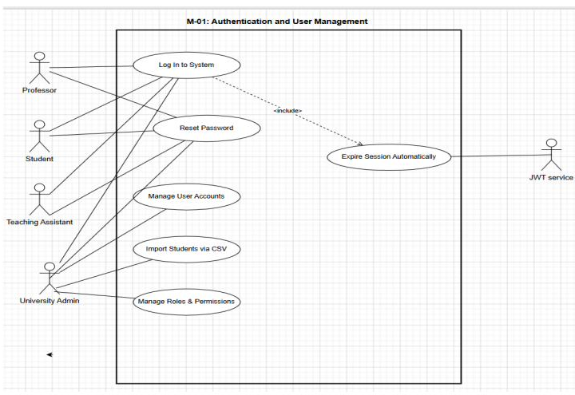
Figure 3.1: M-01 Authentication and User Management - Use Case Diagram

UC-2: Build Grading Rubric for an Assignment
Table 3.14: Details for UC-2: Build Grading Rubric for an Assignment
Field | Description
Actors | Primary: Professor
Description | A professor creates a structured grading rubric by defining criteria, performance levels, and weight distributions for an assignment.
Preconditions | Assignment exists in draft state; professor is assigned to the course
Normal Flow | 1) Professor opens the rubric builder. 2) Professor adds grading criteria. 3) Professor defines performance-level descriptions per criterion. 4) Professor assigns weight percentages. 5) System validates total weight distribution. 6) Professor saves the rubric. 7) System associates the rubric with the assignment.
Alternative Flows | Professor clones an existing rubric from a previous assignment and modifies it before saving
Exceptions | Total criterion weights exceed or fall below 100%; required rubric fields are incomplete
Postconditions | Rubric stored and linked to the assignment; assignment becomes eligible for publication
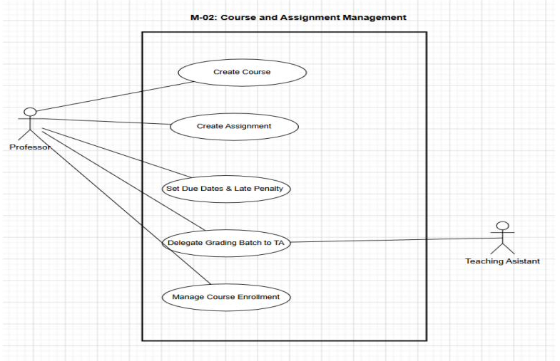
Figure 3.2: M-02 Course and Assignment Management - Use Case Diagram

UC-3: Review and Override AI Grade
Table 3.15: Details for UC-3: Review and Override AI Grade
Field | Description
Actors | Primary: Professor; Secondary: Teaching Assistant
Description | A professor or delegated teaching assistant reviews AI-generated grades, feedback, and explanations before approving or modifying the final evaluation.
Preconditions | AI grading results are available; user is authorised to access the course grading panel
Normal Flow | 1) User opens the grading review panel. 2) System displays submission details, scores, and AI feedback. 3) User reviews criterion-level evaluations. 4) User approves the generated grade. 5) System releases the approved result to the student.
Alternative Flows | User overrides one or more criterion scores with revised values and written justification before approval
Exceptions | Override value exceeds assignment grading limits; submission is flagged for additional review
Postconditions | Submission status updated; approved grades visible to student; override actions recorded in the audit log
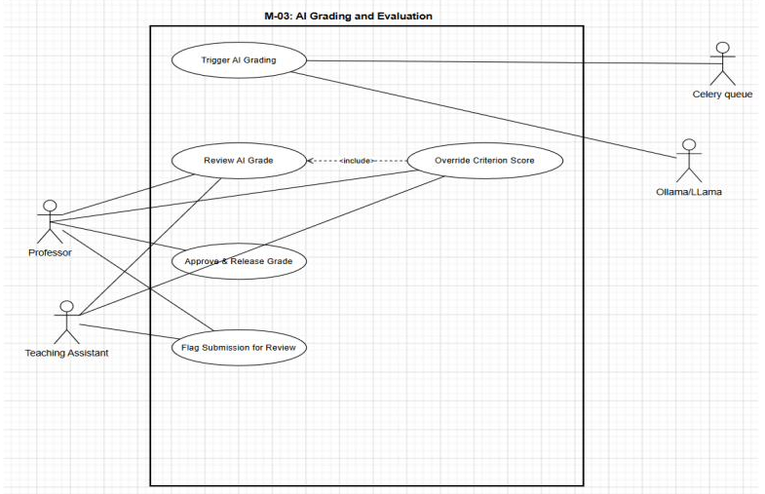
Figure 3.3: M-03 AI Grading and Evaluation - Use Case Diagram

UC-4: View XAI Explanation as Student
Table 3.16: Details for UC-4: View XAI Explanation as Student
Field | Description
Actors | Primary: Student
Description | A student views detailed grading feedback and explainable AI visualisations for an approved submission.
Preconditions | Submission grade has been approved; student owns the submission being viewed
Normal Flow | 1) Student opens the feedback viewer. 2) System retrieves grading feedback and explanation data. 3) System displays submission highlights and criterion-level explanations. 4) Student reviews scores, feedback, and visual indicators. 5) System provides access to the dispute submission option.
Alternative Flows | If explanation data is unavailable, the system regenerates it before displaying results
Exceptions | Objective assessment types display simplified feedback summaries instead of textual explanations
Postconditions | Student reviews criterion-level feedback and explanations; feedback access activity is logged
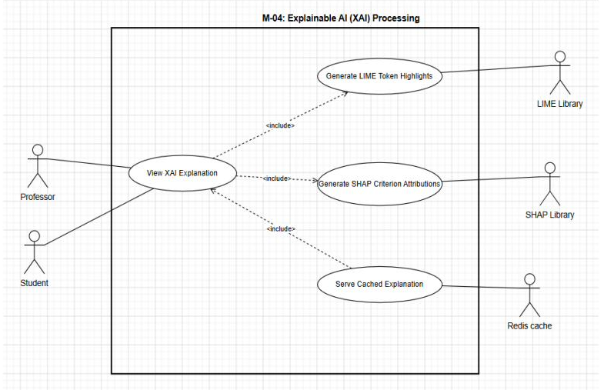
Figure 3.4: M-04 Explainable AI (XAI) Processing - Use Case Diagram

UC-5: Submit Assignment
Table 3.17: Details for UC-5: Submit Assignment
Field | Description
Actors | Primary: Student
Description | A student submits coursework through the platform using the supported submission format for the assignment.
Preconditions | Assignment is published and accessible; student is enrolled; submission attempts are permitted
Normal Flow | 1) Student opens the assignment page. 2) System displays the submission interface. 3) Student enters or uploads content. 4) Student submits the assignment. 5) System validates submission requirements. 6) System records submission and timestamp. 7) System applies any applicable late penalty. 8) System forwards the submission for grading. 9) System confirms successful submission.
Alternative Flows | For programming assignments, the student may execute code multiple times before submitting the final version
Exceptions | Uploaded file exceeds permitted size limits; submission content is empty; assignment is unavailable/unpublished
Postconditions | Submission stored; timestamp recorded; submission forwarded for grading; confirmation displayed
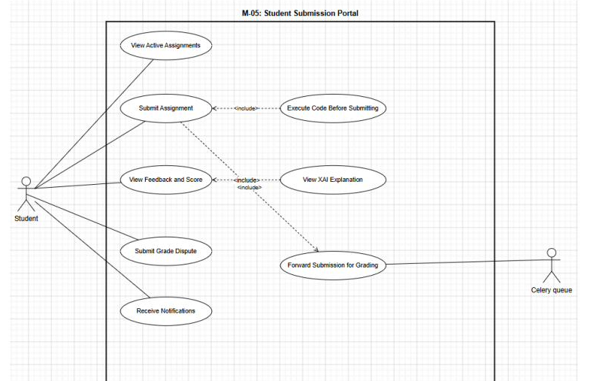
Figure 3.5: M-05 Student Submission Portal - Use Case Diagram

UC-6: Identify At-Risk Students
Table 3.18: Details for UC-6: Identify At-Risk Students
Field | Description
Actors | Primary: Professor
Description | A professor reviews course analytics to identify students requiring academic intervention.
Preconditions | Course contains approved grading data; professor is assigned to the course
Normal Flow | 1) System displays the at-risk student dashboard. 2) Professor reviews student performance indicators. 3) Professor opens detailed student performance history. 4) Professor optionally sends a notification to the student.
Alternative Flows | None
Exceptions | No students currently meet the at-risk criteria
Postconditions | Professor reviews identified students; may initiate communication with flagged students
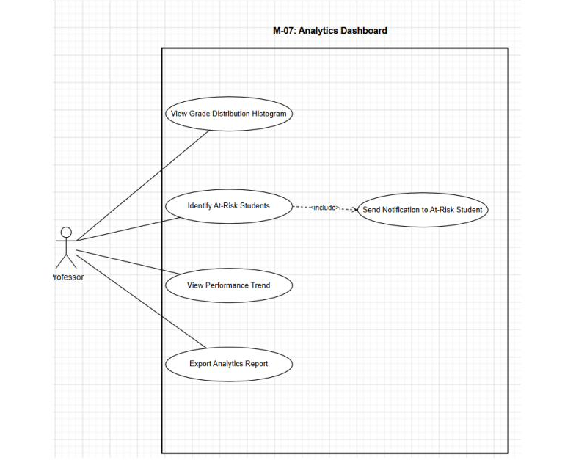
Figure 3.6: M-06 Analytics Dashboard - Use Case Diagram

UC-7: Detect and Log Focus Violation
Table 3.19: Details for UC-7: Detect and Log Focus Violation
Field | Description
Actors | Primary: Student
Description | The system detects examination focus violations during a proctored assessment session and records the incident for professor review.
Preconditions | A proctored examination session is active; student is participating in Focus Mode
Normal Flow | 1) System detects a focus violation event. 2) System records the violation locally and on the server. 3) System updates the violation counter. 4) System notifies the professor dashboard. 5) System displays a return warning overlay to the student.
Alternative Flows | If the device is offline, the violation is stored locally and synchronised after reconnection
Exceptions | Network connection is unavailable during synchronisation
Postconditions | Violation event recorded; professor dashboard updated; student receives a violation warning
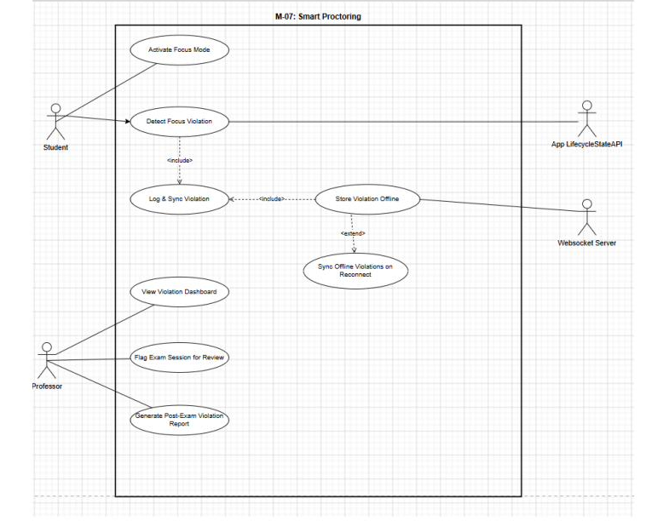
Figure 3.7: M-07 Smart Proctoring - Use Case Diagram

UC-8: Execute Code and View Results
Table 3.20: Details for UC-8: Execute Code and View Results
Field | Description
Actors | Primary: Student
Description | A student executes code within the integrated programming environment and reviews compilation and execution results.
Preconditions | Assignment type is programming-based; student has access to the assignment
Normal Flow | 1) Student writes or pastes source code into the editor. 2) Student selects a programming language. 3) Student executes the code. 4) System processes the execution request. 5) System retrieves execution results. 6) System displays compilation output, execution statistics, and test-case outcomes.
Alternative Flows | None
Exceptions | Compilation failure; execution exceeds allowed time/memory limit; code execution service unavailable
Postconditions | Execution output displayed; test-case results updated
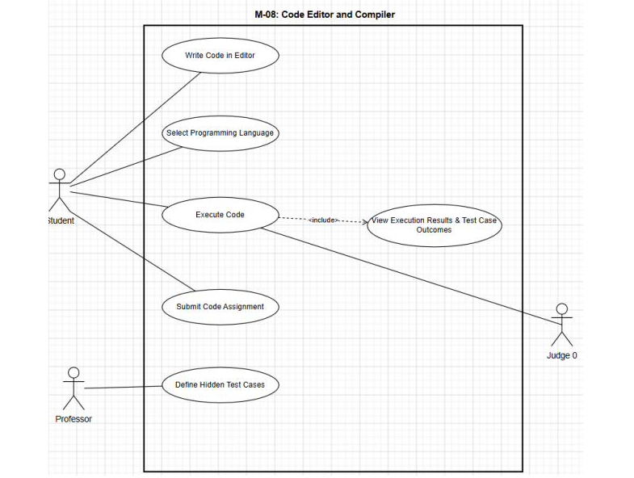
Figure 3.8: M-08 Code Editor and Compiler - Use Case Diagram

UC-9: Ask AI Teaching Assistant a Course Question
Table 3.21: Details for UC-9: Ask AI Teaching Assistant a Course Question
Field | Description
Actors | Primary: Student
Description | A student submits a course-related question to the AI Teaching Assistant and receives a response generated from instructor-provided learning materials.
Preconditions | Course learning materials have been uploaded; student is enrolled in the course
Normal Flow | 1) Student enters a question in the AI Teaching Assistant interface. 2) System retrieves relevant course material. 3) System generates a contextual response. 4) System displays the response with source references.
Alternative Flows | None
Exceptions | No relevant course material is available for the query; AI response service is temporarily unavailable
Postconditions | Student receives a contextual response with supporting references; interaction is logged
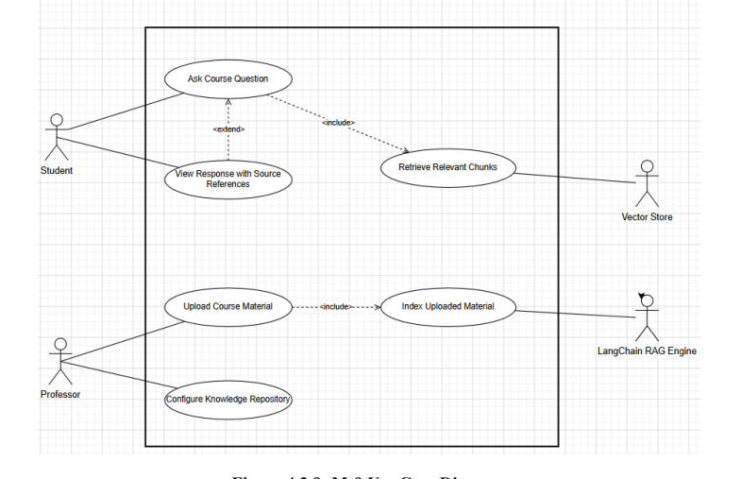
Figure 3.9: M-09 AI Teaching Assistant - Use Case Diagram

3.7 User Stories and Acceptance Criteria
ProfessorOS requirements were elicited using the observation and storyboarding techniques described in Section 3.1 rather than a formal Agile user-story backlog; a prioritized user-story catalogue was not produced and is not applicable to the current requirements process.

3.8 External Interface Requirements

3.8.1 User Interface Requirements
UI-1: All web interfaces use Tailwind CSS 3.4 utility classes for consistent spacing, typography, and colour application, with no custom overrides of Tailwind base classes. UI-2: All interactive elements meet WCAG 2.1 Level AA contrast ratios (minimum 4.5:1 for normal text, 3:1 for large text). UI-3: The grading review panel uses a split-panel layout - submission text with SHAP highlights on the left (60% width) and criterion cards on the right (40% width) on screens 1280px or wider, stacking vertically below that width. UI-4: All forms display inline validation errors adjacent to the field in error, re-validating on blur. UI-5: A loading skeleton or spinner is displayed for any operation expected to take longer than 500 milliseconds. UI-6: The Flutter mobile bottom navigation bar contains exactly four items - Courses, Assignments, AI Assistant, and Profile.

3.8.2 Software Interfaces
Table 3.22: ID details for 3.8.2 Software Interfaces
ID | System | Interface Description
SI-1 | Judge0 CE API (self-hosted) | REST API. POST /submissions to submit code with language_id, source_code, stdin, cpu_time_limit, memory_limit. GET /submissions/{token} to poll results.
SI-2 | Ollama | REST API at http://ollama:11434. POST /api/generate with model llama3.1:8b-instruct and a structured rubric prompt.
SI-3 | Redis 7.2+ | Celery message broker on port 6379 (DB 0); explanation cache on DB 1 keyed explanation:{submissionId}:{type} with a 30-day TTL.
SI-4 | PostgreSQL 15+ | Primary data store, connected via SQLAlchemy 2.x async ORM using the asyncpg driver; schema migrations via Alembic.
SI-5 | sentence-transformers | Local Python library (model all-MiniLM-L6-v2) for submission embeddings and RAG question embeddings.
SI-6 | LangChain 0.2+ | Python RAG pipeline library using document loaders, RecursiveCharacterTextSplitter, FAISS vector store, and a RetrievalQA chain with the Ollama LLM.
SI-7 | FastAPI OpenAPI | Backend auto-generates an OpenAPI 3.0 schema at /docs (Swagger UI) and /redoc for API contract verification.

3.8.3 Hardware Interfaces
HI-1: The Ollama container requires host GPU access for accelerated inference via docker compose --gpus all, with CPU-only fallback at approximately 5x latency. HI-2: The Flutter mobile app interfaces with device biometric hardware via the local_auth package, falling back to password authentication where biometrics are unavailable. HI-3: The server requires a minimum of 16 GB RAM to run all Docker Compose services simultaneously (FastAPI, Celery workers, Redis, PostgreSQL, Ollama, and Judge0).

3.8.4 Communications Interfaces
CI-1: All HTTP communication between web clients and the FastAPI backend uses HTTPS with TLS 1.3 in production. CI-2: Real-time proctoring violation events are transmitted via WebSocket Secure (WSS), established when a proctored exam begins and maintained until submission or timeout. CI-3: In-platform grade release and assignment notifications are delivered via Server-Sent Events (SSE). CI-4: Email notifications are sent via SMTP using the university email server, with connection details configured through Docker Compose environment variables.

3.9 Data Requirements
The core persistent data entities required by ProfessorOS, summarised from the project data dictionary, are listed below. Full attribute-level detail is provided in Section 4.9 (Database and Persistence Design).
Table 3.23: Data Item / Entity
Data Item / Entity | Source / Owner | Sensitivity / Retention
users | Self-registered / Administrator (CSV import) | Contains password hashes and PII; retained for account lifetime
courses, assignments | Professor | Institutional academic data; retained for course lifecycle
rubrics, criteria | Professor | Academic configuration data; versioned with assignments
submissions | Student | Academic work product; retained per institutional policy
grading_results, criterion_results | AI engine / Professor override | Sensitive grade data; audit-logged, tamper-evident
explanations (LIME/SHAP) | AI engine | Derived explainability data; Redis-cached 30-day TTL
proctor_sessions, focus_violations | Mobile app (Flutter) | Examination integrity data; immutable once created
chat_sessions, chat_messages | AI Teaching Assistant | Conversational data scoped to course context
course_materials | Professor upload | Source documents for the RAG knowledge base

3.10 Requirements Traceability and Validation
The Requirements Traceability Matrix (RTM) maps every functional and non-functional requirement to the business objective it satisfies, its source, and its priority, ensuring no requirement exists without a business justification and none is left untested.
Table 3.24: Req ID
Req. ID | Module | Business Objective | Priority
FR-M01 | M-01 Authentication and User Management | BO-9: Secure role-controlled deployment | High
FR-M02 | M-02 Course and Assignment Management | BO-1: Grading pipeline foundation; BO-3: Rubric quality drives IRR | High
FR-M03 | M-03 AI Grading and Evaluation | BO-1: 75% grading time reduction; BO-2: 60s feedback; BO-3: 85% IRR | High
FR-M04 | M-04 Explainable AI (XAI) Processing | BO-4: LIME/SHAP transparency for students and professors | High
FR-M05 | M-05 Student Submission Portal | BO-1: Unified submission; BO-2: Feedback delivery; BO-4: XAI viewing | High
FR-M06 | M-06 Analytics Dashboard | BO-8: Real-time at-risk identification and course performance | High
FR-M07 | M-07 Smart Proctoring | BO-6: 60% reduction in single-device cheating | High
FR-M08 | M-08 Code Editor and Compiler | BO-5: Sandboxed in-browser execution for 12 languages | High
FR-M09 | M-09 AI Teaching Assistant | BO-7: 24/7 course-specific RAG-grounded student support | Medium
NFR-R1 | Reliability | Consistent, uninterrupted academic operations | High
NFR-P1 | Performance | BO-2: 60-second feedback delivery under 180 concurrent students | High
NFR-S1 | Security (cross-cutting) | BO-9: Secure institutional deployment | High
NFR-M1 | Maintainability | BO-9: Single-command, modular deployment | High

CHAPTER 4 SYSTEM ANALYSIS AND DESIGN
This chapter presents the structural, behavioural, data, interface, security, and deployment design of ProfessorOS, consolidated from the project's Software Design Specification (SDS v1.1). Every design decision traces back to the requirements documented in Chapter 3.

4.1 Design Approach and Principles
The design follows an object-oriented approach because the problem domain naturally maps to objects: a Course has Assignments, each Assignment has a Rubric composed of RubricCriteria, a Student submits a Submission, and an AIGradeResult attaches to that submission with explainable scores. Encapsulation keeps grading logic inside dedicated service classes. Inheritance treats Professor, Student, Teaching Assistant, and Administrator as specialised User types sharing common authentication attributes. Polymorphism allows different grading pipelines - text, code, and MCQ - to be invoked through the same interface. The backend (Python) and web frontend (TypeScript/React) both support these object-oriented patterns, and the Flutter mobile app uses a class-based component model.

4.2 System Context and External Interfaces
ProfessorOS is a multi-tier web and mobile platform deployed entirely on university intranet hardware. It handles four submission types - text essay, MCQ, code, and file upload - and serves four user roles across two client surfaces: a React 18 web portal and a Flutter 3.22 mobile application. All AI inference runs locally via Ollama on the university server, and external interfaces with Judge0, Redis, PostgreSQL, and the sentence-transformers/LangChain RAG stack are documented in Section 3.8.2.

4.3 Overall System Architecture
A layered architecture was selected because it separates concerns cleanly, with each layer communicating only with the layer directly below it (or via asynchronous queues). From bottom to top, the layers are:
Table 4.1: Layer
Layer | Components | Responsibility
1. Infrastructure | PostgreSQL, Redis, FAISS, Ollama, Judge0 | Persistence, caching/broker, vector store, LLM inference, code sandbox
2. Data Access | SQLAlchemy ORM, Redis client, FAISS wrapper | Abstracts persistence and cache access from business logic
3. Business Logic / Service | Celery tasks (grading, XAI, RAG), proctoring event handler, rubric scoring engine | Executes asynchronous AI processing and domain rules
4. API / Application | FastAPI REST endpoints (JWT-protected), WebSocket server, SSE | Exposes secure APIs, live proctoring channel, and notification streaming
5. Presentation | React web portals (Professor, Student, Admin), Flutter mobile app | User-facing interfaces across web and mobile clients
Communication rules: web clients communicate with FastAPI over HTTPS/REST (or WSS for proctoring); FastAPI communicates with Celery via Redis as the message broker; Celery workers call Ollama, Judge0, and sentence-transformers directly; and all containers communicate over a dedicated Docker network, with only the Nginx reverse proxy exposing external ports 80/443.
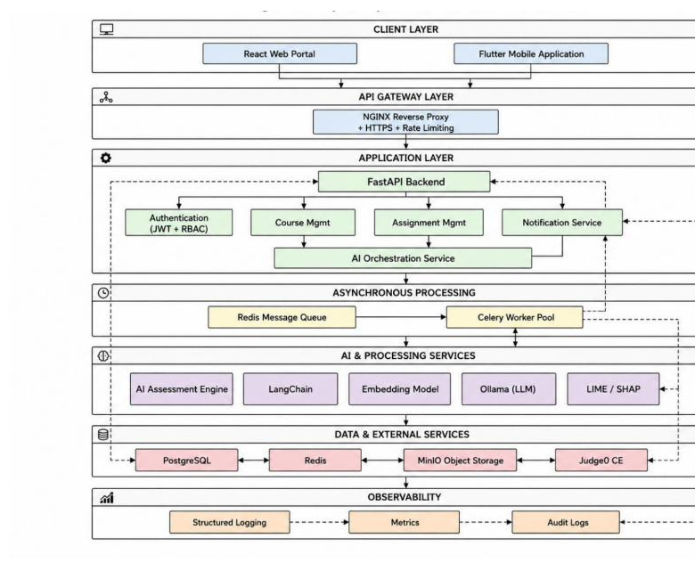
Figure 4.1: Layered System Architecture Diagram

4.4 Domain Model
The User entity is the central abstract concept, specialised into four subtypes - Professor, Student, Teaching Assistant, and University Administrator - each inheriting common authentication attributes while differing in role-based access. A Course is created and owned by a Professor and contains one or more Assignments. Each Assignment has exactly one Rubric, composed of one to ten Rubric Criteria. When a Student submits work against an Assignment, a Submission record is created and triggers one AIGradeResult (via the AI grading pipeline) and one XAIExplanation (via LIME and SHAP post-processing). Each Rubric Criterion within the AIGradeResult carries an individual criterion score, a performance-level label, and AI-generated feedback text.
During proctored examinations, a Proctoring Session is created per student per exam and accumulates ViolationEvent records triggered by app-switch detection. For code-type assignments, a Code Execution Result is produced by Judge0 for each Run action and linked to the Submission on final submission. Finally, each Course maintains a collection of Course Material documents indexed into a FAISS vector store and consulted by the AI Teaching Assistant during chat sessions.
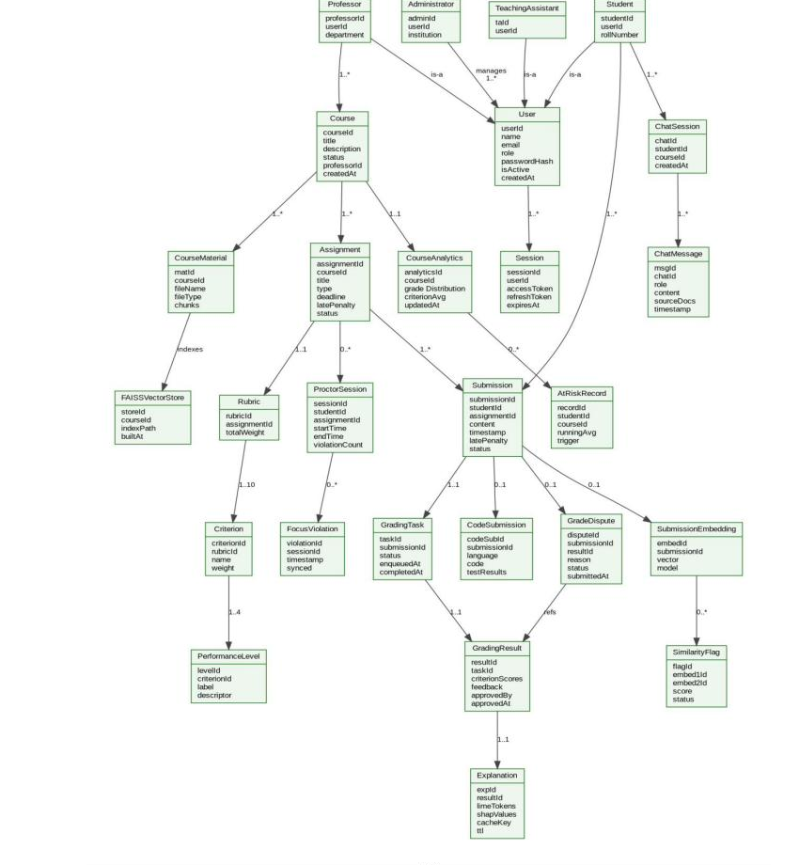
Figure 4.2: Unified System Domain Model - ProfessorOS

4.5 Class Design
The class design refines the domain model into implementation-level classes. User is modelled as an abstract base class; Professor, Student, TeachingAssistant, and Administrator inherit from it, sharing base authentication attributes while adding role-specific ones. GradingResult is composed of CriterionResult objects, one per rubric criterion, allowing a professor to override a single criterion without affecting others. Explanation stores LIME token-level scores and SHAP criterion attributions as JSONB, enabling sub-500ms Redis-cached serving on subsequent views. ProctorSession aggregates independently logged and synced FocusViolation objects, supporting offline-first recording when a student device loses connectivity during an exam.
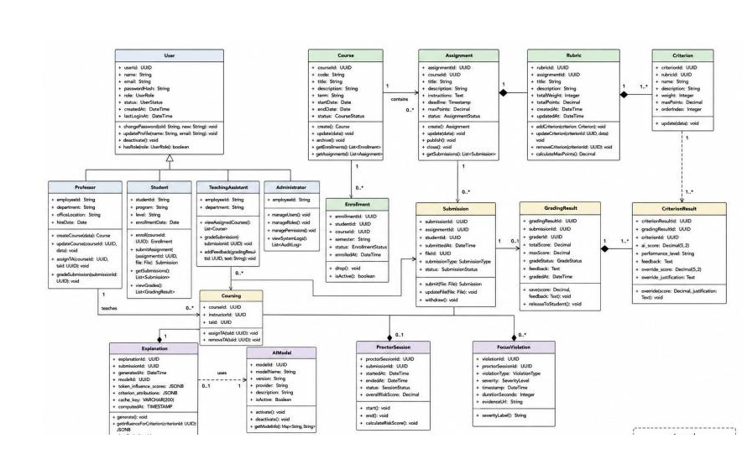
Figure 4.3: Class Diagram - ProfessorOS Core Domain Model

4.6 Package and Component Design
The system is organised into deployable components that mirror the layered architecture in Section 4.3: a FastAPI application package exposing REST/WebSocket/SSE endpoints; a Celery worker package containing the grading, XAI, and RAG task queues; a React web package split into Professor, Student, and Admin portal bundles; and a Flutter mobile package covering submission, proctoring, and code-editor features. Each package communicates only through its defined API or message-queue contract, consistent with constraint CON-1 through CON-9 in Section 4.11.

4.7 Interaction and Workflow Design

4.7.1 Activity Diagram - AI Grading Pipeline (M-03)
This workflow uses four swimlanes - Student, FastAPI Backend, Celery Worker and Ollama AI, and Professor - covering the full lifecycle from submission through asynchronous grading, XAI computation, professor review with optional override, grade approval, and student feedback delivery.
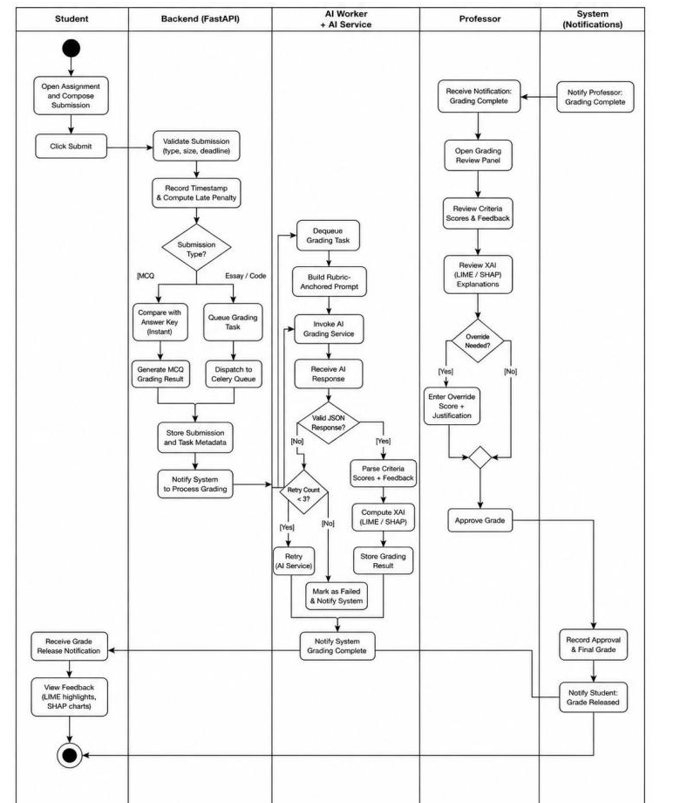
Figure 4.4: Activity Diagram - AI Grading Pipeline (M-03)

4.7.2 Activity Diagram - Student Submission and Feedback (M-05)
This workflow uses two swimlanes - Student and System - covering selection and composition of a submission, submitting, waiting for AI grading, receiving the grade-release notification, viewing XAI feedback, and optionally raising a grade dispute.
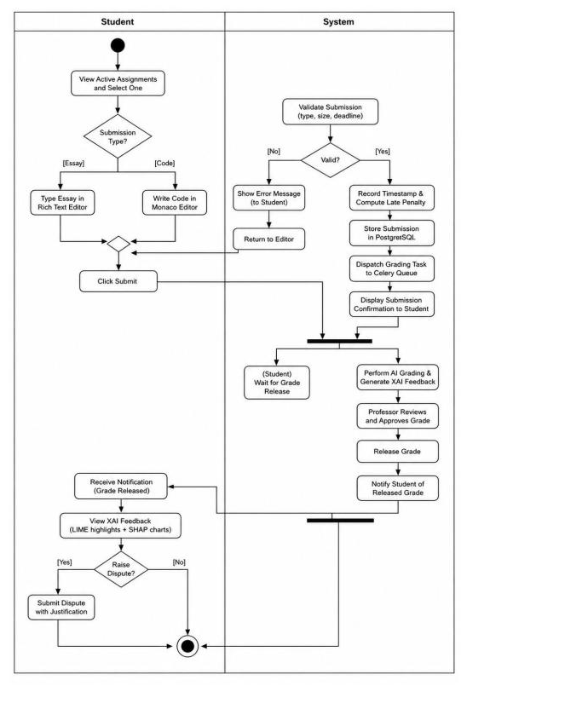
Figure 4.5: Activity Diagram - Student Submission and Feedback (M-05)

4.7.3 Sequence Diagram - Grading Pipeline
The sequence diagram traces the complete interaction from student submission through backend validation, Celery task dispatch, Ollama LLM inference, LIME and SHAP XAI computation, PostgreSQL storage, professor review, optional override, grade approval, and SSE notification to the student.
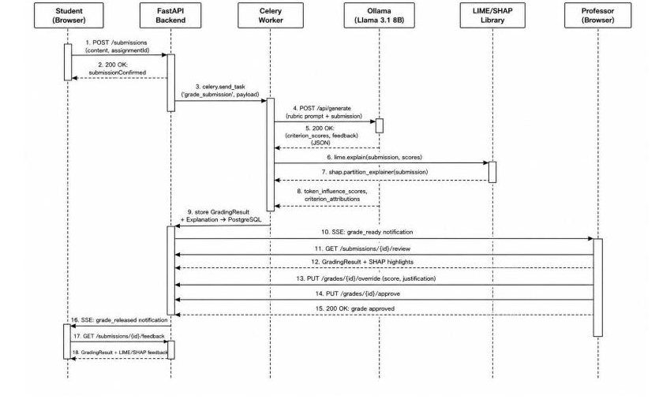
Figure 4.6: Sequence Diagram - Grading Pipeline

4.8 State and Lifecycle Design
A state machine models the complete lifecycle of a Smart Proctoring session on the Flutter mobile application, covering all states: IDLE, FOCUS MODE ACTIVE, VIOLATION DETECTED, RETURNED IN TIME, CRITICAL VIOLATION, FLAGGED FOR REVIEW, DISCONNECTED, and SUBMITTED/COMPLETED.
Table 4.2: Current State
Current State | Event / Guard | Action | Next State
IDLE | Exam session starts | Create ProctorSession; sync to server | FOCUS_MODE_ACTIVE
FOCUS_MODE_ACTIVE | AppLifecycleState.paused detected | Create FocusViolation; increment counter; start 30s countdown | VIOLATION_DETECTED
VIOLATION_DETECTED | Student returns before timer expires | Mark violation resolved | RETURNED_IN_TIME
VIOLATION_DETECTED | Countdown timer expires | Flag session if violations ≥ 3 | CRITICAL_VIOLATION
RETURNED_IN_TIME | Student remains in app | Resume monitoring | FOCUS_MODE_ACTIVE
Any active state | Network unavailable | Buffer violations locally | DISCONNECTED
DISCONNECTED | Network reconnects | Batch-sync buffered violations | FOCUS_MODE_ACTIVE
Any active state | Student submits exam | Sync final session state | SUBMITTED / COMPLETED
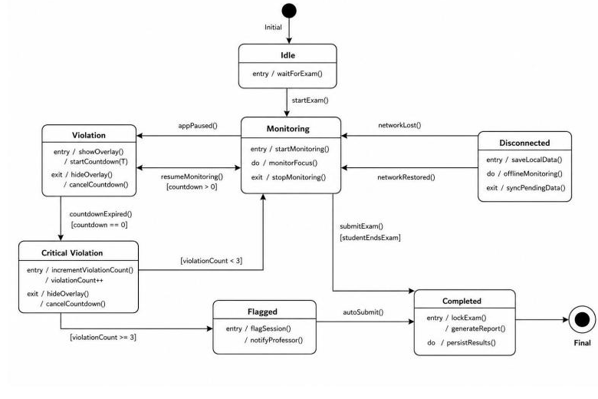
Figure 4.7: State Machine Diagram - Smart Proctoring (M-07)

4.9 Database and Persistence Design
Persistent data is stored in PostgreSQL; transient data (cached explanations, session state) lives in Redis; and vector embeddings for course materials are stored in per-course FAISS indexes. The data dictionary below documents the core entities and their key attributes.
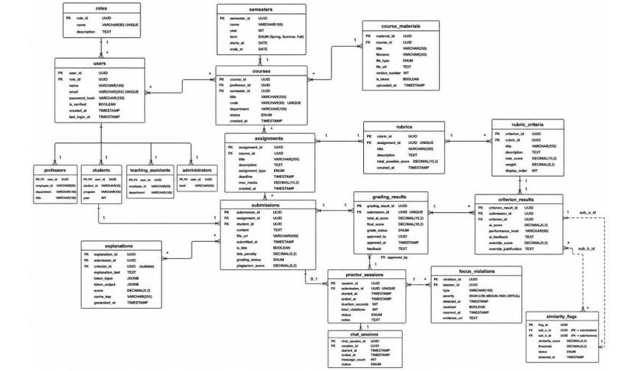
Figure 4.8: Entity-Relationship / Data Model Diagram - ProfessorOS
Table 4.3: Entity / Attribute
Entity / Attribute | Type | Constraints | Description
users.user_id | UUID | PK, NOT NULL | Unique identifier for each user account
users.password_hash | VARCHAR(512) | NOT NULL | Argon2id hashed password; plain text is never stored
users.role | ENUM | NOT NULL | PROFESSOR, STUDENT, TEACHING_ASSISTANT, or ADMINISTRATOR
courses.course_id | UUID | PK, NOT NULL | Unique identifier for each course
assignments.submission_type | ENUM | NOT NULL | TEXT_ESSAY, FILE_UPLOAD, MCQ, or CODE
rubrics.total_weight | INT | DEFAULT 100 | Sum of all criterion weights; must equal 100 before publication
submissions.grading_status | ENUM | NOT NULL | QUEUED, PROCESSING, COMPLETED, FAILED, APPROVED, or FLAGGED
grading_results.total_score | DECIMAL(6,2) | NOT NULL | Sum of all criterion scores, reflecting overrides if applied
criterion_results.overridden_score | DECIMAL(5,2) | NULLABLE | Professor-set score; NULL if no override was performed
explanations.token_influence_scores | JSONB | NOT NULL | Array of {token, influence_score} objects produced by LIME
explanations.criterion_attributions | JSONB | NOT NULL | Array of {criterion_id, shapley_values[]} produced by SHAP
proctor_sessions.flagged_for_review | BOOLEAN | DEFAULT FALSE | Set to TRUE when unresolved violations reach 3
focus_violations.synced_to_server | BOOLEAN | DEFAULT FALSE | FALSE while device is offline; TRUE after WebSocket sync
chat_messages.source_docs | JSONB | NULLABLE | Source chunk references returned by RAG for assistant messages
course_materials.chunk_count | INT | NOT NULL | Number of text chunks generated after splitting for FAISS indexing

4.10 User Interface and Experience Design
All interfaces - the Professor Web Portal, Student Web Portal, and Flutter Mobile App - use the Tailwind CSS 3.4 utility system and meet WCAG 2.1 Level AA contrast ratios. Five design principles guide the interface: (1) minimum formatting, with no sidebars or popups for routine grading actions so everything needed during review is visible on one screen; (2) semantic colour only - green for positive/approval, amber for neutral/developing, red for negative/flag; (3) permanent legend visibility for the SHAP colour scale on every feedback page; (4) plain language, so the student-facing UI never exposes technical terms such as LIME, SHAP, or embedding; and (5) one-handed mobile operation, with all exam interactions reachable by the right thumb on 5-inch-or-larger screens.
Table 4.4: Screen Object
Screen Object | Type | Action / Description
SHAP Highlight (Green/Red) | Visual overlay on text | Non-interactive; shows positive/negative token contribution proportional to Shapley value magnitude
SHAP Colour Scale Legend | Static legend | Permanently visible below the submission text
Criterion Card | Expandable card | Click to expand/collapse the SHAP bar chart of the top 5 most influential tokens
AI Score Badge | Read-only badge | Displays the raw AI-assigned score; replaced by the overridden score once saved
Override Button | Primary action button | Opens an inline override input with mandatory justification; creates an audit log entry
Approve Grade | Primary success button | Sets grade_status to APPROVED; triggers SSE notification; logs the approval event
Flag for Review | Warning action button | Sets grade_status to FLAGGED; grade is not released; moves to the flagged review queue
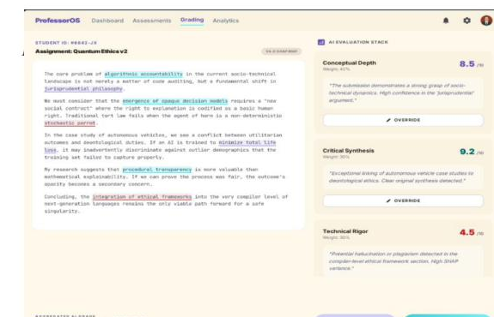
Figure 4.9: Professor Grading Review Panel - Interface Mockup
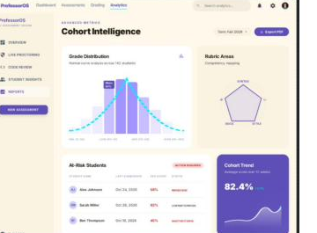
Figure 4.10: Analytics Dashboard - Interface Mockup

4.11 Security and Privacy Design
Security and privacy controls are embedded throughout the architecture as non-negotiable design constraints:
Table 4.5: Constraint ID details for 4.11 Security and Privacy Design
Constraint ID | Constraint
CON-1 | All backend and AI/ML components use Python 3.11 or later; no Python 2.x code is permitted
CON-2 | LLM inference uses Ollama running Llama 3.1 8B Instruct locally; no external OpenAI, Anthropic, or Gemini API calls are permitted in production
CON-3 | All code execution is routed through the self-hosted Judge0 CE sandbox; student code never executes on the FastAPI application server
CON-4 | All passwords must be hashed with Argon2id; MD5, SHA-1, SHA-256, and bcrypt are not acceptable alternatives
CON-5 | The React frontend must use Tailwind CSS 3.4 utility classes with no custom overrides of Tailwind base classes
CON-6 | The Flutter app must use the AppLifecycleState API for proctoring; camera, microphone, and facial-recognition APIs are explicitly forbidden
CON-7 | All database schema changes are managed through Alembic migration scripts; direct DDL modification of the production database is not permitted
CON-8 | The system must be deployable via a single command: docker compose up --build -d, with no manual server configuration outside the .env file
CON-9 | All API endpoints must be documented via FastAPI's auto-generated OpenAPI 3.0 schema at /docs and /redoc
CON-10 | Access tokens must not be stored in browser localStorage; they must be stored in httpOnly cookies or managed in-memory on the client

4.12 Deployment Design and Design Rationale
ProfessorOS is designed for single-command deployment via Docker Compose (constraint CON-8), with all services - FastAPI, Celery workers, Redis, PostgreSQL, Ollama, and Judge0 - running as isolated containers on a dedicated Docker network. Only the Nginx reverse proxy exposes external ports 80 and 443, minimising the attack surface. The layered architecture (Section 4.3) was chosen over a monolithic design specifically to allow the AI/ML components (Ollama, Judge0) to scale or be replaced independently of the core FastAPI application, and to allow the Celery worker pool to scale horizontally to absorb grading-queue spikes during assignment deadlines without requiring changes to the presentation or API layers.

CHAPTER 5 IMPLEMENTATION AND INTEGRATION
This chapter explains how the approved design is being translated into a working product, describing the actual technologies, algorithms, and external-service integrations defined for ProfessorOS. As of this report, implementation is in progress under the FYP-II development cycle described in Section 1.9; sections describing artefacts not yet produced are marked accordingly.

5.1 Development Environment and Technology Stack
Table 5.1: Category
Category | Tool | Version | Rationale
Frontend | Flutter SDK | 3.22+ | Single codebase for iOS, Android, and Web
Frontend | Dart | 3.x | Strongly-typed language natively built into the Flutter SDK
Frontend | go_router | Latest | URL-safe navigation for Flutter web with browser history support
Frontend | fl_chart | Latest | Native Flutter charting library for analytics dashboards
Backend | Python FastAPI | 0.111+ | Async API framework with automatic OpenAPI documentation
Backend | SQLAlchemy | 2.x | Async ORM with Alembic migration support
Backend | Celery + Redis | 5.x / 7.x | Distributed async task queue for the AI grading pipeline
AI / ML | Llama 3.1 8B Instruct | 3.1 | Open-source model for local, cost-free grading
AI / ML | Ollama | Latest | Local LLM inference server
AI / ML | LangChain | 0.2+ | RAG pipeline for the AI Teaching Assistant
AI / ML | LIME | 0.2+ | Local, model-agnostic post-hoc text explanations
AI / ML | SHAP | 0.45+ | Shapley-value-based criterion-level attributions
Code Execution | Judge0 | API v1 | Self-hosted multi-language compilation and execution
Code Execution | re_editor / Monaco Editor | Latest | Native code editor with syntax highlighting and Judge0 integration
Database | PostgreSQL | 15+ | ACID-compliant relational database
Database | Redis | 7.2+ | Celery broker and explanation cache
DevOps | GitHub Actions | Latest | CI/CD pipeline for automated testing
DevOps | Docker Compose | Latest | Multi-container deployment
Security | JWT / python-jose | 3.x | Stateless authentication token management
Design | Figma | Latest | UI/UX wireframing and component design

5.2 Repository Structure and Configuration Management
The final repository tree, branch strategy, and release-tagging convention had not yet been finalised at the time this report was compiled and will be documented once the codebase structure is established during implementation.

5.3 Implementation of Major Modules
Module-by-module implementation summaries (key classes/services, requirement coverage, and status) are pending completion of the FYP-II build phases outlined in Section 1.9 and will be documented as each module reaches a testable increment.

5.4 Algorithms and Core Logic
Five core algorithms drive the ProfessorOS backend and mobile logic, reproduced below at an implementation-guidance level of abstraction.

5.4.1 Rubric-Anchored AI Grading (M-03)
MCQ submissions follow a direct comparison branch; text and file submissions are graded by Llama 3.1 8B via Ollama.
ALGORITHM: RubricAnchoredGrading(submission_id)
1. FETCH submission, assignment, rubric, criteria[] FROM PostgreSQL
2. IF submission.grading_status != QUEUED THEN RETURN
3. SET submission.grading_status = PROCESSING
4. IF submission.type == MCQ THEN
score = (correct_count / total_questions) * assignment.max_marks
INSERT GradingResult(total_score=score, status=PENDING_REVIEW); RETURN
5. BUILD prompt: rubric criteria, weights, descriptors, submission text
6. CALL Ollama API: POST /api/generate {model:'llama3.1:8b', prompt, stream:false}
7. PARSE JSON response into criterion_results[]
8. VALIDATE: SUM(criterion.score * criterion.weight / 100) == total_score
9. INSERT GradingResult(total_score, grade_status=PENDING_REVIEW)
10. FOR EACH cr IN criterion_results[]: INSERT CriterionResult(...)
11. UPDATE submission.grading_status = COMPLETED
12. DISPATCH xai_task.apply_async(args=[submission_id], countdown=2)
13. RETURN grading_result_id

5.4.2 Explainable AI Processing (M-04)
This algorithm computes LIME token-level influence scores and SHAP-style criterion attributions using criterion ablation, with results cached in Redis for 30 days.
ALGORITHM: ExplainGrade(submission_id)
1. FETCH submission.text, grading_result, criteria[] FROM PostgreSQL
2. CHECK Redis cache 'explanation:{submission_id}'; IF hit RETURN cached
-- LIME Token Influence --
3. tokens[] = TOKENIZE(submission.text)
4. FOR EACH token t: masked_score = CALL_OLLAMA_SCORE(text without t)
influence[t] = baseline_score - masked_score
5. NORMALIZE influence[] to [-1.0, +1.0]
-- Criterion Ablation (Shapley approximation) --
6. FOR EACH criterion c: shapley_value[c] = MEAN(score_with_c - score_without_c)
7. INSERT Explanation(token_influence_scores, criterion_attributions)
8. CACHE in Redis with 30-day TTL; RETURN explanation_id

5.4.3 Smart Proctoring (M-07)
This algorithm runs on the Flutter mobile app and uses the AppLifecycleState API exclusively; no camera, microphone, or biometric data is captured. Violations are buffered locally when offline and synced over WebSocket on reconnect.
ALGORITHM: FocusMonitor(exam_id, student_id)
1. CREATE ProctorSession; SET status = FOCUS_MODE_ACTIVE; sync via WebSocket
2. REGISTER AppLifecycleObserver
3. LOOP WHILE session.status != SUBMITTED:
IF event == paused:
CREATE FocusViolation; INCREMENT total_violations
SET status = VIOLATION_DETECTED; START 30s countdown
IF total_violations >= 3: flagged_for_review = TRUE
IF network_available: SYNC violation ELSE BUFFER locally
IF resumed BEFORE timer: status = RETURNED_IN_TIME
ELSE: status = CRITICAL_VIOLATION
IF network_reconnect: BATCH_SYNC buffered violations
4. SET status = SUBMITTED; sync final session state

5.4.4 Code Editor and Compiler - Judge0 Execution (M-08)
All student-submitted code executes inside the self-hosted Judge0 CE sandbox. The FastAPI backend brokers the request; code never executes on the FastAPI application server.
ALGORITHM: ExecuteCode(source_code, language_id, stdin)
1. IF language_id NOT IN SUPPORTED_LANGUAGES: RETURN Error
2. payload = { source_code, language_id, stdin, cpu_time_limit:5, memory_limit:128000 }
3. token = POST /submissions?wait=false (payload)
4. LOOP: SLEEP(1s); result = GET /submissions/{token}
IF status IN [Queued, Processing]: retry (max 10) ELSE BREAK
5. RETURN { stdout, stderr, status_label, time_ms, memory_kb }

5.4.5 AI Teaching Assistant - RAG Pipeline (M-09)
The teaching assistant uses LangChain with a per-course FAISS vector store and sentence-transformers embeddings, strictly scoped to uploaded course materials.
ALGORITHM: RAGQuery(student_question, course_id, session_id)
1. LOAD FAISS index for course_id; IF missing RETURN 'no materials uploaded'
2. question_embedding = sentence_transformer.encode(student_question)
3. distances[], chunk_ids[] = faiss_index.search(question_embedding, k=5)
4. IF MIN(distances) > 0.75: RETURN 'answer only from uploaded materials'
5. context = JOIN(chunk_texts)
6. prompt = 'Answer using ONLY the following materials: {context} ...'
7. response = (PromptTemplate | OllamaLLM('llama3.1:8b') | StrOutputParser).invoke(prompt)
8. STORE ChatMessage(session_id, ASSISTANT, response, source_docs=chunk_ids)
9. RETURN { response, source_docs }

5.5 Database, API, and External-Service Implementation
The following third-party services and APIs are integrated into the ProfessorOS implementation.
Table 5.2: Name of API and Version
Name of API and Version | Purpose of Usage | Endpoint / Function Used
Judge0 CE v1 (self-hosted) | Sandboxed multi-language code compilation and execution | POST /submissions, GET /submissions/{token}
Ollama (latest) | Local Llama 3.1 8B inference for grading, XAI, and RAG generation | POST /api/generate
Redis 7.2+ | Celery message broker and 30-day explanation cache | Celery broker DB 0; cache DB 1
PostgreSQL 15+ | Primary relational data store via SQLAlchemy 2.x async ORM | asyncpg connection pool (10 min / 20 max)
sentence-transformers (all-MiniLM-L6-v2) | Submission and RAG question embedding generation | Local Python library encode() call
LangChain 0.2+ | RAG pipeline: document loading, chunking, FAISS retrieval, QA chain | RetrievalQA chain with Ollama LLM
FastAPI OpenAPI (auto-generated) | API contract documentation and verification | /docs, /redoc

5.6 User Interface Implementation
Implemented screen captures for the Professor Web Portal, Student Web Portal, and Flutter Mobile App were not yet available at the time this report was compiled; Figma-based interface designs are documented in Section 4.10 and will be replaced with implementation screenshots once development is complete.

5.7 System Integration
A recorded end-to-end system integration workflow (across the user interface, services, data store, and external dependencies) is pending completion of the module implementation phases described in Section 1.9.

5.8 Coding Quality, Build Automation, and Technical Documentation
Coding-quality practices defined for the project include a GitHub Actions CI/CD pipeline (constraint CON-8/CON-9) that runs automated tests on every commit before deployment, and FastAPI's auto-generated OpenAPI 3.0 documentation at /docs and /redoc for API contract verification. Execution evidence for these practices (CI run logs, static-analysis results) will be attached once the corresponding pipelines are operational.

5.9 Release Preparation and Deployment Readiness
A release checklist, version tag, and artefact inventory had not yet been produced at the time this report was compiled and will be added ahead of the FYP-II final submission.

CHAPTER 6 VERIFICATION, VALIDATION, TESTING, AND EVALUATION
This chapter is intended to provide objective evidence that the completed product satisfies the requirements documented in Chapter 3. At the current project stage, implementation and system testing have not yet been carried out, so the sections below are retained as placeholders to be completed once verification and validation activities take place during FYP-II.

6.1 Evaluation Strategy and Test Environment
[Content not available in current project documents - to be completed during subsequent development phases.]

6.2 Unit Testing
[Content not available in current project documents - to be completed during subsequent development phases.]

6.3 Functional and Business-Rule Testing
[Content not available in current project documents - to be completed during subsequent development phases.]

6.4 Integration Testing
[Content not available in current project documents - to be completed during subsequent development phases.]

6.5 System and End-to-End Testing
[Content not available in current project documents - to be completed during subsequent development phases.]

6.6 Non-Functional Requirement Testing
[Content not available in current project documents - to be completed during subsequent development phases.]

6.7 Security and Privacy Testing
[Content not available in current project documents - to be completed during subsequent development phases.]

6.8 Usability and User Acceptance Validation
[Content not available in current project documents - to be completed during subsequent development phases.]

6.9 Results and Defect Summary
[Content not available in current project documents - to be completed during subsequent development phases.]

6.10 Requirements and Objectives Validation
[Content not available in current project documents - to be completed during subsequent development phases.]

6.11 Discussion of Evaluation Findings
[Content not available in current project documents - to be completed during subsequent development phases.]

CHAPTER 7 SOFTWARE DEPLOYMENT AND USER DOCUMENTATION
This chapter documents the release environment and operational requirements defined for ProfessorOS. Deployment execution records, monitoring evidence, and end-user manuals will be added once the system reaches deployment readiness during FYP-II.

7.1 Deployment Architecture and Target Environment
ProfessorOS is designed for deployment on university-owned server hardware running Ubuntu 22.04 LTS or later with a minimum of 16 GB RAM (OE-1), using an NVIDIA GPU with at least 8 GB VRAM where available for accelerated Ollama inference (HI-1), with CPU-only inference supported at degraded performance. The system operates on the university intranet without requiring open internet access for core grading, submission, or proctoring features (OE-4). All Docker containers run on an isolated internal network, with only the Nginx reverse proxy exposing external ports 80 and 443 (HI-5).

7.2 Deployment Prerequisites and Configuration
Table 7.1: Prerequisite / Configuration
Prerequisite / Configuration | Required Value or Condition
Server operating system | Ubuntu 22.04 LTS or later
Server memory | Minimum 16 GB RAM to run FastAPI, Celery workers (x2), Redis, PostgreSQL, Ollama, and Judge0 simultaneously
GPU (recommended) | NVIDIA GPU with ≥ 8 GB VRAM for Ollama inference; docker compose --gpus all
Container orchestration | Docker Compose with all services defined in a single docker-compose.yml
Reverse proxy | Nginx exposing only ports 80 and 443
TLS | TLS 1.3 certificates configured for HTTPS/WSS in production
Environment configuration | All secrets and connection strings supplied via a .env file; no hardcoded credentials

7.3 Installation and Deployment Procedure
The system is designed to be deployable via a single command, docker compose up --build -d, per design constraint CON-8, with no manual server configuration steps required outside the .env file. A step-by-step executed deployment record with screenshots and release-tag evidence will be produced once the FYP-II implementation reaches a releasable increment.

7.4 Operational Monitoring, Logging, and Maintenance
Per maintainability requirement NFR-M1, all modules are designed to include structured logging and expose health-check endpoints consumable by standard monitoring tools. Detailed operational monitoring evidence and a maintenance schedule will be documented once the system is deployed.

7.5 Backup, Recovery, and Rollback
A backup/restore test and rollback record have not yet been produced and will be added once the persistence layer (Section 4.9) is implemented and deployed.

7.6 Production or Release Smoke Testing
[Content not available in current project documents - to be completed during subsequent development phases.]

7.7 User Manual and Operational Handover
A full user manual and administrator guide covering roles, access, workflows, and troubleshooting will be authored once the user interfaces described in Section 4.10 are implemented.

CHAPTER 8 CONCLUSION

8.1 Conclusion
This report has presented ProfessorOS, an AI-powered academic assessment platform designed to address the documented 12-18 hour weekly grading burden faced by professors at Shifa Tameer-e-Millat University and comparable Pakistani institutions. Chapter 1 established the project vision, problem statement, and objectives; Chapter 2 presented the proposed system and its module structure; Chapter 3 documented a complete Software Requirements Specification covering nine functional modules, eight non-functional requirement categories, and nine detailed use cases; and Chapter 4 presented the corresponding system design, including the layered architecture, domain model, database design, and interface design. Chapter 5 outlined the technology stack and the five core algorithms underpinning AI grading, explainability, proctoring, code execution, and the AI teaching assistant. As the project moves into the FYP-II implementation and testing cycle, Chapters 6 and 7 will be completed with verification evidence and deployment documentation.

8.2 Achievement of Objectives
A formal, evidence-backed achievement-of-objectives matrix will be completed once implementation and testing (Chapter 6) are finished.

8.3 Limitations
The limitations accepted for the current scope of ProfessorOS are documented in Section 1.12 and include exclusive support for digital (non-handwritten) submissions, dependence on rubric quality for grading accuracy, single-device-only proctoring coverage, a fixed set of 12 supported programming languages, no LLM fine-tuning, English-only language support, and CSV-only data import in place of direct ERP integration.

8.4 Future Work
Future work identified from the current scope includes extending Urdu-language interface support, integrating direct ERP connectivity in place of CSV-only import, exploring optional handwritten-submission scanning, and expanding offline mobile functionality beyond cached grade viewing.

REFERENCES
Ribeiro, M. T., Singh, S., and Guestrin, C. (2016). "Why Should I Trust You?": Explaining the Predictions of Any Classifier. Proceedings of the ACM SIGKDD International Conference on Knowledge Discovery and Data Mining, pp. 1135-1144.
Lundberg, S. M., and Lee, S. I. (2017). A Unified Approach to Interpreting Model Predictions. Advances in Neural Information Processing Systems, vol. 30.
Reimers, N., and Gurevych, I. (2019). Sentence-BERT: Sentence Embeddings using Siamese BERT-Networks. Proceedings of EMNLP, pp. 3982-3992.
Shermis, M. D., and Burstein, J. (2013). Handbook of Automated Essay Evaluation. New York: Routledge.
Meta AI. (2024). Llama 3 Technical Report. Meta Platforms Inc. Available at: https://ai.meta.com/research/publications/
Ramesh, A., and Pradeep, P. (2022). Automated Assessment in Education: A Literature Review. IEEE Transactions on Learning Technologies, vol. 15, no. 3, pp. 301-315.
Judge0. (2024). Judge0 CE: Open-Source Online Code Execution System. GitHub. Available at: https://github.com/judge0/judge0
Higher Education Commission (HEC) Pakistan. (2023). Annual Report 2022-2023: Higher Education Statistics. HEC, Islamabad.
Wang, W., and Scott, D. (2016). Automatic Essay Scoring: A Survey. Natural Language Engineering, vol. 22, no. 4, pp. 537-571.
Google. (2024). Flutter: Build apps for any screen. Available at: https://flutter.dev
Hambleton, R. K., and Swaminathan, H. (1985). Item Response Theory: Principles and Applications. Boston: Kluwer-Nijhoff Publishing.
Ollama. (2024). Ollama: Get up and running with large language models locally. GitHub. Available at: https://github.com/ollama/ollama
Payne, D. B., and Smith, J. G. (2021). Feedback timing and student learning outcomes in higher education. Journal of Educational Research, vol. 48, no. 2, pp. 112-128.
Deane, P. (2013). On the relation between automated essay scoring and modern views of the writing construct. Assessing Writing, vol. 18, no. 1, pp. 7-24.
Ramirez, S. (2018). FastAPI: Modern, Fast Web Framework for Building APIs with Python. Available at: https://fastapi.tiangolo.com
Chase, H. (2022). LangChain: Building Applications with LLMs through Composability. GitHub. Available at: https://github.com/langchain-ai/langchain
Johnson, J., Douze, M., and Jegou, H. (2021). Billion-Scale Similarity Search with GPUs. IEEE Transactions on Big Data, vol. 7, no. 3, pp. 535-547.
Solem, A., and contributors. (2009). Celery: Distributed Task Queue. GitHub. Available at: https://github.com/celery/celery
Microsoft. (2016). Monaco Editor. GitHub. Available at: https://github.com/microsoft/monaco-editor

APPENDIX A REQUIREMENTS SPECIFICATION ARTEFACTS
The complete set of functional requirements, non-functional requirements, use cases, and the requirements traceability matrix is presented in Chapter 3 of this report.

APPENDIX B DESIGN MODELS AND ARCHITECTURE ARTEFACTS
The system architecture, domain model, class design, and data dictionary are presented in Chapter 4 of this report. Source UML diagrams (class, activity, sequence, and state-machine diagrams) are maintained in the project's design workspace and will be inserted here as high-resolution exports.

APPENDIX C DETAILED TEST CASES AND EVALUATION EVIDENCE
To be completed following the verification and validation activities described in Chapter 6.

APPENDIX D USER MANUAL
To be completed following user-interface implementation, as referenced in Section 7.7.

APPENDIX E INSTALLATION AND DEPLOYMENT GUIDE
To be completed following deployment, as referenced in Chapter 7.

APPENDIX F PROJECT MANAGEMENT AND TEAM CONTRIBUTION RECORD
Table 8.1: Student Name
Student Name | Registration No. | Responsibility / Module / Feature
Muhammad Yasin Asif | BSSE-23S-0036 | M-03 (AI Grading and Evaluation), M-04 (XAI Processing Engine), M-09 (AI Teaching Assistant); backend API architecture using FastAPI and SQLAlchemy; Celery and Redis task-queue configuration
Muhammad Fahim | BSSE-23S-0033 | M-02 (Course and Assignment Management), M-06 (Analytics Dashboard), partial M-01 (Admin user management); Flutter web development, fl_chart visualisation, PostgreSQL schema design
Rayyan Shahid | BSSE-23S-0037 | Partial M-01 (Authentication), M-05 (Student Submission Portal), M-07 (Smart Proctoring), M-08 (Code Editor and Compiler); Flutter mobile application, Judge0 API, WebSocket real-time features

APPENDIX G ETHICS, PERMISSIONS, AND LICENCE RECORDS
To be completed as ethics approvals and third-party licence records are finalised.

APPENDIX H PLAGIARISM / SIMILARITY REPORT
Attach the Turnitin plagiarism/similarity report for this report prior to final submission (http://turnitin.com).

