**安装jdk 省略步骤。。。。**

**安装jmeter**

解压apache-jmeter-2.7.zip到c盘跟目录下c:\apache-jmeter-2.7,当然看你个人的习惯了.  
[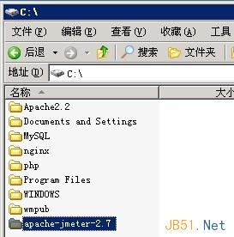](http://files.jb51.net/file_images/article/201412/201412271658056.jpg)  
设置jmeter环境变量:  
在用户变量中,新建变量名"JMETER_HOME",变量值为C:\apache-jmeter-2.7.  
[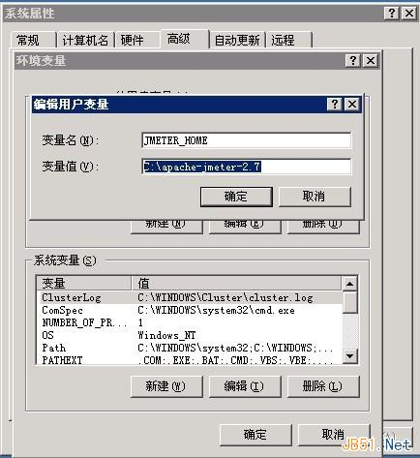](http://files.jb51.net/file_images/article/201412/201412271658067.jpg)  
修改"CLASSPATH",在后面添加;%JMETER_HOME%/lib/ext/ApacheJMeter_core.jar;%JMETER_HOME%/lib/jorphan.jar;%JMETER_HOME%/lib/logkit-2.0.jar  
[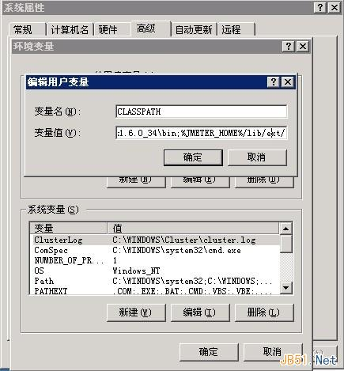](http://files.jb51.net/file_images/article/201412/201412271658068.jpg)

**4.在系统cmd命令提示符下输入java -version,如果可以到java版本信息,说明jdk安装成功.**

**5.运行jmeter,直接打开C:\apache-jmeter-2.7\bin\jmeter.bat就可以了.**

[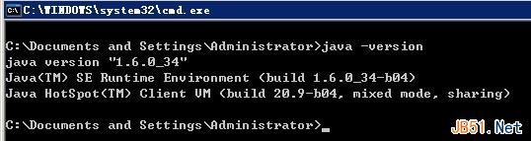](http://files.jb51.net/file_images/article/201412/201412271658079.jpg)