Yasin Küçükler

18290114

Computer Graphics Lab1 Report

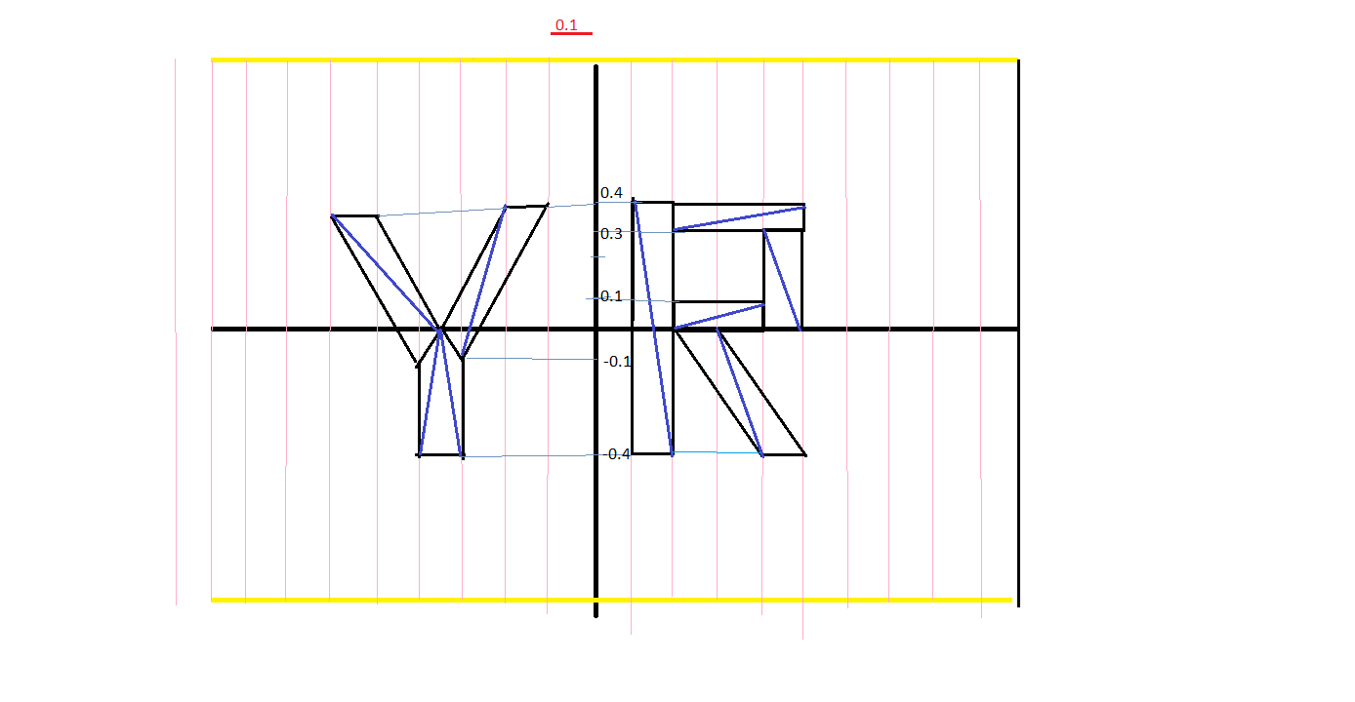

By using coordinate system I created this images. Also I created each letter by using triangles. You can see the figure shown upwards. There is 17 triangles. And with the multiplication 17 and 3, there is 51 points.

Background colour (r, g, b) and opacity values = (1.0, 0.1, 0.1, 0.9)

At the begining the (r, g, b) values of words = (0.0 , 0.0 , 0.0)

There is up limit and down limit for letters while changing its colour :

Up limit = 1.0

Down limit = 0.0

Keyboard inputs:

|  |  |  |
| --- | --- | --- |
| Colour change | Beginning | 0.0 |
| Shift + r | Increase | 0.1 |
| r | Decrease | 0.1 |
| Shift + g | Increase | 0.1 |
| g | Decrease | 0.1 |
| Shift + b | Increase | 0.1 |
| b | Decrease | 0.1 |
|  |  |  |

R, G, B = 0.0, 0.0, 0.0 🡺 Black

R, G , B = 1.0, 1.0, 1.0 🡺 White

R, G, B = 1.0, 0.0, 0.0 🡺 Red

R, G , B = 0.0, 1.0, 0.0 🡺 Green

R, G, B = 0.0, 0.0, 1.0 🡺 Blue

There is 1 direction changer button and 1 speed adjuster. You can use it with the help of your mouse.

Min speed = "0"

Max speed = "500"

Step = "10"

Value that changes at every step = "100"

🡺You can click somewhere at that adjuster to adjust the rotating speed,

🡺There is a button named “Change Direction Button” . By clicking that button you can change the rotation to clockwise rotation or counterclockwise rotation.

<!--html file-->

uniform vec3 myFragment; 🡺myFragment could includes 3 parameters.

void main() {

gl_FragColor = vec4( myFragment, 1.0 ); 🡺 like that we can get inputs from user

}

//js file

var r = 0.0; //declearing red , green , blue values as 0 to get black

var g = 0.0;

var b = 0.0;

var myFragment = vec3(r, g, b); //And our first colour datas that we were sent to html

//we were declared a

colorLoc = gl.getUniformLocation(program, "myFragment");

//with these codes we are limiting our colouring value between 0 and 1 also with the //increments and decrements we can display wide range of colours

if(button == 'r'){

if(r > 0.0){

r = r - 0.1;

console.log(r);

} }

if (button == 'R') {

if(r < 1.0){

r = r + 0.1;

} }

//inside of render function

theta += (isDirClockwise ? -0.1 : 0.1); //it changes the rotation way

myFragment = vec3(r,g,b); // renders the last r,g,b values

gl.uniform3fv(locationOfColor, myFragment); // sends our r, g, b values to html file

gl.drawArrays( gl.TRIANGLES, 0, 51 ); //draws the triangles that have 51 points