Operating Systems Project Report
Name: Kahathota Liyanage Yasindu Janiya Weerasinghe
Matriculation Number: 557466
Course: Operating Systems Part A

Deadlock Avoidance using Banker’s Algorithm

1. Introduction
In multiprogramming operating systems, multiple processes execute concurrently while sharing limited system resources such as memory, CPU cycles, and I/O devices. This concurrent execution introduces the critical risk of deadlocks—a state in which a set of processes becomes permanently blocked because each process is waiting for resources currently held by another process within the set.
To manage this, modern systems can utilize prevention, avoidance, or detection strategies. This project specifically focuses on dynamic Deadlock Avoidance through the implementation of Dijkstra’s classical Banker’s Algorithm. The primary objective of this project is to simulate the algorithm, validate its ability to distinguish between safe and unsafe system configurations, and conduct a rigorous computational evaluation of its performance metrics across scaling workloads.

2. Objectives
- Algorithmic Implementation: To implement a robust version of the Banker’s Algorithm for dynamic deadlock avoidance.
- State Verification: To accurately determine whether a given system state is safe or unsafe based on current resource allocations.
- Sequence Generation: To dynamically calculate and output a safe execution sequence when one exists.
- Computational Analysis: To evaluate the algorithm's scalability by measuring execution time, array comparisons, and iteration counts under varying process loads.
- Interactive Visualization: To provide a comprehensive, Flask-based User Interface that maps resource needs and visualizes performance metrics.

3. Theoretical Background

3.1 Deadlock
A deadlock is a structural condition where processes wait indefinitely for resources held by others, bringing system throughput to a halt. It requires four simultaneous conditions: Mutual Exclusion, Hold and Wait, No Preemption, and Circular Wait.

3.2 Safe State

The core principle of deadlock avoidance is maintaining the system in a Safe State. A state is considered mathematically safe if the operating system can allocate resources to each process (up to its maximum need) in some specific order, allowing all processes to eventually execute and terminate.

3.3 Banker’s Algorithm

The algorithm relies on four primary data structures (where n is the number of processes and m is the number of resource types):
- Available: A vector of length m indicating available resources.
- Max: An n times m matrix defining the maximum demand of each process.
- Allocation: An n times m matrix defining resources currently allocated.
- Need: An n x m matrix indicating remaining resource needs, calculated as:
Need[i,j] = Max[i,j] - Allocation[i,j]

4. System Design
The project was engineered using a modular architecture:
- Simulation Engine (Backend): Developed in Python to handle the matrix mathematics and core Banker's logic.
- Evaluation Module: Automates the generation of multiprogramming scenarios (scaling from 10 to 1000 processes) to track algorithmic metrics.
- Web Interface (Frontend): A Flask-based interactive dashboard that allows users to input custom matrices and visualizes results via Matplotlib.

User Interface
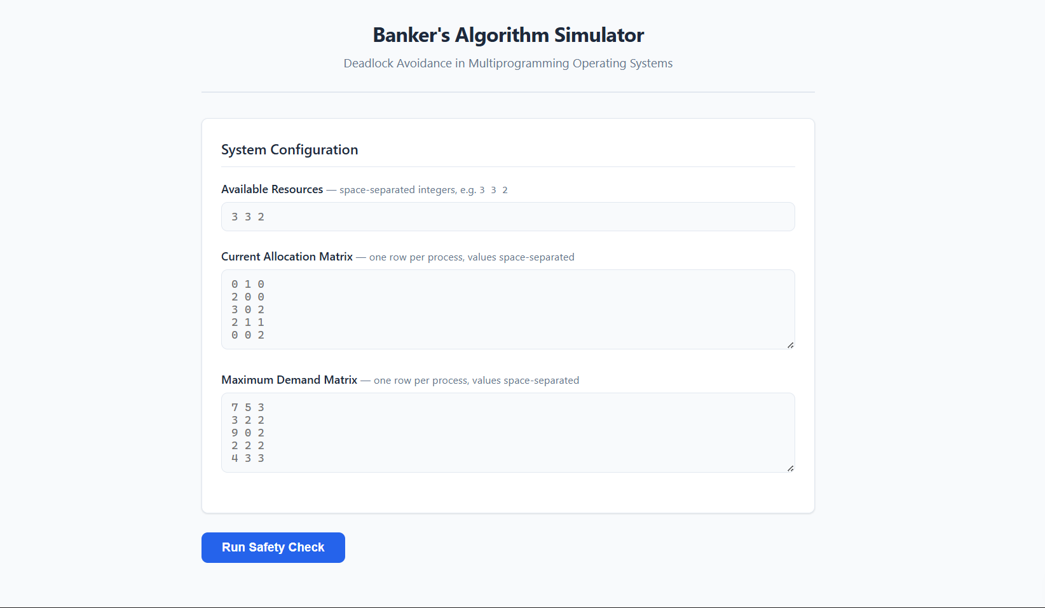

5. Case Studies and System Simulation
To validate the correctness of the core algorithm, the system was tested using custom, manually inputted matrices via the Flask interface.
Case Study A: Safe State Validation
In this scenario, the system was initialized with 5 concurrent processes (P_0 through P_4) and 3 distinct resource types (R_0, R_1, R_2).
- Available Resources: (3, 3, 2)
- Outcome: The algorithm successfully verified that granting the current allocations would not lead to a deadlock.
- Safe Sequence: The system generated the safe execution path: P_1 \rightarrow P_3 \rightarrow P_0 \rightarrow P_2 \rightarrow P_4.
- Metrics: Identifying this safe state required 18 matrix comparisons and 5 iterations, completing in just 0.122 ms.
This confirms that the system can avoid deadlock and complete all processes successfully.
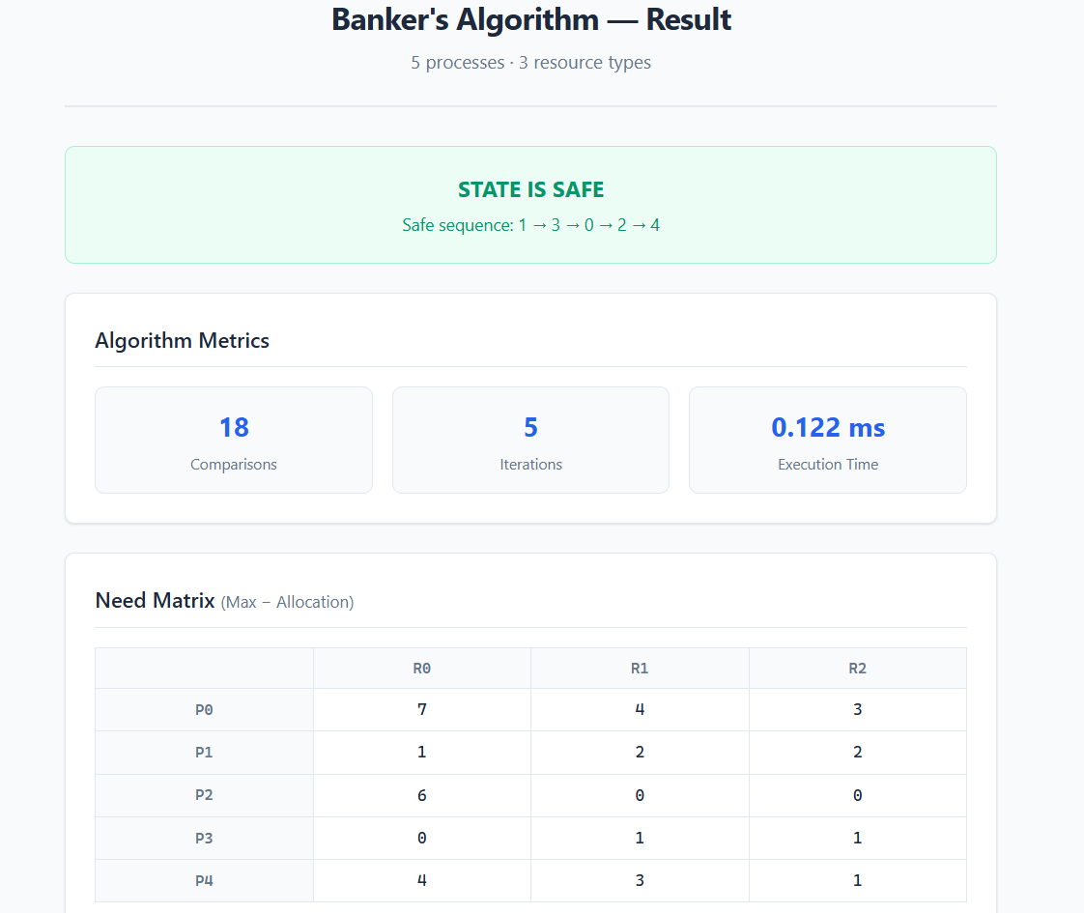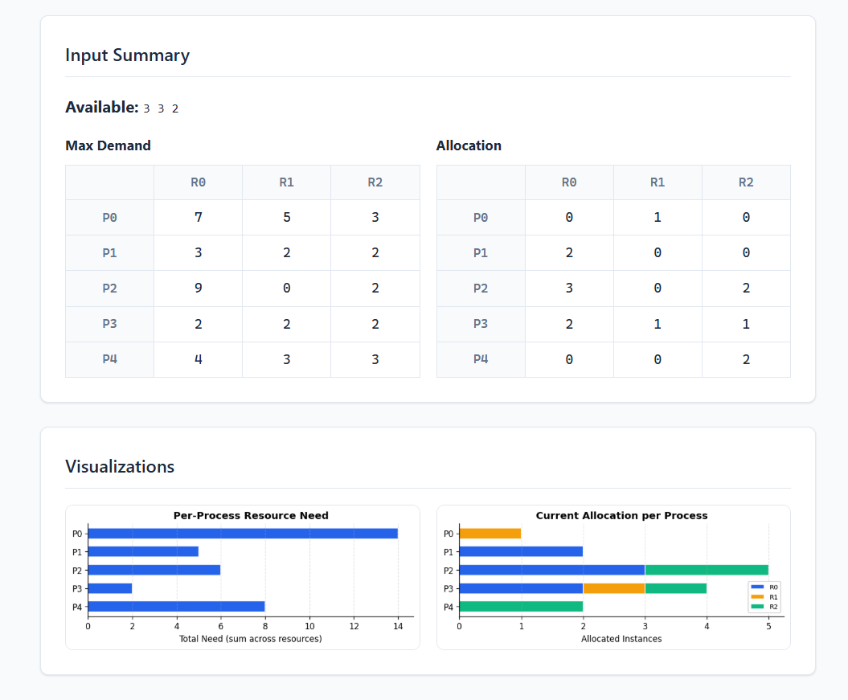
Case Study B: Unsafe State Detection (Deadlock Risk)
In a contrasting scenario, the system was tightly constrained with 3 processes (P_0 through P_2) and 3 resource types.
- Available Resources: Only (1, 0, 0) remained available.
- Outcome: The algorithm correctly identified an UNSAFE STATE. Because the available resources were insufficient to satisfy the minimum remaining needs of any single process to completion, a circular wait is inevitable.
- Metrics: The algorithm optimized its execution by failing fast. It terminated after only 7 comparisons and 1 iteration (0.008 ms), successfully preventing the OS from granting the allocation that would trigger the deadlock.
This confirms that the system is unsafe and may lead to deadlock if resources are allocated.
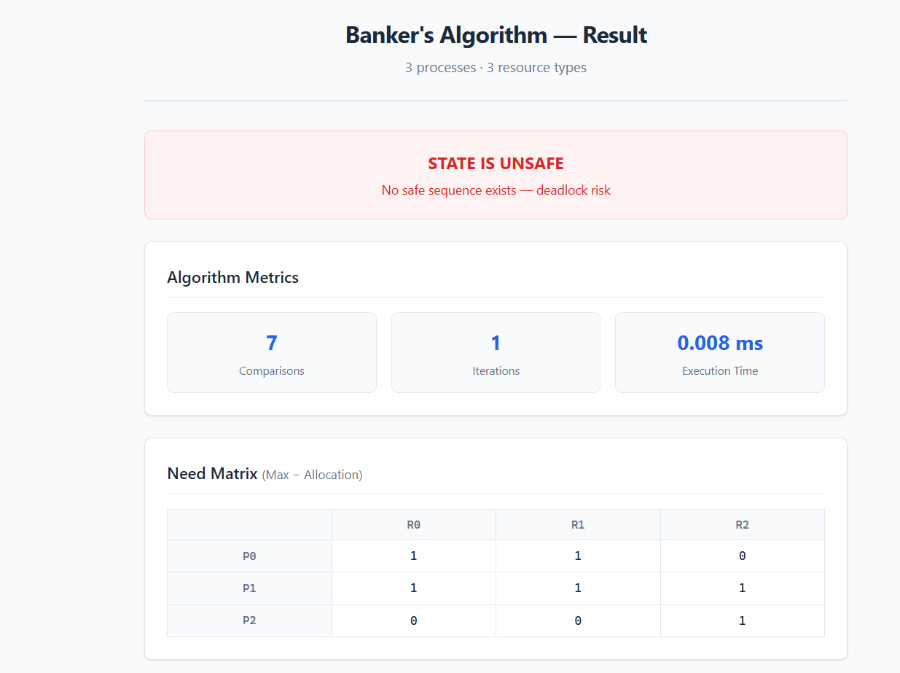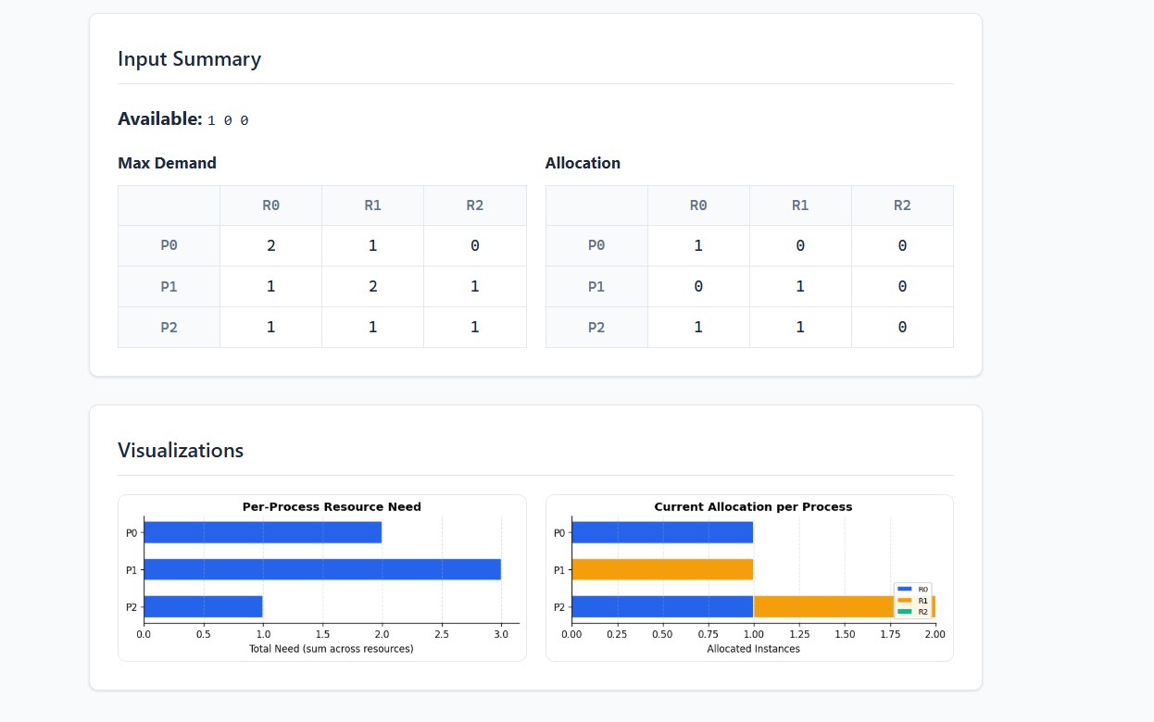

6. Experimental Evaluation and Scalability Analysis

Following the micro-level validation, a macro-level evaluation was conducted to analyze how the algorithm scales as the multiprogramming level increases.

6.1 Execution Time vs. Process Load

As shown in the evaluation data, execution time scales non-linearly. While handling 10 to 100 processes is virtually instantaneous, scaling up to 1000 processes results in a steep curve, hitting roughly 3.75 ms. This visualizes the O(n^2 \cdot m) time complexity of the Banker's Algorithm.
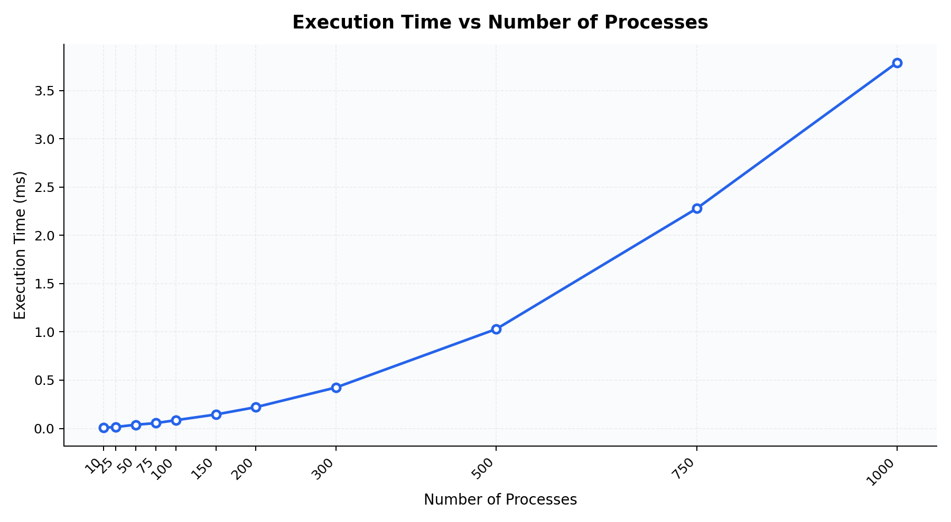

6.2 Computational Overhead (Comparisons and Iterations)

The algorithm's overhead is directly tied to the number of safety checks it must perform. The data demonstrates a strict linear increase in array comparisons (reaching 3000 comparisons for 1000 processes) and main-loop iterations (reaching 500 for 1000 processes).
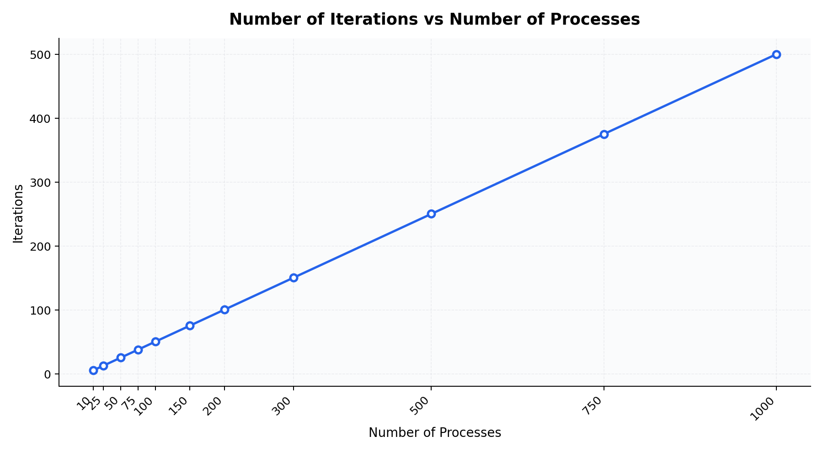

6.3 Safe vs. Unsafe Scenario Distribution

By generating randomized allocation matrices, the evaluation tracked the probability of entering an unsafe state. The data confirms that as resource contention increases (higher number of processes fighting for fixed resources), the percentage of Unsafe states dramatically overtakes Safe states, reaching a near 90-100% failure rate at extreme loads.

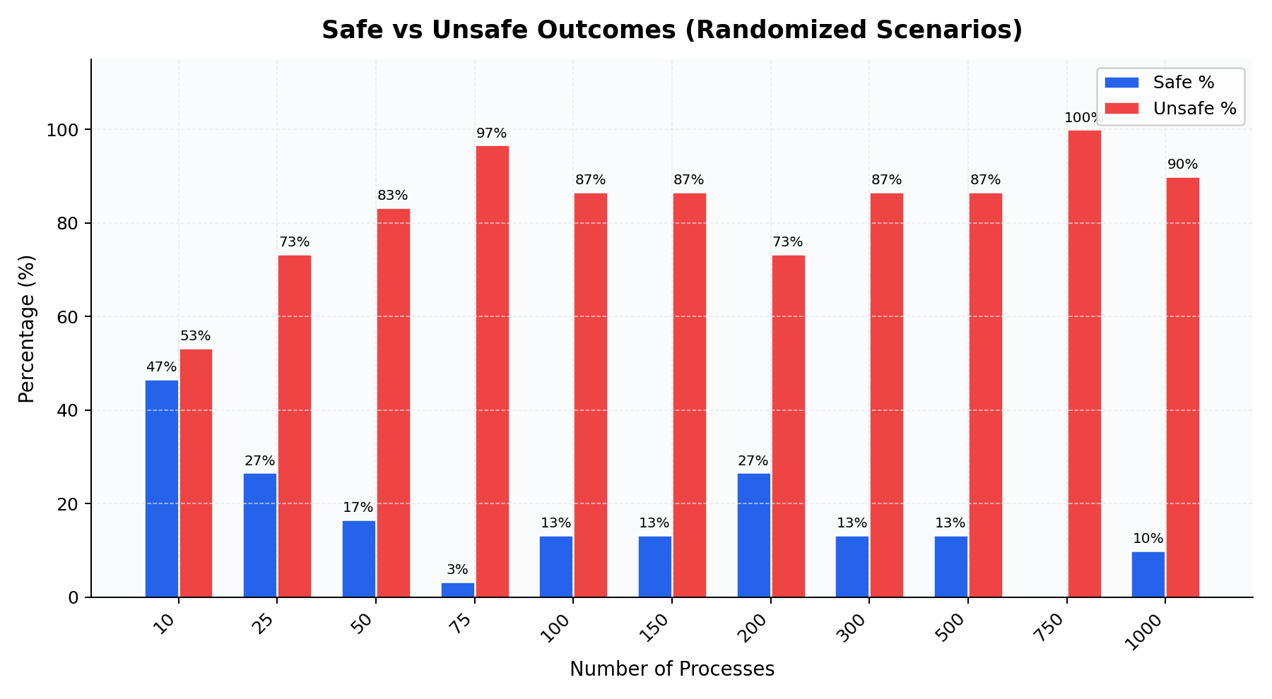

7. Discussion and Trade-offs

The empirical results highlight the primary trade-off of the Banker’s Algorithm:
Advantages: It is highly effective at ensuring absolute system safety without utilizing the draconian constraints of Deadlock Prevention.
Disadvantages: It requires a priori knowledge of maximum process demands (which is rarely possible in modern, dynamic operating systems). Furthermore, as proven by the scalability graphs, running an O(n 2 ⋅m) matrix check on every single resource request introduces unacceptable computational overhead in kernels dealing with thousands of active threads.

8. Conclusion

This project successfully modeled, simulated, and evaluated deadlock avoidance frameworks. The Flask implementation visually proved the algorithm's mathematical correctness in tracking Safe Sequences, while the Python evaluation engine empirically demonstrated its theoretical limitations regarding computational scalability in high-concurrency environments.

9. Future Improvements

Future iterations of this project could implement dynamic resource requests (simulating real-time thread behavior rather than static matrices), multi-threading for the evaluation engine, and a comparison module to benchmark Banker's Algorithm against Deadlock Detection algorithms (like Wait-For Graphs).

10. References
Operating Systems slides and standard textbooks.

