PrestaShop Attack Simulation Report & Defense Validation

Methodology
A locally deployed PrestaShop instance running in Docker was assessed using vulnerability scanning, manual validation, configuration review, security hardening, and post-remediation testing.

Tools Used
Nikto, Docker, Apache, curl, and a web browser.

Exploited Vector
Clickjacking risk due to missing X-Frame-Options header. Additional findings included missing X-Content-Type-Options, exposed INSTALL.txt, and robots.txt information disclosure.

Evidence

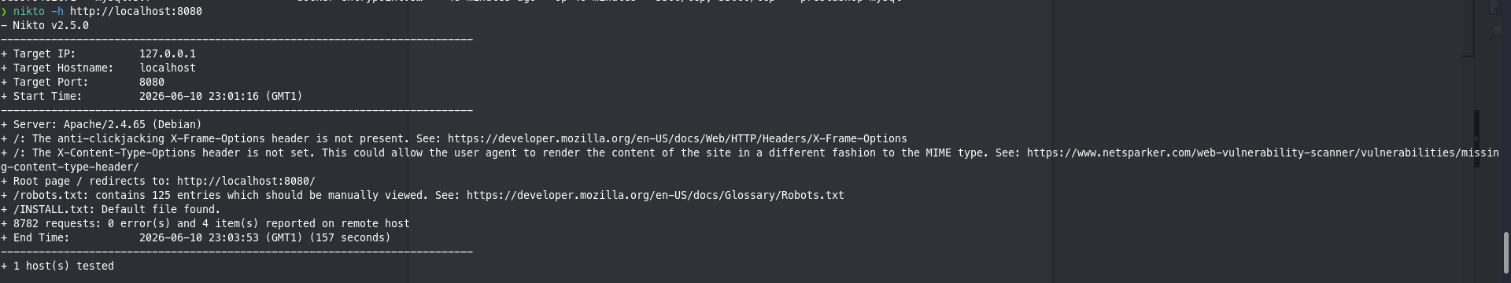
Nikto Scan report

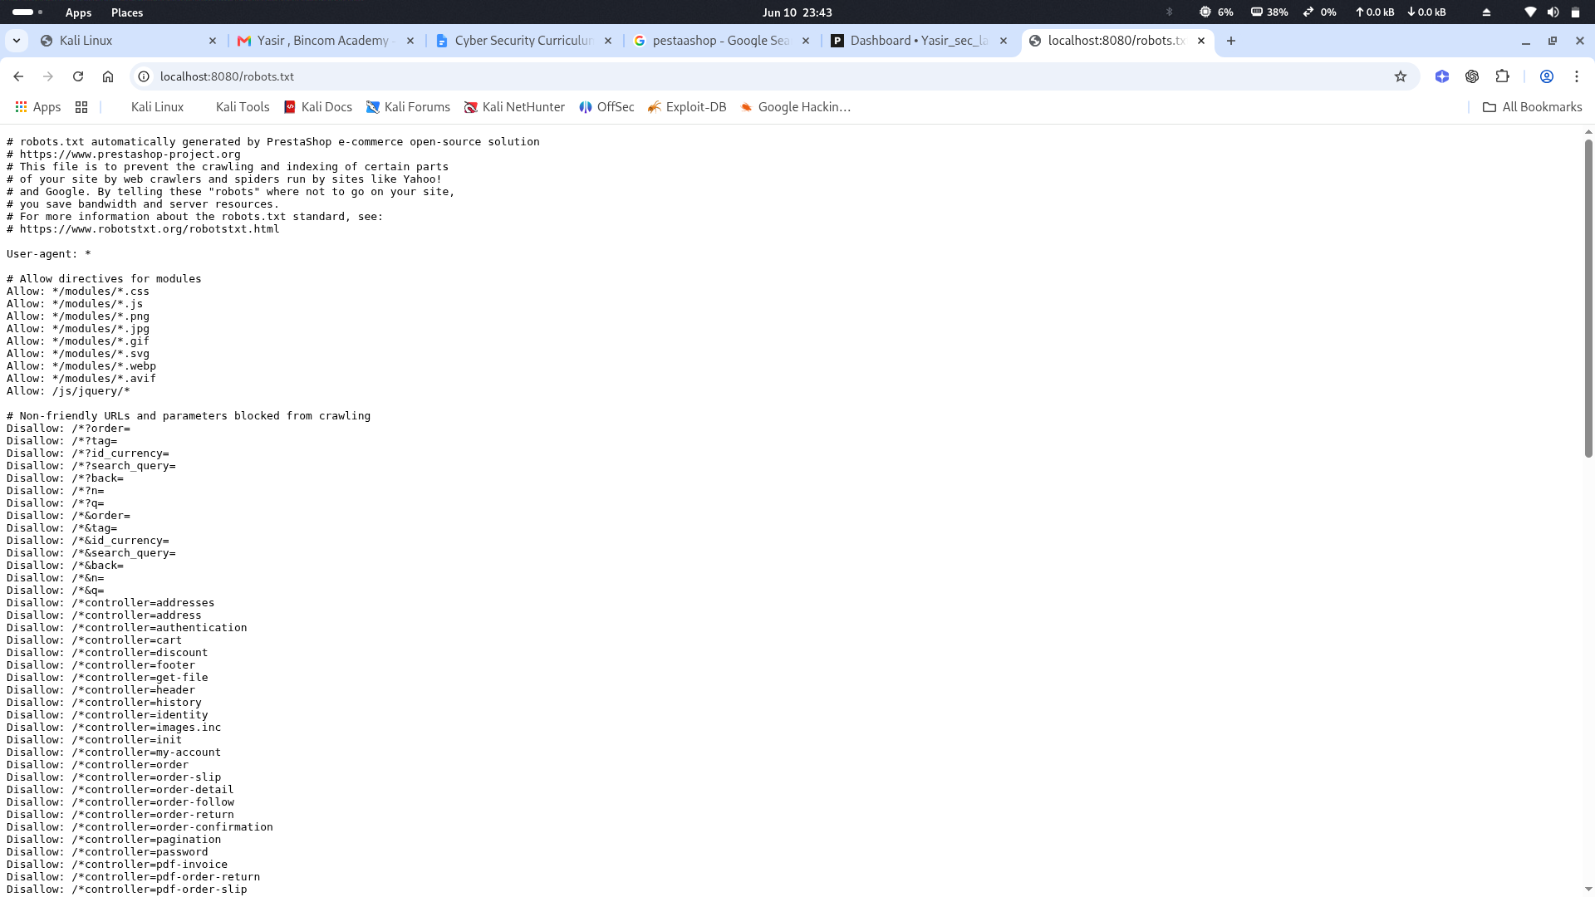
Robot.txt
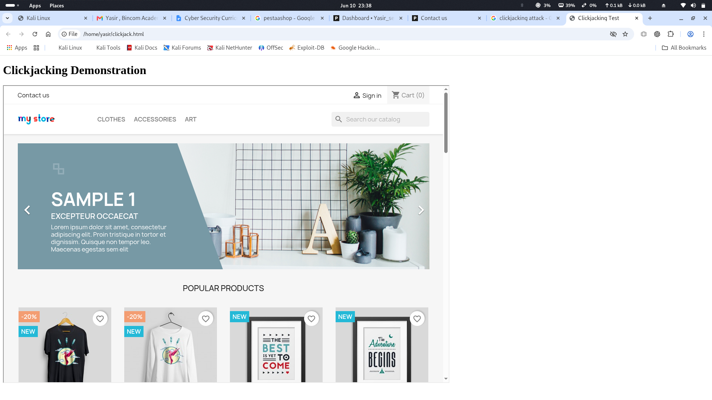
Clickjacking attack validation

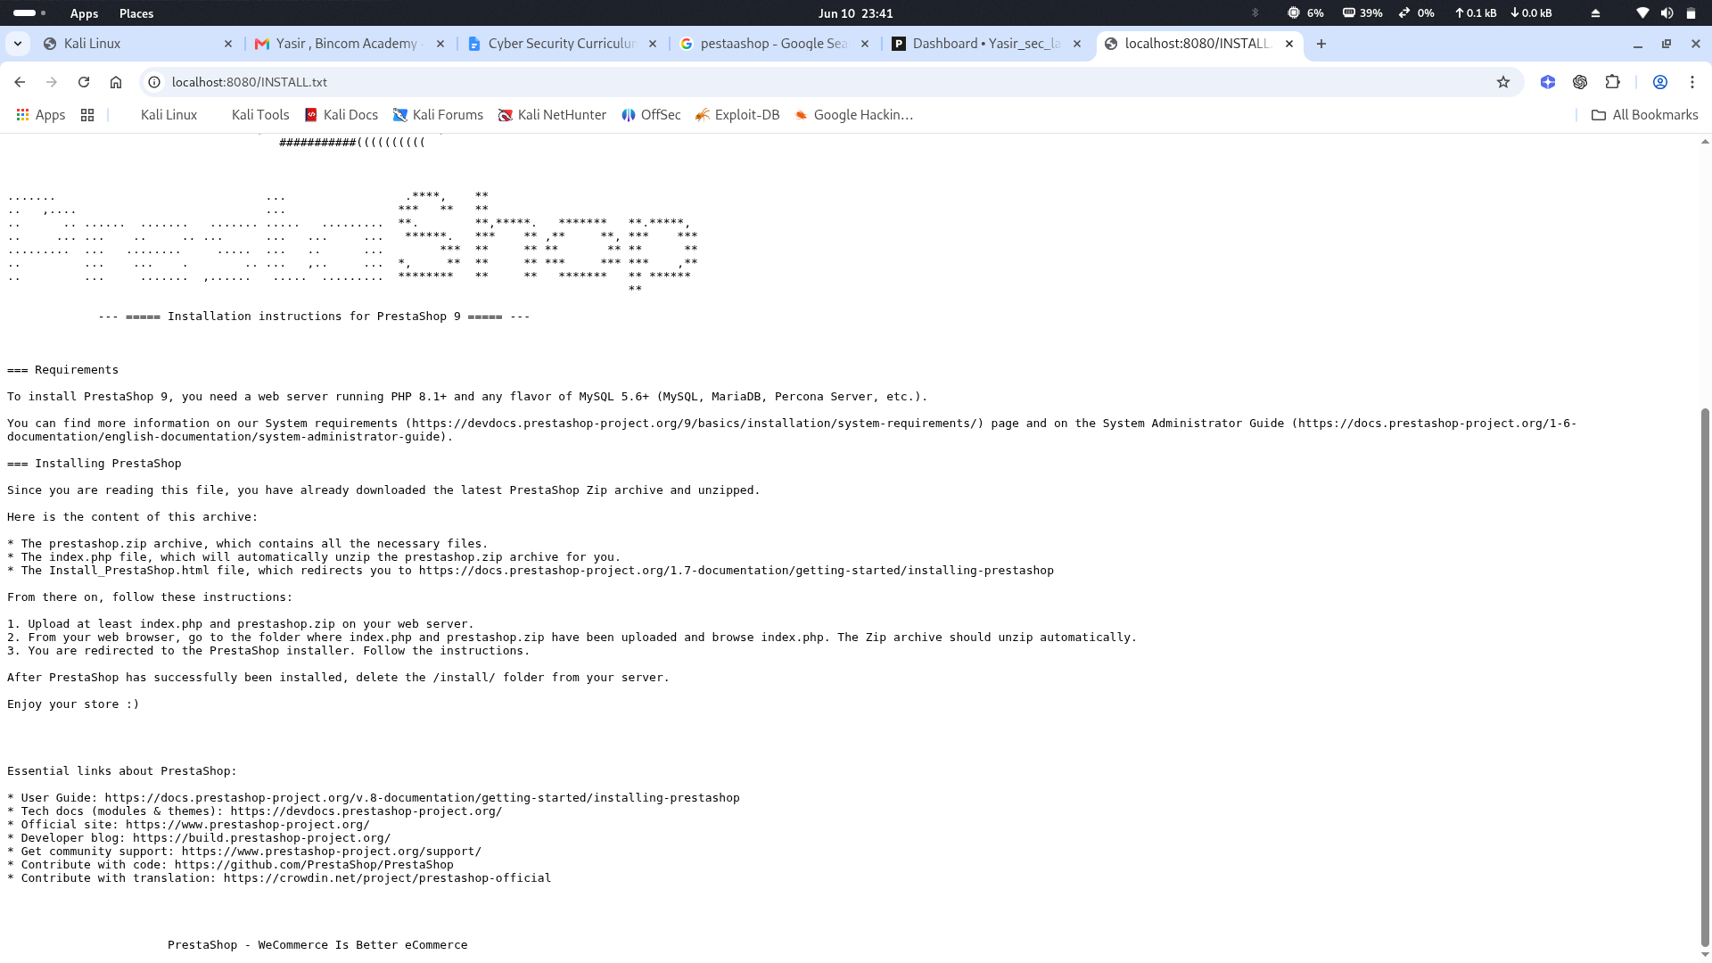
INSTALL.txt

Logs


Mitigation
Implemented Apache security headers and created a ModSecurity-compatible WAF rule file to protect against XSS, SQL Injection, and Directory Traversal.

Defense Validation
Validation was performed using curl -I http://localhost:8080. The response confirmed the presence of X-Frame-Options, X-Content-Type-Options, CSP, and Referrer-Policy headers.

Attack Success Screenshot


Attack Block Screenshot
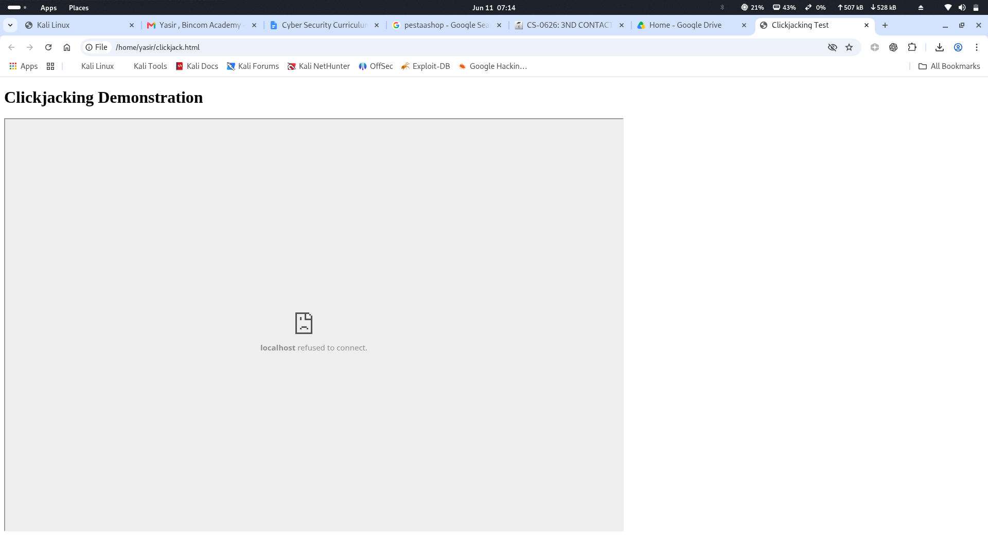

Conclusion
The identified weaknesses were successfully mitigated and validated through post-remediation testing.

