Day 5 Internship Report – Statistical Analysis (t-test)
Name: Yasir
Internship Role: Data Analyst Intern
Day: 5

Objective
The objective of Day 5 was to perform basic statistical analysis using Python, including descriptive statistics and an independent t-test to compare sales between two product categories.

Tools Used
- Python
- Jupyter Notebook
- Pandas
- SciPy
- SampleSuperstore.csv dataset

Tasks Performed
1. Loaded the SampleSuperstore dataset into Jupyter Notebook.
2. Calculated descriptive statistics using df.describe().
3. Created two groups of sales data: Technology and Furniture categories.
4. Performed an independent t-test using scipy.stats.ttest_ind.
5. Interpreted the t-statistic and p-value to understand statistical significance.

t-Test Result (Your Screenshot)
Below is the output obtained from the t-test comparing Technology vs Furniture sales:
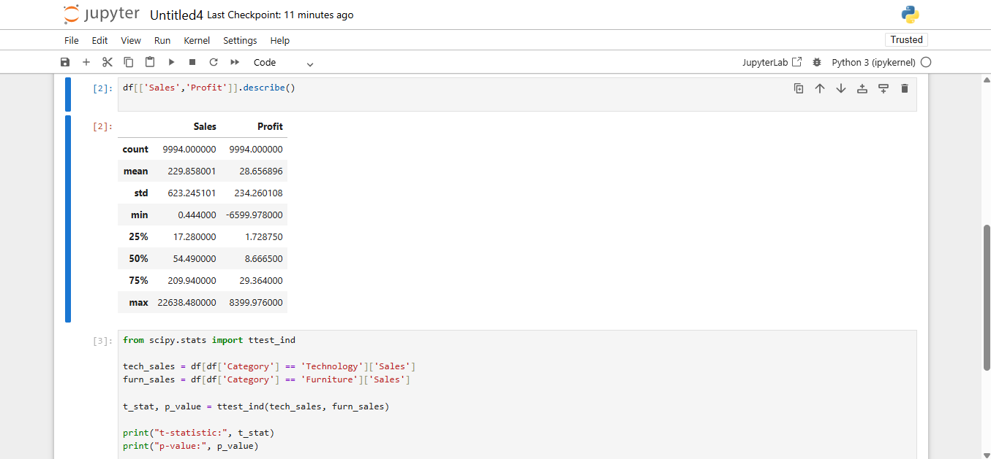

Interpretation of Results
The t-test compares the average sales of two independent categories. If the p-value is less than 0.05, the difference in sales is considered statistically significant. Otherwise, there is no strong evidence of a meaningful difference between the two categories.

Learning Outcome
I learned how to apply basic statistical techniques in Python, perform hypothesis testing, and interpret statistical results in a business context.

Conclusion
Day 5 objectives were successfully completed. The statistical analysis helped demonstrate how Python can be used for data-driven decision making.

