**CS 3321 (Software Engineering)  
Team Project Report  
Learning Management System (LMS)**

**Contents:**

* Project General information
* Software Project Management Plan (SPMP)
* Use case diagram
* UML Class Diagram

**There are five team members, collaborating in the project.**

* Gerardo Sanchez
* Nabil Parwez
* Jesse Rubio
* Tong Ha
* Yasir Hassan

**The Five core workflows of the Unified Process used in the project are:**

* Requirements workflow
* Analysis workflow
* Design workflow
* Implementation workflow
* Test workflow

**The requirement workflow:**

The team explored the client’s needs, by acquiring a basic understanding of the application domain, which stated in the assignment instructions.

The team decided that the client’s descriptions of the desired product were clear and reasonable. Therefore, after investigating potential constraints, such as deadline and reliability, the team decided to proceed with the project.

To build a business model, the team use UML to describe the client’s business processes.

Iteration of the requirement workflow was not planed, to obtain the target software product, because the initial requirements were fixed (not a moving target).

**Analysis Workflow:**

The team analyzed and refined the requirements to achieve the detailed understanding of the requirements essential for developing the software product correctly and easily maintained.

The team ensured the specifications were complete and correct as the basis for testing and maintenance.

In the analysis workflow, the team employed more precise language to ensures that the design and implementation workflows were correctly carried out.

At the conclusion of the analysis workflow, as the specification document (instructions) clearly reviewed, the team drew up a Software Project Management Plan, focusing on duration estimate which based on the IEEE Standard 1058 [1998]. (See SPMP below)

Also, the team finalized nonfunctional requirements such as the choice of programming language(s), where Java was established as the project programming language, using NetBeans IDE 8.2 edition.

At this stage, the team extracted Java Classes for the project for the object-oriented methodology.

**System Development Life Cycle:**

The waterfall model life cycle was used in the project because the project requirements were clearly documented and stated.

The waterfall model implemented enforced disciplined approach. The prerequisite of cycle was that documentation be provided at each phase and all the products of each phase were accurately checked by the team.

**What type of team model is used in the project?**

This project was built on the concept of Democratic Team Approach model. The work was based on egoless programming*…* The model encouraged team members to find faults in code and the idea that the modules would belong to the team as whole.

**Paste all UML diagrams you used in the project.**

(See pages below)

**Software Project Management Plan (SPMP):**

**Project summary:**

This project develops a learning management system (LMS) to help a university IT department manages activities and improves its services, and for the management to track student’s basic information.

**Constraints:**

Delivery date: May 3, 2020

**Project deliverables:**

The target software project.

**Evolution of the project management plan:**

The project progressed, in continual updating, as the development of the software and the team members proceeded with the implementation workflows.

**Reference materials:**

The original client’s specification documents (instructions) were the primary reference materials.

**Definitions and acronyms:**

The information in the final software is designed in such way that it can be understood the same way by everyone.

**Internal structure:**

The software development team was divided into two types of groups: a development group that worked on writing the code and a support group that provided support functions, such as configuration management, and test.

**Estimation plan:**

The team estimated the duration of the project for and an projected period of three months. For every two weeks, the project progressed, the team made checks and evaluation steps.

**Testing plan:**

All members of the team were assigned to test the project, during the last three weeks before the deadline of the project.

**Problem resolution plan:**

In addition to the administrator and student, a third type of accessing mode, a professor, was added to the system to enter the students’ grades.

**Use case diagram:**

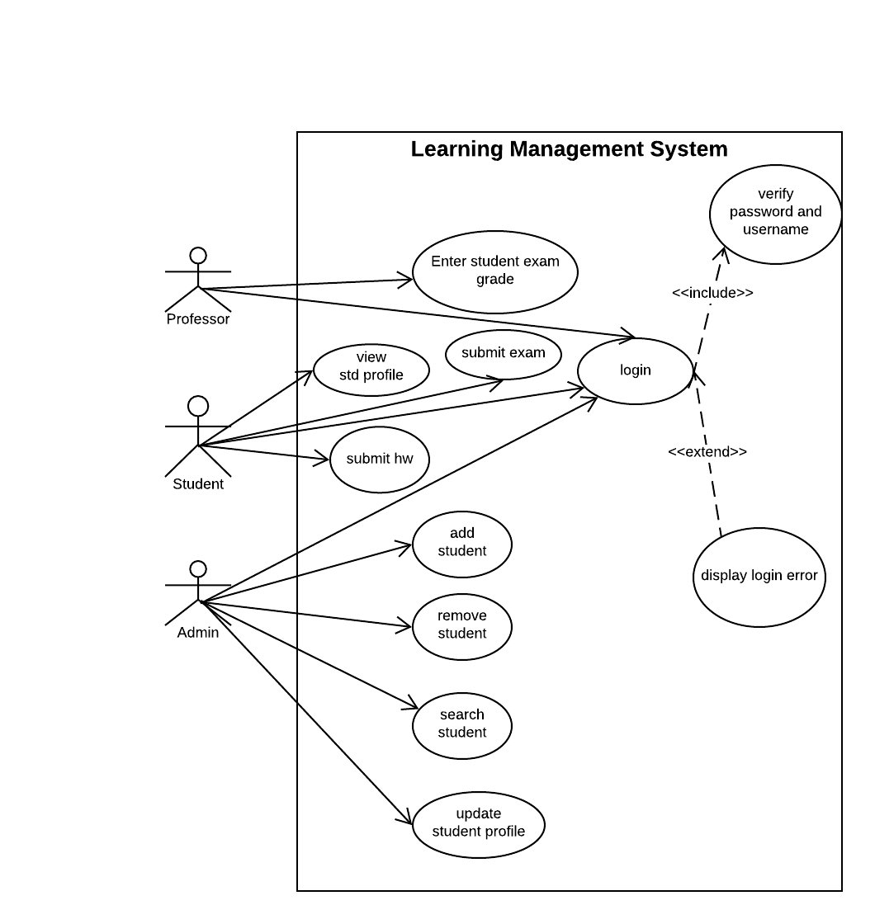

**UML Class Diagram:**

