CURICULUM VITAE

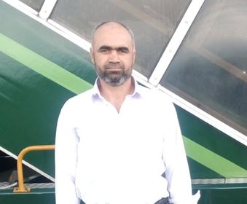

***cr***

**Muhammad Darwaish**

**Education**

**Objective**

FA, govt degree college thana kpk Malakand agency, Batkhela, kpk

March 1993 - March 1995

To become an integral part of an organization to serve with all my abilities basing on my qualifications and experiences

**Skills**

391-mail4.png

* DDR. Disarmament Demobilizations Resettlement of terrorism groups expert
* CIMIC civilians and military coordination expert.
* HIV AIDS peer education and awareness.
* Earthquake and tsunami duty and management experience
* Special awareness and experience over in security and guard.
* Qualified and expert first aid course qualified and evacuation in accidents or blasting and terrorism groups attack blasting evacuation first aid

talhajan456@gmail.com

+923456611285

067-phone.png

**Date of Birth**

08 April, 1977

**Permanent Address:**

District Dir lower village & post office Mayar khadagzai, Batkhela, KPK 23020



CURICULUM VITAE

**Muhammad Darwaish**

**Experience**

**Skills Continue….**

* Management, training. sports Rawalpindi,
* Un Mission (PAKISTAN Army)
* contingent training capsule. campaign lecturers
* Weapons ammo or any other explosive devices is criminal
* Flutes duty experience
* Camp layouts, security, management, administration, requirement, expert.
* Contingent training capsule. campaign lecturers
* Save the children department expert

**Personnel dossier**

**Name:** Muhammad Darwaish

**Father Name:** Muhammad Kamal

**CNIC:**  15307-8297392-7

**Marital status:** Single

**Nationality:** Pakistani

**Religion:** Islam

**Personality traits**

* Team Player and capable of managing group dynamics
* Ability to perform under any kind of pressure
* Highly adjustable in all sought of work environment
* Respect to all staff and department
* Respect of culture and habits of different kind in different countries
* Sexual harassment zero tolerance policy