**FEEDBACKS.IO**

**Introduction**

Feedbacks.io is an app for collecting Visual, Text and Video Feedbacks from Clients and customers.

This app will run as Software as a Service (SaaS) where agencies will be required to signup with the ability to add team members. And they’ll be billed monthly/annually.

**How it Works**

Feedbacks.io primary function is to collect feedbacks from customers which will be sent to the dashboard of the respective agencies and email will be sent to the team notifying them of each feedback collected.

The agencies will place a JavaScript code on the header of their page and this will place a FEEDBACK button on the selected position on the page and when this form is clicked, the users will select what type of Feedback they’d like to leave.

**FEEDBACKS**

1. **General Feedback**

This is a feedback form with Emoji/star rating with comment. The user will select an emoji/star based on their level of satisfaction of service, enter their email and then a comment in the comment form.

Users should be able to attach images to the feedback.

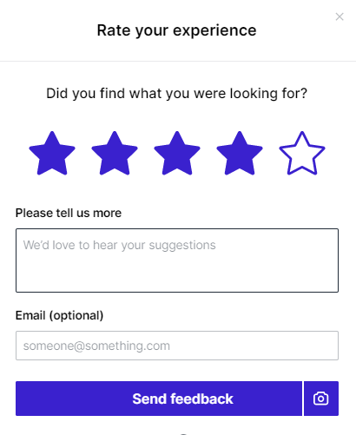

1. **Draw & Annotate on Screen**

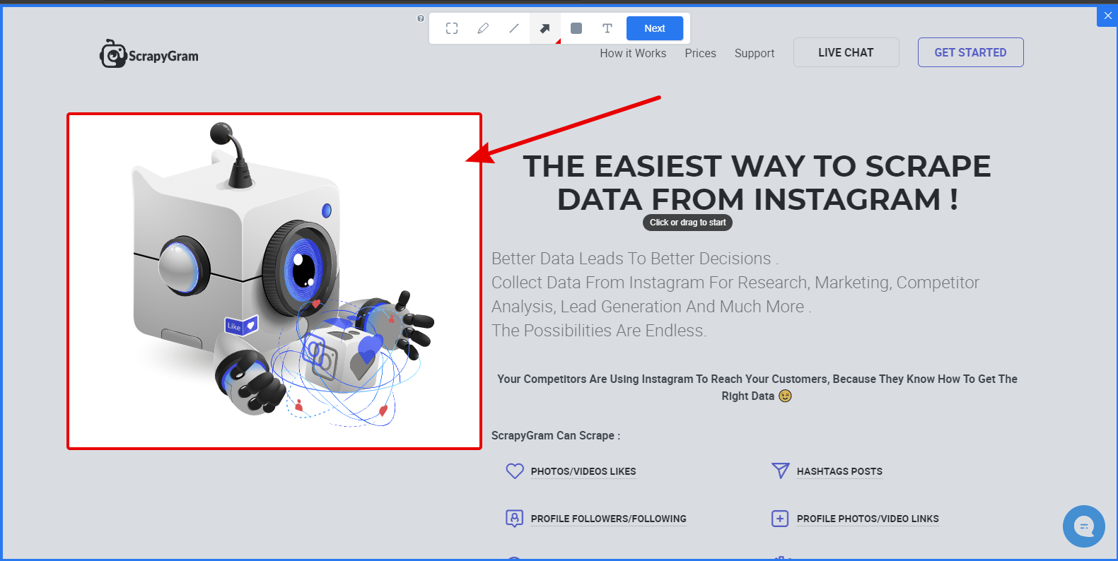

When this function is selected, the users will be able to draw and leave comments on the active screen. This includes multiple comments, annotations and shots on the same feedback. Which will be sent as a single feedback.

1. **Video Feedback**

This option gives the users options to take 2-3 minutes screencast with audio enabled so they can explain in detail what they’re trying to report. And this will be sent as a feedback.

**AGENCY DASHBOARD**

The agency dashboard consists of four primary menus;

> Feedbacks

> Projects

> Designs

> Team

**Feedbacks**

This is a central inbox where all feedbacks (for all projects) will be located.

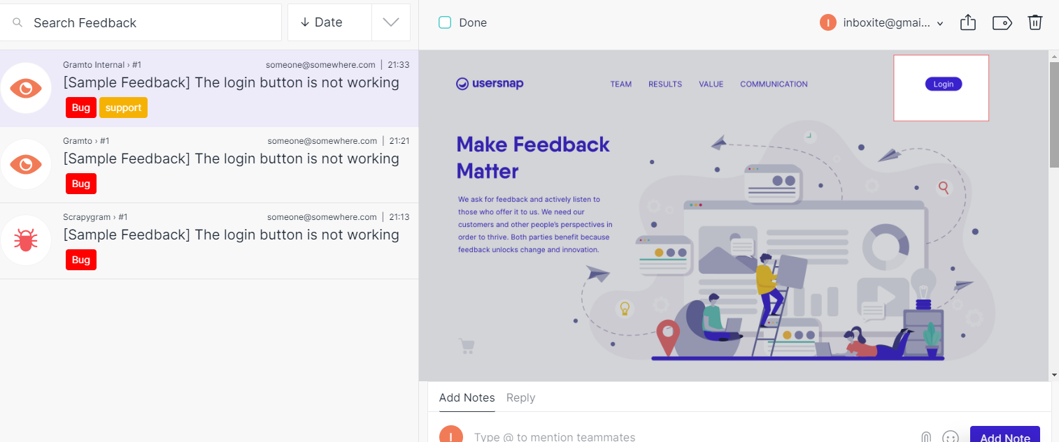

**Projects**

This is where projects will be created. Each project will have its own sub-menu which includes:

> *Feedbacks*: Feedbacks relating to the current project only.

> *Designs*: The Agency can upload custom files Images or grab screenshots from a webpage. The asset link can be sent to the client to add feedbacks which will be returned as a Feedback.

> *Statistics*: Stats about the number of feedbacks for the project.

> *Widget Settings*: Where the project widget and form will be customized.

> *Integration*: This is where a user select what third-party app to share the collected feedback. Example, Slack, Microsoft Team, Jira, Trello, TeamWork, Asana, Zapier, etc.

> *Widget Code:* This is where the user gets the project widget to paste to the header of their webpage.

**Designs**

This page is basically for graphic designers. A designer can upload their designed work and share the file link with their client. When the client open such link (<https://feedbacks.io/view/63553/file/exampledesign>), they’ll be able to annotate and drop comments which will automatically save to the design assets and the designer can get the client’s message easily.

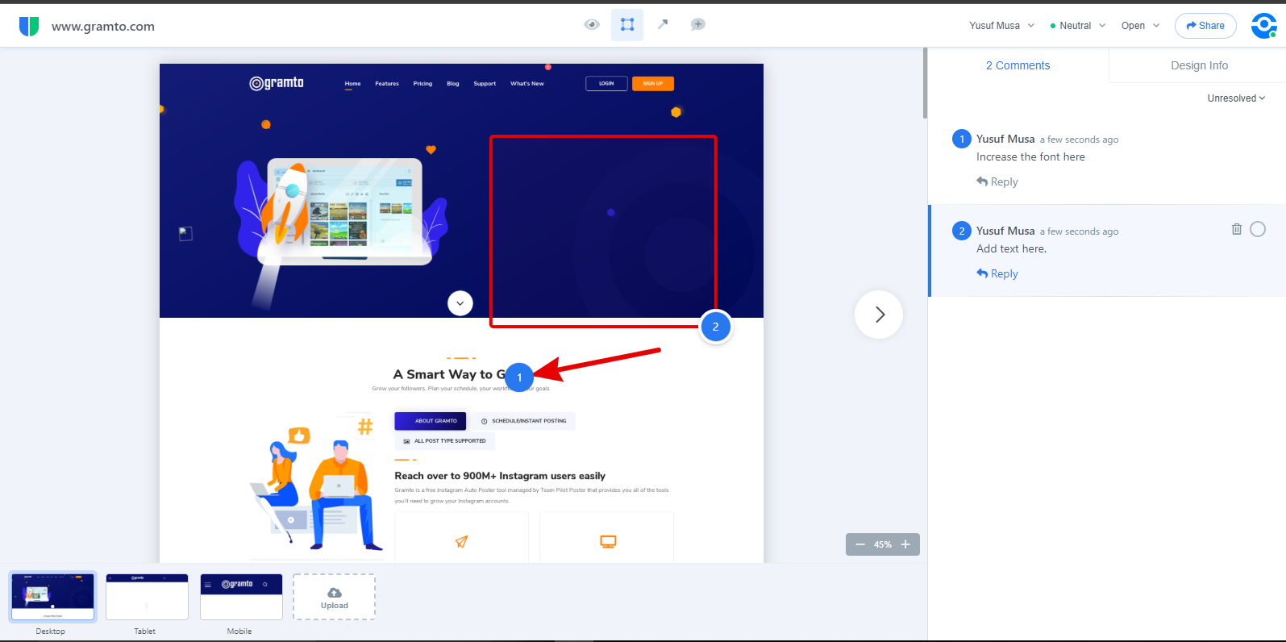

**Team**

This is where the agency owner can invite team members. The invited team member may be assigned to a project or given full privilege.

Team members should be able to tag one another using @username in feedback comments to call the notice of other members to the feedback.

**Account Settings**

A user should be able to manage their profile and change subscription plans.

**ADMIN DASHBOARD**

The admin should be able to manage;

> Users (Create, Edit, Manage subscriptions).

> Manage Plans (Features, Set Limits and Prices)

> Manage payment gateways and keys.

**PACKAGE LIMITS**

The system admin should able to create package plans with some set limits including;

* Number of Team Members
* Number of Projects
* Number of Feedbacks to Collect
* Ability to Enable/Disable Video Feedback
* Storage Limits for Uploaded Feedbacks and Designs

**PAYMENT GATEWAYS AND INTEGRATIONS**

The primary payment gateways would be **Stripe** and **Paypal**.

The system should integrate with related third-party services like Slack, Microsoft Teams, Trello, Jira, Asana, Zapier and a few others so that the users can easily push their collected data to these platforms for better team collaborations.

**CHROME EXTENSION**

The function of the chrome extension is to collect feedback from web pages without installing the widget on such site.

When a user installs the extension, they’ll be required to login to their account. And when they click on the extension icon, they’ll be able to take a feedback from their current chrome page and select what project to add such feedback.

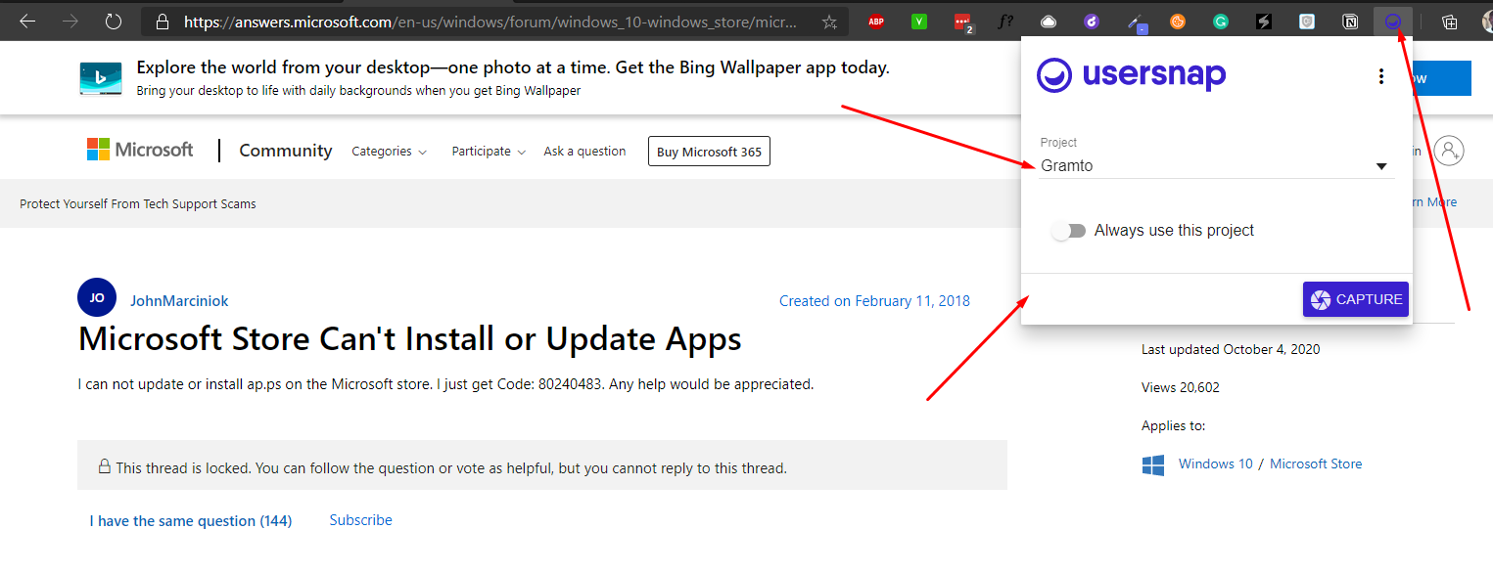  
  
Kindly see - <https://usersnap.com/s/browser-extension-welcome>

And this - <https://app.userback.io/extension/>

**RELATED SERVICES**

The idea of building this service came after using <https://usersnap.com> for a few months because of the ability to annotate screenshots and send as feedbacks. So, I thought that the service could be better with a video feedback after receiving video screencast from the users of one of my projects.

However, after researching the market, I discovered that there’s only one service that offers feedbacks, annotation and video and that is <https://userback.io>.

So, in terms of functionality, userback.io got all of what we wanted with feedbacks.io. However, with a very poor UI/UX.

Therefore, the aim is to build a service with a clean UI like usersnap.com and with functionality matching userback.io or even better.

I’ve got premium accounts at userback.io and usersnap.com so we can see all of their features and functionalities.