**Analysis**

Our further analysis reveals that between 2013 and 2017, 682 clients took out loans which summed up to $126,000,000, none of which were over the age of 65 as accessing loans becomes challenging at retirement. Within the age range of 31 and 65, fluctuations in the prevalence of taking out a loan was evident. The initial decline in trend can be seen from 2014 to 2015, coinciding with the crash of oil prices and the Russian annexation of Crimea, which both triggered economic impacts on the US. Despite the decrease in the number of loans taken out during this period, there was a slight increase in the amount of money being loaned, therefore, less clients taking loans but a higher amount being loaned.

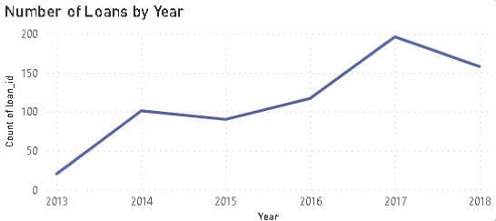

Fig. 1 - Graph showing the total number of loans taken out each year from 2013 - 2018

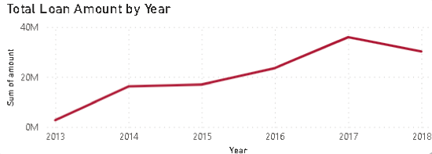

Fig. 2 - Graph showing the total amount (in $) loaned each year from 2013 - 2018

Upon further analysis of the 18 to 30 age group, the data shows a pattern with loans from 2013 to 2015 where it increases significantly, only to be followed by a minor decline the following year. This slight decrease is shown to be attributed to Trump being elected as the US president, as 24 million youth were present to vote, and the majority rejected Trump.

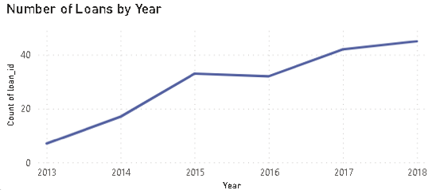

fig . 3 - Graph showing the total number of loans taken out each year from 2013 - 2018 from 18-30 age group

From 2015 onwards, there was a steady increase in loan uptake until 2018 (observed in Fig. 1), where President Trump triggered a Trade War. This resulted with the imposing of tariffs on imported washing machines and solar panels, then escalating to tariffs on imported steel and aluminium. Subsequently, Trump then imposed tariffs on $50 billion worth of Chinese imports, which then raised it to $250 billion. Ultimately, it became evident that Trump’s tariffs had a more detrimental effect on Americans rather than providing assistance. The stock market then sold off and the US trade deficit widened. Other countries soon imposed their own retaliatory tariffs on US exports, which lead to the US losing overseas markets and caused US manufacturers to cut jobs.

Between 2014 to 2015, as the amount of loans decreased, the amount being loaned also decreased. From the maps on loan analysis, the data demonstrates that the top five states with clients taking out the most loans and the amount being loaned is directly proportional to the top five states that have registered accounts across the US. The five states comprise of New York, Massachusetts, Connecticut, California, and Texas.

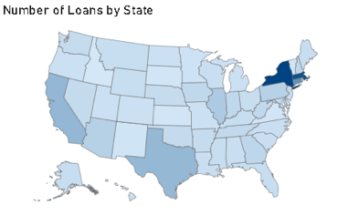

Fig. 4 - Map of the US showing the amount of loans taken out from 2013 to 2018. The darker the shade of blue, the more loans were taken

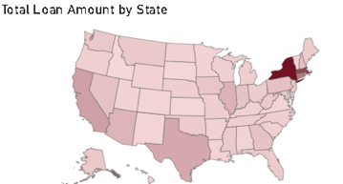

Fig. 5 - Map of the US showing the loans amount (in $) taken out from 2013 to 2018. The darker the shade of red, the more money was borrowed

Delving further into loans for the five states mentioned above, it can be observed (Fig. 6) that home loans (mortgages) contribute up to 78.74% of the total loans, far outweighing the other loans such as debt consolidation, home improvements and car loans. Across all age groups, home loans are the predominant type of loans. Mortgages make up for 79.6% for 18-30, 77.9% for 31-45 and 79.9% for 46-65.

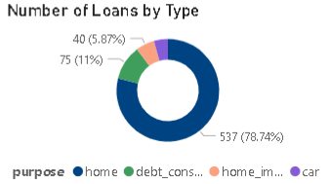

Fig. 6 - Chart showing the type of loans by percentage

Trends in saving behaviour is also captured from clients taking out loans; there is a high rate of savings from those who borrow between $101,000 and $500,000, which amounts to a general amount taken out for a mortgage.

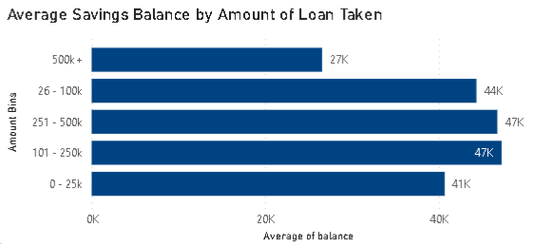

Fig. 7 - Graph showing the average savings balance per loan group amount

When purchasing a home, a minimum deposit of 10% is required, along with additional costs for unexpected expenses such as Homeowners Association or maintenance. The data demonstrates that with the amount of loan taken accounts for 74.9% share of the total amount borrowed.

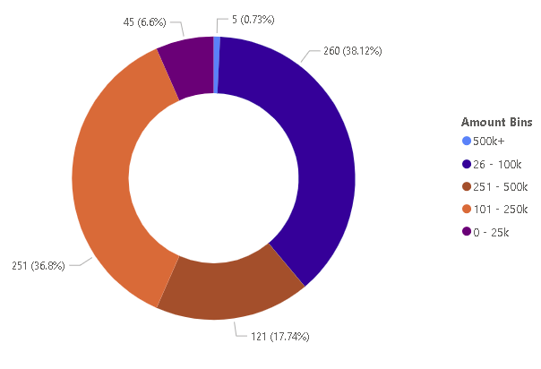

fig . 8 - Chart showing the amount taken out as loans for different amount groups for home loans

By looking further into the overall results from our previously defined five states, similar trends are observed with all. When considering average property prices throughout the years for those states, there is a correlation between the average property price and how much can be borrowed based on savings.

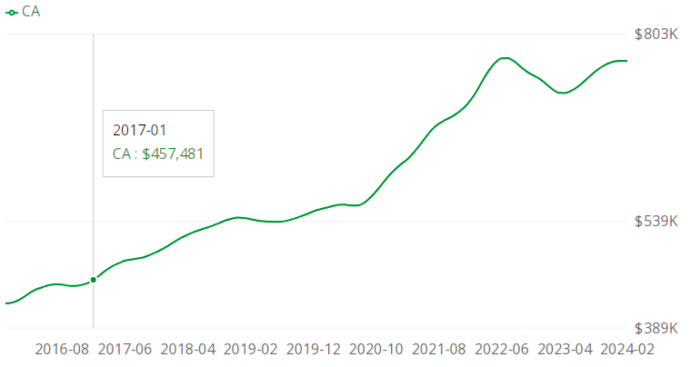

Fig. 9 - Graph showing the average home prices in the state of california in 2017

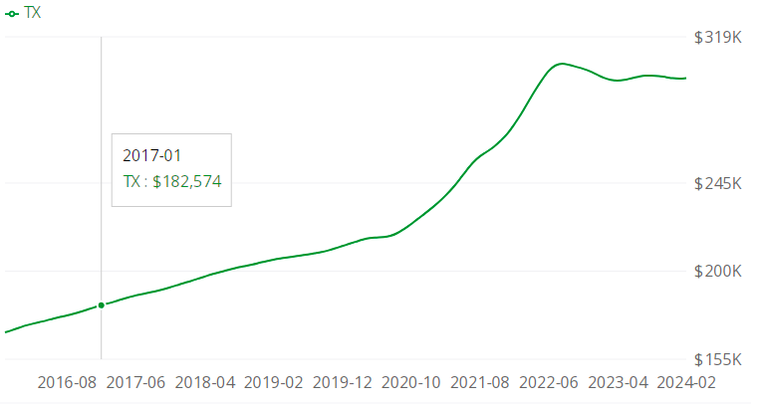

Fig. 10 - Graph showing the average home prices in the state of texas in 2017

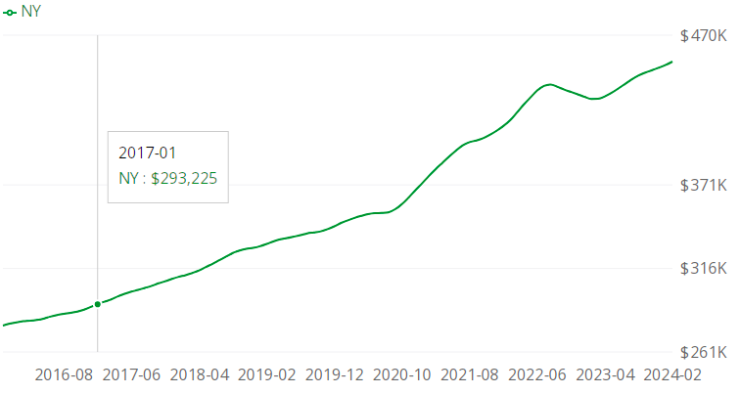

Fig. 11 - Graph showing the average home prices in the state of new york in 2017

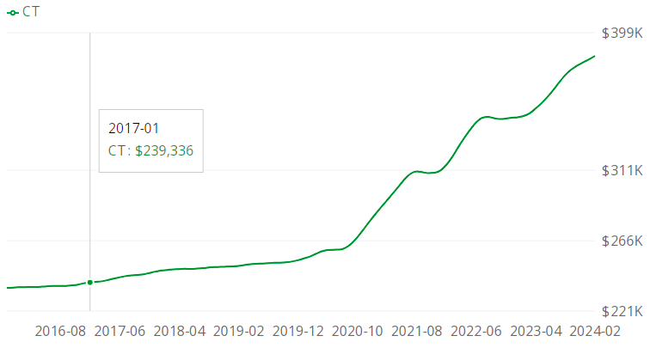

Fig. 12 - Graph showing the average home prices in the state of connecticut in 2017

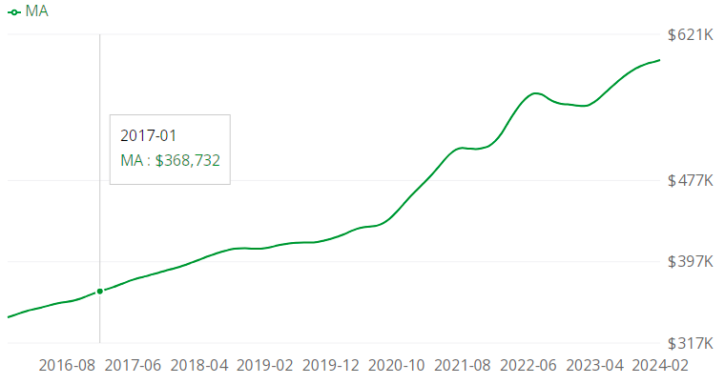

Fig. 13 - Graph showing the average home prices in the state of massachusetts in 2017

To explore further, the states can be analysed focusing on their cities, where the bigger economic states such as Texas, New York, and California account for the most loans for their largest cities. Whereas in the smaller states of Connecticut and Massachusetts, the distribution of loans shows less of a disparity for different cities as these states are normally for families looking to settle down. We can observe that the average age of someone who is taking out a mortgage is 41, with a savings balance of $46,120 on average.

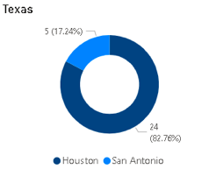

fig . 14 - Chart showing the popularity of buying homes in Houston

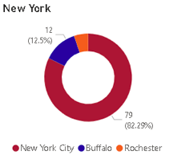

Fig. 15 - Chart showing the popularity of buying homes in New York City

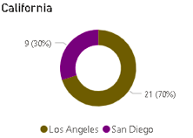

Fig 16 - Chart showing the popularity of buying homes in Los Angeles

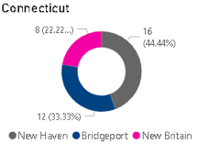

Fig. 17 - Chart showing that the popularity of buying homes in Connecticut is more spread out

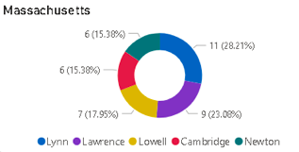

Fig. 18 - Chart showing that that popularity in buying homes in Massachusetts is also more spread out