**Czechoslovakia Banking Financial Data Analysis**

# Introduction

The Czechoslovakia Bank has provided a dataset containing information about its financial activities for the past 5 years. The dataset consists of the following tables:

1. **Account**: This table contains information about the accounts held by the bank's clients. It includes the account ID, the date the account was opened, the associated client ID, and the account type.
2. **Card**: This table contains information about the card issued by the bank. It includes the card ID, the date the card was issued, and the card type.
3. **Client**: This table contains information about the bank's clients. It includes the client ID, the client's birthdate, gender, and the district where the client lives.
4. **Disposition**: This table contains information about the relationship between clients and their accounts. It includes the disposition ID, the client ID associated with the disposition, and the type of disposition (e.g., owner, authorized person, etc.).
5. **District**: This table contains information about the various districts in Czechoslovakia. It includes the district ID, the name of the district, and various demographic and economic indicators for the district.
6. **Loan**: This table contains information about the loans issued by the bank. It includes the loan ID, the date the loan was issued, the account ID associated with the loan, the amount of the loan.
7. **Order**: This table contains information about the orders issued by the bank's clients. It includes the order ID, the account ID associated with the order, the date the order was issued, and a description of the order.
8. **Transaction**: This table contains information about the transactions made by the bank's clients. It includes the transaction ID, the account ID associated with the transaction, the transaction date, the type of transaction, and the transaction amount.

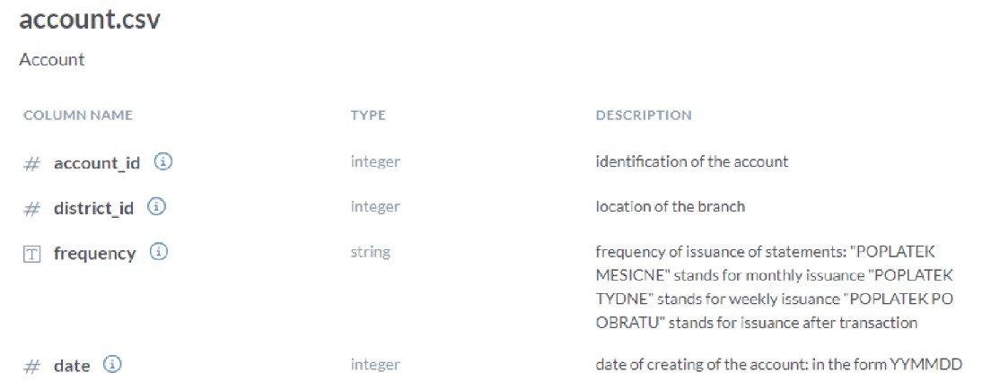

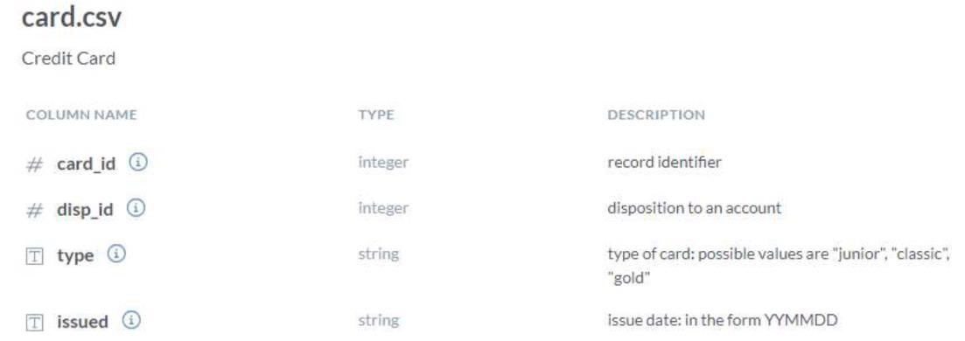

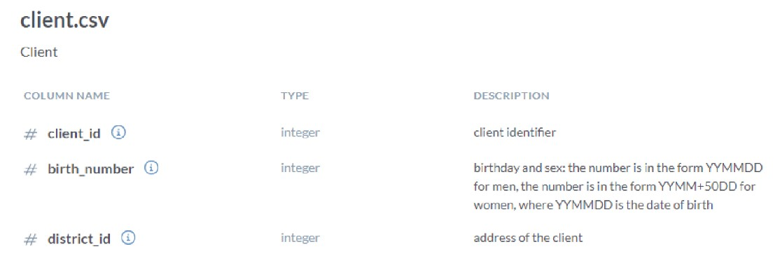

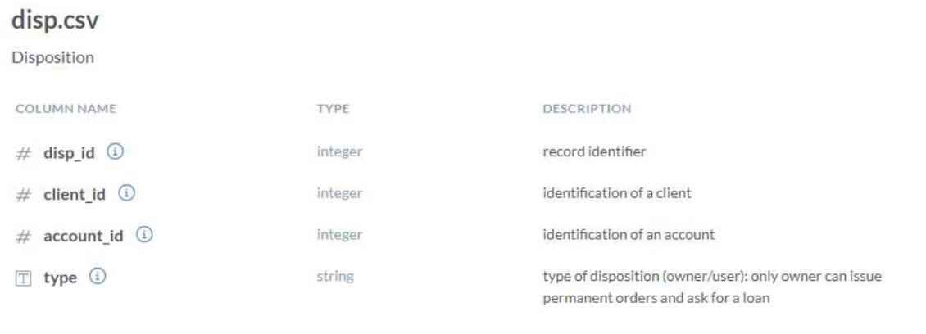

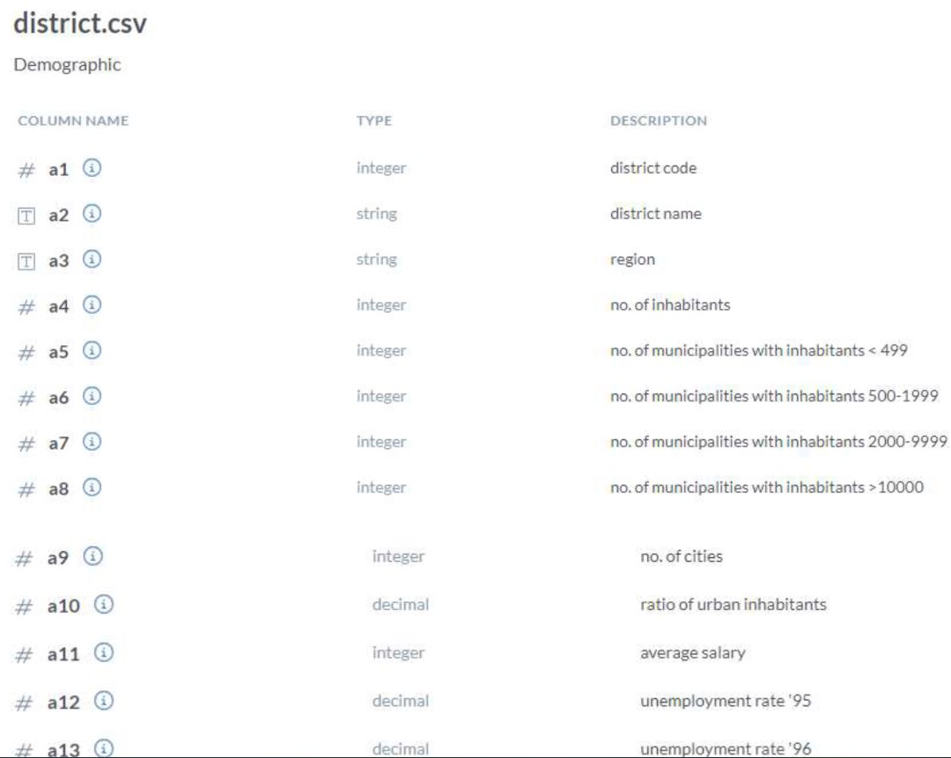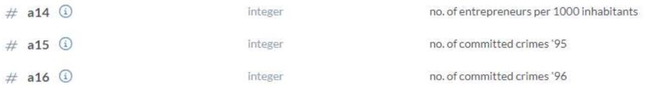

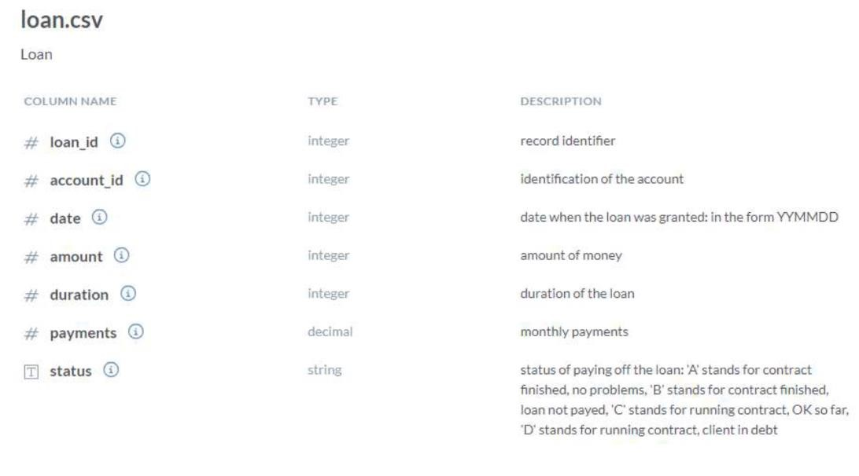

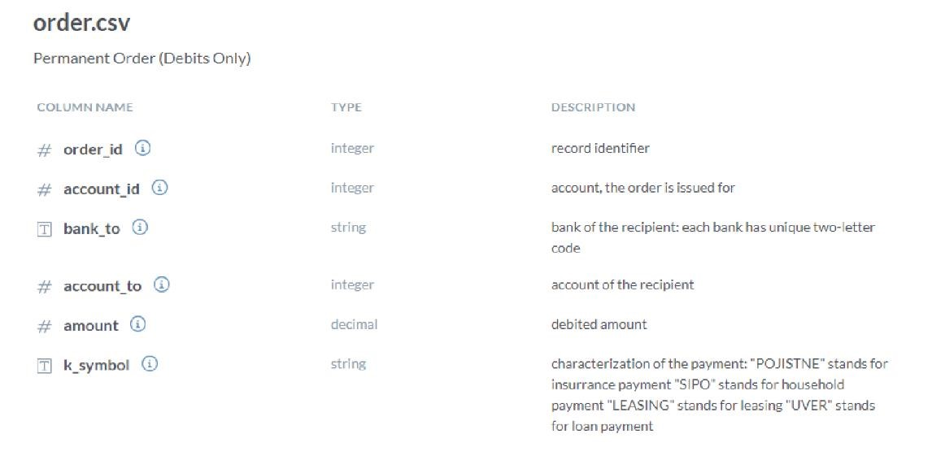

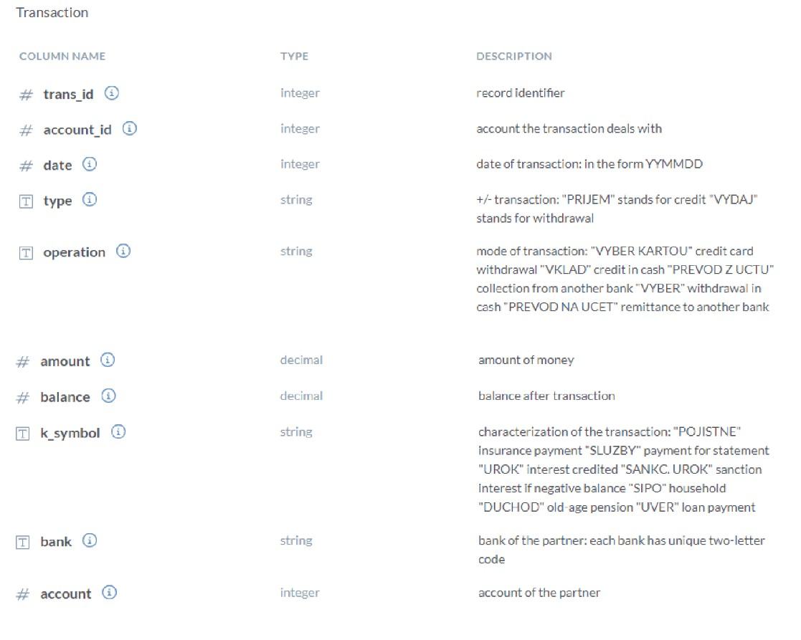

# Ad-hoc Data Analysis

The Czechoslovakia Bank wants to analyse its financial data to gain insights and make informed decisions. The bank needs to identify trends, patterns, and potential risks in its financial operations. They also want to explore the possibility of introducing new financial products or services based on their analysis.

The bank has identified the following questions as important for their analysis:

1. What is the demographic profile of the bank's clients and how does it vary across districts?
2. How the banks have performed over the years. Give their detailed analysis year & month-wise.
3. What are the most common types of accounts and how do they differ in terms of usage and profitability?
4. Which types of cards are most frequently used by the bank's clients and what is the overall profitability of the credit card business?
5. What are the major expenses of the bank and how can they be reduced to improve profitability?
6. What is the bank’s loan portfolio and how does it vary across different purposes and client segments?
7. How can the bank improve its customer service and satisfaction levels?
8. Can the bank introduce new financial products or services to attract more customers and increase profitability?

The objective of this analysis is to provide the Czechoslovakia Bank with actionable insights that can help them make informed decisions about their financial operations. The analysis will involve data cleaning, exploratory data analysis, and predictive modelling to identify patterns and trends in the data.

**Source:** Data world

https://data.world/lpetrocelli/czech-financial-dataset-real-anonymized-transactions