CSE462 – Applied Augmented Reality and 3D User Interfaces

Term Project – Report

Yasir Nacak – 161044042

Desker – The Desk Design Application

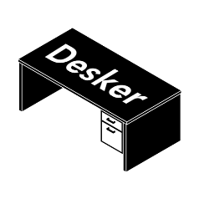

1. **What’s Desker?**

Desker is a mobile application that helps its users design desk layouts using their phone camera. It utilizes Augmented Reality so the users can use any existing desk to create designs. Desker provides a catalog of objects to choose from. The users can add any item in that catalog to a desk, arrange them in any way they want, add as many objects as they want, remove items they are not satisfied with and finally come up with a layout they are satisfied with. Users can share the current design from the application via a chat application to anybody they want. This enables users to receive feedbacks from other people.

1. **How to Use Desker?**

Desker is currently available open source in [www.github.com/YasirNacak/Desker](http://www.github.com/YasirNacak/Desker). It is also pending review on Google Play Store. After obtaining the application, users need to have a printed copy of the image target provided in the GitHub link. When the user puts the prints to a surface (desk in this case), they can then use the “Objects” menu in the top right corner.

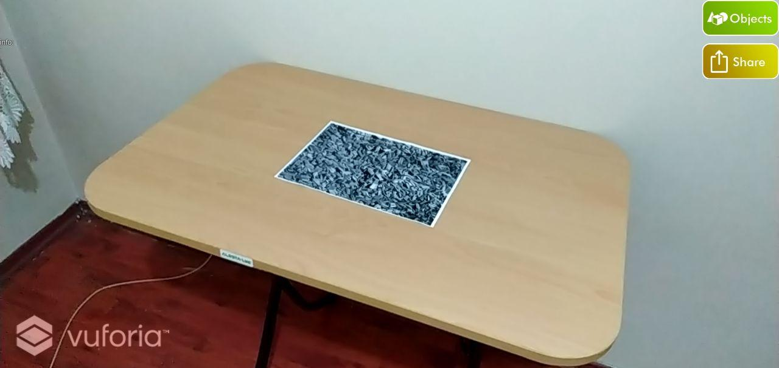

Figure 2.1 – Screen comes up when the Desker first started. “Objects” menu is in the top right corner.

From the objects catalog, the user can select an object they want. This selection brings the object into the camera view, meaning that it is part of the desk. After that, the user can touch the newly created object, if the selection is successful, the object gets highlighted and the object modification menu comes up.

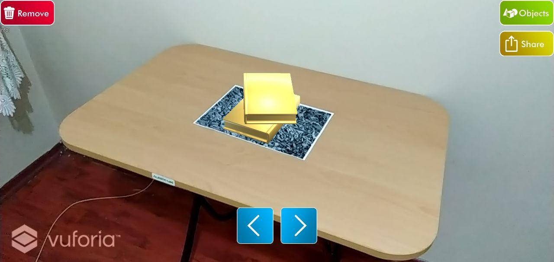

Figure 2.2 – Touching an object gets it highlighted so the user knows that they can modify it.

Buttons on to bottom of the screen makes the user move the object to the left and right from the position they are looking at. The button on the top left corner makes the user remove the selected object from the desk. At this stage, the user can arrange the current item, or add more items to arrange later. The move part is not restricted to just the time the object gets added, so the user can modify their layouts whenever they want. The object catalog currently has items that are commonly used at desks like laptops, desktops, coffee mugs, books, notebooks, small decorations like figures and toys, and plants.

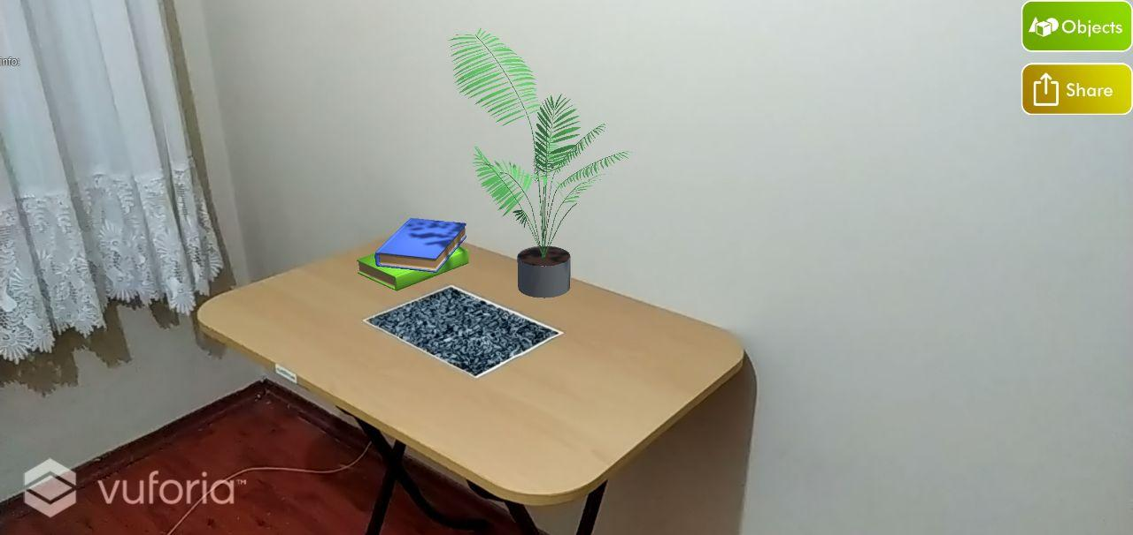

Figure 2.3 – A simple finished layot.

Another feature Desker provides is the ability to share the designs. This feature is also available at a button click that lies at the top left of the screen. Pressing the “Share” button redirects the user to most of the commonly used chat applications and with a single click, they share a screenshot of the design with anybody they want.

1. **What has been done in Desker? (Example Designs)**

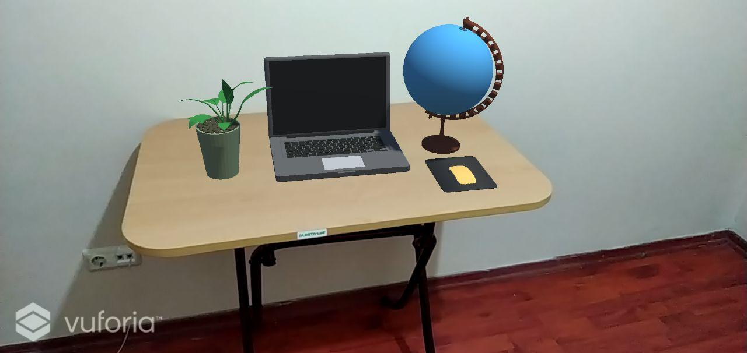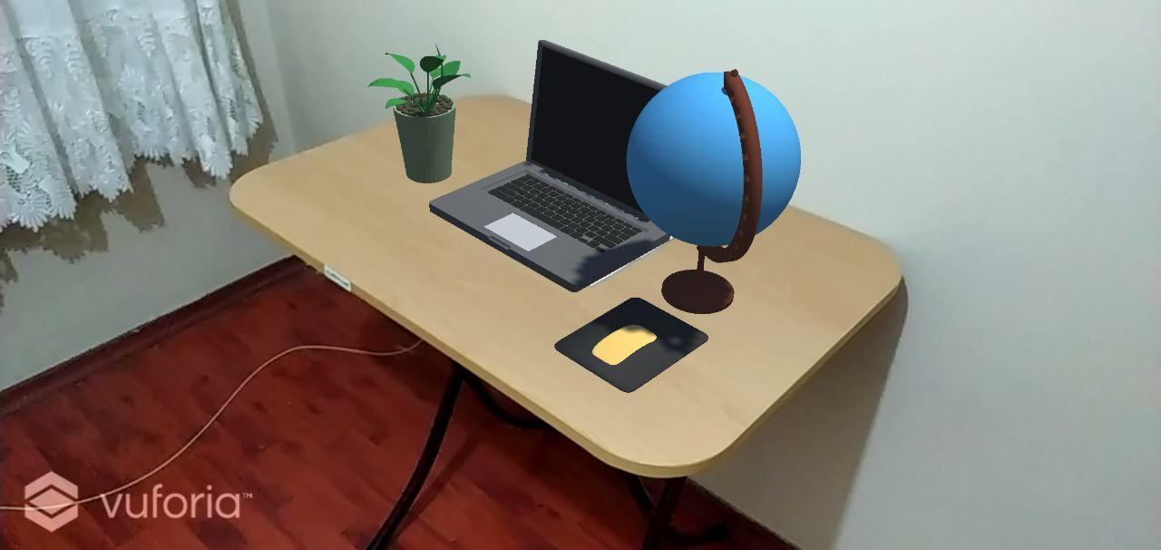

Figure 3.1 and 3.2 – An example design that uses the laptop, mouse and some decorations.

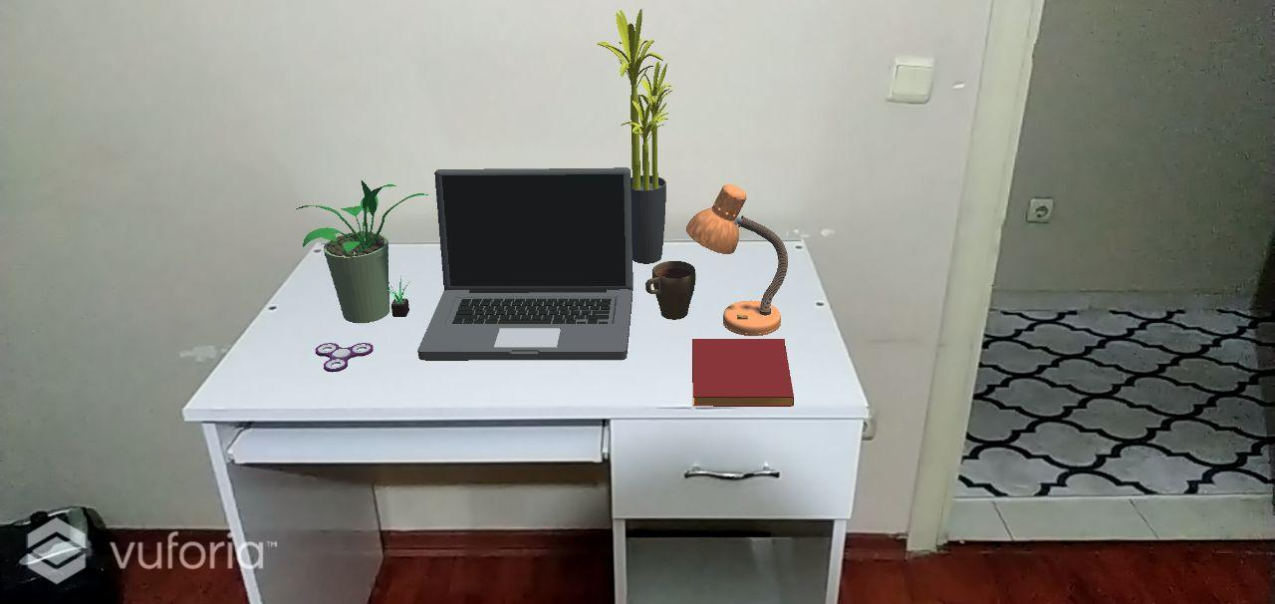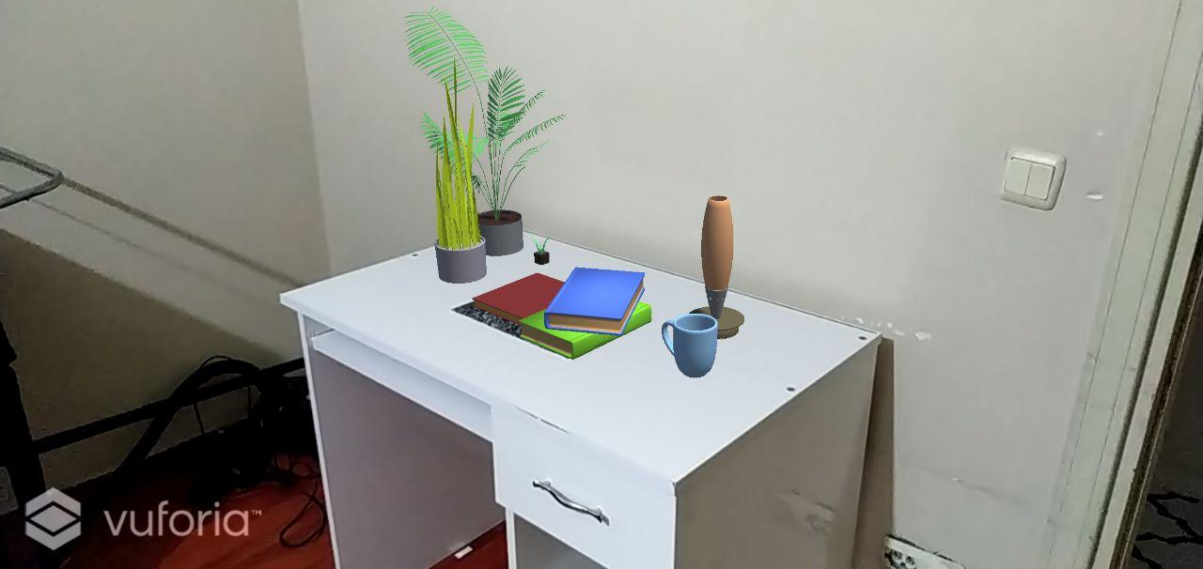

Figure 3.3 and 3.4 – Two more examples with a different desk from the previous one. While Figure 3.3 is for “young computer user” type users, the other is for the “bookworm” type users.

1. **Technical Specifications**

Desker is designed and developed using the following tools:

1. Unity (For the base application systems)
2. Vuforia Engine for Unity (For the AR integration)
3. Blender (For 3D modelling and texturing)
4. Adobe Photoshop (For 2D designs)

At the center of the system, I utilized Unity. Unity enables the core features of a game engine and because of that, it is a powerful tool to create these types of applications. Vuforia Engine is an AR engine that can be integrated to Unity and it is easy to get up and running quickly, so I picked that. These two tools made the Desker an application that can be used to designs desk with, but without any objects to put anywhere, they come short. Because of that, I picked Blender to designs the objects. Almost all objects in the catalog is designed with Blender and got their textures from it. With a simple pipeline, I integrated my 3D designs into Unity and created a catalog of objects that are compatible with Desker. For the design of the logos, buttons and other things 2D, I used Adobe Photoshop. It is a fast and easy tool to what Desker needs.