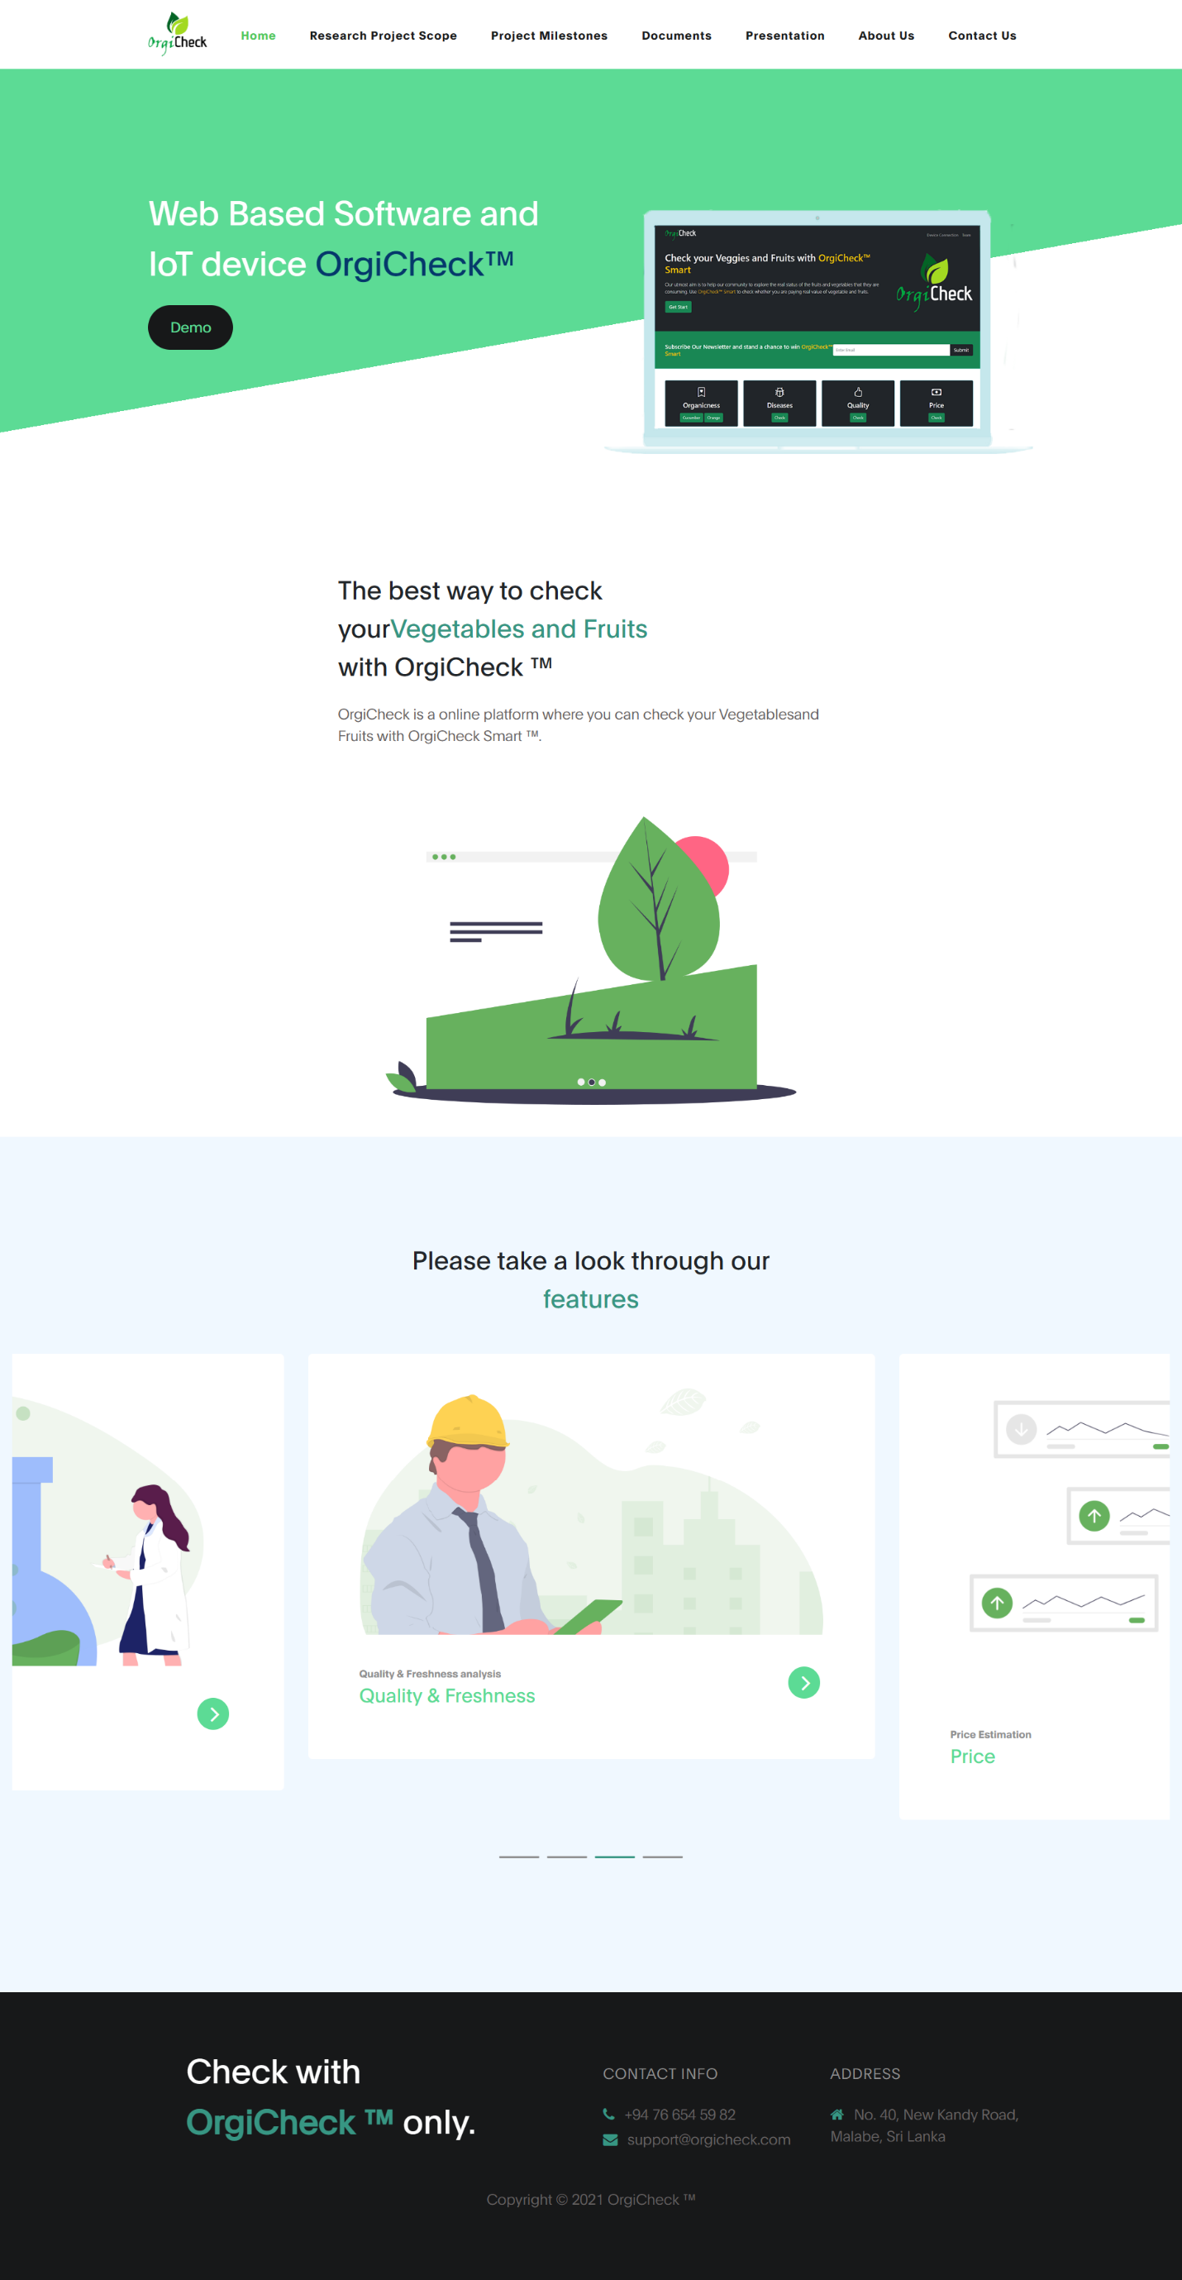

**Weed Identification**

**Disease Identification**

**Deficiency Identification**

**Pest Identification**

**The best way to check your gardening problems with Smart Farmer**

**The best way to check your gardening problems with Smart Farmer**

**Smart Farmer (Agriculture based Mobile Application for Farmers).**

# **Research Project Scope**

RESEARCH PROBLEM

* With Sri Lanka's present economic and food crises, agriculture has taken the lead as a sector.
* Here, it can be studied that the majority of individuals choose to cultivate their own food.
* The newcomers who start cultivating in this place run into a number of issues.
* The primary goal of this research is to provide better solution for these issues

Above are the Research Problems we should address.

#### RESEARCH OBJECTIVE

* Identify pests that can damage crops and suggest control methods.
* Identify deficiency of plants.
* Identify disease that can damage crops and suggest control methods.
* Weed identification and control methods.

#### METHODOLOGY

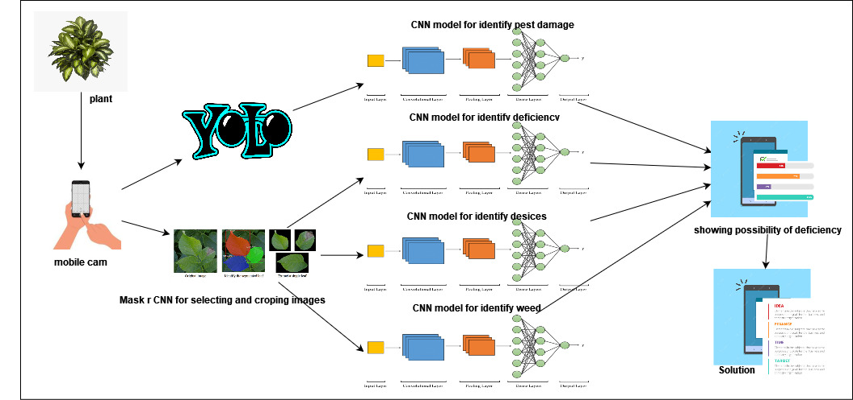

Here is the systematic software component diagram.

#### TECHNOLOGIES

* Frontend

ReactNative

* Backend

Python

Jupyter Notebook and Google colab

* Libraries

TensorFlow

Matplotlib, Numpy, Pandas

Python REST API : Flask

* Database

Firebase

Here are the technologies we used to develop the system.

# **Project Milestones**

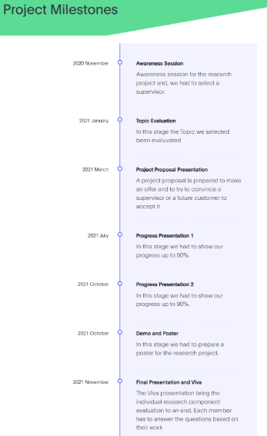

# **Documents**

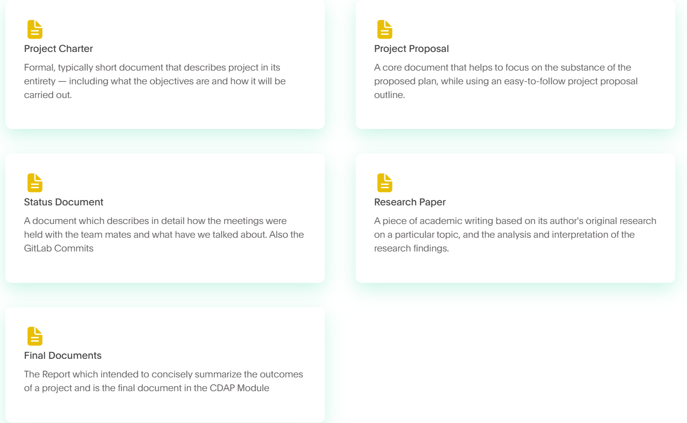

# **Presentation**

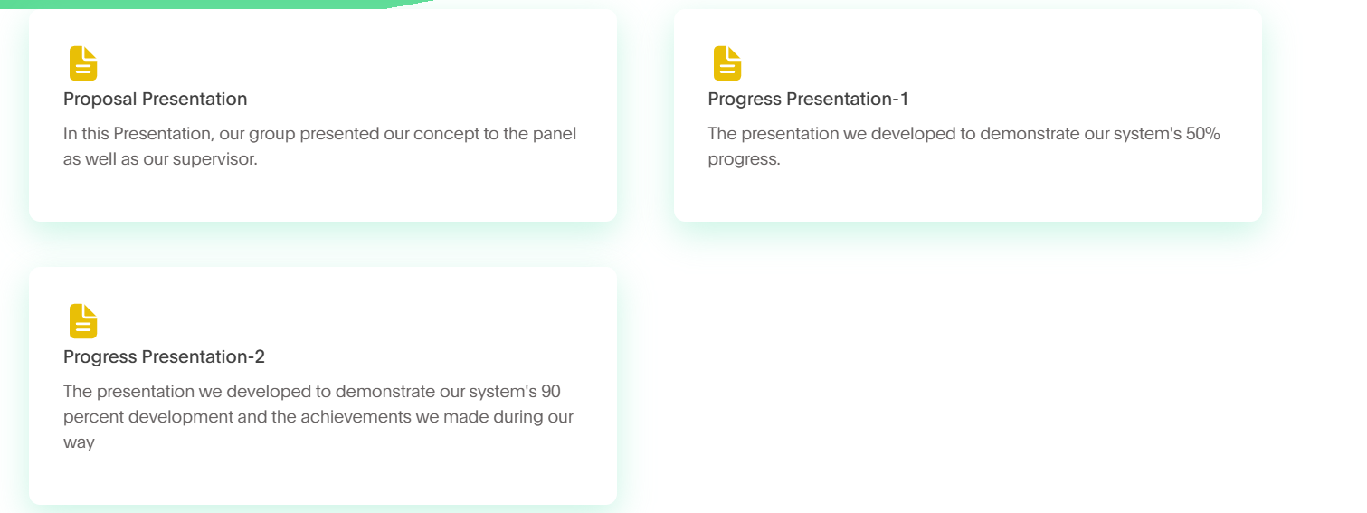

# **About Us**

#### SUPERVISOR - Ms. Suriyaa Kumari

###### **Email :** [**suriyaa.k@sliit.lk**](mailto:suriyaa.k@sliit.lk)



#### CO-SUPERVISOR - Mr. Supunya Swarnakantha

###### **Email :** **ravi.s@sliit.lk**



#### GROUP LEADER - M.D.S. WARNASOORIYA

#### Email : it19214412 @my.sliit.lk

#### 

#### GROUP MEMBER - G.D.M. GODAHEWAGE

###### **Email :it19106816@my.sliit.lk**

#### GROUP MEMBER - B.V.C.BHASHINI

###### **Email :it19166452@my.sliit.lk**

#### GROUP MEMBER - MANUKALPANI G.S.

###### **Email :it19111698@my.sliit.lk**



# **Contact Us**

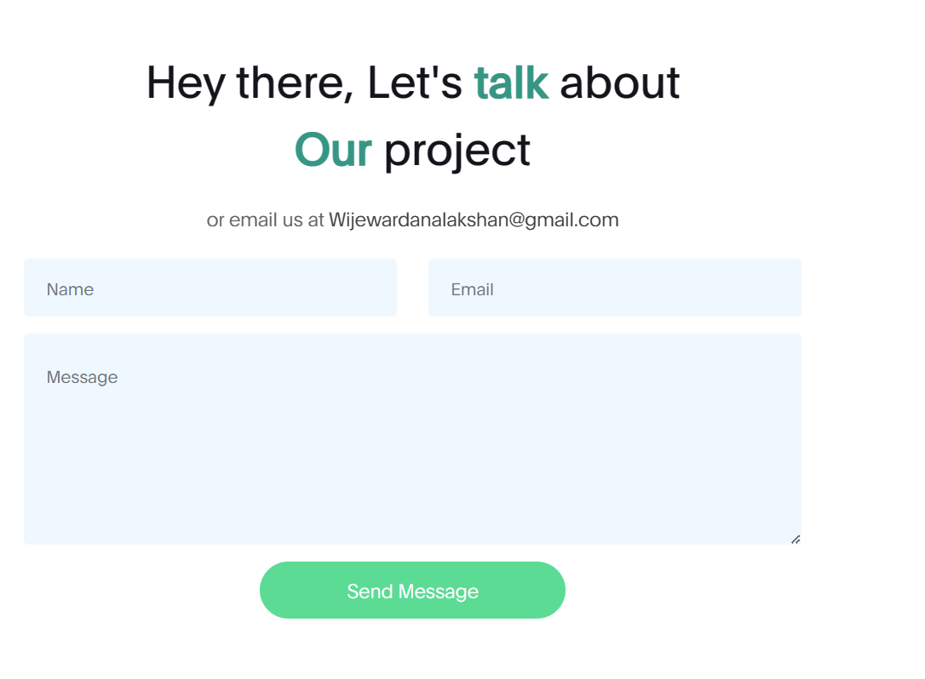

smartfarmerresearch@gmail.com